Lawak Store

Test Evidence - regression-sprint-2-chk / RunTest1
Item | Value
Application | Lawak Store (demo shop with admin panel)
Suite | Regression
Filters | sprint 2, module chk
Run | RunTest1 (13 Oct 2026 03:17 to 13 Oct 2026 03:17)
Target | http://127.0.0.1:4173
Browser | Microsoft Edge (msedge)
Command | node scripts/run-suite.js --suite regression --sprint 2 --module chk
Result | 5 Pass, 1 Fail, 0 Skipped of 6 cases

Status of all cases
ID | Test case | Module | Sprint | Layer | Tool | Result
TC-CHK-001 | Checkout with the test card creates an order | Checkout | Sprint 2 | UI | Playwright | Pass
TC-CHK-002 | Empty required fields are reported | Checkout | Sprint 2 | UI | Playwright | Pass
TC-CHK-003 | Declined card shows a payment error | Checkout | Sprint 2 | UI | Playwright | Pass
TC-CHK-004 | Invalid card number is rejected | Checkout | Sprint 2 | UI | Playwright | Pass
TC-CHK-005 | Expired card is rejected | Checkout | Sprint 2 | UI | Playwright | Pass
TC-CHK-006 | Postal code must have exactly 5 digits | Checkout | Sprint 2 | UI | Playwright | Fail

Failure summary
ID | Test case | Failed step | Actual result | Layer - owner | Recommendation | Evidence
TC-CHK-006  DEF-001 | Postal code must have exactly 5 digits | S01 Pay with postal code 4011 | Error: DEF-001: the app accepts 4 digits and creates the order expect(locator).toHaveText(expected) failed Locator: locator('#err-postalCode') Expected: "Enter a 5-digit postal code." | API (validation rule) - Backend | Change the postal code rule from 4-5 digits to exactly 5 digits (regex ^\d{5}$) in the order validation, and add the same check to the checkout form for fast feedback. | TC-CHK-006_01-UI.png

Backend: TC-CHK-006
Check: 5 Pass + 1 Fail + 0 Skipped = 6 cases.

Module: Checkout

Scenario: Payment

TC-CHK-001 - Checkout with the test card creates an order [Pass]
Type Positive | Priority High | Sprint 2 | Layer UI | Tool Playwright | Reference US-030
No | Layer | Step | Expected result | Result | Actual result
S01 | UI | [UI] Add Kopi Toraja Beans to the cart and open Checkout | The Pay button shows Rp 110.000 | Pass | As expected.
S02 | UI | [UI] Fill a valid address and card 4242 4242 4242 4242, then select Pay | The page says "Thank you! Your order LS-... is confirmed." and the cart count is 0 | Pass | Order LS-10007 is confirmed. The cart count is 0.
Evidence TC-CHK-001_01-UI.png
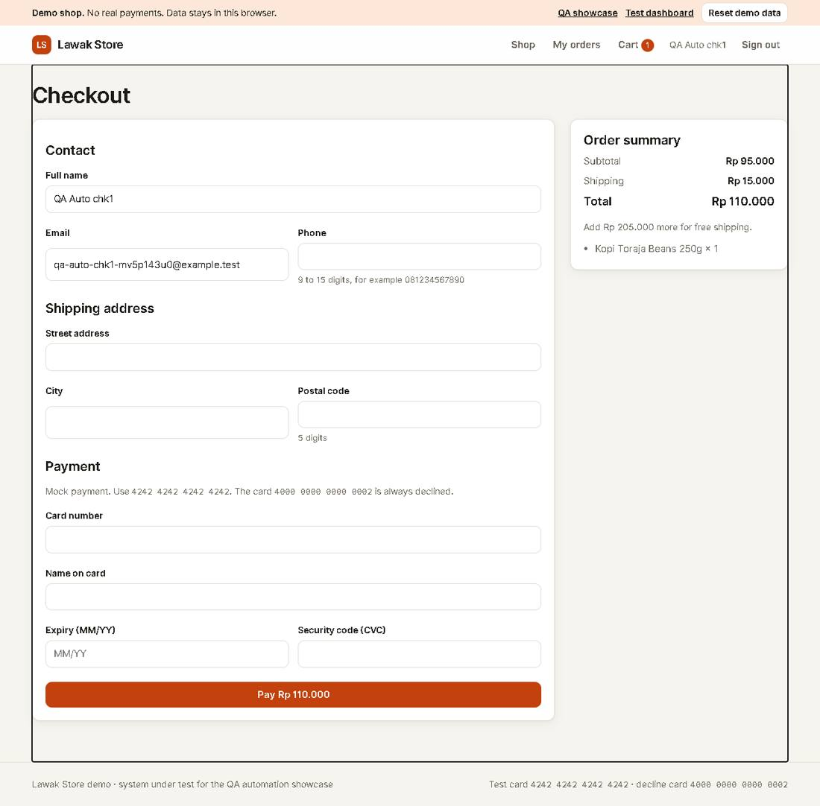
Evidence TC-CHK-001_02-UI.png
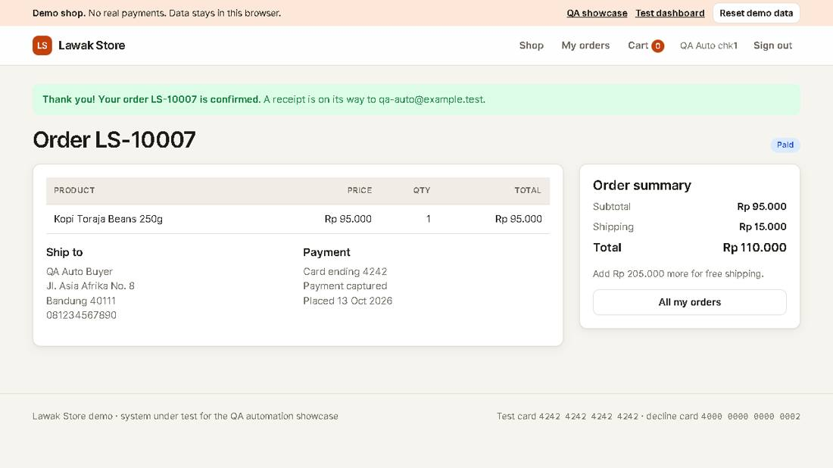

Scenario: Validation

TC-CHK-002 - Empty required fields are reported [Pass]
Type Negative | Priority High | Sprint 2 | Layer UI | Tool Playwright | Reference US-030
No | Layer | Step | Expected result | Result | Actual result
S01 | UI | [UI] Open Checkout with one item and clear the Full name field | The form shows | Pass | As expected.
S02 | UI | [UI] Select Pay without filling the form | Each empty field shows "This field is required." and no order is created | Pass | 9 empty fields show "This field is required." No order was created.
Evidence TC-CHK-002_01-UI.png
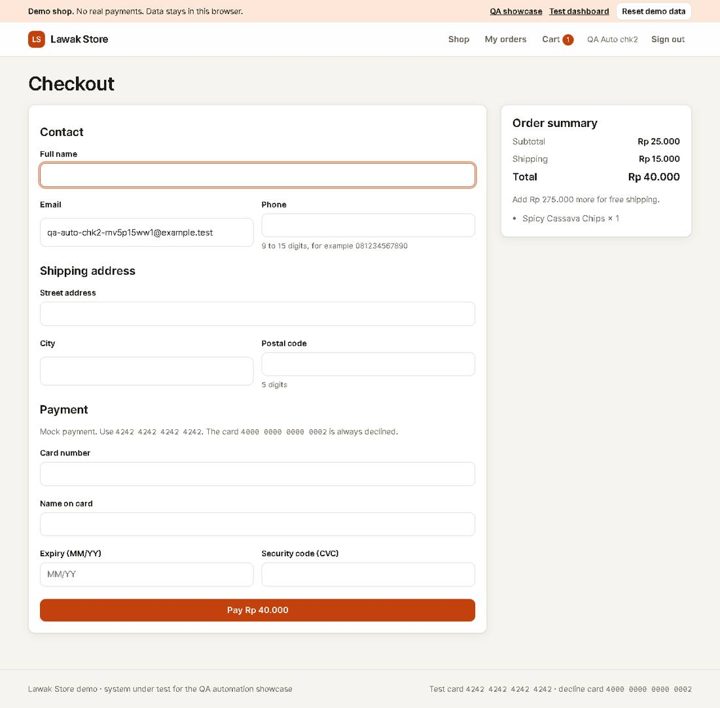
Evidence TC-CHK-002_02-UI.png
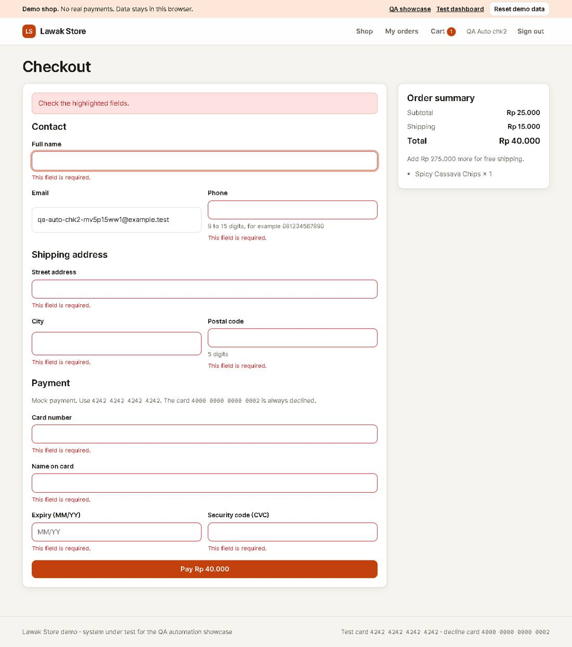

Scenario: Payment

TC-CHK-003 - Declined card shows a payment error [Pass]
Type Negative | Priority High | Sprint 2 | Layer UI | Tool Playwright | Reference US-031
No | Layer | Step | Expected result | Result | Actual result
S01 | UI | [UI] Fill Checkout with card 4000 0000 0000 0002 and select Pay | The alert says "The card was declined. Use another card." | Pass | As expected.
S02 | UI | [UI] Open the cart | The item is still in the cart | Pass | The item is still in the cart after the declined payment.
Evidence TC-CHK-003_01-UI.png
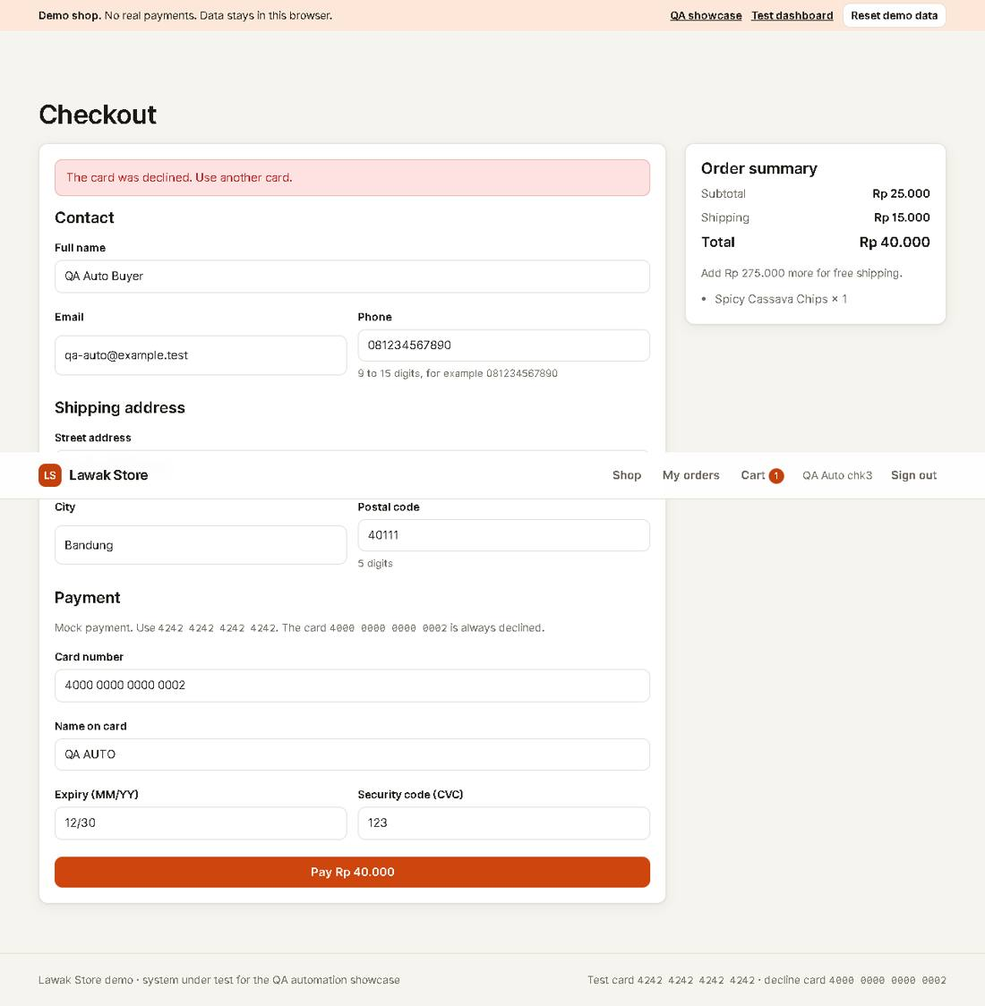
Evidence TC-CHK-003_02-UI.png
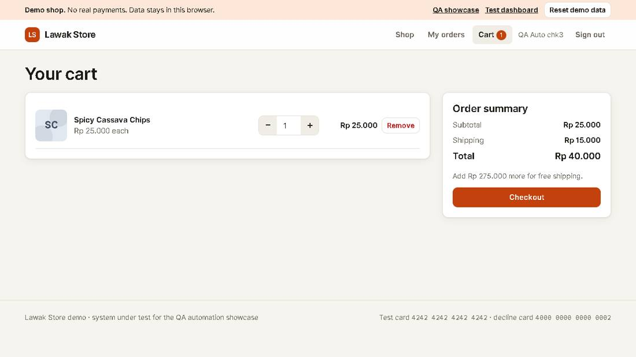

Scenario: Validation

TC-CHK-004 - Invalid card number is rejected [Pass]
Type Negative | Priority Medium | Sprint 2 | Layer UI | Tool Playwright | Reference US-031
No | Layer | Step | Expected result | Result | Actual result
S01 | UI | [UI] Fill Checkout with card 1234 5678 9012 3456 and select Pay | The Card number field shows "Enter a valid 16-digit card number." | Pass | As expected.
Evidence TC-CHK-004_01-UI.png
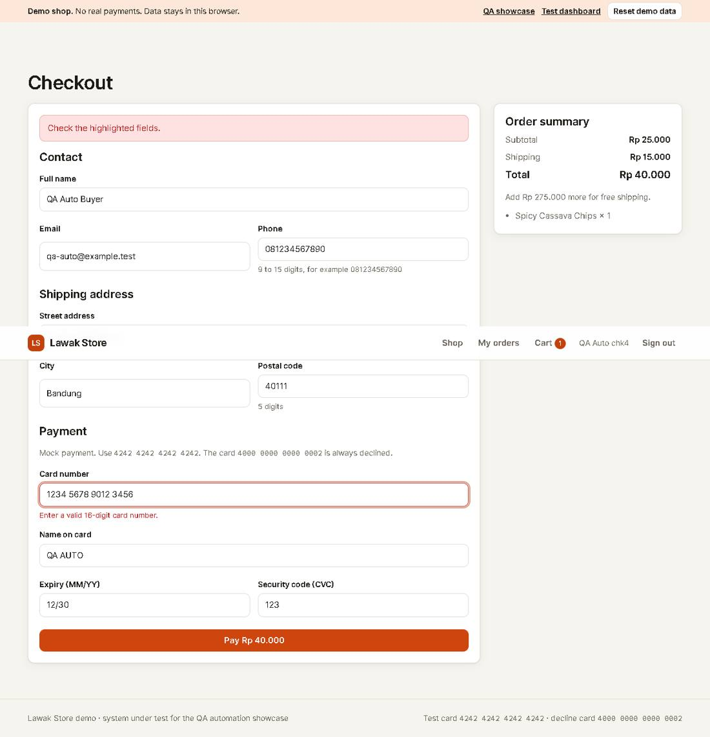

TC-CHK-005 - Expired card is rejected [Pass]
Type Negative | Priority Medium | Sprint 2 | Layer UI | Tool Playwright | Reference US-031
No | Layer | Step | Expected result | Result | Actual result
S01 | UI | [UI] Fill Checkout with expiry 01/20 and select Pay | The Expiry field shows "This card has expired." | Pass | As expected.
Evidence TC-CHK-005_01-UI.png
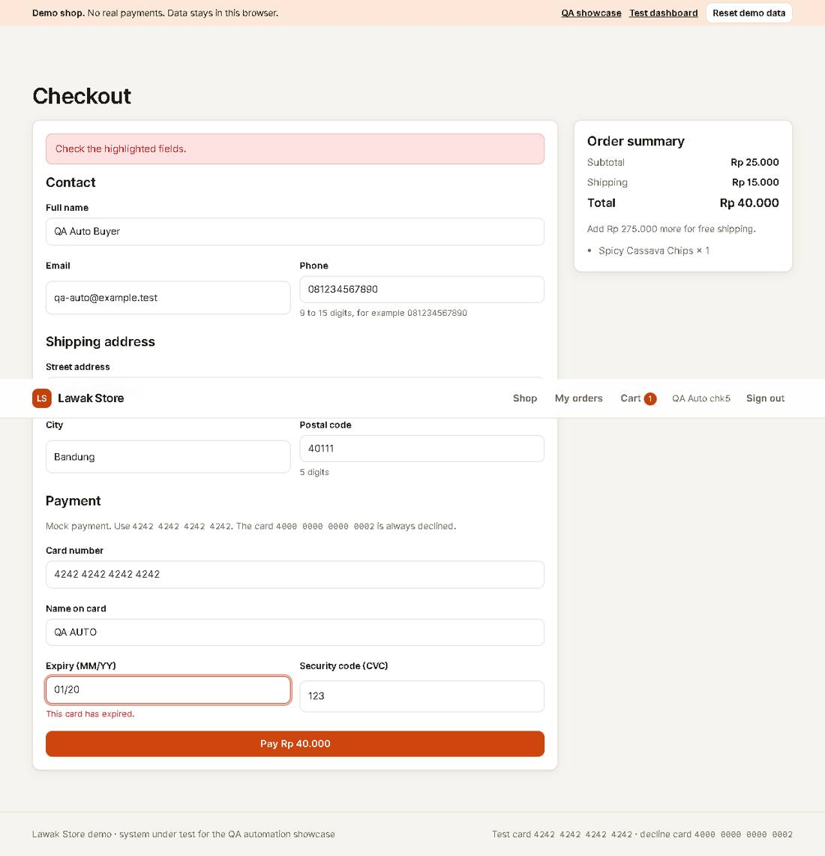

TC-CHK-006 - Postal code must have exactly 5 digits [Fail]
Type Negative | Priority Medium | Sprint 2 | Layer UI | Tool Playwright | Reference US-030 rule R-07 (known defect DEF-001)
No | Layer | Step | Expected result | Result | Actual result
S01 | UI | [UI] Fill Checkout with postal code 4011 (4 digits) and select Pay | The Postal code field shows "Enter a 5-digit postal code." and no order is created | Fail | Error: DEF-001: the app accepts 4 digits and creates the order expect(locator).toHaveText(expected) failed Locator: locator('#err-postalCode') Expected: "Enter a 5-digit postal code."
Evidence TC-CHK-006_01-UI.png
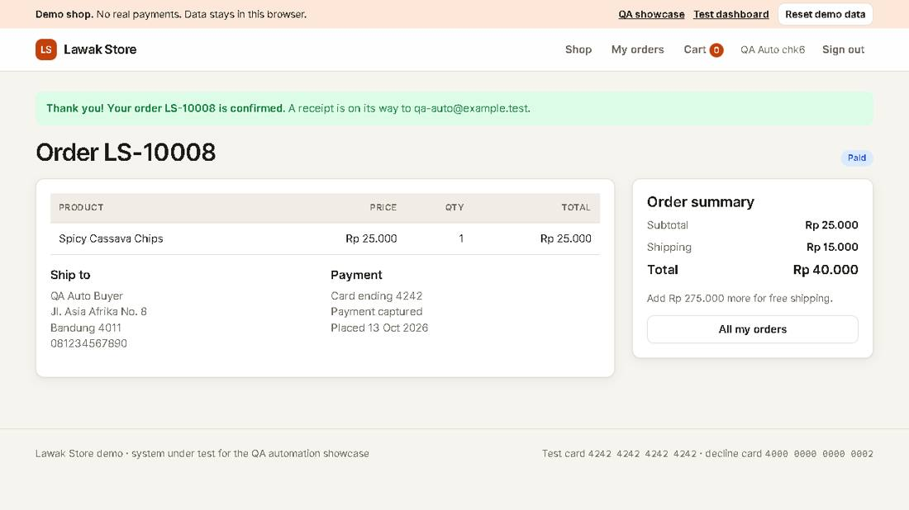
Note: DEF-001: a 4-digit postal code is accepted. This case fails until the defect is fixed.

