Lawak Store

Test Evidence - regression / RunTest1
Item | Value
Application | Lawak Store (demo shop with admin panel)
Suite | Regression
Filters | none
Run | RunTest1 (13 Oct 2026 03:09 to 13 Oct 2026 03:10)
Target | http://127.0.0.1:4173
Browser | Microsoft Edge (msedge)
Command | node scripts/run-suite.js --suite regression
Result | 40 Pass, 1 Fail, 0 Skipped of 41 cases

Status of all cases
ID | Test case | Module | Sprint | Layer | Tool | Result
TC-AOR-001 | A new customer order shows in admin Orders | Admin Orders | Sprint 3 | UI | Playwright | Pass
TC-AOR-002 | Admin moves an order from Paid to Processing | Admin Orders | Sprint 3 | UI | Playwright | Pass
TC-AOR-003 | Cancelling an order puts the stock back | Admin Orders | Sprint 3 | UI | Playwright | Pass
TC-AUTH-001 | Sign in with the demo admin account | Authentication | Sprint 1 | UI | Playwright | Pass
TC-AUTH-002 | Wrong password shows an error | Authentication | Sprint 1 | UI | Playwright | Pass
TC-AUTH-003 | Invalid email format is rejected | Authentication | Sprint 1 | UI | Playwright | Pass
TC-AUTH-004 | Disabled account cannot sign in | Authentication | Sprint 1 | UI | Playwright | Pass
TC-AUTH-005 | Register a new customer account | Authentication | Sprint 1 | UI | Playwright | Pass
TC-AUTH-006 | Register with an existing email is rejected | Authentication | Sprint 1 | UI | Playwright | Pass
TC-AUTH-007 | Weak password is rejected | Authentication | Sprint 1 | UI | Playwright | Pass
TC-AUTH-008 | Sign out ends the session | Authentication | Sprint 1 | UI | Playwright | Pass
TC-AUTH-009 | A protected page asks for sign in, then returns to it | Authentication | Sprint 1 | UI | Playwright | Pass
TC-CART-001 | Add a product to the cart | Cart | Sprint 2 | UI | Playwright | Pass
TC-CART-002 | Changing the quantity updates the totals | Cart | Sprint 2 | UI | Playwright | Pass
TC-CART-003 | Shipping is free from Rp 300.000 | Cart | Sprint 2 | UI | Playwright | Pass
TC-CART-004 | Removing the last item shows an empty cart | Cart | Sprint 2 | UI | Playwright | Pass
TC-CART-005 | Quantity limit of 10 is enforced | Cart | Sprint 2 | UI | Playwright | Pass
TC-CAT-001 | Shop lists all active products and hides drafts | Catalog | Sprint 1 | UI | Playwright | Pass
TC-CAT-002 | Search finds a product by name | Catalog | Sprint 1 | UI | Playwright | Pass
TC-CAT-003 | Category filter shows only that category | Catalog | Sprint 1 | UI | Playwright | Pass
TC-CAT-004 | Sort by price from low to high | Catalog | Sprint 1 | UI | Playwright | Pass
TC-CAT-005 | Search with no result shows an empty state | Catalog | Sprint 1 | UI | Playwright | Pass
TC-CAT-006 | Product detail shows the price and stock | Catalog | Sprint 1 | UI | Playwright | Pass
TC-CAT-007 | Out-of-stock product cannot be added to the cart | Catalog | Sprint 1 | UI | Playwright | Pass
TC-CHK-001 | Checkout with the test card creates an order | Checkout | Sprint 2 | UI | Playwright | Pass
TC-CHK-002 | Empty required fields are reported | Checkout | Sprint 2 | UI | Playwright | Pass
TC-CHK-003 | Declined card shows a payment error | Checkout | Sprint 2 | UI | Playwright | Pass
TC-CHK-004 | Invalid card number is rejected | Checkout | Sprint 2 | UI | Playwright | Pass
TC-CHK-005 | Expired card is rejected | Checkout | Sprint 2 | UI | Playwright | Pass
TC-CHK-006 | Postal code must have exactly 5 digits | Checkout | Sprint 2 | UI | Playwright | Fail
TC-DSH-001 | Admin dashboard shows the KPIs | Admin Dashboard | Sprint 4 | UI | Playwright | Pass
TC-ORD-001 | A new order shows in My orders | Customer Orders | Sprint 2 | UI | Playwright | Pass
TC-ORD-002 | A customer cannot open another customer's order | Customer Orders | Sprint 2 | UI | Playwright | Pass
TC-PRD-001 | Admin creates a product | Admin Products | Sprint 3 | UI | Playwright | Pass
TC-PRD-002 | Admin edits a product price | Admin Products | Sprint 3 | UI | Playwright | Pass
TC-PRD-003 | Admin deletes a product | Admin Products | Sprint 3 | UI | Playwright | Pass
TC-PRD-004 | Product form rejects invalid data | Admin Products | Sprint 3 | UI | Playwright | Pass
TC-PRD-005 | A draft product is hidden from the shop | Admin Products | Sprint 3 | UI | Playwright | Pass
TC-USR-001 | A customer cannot open admin pages | Admin Users | Sprint 4 | UI | Playwright | Pass
TC-USR-002 | A disabled customer cannot sign in | Admin Users | Sprint 4 | UI | Playwright | Pass
TC-USR-003 | Admin cannot change their own role or status | Admin Users | Sprint 4 | UI | Playwright | Pass

Failure summary
ID | Test case | Failed step | Actual result | Layer - owner | Recommendation | Evidence
TC-CHK-006  DEF-001 | Postal code must have exactly 5 digits | S01 Pay with postal code 4011 | Error: DEF-001: the app accepts 4 digits and creates the order expect(locator).toHaveText(expected) failed Locator: locator('#err-postalCode') Expected: "Enter a 5-digit postal code." | API (validation rule) - Backend | Change the postal code rule from 4-5 digits to exactly 5 digits (regex ^\d{5}$) in the order validation, and add the same check to the checkout form for fast feedback. | TC-CHK-006_01-UI.png

Backend: TC-CHK-006
Check: 40 Pass + 1 Fail + 0 Skipped = 41 cases.

Module: Authentication

Scenario: Sign in

TC-AUTH-001 - Sign in with the demo admin account [Pass]
Type Positive | Priority High | Sprint 1 | Layer UI | Tool Playwright | Reference US-001
No | Layer | Step | Expected result | Result | Actual result
S01 | UI | [UI] Open the Sign in page | The Sign in form shows the Email and Password fields | Pass | The Sign in form shows Email and Password.
S02 | UI | [UI] Enter login@demo.com and Logindemo123, then select Sign in | The admin Dashboard opens and the header shows Demo Admin | Pass | The admin Dashboard opened. The header shows Demo Admin.
Evidence TC-AUTH-001_01-UI.png
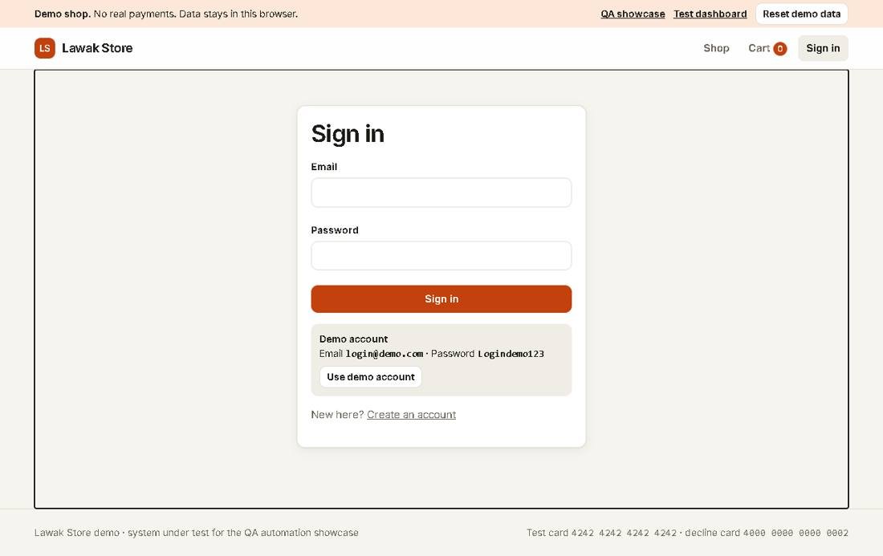
Evidence TC-AUTH-001_02-UI.png
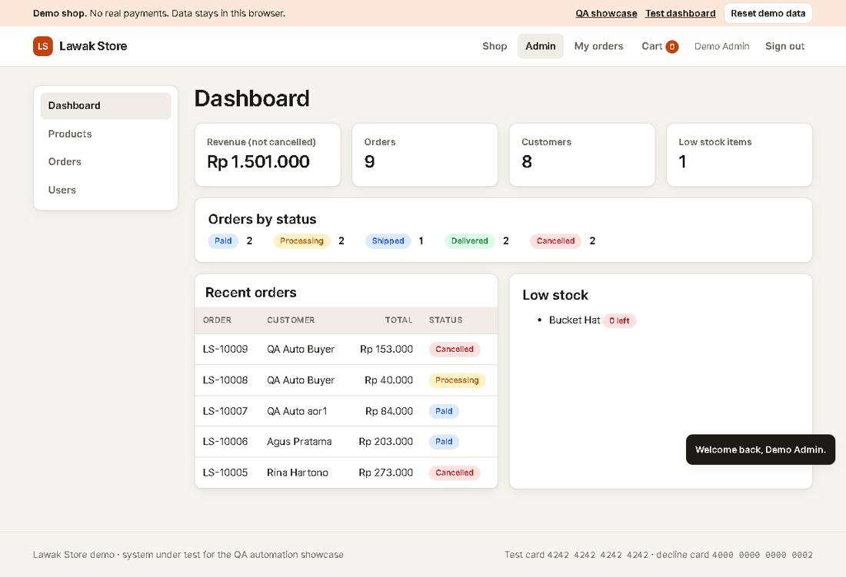

TC-AUTH-002 - Wrong password shows an error [Pass]
Type Negative | Priority High | Sprint 1 | Layer UI | Tool Playwright | Reference US-001
No | Layer | Step | Expected result | Result | Actual result
S01 | UI | [UI] Open the Sign in page | The Sign in form shows | Pass | As expected.
S02 | UI | [UI] Enter login@demo.com with a wrong password, then select Sign in | The alert says "Invalid email or password." and the user stays signed out | Pass | The alert says "Invalid email or password." The user is still signed out.
Evidence TC-AUTH-002_01-UI.png
Evidence TC-AUTH-002_02-UI.png
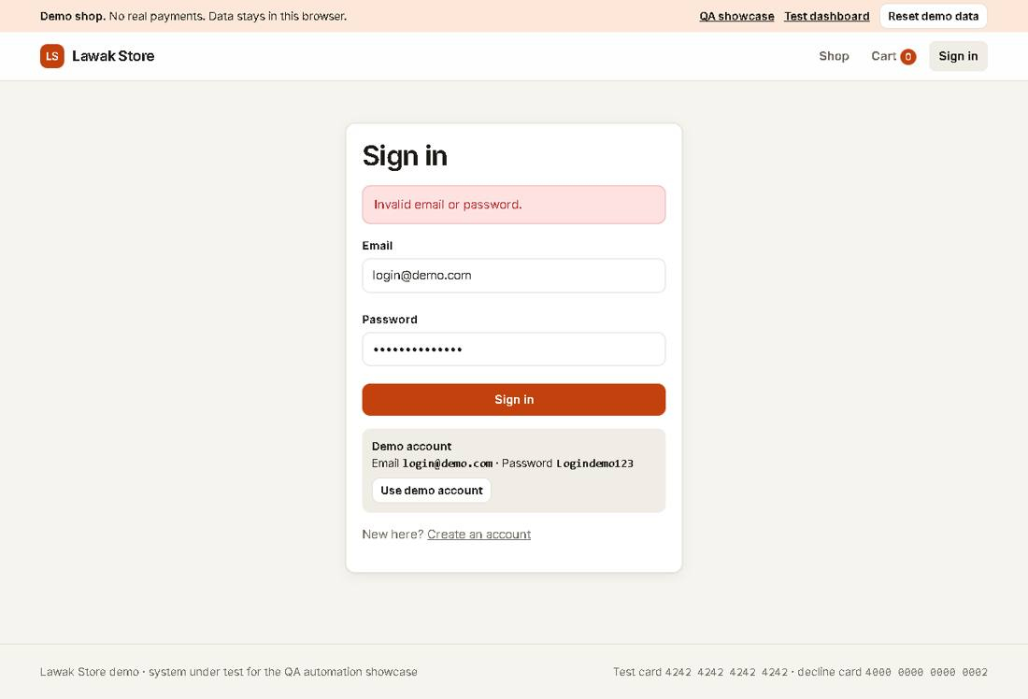

TC-AUTH-003 - Invalid email format is rejected [Pass]
Type Negative | Priority Medium | Sprint 1 | Layer UI | Tool Playwright | Reference US-001
No | Layer | Step | Expected result | Result | Actual result
S01 | UI | [UI] Open the Sign in page | The Sign in form shows | Pass | As expected.
S02 | UI | [UI] Enter "not-an-email" and any password, then select Sign in | The Email field shows "Enter a valid email address." | Pass | The Email field shows "Enter a valid email address."
Evidence TC-AUTH-003_01-UI.png
Evidence TC-AUTH-003_02-UI.png
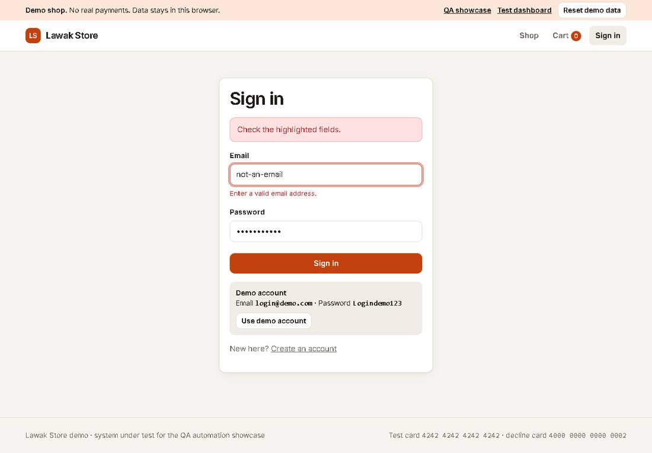

TC-AUTH-004 - Disabled account cannot sign in [Pass]
Type Negative | Priority Medium | Sprint 1 | Layer UI | Tool Playwright | Reference US-002
No | Layer | Step | Expected result | Result | Actual result
S01 | UI | [UI] Open the Sign in page | The Sign in form shows | Pass | As expected.
S02 | UI | [UI] Sign in as budi@demo.com (disabled account) | The alert says "This account is disabled. Contact support." | Pass | The alert says the account is disabled.
Evidence TC-AUTH-004_01-UI.png
Evidence TC-AUTH-004_02-UI.png
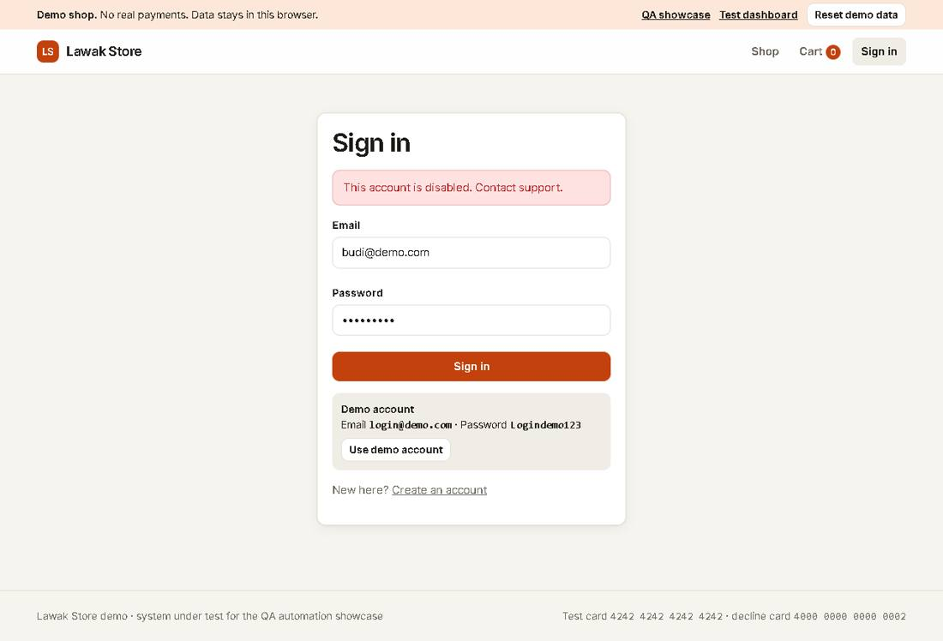

Scenario: Registration

TC-AUTH-005 - Register a new customer account [Pass]
Type Positive | Priority High | Sprint 1 | Layer UI | Tool Playwright | Reference US-003
No | Layer | Step | Expected result | Result | Actual result
S01 | UI | [UI] Open Create account | The registration form shows four fields | Pass | As expected.
S02 | UI | [UI] Enter a unique qa-auto email, a valid name and a valid password twice, then submit | The Sign in page shows "Account created. Sign in to continue." with the email filled in | Pass | The account qa-auto-register-mv5orhoud@example.test was created. The Sign in page has the email filled in.
S03 | UI | [UI] Sign in with the new account | The Shop page opens and the header shows the new name | Pass | As expected.
Evidence TC-AUTH-005_01-UI.png
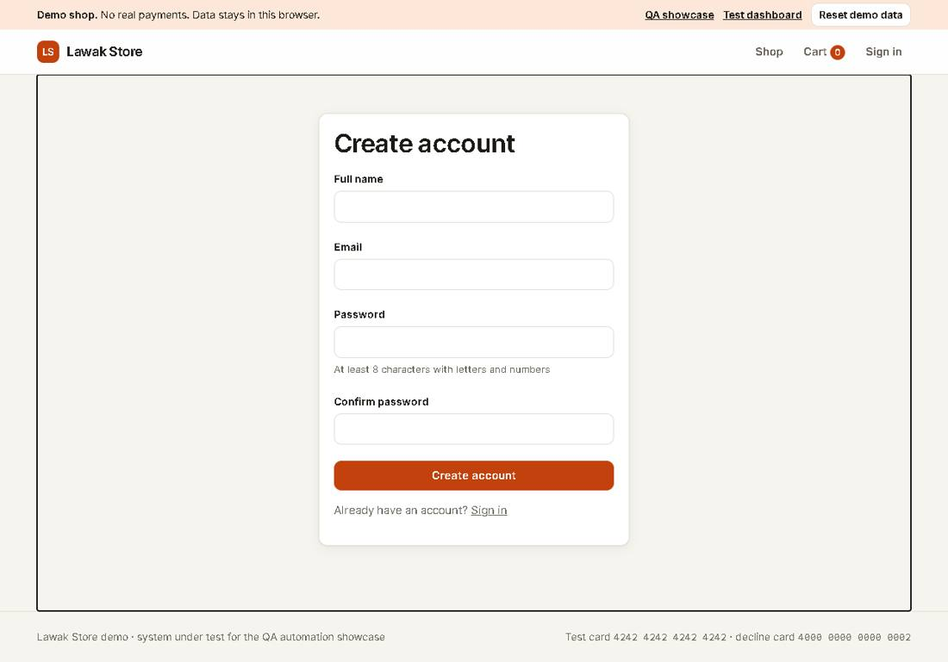
Evidence TC-AUTH-005_02-UI.png
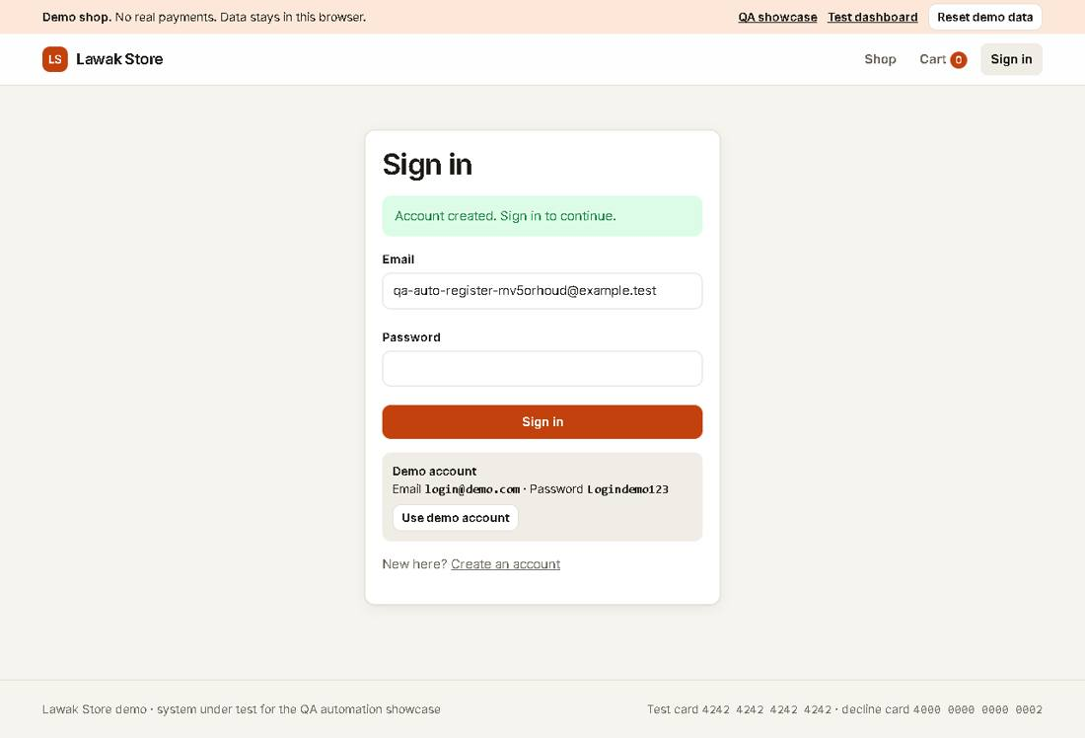
Evidence TC-AUTH-005_03-UI.png
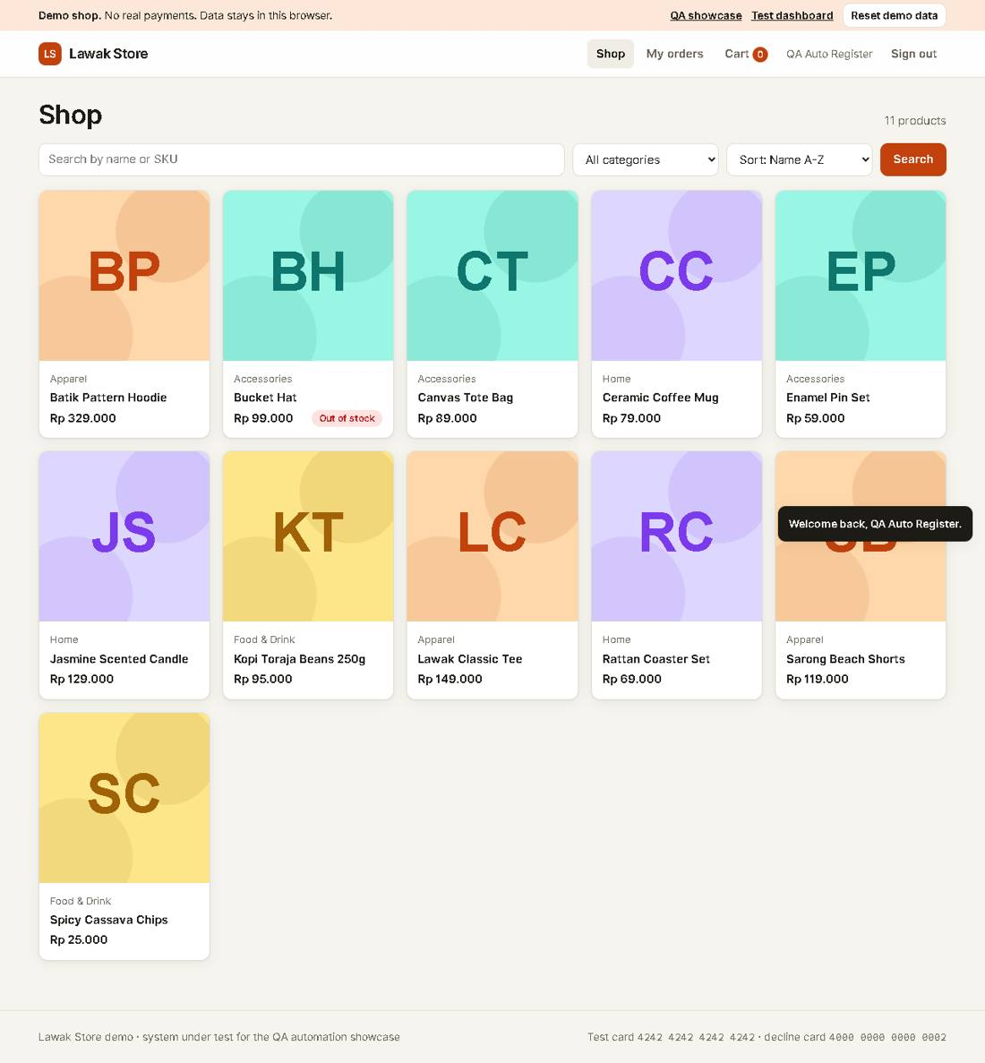

TC-AUTH-006 - Register with an existing email is rejected [Pass]
Type Negative | Priority Medium | Sprint 1 | Layer UI | Tool Playwright | Reference US-003
No | Layer | Step | Expected result | Result | Actual result
S01 | UI | [UI] Open Create account | The registration form shows | Pass | As expected.
S02 | UI | [UI] Register with customer@demo.com | The Email field shows "An account with this email already exists." | Pass | As expected.
Evidence TC-AUTH-006_01-UI.png
Evidence TC-AUTH-006_02-UI.png
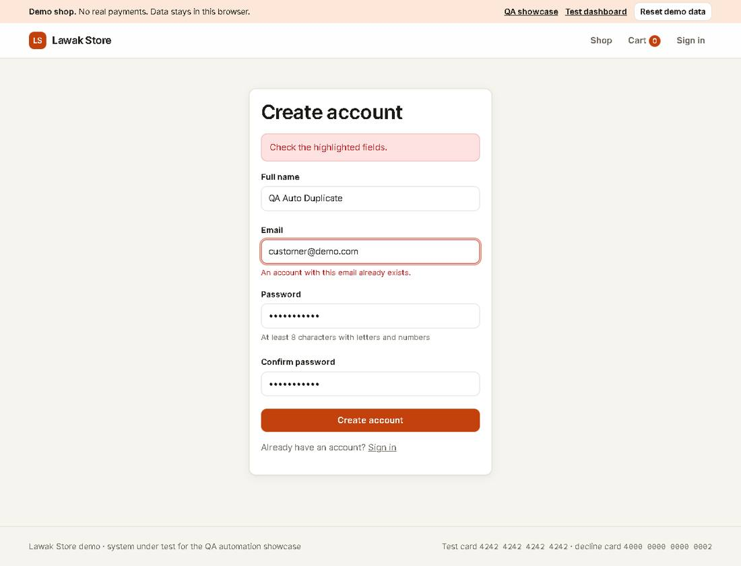

TC-AUTH-007 - Weak password is rejected [Pass]
Type Negative | Priority Medium | Sprint 1 | Layer UI | Tool Playwright | Reference US-003 rule R-01
No | Layer | Step | Expected result | Result | Actual result
S01 | UI | [UI] Open Create account | The registration form shows | Pass | As expected.
S02 | UI | [UI] Register with the password "short" | The Password field shows "Use at least 8 characters with letters and numbers." | Pass | As expected.
Evidence TC-AUTH-007_01-UI.png
Evidence TC-AUTH-007_02-UI.png
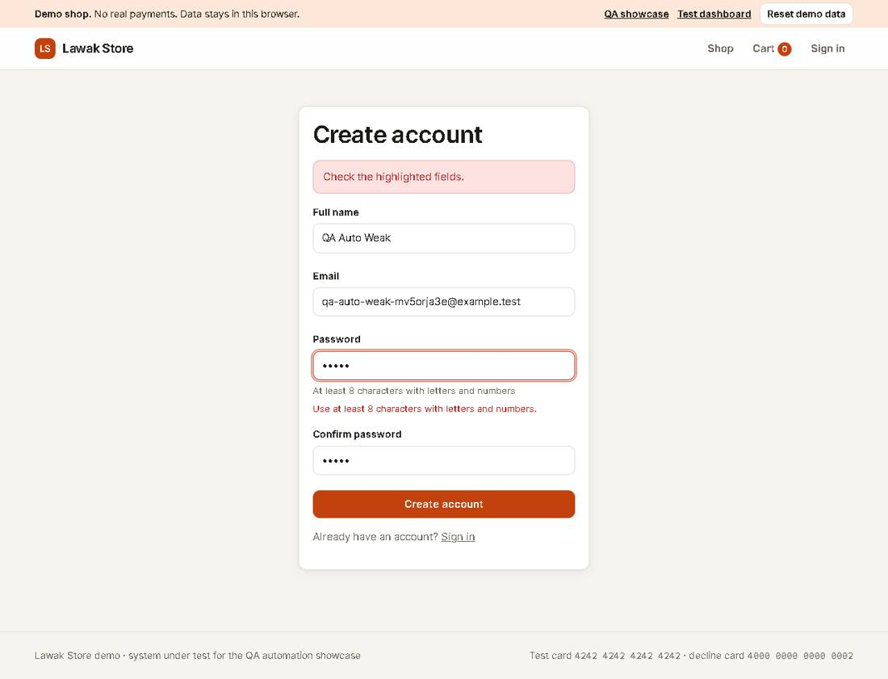

Scenario: Sign out

TC-AUTH-008 - Sign out ends the session [Pass]
Type Positive | Priority High | Sprint 1 | Layer UI | Tool Playwright | Reference US-004
No | Layer | Step | Expected result | Result | Actual result
S01 | UI | [UI] Sign in as customer@demo.com | The header shows Sari Wulandari and Sign out | Pass | As expected.
S02 | UI | [UI] Select Sign out | The header shows Sign in | Pass | As expected.
S03 | UI | [UI] Open My orders by its address | The Sign in page opens instead | Pass | My orders sent the signed-out user to Sign in.
Evidence TC-AUTH-008_01-UI.png
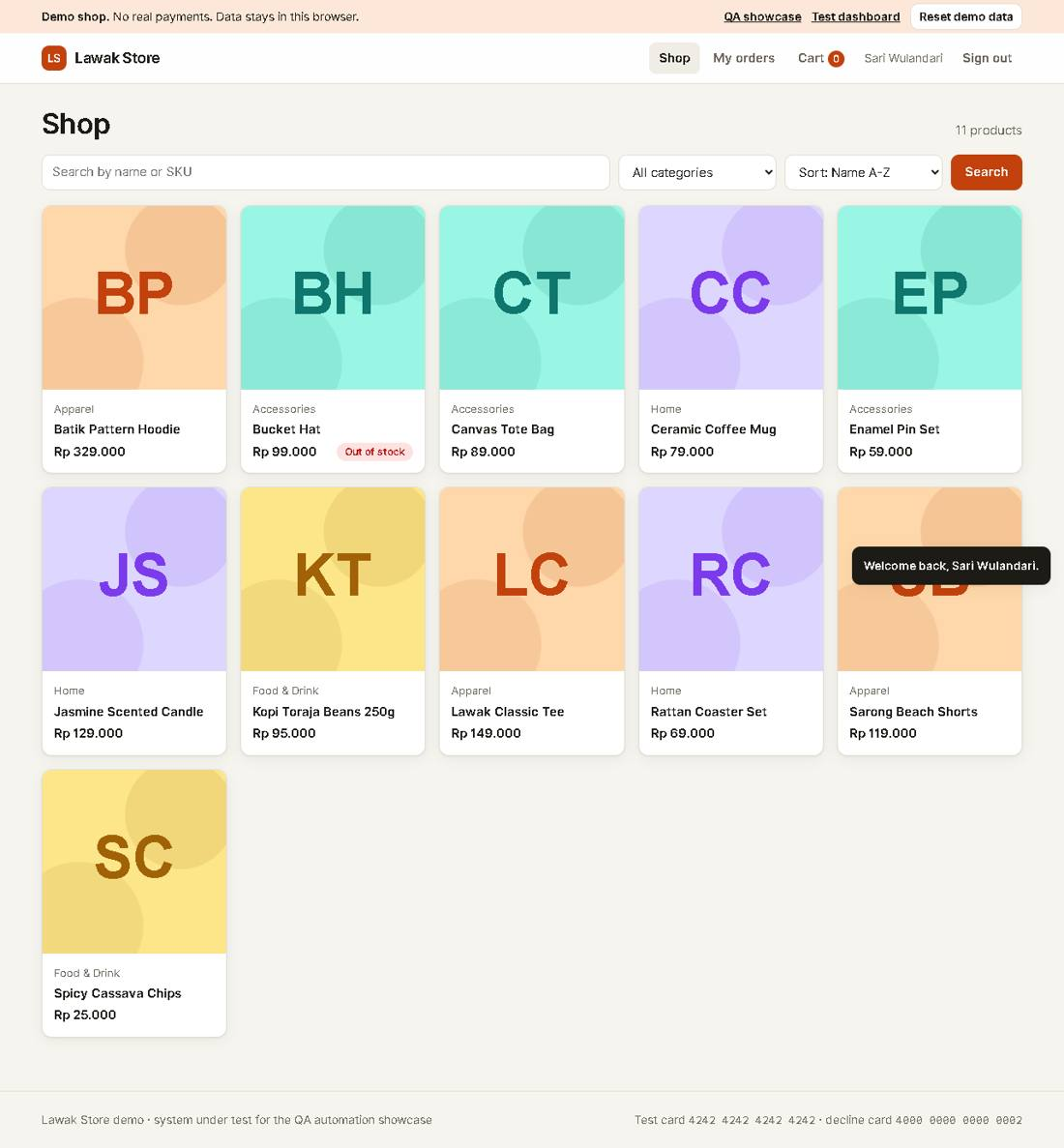
Evidence TC-AUTH-008_02-UI.png
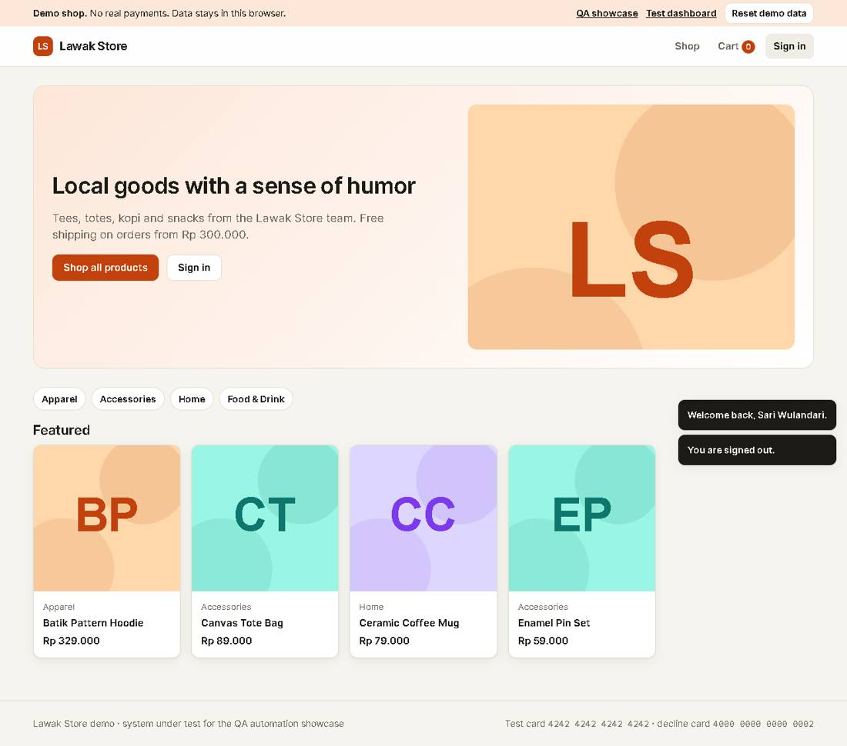
Evidence TC-AUTH-008_03-UI.png
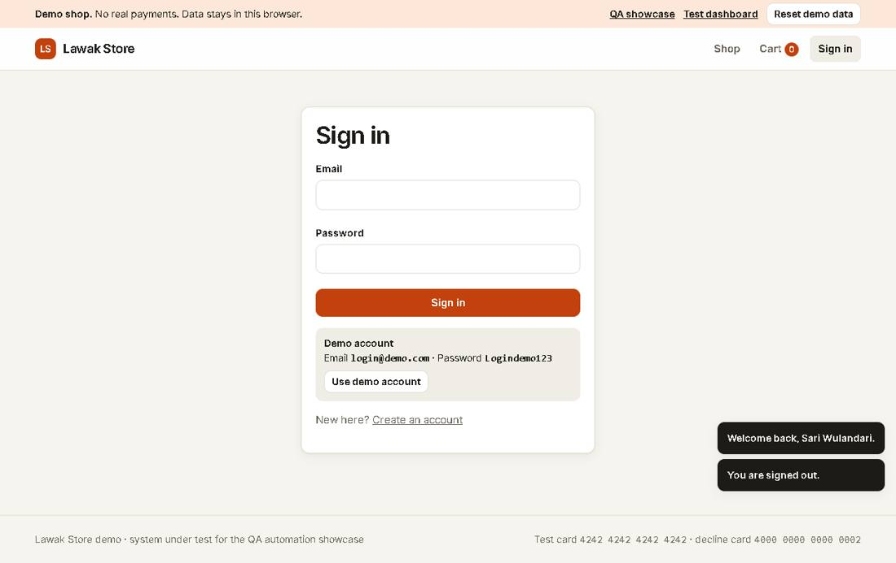

Scenario: Protected pages

TC-AUTH-009 - A protected page asks for sign in, then returns to it [Pass]
Type Positive | Priority High | Sprint 1 | Layer UI | Tool Playwright | Reference US-004
No | Layer | Step | Expected result | Result | Actual result
S01 | UI | [UI] Open the Cart page while signed out | The Sign in page opens | Pass | As expected.
S02 | UI | [UI] Sign in as customer@demo.com | The Cart page opens | Pass | As expected.
Evidence TC-AUTH-009_01-UI.png
Evidence TC-AUTH-009_02-UI.png
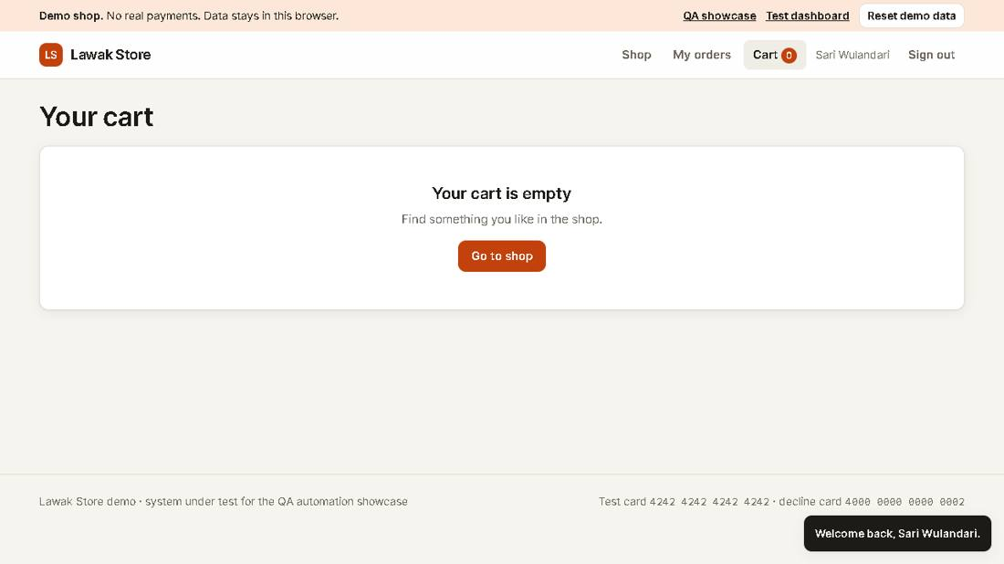

Module: Catalog

Scenario: Product list

TC-CAT-001 - Shop lists all active products and hides drafts [Pass]
Type Positive | Priority High | Sprint 1 | Layer UI | Tool Playwright | Reference US-010
No | Layer | Step | Expected result | Result | Actual result
S01 | UI | [UI] Open the Shop page | The count shows "11 products" | Pass | As expected.
S02 | UI | [UI] Look for the draft product Anniversary Jacket | Anniversary Jacket is not in the list | Pass | Anniversary Jacket (draft) is not in the list.
Evidence TC-CAT-001_01-UI.png
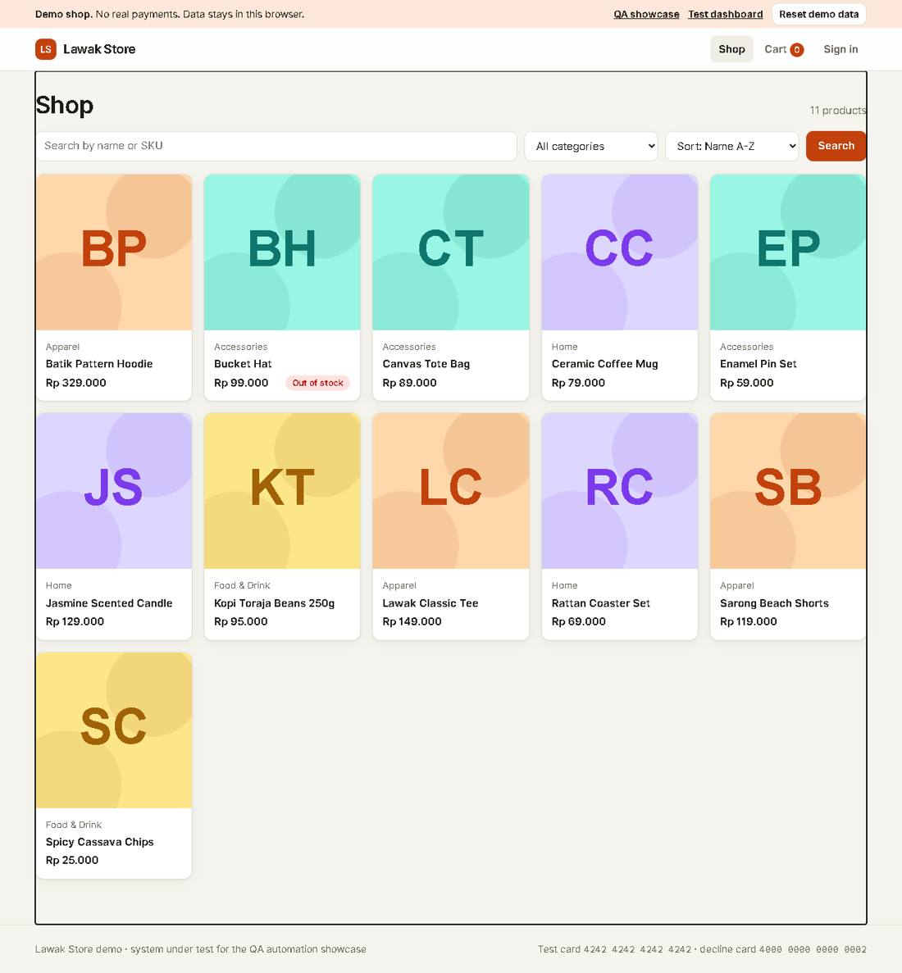
Evidence TC-CAT-001_02-UI.png

TC-CAT-002 - Search finds a product by name [Pass]
Type Positive | Priority Medium | Sprint 1 | Layer UI | Tool Playwright | Reference US-011
No | Layer | Step | Expected result | Result | Actual result
S01 | UI | [UI] Search the shop for "mug" | The count shows "1 product" and the card is Ceramic Coffee Mug | Pass | As expected.
Evidence TC-CAT-002_01-UI.png
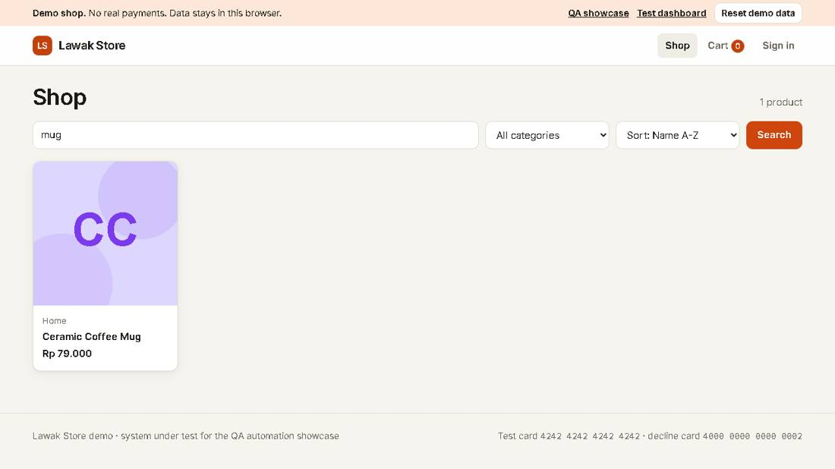

TC-CAT-003 - Category filter shows only that category [Pass]
Type Positive | Priority Medium | Sprint 1 | Layer UI | Tool Playwright | Reference US-011
No | Layer | Step | Expected result | Result | Actual result
S01 | UI | [UI] Choose the category Home | The count shows "3 products" and every card says Home | Pass | As expected.
Evidence TC-CAT-003_01-UI.png
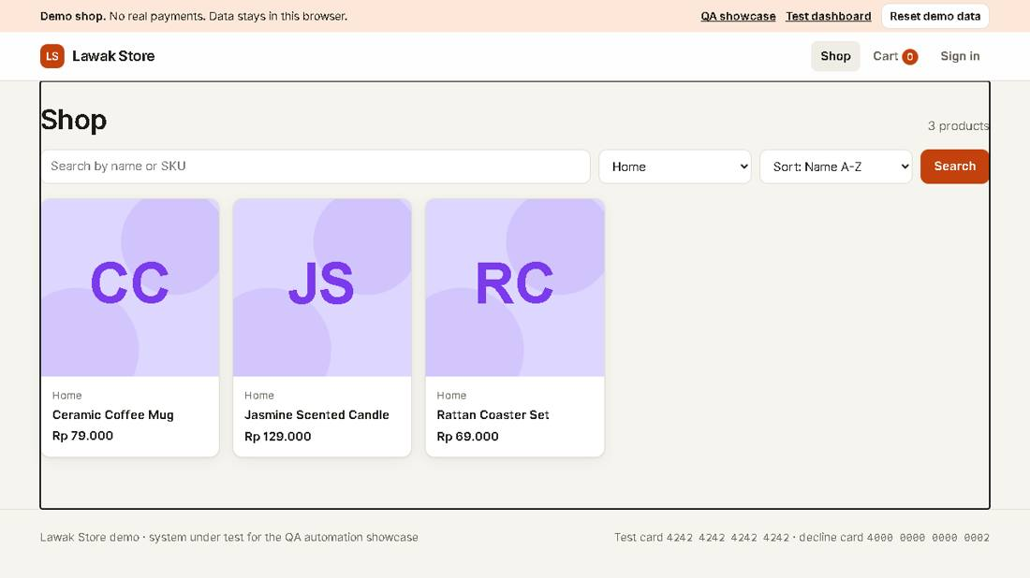

TC-CAT-004 - Sort by price from low to high [Pass]
Type Positive | Priority Low | Sprint 1 | Layer UI | Tool Playwright | Reference US-011
No | Layer | Step | Expected result | Result | Actual result
S01 | UI | [UI] Choose "Price: low to high" | The first card is Spicy Cassava Chips at Rp 25.000 | Pass | As expected.
Evidence TC-CAT-004_01-UI.png
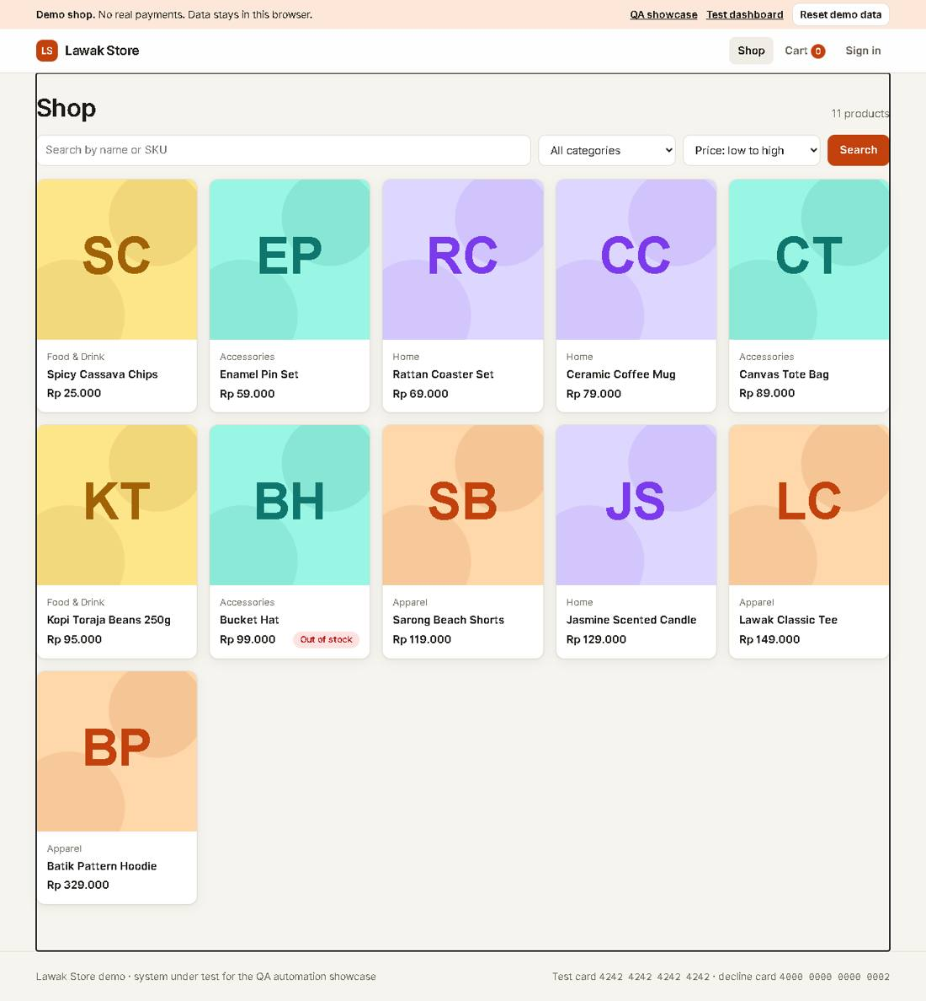

TC-CAT-005 - Search with no result shows an empty state [Pass]
Type Negative | Priority Low | Sprint 1 | Layer UI | Tool Playwright | Reference US-011
No | Layer | Step | Expected result | Result | Actual result
S01 | UI | [UI] Search the shop for "zzzz" | The page shows "No products match your search" and a Clear filters link | Pass | As expected.
Evidence TC-CAT-005_01-UI.png
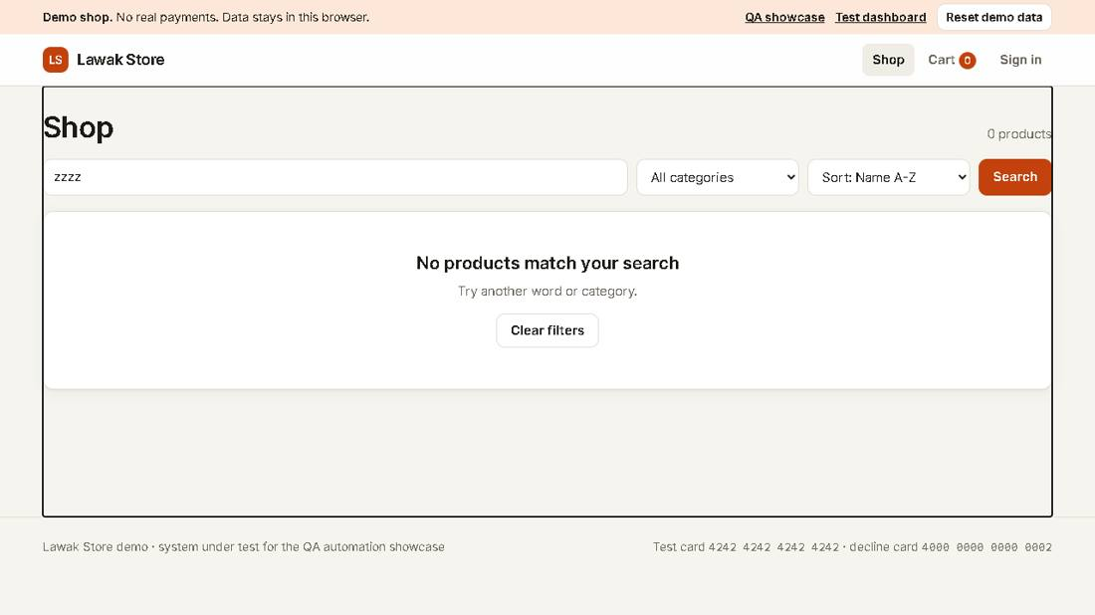

Scenario: Product detail

TC-CAT-006 - Product detail shows the price and stock [Pass]
Type Positive | Priority Medium | Sprint 1 | Layer UI | Tool Playwright | Reference US-012
No | Layer | Step | Expected result | Result | Actual result
S01 | UI | [UI] Open Lawak Classic Tee from the shop | The page shows the name, Rp 149.000 and "In stock" | Pass | As expected.
Evidence TC-CAT-006_01-UI.png
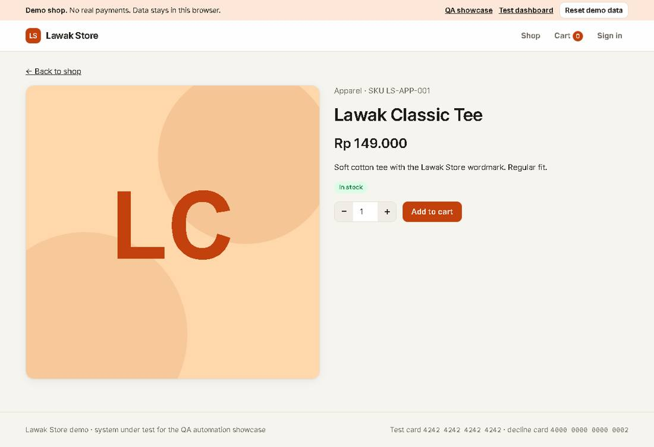

TC-CAT-007 - Out-of-stock product cannot be added to the cart [Pass]
Type Negative | Priority Medium | Sprint 1 | Layer UI | Tool Playwright | Reference US-012
No | Layer | Step | Expected result | Result | Actual result
S01 | UI | [UI] Open Bucket Hat | The page shows "Out of stock" and the button is disabled | Pass | As expected.
Evidence TC-CAT-007_01-UI.png
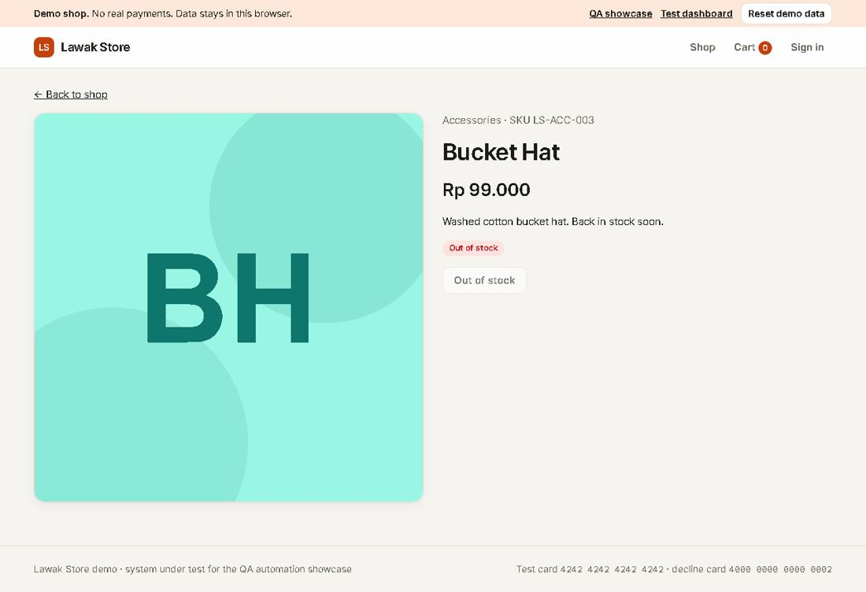

Module: Cart

Scenario: Add to cart

TC-CART-001 - Add a product to the cart [Pass]
Type Positive | Priority High | Sprint 2 | Layer UI | Tool Playwright | Reference US-020
No | Layer | Step | Expected result | Result | Actual result
S01 | UI | [UI] Sign in as a new qa-auto customer and open Ceramic Coffee Mug | The cart count in the header is 0 | Pass | As expected.
S02 | UI | [UI] Select Add to cart | The message says "Added to cart." and the cart count is 1 | Pass | The message says "Added to cart." The cart count is 1.
Evidence TC-CART-001_01-UI.png
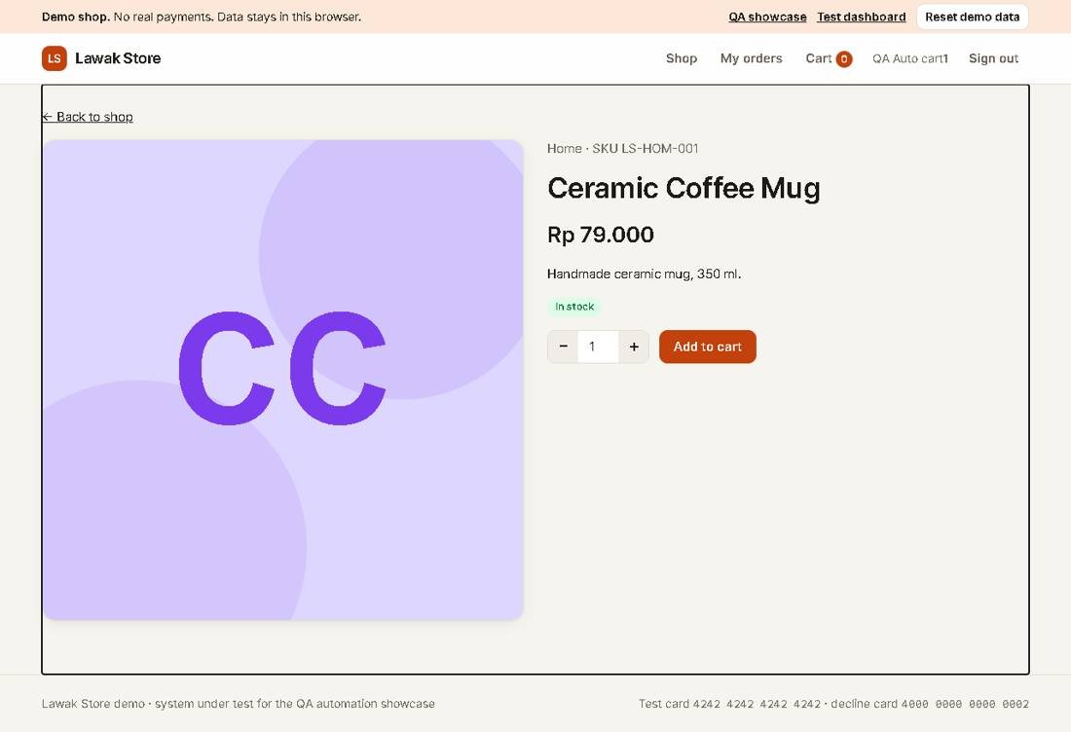
Evidence TC-CART-001_02-UI.png
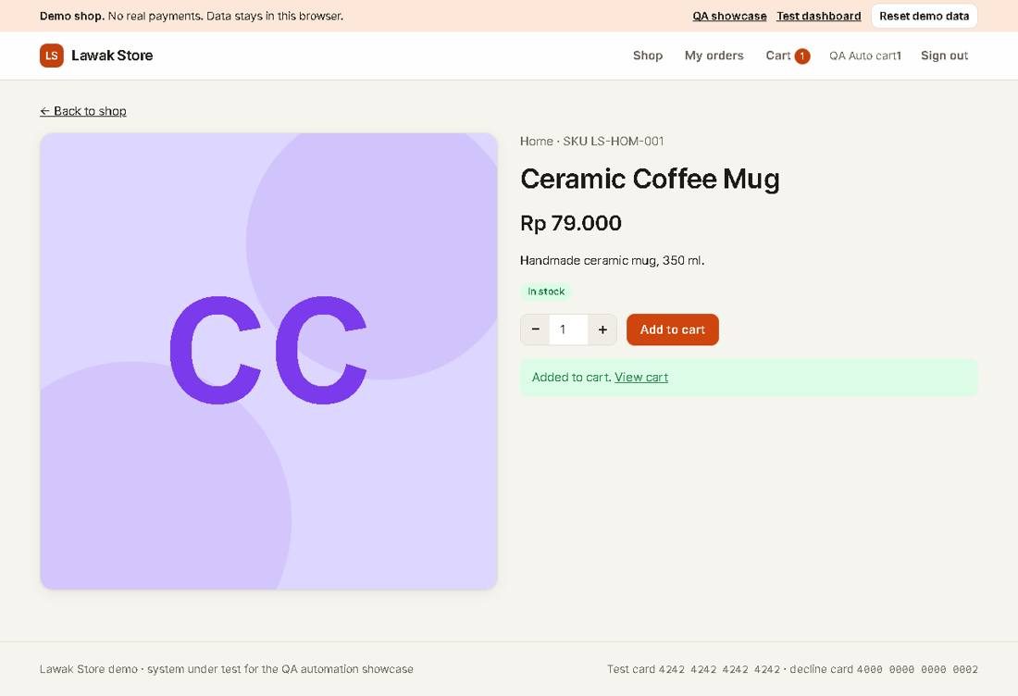

Scenario: Cart totals

TC-CART-002 - Changing the quantity updates the totals [Pass]
Type Positive | Priority High | Sprint 2 | Layer UI | Tool Playwright | Reference US-021 rule R-05
No | Layer | Step | Expected result | Result | Actual result
S01 | UI | [UI] Add Lawak Classic Tee to the cart and open the cart | Subtotal is Rp 149.000, shipping is Rp 15.000 | Pass | As expected.
S02 | UI | [UI] Increase the quantity to 2 | Subtotal is Rp 298.000 and total is Rp 313.000 | Pass | Subtotal Rp 298.000, shipping Rp 15.000, total Rp 313.000.
Evidence TC-CART-002_01-UI.png
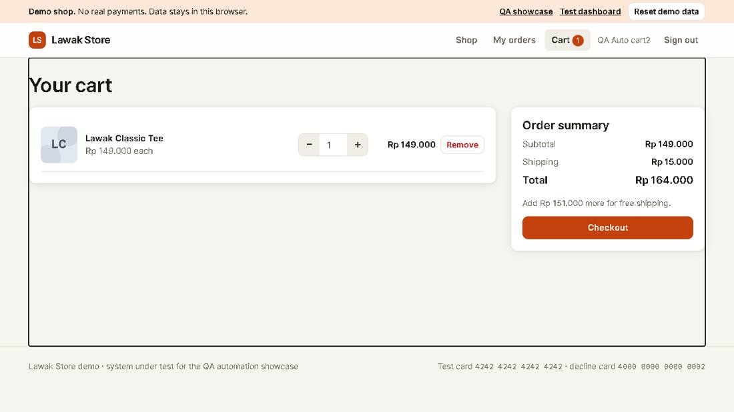
Evidence TC-CART-002_02-UI.png
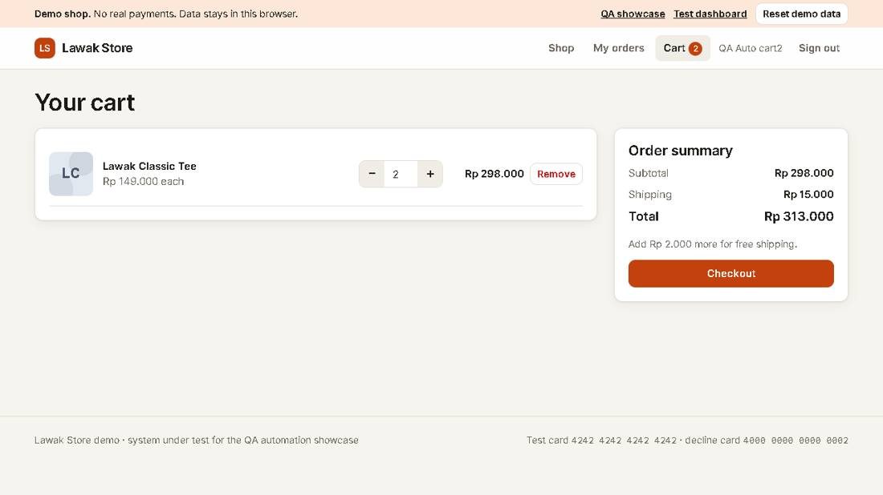

TC-CART-003 - Shipping is free from Rp 300.000 [Pass]
Type Positive | Priority Medium | Sprint 2 | Layer UI | Tool Playwright | Reference US-021 rule R-05
No | Layer | Step | Expected result | Result | Actual result
S01 | UI | [UI] Add Batik Pattern Hoodie (Rp 329.000) and open the cart | Shipping shows "Free" and total is Rp 329.000 | Pass | As expected.
Evidence TC-CART-003_01-UI.png
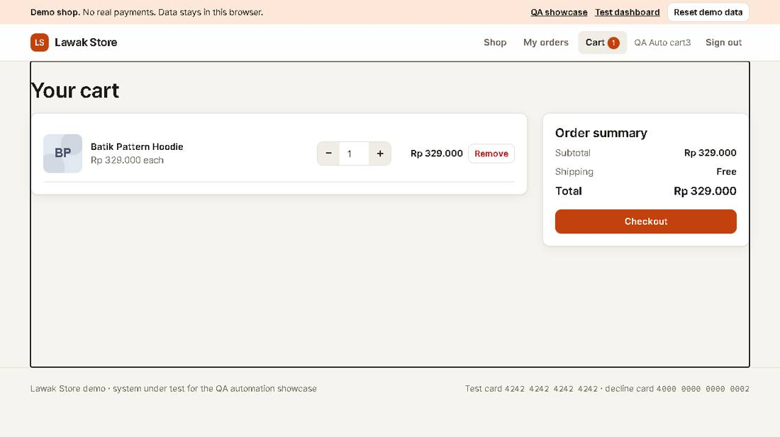

Scenario: Remove from cart

TC-CART-004 - Removing the last item shows an empty cart [Pass]
Type Positive | Priority Medium | Sprint 2 | Layer UI | Tool Playwright | Reference US-022
No | Layer | Step | Expected result | Result | Actual result
S01 | UI | [UI] Add Canvas Tote Bag and open the cart | The cart shows one line | Pass | As expected.
S02 | UI | [UI] Select Remove | The page shows "Your cart is empty" and the cart count is 0 | Pass | As expected.
Evidence TC-CART-004_01-UI.png
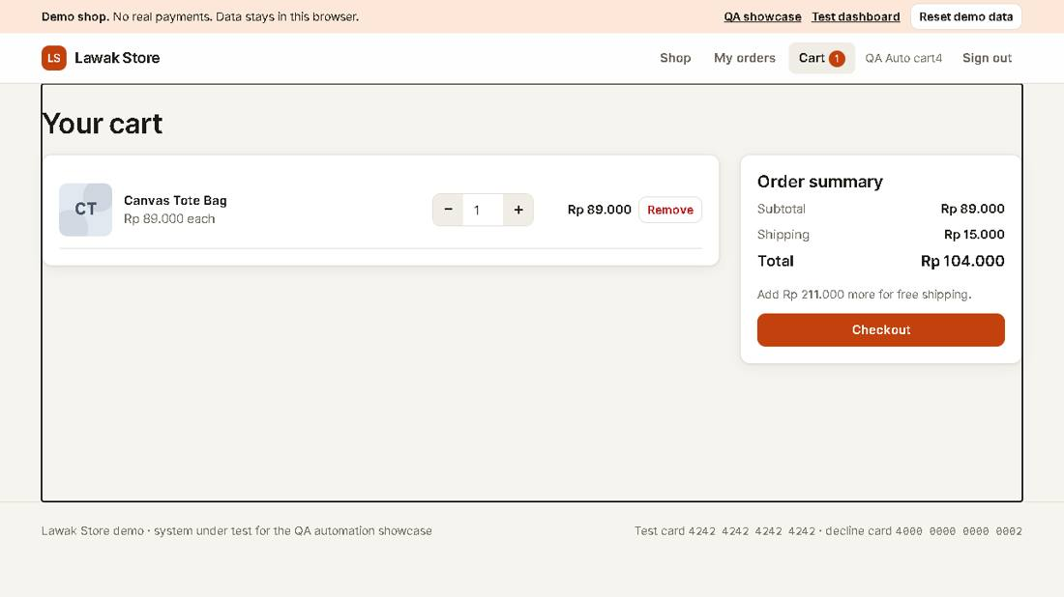
Evidence TC-CART-004_02-UI.png
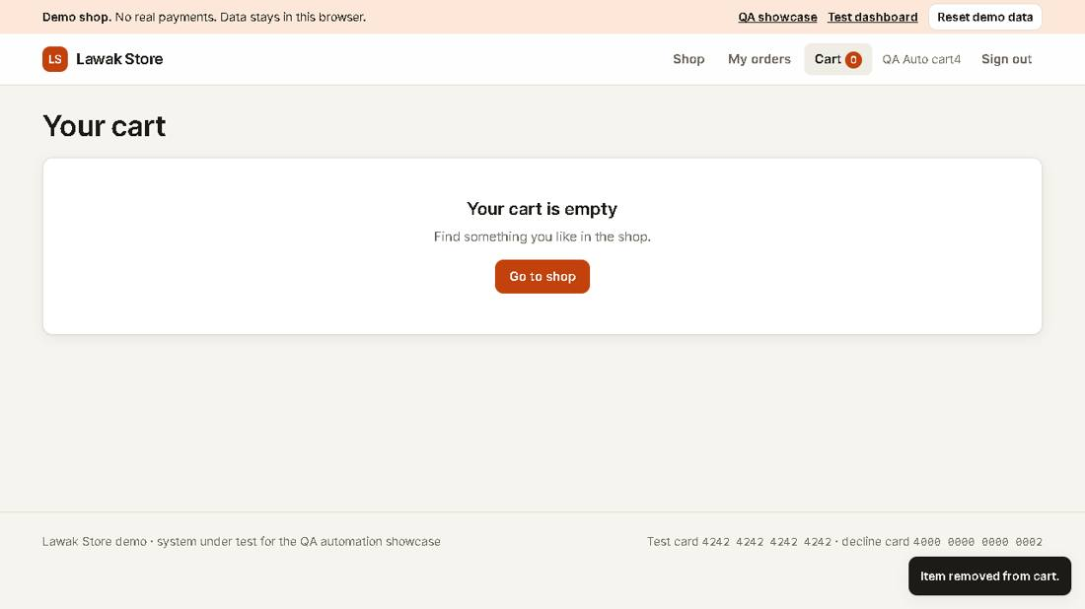

Scenario: Cart totals

TC-CART-005 - Quantity limit of 10 is enforced [Pass]
Type Negative | Priority Medium | Sprint 2 | Layer UI | Tool Playwright | Reference US-021 rule R-06
No | Layer | Step | Expected result | Result | Actual result
S01 | UI | [UI] Add Jasmine Scented Candle and open the cart | The line shows quantity 1 | Pass | As expected.
S02 | UI | [UI] Type 11 in the quantity box | The alert says "Quantity must be 1 to 10." and the quantity stays 1 | Pass | As expected.
Evidence TC-CART-005_01-UI.png
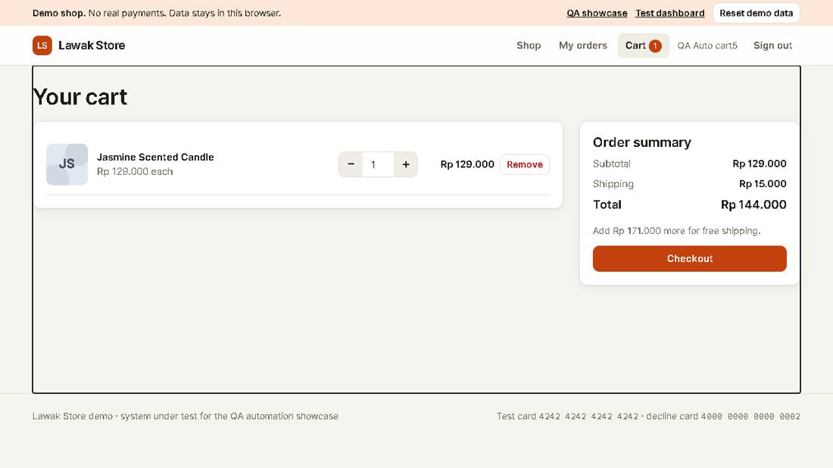
Evidence TC-CART-005_02-UI.png
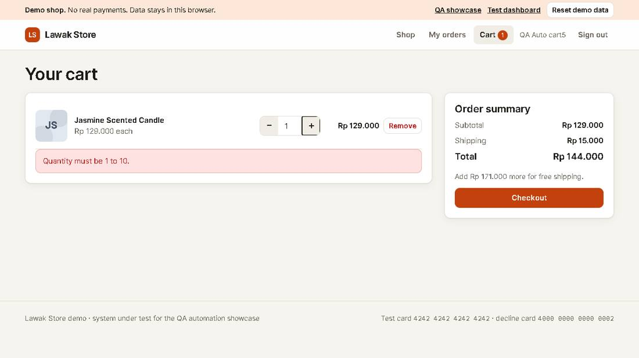

Module: Checkout

Scenario: Payment

TC-CHK-001 - Checkout with the test card creates an order [Pass]
Type Positive | Priority High | Sprint 2 | Layer UI | Tool Playwright | Reference US-030
No | Layer | Step | Expected result | Result | Actual result
S01 | UI | [UI] Add Kopi Toraja Beans to the cart and open Checkout | The Pay button shows Rp 110.000 | Pass | As expected.
S02 | UI | [UI] Fill a valid address and card 4242 4242 4242 4242, then select Pay | The page says "Thank you! Your order LS-... is confirmed." and the cart count is 0 | Pass | Order LS-10010 is confirmed. The cart count is 0.
Evidence TC-CHK-001_01-UI.png
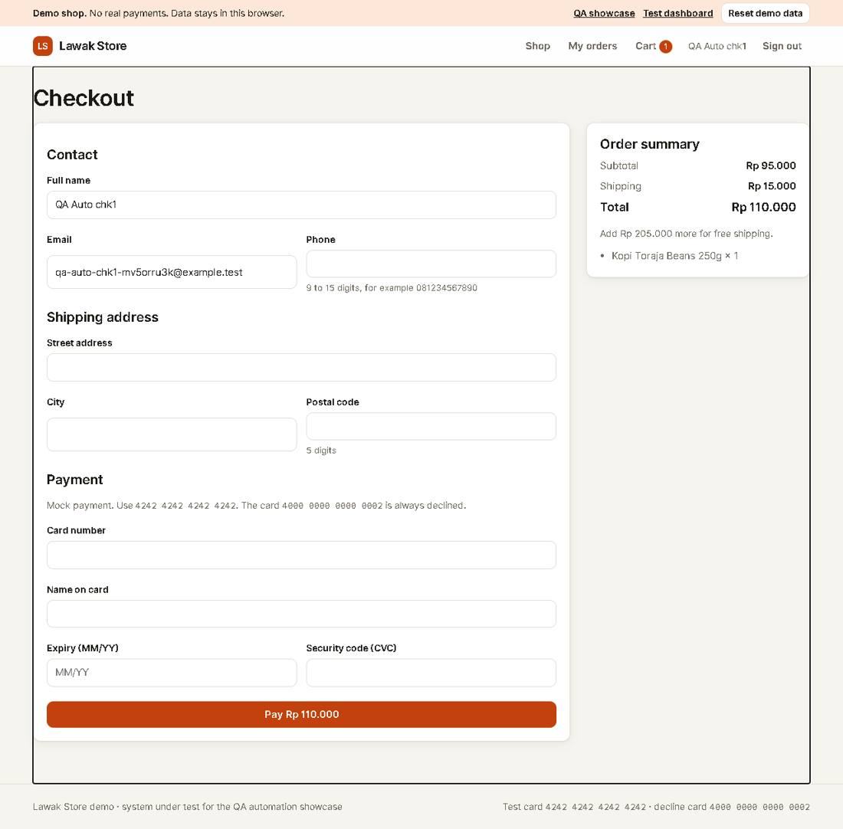
Evidence TC-CHK-001_02-UI.png
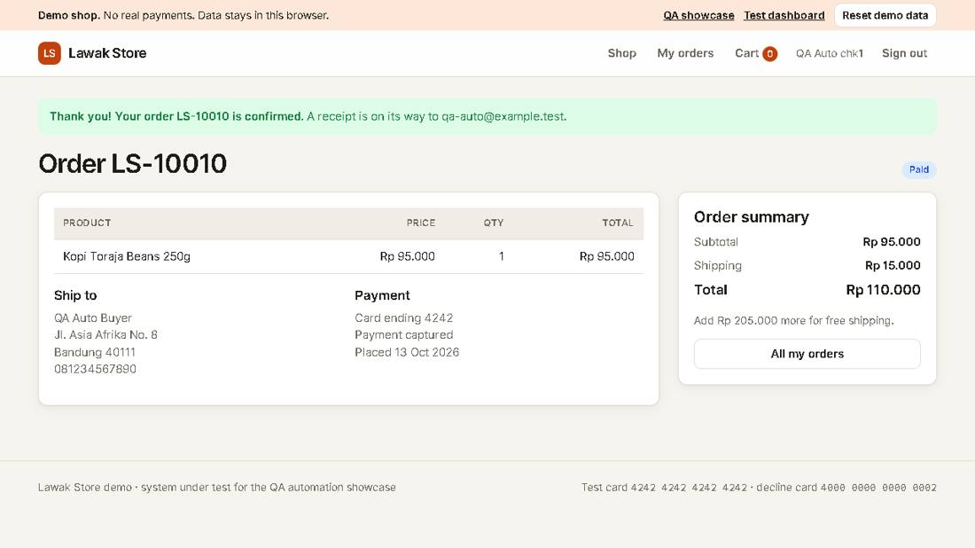

Scenario: Validation

TC-CHK-002 - Empty required fields are reported [Pass]
Type Negative | Priority High | Sprint 2 | Layer UI | Tool Playwright | Reference US-030
No | Layer | Step | Expected result | Result | Actual result
S01 | UI | [UI] Open Checkout with one item and clear the Full name field | The form shows | Pass | As expected.
S02 | UI | [UI] Select Pay without filling the form | Each empty field shows "This field is required." and no order is created | Pass | 9 empty fields show "This field is required." No order was created.
Evidence TC-CHK-002_01-UI.png
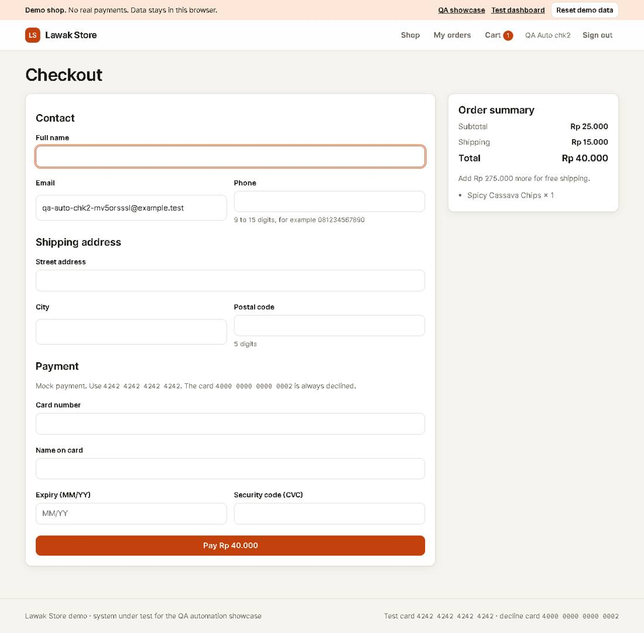
Evidence TC-CHK-002_02-UI.png
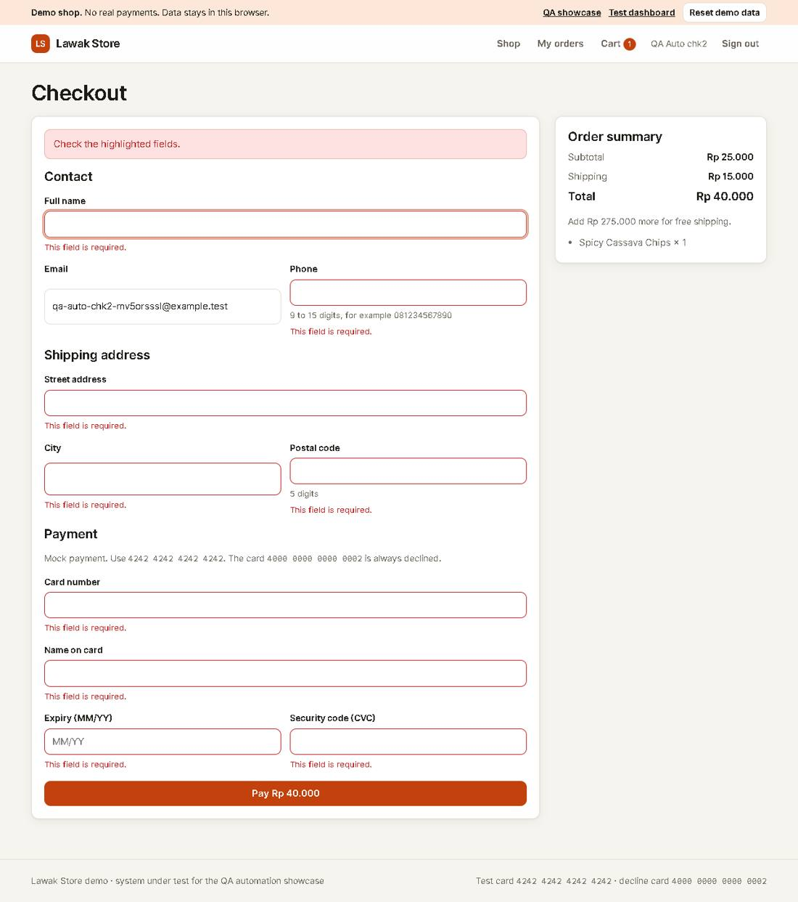

Scenario: Payment

TC-CHK-003 - Declined card shows a payment error [Pass]
Type Negative | Priority High | Sprint 2 | Layer UI | Tool Playwright | Reference US-031
No | Layer | Step | Expected result | Result | Actual result
S01 | UI | [UI] Fill Checkout with card 4000 0000 0000 0002 and select Pay | The alert says "The card was declined. Use another card." | Pass | As expected.
S02 | UI | [UI] Open the cart | The item is still in the cart | Pass | The item is still in the cart after the declined payment.
Evidence TC-CHK-003_01-UI.png
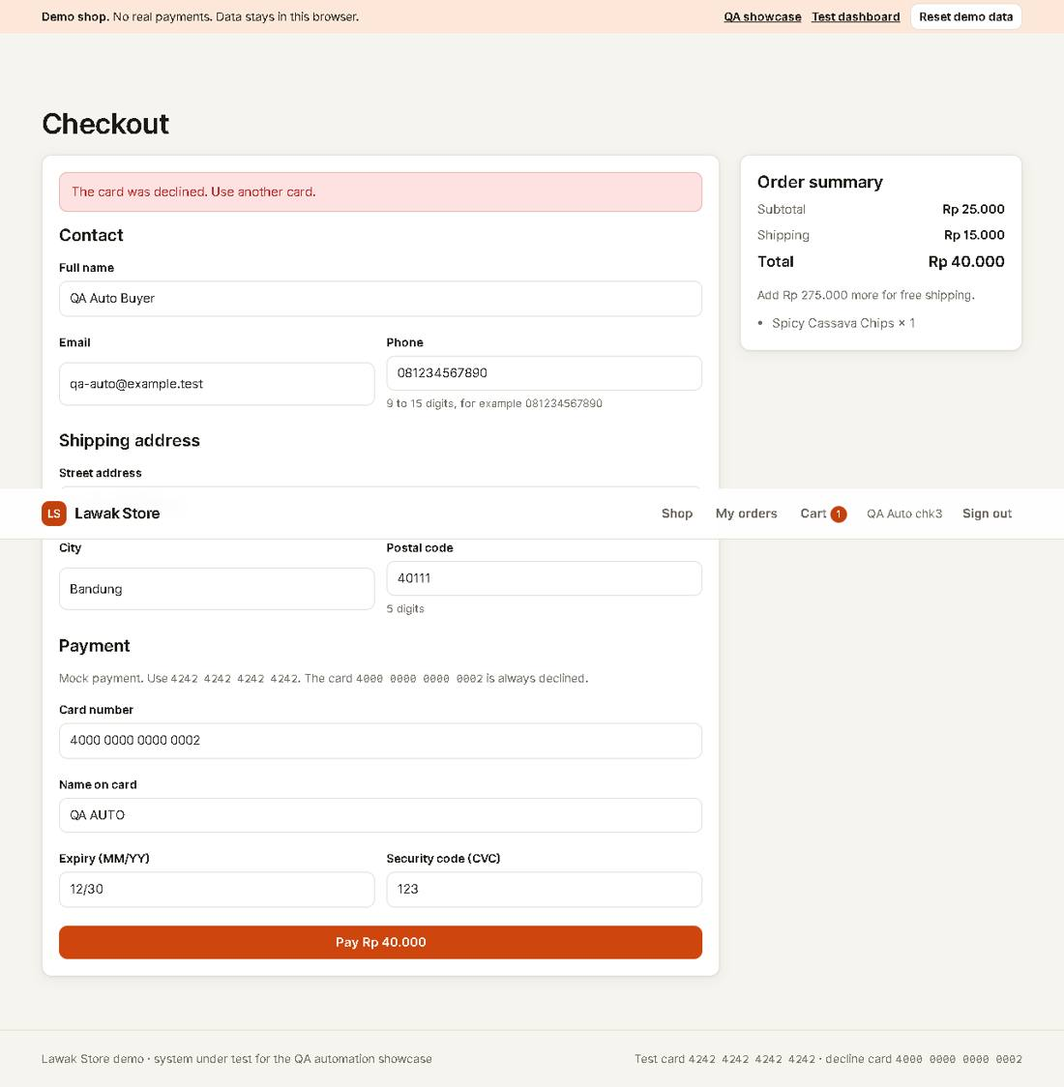
Evidence TC-CHK-003_02-UI.png
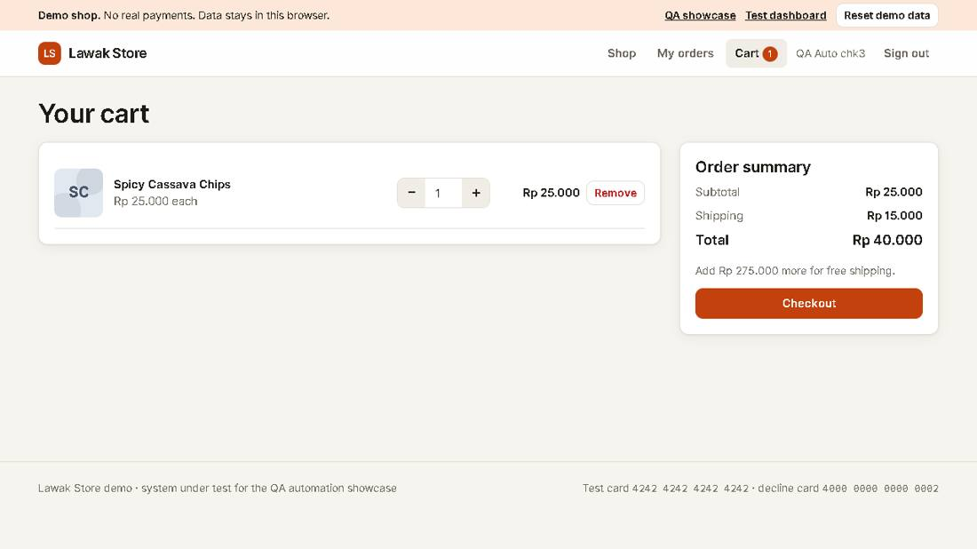

Scenario: Validation

TC-CHK-004 - Invalid card number is rejected [Pass]
Type Negative | Priority Medium | Sprint 2 | Layer UI | Tool Playwright | Reference US-031
No | Layer | Step | Expected result | Result | Actual result
S01 | UI | [UI] Fill Checkout with card 1234 5678 9012 3456 and select Pay | The Card number field shows "Enter a valid 16-digit card number." | Pass | As expected.
Evidence TC-CHK-004_01-UI.png
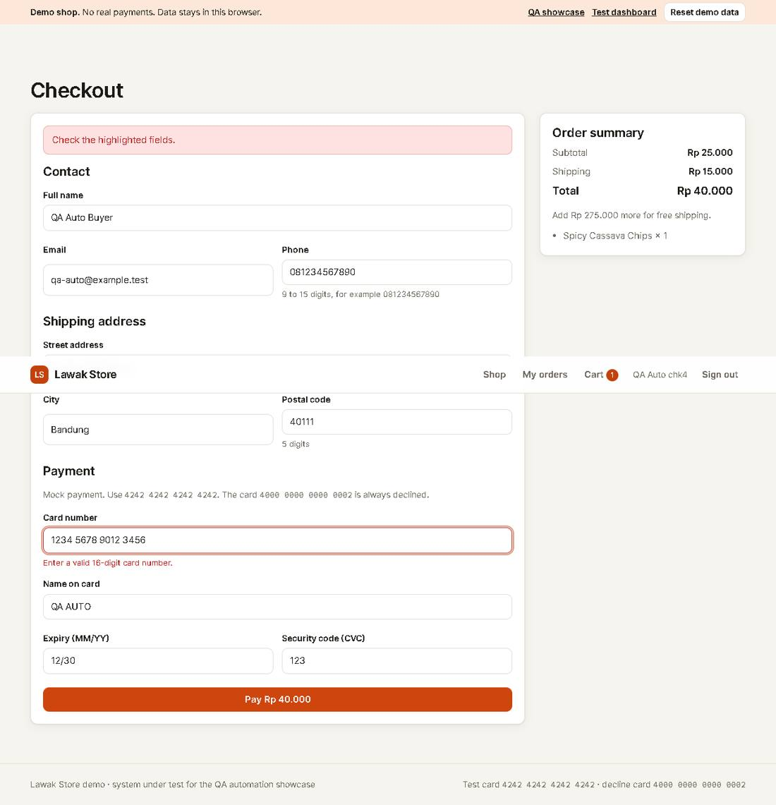

TC-CHK-005 - Expired card is rejected [Pass]
Type Negative | Priority Medium | Sprint 2 | Layer UI | Tool Playwright | Reference US-031
No | Layer | Step | Expected result | Result | Actual result
S01 | UI | [UI] Fill Checkout with expiry 01/20 and select Pay | The Expiry field shows "This card has expired." | Pass | As expected.
Evidence TC-CHK-005_01-UI.png
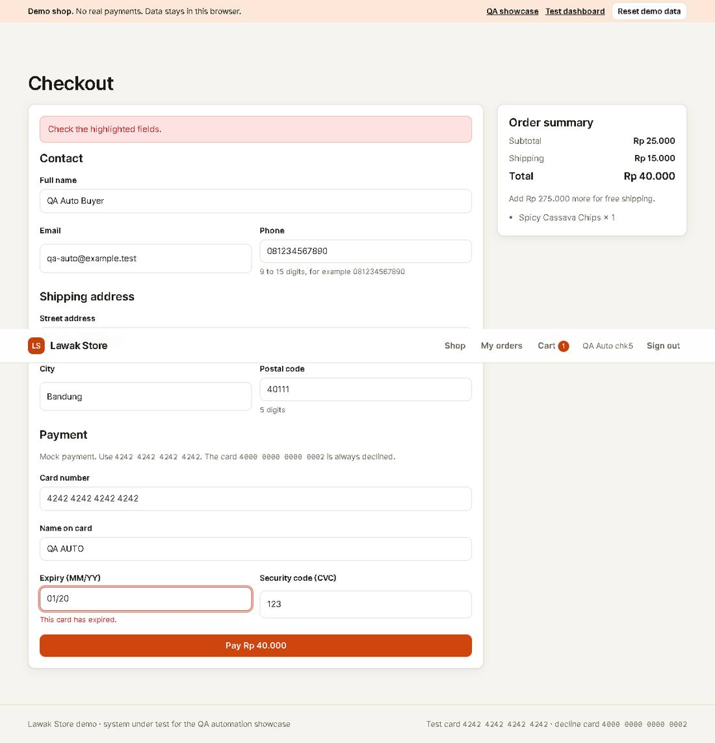

TC-CHK-006 - Postal code must have exactly 5 digits [Fail]
Type Negative | Priority Medium | Sprint 2 | Layer UI | Tool Playwright | Reference US-030 rule R-07 (known defect DEF-001)
No | Layer | Step | Expected result | Result | Actual result
S01 | UI | [UI] Fill Checkout with postal code 4011 (4 digits) and select Pay | The Postal code field shows "Enter a 5-digit postal code." and no order is created | Fail | Error: DEF-001: the app accepts 4 digits and creates the order expect(locator).toHaveText(expected) failed Locator: locator('#err-postalCode') Expected: "Enter a 5-digit postal code."
Evidence TC-CHK-006_01-UI.png
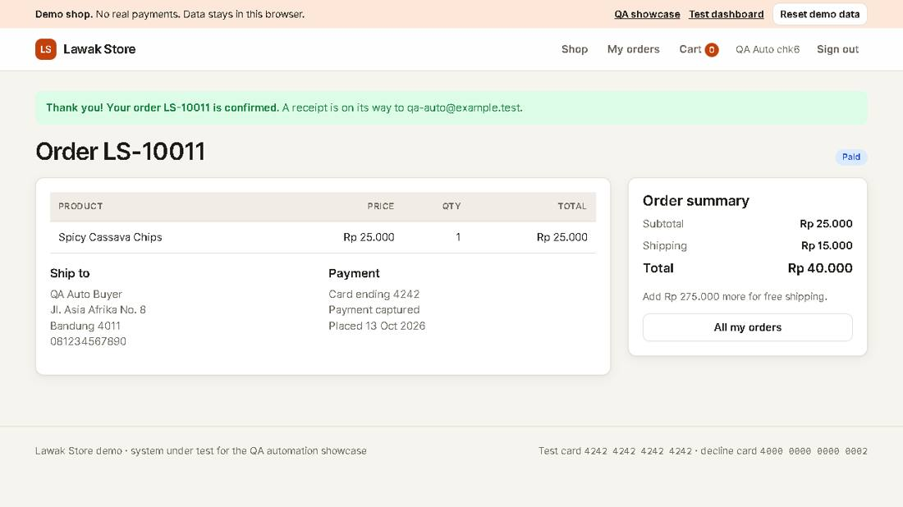
Note: DEF-001: a 4-digit postal code is accepted. This case fails until the defect is fixed.

Module: Customer Orders

Scenario: Order history

TC-ORD-001 - A new order shows in My orders [Pass]
Type Positive | Priority High | Sprint 2 | Layer UI | Tool Playwright | Reference US-032
No | Layer | Step | Expected result | Result | Actual result
S01 | UI | [UI] Place an order with the test card | The confirmation shows the order ID | Pass | Order LS-10012 is confirmed.
S02 | UI | [UI] Open My orders | The list shows that order ID with status Paid | Pass | As expected.
Evidence TC-ORD-001_01-UI.png
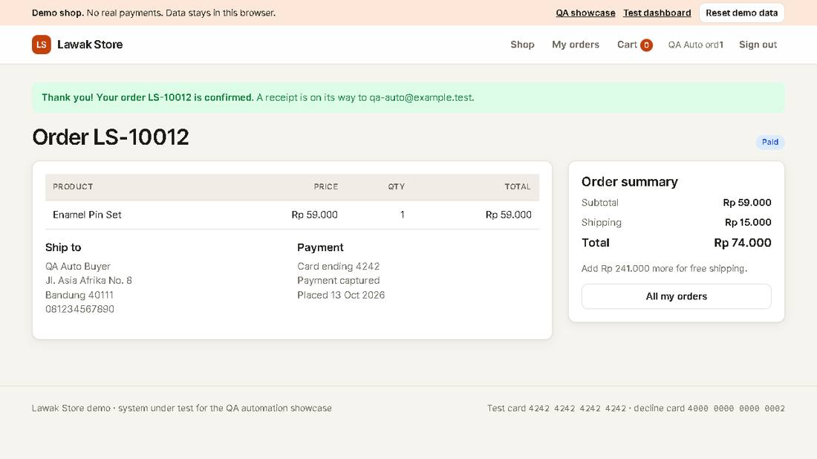
Evidence TC-ORD-001_02-UI.png
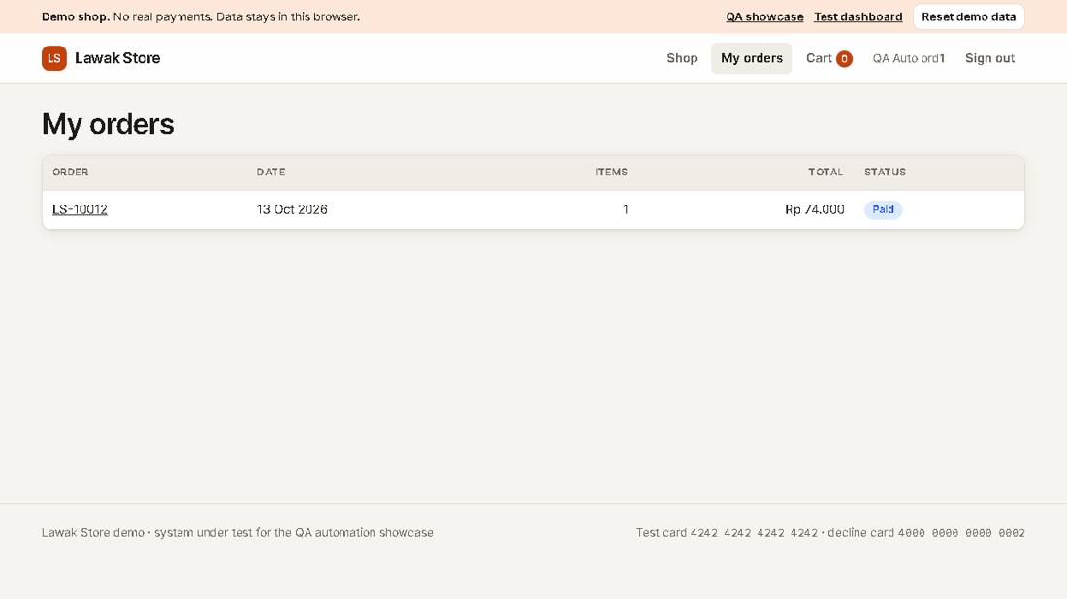

Scenario: Order privacy

TC-ORD-002 - A customer cannot open another customer's order [Pass]
Type Negative | Priority High | Sprint 2 | Layer UI | Tool Playwright | Reference US-032 rule R-08
No | Layer | Step | Expected result | Result | Actual result
S01 | UI | [UI] Sign in as customer@demo.com and open order LS-10002 (it belongs to Rina) | The page shows "This order does not exist." | Pass | The page says "This order does not exist." No data from Rina shows.
Evidence TC-ORD-002_01-UI.png
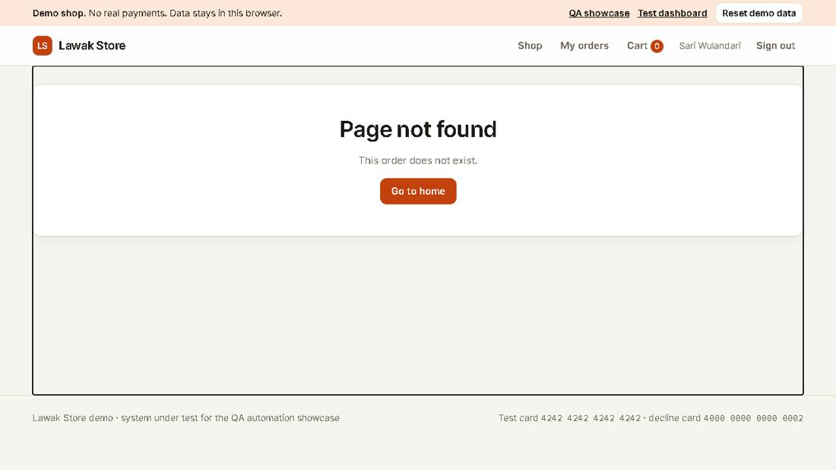

Module: Admin Products

Scenario: Create product

TC-PRD-001 - Admin creates a product [Pass]
Type Positive | Priority High | Sprint 3 | Layer UI | Tool Playwright | Reference US-040
No | Layer | Step | Expected result | Result | Actual result
S01 | UI | [UI] Sign in as admin and open Products > Add product | The Add product form shows | Pass | As expected.
S02 | UI | [UI] Fill a qa-auto product and select Create product | The message says "Product created." and the list shows the new SKU | Pass | Product QA-MV5OR8WS4 is in the admin list.
S03 | UI | [UI] Search the shop for the new product | The shop shows the new product | Pass | As expected.
Evidence TC-PRD-001_01-UI.png
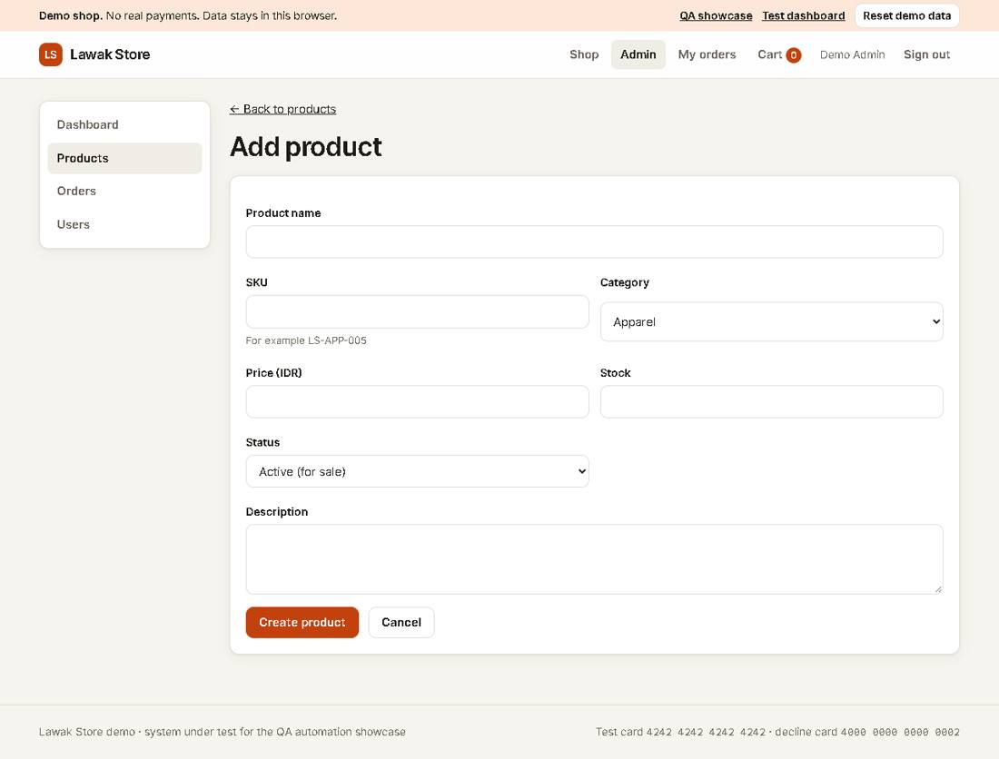
Evidence TC-PRD-001_02-UI.png
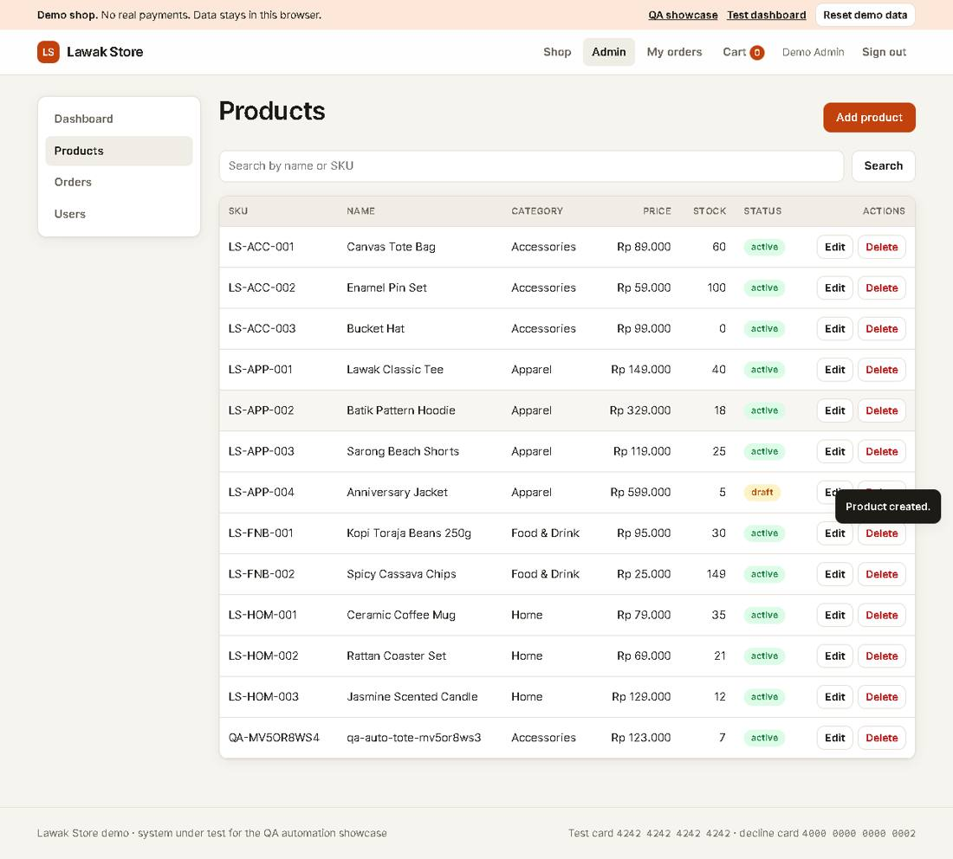
Evidence TC-PRD-001_03-UI.png
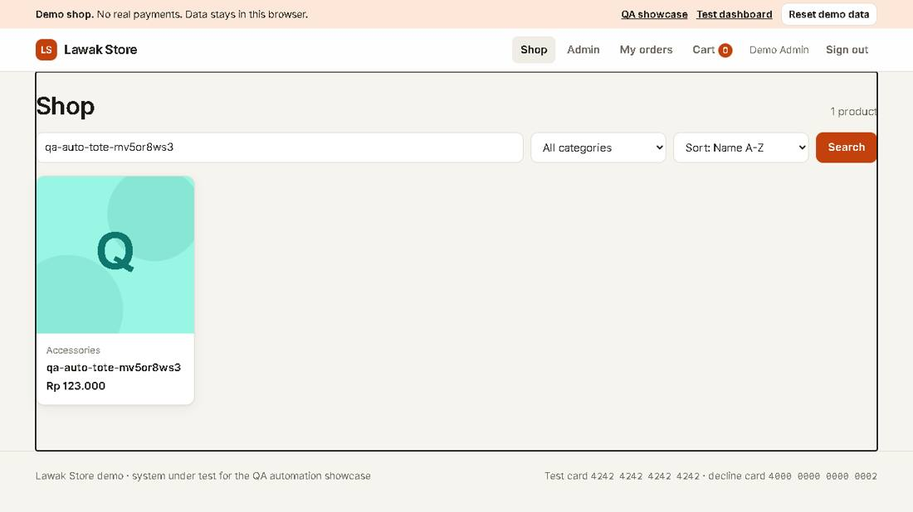

Scenario: Edit product

TC-PRD-002 - Admin edits a product price [Pass]
Type Positive | Priority High | Sprint 3 | Layer UI | Tool Playwright | Reference US-041
No | Layer | Step | Expected result | Result | Actual result
S01 | UI | [UI] Create a qa-auto product, then select Edit on its row | The Edit product form shows the current price | Pass | As expected.
S02 | UI | [UI] Change the price to 175000 and save | The message says "Product updated." and the row shows Rp 175.000 | Pass | As expected.
Evidence TC-PRD-002_01-UI.png
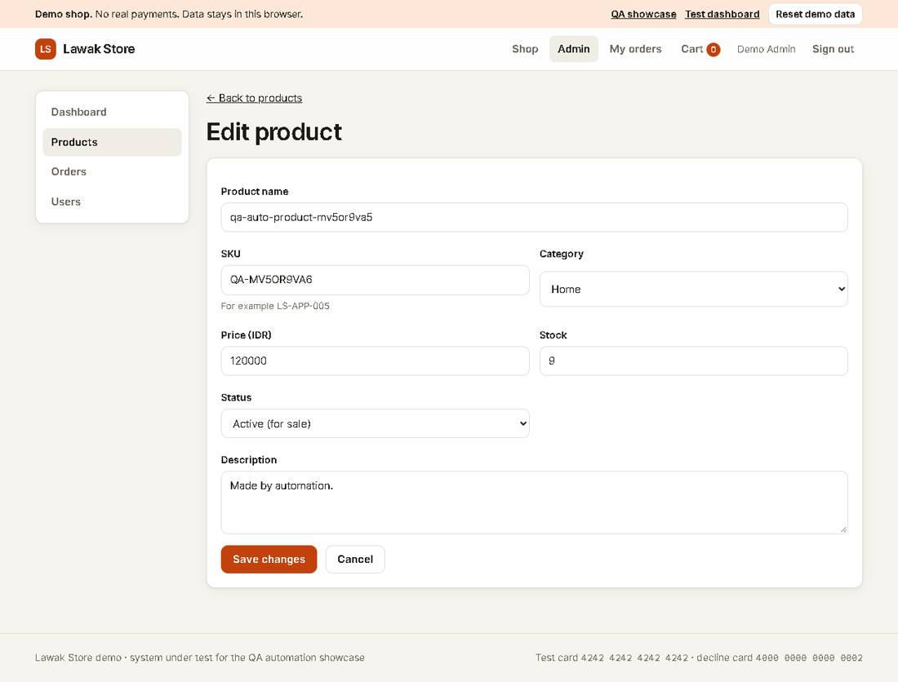
Evidence TC-PRD-002_02-UI.png
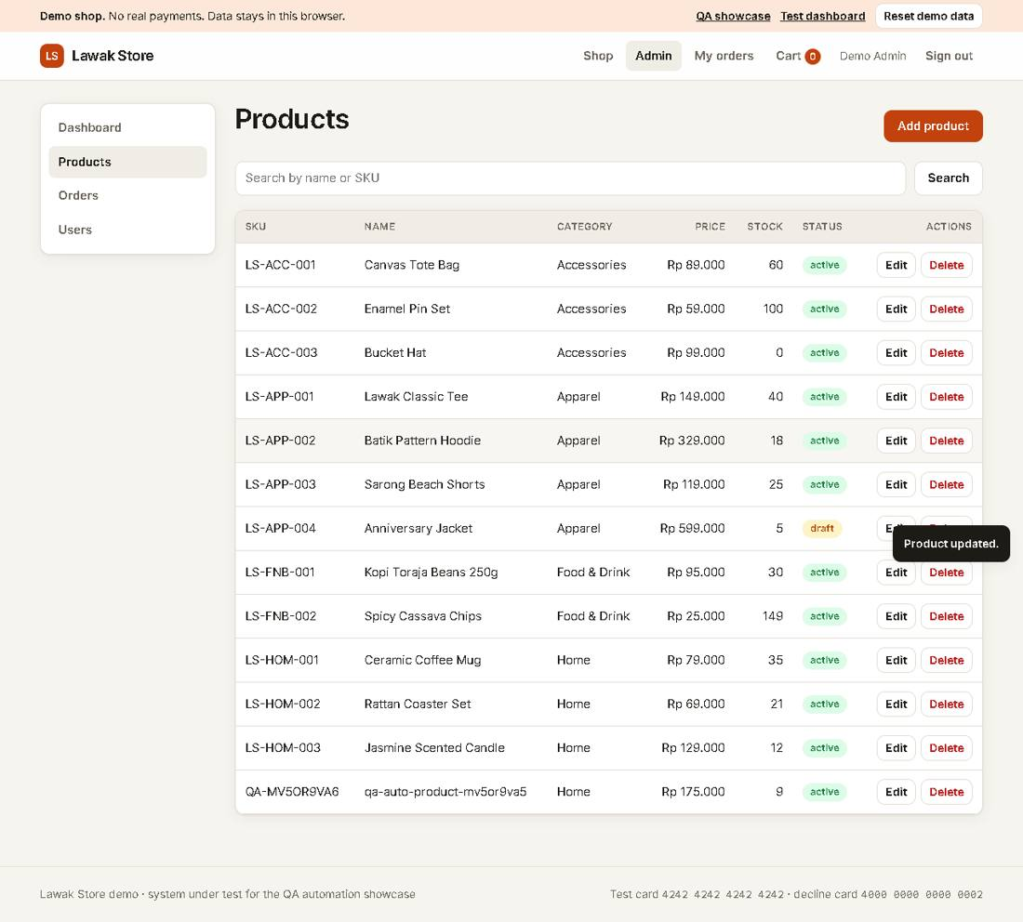

Scenario: Delete product

TC-PRD-003 - Admin deletes a product [Pass]
Type Positive | Priority High | Sprint 3 | Layer UI | Tool Playwright | Reference US-042
No | Layer | Step | Expected result | Result | Actual result
S01 | UI | [UI] Create a qa-auto product, then select Delete on its row | A confirmation dialog asks to delete it | Pass | As expected.
S02 | UI | [UI] Confirm the delete | The message says "Product deleted." and the row is gone | Pass | As expected.
Evidence TC-PRD-003_01-UI.png
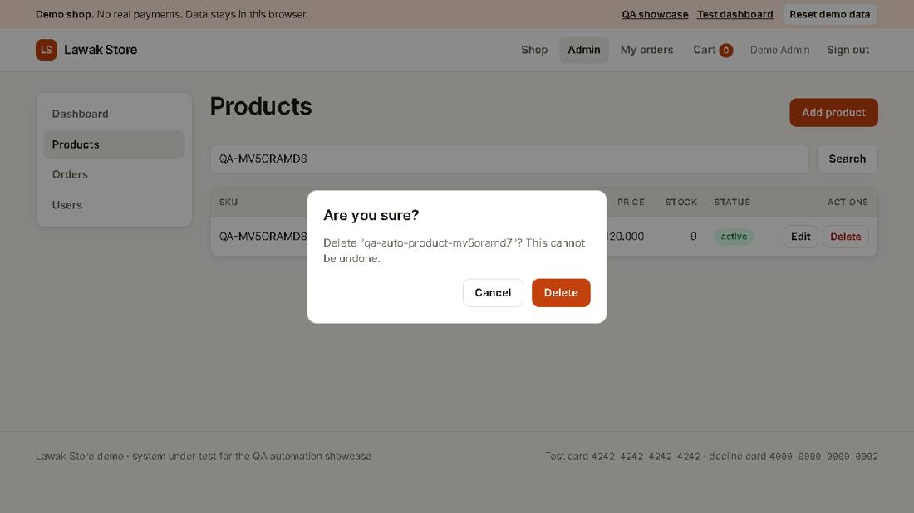
Evidence TC-PRD-003_02-UI.png
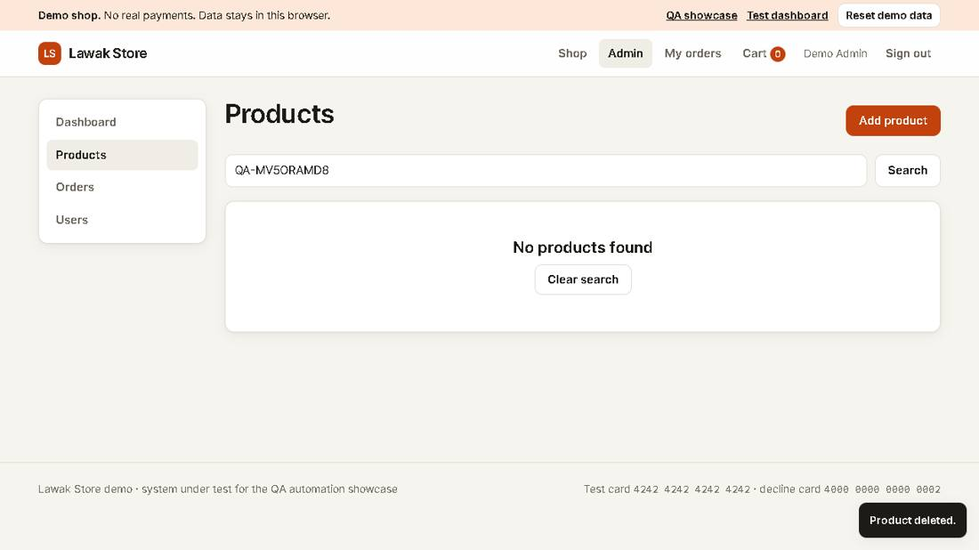

Scenario: Create product

TC-PRD-004 - Product form rejects invalid data [Pass]
Type Negative | Priority Medium | Sprint 3 | Layer UI | Tool Playwright | Reference US-040
No | Layer | Step | Expected result | Result | Actual result
S01 | UI | [UI] Open Add product and submit an empty form | Name, SKU, Price and Stock show their errors | Pass | Name, SKU, Price and Stock show their errors.
S02 | UI | [UI] Use the existing SKU LS-APP-001 | The SKU field shows "This SKU is already used." | Pass | As expected.
Evidence TC-PRD-004_01-UI.png
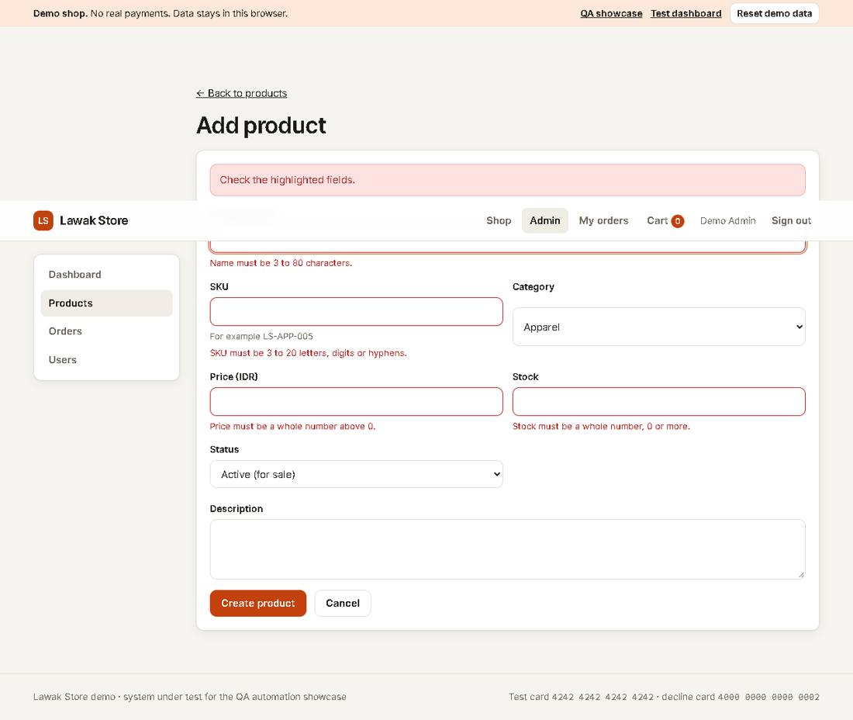
Evidence TC-PRD-004_02-UI.png
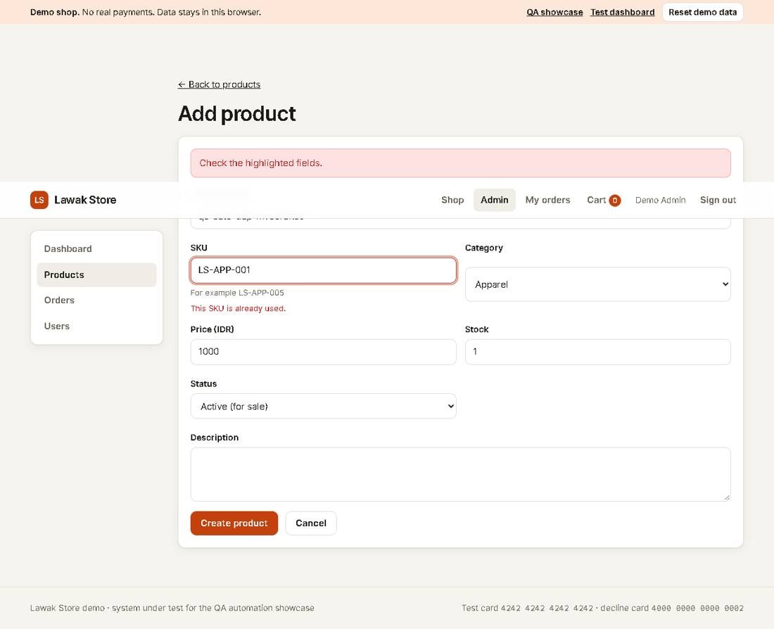

Scenario: Edit product

TC-PRD-005 - A draft product is hidden from the shop [Pass]
Type Positive | Priority Medium | Sprint 3 | Layer UI | Tool Playwright | Reference US-041
No | Layer | Step | Expected result | Result | Actual result
S01 | UI | [UI] Create a qa-auto product with status Draft | The admin list shows it with status draft | Pass | As expected.
S02 | UI | [UI] Search the shop for it | The shop shows "No products match your search" | Pass | As expected.
Evidence TC-PRD-005_01-UI.png
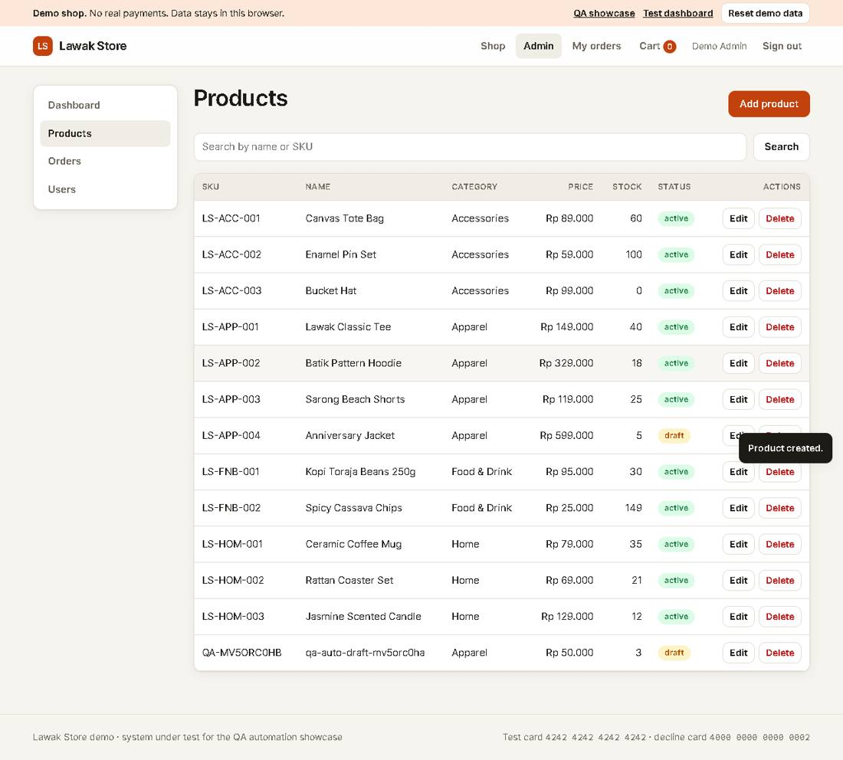
Evidence TC-PRD-005_02-UI.png
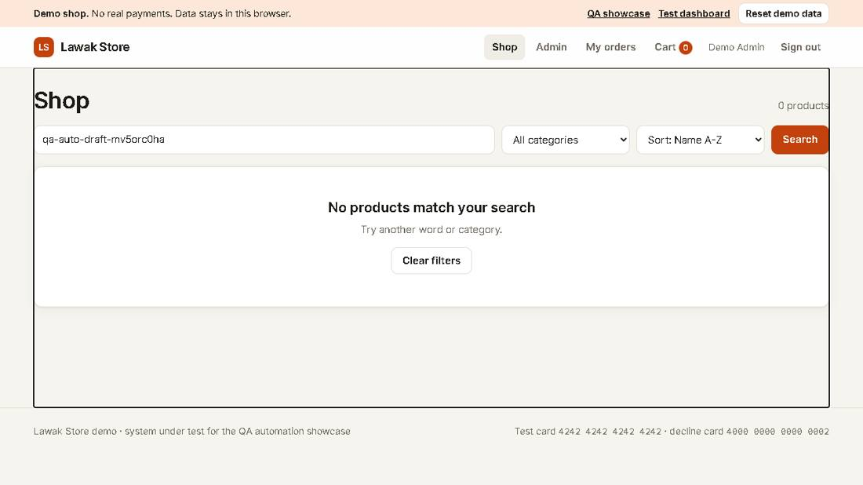

Module: Admin Orders

Scenario: Order list

TC-AOR-001 - A new customer order shows in admin Orders [Pass]
Type Positive | Priority High | Sprint 3 | Layer UI | Tool Playwright | Reference US-050
No | Layer | Step | Expected result | Result | Actual result
S01 | UI | [UI] Place an order as a new qa-auto customer | The confirmation shows the order ID | Pass | As expected.
S02 | UI | [UI] Sign in as admin and open Orders | The list shows that order with status Paid and the customer name | Pass | Order LS-10007 shows as Paid for QA Auto aor1.
Evidence TC-AOR-001_01-UI.png
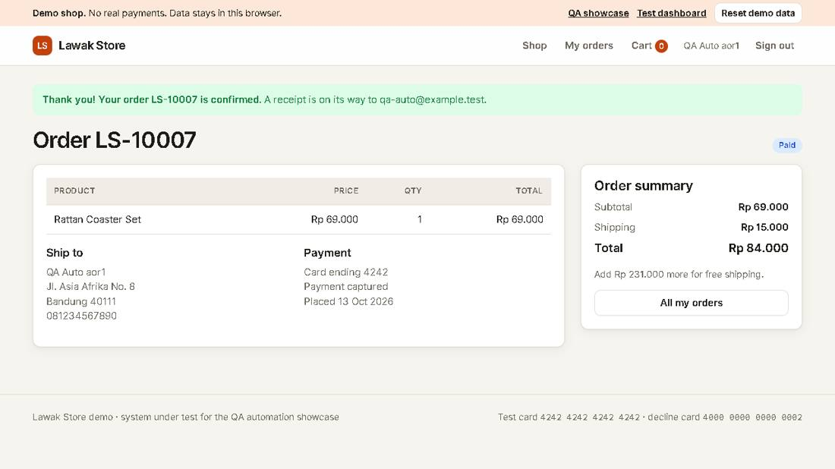
Evidence TC-AOR-001_02-UI.png
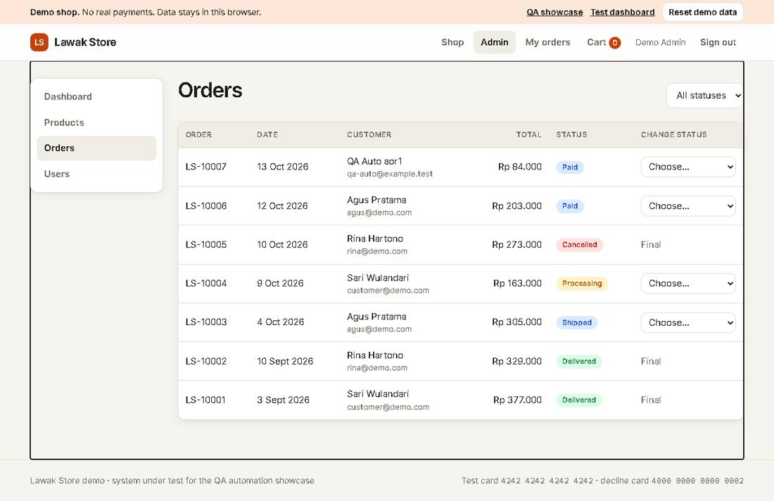

Scenario: Order status

TC-AOR-002 - Admin moves an order from Paid to Processing [Pass]
Type Positive | Priority High | Sprint 3 | Layer UI | Tool Playwright | Reference US-051 rule R-09
No | Layer | Step | Expected result | Result | Actual result
S01 | UI | [UI] Place an order as a new qa-auto customer, then open admin Orders | The order row offers Processing and Cancelled | Pass | As expected.
S02 | UI | [UI] Choose Processing | The message says the order is now Processing and the row shows Processing | Pass | As expected.
Evidence TC-AOR-002_01-UI.png
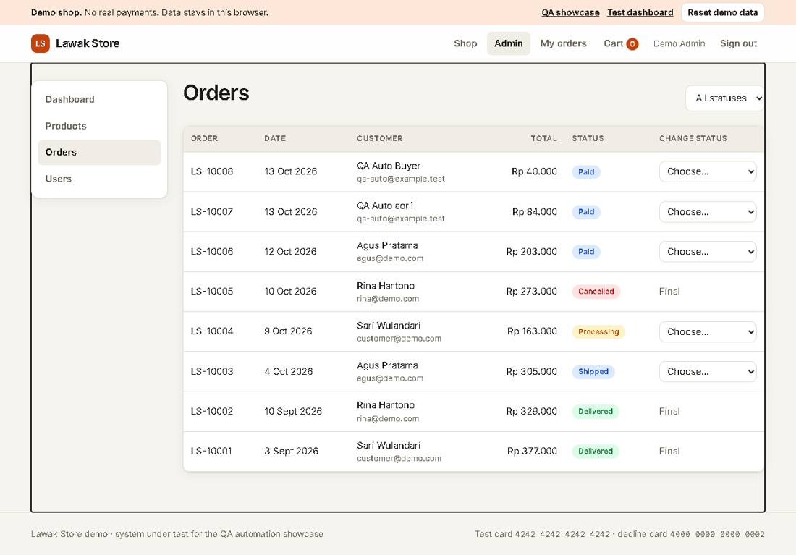
Evidence TC-AOR-002_02-UI.png
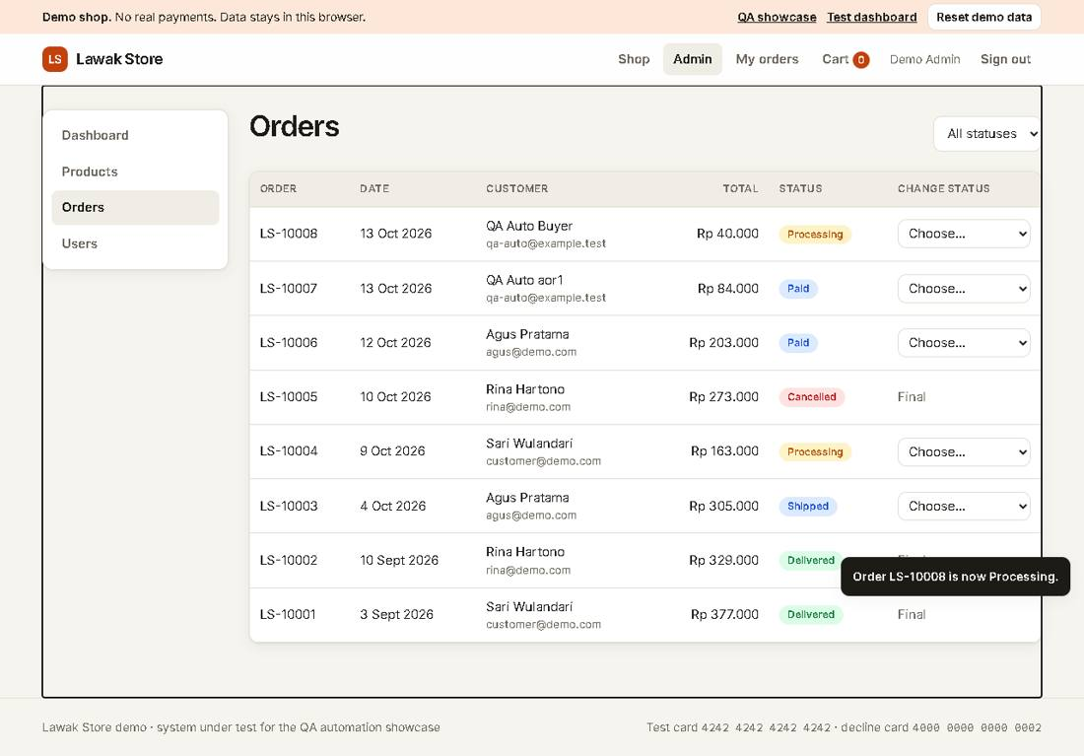

TC-AOR-003 - Cancelling an order puts the stock back [Pass]
Type Positive | Priority Medium | Sprint 3 | Layer UI | Tool Playwright | Reference US-051 rule R-10
No | Layer | Step | Expected result | Result | Actual result
S01 | UI | [UI] Note the stock of Rattan Coaster Set in admin Products, then order 2 as a qa-auto customer | Admin Products shows the stock 2 lower | Pass | Stock went from 21 to 19 after order LS-10009.
S02 | UI | [UI] Cancel the order in admin Orders | The row shows Cancelled and the stock is back to the first value | Pass | Order LS-10009 is Cancelled. Stock is back to 21.
Evidence TC-AOR-003_01-UI.png
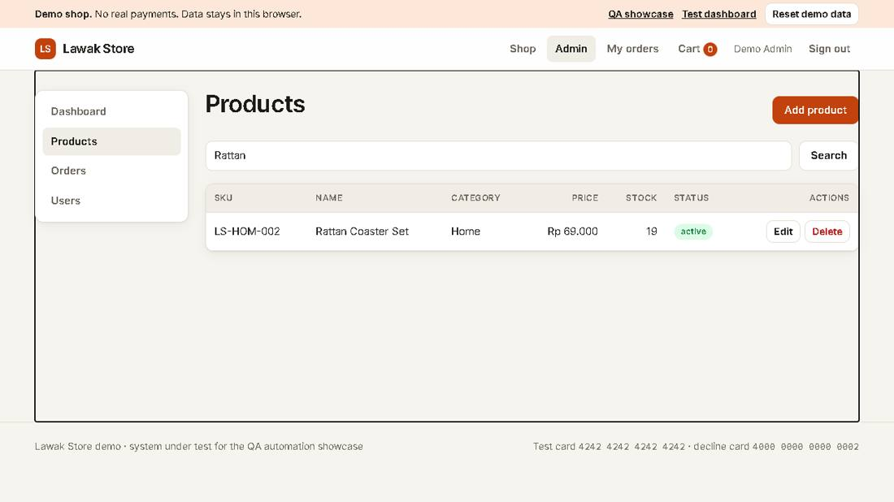
Evidence TC-AOR-003_02-UI.png
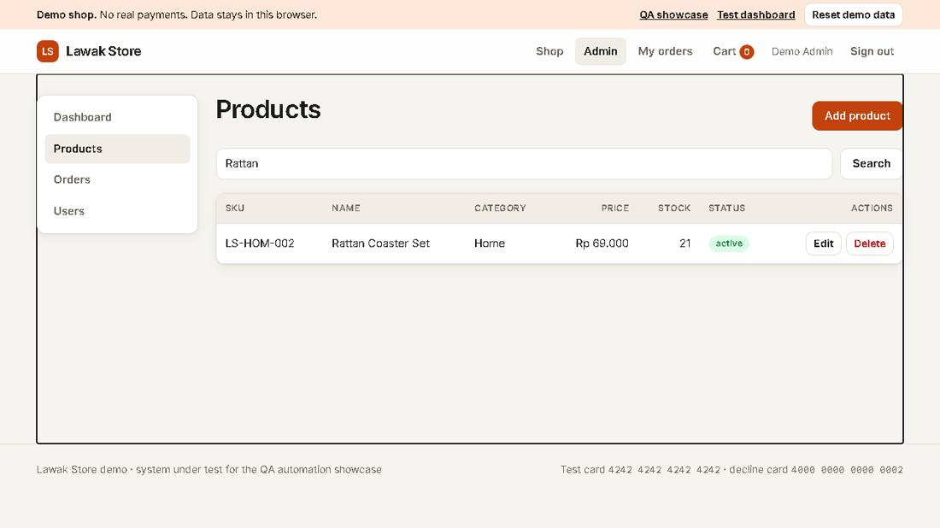

Module: Admin Users

Scenario: Access control

TC-USR-001 - A customer cannot open admin pages [Pass]
Type Negative | Priority High | Sprint 4 | Layer UI | Tool Playwright | Reference US-060 rule R-11
No | Layer | Step | Expected result | Result | Actual result
S01 | UI | [UI] Sign in as customer@demo.com | The header has no Admin link | Pass | As expected.
S02 | UI | [UI] Open the admin Users page by its address | The page says "You do not have access to this page" | Pass | As expected.
Evidence TC-USR-001_01-UI.png
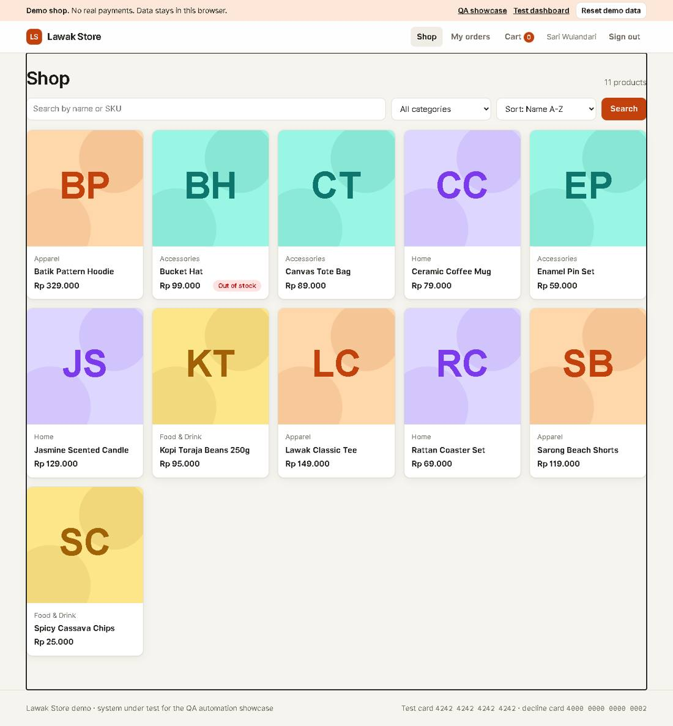
Evidence TC-USR-001_02-UI.png
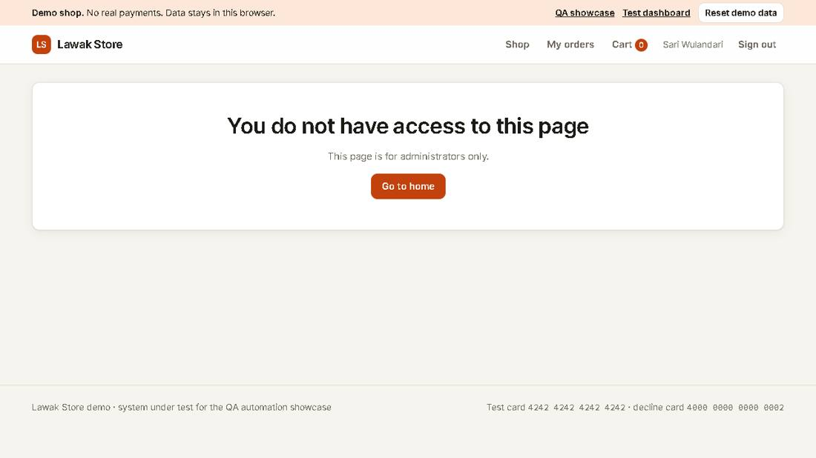

Scenario: Disable user

TC-USR-002 - A disabled customer cannot sign in [Pass]
Type Positive | Priority High | Sprint 4 | Layer UI | Tool Playwright | Reference US-061
No | Layer | Step | Expected result | Result | Actual result
S01 | UI | [UI] Register a qa-auto customer, then sign in as admin and open Users | The new user shows status active | Pass | As expected.
S02 | UI | [UI] Select Disable and confirm | The row shows status disabled | Pass | As expected.
S03 | UI | [UI] Sign in as the disabled customer | The alert says "This account is disabled. Contact support." | Pass | As expected.
Evidence TC-USR-002_01-UI.png
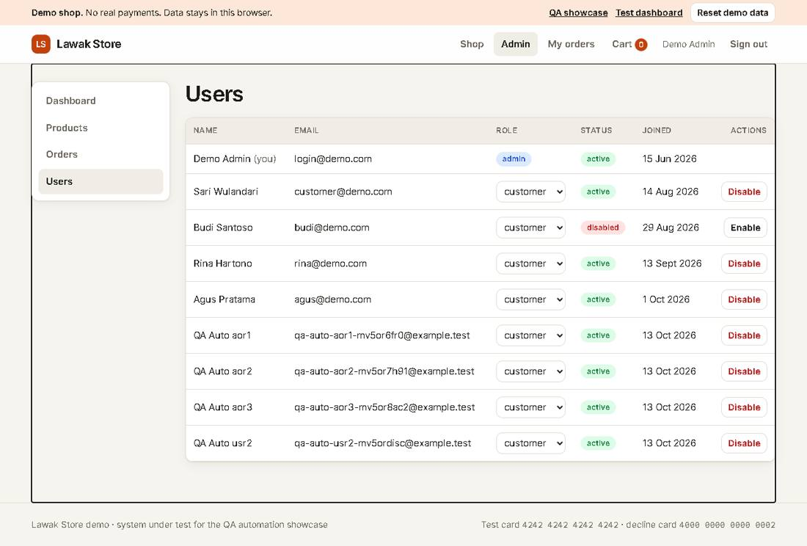
Evidence TC-USR-002_02-UI.png
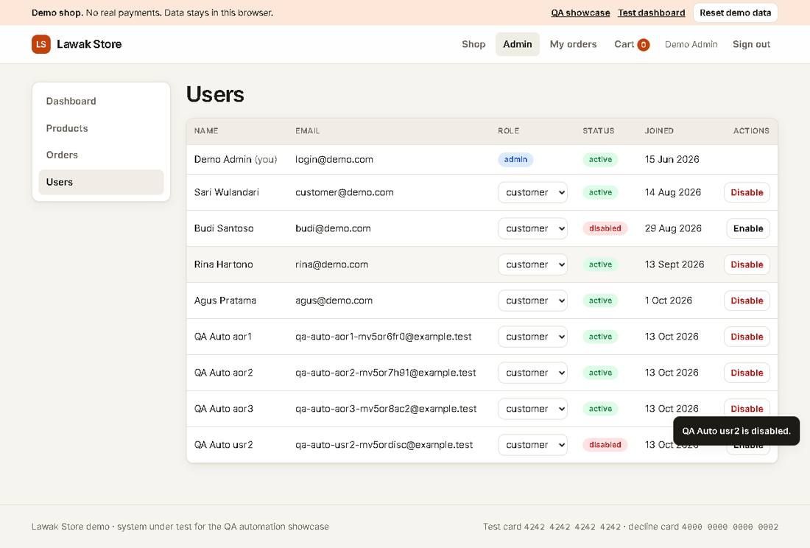
Evidence TC-USR-002_03-UI.png
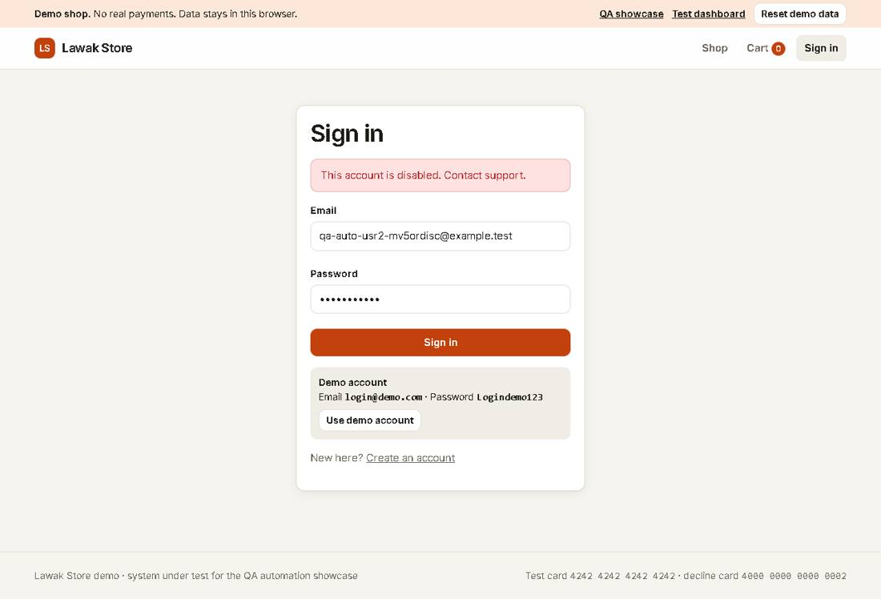

Scenario: Access control

TC-USR-003 - Admin cannot change their own role or status [Pass]
Type Negative | Priority Medium | Sprint 4 | Layer UI | Tool Playwright | Reference US-061 rule R-12
No | Layer | Step | Expected result | Result | Actual result
S01 | UI | [UI] Sign in as admin and open Users | The Demo Admin row has no role list and no Disable button | Pass | As expected.
Evidence TC-USR-003_01-UI.png
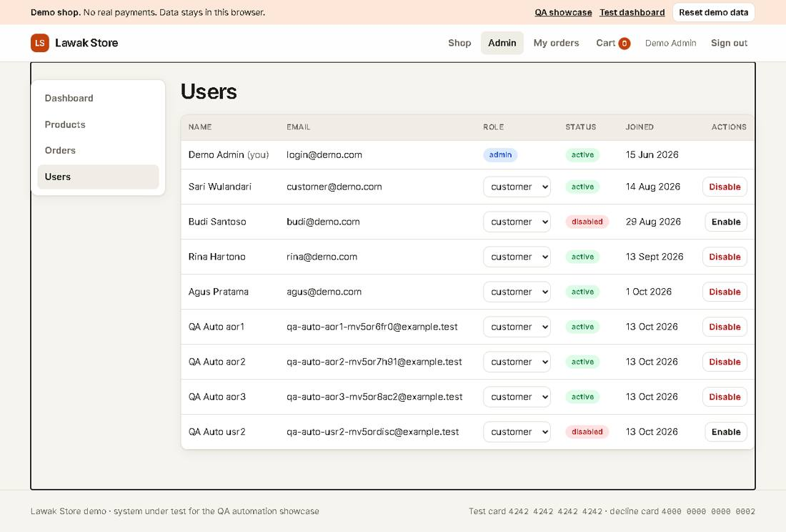

Module: Admin Dashboard

Scenario: KPIs

TC-DSH-001 - Admin dashboard shows the KPIs [Pass]
Type Positive | Priority Medium | Sprint 4 | Layer UI | Tool Playwright | Reference US-070
No | Layer | Step | Expected result | Result | Actual result
S01 | UI | [UI] Sign in as admin and open Dashboard | Revenue, Orders, Customers and Low stock items show numbers, and Recent orders lists 5 rows | Pass | Revenue Rp 1.501.000, orders 9.
Evidence TC-DSH-001_01-UI.png
