Lawak Store

Test Evidence - smoke / RunTest1
Item | Value
Application | Lawak Store (demo shop with admin panel)
Suite | Smoke
Filters | none
Run | RunTest1 (13 Oct 2026 03:05 to 13 Oct 2026 03:05)
Target | http://127.0.0.1:4173
Browser | Microsoft Edge (msedge)
Command | node scripts/run-suite.js --suite smoke
Result | 17 Pass, 0 Fail, 0 Skipped of 17 cases

Status of all cases
ID | Test case | Module | Sprint | Layer | Tool | Result
TC-AOR-001 | A new customer order shows in admin Orders | Admin Orders | Sprint 3 | UI | Playwright | Pass
TC-AUTH-001 | Sign in with the demo admin account | Authentication | Sprint 1 | UI | Playwright | Pass
TC-AUTH-002 | Wrong password shows an error | Authentication | Sprint 1 | UI | Playwright | Pass
TC-AUTH-005 | Register a new customer account | Authentication | Sprint 1 | UI | Playwright | Pass
TC-AUTH-008 | Sign out ends the session | Authentication | Sprint 1 | UI | Playwright | Pass
TC-AUTH-101 | API: valid sign in returns a token | Authentication | Sprint 1 | API | Bruno CLI | Pass
TC-CART-001 | Add a product to the cart | Cart | Sprint 2 | UI | Playwright | Pass
TC-CAT-001 | Shop lists all active products and hides drafts | Catalog | Sprint 1 | UI | Playwright | Pass
TC-CAT-101 | API: product list returns 11 active products | Catalog | Sprint 1 | API | Bruno CLI | Pass
TC-CHK-001 | Checkout with the test card creates an order | Checkout | Sprint 2 | UI | Playwright | Pass
TC-CHK-003 | Declined card shows a payment error | Checkout | Sprint 2 | UI | Playwright | Pass
TC-DSH-001 | Admin dashboard shows the KPIs | Admin Dashboard | Sprint 4 | UI | Playwright | Pass
TC-ORD-002 | A customer cannot open another customer's order | Customer Orders | Sprint 2 | UI | Playwright | Pass
TC-PRD-001 | Admin creates a product | Admin Products | Sprint 3 | UI | Playwright | Pass
TC-USR-001 | A customer cannot open admin pages | Admin Users | Sprint 4 | UI | Playwright | Pass
TC-USR-101 | API: admin endpoint without a token returns 401 | Admin Users | Sprint 4 | API | Bruno CLI | Pass
TC-USR-102 | API: admin endpoint as a customer returns 403 | Admin Users | Sprint 4 | API | Bruno CLI | Pass

Failure summary
No case failed in this run.
Check: 17 Pass + 0 Fail + 0 Skipped = 17 cases.

Module: Authentication

Scenario: Sign in

TC-AUTH-001 - Sign in with the demo admin account [Pass]
Type Positive | Priority High | Sprint 1 | Layer UI | Tool Playwright | Reference US-001
No | Layer | Step | Expected result | Result | Actual result
S01 | UI | [UI] Open the Sign in page | The Sign in form shows the Email and Password fields | Pass | The Sign in form shows Email and Password.
S02 | UI | [UI] Enter login@demo.com and Logindemo123, then select Sign in | The admin Dashboard opens and the header shows Demo Admin | Pass | The admin Dashboard opened. The header shows Demo Admin.
Evidence TC-AUTH-001_01-UI.png
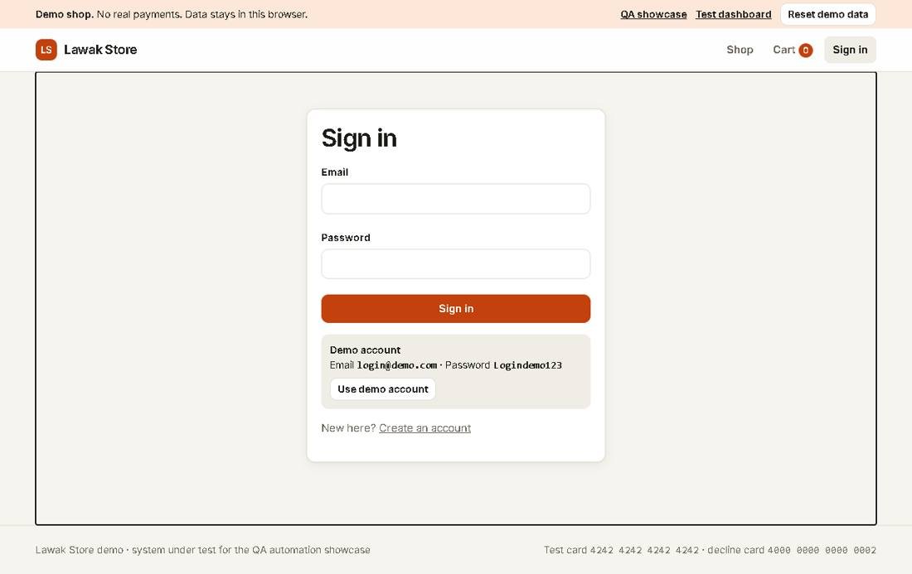
Evidence TC-AUTH-001_02-UI.png
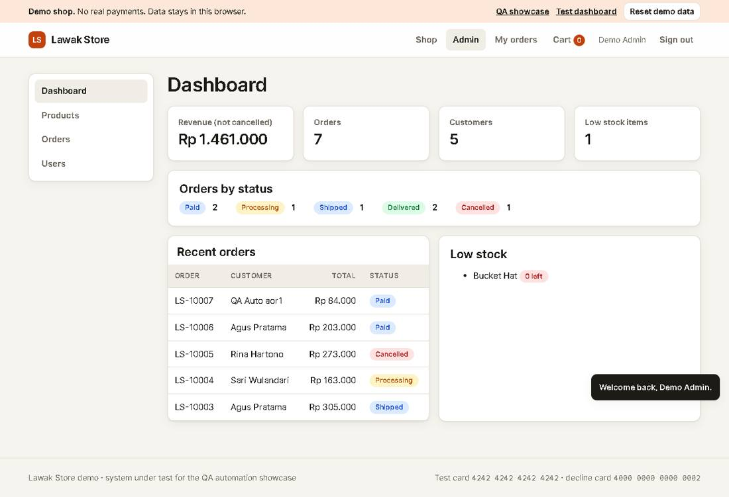

TC-AUTH-002 - Wrong password shows an error [Pass]
Type Negative | Priority High | Sprint 1 | Layer UI | Tool Playwright | Reference US-001
No | Layer | Step | Expected result | Result | Actual result
S01 | UI | [UI] Open the Sign in page | The Sign in form shows | Pass | As expected.
S02 | UI | [UI] Enter login@demo.com with a wrong password, then select Sign in | The alert says "Invalid email or password." and the user stays signed out | Pass | The alert says "Invalid email or password." The user is still signed out.
Evidence TC-AUTH-002_01-UI.png
Evidence TC-AUTH-002_02-UI.png
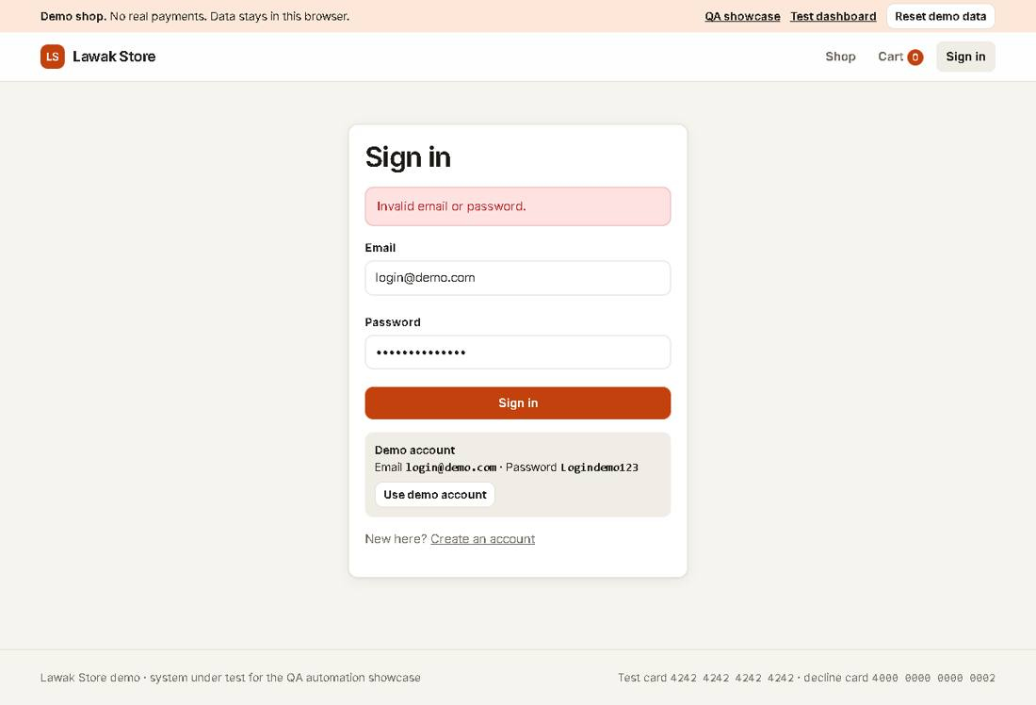

Scenario: Registration

TC-AUTH-005 - Register a new customer account [Pass]
Type Positive | Priority High | Sprint 1 | Layer UI | Tool Playwright | Reference US-003
No | Layer | Step | Expected result | Result | Actual result
S01 | UI | [UI] Open Create account | The registration form shows four fields | Pass | As expected.
S02 | UI | [UI] Enter a unique qa-auto email, a valid name and a valid password twice, then submit | The Sign in page shows "Account created. Sign in to continue." with the email filled in | Pass | The account qa-auto-register-mv5olsk83@example.test was created. The Sign in page has the email filled in.
S03 | UI | [UI] Sign in with the new account | The Shop page opens and the header shows the new name | Pass | As expected.
Evidence TC-AUTH-005_01-UI.png
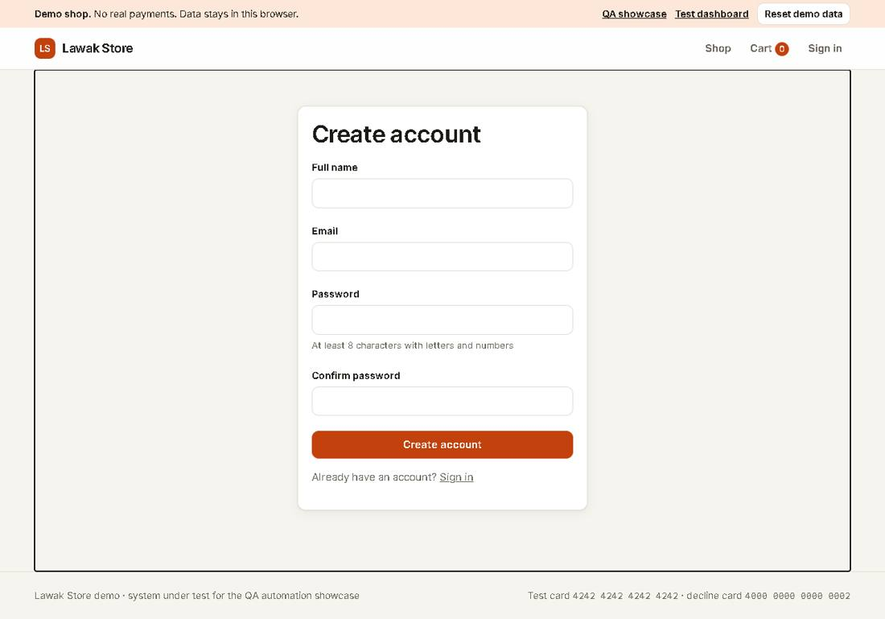
Evidence TC-AUTH-005_02-UI.png
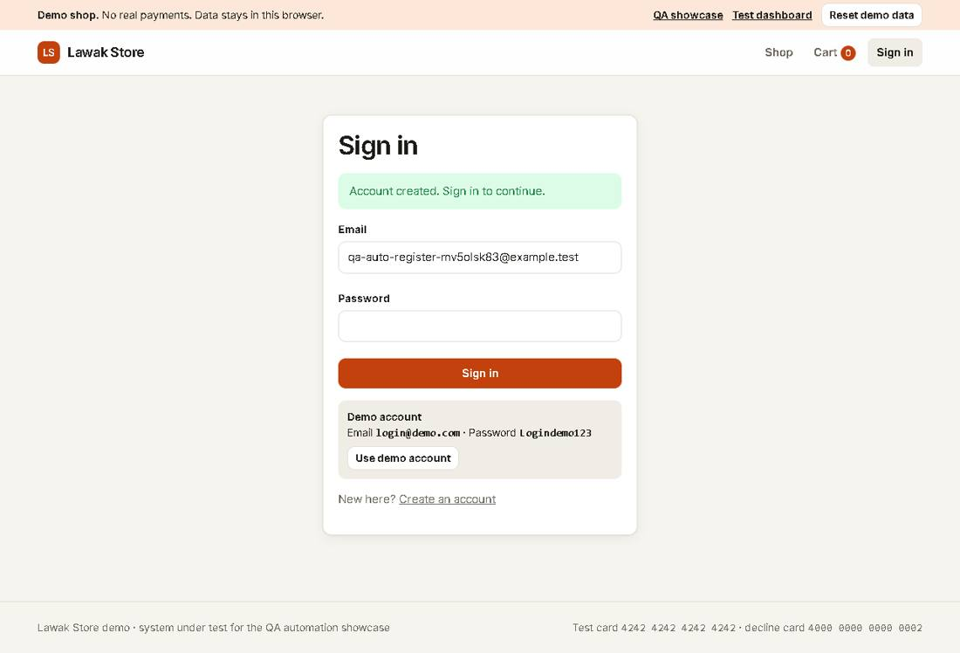
Evidence TC-AUTH-005_03-UI.png
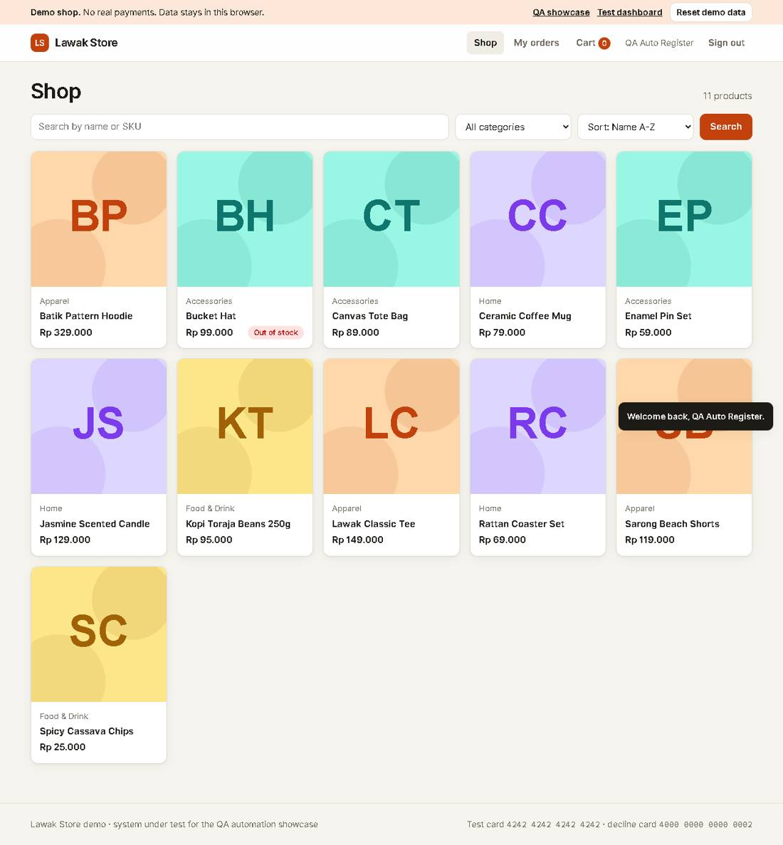

Scenario: Sign out

TC-AUTH-008 - Sign out ends the session [Pass]
Type Positive | Priority High | Sprint 1 | Layer UI | Tool Playwright | Reference US-004
No | Layer | Step | Expected result | Result | Actual result
S01 | UI | [UI] Sign in as customer@demo.com | The header shows Sari Wulandari and Sign out | Pass | As expected.
S02 | UI | [UI] Select Sign out | The header shows Sign in | Pass | As expected.
S03 | UI | [UI] Open My orders by its address | The Sign in page opens instead | Pass | My orders sent the signed-out user to Sign in.
Evidence TC-AUTH-008_01-UI.png
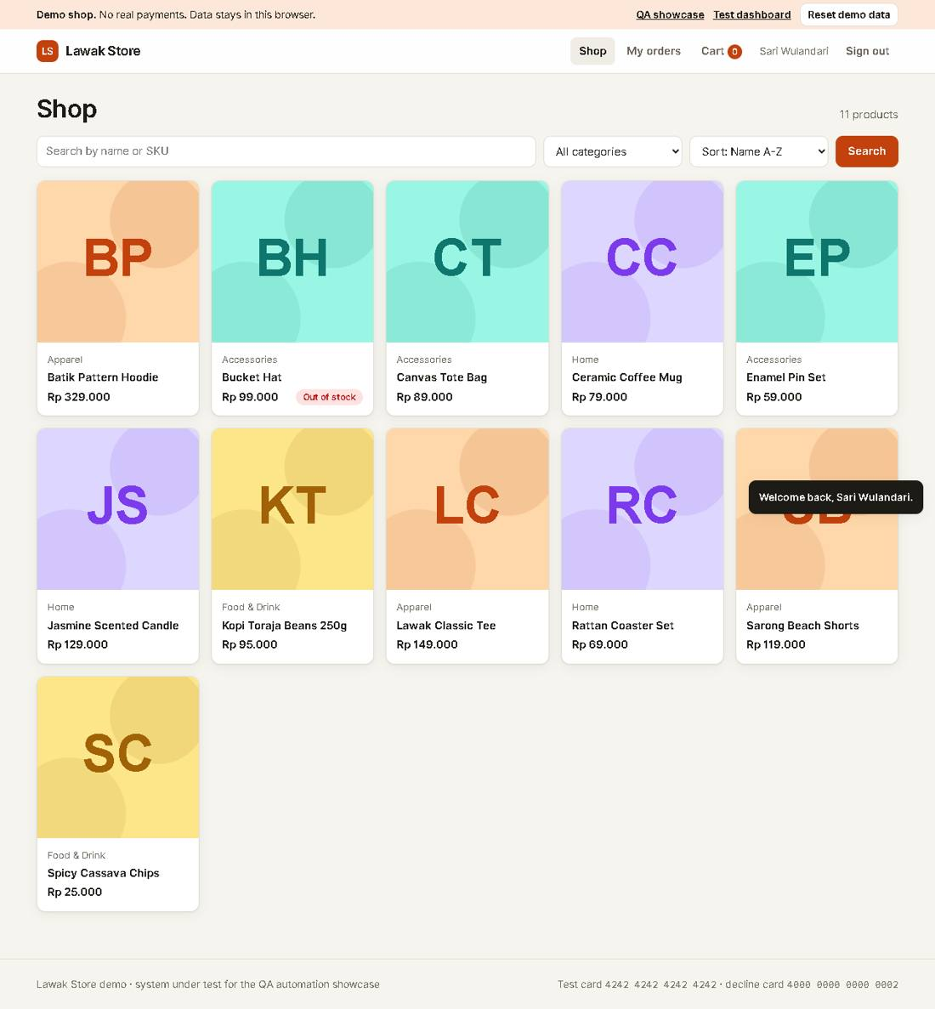
Evidence TC-AUTH-008_02-UI.png
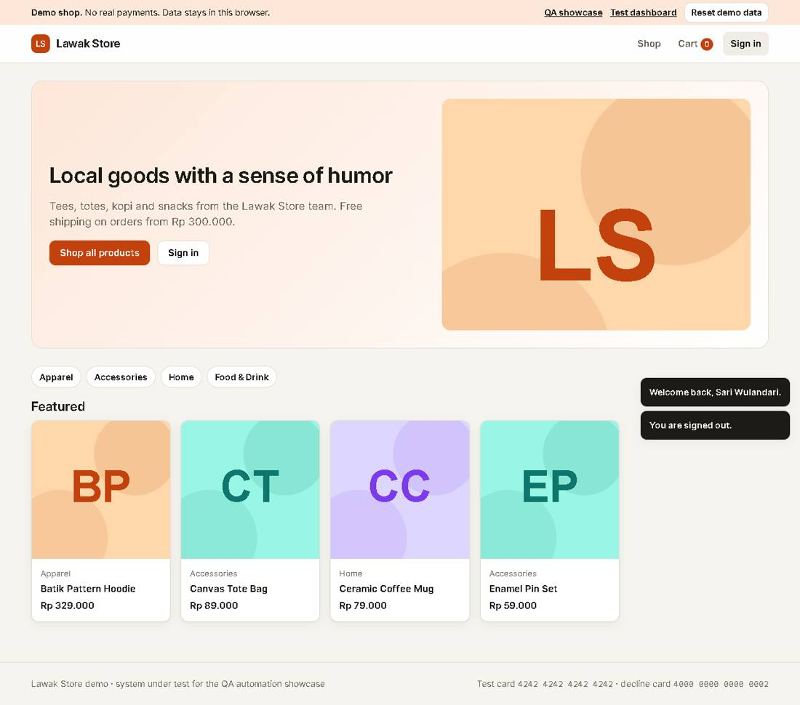
Evidence TC-AUTH-008_03-UI.png
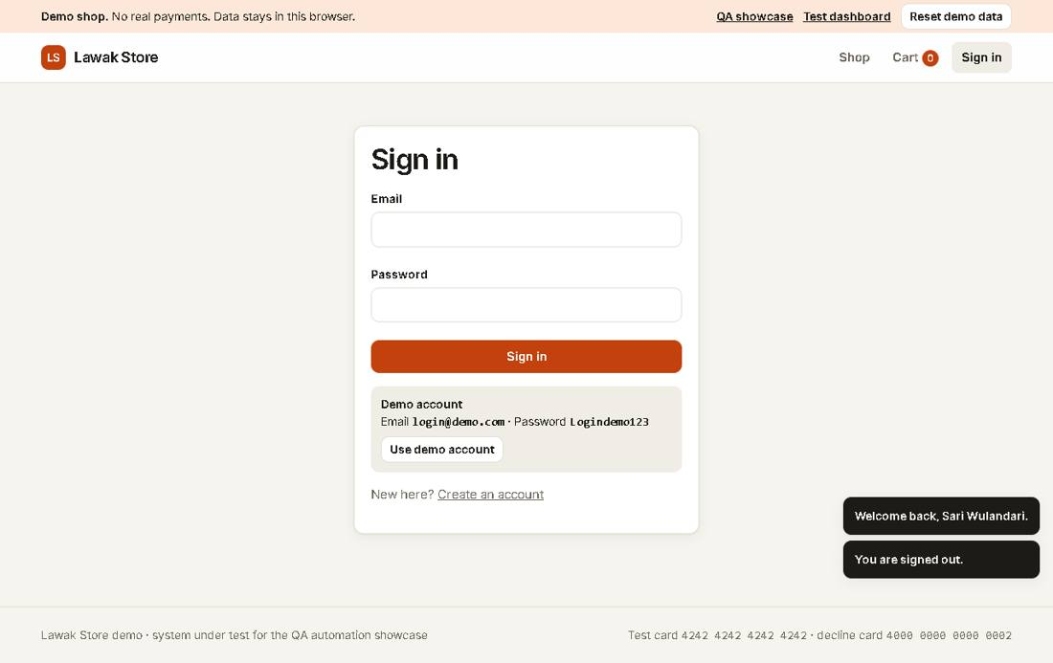

Scenario: Sign in

TC-AUTH-101 - API: valid sign in returns a token [Pass]
Type Positive | Priority High | Sprint 1 | Layer API | Tool Bruno CLI | Reference US-001
No | Layer | Step | Expected result | Result | Actual result
S01 | API | [API] POST /api/auth/login with the demo admin account | HTTP 200, body has token and user.role admin | Pass | HTTP 200 OK.
Evidence TC-AUTH-101_01-API.json
{
"request": {
"method": "POST",
"url": "http://127.0.0.1:4173/api/auth/login"
},
"response": {
"status": 200,
"body": {
"token": "***",
"user": {
"id": "u1",
"name": "Demo Admin",
"email": "login@demo.com",
"role": "admin",
"status": "active",
"createdAt": "2026-06-14T20:05:31.645Z"
}
}
}
}

Module: Catalog

Scenario: Product list

TC-CAT-001 - Shop lists all active products and hides drafts [Pass]
Type Positive | Priority High | Sprint 1 | Layer UI | Tool Playwright | Reference US-010
No | Layer | Step | Expected result | Result | Actual result
S01 | UI | [UI] Open the Shop page | The count shows "11 products" | Pass | As expected.
S02 | UI | [UI] Look for the draft product Anniversary Jacket | Anniversary Jacket is not in the list | Pass | Anniversary Jacket (draft) is not in the list.
Evidence TC-CAT-001_01-UI.png
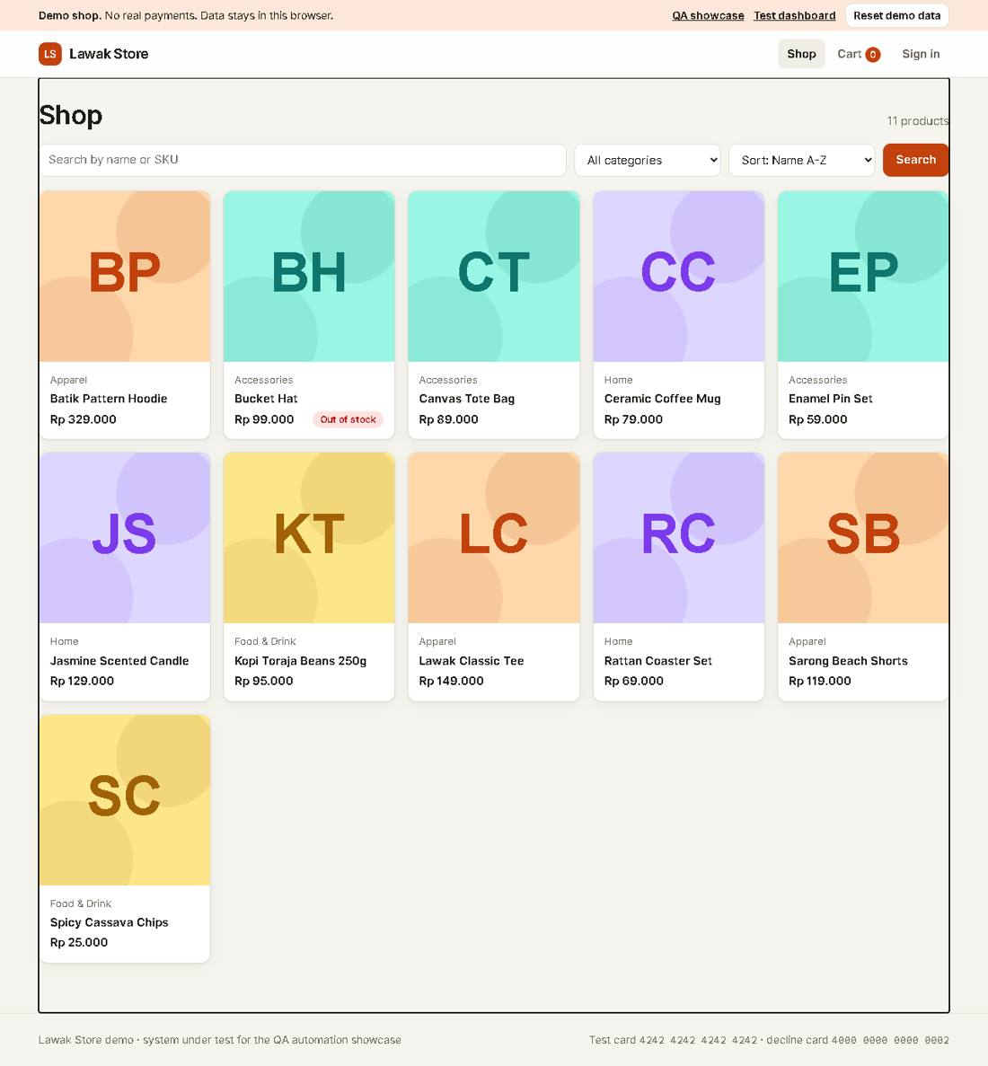
Evidence TC-CAT-001_02-UI.png

TC-CAT-101 - API: product list returns 11 active products [Pass]
Type Positive | Priority High | Sprint 1 | Layer API | Tool Bruno CLI | Reference US-010
No | Layer | Step | Expected result | Result | Actual result
S01 | API | [API] GET /api/products | HTTP 200, total 11, no product with status draft | Pass | HTTP 200 OK.
Evidence TC-CAT-101_01-API.json
{
"request": {
"method": "GET",
"url": "http://127.0.0.1:4173/api/products"
},
"response": {
"status": 200,
"body": {
"products": [
{
"id": "p2",
"sku": "LS-APP-002",
"name": "Batik Pattern Hoodie",
"category": "Apparel",
"price": 329000,
"stock": 18,
"description": "Fleece hoodie with a modern batik pattern on the sleeves.",
"status": "active",
"createdAt": "2026-07-14T20:05:31.645Z"
},
{
"id": "p6",
"sku": "LS-ACC-003",
"name": "Bucket Hat",
"category": "Accessories",
"price": 99000,
"stock": 0,
"description": "Washed cotton bucket hat. Back in stock soon.",
"status": "active",
"createdAt": "2026-07-14T20:05:31.645Z"
},
{
"id": "p4",
"sku": "LS-ACC-001",
"name": "Canvas Tote Bag",
"category": "Accessories",
"price": 89000,
"stock": 60,
"description": "Heavy canvas tote with an inside pocket.",
"status": "active",
"createdAt": "2026-07-14T20:05:31.645Z"
},
{
"id": "p7",
"sku": "LS-HOM-001",
"name": "Ceramic Coffee Mug",
"category": "Home",
"price": 79000,
"stock": 35,
"description": "Handmade ceramic mug, 350 ml.",
"status": "active",
"createdAt": "2026-07-14T20:05:31.645Z"
},
{
"id": "p5",
"sku": "LS-ACC-002",
"name": "Enamel Pin Set",
"category": "Accessories",
"price": 59000,
"stock": 100,
"description": "Set of four enamel pins: wayang, kopi, sc
...

Module: Cart

Scenario: Add to cart

TC-CART-001 - Add a product to the cart [Pass]
Type Positive | Priority High | Sprint 2 | Layer UI | Tool Playwright | Reference US-020
No | Layer | Step | Expected result | Result | Actual result
S01 | UI | [UI] Sign in as a new qa-auto customer and open Ceramic Coffee Mug | The cart count in the header is 0 | Pass | As expected.
S02 | UI | [UI] Select Add to cart | The message says "Added to cart." and the cart count is 1 | Pass | The message says "Added to cart." The cart count is 1.
Evidence TC-CART-001_01-UI.png
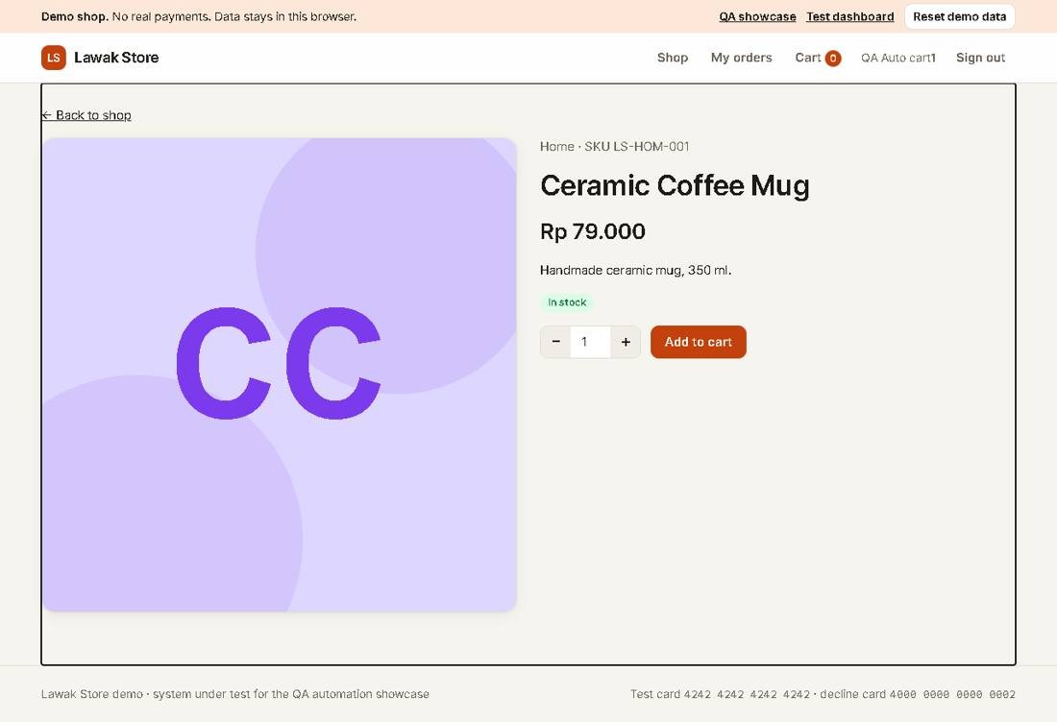
Evidence TC-CART-001_02-UI.png
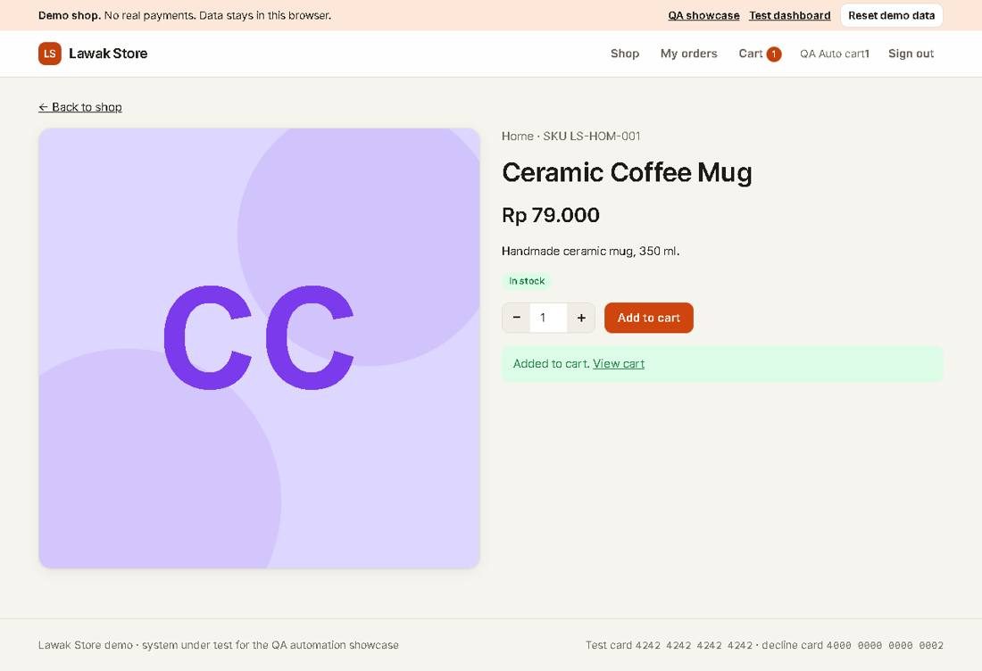

Module: Checkout

Scenario: Payment

TC-CHK-001 - Checkout with the test card creates an order [Pass]
Type Positive | Priority High | Sprint 2 | Layer UI | Tool Playwright | Reference US-030
No | Layer | Step | Expected result | Result | Actual result
S01 | UI | [UI] Add Kopi Toraja Beans to the cart and open Checkout | The Pay button shows Rp 110.000 | Pass | As expected.
S02 | UI | [UI] Fill a valid address and card 4242 4242 4242 4242, then select Pay | The page says "Thank you! Your order LS-... is confirmed." and the cart count is 0 | Pass | Order LS-10008 is confirmed. The cart count is 0.
Evidence TC-CHK-001_01-UI.png
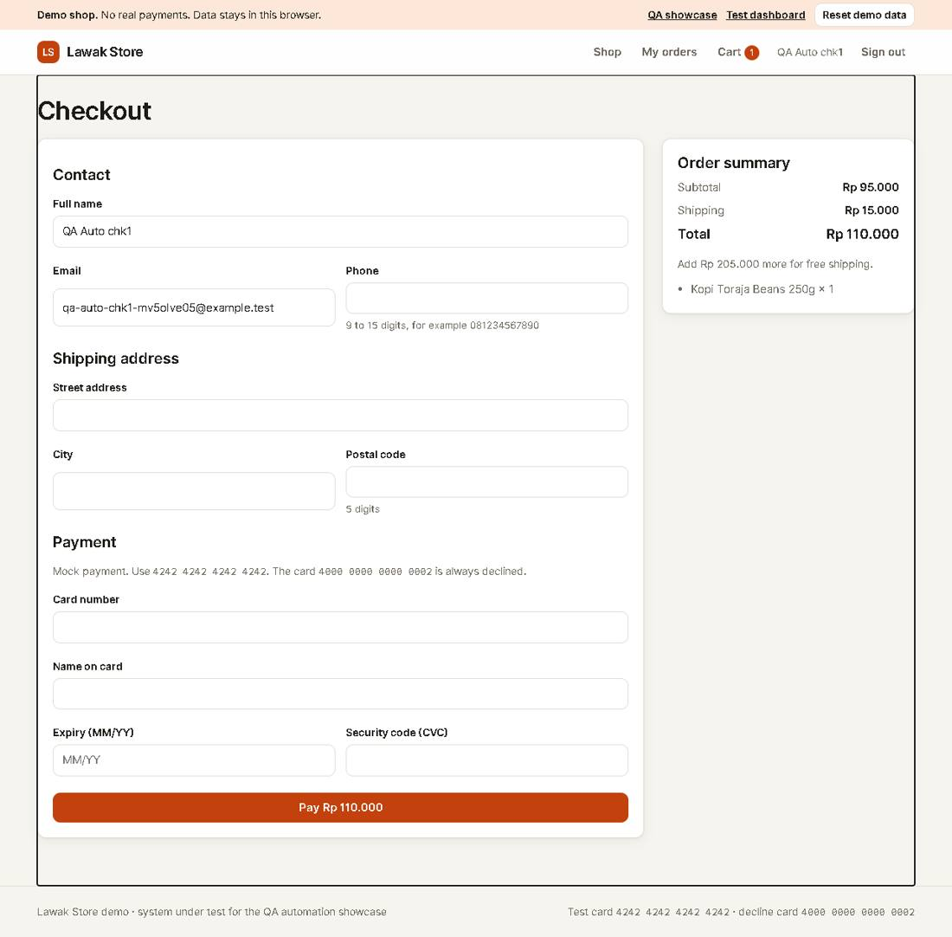
Evidence TC-CHK-001_02-UI.png
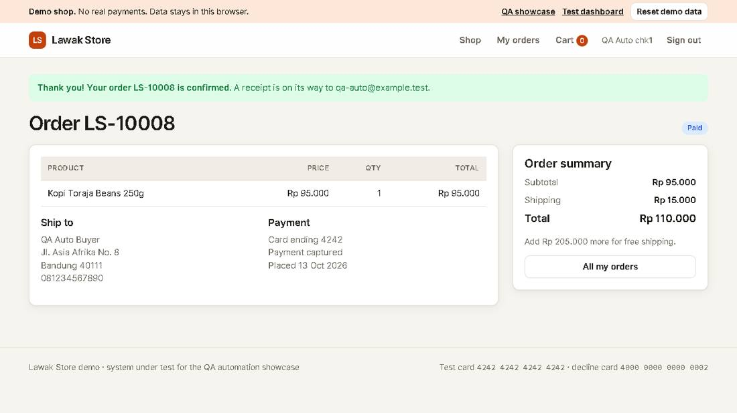

TC-CHK-003 - Declined card shows a payment error [Pass]
Type Negative | Priority High | Sprint 2 | Layer UI | Tool Playwright | Reference US-031
No | Layer | Step | Expected result | Result | Actual result
S01 | UI | [UI] Fill Checkout with card 4000 0000 0000 0002 and select Pay | The alert says "The card was declined. Use another card." | Pass | As expected.
S02 | UI | [UI] Open the cart | The item is still in the cart | Pass | The item is still in the cart after the declined payment.
Evidence TC-CHK-003_01-UI.png
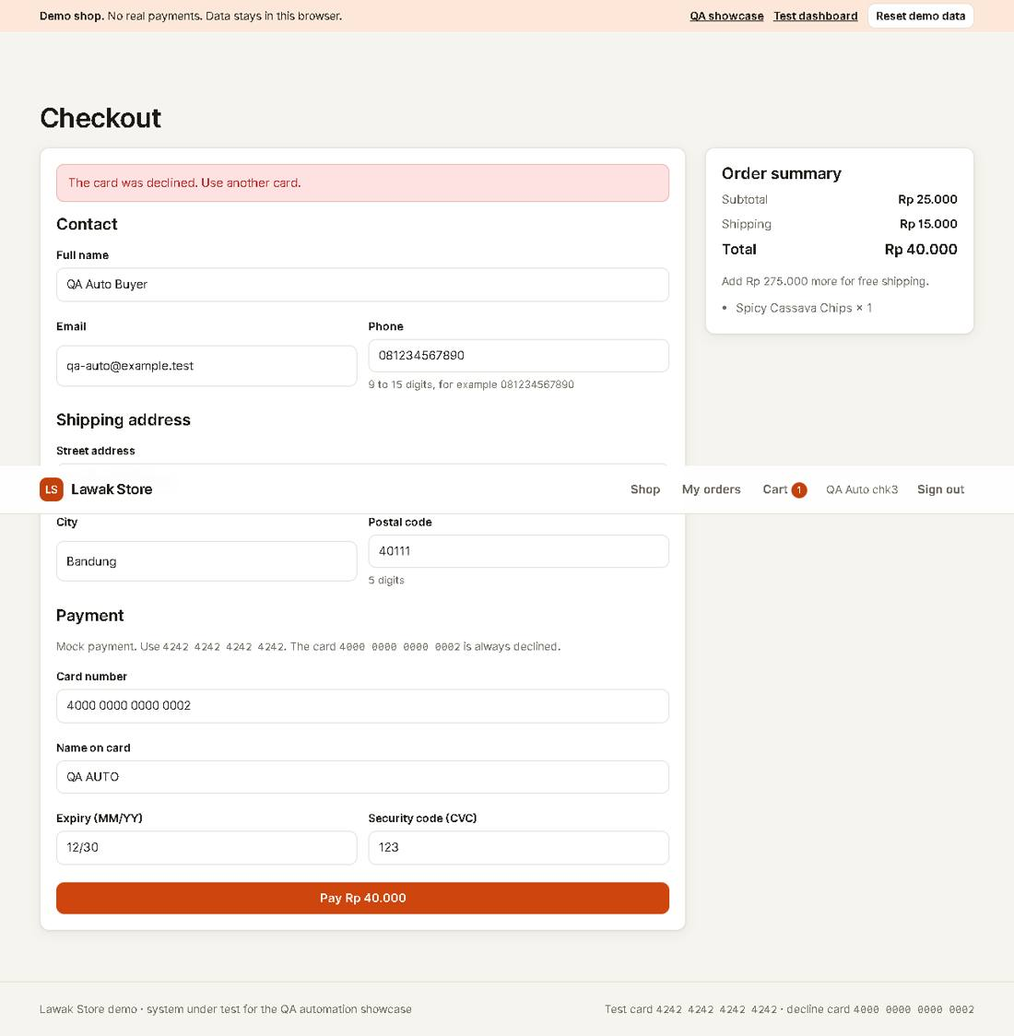
Evidence TC-CHK-003_02-UI.png
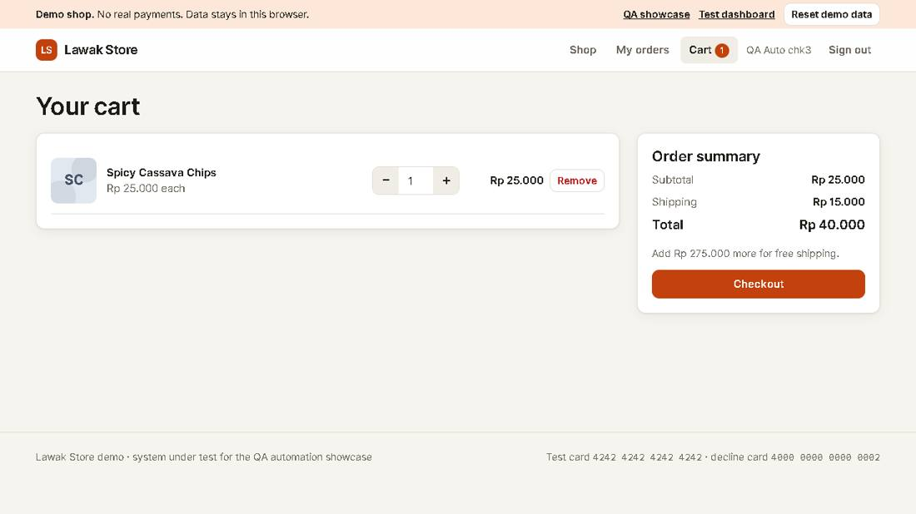

Module: Customer Orders

Scenario: Order privacy

TC-ORD-002 - A customer cannot open another customer's order [Pass]
Type Negative | Priority High | Sprint 2 | Layer UI | Tool Playwright | Reference US-032 rule R-08
No | Layer | Step | Expected result | Result | Actual result
S01 | UI | [UI] Sign in as customer@demo.com and open order LS-10002 (it belongs to Rina) | The page shows "This order does not exist." | Pass | The page says "This order does not exist." No data from Rina shows.
Evidence TC-ORD-002_01-UI.png
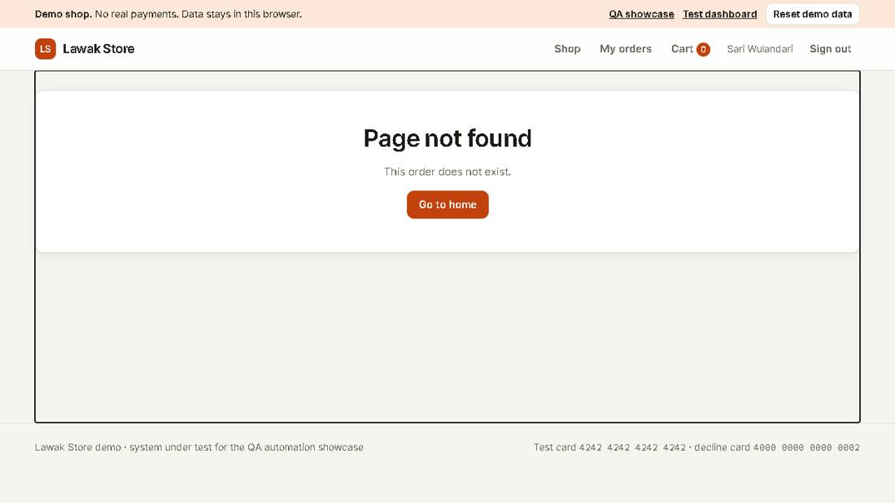

Module: Admin Products

Scenario: Create product

TC-PRD-001 - Admin creates a product [Pass]
Type Positive | Priority High | Sprint 3 | Layer UI | Tool Playwright | Reference US-040
No | Layer | Step | Expected result | Result | Actual result
S01 | UI | [UI] Sign in as admin and open Products > Add product | The Add product form shows | Pass | As expected.
S02 | UI | [UI] Fill a qa-auto product and select Create product | The message says "Product created." and the list shows the new SKU | Pass | Product QA-MV5OLP8S2 is in the admin list.
S03 | UI | [UI] Search the shop for the new product | The shop shows the new product | Pass | As expected.
Evidence TC-PRD-001_01-UI.png
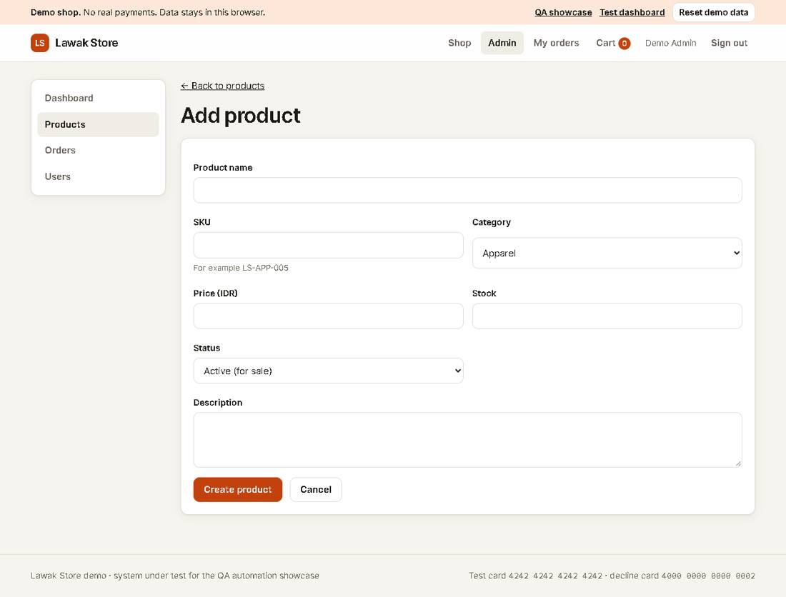
Evidence TC-PRD-001_02-UI.png
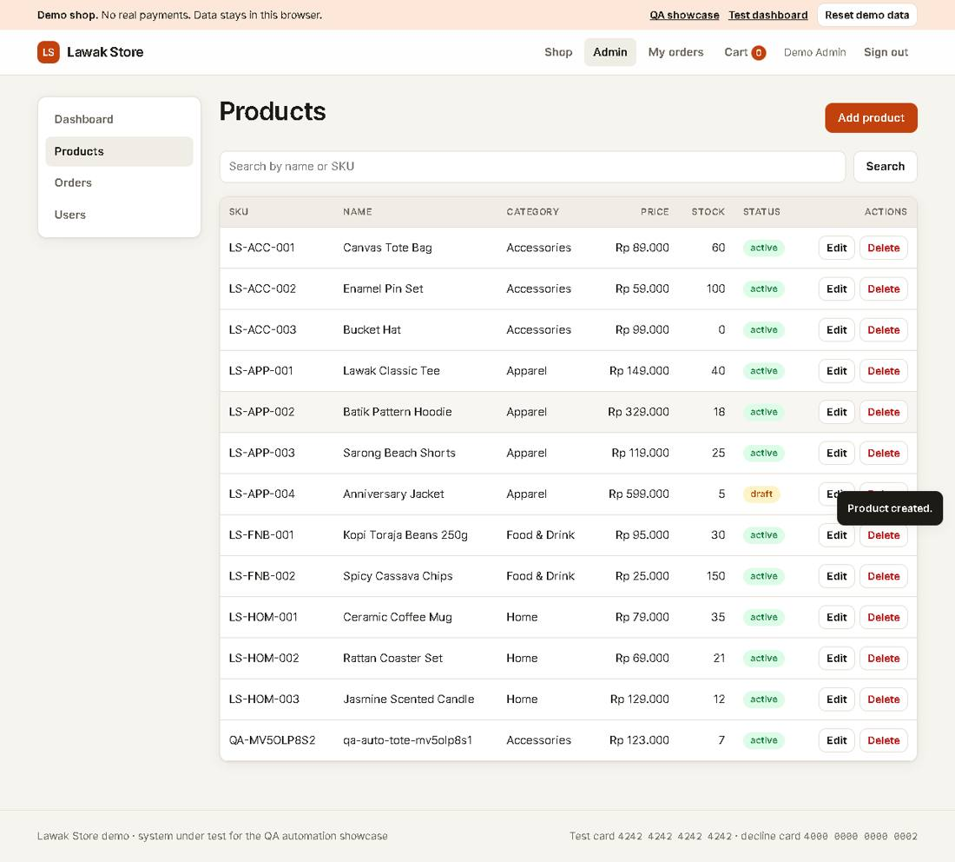
Evidence TC-PRD-001_03-UI.png
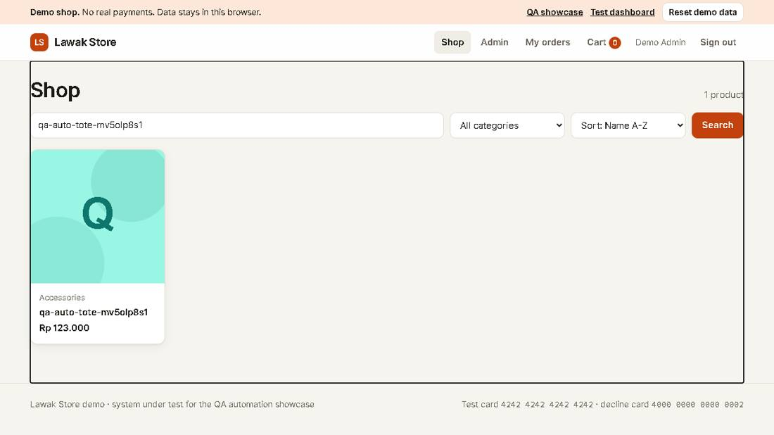

Module: Admin Orders

Scenario: Order list

TC-AOR-001 - A new customer order shows in admin Orders [Pass]
Type Positive | Priority High | Sprint 3 | Layer UI | Tool Playwright | Reference US-050
No | Layer | Step | Expected result | Result | Actual result
S01 | UI | [UI] Place an order as a new qa-auto customer | The confirmation shows the order ID | Pass | As expected.
S02 | UI | [UI] Sign in as admin and open Orders | The list shows that order with status Paid and the customer name | Pass | Order LS-10007 shows as Paid for QA Auto aor1.
Evidence TC-AOR-001_01-UI.png
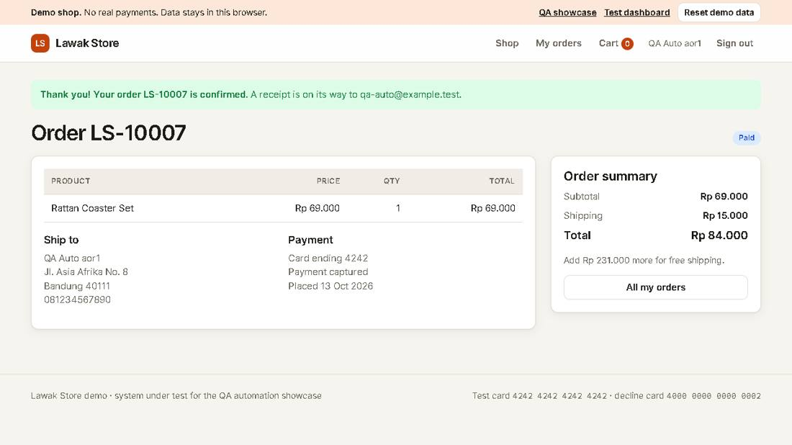
Evidence TC-AOR-001_02-UI.png
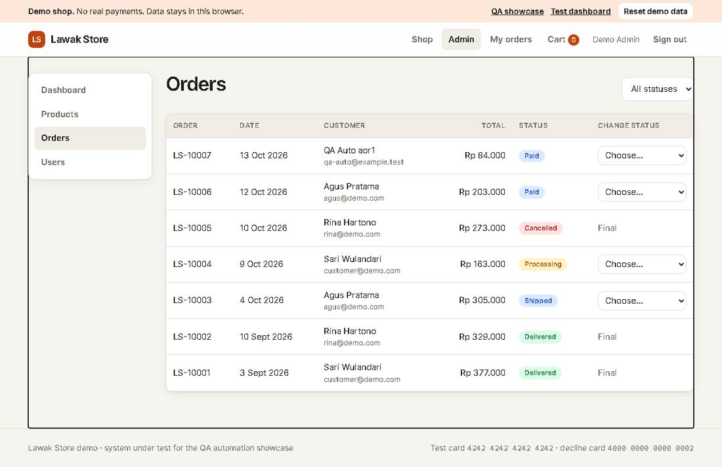

Module: Admin Users

Scenario: Access control

TC-USR-001 - A customer cannot open admin pages [Pass]
Type Negative | Priority High | Sprint 4 | Layer UI | Tool Playwright | Reference US-060 rule R-11
No | Layer | Step | Expected result | Result | Actual result
S01 | UI | [UI] Sign in as customer@demo.com | The header has no Admin link | Pass | As expected.
S02 | UI | [UI] Open the admin Users page by its address | The page says "You do not have access to this page" | Pass | As expected.
Evidence TC-USR-001_01-UI.png
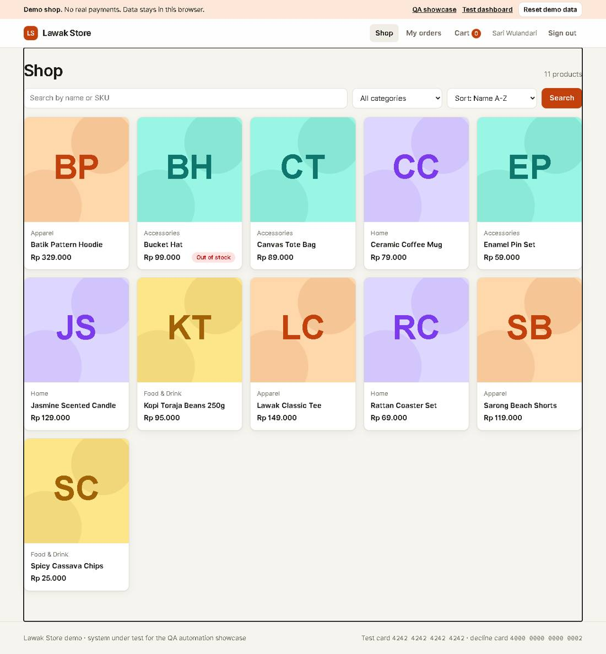
Evidence TC-USR-001_02-UI.png
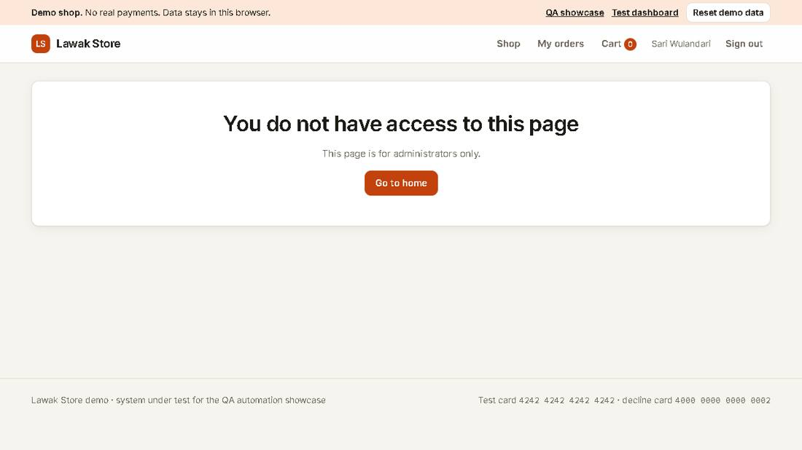

TC-USR-101 - API: admin endpoint without a token returns 401 [Pass]
Type Negative | Priority High | Sprint 4 | Layer API | Tool Bruno CLI | Reference US-060 rule R-11
No | Layer | Step | Expected result | Result | Actual result
S01 | API | [API] GET /api/admin/stats without a token | HTTP 401, error.code UNAUTHORIZED | Pass | HTTP 401 Unauthorized.
Evidence TC-USR-101_01-API.json
{
"request": {
"method": "GET",
"url": "http://127.0.0.1:4173/api/admin/stats"
},
"response": {
"status": 401,
"body": {
"error": {
"code": "UNAUTHORIZED",
"message": "Sign in to continue."
}
}
}
}

TC-USR-102 - API: admin endpoint as a customer returns 403 [Pass]
Type Negative | Priority High | Sprint 4 | Layer API | Tool Bruno CLI | Reference US-060 rule R-11
No | Layer | Step | Expected result | Result | Actual result
S01 | API | [API] GET /api/admin/stats with a customer token | HTTP 403, error.code FORBIDDEN | Pass | HTTP 403 Forbidden.
Evidence TC-USR-102_01-API.json
{
"request": {
"method": "GET",
"url": "http://127.0.0.1:4173/api/admin/stats"
},
"response": {
"status": 403,
"body": {
"error": {
"code": "FORBIDDEN",
"message": "You do not have access to this page."
}
}
}
}

Module: Admin Dashboard

Scenario: KPIs

TC-DSH-001 - Admin dashboard shows the KPIs [Pass]
Type Positive | Priority Medium | Sprint 4 | Layer UI | Tool Playwright | Reference US-070
No | Layer | Step | Expected result | Result | Actual result
S01 | UI | [UI] Sign in as admin and open Dashboard | Revenue, Orders, Customers and Low stock items show numbers, and Recent orders lists 5 rows | Pass | Revenue Rp 1.461.000, orders 7.
Evidence TC-DSH-001_01-UI.png
