

Mini outline

Title: Why we need to use AI.

General Purpose: To persuade.

Specific purpose: By the end of my speech, I want my audience to use AI.

Controlling Idea: There are three main points that tells us why we need use AI.

Main points:

1. Minimizing Human Error

2. Improve Customer Experience

3. Smart Decision-Making

Introduction

Good morning, everyone, I am Fatima Alan and I’m a second-year software engineering student in UKH. The use of AI has risen in a dramatical way over recent years, and I am sure we are all aware about it since most of us interact with AI almost every day. Through my speech, I will discuss why do we need to use AI. So, let’s define Artificial intelligence. AI is a computer system what is developed to perform tasks that require intelligence. For example, learning, assisting in daily activities, or even tasks like image editing and writing code. AI is an algorithm what depends on training data with the ability to learn from data and improve over time simply more data the better AI will learn. The algorithm learns from the data by finding relations and patterns. During my speech, I will talk about 3 key points. I will start by discussing how AI can help us with minimizing human errors. Then, I’ll continue with improving customer using AI. Finally, I’ll discuss how AI is a smart decision maker.

Main Body

1. Minimizing Human Error

Minimizing human error is another essential benefit of AI. Learning algorithms help determine potential scenarios for error and make real-time corrections. When applied, manufacturing companies can closely monitor output, increase employee safety, and reduce the chances of production errors. Shipping industries can account for potential input inaccuracies, shipping delays, or lost goods, therefore limiting revenue loss. And even healthcare providers can increase patient care and outcomes by ensuring a patient’s test result does not go overlooked. Through using AI as a tool to help minimize human error, every industry increases its potential for success.

2. Improve Customer Experience

The days of calling for customer service and waiting on hold to speak with someone are quickly becoming a thing of the past. Many companies now use online chatbots to make responding to and problem-solving for customer concerns a simpler process. Through programmed natural language processing (NLP), chatbots can learn and mimic natural human language. Chatbots also use prediction software to learn and adapt to each customer’s inquiry, providing fast and customer-centered solutions.

Not only does AI improve customer experience but it also allows for heightened security measures. Using deep learning, an advanced level of machine learning, companies can employ encryption software and deep neural networks to protect sensitive information. And as more and more personal information is online, the demand for cybersecurity professionals will only increase.

1. Smart Decision-Making

Companies are using AI technology to streamline their daily processes, analyze upcoming trends, forecast growth, and predict outcomes. For instance, anytime a customer places an item into their shopping cart on the websites of some major retailers, they are immediately given an additional suggested item to purchase based on an advanced algorithm. This algorithm has been programmed to compare thousands of other customers who have purchased similar items and make an informed suggestion. Additionally, social media platforms use a form of applied AI, known as machine learning, to display specific content to their users, and the more an individual uses the platform, the more the AI learns about them. By utilizing extensive neural networking, machine learning becomes superior in smart-decision making.

Conclusion

In conclusion, the advantages of using Artificial Intelligence (AI) are multifaceted and extend across various domains. AI's ability to process vast amounts of data, analyze patterns, and make predictions contributes to more informed decision-making. It excels in automating routine tasks, optimizing processes, and adapting to dynamic environments through machine learning. The precision, efficiency, and consistency offered by AI enhance productivity and allow humans to focus on more strategic aspects of their work. Moreover, AI contributes to improved risk management, personalized experiences, and the overall enhancement of various industries. However, it's crucial to approach AI deployment with careful consideration of ethical implications, ensuring responsible development and human oversight to mitigate potential risks and biases. As a powerful tool, AI stands poised to revolutionize industries and significantly impact the way we approach complex problem-solving and decision-making processes.

Illustrations: Relevant stories that illustrate your idea, issue, or problem.

Descriptions: Imagine this, tomorrow in the morning, we have a very hard assignment, and we have little time to study, and we don’t have enough information. At that time, the best way to learn is using AI because in that way we can learn anything that we want step by step and if we have any question we can do and get our answer as soon as possible.

Source: Fatima Alan Zaynal

Explanations: Statements that make clear how something is done or why it exists in its present form or existed in a past form

Description: AI is designed to enhance efficiency by automating repetitive tasks. It processes vast amounts of data and performs complex computations at speeds unattainable by humans. This leads to increased productivity and allows human workers to focus on more creative and strategic aspects of their work.

Source: <https://www.coursera.org/articles/author/coursera-staff>

Description: Word pictures

Descriptions: When a human is using AI.

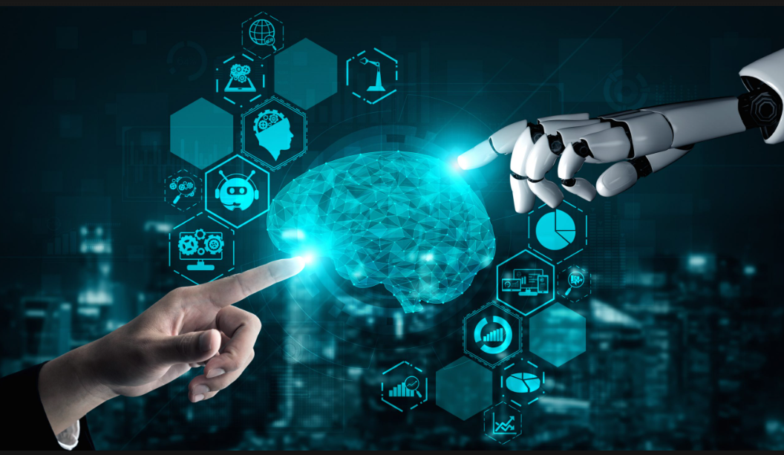

Source: https://www.eweek.com/wp-content/uploads/2023/12/ew_20231205-best-generative-ai-app-builders.png

Definitions:Concise explanations of a word or concept

Description: An algorithm is a step-by-step set of instructions, or a sequence of operations designed to perform a specific task. In the context of AI, algorithms are crucial for processing data and making intelligent decisions.

Source: Fatima Alan

**Analogies:** Comparisons between two things

**Description:**

**Source:**

Statistics: Numbers that summarize data or examples.

Description: Is promoting beneficial AI neglected?

Historically, promoting beneficial AI was *severely* neglected. It has been estimated that in 2014, [less than $2 million USD](https://www.centreforeffectivealtruism.org/blog/changes-in-funding-in-the-ai-safety-field) was spent on safety-specific AI research. However, by 2017, this had grown to nearly $10 million USD:

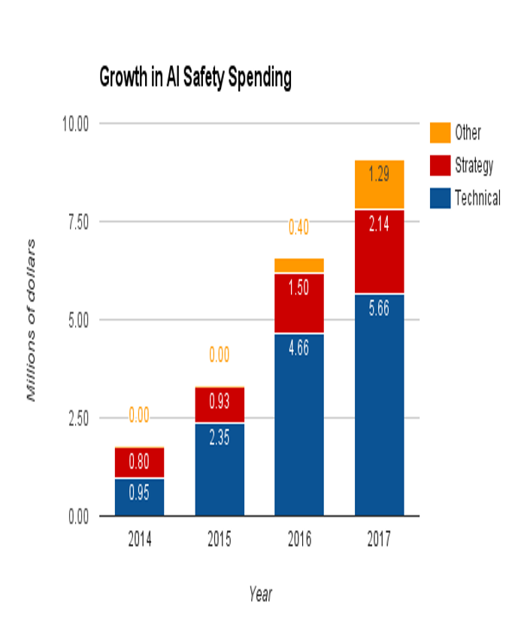

A more recent estimate suggests that in 2019, [roughly $40 million USD](https://80000hours.org/2021/08/effective-altruism-allocation-resources-cause-areas/) was provided by donors and Grantmakers to reduce potential risks from AI. This trend suggests that there is an increasing interest in funding work that promotes beneficial AI.9 This means that compared to our other high-priority causes, there is a smaller gap between the amount of funding organizations can effectively spend and the total amount of funding available.10

But we think that there is still room for additional funding to make a difference. Even with the recent increase in funding, AI receives far less than other causes with comparable scale.11 More importantly, as the field grows, we expect the amount AI safety organizations can effectively spend will increase. Therefore, promoting beneficial AI is neglected.

Source: https://www.givingwhatwecan.org/en-US/cause-areas/long-term-future/artificial-intelligence?gclid=Cj0KCQiAsvWrBhC0ARIsAO4E6f-UDFN8zrfHt4MMx8spy4tAddi4OarwMxVJHpCjsqRwQ0r_m9kuIBEaAvkqEALw_wcB&gad_source=1.