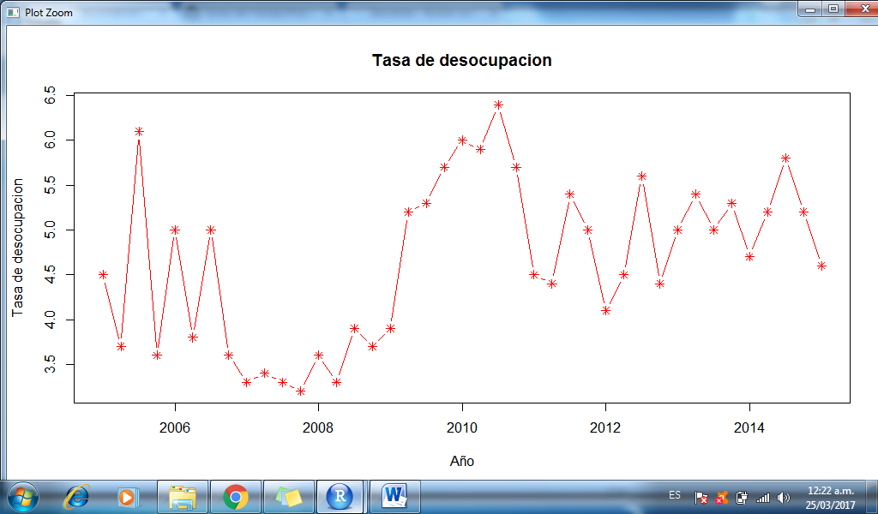

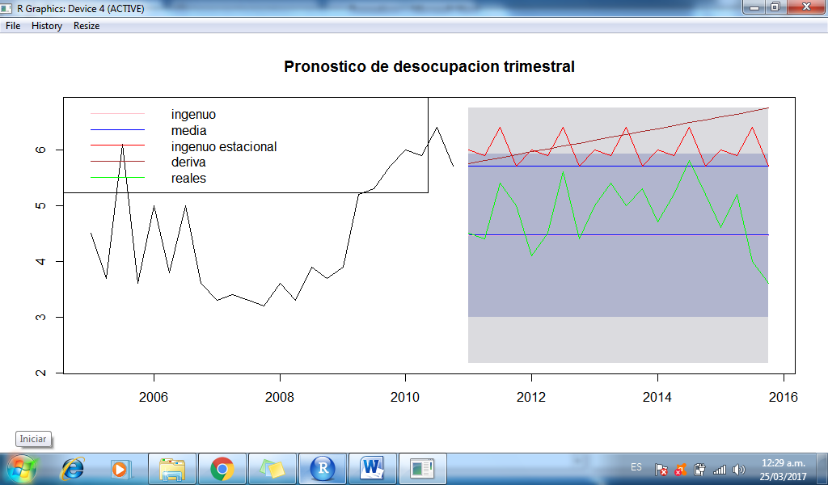

> dmi

Qtr1 Qtr2 Qtr3 Qtr4

2011 -1.2 -1.3 -0.3 -0.7

2012 -1.6 -1.2 -0.1 -1.3

2013 -0.7 -0.3 -0.7 -0.4

2014 -1.0 -0.5 0.1 -0.5

2015 -1.1 -0.5 -1.7 -2.1

> dmp

Qtr1 Qtr2 Qtr3 Qtr4

2011 0.0375 -0.0625 0.9375 0.5375

2012 -0.3625 0.0375 1.1375 -0.0625

2013 0.5375 0.9375 0.5375 0.8375

2014 0.2375 0.7375 1.3375 0.7375

2015 0.1375 0.7375 -0.4625 -0.8625

> dmie

Qtr1 Qtr2 Qtr3 Qtr4

2011 -1.5 -1.5 -1.0 -0.7

2012 -1.9 -1.4 -0.8 -1.3

2013 -1.0 -0.5 -1.4 -0.4

2014 -1.3 -0.7 -0.6 -0.5

2015 -1.4 -0.7 -2.4 -2.1

> dmd

Qtr1 Qtr2 Qtr3 Qtr4

2011 -1.2521739 -1.4043478 -0.4565217 -0.9086957

2012 -1.8608696 -1.5130435 -0.4652174 -1.7173913

2013 -1.1695652 -0.8217391 -1.2739130 -1.0260870

2014 -1.6782609 -1.2304348 -0.6826087 -1.3347826

2015 -1.9869565 -1.4391304 -2.6913043 -3.1434783