KRISHIBAZAR
Testing Report
AI-Powered Smart Agriculture Platform
Course: Software Development and Project Management
Team: Faujul Kabir, Rakib Hasan, Mahmud Hossain, Jubair Abdullah(Rohan)
Instractor: Ms. Namirah Rasul

Testing scope: Farmer-side frontend and API-integrated prototype

1. Testing Overview
Testing was performed to verify that the implemented KrishiBazar farmer-side features work correctly, remain usable across the main application routes, handle API failures safely, and preserve the Bangla/English interface. The current submission focuses on the implemented frontend and API integrations. A full production backend, persistent database, and physical IoT hardware were outside the completed scope.
Testing Area | Purpose | Result
Functional testing | Verify major farmer workflows and page actions | Passed
API integration testing | Verify Open-Meteo and Gemini integration behavior | Passed
Error/fallback testing | Prevent blank pages and broken UI during API failures | Passed
UI/navigation testing | Verify routes, responsive layout and navigation | Passed
Build/type checking | Detect TypeScript and build-time errors | Passed
IoT prototype testing | Verify simulated telemetry presentation | Passed

2. Functional Testing
The following test cases cover the main farmer-facing workflows implemented in the project.
ID | Feature | Expected Result | Outcome
FT-01 | Register / Login | User can register/login and reach the Farmer Dashboard. | Passed
FT-02 | Dashboard | Dashboard displays farm information, weather, alerts and quick actions. | Passed
FT-03 | Add Farm | Five-step farm registration accepts farm, soil, map, market and recommendation inputs. | Passed
FT-04 | AI Crop Recommendation | System generates crop recommendations using farm conditions and weather context. | Passed
FT-05 | AI Intelligence Center | Farm-specific intelligence page loads the AI modules and daily summary. | Passed
FT-06 | Crop Lifecycle | Lifecycle stages and stage-specific tasks can be viewed and interacted with. | Passed
FT-07 | Seasonal Planner | Season timeline and farming task cards are displayed. | Passed
FT-08 | Disease Detection | Leaf upload/camera workflow and disease-result interface are available. | Passed
FT-09 | Farm Monitoring | IoT monitoring dashboard displays simulated sensor telemetry. | Passed / Simulated
FT-10 | Marketplace | Farmer can create/view produce listings and review order status. | Passed
FT-11 | Notifications | Weather, irrigation, crop, disease and marketplace notifications are displayed. | Passed
FT-12 | Language Toggle | Bangla/English switching works across supported farmer views. | Passed

3. API & Integration Testing

3.1 Open-Meteo Weather API
Open-Meteo was integrated for live weather information. The service retrieves current and daily forecast variables including temperature, humidity, precipitation, wind speed and weather code. The application also uses caching and coordinate resolution to reduce unnecessary requests.
Test | Expected Result | Observed Result | Status
Valid weather request | API returns weather data | Successful 200 responses were received during development. | Passed
Weather display | Dashboard displays current weather | Live weather appears in the dashboard and farm intelligence page. | Passed
Invalid coordinates | API rejects invalid location | Latitude 999 returned HTTP 400 with a validation error. | Passed
Network/API delay | UI should not crash | Fallback weather values and defensive checks prevent blank-page crashes. | Passed
Repeated requests | Avoid unnecessary requests | 10-minute in-memory cache implemented. | Passed

3.2 Gemini AI Integration
Gemini is used through the project's server-side API layer for AI-generated farm recommendations, assistant responses and disease-analysis workflows. A deterministic fallback engine is also available when the AI service is unavailable.
Test | Expected Result | Outcome
AI recommendation request | Structured farm recommendation is returned | Passed
AI daily advisory | Advice uses farm/crop/weather context | Passed
Disease analysis workflow | Disease result and treatment guidance are displayed | Passed
AI service unavailable | Application remains usable using fallback logic | Passed

4. UI, Navigation & Responsiveness Testing
Test | Purpose | Outcome
Route navigation | Verify major farmer routes open without runtime errors | Passed
Mobile layout | Verify primary UI remains usable in mobile presentation mode | Passed
Bottom navigation | Verify navigation remains accessible on farmer pages | Passed
Top app bar | Verify language, assistant, call and notification controls remain visible | Passed
Bangla text rendering | Verify Bengali content is readable and not broken | Passed
Loading/error states | Prevent a failed API request from blanking the page | Passed

Evidence to attach: dashboard screenshot, AI Intelligence Center screenshot, Add Farm screenshot, Marketplace screenshot, and Farm Monitoring screenshot.

5. Build & Technical Verification
Check | Purpose | Result
TypeScript type check | Detect compile-time/type errors | Passed — 0 errors
Production build | Confirm the application can be built successfully | Passed
Dashboard HTTP check | Verify dashboard route responds | Passed — HTTP 200
AI Intelligence route HTTP check | Verify AI Intelligence route responds | Passed — HTTP 200

6. Error Handling & Regression Testing
During Open-Meteo integration, the AI Intelligence Center temporarily produced a blank page when weather data was unavailable during rendering. The problem was traced to unsafe access to weather properties before the asynchronous request completed.
The issue was fixed by:
- Adding fallback farm and crop objects.
- Guarding weather values before formatting or rendering them.
- Providing a fallback NormalizedWeatherData object in the weather hook.
- Validating weather coordinates before making requests.
- Making numeric/Bangla-number formatting null-safe.
- Adding defensive weather handling to the Dashboard.
After the fix, the project passed the TypeScript check and production build, and both the Dashboard and AI Intelligence routes returned HTTP 200 during verification.

7. Testing Limitations & Unimplemented Scope
Area | Current State
Production backend/database | Not completed; current application is primarily frontend with API integrations.
Persistent multi-user data | Not fully implemented; some prototype state uses local/browser storage or mock data.
Physical IoT hardware | Not implemented; monitoring telemetry is simulated for demonstration.
Marketplace real transactions | Prototype interface only; no real payment/fulfillment backend.
Production agricultural ML models | AI advisory is API/rule based; model accuracy claims are not treated as independently validated test results.
Large-scale performance testing | Not performed for production-level concurrent users.
Security penetration testing | Not performed as a production security audit.

8. Test Evidence / Screenshots
Insert screenshots below as evidence of the corresponding tests. Recommended screenshots:

Figure 1 — Farmer Dashboard with live Open-Meteo weather
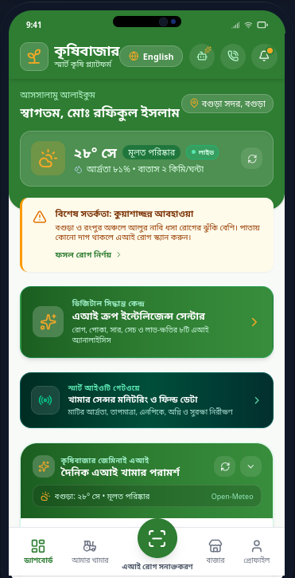
Figure 2 — Add Farm / AI Crop Recommendation
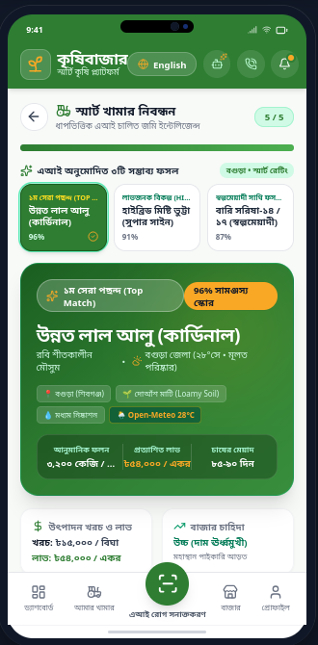
Figure 3 — AI Farm Intelligence Center
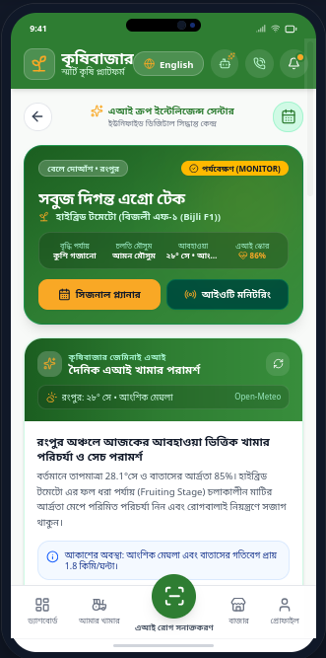
Figure 4 — Seasonal Farming Planner
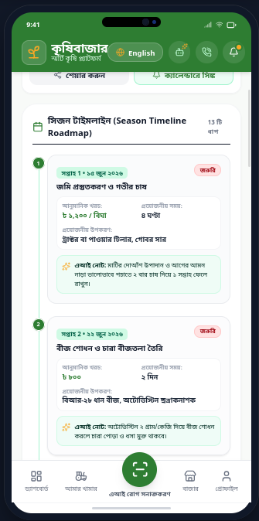
Figure 5 — Disease Detection / Result
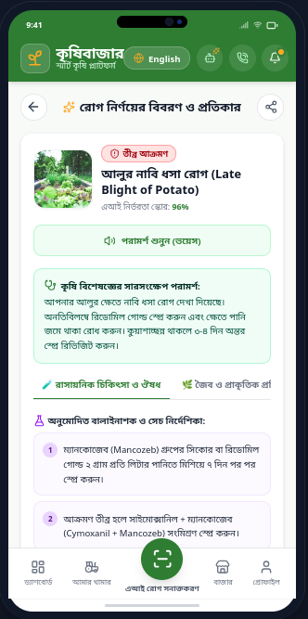
Figure 6 — Farm Monitoring / simulated IoT telemetry
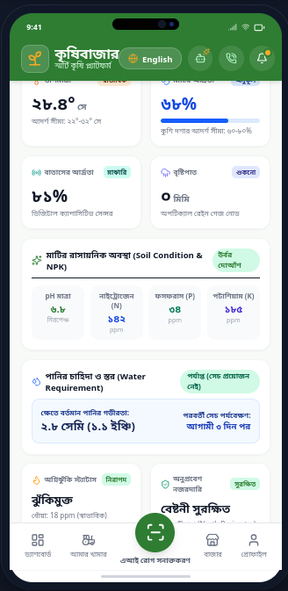
Figure 7 — Marketplace / Farmer Listings
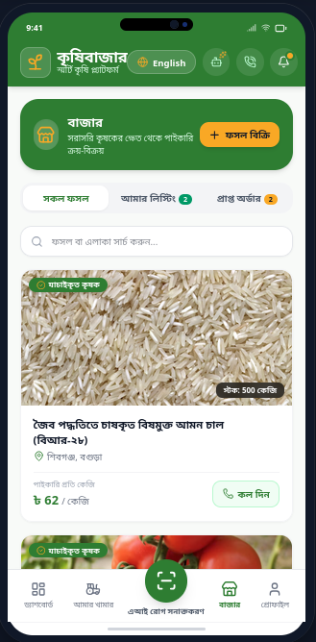
Figure 8 — Notifications or Bangla/English interface
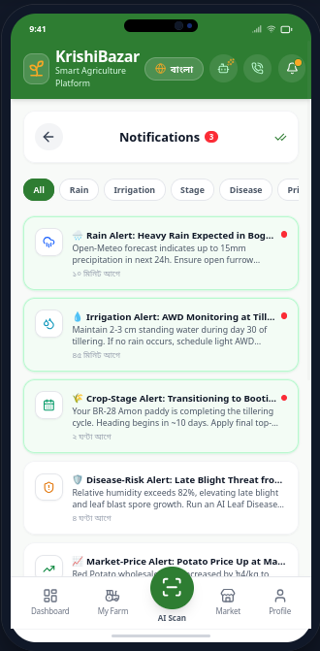

9. Conclusion
Testing confirms that the implemented KrishiBazar farmer-side prototype operates across its main workflows and API-integrated features. The project successfully integrates live weather data through Open-Meteo and AI functionality through Gemini while maintaining bilingual UI support and defensive fallback behavior. The remaining limitations mainly concern the originally planned full ecosystem: production backend/database, the other stakeholder dashboards, real marketplace transactions, and physical IoT deployment. These limitations are recorded rather than presented as completed features.

