Beyond The Danube - Scientific Paper
Design Paper for Oral Exam / Design Brief Summary

Beyond The Danube — An Interactive Hybrid Experience

Authors
Samuele Bertelli · Alpamys Ualbekov · Gaurav Gautam · Mayank Nautiyal

Affiliations / Course / Institution
Master's in Digital Humanities and Digital Knowledge (DHDK), University of Bologna, Interaction Media Design Course, 2025–2026

Author emails
samuele.bertelli@studio.unibo.it
mayank.nautiyal@studio.unibo.it
gaurav.gautam@studio.unibo.it
alpamys.ualbekov@studio.unibo.it

Abstract

«Beyond The Danube» is an interactive hybrid experience conceived for the Marsili Collection of the Palazzo Poggi Museum in Bologna, reimagining the conventional museum visit as a guided, first-person story with Luigi Ferdinando Marsili (1658–1730) soldier, naturalist, cartographer, and founder of Bologna's Institute of Sciences, who recounts his own life to the visitor.
The Marsili Collection relies on static text panels that fail to engage younger visitors or those with no prior knowledge of Marsili, resulting in a passive, inaccessible experience. This project transforms it into an interactive, digital-physical narrative authored in Twine, delivered directly on the visitor's own device and unlocking chapter by chapter during the visit. Our goal is to drive visitor growth and enhance immersion with educational activities, thereby elevating overall satisfaction and fostering active visitor participation.
It is the documented conclusion of a structured co-design exercise carried out using the Perceive CoDesignTool — every requirement, goal, and feature can be traced back to a specific card for the team consciously selected, debated, and retained. Two personas drawn from our audience keep the design human-centered, and the brief closes with theoretical grounding, an evaluation framework, and a concluding synthesis.
Keywords (5–7)
Hybrid Museum Experience, object-anchored narrative, CoDesign Tool, Twine, cultural heritage, Palazzo Poggi Museum.

1. Introduction and Design Problem
1.1 Context of the project
Marsili's Collection, located in the Museum of Palazzo Poggi in Bologna, is a university museum whose holdings of maps, manuscripts, scientific instruments, and natural-history specimens were assembled by Luigi Ferdinando Marsili himself. Currently presented through static, single-language text panels, the collection fails to actively engage visitors; a newcomer can walk through the room without ever understanding why these objects matter or what connects them. This is the design problem the project addresses.

1.2 Main pain points / problems the project aims to solve
Visitors with no prior familiarity with Marsili’s life currently arrive in a dense, single-language labelled room which leads to have a poor signage and leave without a personal connection. The collection relies largely on static text panels, and the experience offers little to visitors who expect agency, responsiveness, and immersion.

Pain point / problem | Who is affected? | Why does it matter for the design?
Visitors leave without a personal connection to Marsili | Primary audience (newcomers) / Secondary audience | The experience must convert objects into a first-person story, not parallel text
Collection is too dense, with single-language academic labelling that leads to poor signage and excludes international visitors. | All audiences, especially non-Italian speakers and newcomers | The design must offer clear, large-print, plain-language, multilingual, audio-led guidance
Visitors with certain disabilities could be left behind | People with disabilities | A museum experience should try to help as many visitors with disabilities as possible

2. Related Work, Benchmarks and Existing Solutions

2.1 Existing references, comparable projects and technologies
Reference / Project / Technology | What it does well | Gap for your project
Museum audio guides | Adds an audio narrative to the physical visit | Visitor remains a passive observer
QR-code museum apps | Allows digital content to be linked to physical objects via the visitor's own device | Typically deliver isolated facts per object with no overarching narrative
Twine | Enables branching, choice-driven narrative delivered directly in a browser with no installation required | Not inherently designed for hybrid physical-digital museum use
ElevenLabs AI voice narration | Produces high-quality, natural-sounding synthetic voice | It must be embedded within a structured narrative to be meaningful
DIVE: Digital Interactive Voyage into Egypt – Museo Civico Archeologico di Bologna (Bertelli et al., 2024) — 4-seasons.github.io | Demonstrates a working Twine-based gamified narrative for a Bologna museum | Designed for a fixed-device, guided group context and does not address the solo adult visitor on their own device

2.2 Gap statement: what existing solutions do not solve
Existing solutions address either the physical or the digital dimension of the museum visit but rarely integrate the two into a coherent experience. Static text panels and audio guides are linear and passive, offering no narrative connection between objects and no reason for a newcomer to understand why the collection exists. Generic QR-code applications deliver isolated facts per object but create no emotional or narrative arc that transforms a room into a meaningful encounter with a person. Twine as a standalone tool provides branching narrative capability but has no built-in mechanism for linking story progression to the visitor's physical movement through a museum space. Finally, the closest comparable project, DIVE (Bertelli et al., 2024), demonstrates that artefact-anchored Twine storytelling works in a Bologna museum context but is designed for guided school groups on fixed institutional displays, leaving the independent adult newcomer on their own device entirely unaddressed.

3. Method and Design Process

3.1 Design method used
The design follows the Perceive CoDesignTool, a tabletop card-based co-design method in which a team goes through seven stages of designing a project. At each stage the team deals, proposes, debates, and ranks decision cards. Surviving "top cards" advance to the next stage and rejected cards are moved to a "drawer of alternatives". Every requirement, goal and feature is documented, producing an auditable chain of reasoning from the audience to the final feature.

Design activity | Output produced | Where it appears in this paper
Concept design | A narrative experience in which Luigi Ferdinando Marsili guides a visitor through his life and subsequently through collection at Palazzo Poggi | Section 4
Game mechanics | Basic game mechanics include fourteen chapters each tied to a specific physical artefact; AI-generated voice narration with ambient sound carries each chapter; end-of-chapter interactive test must be completed to unlock the next chapter | Section 5
User flowchart | A user flowchart was made describing the following steps: Discovery (online, pre-visit), Arrival (QR scan at entrance hall), Exploration (chapters unlock room by room), Connection (emotional bond with Marsili), Conclusion (exit hall, reflection) | Section 6
Swimlane flowchart | A complete swimline flowchart was produced including all the steps and states that visitors can face during the interaction with the narrative game. | Section 6
User journey map | UX journey from pre-visit online discovery, artefact-by-artefact exploration, emotional peak moments (Bosphorus, coffee set, coral), and a reflective conclusion | Section 7

3.2 Data/materials used: cards, museum sources, student observations, references
The design was produced through a single extended PERCEIVE CoDesignTool session in which the team played thirty-two cards across seven sequential stages. Primary-source documentation on Marsili's life was drawn from Wikipedia, the Encyclopædia, and the University of Bologna's historical archives, with visual assets sourced from team photographs and Wikimedia Commons. The production toolchain consists of Twine for the branching narrative, Figma and Canva for interface and visual design, HTML and CSS for the web layer, ElevenLabs for AI-generated voice narration and ambient audio, and Git and GitHub for version control.

4. Design Brief

Design brief element |  |  |  | Student answer
Title |  |  |  | Beyond The Danube
Type of application / game |  |  |  | Hybrid interactive narrative museum experience / Browser-based Twine story triggered by QR code.
Primary audience |  |  |  | Young visitors aged 14–27, students with interest in Marsili collection and digitally fluent visitors who prefer participation over passive reading.
Secondary audience |  |  |  | International visitors who are not familiar with Marsili’s collection might face the language barrier.
Primary persona, short description |  |  |  | Leonardo, 17, a classical high-school student from Bologna. Curious about history but impatient with text panels; wants to explore and discover the story himself
Secondary persona, short description |  |  |  | Thomas, 52, an architect from Munich on a short holiday. Intellectually curious, prefers spatial and material storytelling; limited Italian, no prior knowledge of Marsili
Project focus / context |  |  |  | Transform the static Marsili Collection at Palazzo Poggi into an active interaction, interactive story-driven where user interact with different artefact of Marsili collection.
Star asset |  | Short description |  |  |  | Media / image placeholder
Maps |  | Marsili’s cartographic work, above all his surveys of the Danube and his observations of the Bosphorus, anchors the chapters concerned with geography, exploration, and discovery. |  |  |  | 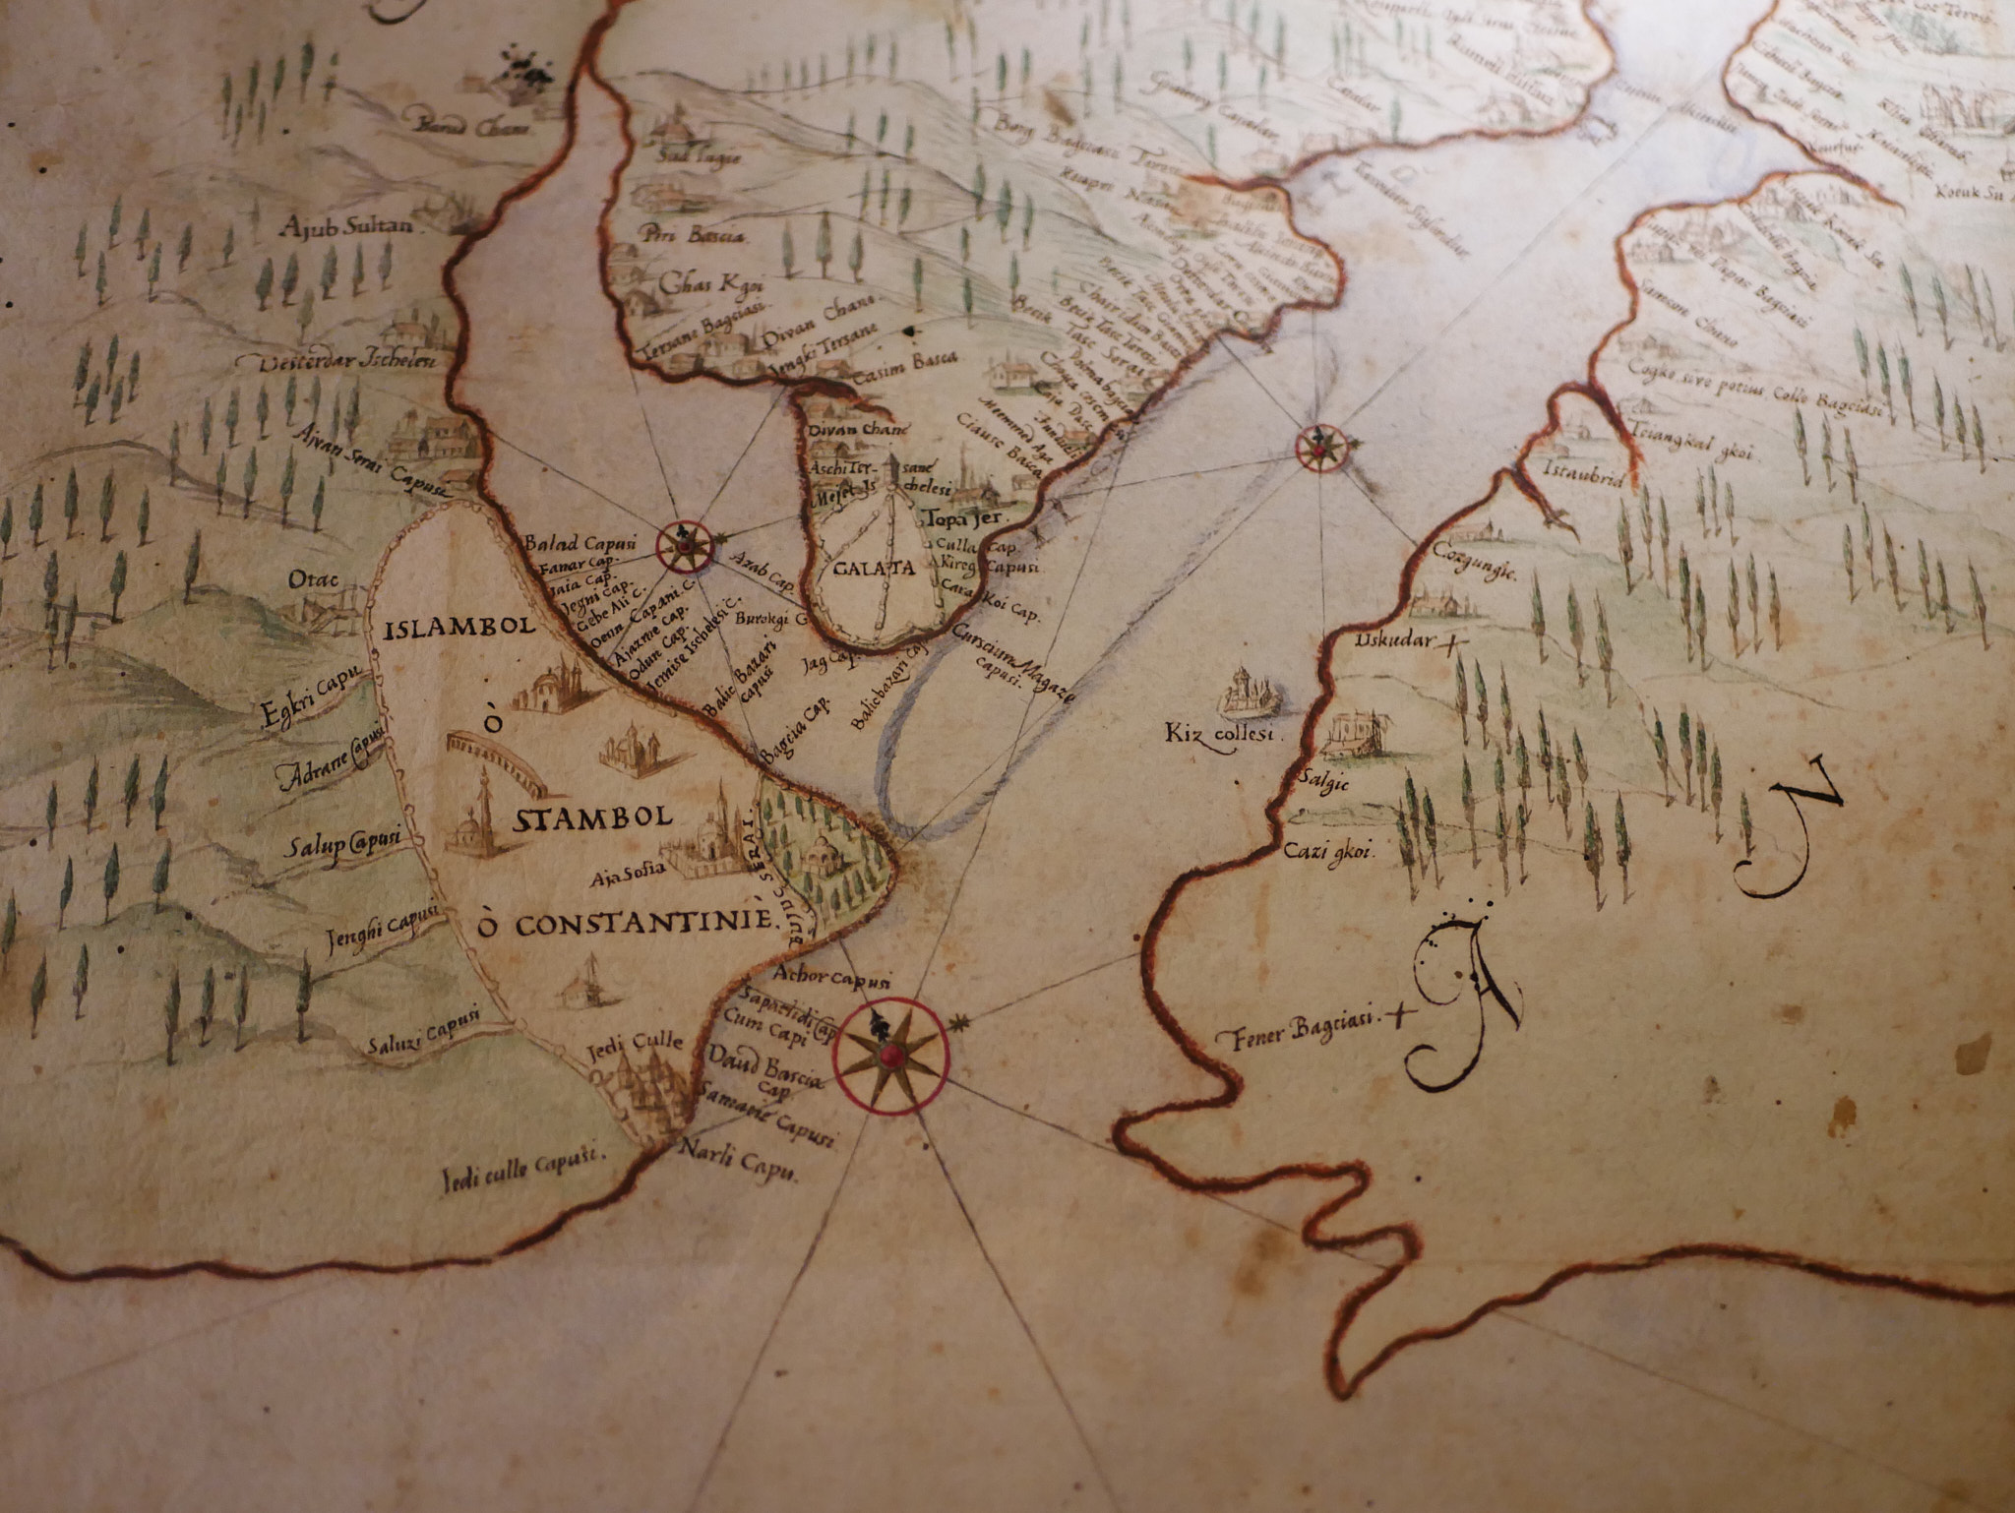  Bosphorus Map
Cannons |  | Marsili's study of Ottoman artillery, conducted during his years of captivity along the Danube frontier; cannons and more importantly his observations anchored the chapters concerned with warfare, observation, and the price of knowledge gained in the field. |  |  |  | 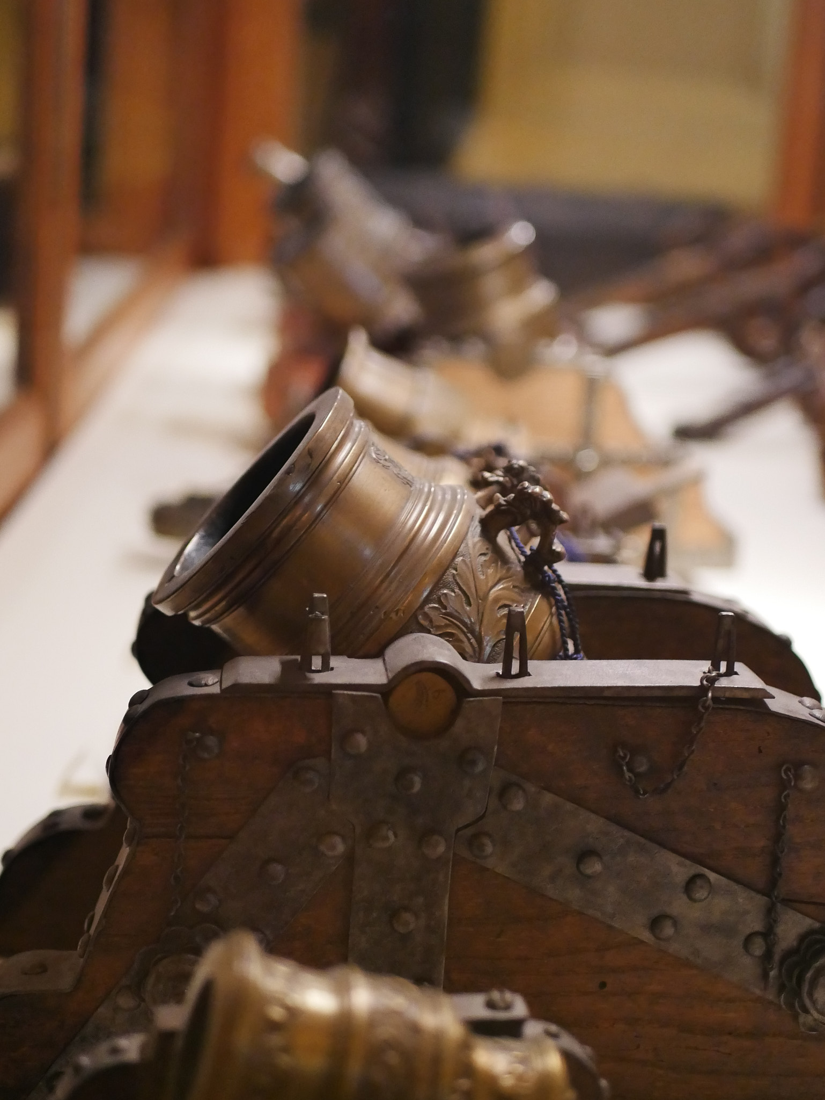  Cannons
Corals |  | Marsili's underwater observations of coral in the Mediterranean, among the first to treat it as an animal rather than a plant; Corals anchors the passages concerned with curiosity, method, and the limits of what books alone can teach. |  |  |  | 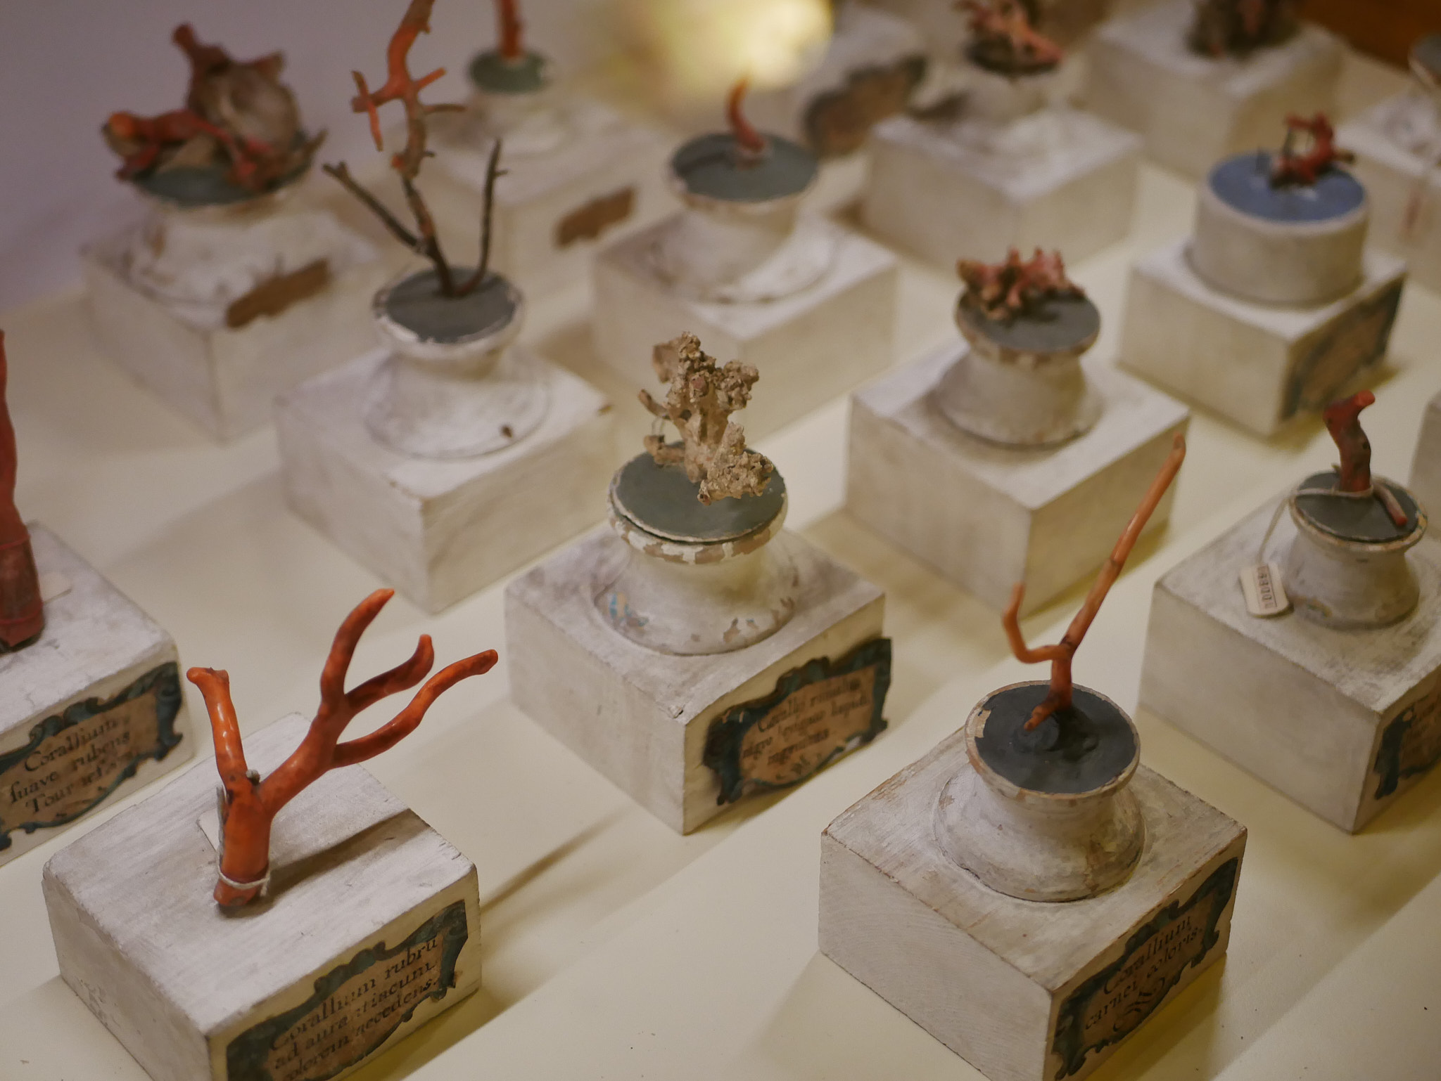  Corals collected by Marsili
Institution |  | Institutional goals |  |  |  | Audience goals
Sistema Museale D’Ateneo |  | Increase educational activities |  |  |  | Authenticity - World: Create the appropriate mood, make visitors feel familiar with the environment.  Authenticity - Others: Design for visitors who should feel closer to the people they came with; the experience becomes a shared memory that strengthens their bond.  Authenticity – Self: Strengthen personal Disposition Design for visitors who should leave with a renewed sense of curiosity and opennessa and more willing to question what they thought they knew.
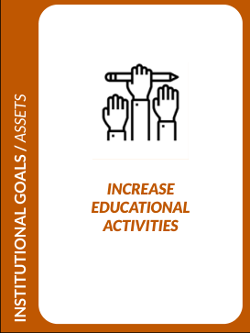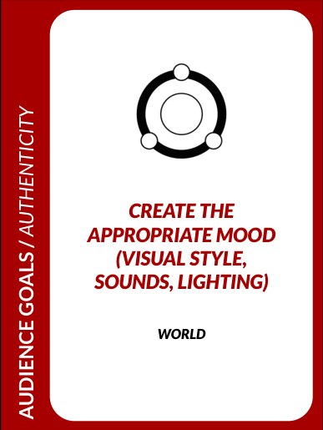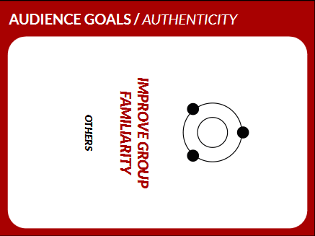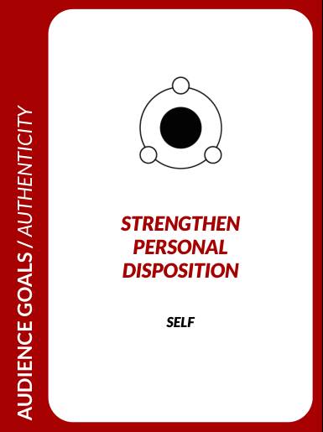
Audience | Motivations |  | Barriers |  | Capabilities |  | Devices
Student, with no prior knowledge (14-27) | Curiosity in Marsili life and his collection, searching for actively participation and with immersivity |  | Technology could be a barrier (need smartphones to scan the code at the gate of the museum) |  | Confident with smartphones and QR scanning, familiar with making choices and exploring digital content without instructions. |  | Smartphone  Tablet  Computer
International Tourist | Visiting the historical and scientific collection of Bologna, Marsili as international figure is well known worldwide for his collection and invention |  | Language barrier: International visitors with no knowledge of Italian can face language barrier |  | Comfortable using a smartphone and basic apps; can follow visual icons and simple navigation; may have limited Italian, so relies on the English option and clear, language-light design.  Uses everyday consumer tech rather than specialist tools |  | Smartphone  Tablets  Computer

5. Design: Concept and Mechanics

5.1 Main idea of the project / user experience description
"Beyond The Danube" is a hybrid first-person narrative experience. The visitor follows Marsili's own story, told in first person by Marsili himself, brought to life through AI-generated voice and ambient sound. The story is split into fourteen short chapters, each tied to a different artifact (maps, the Armenian dome, the coffee set, the coral specimen, etc.). The story is unlocked by the QR code located at the museum entrance and then played out chapter by chapter at the visitor's own pace. The defining principle is that visitors learn about the objects in the museum through a story, creating long-lasting knowledge about the life of Luigi Ferdinando Marsili.
5.2 Winning/completion condition and scoring system
Completion condition: the experience completes when the visitor has go through the all storyboard chapters and moments (Discovery, Arrival, Exploration, Connection, Conclusion) and reached the final scene in the Exit Hall, in which Marsili reveals that he donated his collection to found the Institute of Sciences and invites the visitor to continue his mission of curiosity.

6. User Flow, Interaction and Hybrid System

6.1 General user flow description
The experience unfolds across five connected moments.

- Discovery happens online before the visit: the game is advertised through schools and museum channels, allowing visitors to meet Marsili and begin the story before ever arriving at the museum.

- At Arrival, in the Entrance Hall, the visitor scans up a QR code at the entry gate to start the on-site experience, receiving a real-time guide to navigate the collection.

- During Exploration, the visitor moves through the rooms of the Marsili Collection where lighting and audio establish the mood, Marsili welcomes them, and chapters begin to unlock the story behind each artefact.

- Through Connection, historical-character and theory-of-mind moments allow the visitor to form a genuine emotional bond with Marsili and the people of his world.

- Finally, at the Conclusion in the Exit Hall, Marsili reveals that he donated his entire collection to found the Institute of Sciences and invites the visitor to keep exploring; the visit closes with reflection and a sense of completion.

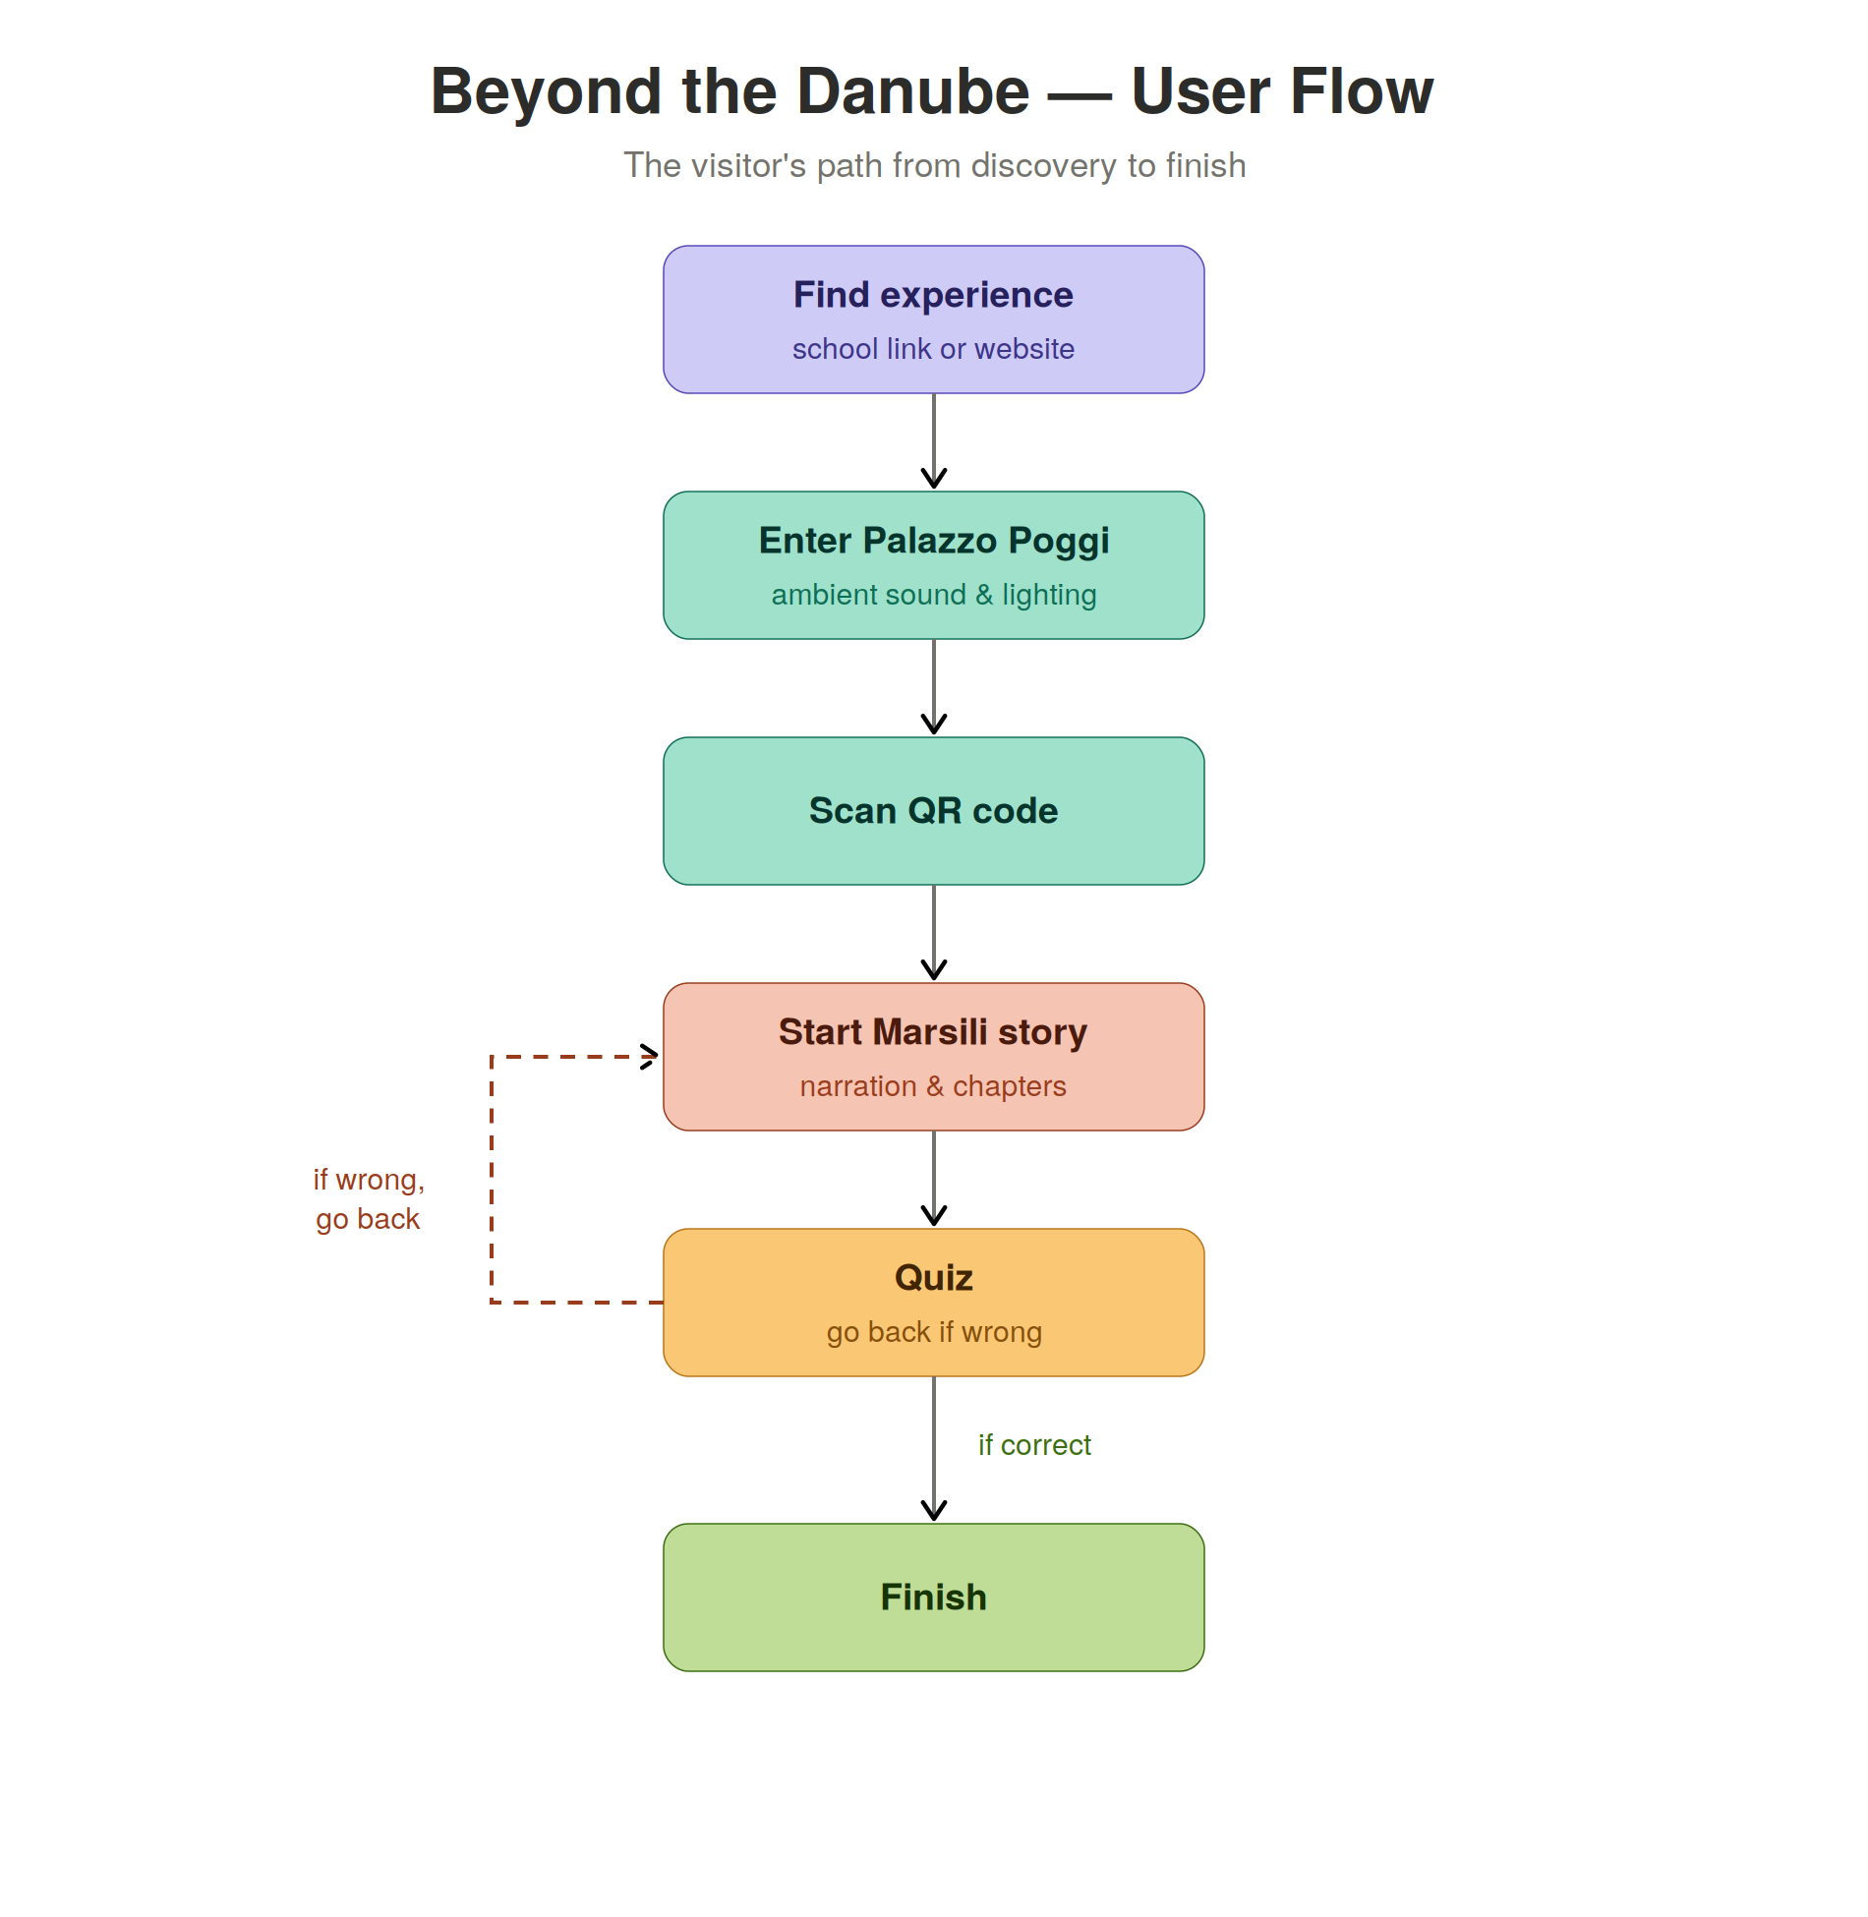
Figure 1. General user flow diagram / flowchart

The flow has been designed to satisfy each ranked goal in turn: the Discovery moment serves the institutional priority of attracting new young visitors, Arrival and Exploration build the Authenticity-of-World mood targeted in Stage Three, Connection delivers the Sense-of-Care emotional bond, and Conclusion closes the loop between the person of Marsili and the institution the visitor is standing inside.

6.2 Interaction description and interaction categories
Interactions fall into two categories drawn from the Ideation stage. Persona interactions: the visitor adopts a character framed through Catherina, whose curiosity awakens Marsili's memory, so events are seen through a personal lens. Game interactions: a small interactive test at the end of each chapter (a short quiz, a light puzzle, or an observational task). Sensory interactions are layered throughout: AI-generated voice (ElevenLabs) carries the narrative; ambient sound establishes mood for each scene.
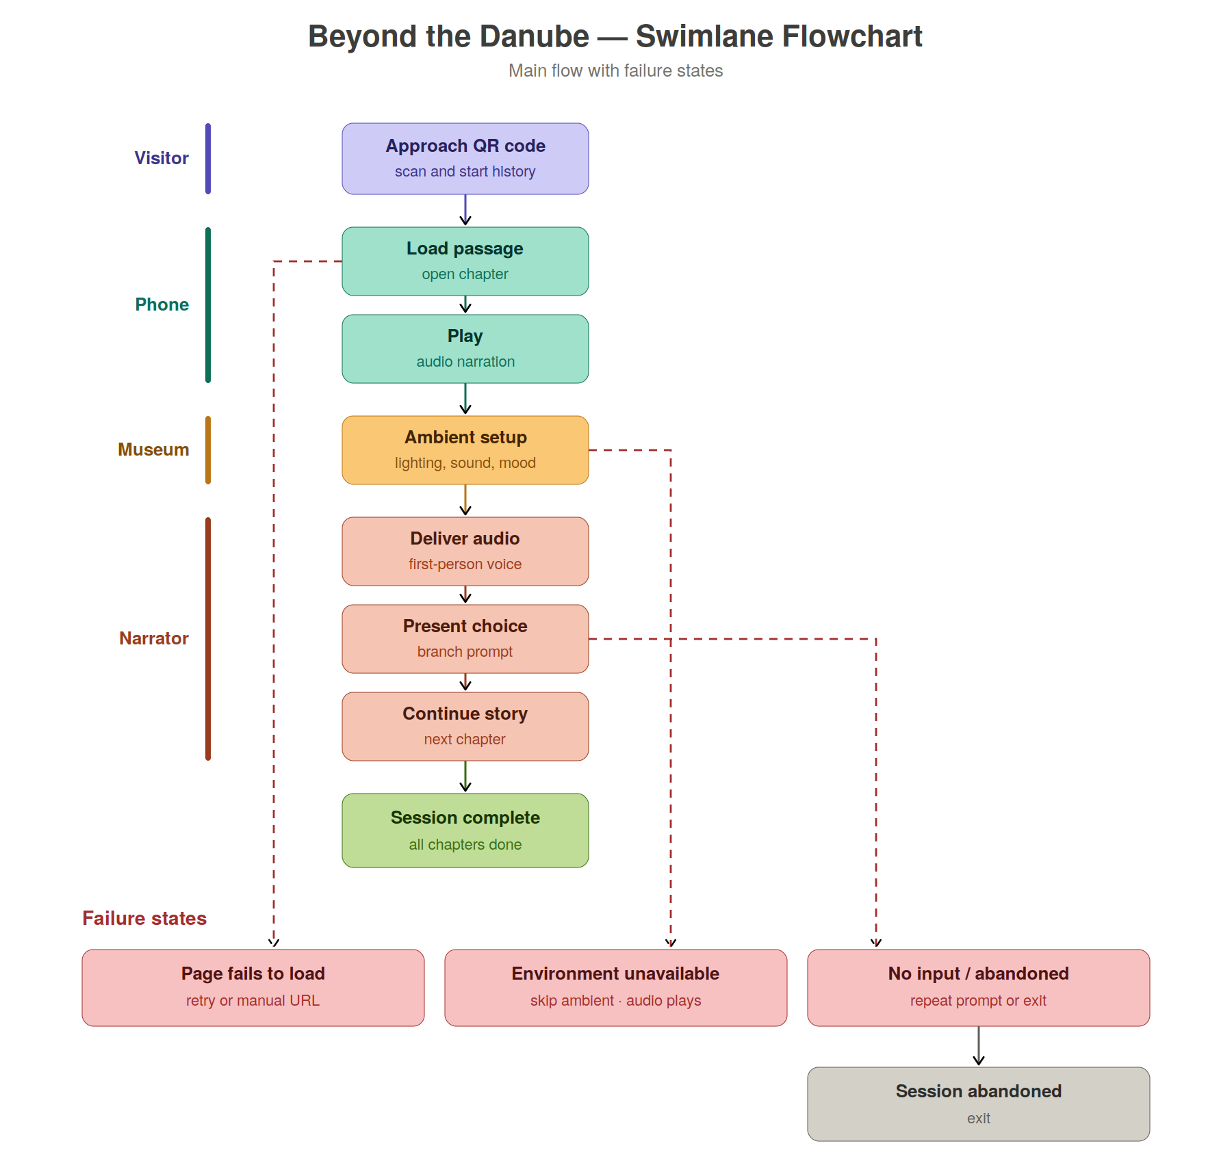
Figure 2. Swimlane flowchart

6.3 Hybrid and technological layers
The experience is built across several layers.

Layer | Software / hardware / material | Function
Physical layer | Marsili Collection artefacts (maps, coffee set, coral specimen, measuring ampoule, manuscripts) and ambient lighting | Provide the physical anchors for each narrative chapter and establish the eighteenth-century mood
Digital layer | Twine branching narrative, HTML / CSS, ElevenLabs AI voice, Figma. | Deliver the first-person story, decisions, and interactive tests on the visitor's smartphone
Museum layer | Palazzo Poggi curatorial framing; museum-provided backup tablets at entry; pre-visit web presence | Provide institutional grounding, accessibility fallback, and the pre-visit Discovery moment
Social layer | Leonardo and Thomas, persona structure; optional participatory share features for web-literate visitors | Frame events through a personal lens; enable optional content creation without making it mandatory
Other | Git / GitHub | Version-control the Twine + web layer across the four-person team

7. User Experience as User Journey
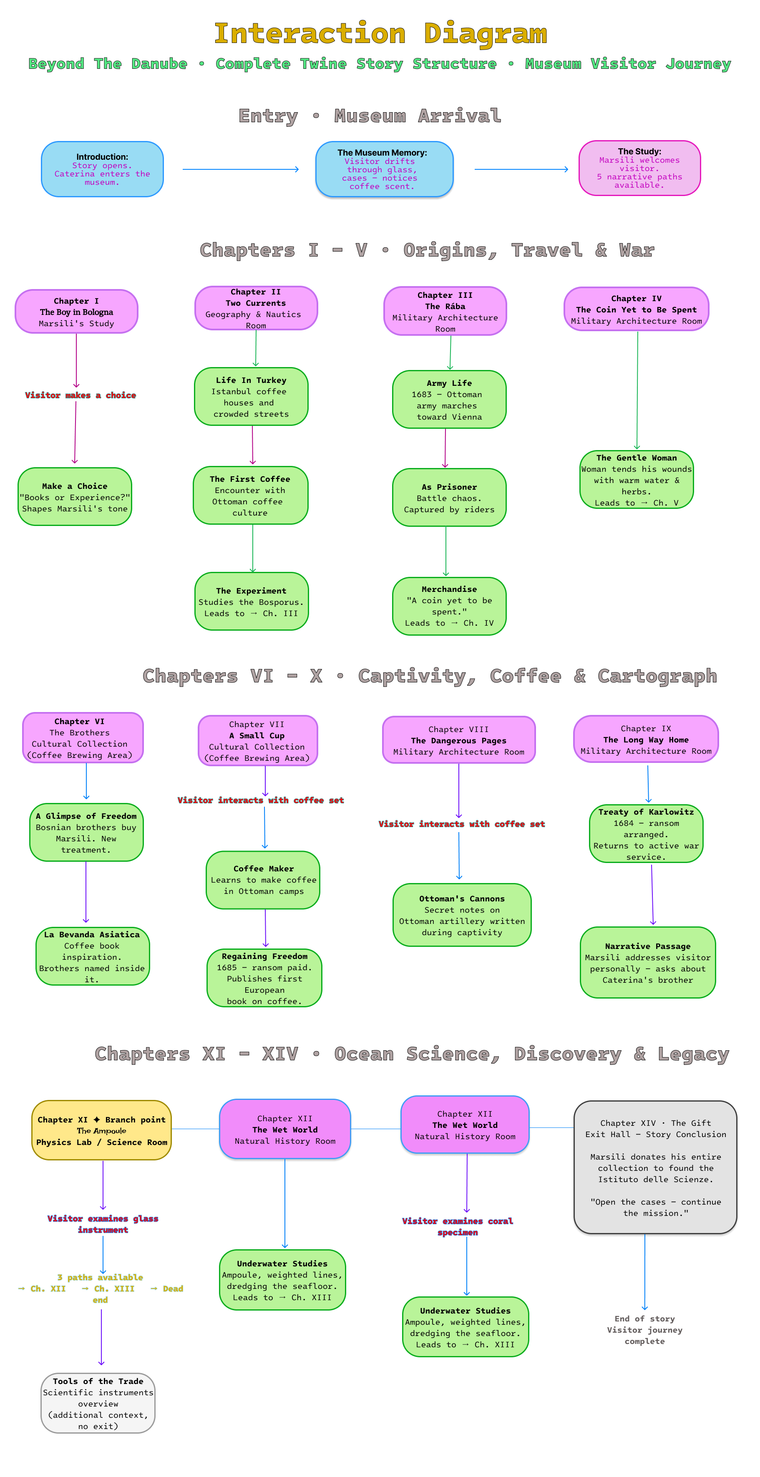
Figure 3. User Journey

7.1 User journey narrative
The journey starts before the museum visits. Leonardo, who studies at a liceo classico, stumbles upon an advertisement about a new game on the school noticeboard. Thomas, who enjoys narrative experiences, discovers it online on Reddit. Both begin playing before even arriving — entering the museum with Catherina, whose curiosity sparks their own interest in Marsili's story without it ever feeling like homework.

Both of them decide to visit the museum itself. On arrival, the visitors drift through the glass cases (The Museum Memory). From there the chapters follow Marsili's life across the museum artifacts. Chapters I–V cover his origins, his travels through Ottoman coffee culture, the Bosphorus experiment, and the war that ends in his capture. Chapters VI–X carry the emotional and human core sold to the Bosnian brothers, learning to make coffee in captivity, secretly sketching Ottoman cannons, his ransom and return to the army. The final chapters follow Marsili into the world of science. The sealed ampoule, his underwater studies, and the delicate coral specimen each mark a step deeper into a life spent observing, collecting, and making sense of the natural world.
Three moments carry the weight: The Experiment (observation beating received wisdom), the coffee set chapters (the vulnerable, cross-cultural turn), and the coral specimen (a quiet myth overturned). The story's one true fork is Chapter XI — The Ampoule, where three paths branch out, including an optional "Tools of the Trade" dead end and a route forward.
It ends in the Exit Hall with Chapter XIV, The Gift: Marsili reveals he donated his entire collection to found the Istituto delle Scienze and asks them to "open the cases and continue the mission." The loop closes, and they leave feeling they took part rather than just looked.

Phase | User action | Touchpoint | Emotion / expectation | Pain point | Design response
Before visit / discovery | Encounters advert via school / museum / online; plays opening segment | Project website + Twine pre-visit chapter | Curious, low commitment | No prior knowledge of Marsili | Free online entry point, meet Marsili and Catherina before arriving
Onboarding | Arrives at Palazzo Poggi entrance; scans QR at entry gate | QR marker, smartphone, museum backup tablet | Anticipation: some uncertainty about "how this works" | No smartphone / no battery, unclear instructions | Large-print plain-language onboarding card; real-time guide
Mission / Goals | Enters Marsili room, receives Marsili's welcome and first chapter goal | Marsili audio voice, room signage | Immersed, curious about Marsili | Mood fails to land, too many parallel cues | Single consistent narrator, controlled ambient audio
Capture / interaction | Approaches all important artefact; makes story-shaping according to that artefact and story behind it | Artefact, Twine chapter | Engaged, authoring the story, surprised at star moments (Bosphorus, coffee, coral) | Connectivity drops; cognitive overload, accessibility barrier. | Offline-capable Twine, skippable challenges
After experience | Reaches Exit Hall, Marsili reveals he founded the Institute of Sciences; invitation to continue exploring | Exit Hall scene, final Twine page | Reflective, changed relationship to the collection | Visitor leaves without the closing reveal | Closing scene is structurally part of the visit, anchored to the Exit Hall artefacts

Interactive story / Twine link
https://faultylogic23.github.io/BeyondTheDanube/Links/Story/Marsili_History.html

8. Response to Pain Points and Innovation
Pain point identified in Section 1 | Design solution | Expected effect
Visitors leave without a personal connection to Marsili (object shown but not told) | Each artefact serves as a narrative anchor, a chapter of Marsili's story told in his own voice | Visitor leaves with a rounded understanding of Marsili and a changed relationship to the collection
Dense, single-language, academic labelling and poor signage | Audio-led narrative + clear, large-print, plain-language, multilingual guidance throughout | Newcomers and non-Italian speakers can follow the experience without prior knowledge
Visitors without a capable smartphone or with differing physical abilities risk a second-rate visit | Museum-provided backup tablets; offline-capable Twine; alt-text, ambient sound cues, audio/text/touch parity | The experience is equally navigable across devices and sensory modes

8.1 Innovation beyond the state of the art
The experience is engineered to carry a visitor from zero prior knowledge of Marsili to a rounded understanding within a single visit, by collapsing biography and cross-cultural context into a single first-person voice anchored to documented life events. An accessibility-first hybrid delivery in which audio narration, ambient sound cues, and museum-provided backup tablets make the experience equally navigable by visitors relying on audio alone, on text alone – an accessibility commitment treated as a structural requirement, not an enhancement.

9. Conclusion
"Beyond The Danube" set out to solve a simple problem: the Marsili Collection is full of remarkable objects and a remarkable life story, but most visitors walk past without understanding either. By turning the visit into a first-person narrative game, told by Marsili himself, chapter by chapter, artefact by artefact, the project transforms a passive walk through a room into an active encounter with a person and his world.
The experience was designed entirely through the CoDesignTool, meaning every decision from the choice of audience to the selection of artefacts to the accessibility mitigations, can be traced back to a specific, debated, and consciously retained design choice. The result is a lightweight, device-agnostic hybrid experience that requires no specialist knowledge, no installation, and no guide: just a smartphone and a willingness to follow Marsili wherever he leads.
If a visitor leaves the Marsili Collection a little more curious than they entered, more willing to ask what an object means rather than merely what it is, the project will have done exactly what it set out to do.

Acknowledgments and Team Roles
Team member | Role in project design | Role in writing the paper
Samuele Bertelli | Technical Lead | Prototyping, Testing, Technical feasibility, SW integration Exhibition Design
Alpamys Ualbekov | Visual Designer | Visual Design / Art direction, User Interface layout, Aesthetic cohesiveness Exhibition Design
Gaurav Gautam | Narrative Concept Designer | Story telling & Theme, Script and Dialogues, Metaphors (concepts)
Mayank Nautyal | Research content Lead | Content Strategy, Information Architecture, Multimedia and Data Production

Acknowledgment text
The authors wish to thank Professor Sofia Pescarin and Professor Chiara Tartarini for their guidance, generosity, and for the unique learning experience this course provided — one that taught us to begin with people rather than technology, and to make our reasoning visible at every step.
We are also grateful to the Museum of Palazzo Poggi and the University of Bologna for providing access to the Marsili Collection and its historical archives, which formed the foundation of this project. Special thanks go to our fellow students of the Digital Humanities and Digital Knowledge programme whose feedback during co-design sessions and presentations helped sharpen the work.
Finally, we thank Luigi Ferdinando Marsili himself — soldier, naturalist, cartographer, and founder — whose life turned out to be more than enough to fill fourteen chapters.

References
- Benyon D. “Designing User Experience: A guide to HCI, UX and interaction design” (2019).
- Marschner S., Shirley P. Fundamentals of computer graphics. CRC Press, 2018.

Web Links
Web links used for benchmarks, museum sources, tools, datasets, images
https://zenodo.org/records/10986215 · https://link.springer.com/chapter/10.1007/978-3-032-13164-5_18
https://en.wikipedia.org/wiki/Luigi_Ferdinando_Marsili · https://www.unibo.it/en/university/who-we-are/our-history/famous-people-and-students/luigi-ferdinando-marsili
https://sma.unibo.it/it/il-sistema-museale/museo-di-palazzo-poggi · https://bub.unibo.it/it/visita-il-palazzo/museo-marsili · https://www.encyclopedia.com/science/encyclopedias-almanacs-transcripts-and-maps/luigi-ferdinando-marsili · https://link.springer.com/chapter/10.1007/978-3-032-07792-9_7

Appendix: Design Brief Summary
Our Project, Beyond The Danube is an interactive hybrid experience.
Its primary audience is young visitors aged 14–27, students with interest in Marsili collection and digitally fluent visitors who prefer participation over passive reading, and its secondary audience are international visitors who are not familiar with Marsili’s collection might face the language barrier.
Their characteristics are:
Primary Audience: Thomas, 52, an architect from Munich on a short holiday. Intellectually curious, prefers spatial and material storytelling; limited Italian, no prior knowledge of Marsili
Secondary Audience: Thomas, 52, an architect from Munich on a short holiday. Intellectually curious, prefers spatial and material storytelling; limited Italian, no prior knowledge of Marsili
Context:
The context of the project is Marsili's Collection, located in the Museum of Palazzo Poggi in Bologna, is a university museum whose holdings of maps, manuscripts, scientific instruments, and natural-history specimens were assembled by Luigi Ferdinando Marsili himself. Currently presented through static, single-language text panels, the collection fails to actively engage visitors; a newcomer can walk through the room without ever understanding why these objects matter or what connects them. This is the design problem the project addresses.
The main and general pain points / problems are:
- Visitors leave without a personal connection to Marsili
- Collection is too dense, with single-language academic labelling that leads to poor signage and excludes international visitors.
- Visitors with certain disabilities could be left behind

Analysing what has been already published / produced and considering what is already available as a solution I have found good references in:
Reference project and Technology: Museum audio guides, QR-code museum apps, Twine, ElevenLabs AI voice narration

Reference / Project / Technology | What it does well | Gap for your project
Museum audio guides | Adds an audio narrative to the physical visit | Visitor remains a passive observer
QR-code museum apps | Allows digital content to be linked to physical objects via the visitor's own device | Typically deliver isolated facts per object with no overarching narrative
Twine | Enables branching, choice-driven narrative delivered directly in a browser with no installation required | Not inherently designed for hybrid physical-digital museum use
ElevenLabs AI voice narration | Produces high-quality, natural-sounding synthetic voice | It must be embedded within a structured narrative to be meaningful
DIVE: Digital Interactive Voyage into Egypt – Museo Civico Archeologico di Bologna (Bertelli et al., 2024) — 4-seasons.github.io | Demonstrates a working Twine-based gamified narrative for a Bologna museum | Designed for a fixed-device, guided group context and does not address the solo adult visitor on their own device
Nevertheless, the solutions already available do not solve:
Existing solutions address either the physical or the digital dimension of the museum visit but rarely integrate the two into a coherent experience. Static text panels and audio guides are linear and passive, offering no narrative connection between objects and no reason for a newcomer to understand why the collection exists. Generic QR-code applications deliver isolated facts per object but create no emotional or narrative arc that transforms a room into a meaningful encounter with a person. Twine as a standalone tool provides branching narrative capability but has no built-in mechanism for linking story progression to the visitor's physical movement through a museum space. Finally, the closest comparable project, DIVE (Bertelli et al., 2024), demonstrates that artefact-anchored Twine storytelling works in a Bologna museum context but is designed for guided school groups on fixed institutional displays, leaving the independent adult newcomer on their own device entirely unaddressed. On top of that we added a low-cost narrator AI voice which can be changed in an easy way by using the web-based interface provided by ElevenLabs.

Star Assets of the project are:
- Maps -> Marsili’s cartographic work, above all his surveys of the Danube and his observations of the Bosphorus, anchors the chapters concerned with geography, exploration, and discovery.

- Cannons -> Marsili's study of Ottoman artillery, conducted during his years of captivity along the Danube frontier; cannons and more importantly his observations anchored the chapters concerned with warfare, observation, and the price of knowledge gained in the field.
The reference institution is: "Sistema Museale D’Ateneo " and its institutional goals are Increase educational activities
Our audience-goals are:
- Authenticity - World: Create the appropriate mood, make visitors feel familiar with the environment.
- Authenticity - Others: Design for visitors who should feel closer to the people they came with; the experience becomes a shared memory that strengthens their bond.

The primary target audience would be motivated to experience the project by:
Curiosity in Marsili life and his collection by searching for active participation with an immersivity touch. However, we might experience specific barriers like the lack of technology since you need devices to scan at the start of the museum.
The Audience is nevertheless capable of: Confident with smartphones and QR scanning, Familiar with making choices, exploring digital content without instructions by using devices such as: Smartphone, Tablet, Computer, that have been used as baselines for the design.
Our secondary target audience would be motivated to experience the project by visiting the historical and scientific collection of Bologna, to learn more about Marsili for his collection and inventions. On the other hand, it might experience specific barriers like:
- Language barriers
- No prior knowledge of Marsili

The Audience is nevertheless capable of:
Comfortable using a smartphone and basic apps and can follow visual icons or simple navigation;
may have limited Italian, so relies on the English option and clear, language-light design.

"Beyond The Danube" is a hybrid first-person narrative experience. The visitor follows Marsili's own story, told in first person by Marsili himself, brought to life through AI-generated voice and ambient sound. The story is split into fourteen short chapters, each tied to a different artifact (maps, the Armenian dome, the coffee set, the coral specimen, etc.). The story is unlocked by the QR code located at the museum entrance and then played out chapter by chapter at the visitor's own pace. The defining principle is that visitors learn about the objects in the museum through a story, creating long-lasting knowledge about the life of Luigi Ferdinando Marsili.
The general user flow is:

General user flow diagram / flowchart

To better describe our project, this is the User Journey:
The journey starts before the museum visits. Leonardo, who studies at a liceo classico, stumbles upon an advertisement about a new game on the school noticeboard. Thomas, who enjoys narrative experiences, discovers it online on Reddit. Both begin playing before even arriving — entering the museum with Catherina, whose curiosity sparks their own interest in Marsili's story without it ever feeling like homework.

Both of them decide to visit the museum itself. On arrival, the visitors drift through the glass cases (The Museum Memory). From there the chapters follow Marsili's life across the museum artifacts. Chapters I–V cover his origins, his travels through Ottoman coffee culture, the Bosphorus experiment, and the war that ends in his capture. Chapters VI–X carry the emotional and human core sold to the Bosnian brothers, learning to make coffee in captivity, secretly sketching Ottoman cannons, his ransom and return to the army. The final chapters follow Marsili into the world of science. The sealed ampoule, his underwater studies, and the delicate coral specimen each mark a step deeper into a life spent observing, collecting, and making sense of the natural world.
Three moments carry the weight: The Experiment (observation beating received wisdom), the coffee set chapters (the vulnerable, cross-cultural turn), and the coral specimen (a quiet myth overturned). The story's one true fork is Chapter XI — The Ampoule, where three paths branch out, including an optional "Tools of the Trade" dead end and a route forward.
It ends in the Exit Hall with Chapter XIV, The Gift: Marsili reveals he donated his entire collection to found the Istituto delle Scienze and asks them to "open the cases and continue the mission." The loop closes, and they leave feeling they took part rather than just looked.
accessible also as interactive story in: https://faultylogic23.github.io/BeyondTheDanube/Links/Story/Marsili_History.html
The interaction include Interactions fall into two categories drawn from the Ideation stage. Persona interactions: the visitor adopts a character framed through Catherina, whose curiosity awakens Marsili's memory, so events are seen through a personal lens. Game interactions: a small interactive test at the end of each chapter (a short quiz, a light puzzle, or an observational task). Sensory interactions are layered throughout: AI-generated voice (ElevenLabs) carries the narrative; ambient sound establishes mood for each scene.
.

The hybrid elements:
Technology: Museum audio guides, QR-code museum app, Twine, EleventLabs AI voice narration
Hardware: SmartPhones, Tablet
Roles are:
Reference / Project / Technology | What it does well | Gap for your project
Museum audio guides | Adds an audio narrative to the physical visit | Visitor remains a passive observer
QR-code | Allows digital content to be linked to physical objects via the visitor's own device | Typically deliver isolated facts per object with no overarching narrative
Twine | Enables branching, choice-driven narrative delivered directly in a browser with no installation required | Not inherently designed for hybrid physical-digital museum use
ElevenLabs AI voice narration | Produces high-quality, natural-sounding synthetic voice | It must be embedded within a structured narrative to be meaningful

The project addresses the above-mentioned pain-points:
- Visitors leave without a personal connection to Marsili
- Collection is too dense, with single-language academic labelling that leads to poor signage and excludes international visitors.
- Visitors with certain disabilities could be left behind

Solved by:
- The experience converts objects into a first-person story, not parallel text
- The design must offer clear, large-print, plain-language, multilingual, audio-led guidance
- A museum experience should try to help as many visitors with disabilities as possible

The experience is engineered to carry a visitor from zero prior knowledge of Marsili to a rounded understanding within a single visit, by collapsing biography and cross-cultural context into a single first-person voice anchored to documented life events. An accessibility-first hybrid delivery in which audio narration, ambient sound cues, and museum-provided backup tablets make the experience equally navigable by visitors relying on audio alone, on text alone (accessibility commitment treated as a structural requirement, not an enhancement).

