Web Authoring Project
Scott Widger
scottwidger@gmail.com
22/04/2024
Web Development Portfolio

Table of Contents
- Web authoring project – Planning and Preparation
  - Strategy
    - Background of business area
    - Target Audience
    - What does the target audience want
    - Objectives
    - Business Goals
  - Scope
  - Structure
  - Skeleton
  - Surface
- Tool Selection
- Github Profile
- Testing
- Future Planning

The 5 planes

Strategy

Background of Business Area
My website is designed to be a portfolio to advertise my skills as a web developer with a focus on growing with me throughout my academic career and an end goal to be used as advertisement for potential clients or job offers.

Target Audience
Since I plan to continue the development of this website throughout my academic career, I have 3 main target audiences.
- College Admissions
- Small Business Owners
- Myself

What does the target Audience want?
- College Admissions
  - Clean concise code following industry standards and a willingness to develop skills independently
- Small Business Owners
  - A working website that both catches the eyes and is intuitive to use
- Myself
  - It to be interesting, as if I ever want to continue this project I need to have a personal interest not a purely professional interest.

Objectives
To create a website based around the various aspects of video games and having a webpage dedicated towards the game I believe to be the best example of said aspect.
This gives me the ability to separate my workload into several distinct chunks. This will create a greater sense of progression (preventing burnout), allow me to add webpages in the future quite seamlessly and allow me to attempt and learn different web development styles and tricks.

Business Goals
To sell myself as a website designer and student.

Scope

Content and Functionality
A home page that scrolls to show an image for 5 separate webpages, 3 webpages dedicated to a game each, a webpage about myself and a webpage dedicated towards where I got some of my code from.
The homepage will include JavaScript in order to allow the user to scroll by dragging the mouse and create a parallax affect within the images.
Each webpage will also include a pop out hamburger menu to redirect you to either the Home Page , About page or the Inspirations page.

Structure
The structure of the website will be organised in this way, when you open the website you will be introduced to a main menu that directs you to one of 5 options About, Hollow Knight, Hyper Light Drifter and Inspirations. When you click into one of these webpages you will have the option of using the hamburger menu to move either the main menu or one of the non gaming menus.
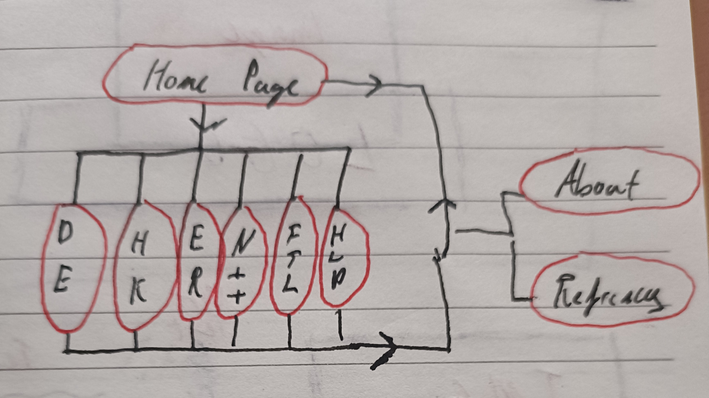
The content of the webpage will be presenting through a variety of text, images , gifs and html/css markup.

Skeleton

Main Menu Skeleton
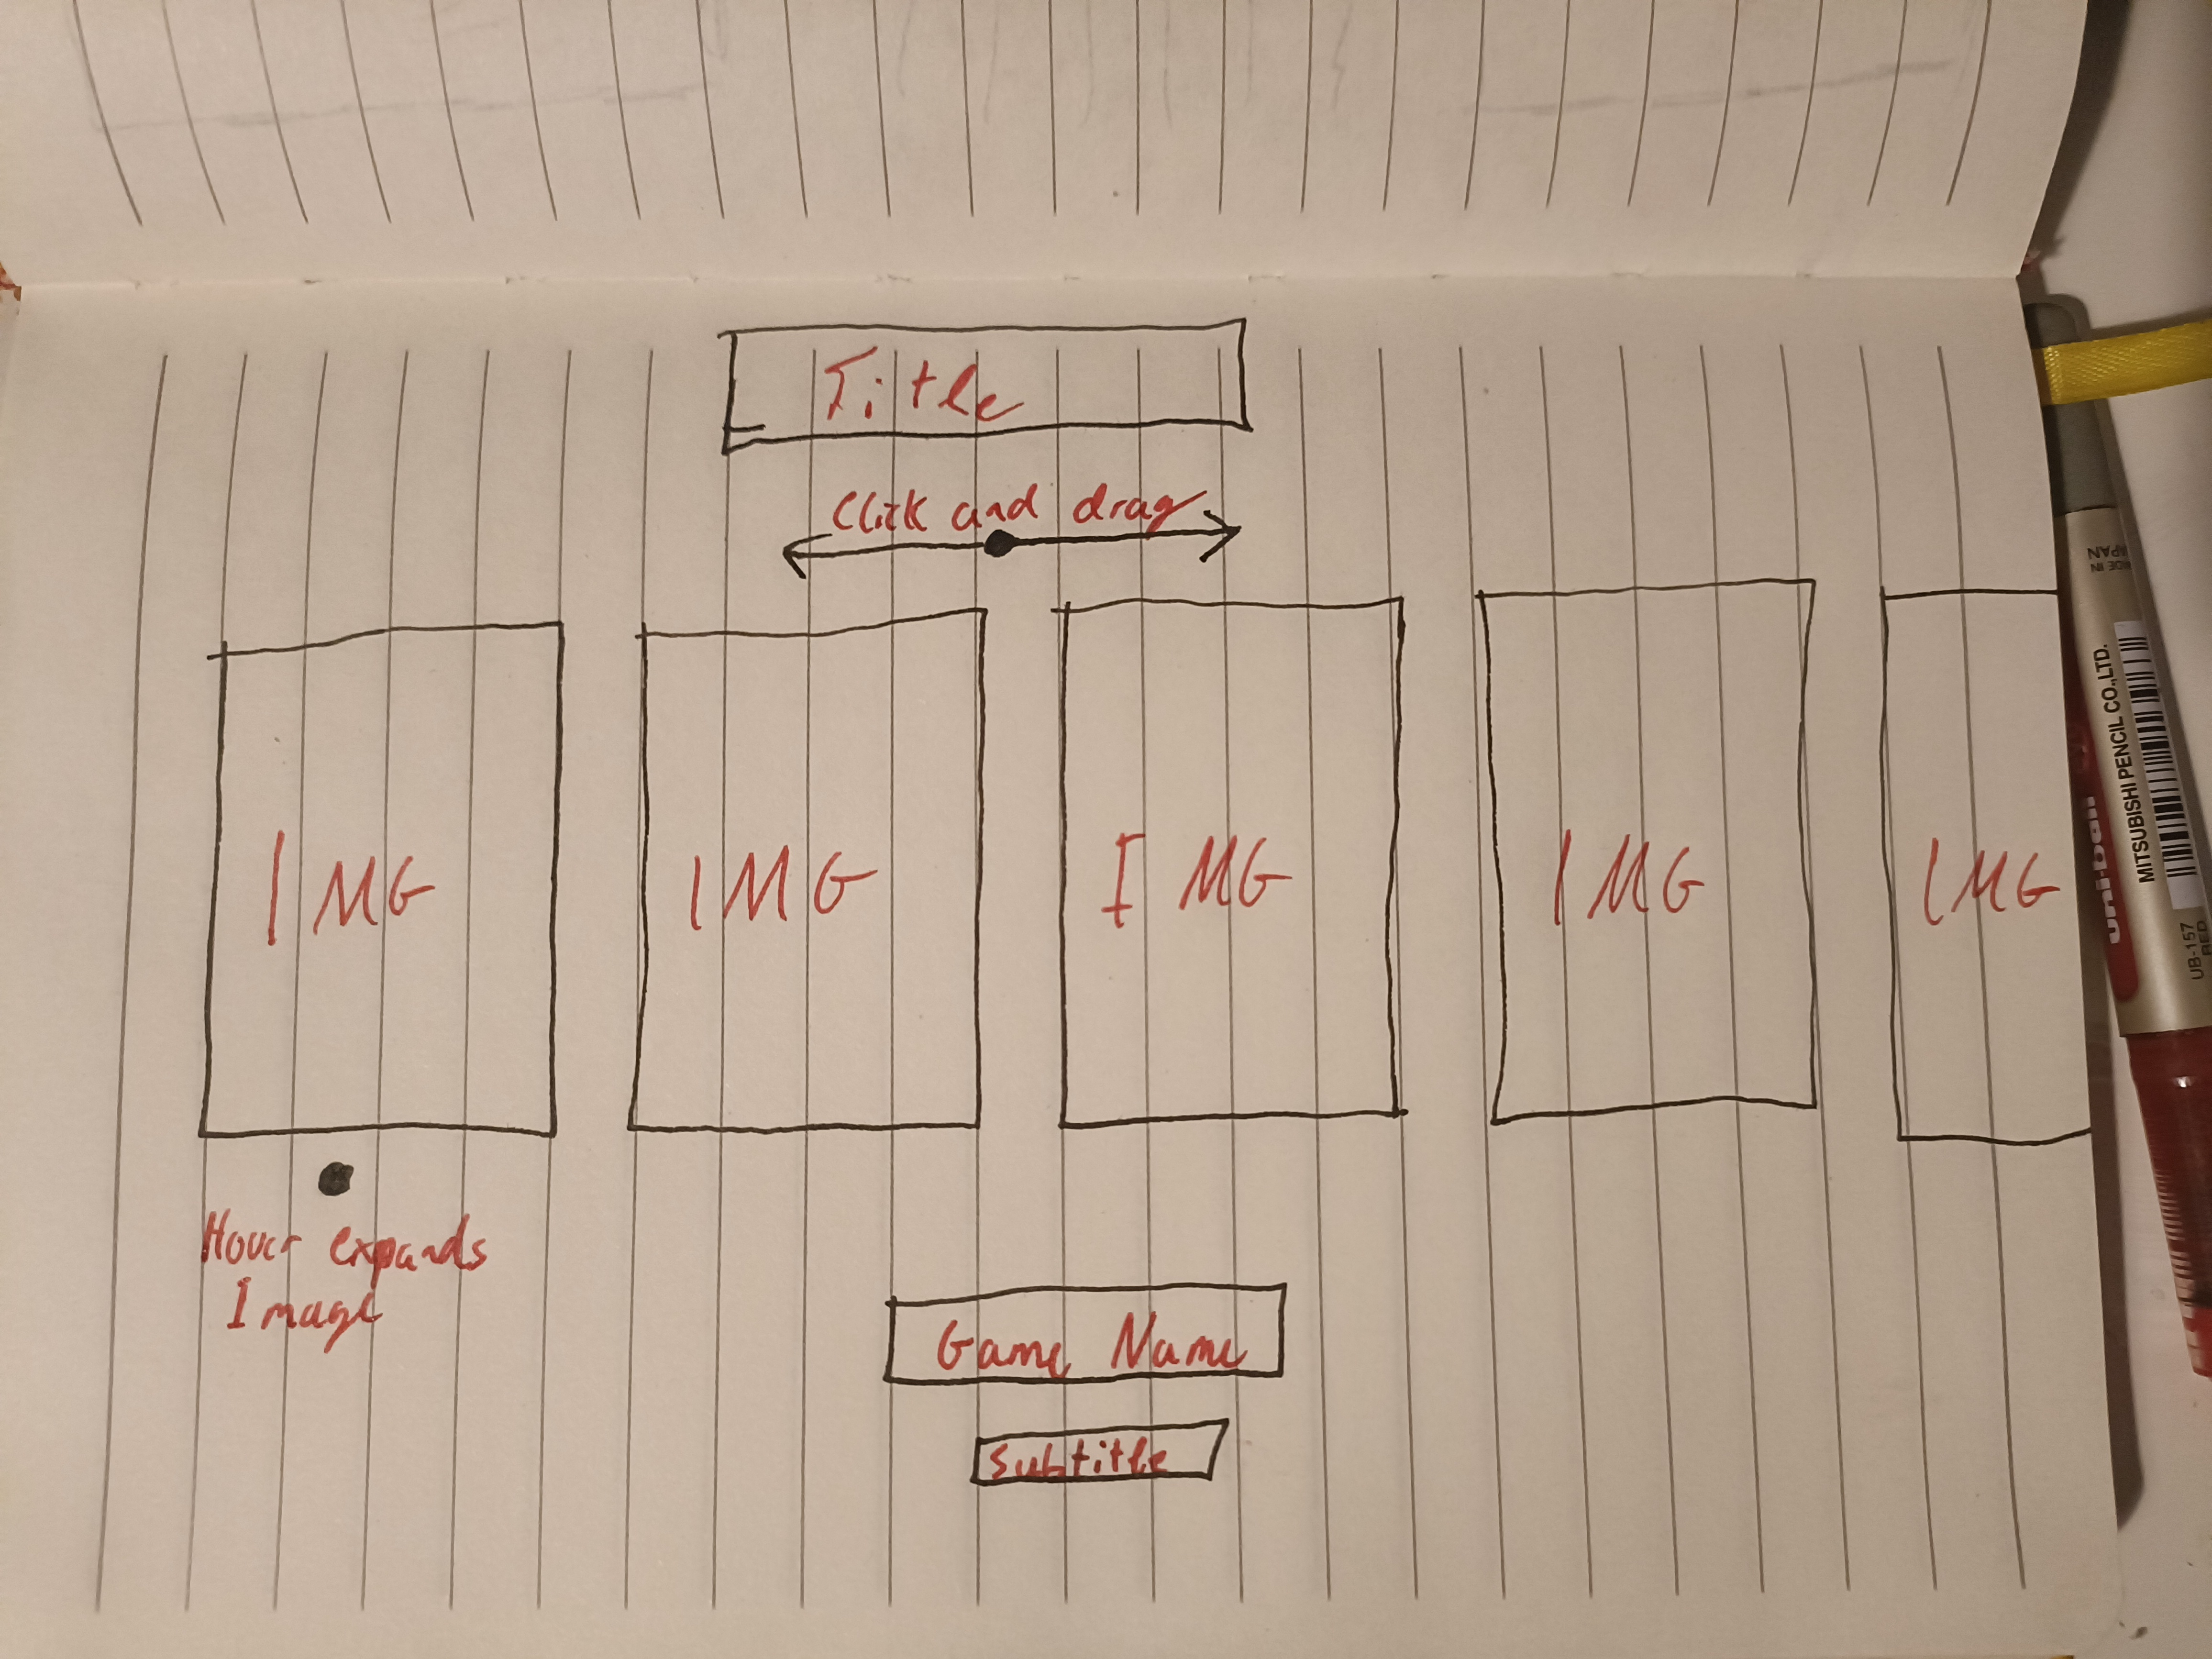

Hollow Knight Skeleton
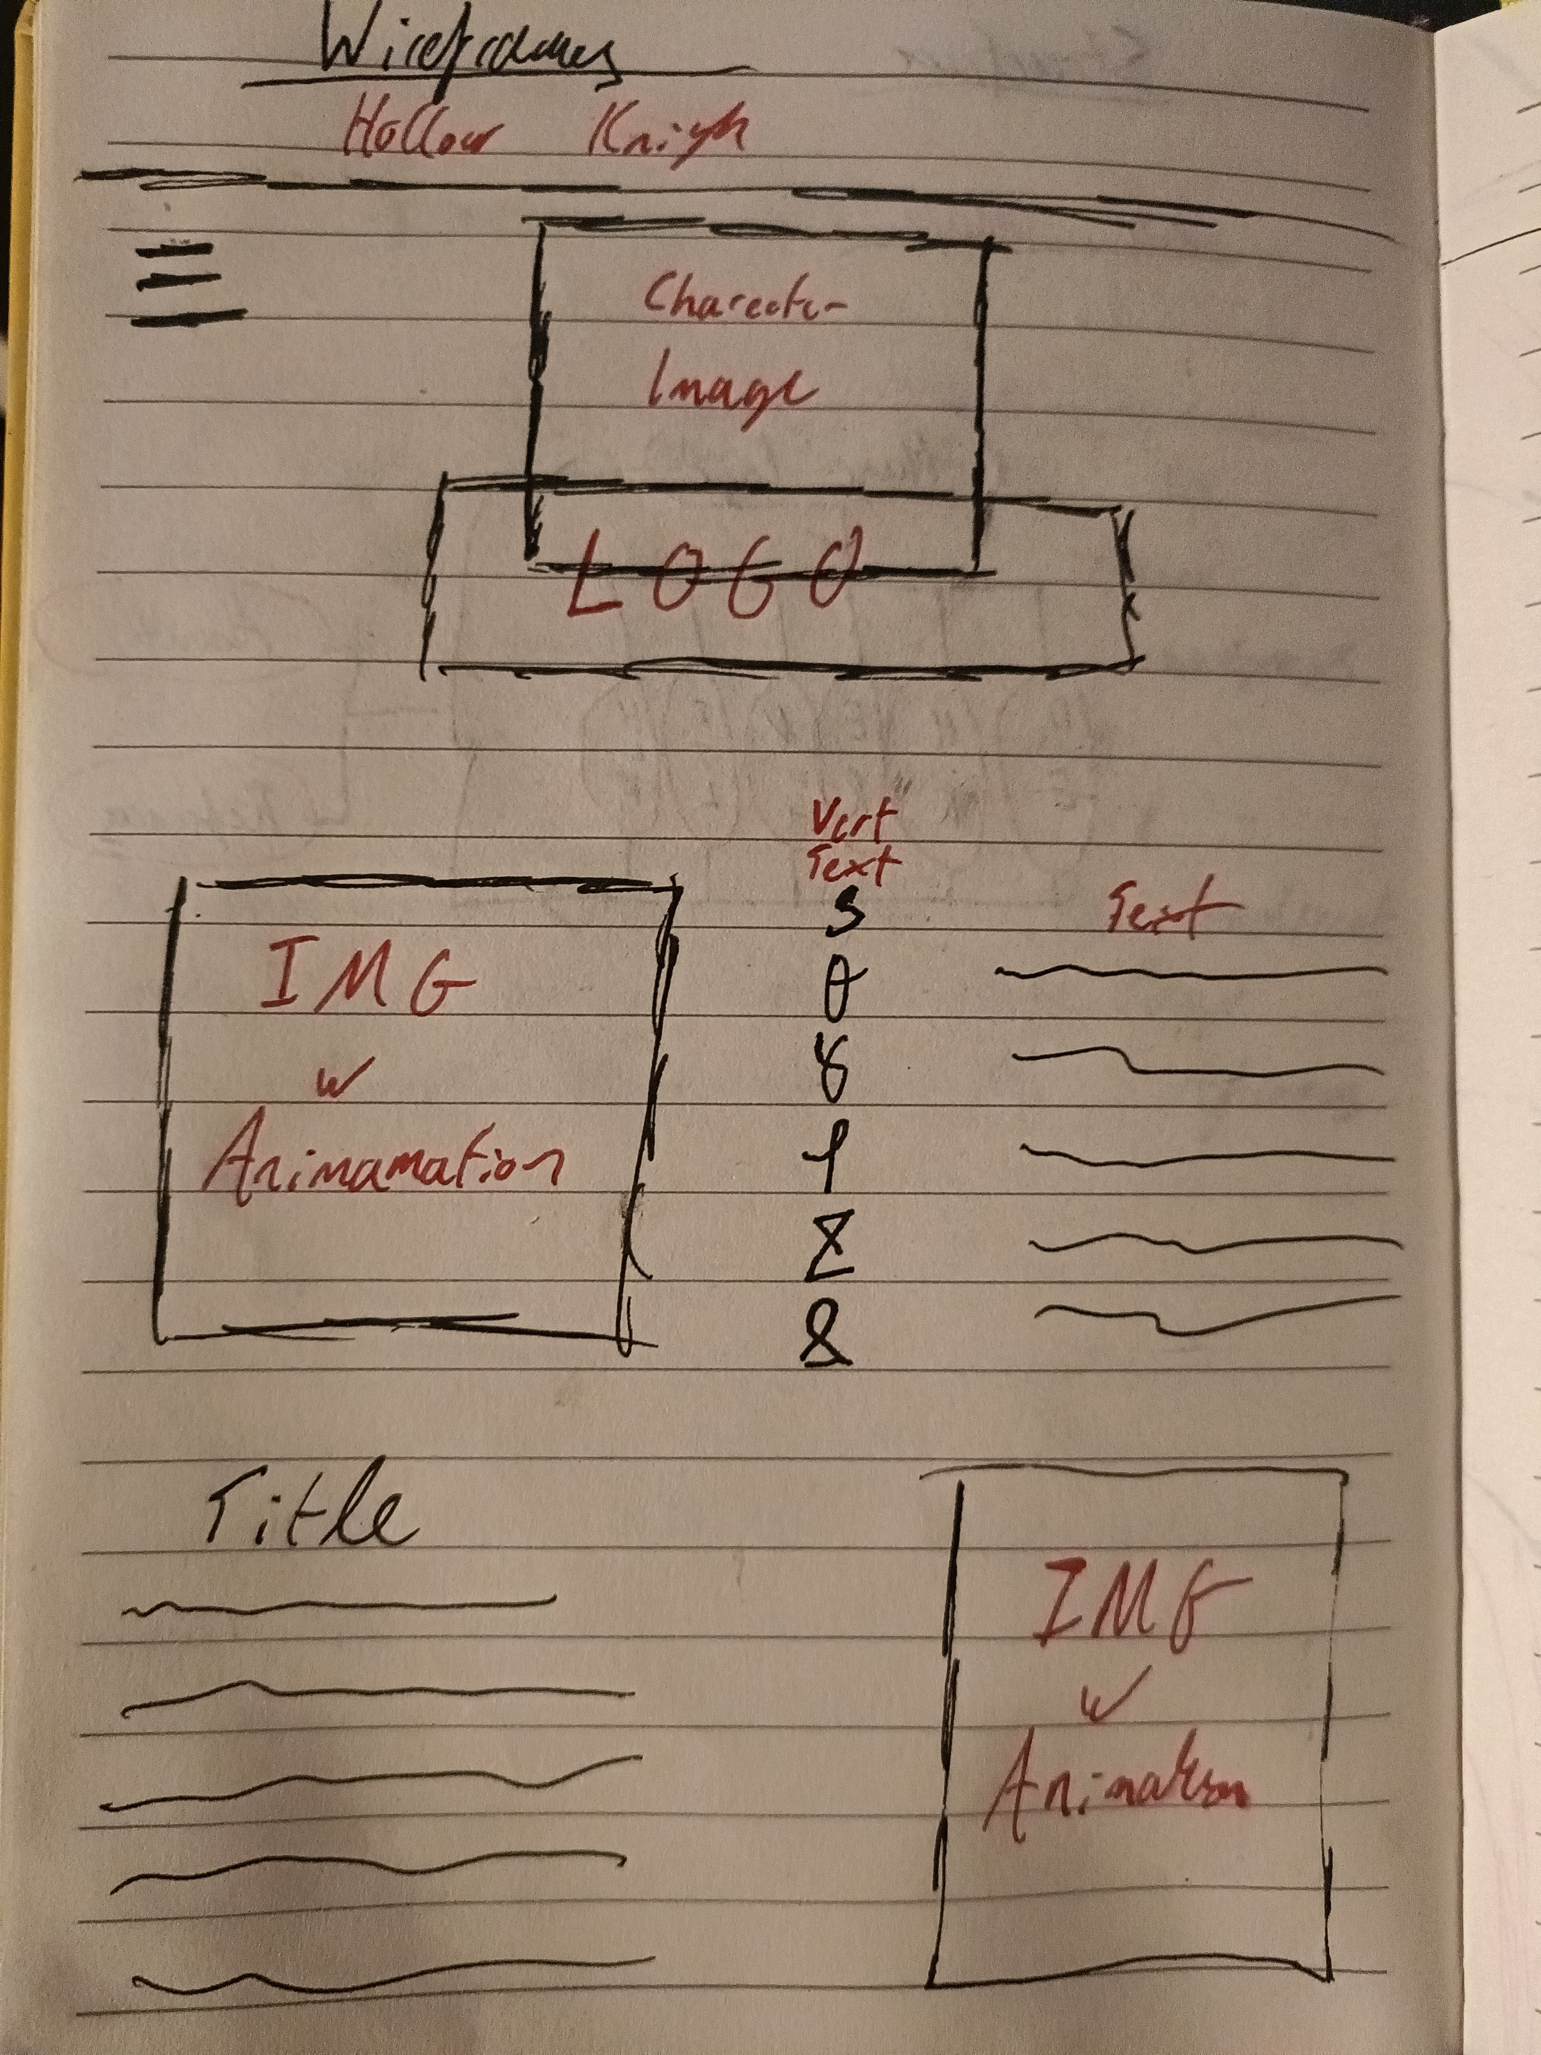

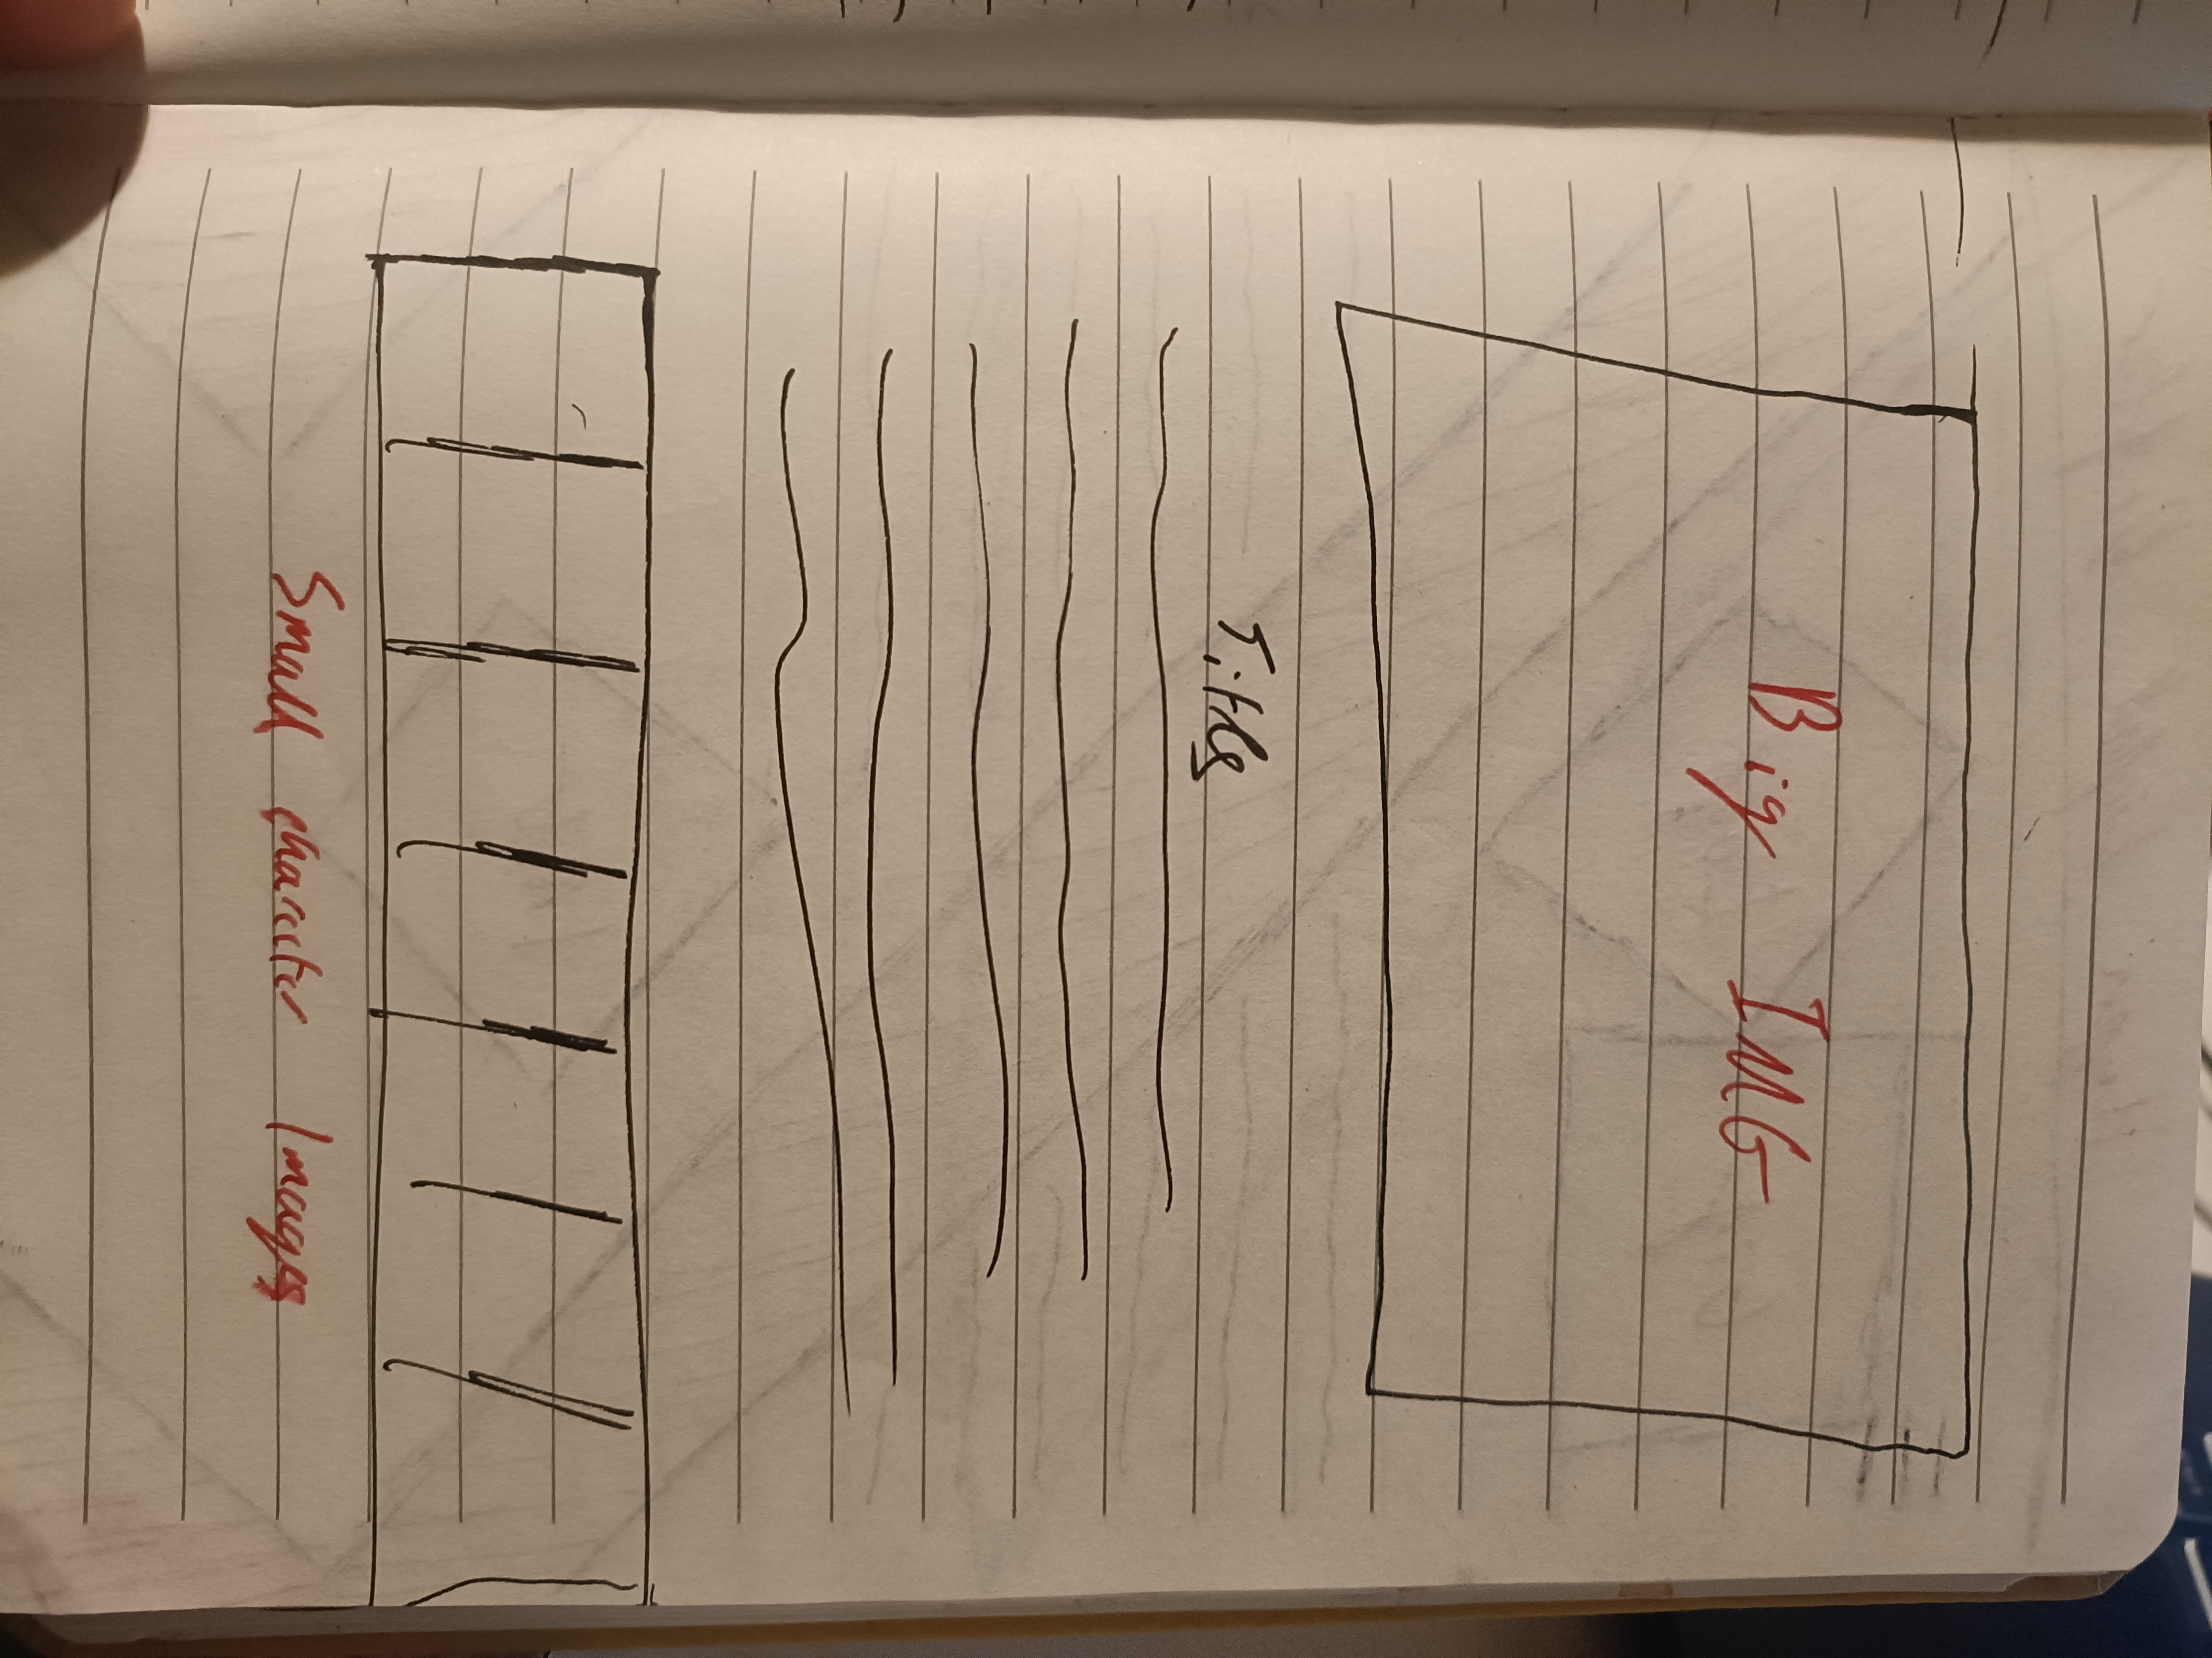

Elden Ring Skeleton
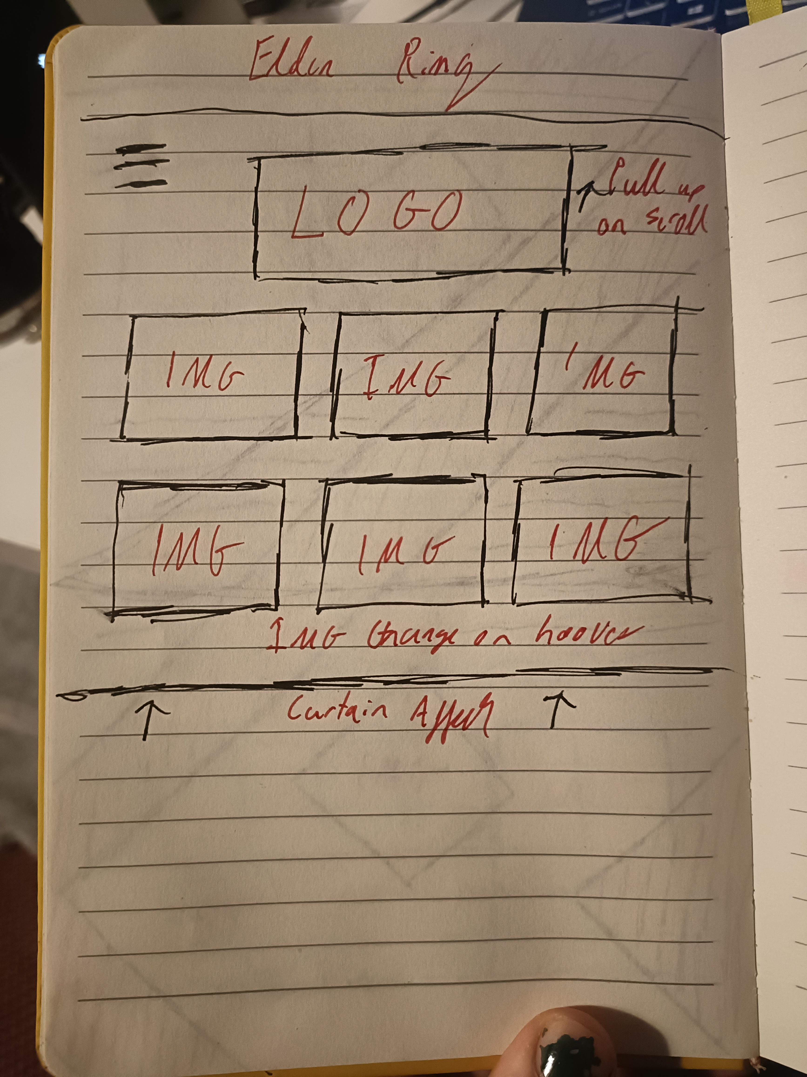
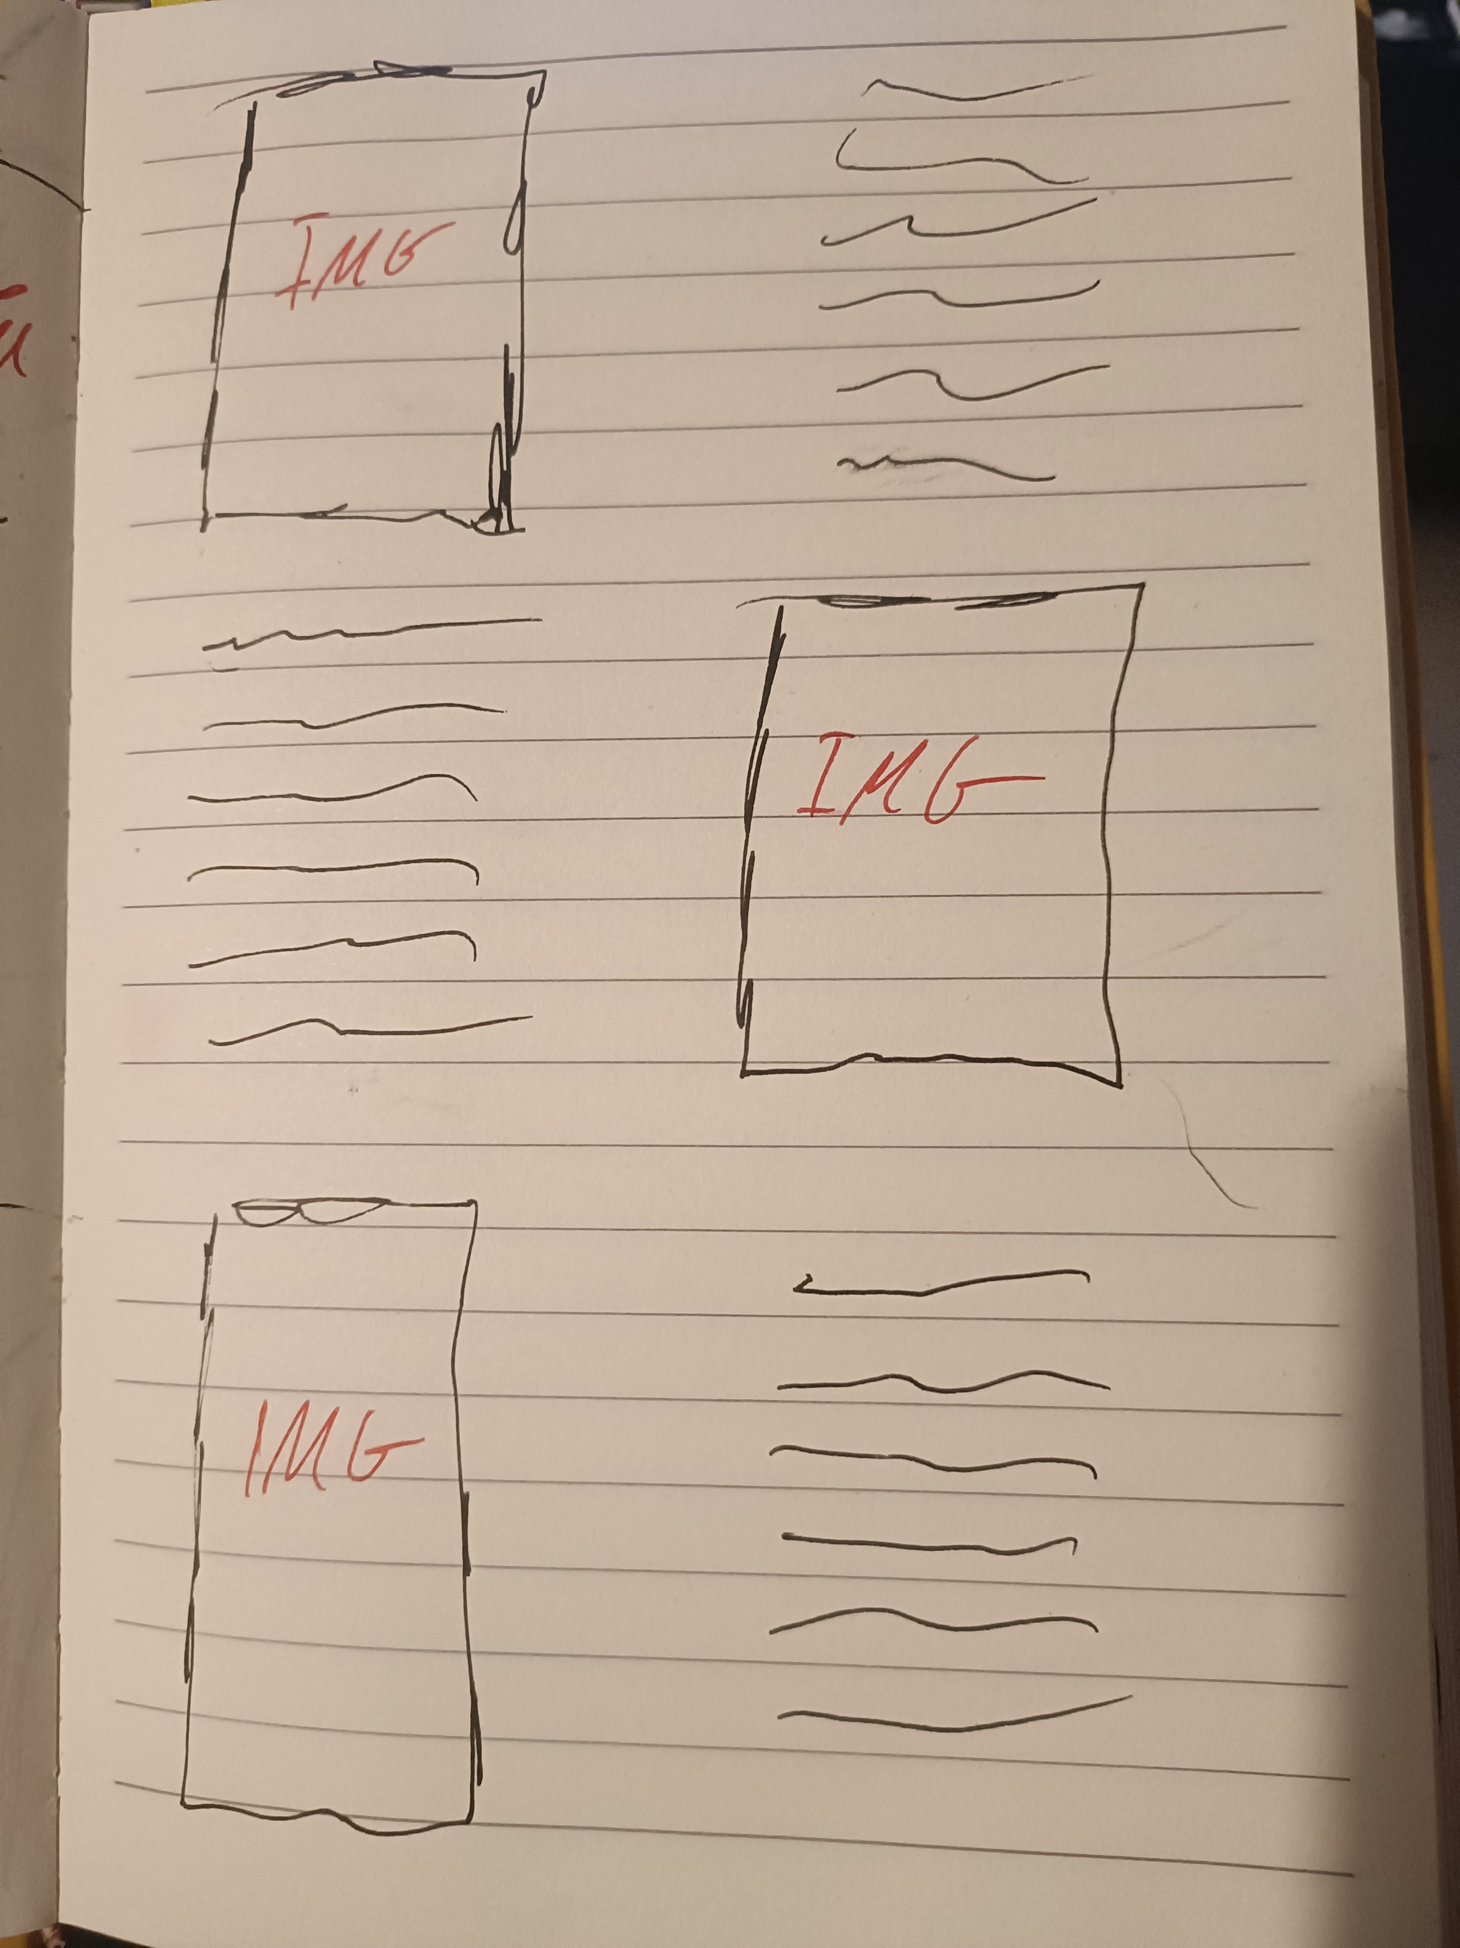

Hyper Light Drifter Skeleton

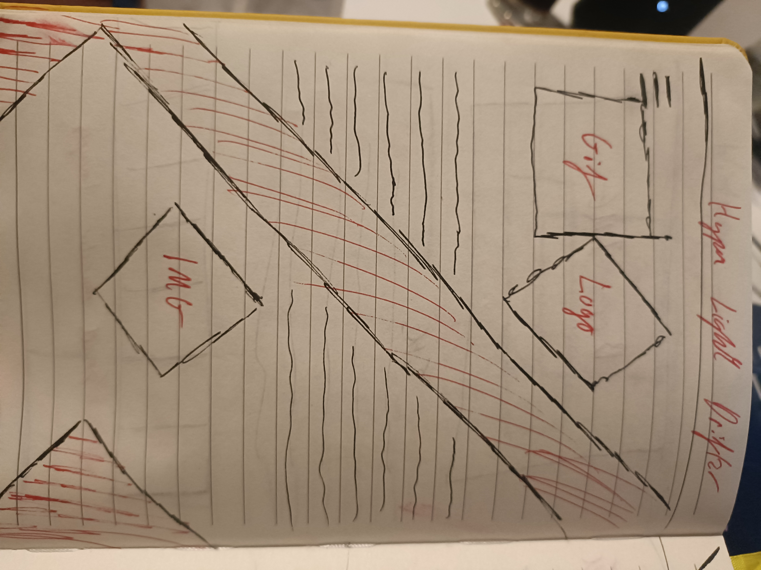

Surface
I did not end up settling on one distinct style of the website but instead tried to attempt a separate style for each individual game. I did this as I believe in the long run it will help me learn different skills and attempt to find my own personal style instead of just copying someone else’s work.
For example for my Hyper Light Drifter webpage I attempted to emulate the hard lines and bold colours of said game.

Testing
No | Description |  |  | 
1 | Index.html renders correctly | ✓ | ✓ | ✓
2 | Images on all pages render in correct position and size | ✓ | ✓ | ✓
3 | Spacing as expected between images, text, sections | ✓ | ✓ | ✓
4 | Links to local “*.html” files working correctly | ✓ | ✓ | ✓
5 | External links working correctly | ✓ | ✓ | ✓
6 | Colour rendering identical across all browsers | ✓ | ✓ | ✓
7 | Functional Script | ✓ | ✓ | ✓
8 | Hover Affects Functioning | ✓ | ✓ | ✓
9 | Scroll Functionality | ✓ | ✓ | ✓
11 | GIF Functionality | ✓ | ✓ | ✓
12 | Z-index functionality | ✓ | ✓ | ✓

Github Profile
My full website including all my assets and links available to the websites I used to code some of the features is available on Github under “Fauscoum792”.
To do this I first created my Github account, I then created a new repository named “Portfolio-Website”. To move my code from Visual Studio Code to Github was quite easy as I already had git installed, I simply went to my terminal and entered the following lines of code.
git remote add origin https://github.com/Fauscoum792/Portfolio-Website.git
git branch -M main
git push -u origin main
I then set up my website for viewing by changing my settings to public and using Github pages .

Proof
Chrome
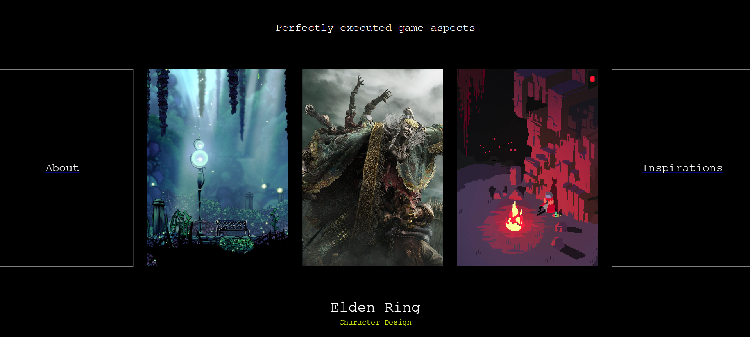
Edge
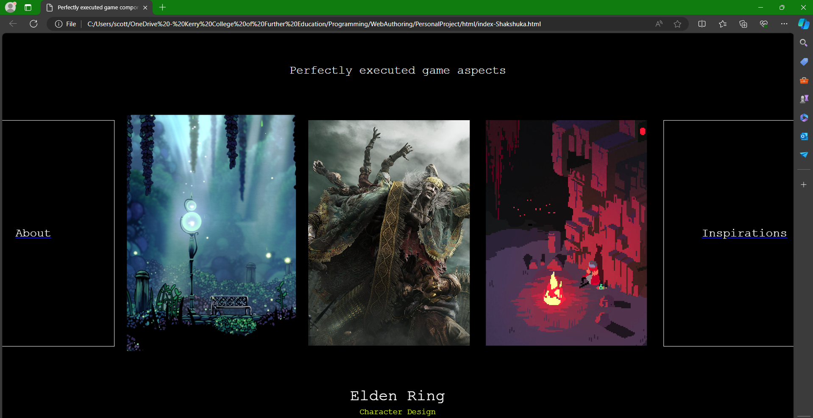
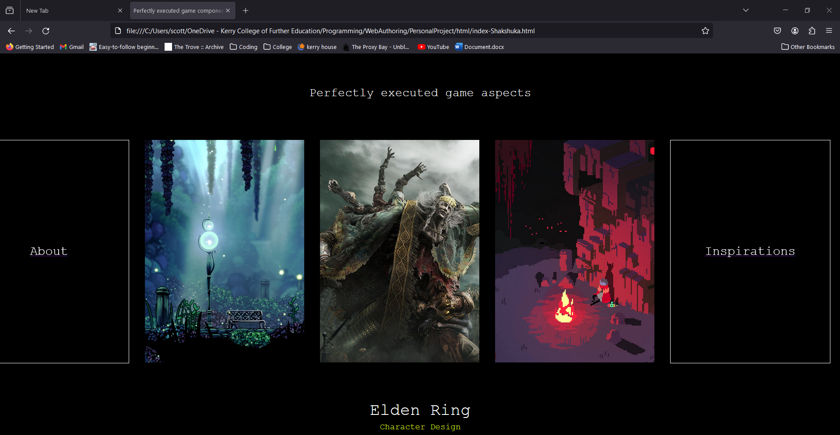
Firefox

Future Planning
With my current method of development I have made it quite easy to expand in the future as all I need to do is add extra webpages to the main menu and it will not interfere with the rest of my code.
I plan to leave my webpages as they are once I am finished with them as it will present a clear line of the advancment of my skills over time which I believe will be quite interesting for myself.
As for the close future I only have 2 plans. I would like to add one extra webpage dedicated to the video game Disco Elysium as it is the favourite game of one of my closest friends. I also would like to translate the entire website to React, a free and open-source front-end JavaScript library for building user interfaces based on components. The reason I would like to do this is that several times so far I have had a part of my website that has been utilised on several webpages and I have had to copy and paste my code: which is quite clunky. React enables me to convert some code into a module which I can then utilise in a way similar to objects in JavaScript, I would like to use this one components such as my hamburger menu.
To learn react I will need to teach myself JavaScript followed by TypeScript and then React.

Maintenance
The current largest problem I have maintenance wise is that a large amount of my code is simply copy pasted across css files. In order to improve this in the future I am planning on transferring the entire website to the React framework. To deal with it in the short term I have changed my VScode settings to recognize file names across multible files in the same folder so that I can change all occurrences at the same time, but this is not perfect and often fails. The most obvious example of this is my hamburger menu, which requires a large amount of code and is present on almost every webpage.
Another thing to help with maintenance is I have tried to break up my css into seperate sections using comments.

Guidelines
Updating text
Go to whatever container has the said text in it whether it be a <h1> or a <p> and change the words then save.
Creating a new Webpage
Create a .html file within my html folder, edit index.html to make sure that their is a associated Image and link bringing you to said html file. You then follow that up by creating css and js files in their respective folders and connecting the html file to it.
Inserting an Image
If the image is for a new html file then you must make a folder within PersonalProject\images_inspiration and add said image. Then perform the normal html method of adding an image.
Creating a link
Use the syntax <a href="url">link text</a>
Uploading updated content
Write the following command into the vscode terminal
git status
git add – A
git commit -m “Commit Name"
git push -u origin main

