Abstract — This paper presents the research on the development of neural network based non-linear controllers for an airplane UAV. Multi-layer perceptrons are used for the training of networks, both off-line and on-line. The data required for off-line training is generated from a validated non-linear flight dynamics model of the Cal Poly Pomona 12' Telemaster UAV. The off-line trained network using multi-layer perceptrons replaces the inverse transformation required for feedback linearization. On-line training is then accomplished to account for the inversion and modeling error. The controllers are tested in the software-in-the-loop simulation environment using FlightGear Flight Simulator. Simulation results compared with flight data are shown. Also shown are the results in the presence of sensor noise.
Nonlinear Control of UAVs using Multi-Layer Perceptrons with Off-Line and On-Line Learning
Subodh Bhandari, Amar Raheja, Daisy Tang, Kevin Ortega, Ohanes Dadian, and Ajay Bettadapura Cal Poly Pomona, Pomona, CA 91768

INTRODUCTION
Unmanned Aerial Vehicles (UAV’s) are assuming greater roles for civilian and military applications. As the role of UAV’s and their level of autonomy increases, they are expected to fly over a wide range of the flight envelope characterized by frequent changes in dynamic pressure (change in speed and altitude). Traditionally, controllers for flight vehicles are designed using linearized flight dynamics models. These controllers are designed to work for particular flight conditions and cannot handle parameter uncertainties. Controllers based on non-linear flight dynamics models can work for the entire flight envelope.
A popular method for handling parameter variations and non-linearity in flight control is gain scheduling [1], [2]. However, gain scheduling has many disadvantages. Frequent and rapid changes of controller gains may lead to instability [3]. Another disadvantage is the high design and implementation costs that increase with the number of operating points [4]. Some of the disadvantages of gain scheduling can be overcome by using non-linear controllers based on feedback linearization [5]. One of the feedback linearization techniques is dynamic inversion and has been applied to aircraft including UAV’s [6], [7]. However, dynamic inversion requires an accurate knowledge of the flight dynamics and the controller may not work if the dynamics model is inaccurate [8], [9] or the system is non-minimum phase. For dynamic inversion to work, all the parameters must be known. They are unable to handle the presence of unknown parameters in the dynamics model. Robust non-linear controllers have been designed [10]. However, these robust controllers are only good for some bounded uncertainties and cannot handle unbounded uncertainties or unmodeled dynamics. Also, an accurate full-envelope non-linear inversion is computationally intensive.
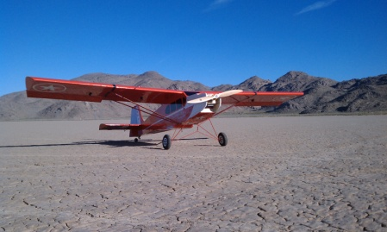

Figure 1: 12' Telemaster Airplane
For this reason, UAV’s need an onboard algorithm for the calculation of controller parameters that take into account the changing flight dynamics and non-linearity and at the same time can handle presence of disturbance, parameter uncertainties, modeling error, and unmolded dynamics. Neural network based controllers can be solution to these problems [11], [12].
This paper presents the research being done at Cal Poly Pomona on the non-linear control of UAV’s using neural networks with both off-line and on-line training. The paper is organized as follows. The second section introduces the flight vehicles being used for this research. The third section talks about the development and validation of non-linear flight dynamics model for the 12' Telemaster airplane. In the fourth section, a multi-layer perceptron (MLP) neural network architecture is discussed. Off-line and on-line training algorithms are discussed in Section V. Section VI talks about the identification and control of the airplane using multi-layer perceptron networks followed by conclusion and discussion of future work in the last section.

Aerial Vehicle Platforms
The aerial vehicle platform being used for this research is the 12' Telemaster airplane, which is 90 inches long with wing span of 144 inches. The airplane is shown in Figure 1. The empty weight of the airplane is about 24 pounds with payload capacity of about 12 pounds. The airplane is equipped with a Piccolo II autopilot [13]. However, we are developing a custom avionics system with open source architecture [14], [15], [16]. The existing autopilots are closed source and are not suitable for the implementation of neural network based controllers [17].

Flight Dynamics models
The dynamics model predicts the behavior of the aircraft following control inputs. It is developed from three force and three moment equations that describe the rigid body motion of the aircraft [18], [19].
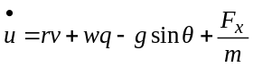 (1)
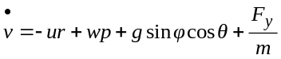 (2)
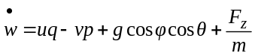 (3)
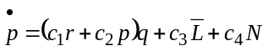 (4)
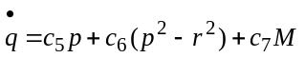 (5)
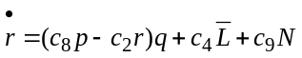 (6)
where c₁, c₂, et cetera are functions of moments of inertias [10], u, v, and w translational velocities, p, q, and r are rotational velocities, L, M, and N and F_{x}, F_{y}, and F_{z} are the moments and forces acting on the airplane, m is the mass of the airplane, and φ, θ, and ψ are Euler angular rates [18].
To completely describe the aircraft motion, the three kinematic equations given below are required.
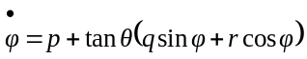 (7)
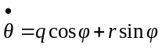 (8)
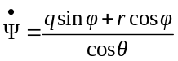 (9)
The nonlinear equations given above are not suitable for control system design. These equations can be reformulated in the form given below [10].
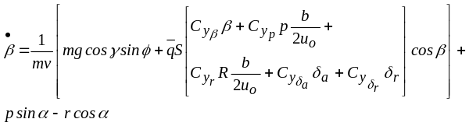 (10)
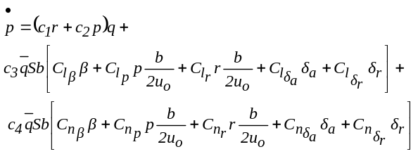 (11)
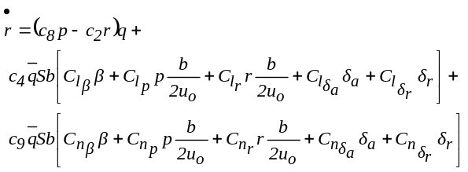 (12)

where 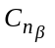, 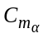, 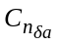, 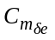, et cetera are stability and control derivatives, β is the sideslip angle, q is the dynamic pressure, b is the wing span and u₀ is the forward velocity [18], [19].
All of the non-linear equations used for this research can be found in [10]. These equations are suitable for use with non-linear dynamic inversion.
Using these equations, a non-linear simulation model was developed for the airplane. Athena Vortex Lattice (AVL) software was used in the determination of stability and control derivatives required for the model [20]. The developed model was verified using flight data. Figure 2 shows the comparison of the flight data with the simulation results. The airplane was flown for doublet inputs in the pitch, roll, and yaw axes. It is seen that the simulation results compare well with the flight data for roll rate and yaw rate. Similar results were obtained for pitch responses.
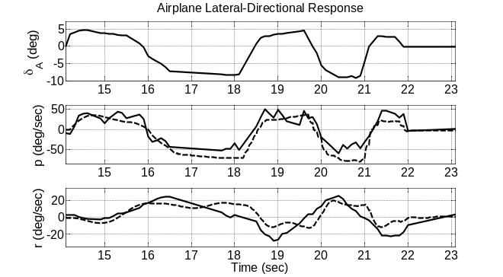
Figure 2: Comparison of the Flight Data (Solid) with the Simulation Results for Roll and Yaw Rates

The general non-linear equation can be written in the following form:
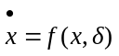 (13)
For the aircraft problem, x is the state vector and δ is the control vector. A linearizing controller can be defined as
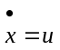 (14)
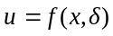 (15)
The above equation can be inverted to yield:
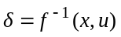 (16)
As discussed below, a neural network can be used to realize this inversion, i.e., the network can be used to represent non-linear transformation for feedback linearization, eliminating the need for dynamic inversion [21].

multi-layer perceptron networks
Artificial neural networks (ANNs) have the ability to approximate general continuous nonlinear functions. Its nonlinear nature provides the system with flexibility to achieve practically any desired input/output mapping [22].
The most commonly used network is the multi-layer perceptron (MLP) feed forward network [23] with some form of error back propagation [24] as the learning algorithm. MLP networks can be used to represent non-linear transformation required for feedback linearization [25].
The network can be trained a-priori or off-line using the data collected during flight tests or generated using validated flight dynamics model. The Off-line network approximately inverts the vehicle dynamics. The on-line neural network can then compensate for non-linearity and inversion error and thus improve the robustness of the controller [26], [27].
MLP’s simplicity provides an ideal architecture for quick training and can still produce good results. It is a feedforward network, which means that the data propagates forward through the network. The structure of an MLP consists of a vector of inputs, any number of hidden layers, and an output layer. This implementation includes 12 neurons in the hidden layer. The network is fully connected, which means that each node is connected to every node in neighboring layers. Figure 3 shows the structure of the MLP network.
Initially, the MLP has “blank” or randomized weights for each edge connecting two nodes. Training follows in three phases, providing a simple gradient with a momentum term. In the first phase or forward phase, a vector of inputs is propagated through the network. At the first layer, each input is copied to every node so that each node is receiving the same signals. Each node applies the weight associated with an edge to the value being received via that edge. This set of weighted values is then computed using activation functions.
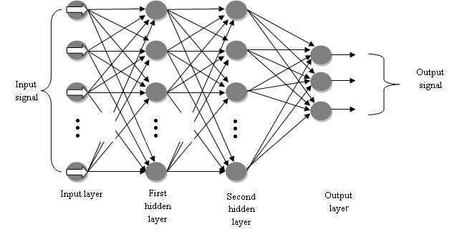
Figure 3: Multi-Layer Perceptron Networks

In the second phase, the value of each output node is compared against the expected or target value and output and an error signal is created. Finally, in the backward phase, the error signal is sent backward through the network. The activation functions are used again to determine which weights contributed to the error and are adjusted accordingly.

Hidden Layer Activation
For hidden node j, the weighted sum, h_{i}, is calculated by accumulating the product of input x_{i} with weight w_{ij}:
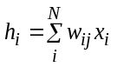 (17)

where N is the number of nodes in the hidden layer.
The activation function, which is the logistic function sigmoid, utilizes the weighted sum and the activation level (β) to determine whether node j triggers or not.
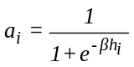 (18)

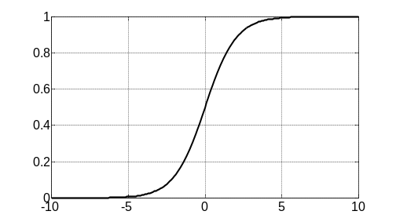
Figure 4: Logistic Function Sigmoid

Output Layer Activation
The output, y_{k}, needs to be from a continuous range, not just 0 or 1. So, the sigmoid functions are not used at the output layer. A linear function is used instead, where the activation function is the weighted sum of output node k.
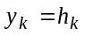 (19)

Error Computation
For each neuron k in the output layer, error, δ_{ok}, is computed by taking the difference of target output (c_{k}) with the neuron’s output (y_{k}).
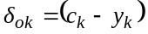 (20)
The error at the hidden layer, δ_{hj}, is then computed using
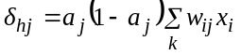 (21)

Updating Weights
Output-layer weights are updated using
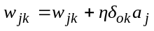 (22)
and for the hidden-layer weights
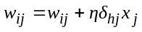 (23)
where η is the learning rate.

online-training
The purpose for on-line training is to accommodate for any modeling errors or training deficiencies. The on-line trainer can learn while the aircraft system is in flight. The data required for this research is obtained from the FlightGear Flight Simulator model of the airplane in the Software-in-the-Loop simulation environment [13]. Initially, the off-line trained network and the on-line training algorithm have the same structure and weight values. However, these weight values update as the system operates. The on-line training uses the back-propagation algorithm to update its weights. This algorithm computes the gradient vector. In future, the real-time flight data from the aircraft will be used as input to the training algorithm, and controls outputs from the off-line trained network to provide targeted values for on-line training. There are two steps in the back-propagation algorithm.

Error Computation
The error at the output layer is calculated by the sum-of-squares error function, which calculates the difference between target output (c) and neural-network output (y) for each node, squares them, sums them together and divides them by two.
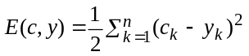 (24)
where
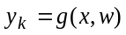 (25)
and g(.) is a differentiable activation function.
To minimize error E(w), the gradient descent algorithm is used. This ensures that the error moves toward the local minimum. As shown below, the partial derivative of the error function with respect to the weights is taken.
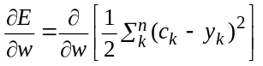 (26)
The derivative will differ depending on the activation function used for the particular layer in question. For the output layer, where
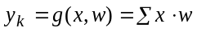 (27)
the derivative becomes
(28)
and for the hidden layer, where
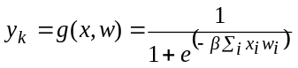 (29)
the derivative becomes
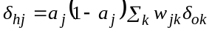 (30)

Hidden Layer Activation
Updating weights moves the error towards the local minimum. To determine the updated value of each weight, the following formula is used:
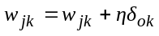 (31)
However, a problem arises when the local minimum is not the global minimum. To alleviate this problem in the neural network, momentum is introduced to the update-weight function. The momentum is generated by adding previous weight changes to the current changes. Thus, the equation (31) changes to
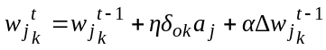 (32)
where α is 0.9.

identification and control of 12' Telemaster airplane
This section talks about the neural network training and control of the 12' Telemaster airplane. The data required for off-line training was generated using the validated non-linear flight dynamics model discussed above. A sinusoidal input was applied to the model to generate the data. In order to learn, the network is trained on a large set of input and output data. The model generated data was divided to training data and validation data. The division occurs so that 70% of the data was used for training and 30% is used for validation. Figure 5 shows the implementation of the off-line trained network.

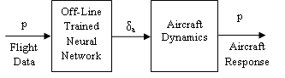
Figure 5: Implementation of Off-Line Trained Network

The real-time flight data from the aircraft serves as input to the on-line training algorithm and controls outputs from the off-line trained network to provide targeted values for the on-line trainer as shown in Figure 6. In this system, the trained neural network and on-line trainer is the same object; so, the weights of the trained neural network are instantaneously updated on completion of the back-propagation process.
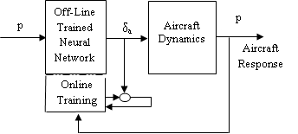
Figure 6: Implementation of On-Line Trained Network

In this work, the data required for on-line training is the simulation data obtained from the FlightGear Flight Simulator.
The neural networks were initially trained in MATLAB. However, for the SIL simulation and on-line training, MLP networks were ported from MATLAB to C. The C implementation ran a trained MLP on the QNX Neutrino Realtime Operating System (RTOS).
Figures 7 shows the responses of the off-line and on-line trained network compared with flight data for aileron. The flight data was collected for doublet inputs in aileron, rudder, and elevator for the 12' Telemaster airplane. It is seen that the response from the online trained network compares better with the flight data than the response from offline trained network only. It is also seen in Figure 7 that with the inclusion of on-line training, the response gets better as the training progresses.
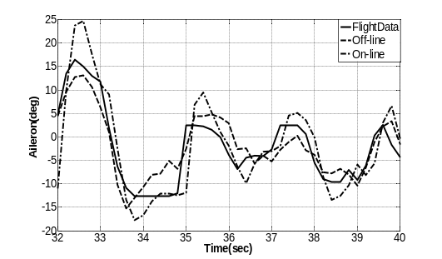
Figure 7: Flight Data vs. Neural Network Response

Figure 8 shows the airplane roll rate response collected during doublet maneuver and the responses from the neural network models. The comparison shows similar trends with online trained producing better results.
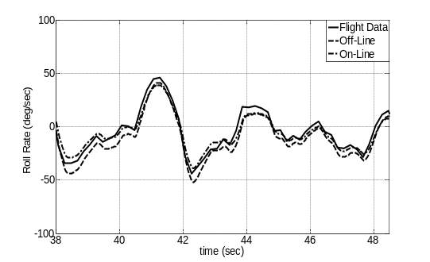
Figure 8: Flight Data vs. Neural Network Model Response (Roll Rate)

Next, trained neural networks were implemented in a closed-loop system with feedback controllers included in the loop as shown in Figure 9.
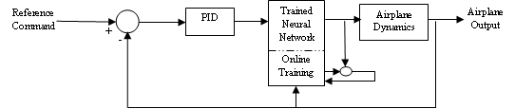
Figure 9: Neural Network Implemented in the Closed-Loop System

The feedback controller ensures stable closed-loop response and good transient characteristics. Figure 10 shows the closed-loop roll rate response of the airplane for a step command in roll rate.

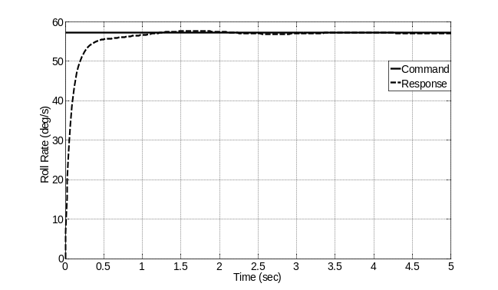
Figure 10: Airplane Response to Roll Rate Command

Figure 11 shows the neural network implementation in a Software-in-the-Loop simulation environment, with the data for the online training obtained from FlightGear simulation of the aircraft.

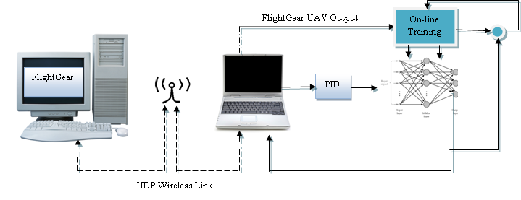
Figure 11: Software-in-the-Loop Simulation Block Diagram

The closed-loop system was then simulated with sensor noise included in the system. The sensor noise was modeled by a white noise of intensity of 0.5 deg./sec. This was done to test the robustness of the neural network controller when operating in non-ideal setting, much like in the real-world application of aircraft. Figure 12 shows the closed-loop response of the aircraft when subject to the white noise. It is seen that the neural network controller is able to track the command with reasonable overshoot and oscillation.

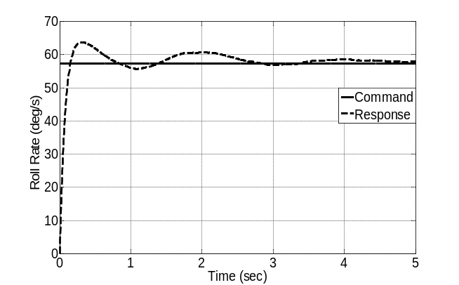
Figure 12: Response of the Aircraft in the Presence of Sensor Noise

Conclusion
Multi-layer perceptrons were used to train the off-line and on-line networks, which can estimate the inputs that need to be applied to the UAVs to achieve a desired flight trajectory. The trained networks were used for the nonlinear control of the 12' Telemaster airplane. The data required for the training was generated using the validated nonlinear flight dynamics model of the UAV. The off-line training is used to represent the inversion required for feedback linearization. The on-line network was then used to compensate for the inversion error and modeling deficiencies. The data required for the on-line training was obtained from the FlightGear simulation of the aircraft. The excellent correlation between the neural network estimation and the flight data is quite encouraging. The response of the trained network compares well with the flight data.
The future work will involve further testing of the controllers in the Software-in-the-Loop (SIL) simulations as well as the Hardware-in-the-Loop (HIL) simulations. The HIL simulation will include the avionics system that is being developed. The future work will also test the robustness of neural network controllers in the presence of more disturbances such as vertical gust. As stated above, the overall goal of this research is the development of robust non-linear adaptive controller for UAV’s. These controllers will be significantly tested in HIL simulations prior to flight testing. An Echo State Network (ESN) is currently in development. Based on a recurrent design, it will provide a more adaptive control system for our UAV’s. Development of Radial Basis Function (RBF) networks is also underway. This will allow us to compare the performance of different artificial neural networks in the control of UAV’s.
Acknowledgment
This research was supported by National Science Foundation under the Award No. 1102382. The authors would like to thank Hovig Yaralian, Matthew Rose, and Nigam Patel for their help with flight testing, data collection, and development and validation of the nonlinear flight dynamics model of the UAV. The authors would also like to thank Mr. Jim Cesari, the Aerospace Engineering Department technician, for his help with flight testing of the UAV.
References
- J. S. Shamma and J. R. Cloutier, “Gain-Scheduled Missile Autopilot Design using Linear Parameter-Varying Transformations,” Journal of Guidance, Control, and Dynamics, vol. 16, no. 2, pp. 256-263, 1993.
- F. Wu, A., Packard, and G. Balas, “Systematic Gain Scheduling Control Design: A Missile Autopilot Example,” Asian Journal of Control, vol. 4, no. 3, pp. 341-347, Sept. 2002.
- K. S. Tsakalis and P. A. Ioannou, Linear Time Varying Systems: Control and Adaptation, New Jersey: Prentice Hall, 1993.
- P. A. Ioannou and J. Sun, Robust Adaptive Control, New Jersey: Prentice Hall PTR, 1995.
- A. Isidori, Non-linear Control Systems, Berlin: Springer-Verlag, 1989.
- D. J. Bugajski, et al., “A Dynamic Inversion Based Control Law with Application to the High Angle of Attack Research Vehicle,” Proceedings of AIAA Guidance, Navigation, and Control Conference, 1990.
- F. Holzapfel and G. Sachs, “Dynamic Inversion Based Control Concept with Application to an Unmanned Aerial Vehicle,” AIAA Guidance, Navigation, and Control Conference and Exhibit, Providence, RI, Aug. 16-19, 2004.
- J. S. Brinker and K. A. Wise, “Stability and Flying Qualities Robustness of a Dynamic Inversion Aircraft Control Law,” Journal of Guidance, Control, and Dynamics, vol. 19, no. 6, 1996.
- B. Mroton, et al., “Stability of Dynamic Inversion Control Laws Applied to Non-linear Aircraft Pitch-Axis Models”, Institute for Mathematics and its Applications, University of Minnesota.
- M. Sadraey and R. Colgren, “Robust Non-linear Controller Design for a Complete UAV Mission,” AIAA Guidance, Navigation, and Control Conference and Exhibit, Keystone, CO, Aug. 21-24, 2006.
- L. Sonneveldt, et al., “Non-linear Adaptive Trajectory Control Applied to an F-16 Model,” AIAA Guidance, Navigation, and Control Conference and Exhibit, Aug. 2008.
- T. Lee and Y. Kim, “Non-linear Adaptive Flight Control using Backstepping and Neural Networks Controller,” Journal of Guidance, Control, and Dynamics, vol. 24, no. 4, July-Aug. 2001.
- N. Anderson, S. Bhandari, et al., “Flight-Testing of a UAV Aircraft for Autonomous Operation using Piccolo II Autopilot”, AIAA Atmospheric Flight Mechanics Conference, Honolulu, HI, Aug. 18-21, 2008.
- N. Brown, S. Bhandari, R. Colgren, et al., “Modular Wireless Avionics System for Autonomous UAVs,” AIAA Guidance, Navigation, and Control Conference and Exhibit, Keystone, CO, Aug. 21-24, 2006.
- M. Whalley, M. Takshashi, G. Schulein, et al., “The NASA/Army Autonomous Rotorcraft Project,” American Helicopter Society 59th Annual Forum, Phoenix, AZ, May 6-8, 2003.
- S. Bhandari, N. Pernalete, A. Bettadapura, et al., “Avionics System for UAV Flight Controls Research,” AIAA Infotech@Aerospace Conference, Boston, MA, 19-22 Aug. 2013.
- S. Bhandari, A. Raheja, D. Tang, et al., “Modeling and Control of UAVs using Neural Networks,” AIAA Modeling and Simulation Technologies Conference, Minneapolis, MN, Aug. 13-16, 2012.
- J. Roskam, Airplane Flight Dynamics and Automatic Flight Controls, Kansas: DAR Corporation, 1998.
- R. C. Nelson, Flight Stability and Automatic Control, Boston: McGraw Hill Higher Education, 1998.
- M. Rose, S. Bhandari, et al, “Development and Validation of Flight Dynamics Model of a UAV Airplane,” AIAA Infotech@Aerospace 2012, Garden Grove, CA, June 19-21, 2012.
- B. S. Kim and A. J. Kalise, “Non-linear Flight Control Using Neural Networks,” AIAA Journal of Guidance, Control, and Dynamics, vol. 20, no. 1, pp. 26-33, 1997.
- K. S. Narendra and K. Parthasarathy, “Identification and Control of Dynamical Systems Using Neural Networks,” IEEE Transactions on Neural Networks, vol. 1, no. 1, pp. 4–27, 1990.
- M. T. Hagan and H. B. Demuth, “Neural Networks for Control,” Proceedings of American Control Conference, San Diego, CA, June 2-4, 1999.
- D. Psaltis, A. Sideris, and A. Yamamura, “A Multi-layered Neural Network Controller,” IEEE Control System Magazine, vol. 10, no. 3, pp. 44-48, 1998.
- J. F. Haffner, N. T. Meyrer, et al., “A Multi-layer Perceptron Replaces a Feedback Linearization Controller in a Non-linear Servomechanism,” IEEE International Joint Conference on Neural Networks, Anchorage, AK, May, 1998.
- M. R. Napolitano and M. Kincheloe, “On-line Learning Neural-Network Controllers for Autopilot Systems,” Journal of Guidance, Control, and Dynamics, vol. 33, no. 6, Nov.-Dec., 1995.
- D. Shin and Y. Kim, “Reconfigurable Flight Control System Design using Adaptive Neural Networks,” IEEE Transactions on Control Systems Technology, vol. 12, no. 1, pp. 87-100, 2004.

 Professor, Department of Aerospace Engineering, AIAA Senior Member, sbhandari@csupomona.edu. Professor, Department of Computer Science, raheja@csupomona.edu. Associate Professor, Department of Computer Science, ftang@csupomona.edu. Graduate Student, Department of Computer Science, kfortega@csupomona.edu. Graduate Research Assistant, Department of Computer Science, oadadian@csupomona.edu. Undergraduate Research Assistant, Department of Aerospace Engineering, AIAA Student Member, abettadapura@csupomona.edu.

