Harry Faust

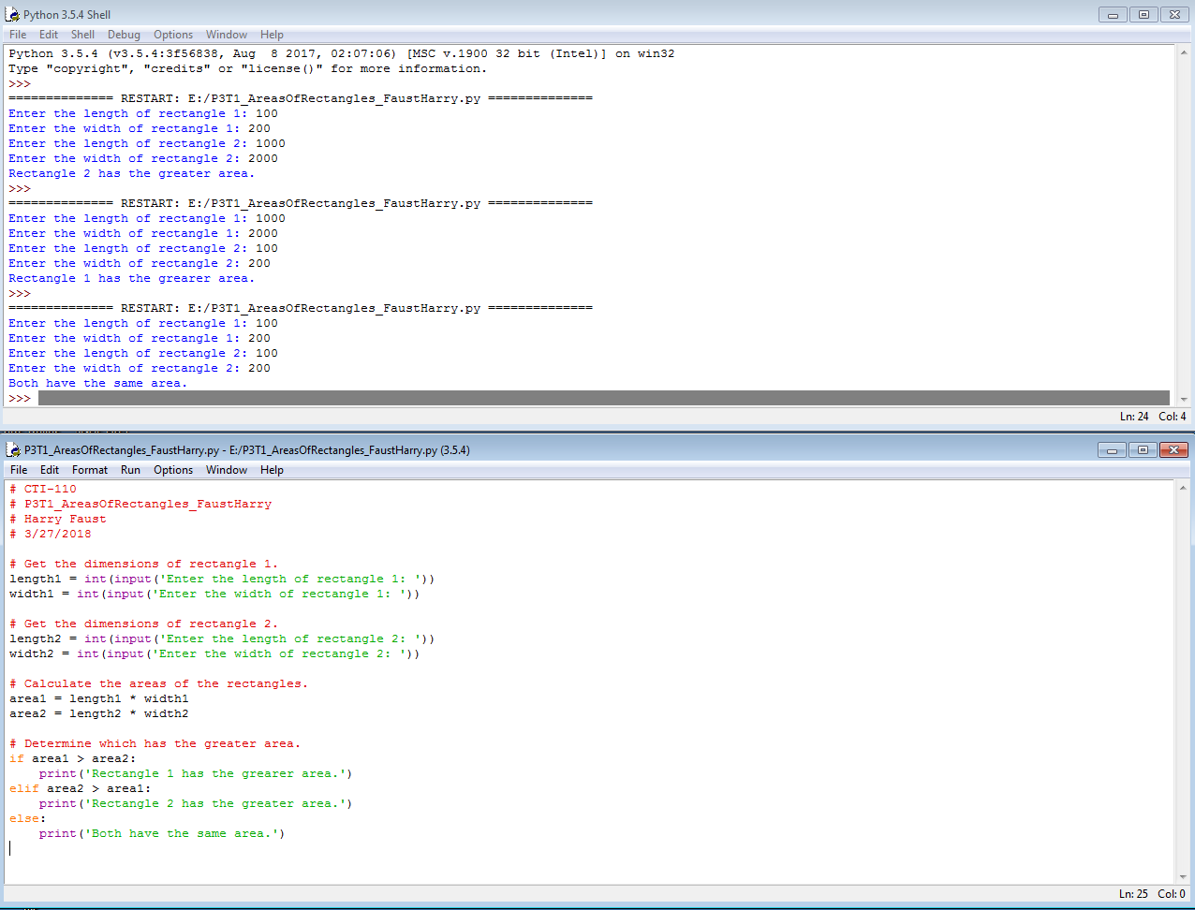P3T1_AreaOfRectangle_FaustHarry 3/27/2018