Database Name : testinteview

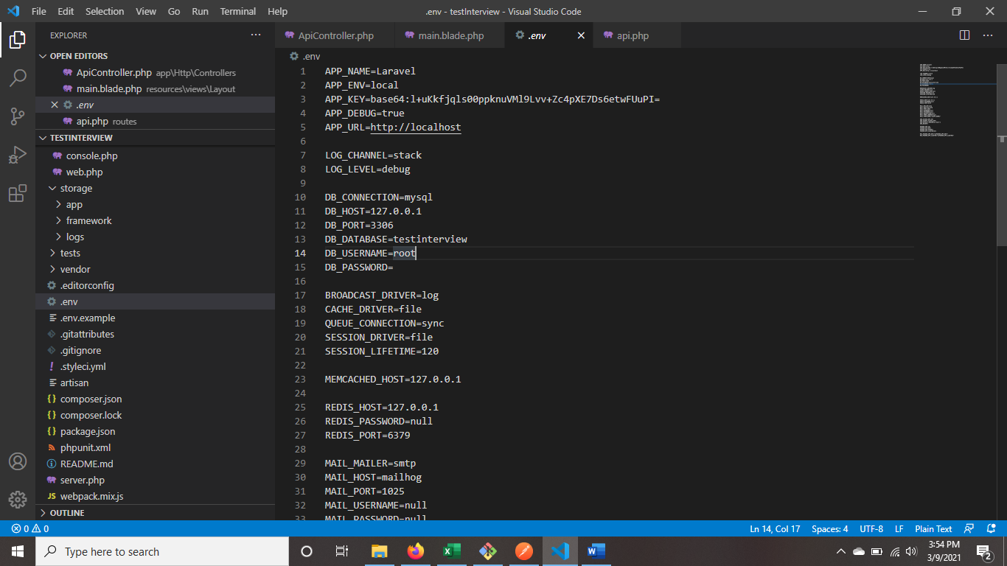

Table : s_user, s_user_table

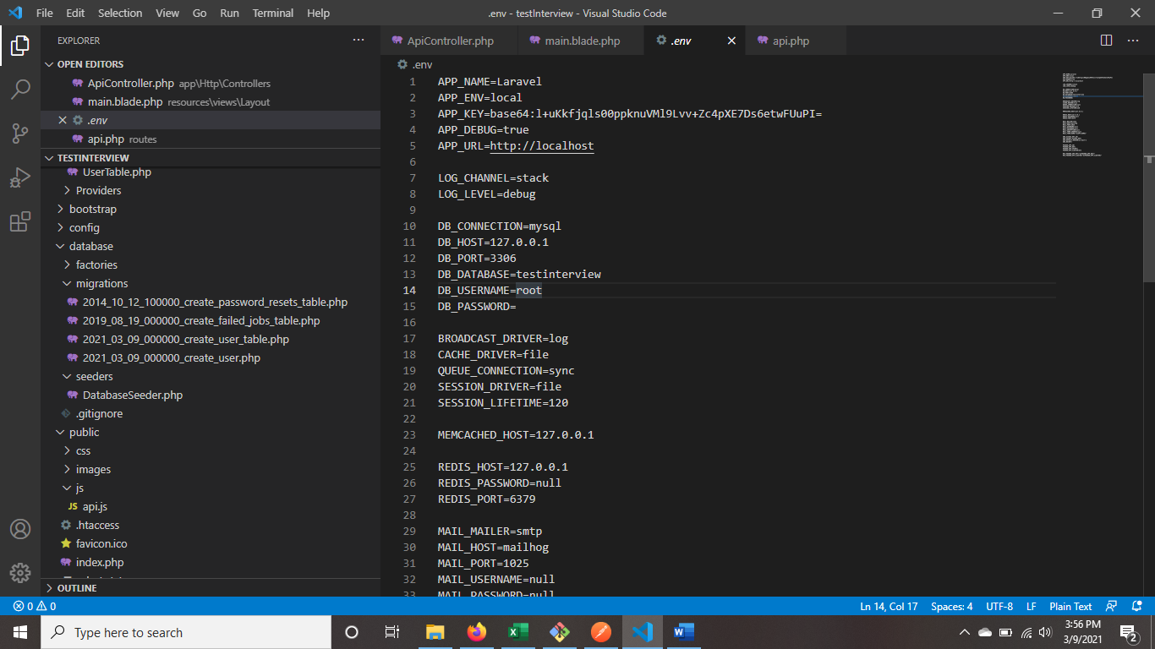

New record for login user_id : 1, password : 1, status : ‘Active’, position : ‘IT’



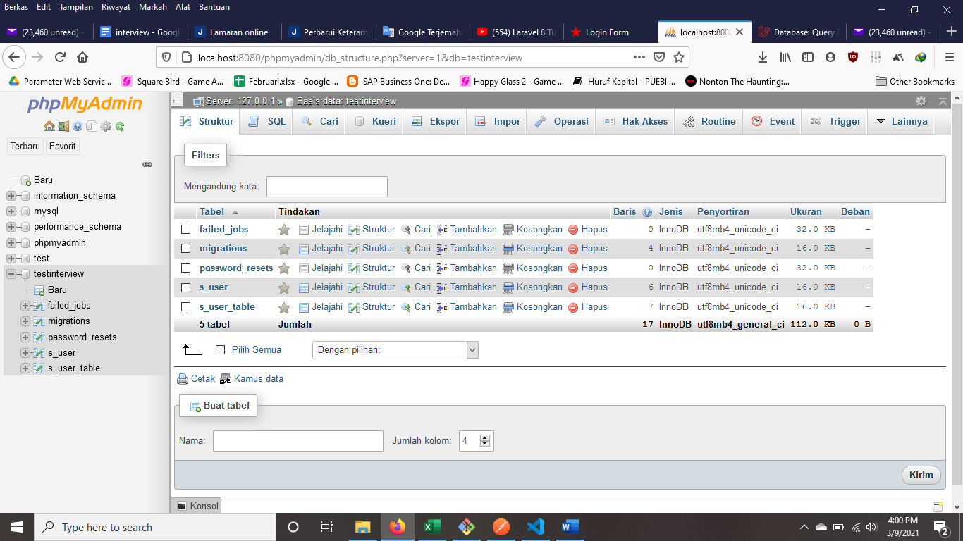

1. Only ‘**Active**’ user can Log In !

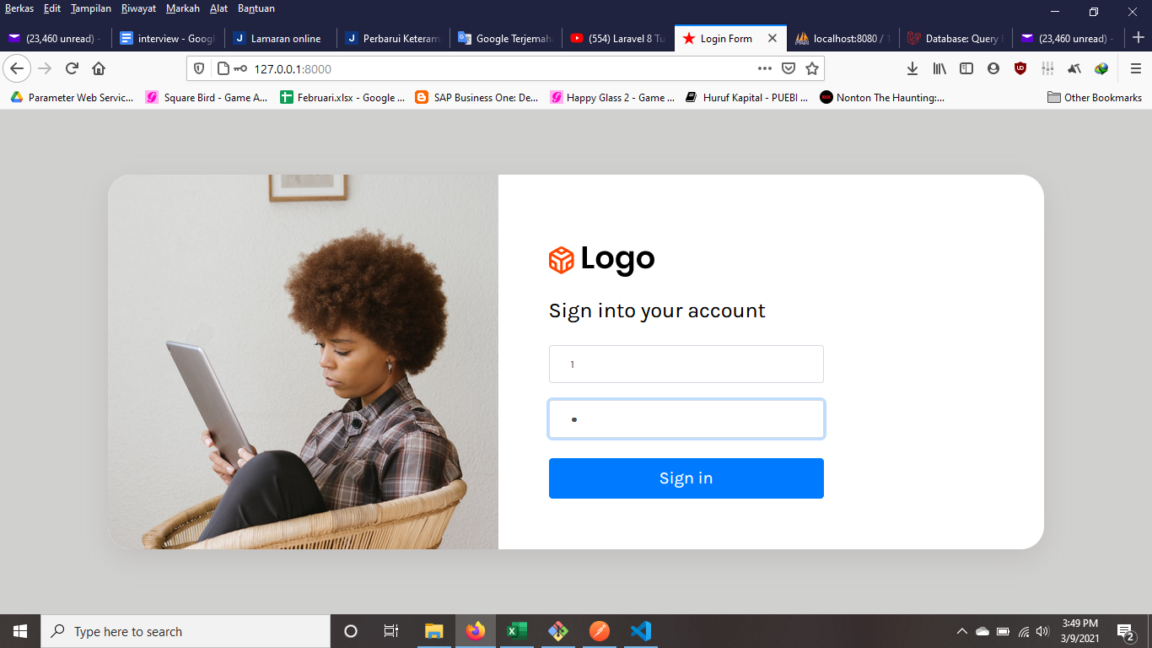

1. Dashboard Page

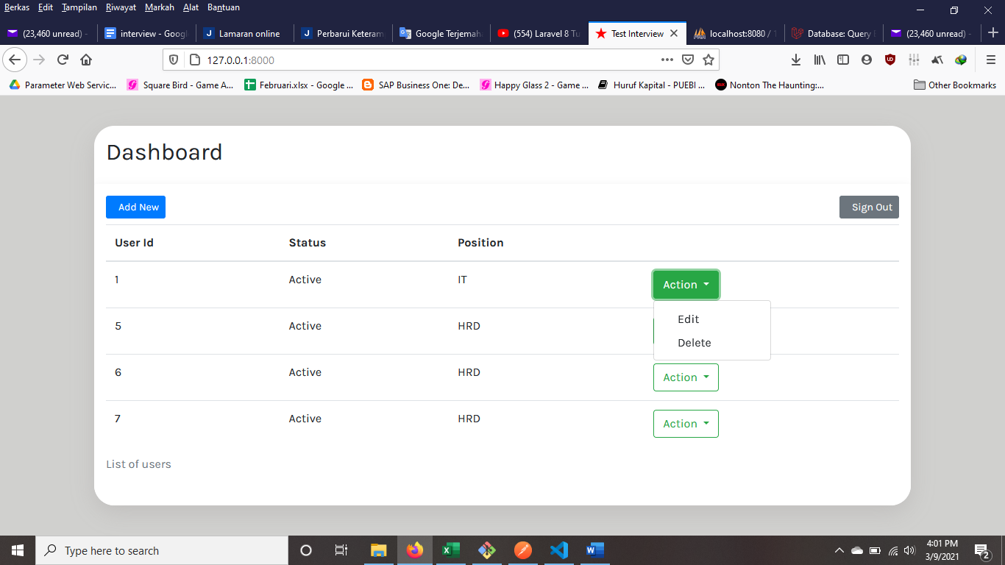

5

4

3

2

1

1. Add New (Create new record)
2. Sign Out
3. Edit (Change record)
4. Delete (Remove record)
5. List Read table ‘s_user_table’
6. GET API (read table)

localhost:8000/api/get

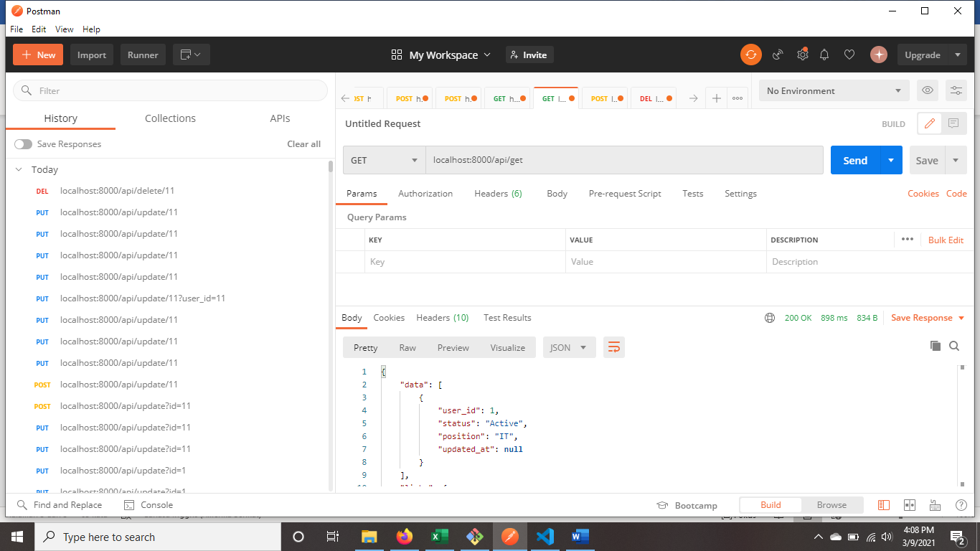

1. POST API (create record)

localhost:8000/api/post

json :

{

    "status" : "Active",

    "position" : "HRD"

}

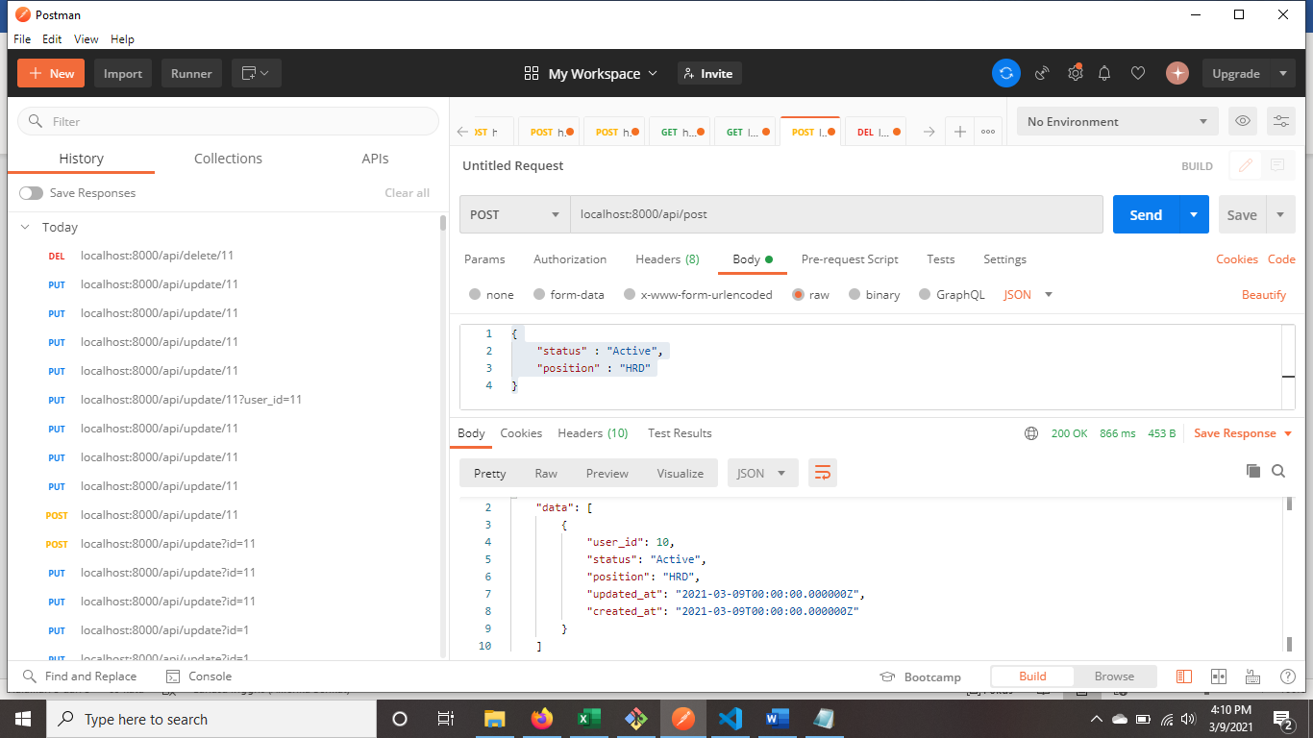

1. PUT API (update record)

localhost:8000/api/update/7

json :

{

    "status" : "Active",

    "position" : "GM"

}

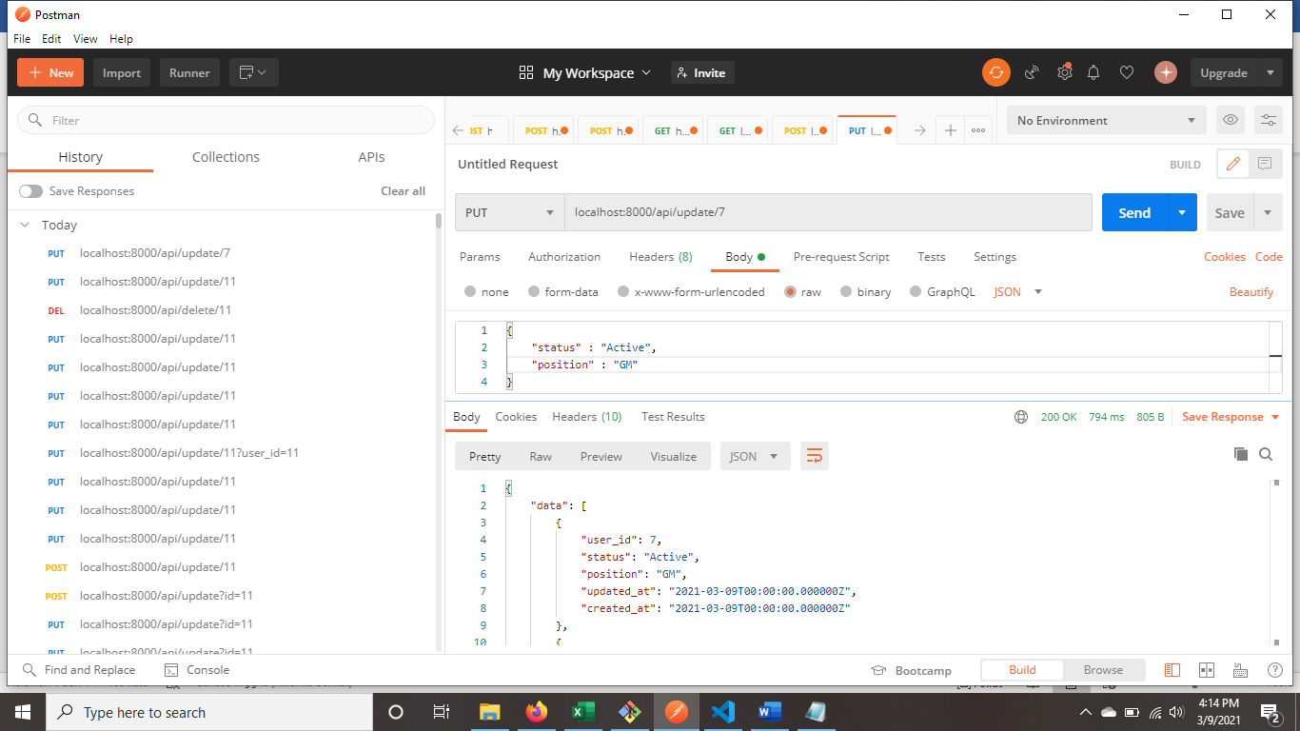

1. DELETE API (delete record)

localhost:8000/api/delete/7

