rainrs-server documentation
Rain Ripple Key Generator - server component
Capture processing, ripple feature extraction and Runge-Kutta key derivation
Version 0.1.0 | 22 October 2026 | Repository: Fauzst/RainRippleV3 | Branch: feat/image_process

Table of contents
- 1. Overview
- 2. Component diagram
- 3. Activity diagram (processing pipeline)
- 4. Class diagram (module design)
- 5. Sequence diagram (runtime behaviour)
- 6. Entity relationship diagram (database)
- 7. Data flow and storage layout
- 8. Command line usage
- 9. Security considerations
- 10. Limitations and known issues
- 11. Verification results

1. Overview
The server component of the Rain Ripple Key Generator turns captured rain ripple images into experimental key material. The pipeline has two stages.
Stage 1 - feature extraction: every capture in storage/images/raw is passed through the trained YOLO26 detector (model/content/runs/detect/rain_ripple_yolo26_cpu/weights/best.pt). For every detected ripple the centre position, the bounding box and the equivalent radius are measured. The measurements are stored in the SQLite database and in a JSON document (storage/features/<name>.json). Captures with measurable ripples are moved to storage/images/processed; captures without any ripple are deleted.
Stage 2 - key derivation: the stored attributes are fed into a Runge-Kutta integration of a coupled oscillator system. The averaged attributes of an image produce one master key; every individual ripple produces one slave key that is bound to its master key. All keys are written to the SQLite database.
The generated material is an experimental research artifact. It is not a production cryptographic key - see section 9.

2. Component diagram
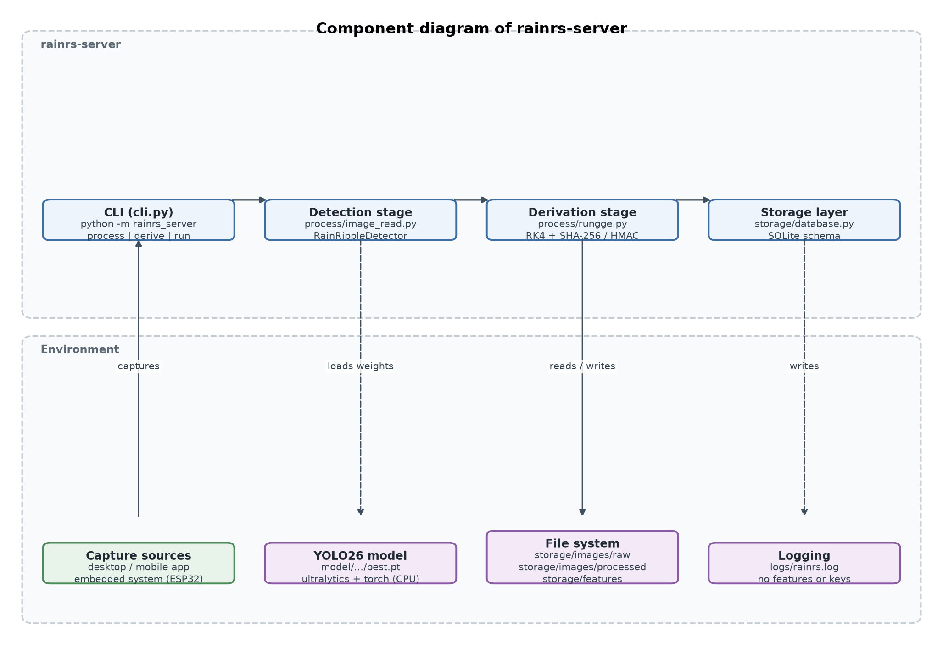
Figure 1 - Components of rainrs-server and their environment.

3. Activity diagram (processing pipeline)
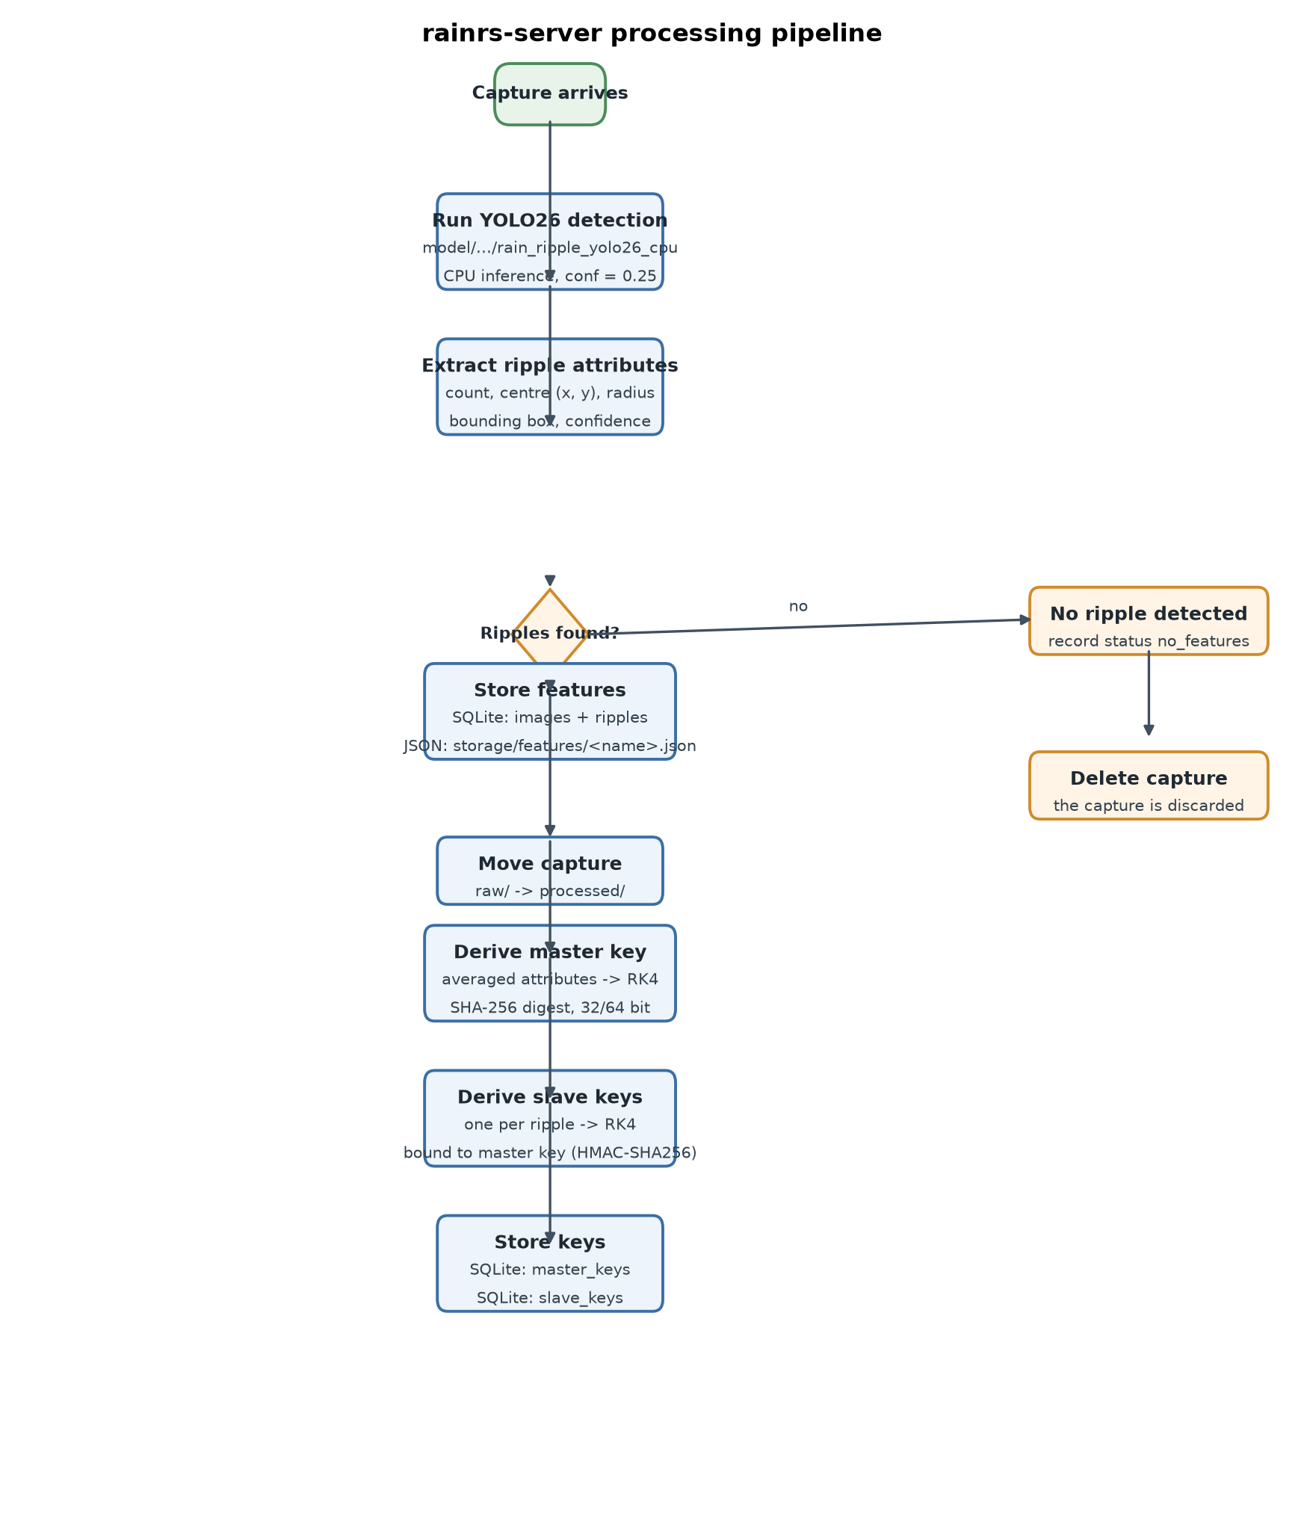
Figure 2 - Activity flow of the capture processing pipeline.

4. Class diagram (module design)
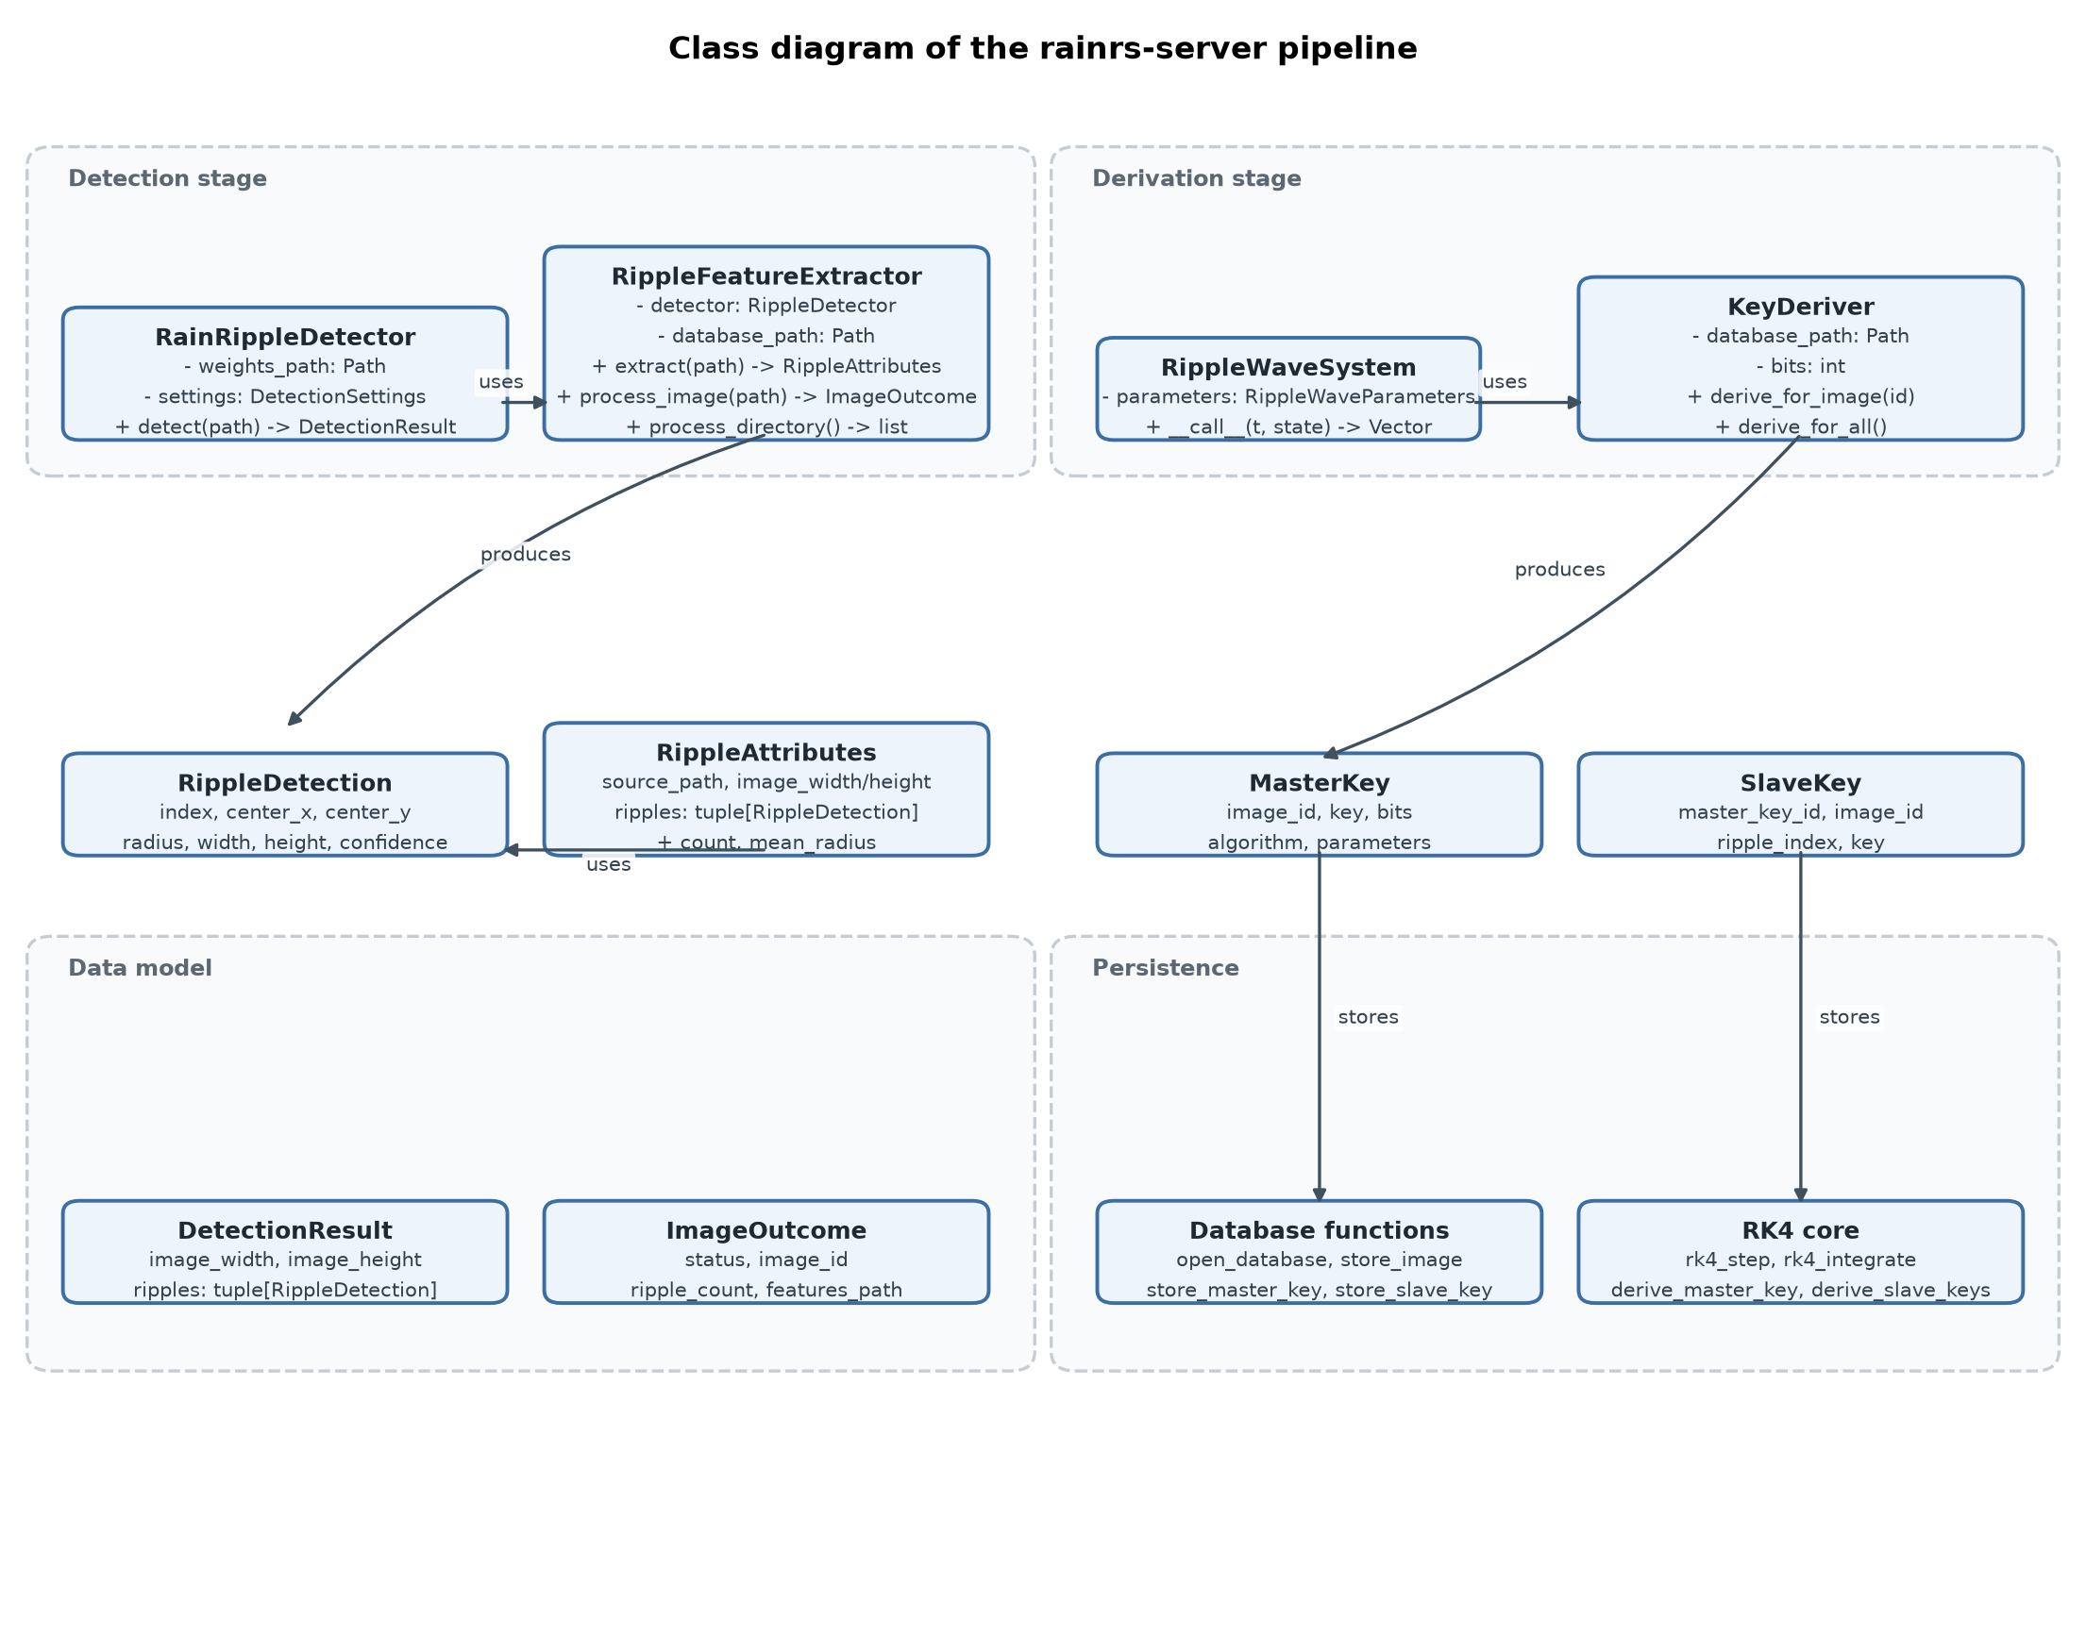
Figure 3 - Classes of the detection stage, the derivation stage, the data model and the persistence layer.

5. Sequence diagram (runtime behaviour)
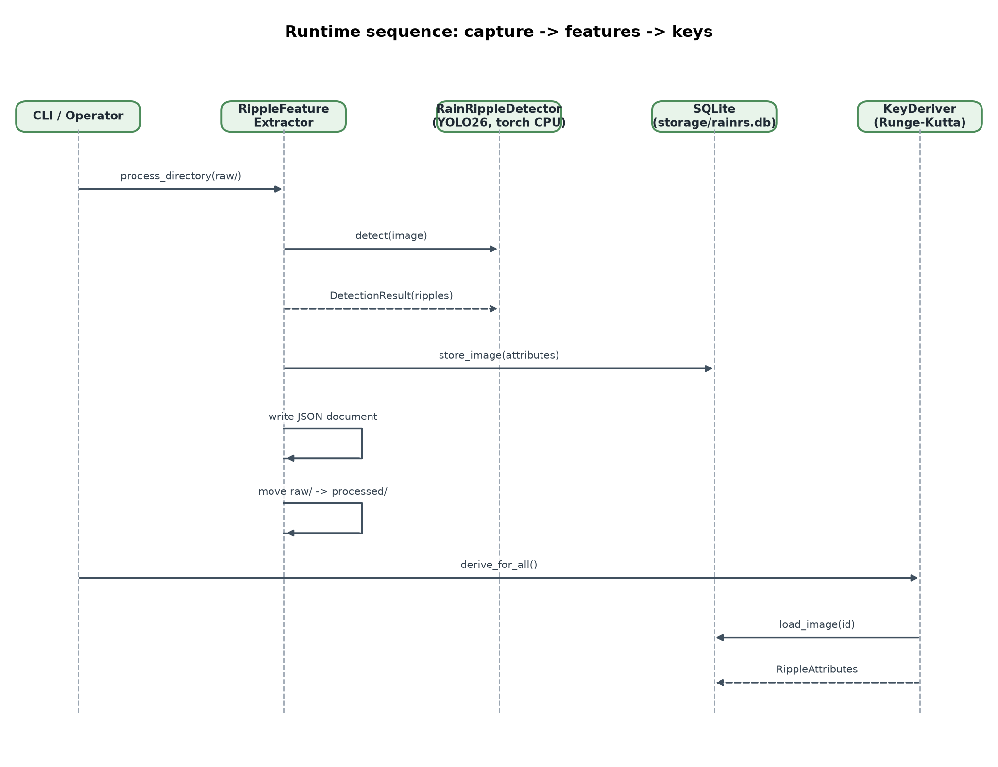
Figure 4 - Runtime sequence between the CLI, the extraction stage, the detector, the database and the derivation stage.

6. Entity relationship diagram (database)
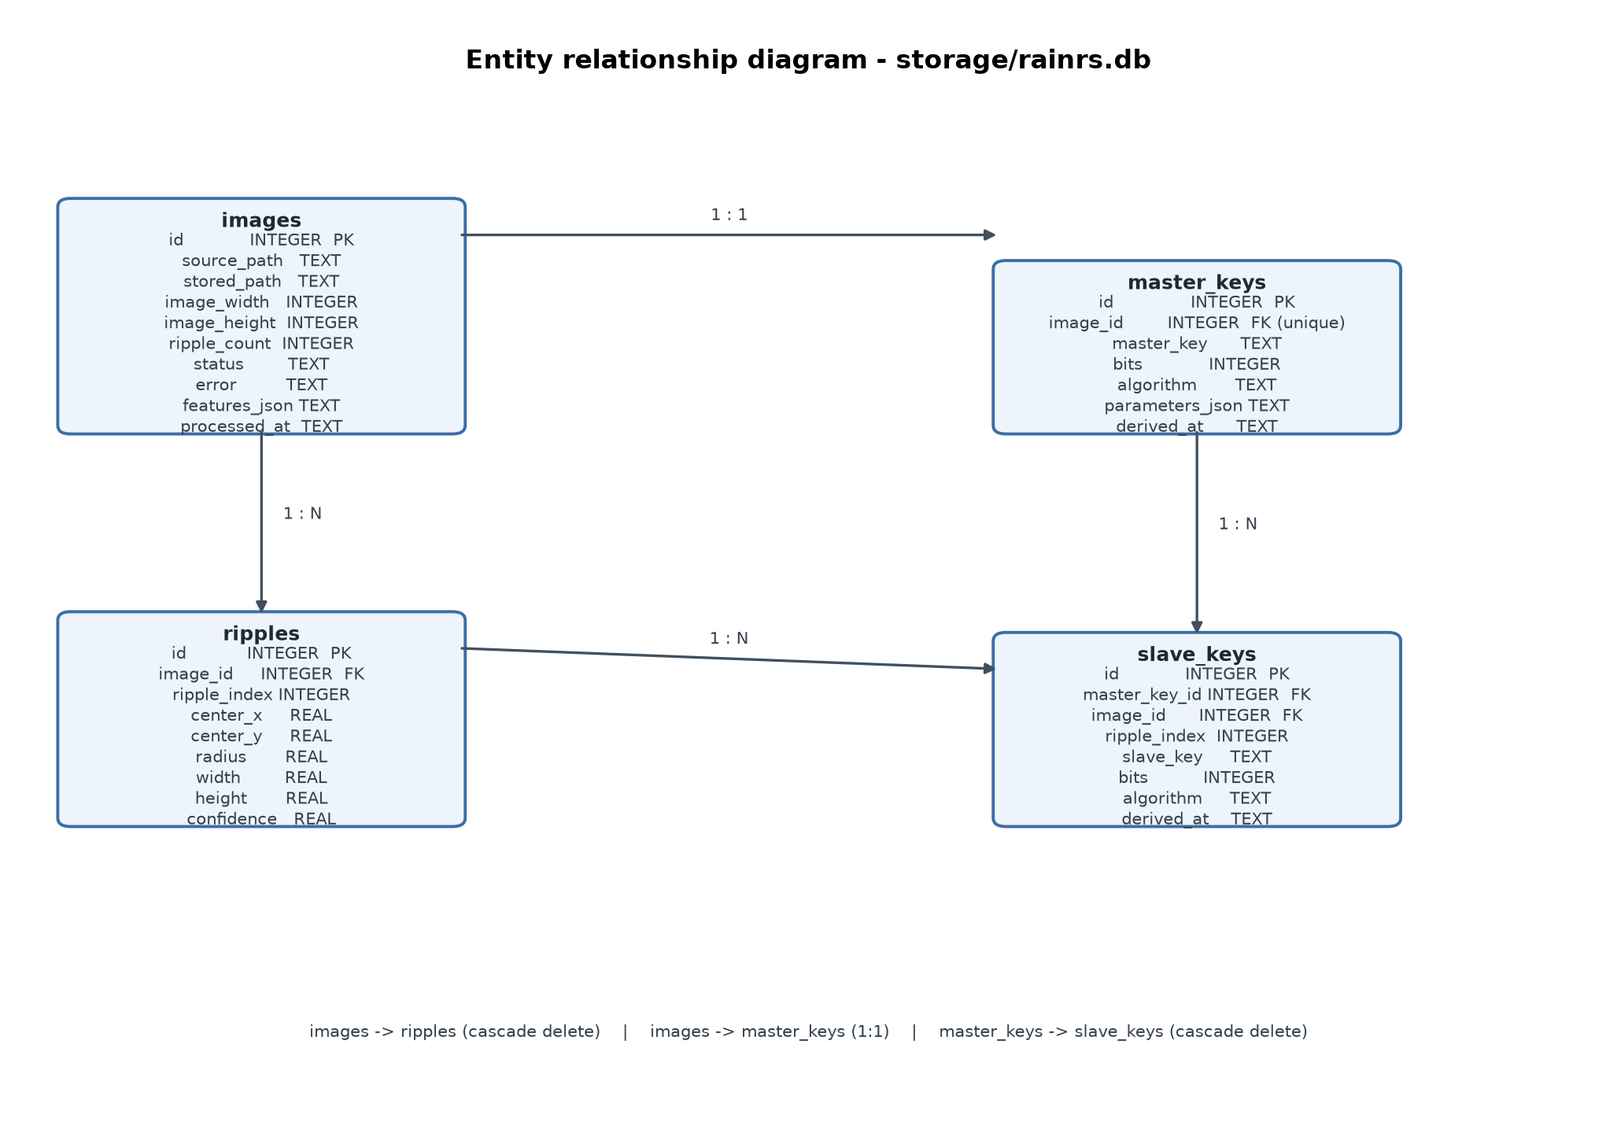
Figure 5 - Tables of storage/rainrs.db and their relationships.
Table | Purpose | Key columns
images | One row per processed capture | id, source_path, stored_path, status, features_json
ripples | One row per detected ripple | id, image_id (FK), center_x/y, radius, confidence
master_keys | Exactly one master key per capture | id, image_id (FK, unique), master_key, bits, algorithm
slave_keys | One row per ripple, bound to a master key | id, master_key_id (FK), image_id (FK), ripple_index, slave_key

7. Data flow and storage layout
rainrs-server/
model/content/runs/detect/rain_ripple_yolo26_cpu/weights/best.pt
storage/
images/raw/ incoming captures (deleted when no ripple)
images/processed/ captures whose features were extracted
features/ JSON attribute documents
rainrs.db SQLite database (features + keys)
logs/rainrs.log pipeline log (no features, no key material)
docs/ this document
The attribute document of one capture looks like this:
{
"image_id": 3,
"image_width": 200,
"image_height": 113,
"ripple_count": 2,
"mean_center_x": 95.01714324951172,
"mean_center_y": 55.14802551269531,
"mean_radius": 10.720739364624023,
"ripples": [
{"index": 0, "center_x": 118.47, "center_y": 37.17,
"radius": 15.68, "width": 29.61, "height": 33.13,
"confidence": 0.5669}
]
}

8. Command line usage
All commands are executed from the rainrs-server directory with uv:
uv sync # install the dependencies
uv run python -m rainrs_server process --print
uv run python -m rainrs_server derive --bits 64
uv run python -m rainrs_server run --print
Command | Effect
process | Detects ripples in storage/images/raw and stores the features.
derive | Derives the master and slave keys from the stored attributes.
run | Runs the detection stage and the derivation stage in sequence.
--print | Enables the development console printing (stdout only).
--no-move | Keeps the captures in the raw directory (dry run).
--keep-no-features | Keeps captures without a detected ripple.
--bits 32|64 | Size of the generated research artifacts.
--binding hmac|xor | Binding of the slave keys to their master key.
The development printing is switched on with the environment variable RAINRS_DEV_PRINT=1 and is implemented in a single place (rainrs_server/process/dev.py), so it can be removed with one edit. It writes to stdout only and never to the log file.

9. Security considerations
- The generated 32/64 bit values are experimental research artifacts. They are far too short for cryptographic use and have not been evaluated with a statistical test suite (for example NIST SP 800-22).
- The derivation is deterministic: the same capture always produces the same key. The unpredictability of the artifact comes from the physical capture, not from the algorithm. An attacker who knows the capture can recompute the key.
- Production encryption must use established cryptographic libraries, approved algorithms and keys generated by a CSPRNG.
- The slave keys are bound to their master key with HMAC-SHA256 instead of a plain XOR: XOR lets two equal inputs cancel out and does not separate the child key from the parent. The XOR variant remains available for comparison.
- The log file never contains captures, derived features or key material. Only file names, counters, statuses and timings are recorded.
- The SQLite database holds derived features and key material; it is excluded from version control.

10. Limitations and known issues
- The detector runs on the CPU; a single 200x113 pixel capture needs a few seconds, so the pipeline is not suited for a high capture rate.
- The trained model was trained at 416 pixel inputs; the captures of the sample set are much smaller and are upscaled during inference.
- The key derivation has not been evaluated statistically. No entropy estimate, no min-entropy analysis and no statistical test results exist yet.
- The extraction stage stores the ripple geometry in pixels of the source image. A capture with a different resolution therefore produces different attributes, which is intended but has to be kept in mind when comparing captures.
- The CLI writes the derived key material only to the database; there is no API surface yet. The API design is still undecided in agent/PLAN.md.

11. Verification results
The pipeline was executed on the ten sample captures of storage/images/raw on the reference host (Debian 13, Intel Core i5-6500, 4 cores, no GPU). Every capture was processed successfully.
Stage | Result
Detection | 10 of 10 captures processed, 0 errors, 37 ripples detected
No-feature branch | verified with conf = 0.95: capture deleted, status no_features
Error branch | verified with a corrupt capture: error logged, capture kept
Key derivation | 10 master keys and 37 slave keys stored
Unit tests | 50 tests pass (pytest)
Lint / format | ruff check and ruff format --check pass
Type check | mypy reports no issues
The measured numbers are documented in agent/PROGRESS.md of the rainrs-server application.

