Lab Cycle 2
CO2: Apply client-side scripting techniques to enforce input validation and enhance user interaction.

PROGRAM 6:
Create an HTML page to demonstrate the use of various predefined functions in a string and math object in java script.
PROGRAM CODE:

Functions.html
<html>
<head>
<title>JavaScript Functions</title>
<style>
body {
font-family: sans-serif;
padding: 20px;
}
.container {
max-width: 600px;
margin: auto;
border: 1px solid #ccc;
padding: 20px;
background-color: #e3e3e3;
border-radius: 8px;
}
input[type="text"] {
width: 95%;
padding: 8px;
margin-bottom: 10px;
}
button {
margin: 5px;
padding: 8px 12px;
cursor: pointer;
background-color: #dbffc8;
border: 1px solid #4CAF50;
}
#result, #result2 {
font-weight: bold;
color: #0056b3;
}
h2 {
border-bottom: 1px solid #eee;
padding-bottom: 5px;
}
h1 {
text-align: center;
}
section {
display: flex;
justify-content: space-around;
flex-wrap: wrap;
gap: 20px;
}
</style>
</head>
<body>

<h1>String and Math Functions</h1>

<section>
<div class="container">

<label for="inputBox">Enter text:</label>
<input type="text" id="inputBox" placeholder="Your input here...">

<p>Result: <span id="result"></span></p>

<h2>String Functions</h2>
<button onclick="getStringLength()">Length</button>
<button onclick="convertToUpperCase()">To Upper Case</button>
<button onclick="convertToLowerCase()">To Lower Case</button>
<button onclick="getCharacterAt()">Character At Index 2</button>
<button onclick="sliceString()">Slice (0 to 4)</button>
<button onclick="replaceText()">Replace 'haha' with 'hehee'</button>
</div>

<div class="container">

<label for="inputBox">Enter a number:</label>
<input type="text" id="inputBox2" placeholder="Your input here...">

<p>Result: <span id="result2"></span></p>

<h2>Math Functions (Input should be a number)</h2>
<button onclick="getSquareRoot()">Square Root</button>
<button onclick="roundNumber()">Round</button>
<button onclick="getCeil()">Ceiling</button>
<button onclick="getFloor()">Floor</button>
<button onclick="getAbsolute()">Absolute Value</button>
<button onclick="showRandom()">Random Number</button>
</div>
</section>

<script>
function getInputElement(box) {
return document.getElementById(box);
}

function getResultElement(resultBox) {
return document.getElementById(resultBox);
}

function getStringLength() {
var input = getInputElement('inputBox').value;
getResultElement('result').innerText = "Length is: " + input.length;
}

function convertToUpperCase() {
var input = getInputElement('inputBox').value;
getResultElement('result').innerText = input.toUpperCase();
}

function convertToLowerCase() {
var input = getInputElement('inputBox').value;
getResultElement('result').innerText = input.toLowerCase();
}

function getCharacterAt() {
var input = getInputElement('inputBox').value;
if (input.length > 2) {
getResultElement('result').innerText = "Character at index 2 is: " + input.charAt(2);
} else {
getResultElement('result').innerText = "Input is too short.";
}
}

function sliceString() {
var input = getInputElement('inputBox').value;
getResultElement('result').innerText = "Sliced string is: " + input.slice(0, 4);
}

function replaceText() {
var input = getInputElement('inputBox').value;
getResultElement('result').innerText = input.replace("haha", "hehee");
}

function getSquareRoot() {
var input = getInputElement('inputBox2').value;
var number = parseFloat(input);
if (isNaN(number)) {
getResultElement('result2').innerText = "Please enter a valid number.";
} else {
getResultElement('result2').innerText = "Square root is: " + Math.sqrt(number);
}
}

function roundNumber() {
var input = getInputElement('inputBox2').value;
var number = parseFloat(input);
if (isNaN(number)) {
getResultElement('result2').innerText = "Please enter a valid number.";
} else {
getResultElement('result2').innerText = "Rounded value is: " + Math.round(number);
}
}

function getCeil() {
var input = getInputElement('inputBox2').value;
var number = parseFloat(input);
if (isNaN(number)) {
getResultElement('result2').innerText = "Please enter a valid number.";
} else {
getResultElement('result2').innerText = "Ceiling value is: " + Math.ceil(number);
}
}

function getFloor() {
var input = getInputElement('inputBox2').value;
var number = parseFloat(input);
if (isNaN(number)) {
getResultElement('result2').innerText = "Please enter a valid number.";
} else {
getResultElement('result2').innerText = "Floor value is: " + Math.floor(number);
}
}

function getAbsolute() {
var input = getInputElement('inputBox2').value;
var number = parseFloat(input);
if (isNaN(number)) {
getResultElement('result2').innerText = "Please enter a valid number.";
} else {
getResultElement('result2').innerText = "Absolute value is: " + Math.abs(number);
}
}

function showRandom() {
getResultElement('result2').innerText = "Random number (0-1): " + Math.random();
}
</script>

</body>
</html>

OUTPUT:

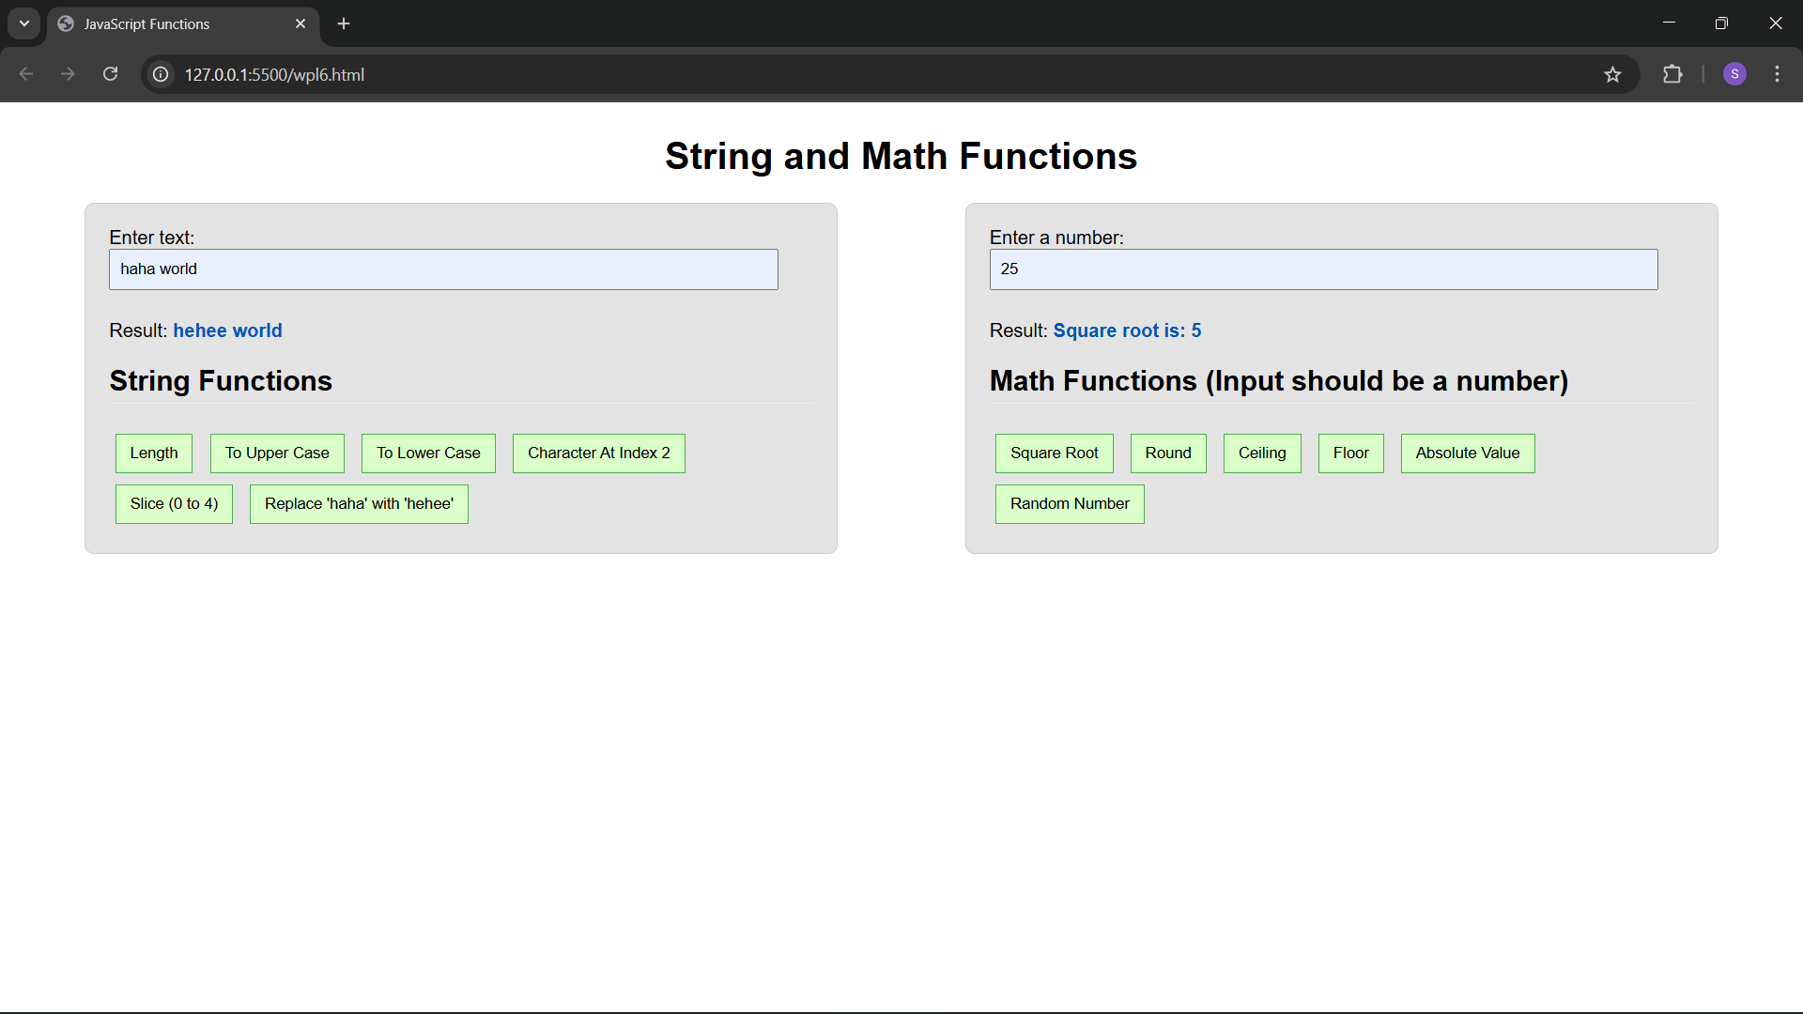

PROGRAM 7:
Generate a calendar using JavaScript code by getting the year and month from the user.
PROGRAM CODE:

calender.html
<html>
<head>

<title>Calendar</title>
<style>
body {
font-family: Arial, Helvetica, sans-serif;
background: #ffffff;
color: #000000;
padding: 20px;
}

.controls {
max-width: 420px;
border: 2px solid #000;
padding: 10px;
background: #f9f9f9;
}

.controls label {
display: block;
margin-bottom: 6px;
font-weight: bold;
}

.controls input[type="number"] {
width: 100%;
padding: 6px;
font-size: 16px;
border: 1px solid #000;
margin-bottom: 8px;
box-sizing: border-box;
background: #ffffff;
}

.controls .buttons {
margin-top: 6px;
}

button {
padding: 6px 10px;
font-size: 16px;
border: 1px solid #000;
background: #e0e0e0;
cursor: pointer;
margin-right: 6px;
}

.calendar {
max-width: 420px;
margin-top: 14px;
border: 2px solid #000;
padding: 6px;
background: #fff;
}

table {
width: 100%;
border-collapse: collapse;
font-size: 14px;
}

th, td {
border: 1px solid #000;
padding: 8px;
text-align: center;
}

th {
background: #dddddd;
font-weight: bold;
}

td.inactive {
color: #888888;
background: #fafafa;
}

td.today {
background: #ffff99;
}

.cal-header {
margin-bottom: 8px;
font-weight: bold;
text-align: left;
}

.footer {
margin-top: 8px;
font-size: 13px;
}
</style>
</head>
<body>
<div class="controls">
<label>
Year
<input id="yearInput" type="number" min="1" max="9999" value="" />
</label>
<label>
Month (1-12)
<input id="monthInput" type="number" min="1" max="12" value="" />
</label>
<div class="buttons">
<button id="showBtn">Show</button>
</div>
</div>

<div id="calendarContainer" class="calendar"></div>

<script>
var yearInput = document.getElementById('yearInput');
var monthInput = document.getElementById('monthInput');
var showBtn = document.getElementById('showBtn');
var container = document.getElementById('calendarContainer');

var monthNames = ["January","February","March","April","May","June","July","August","September","October","November","December"];
var dayNames = ["Sun","Mon","Tue","Wed","Thu","Fri","Sat"];

function renderCalendar(year, month) {
year = parseInt(year, 10);
month = parseInt(month, 10);

if (isNaN(year) || isNaN(month) || month < 1 || month > 12) {
container.innerHTML = '<div class="cal-header">Invalid year or month</div>';
return;
}

var firstDayIndex = new Date(year, month - 1, 1).getDay();
var daysInMonth = new Date(year, month, 0).getDate();
var prevMonthDays = new Date(year, month - 1, 0).getDate();

var html = '';
html += '<div class="cal-header">' + monthNames[month - 1] + ' ' + year + '</div>';
html += '<table>';
html += '<thead><tr>';
for (var d = 0; d < 7; d++) {
html += '<th>' + dayNames[d] + '</th>';
}
html += '</tr></thead><tbody>';

var day = 1;
var started = false;

for (var week = 0; week < 6; week++) {
if (started && day > daysInMonth) {
break;
}

html += '<tr>';
for (var dow = 0; dow < 7; dow++) {
var cell = '';
if (!started && dow === firstDayIndex) {
started = true;
}

if (!started) {
var num = prevMonthDays - (firstDayIndex - 1 - dow);
cell = '<td class="inactive">' + num + '</td>';
} else if (day > daysInMonth) {
var nextDay = day - daysInMonth;
cell = '<td class="inactive">' + nextDay + '</td>';
day++;
} else {
cell = '<td>' + day + '</td>';
day++;
}
html += cell;
}
html += '</tr>';
}

html += '</tbody></table>';
container.innerHTML = html;
}

function showFromInputs() {
var now = new Date();
var defaultYear = now.getFullYear();
var defaultMonth = now.getMonth() + 1;

var y = yearInput.value || defaultYear;
var m = monthInput.value || defaultMonth;
renderCalendar(y, m);
}

var now = new Date();
yearInput.value = now.getFullYear();
monthInput.value = now.getMonth() + 1;
renderCalendar(yearInput.value, monthInput.value);

showBtn.addEventListener('click', showFromInputs);

yearInput.addEventListener('keydown', function (e) {
if (e.key === 'Enter') {
showFromInputs();
}
});
monthInput.addEventListener('keydown', function (e) {
if (e.key === 'Enter') {
showFromInputs();
}
});

monthInput.addEventListener('input', function () {
var m = parseInt(monthInput.value, 10);
if (isNaN(m)) return;
if (m < 1) monthInput.value = 1;
if (m > 12) monthInput.value = 12;
});

yearInput.addEventListener('input', function () {
var y = parseInt(yearInput.value, 10);
if (isNaN(y)) return;
if (y < 1) yearInput.value = 1;
if (y > 9999) yearInput.value = 9999;
});
</script>
</body>
</html>
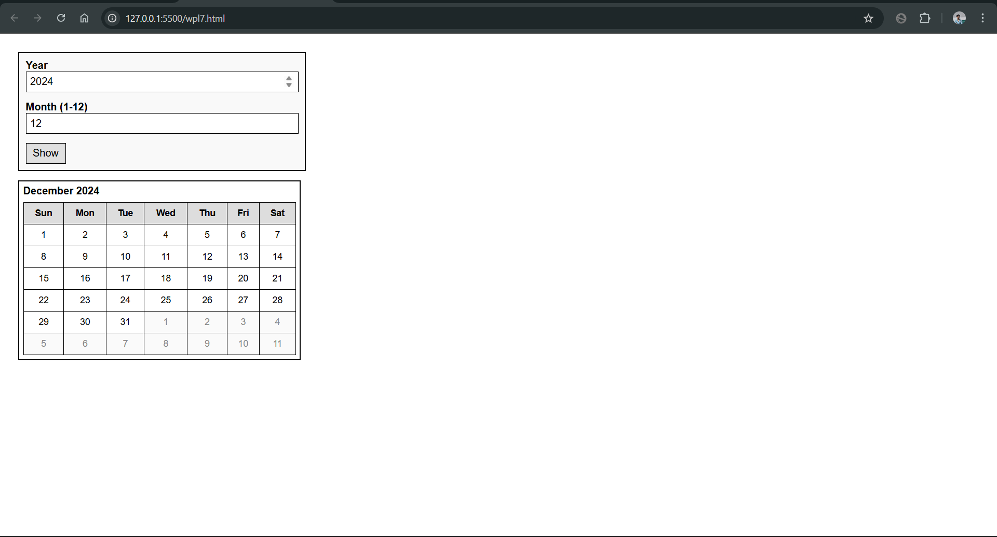
OUTPUT:
PROGRAM 8:
Create a program using the JavaScript Event Listener to add multiple events on the same button.
PROGRAM CODE:

btnEvents.html
<html>
<head>
<title>Js Multiple Events</title>
<style>
body { font-family: Arial, sans-serif; margin: 2rem; background: #fff; color: #111; }
h1 { font-size: 1.1rem; margin-bottom: 0.5rem; }
#btn { padding: 0.5rem 0.8rem; margin-bottom: 0.5rem; }
</style>
</head>
<body>
<div class="container">
<h1>Multiple events on button</h1>

<button id="btn" type="button">Press Me</button>
</div>

<script>
const btn = document.getElementById('btn');

btn.addEventListener('mouseover', mOn);
btn.addEventListener('click', mClick);
btn.addEventListener('mouseout', mMiss);

function appendEntry(text) {
const tn = document.createTextNode(text);
document.body.appendChild(tn);
document.body.appendChild(document.createElement('br'));
}

function mOn() {
appendEntry('Mouse over');
}
function mClick() {
appendEntry('Clicked');
}
function mMiss() {
appendEntry('Mouse out');
}
</script>
</body>
</html>

OUTPUT:

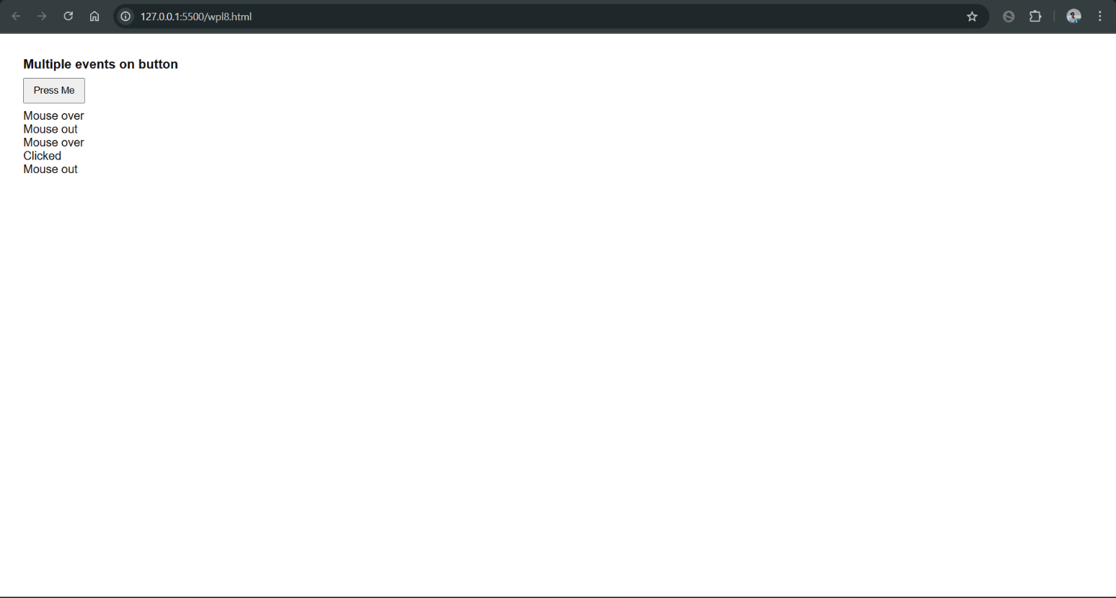

PROGRAM 9:
Develop a JavaScript Event Handling mechanism to change the background colour of an HTML page.
PROGRAM CODE:

bgColor.html
<html>
<head>
<title>Change BG Color</title>
<style>
body {
font-family: sans-serif;
margin: 0;
background: white;
display: flex;
flex-direction: column;
align-items: center;
justify-content: center;
min-height: 100vh;
}
.box {
width: 280px;
padding: 18px;
border: 1px solid #ccc;
border-radius: 6px;
text-align: center;
}
button {
margin-top: 12px;
padding: 8px 12px;
cursor: pointer;
}
</style>
</head>
<body>
<div class="box">
<div>Click the button to change the bgcolor</div>
<button id="changeBtn">change bgcolor</button>
</div>

<script>
document.getElementById('changeBtn').addEventListener('click', function () {
document.body.style.backgroundColor = 'grey';
});
</script>
</body>
</html>

OUTPUT:

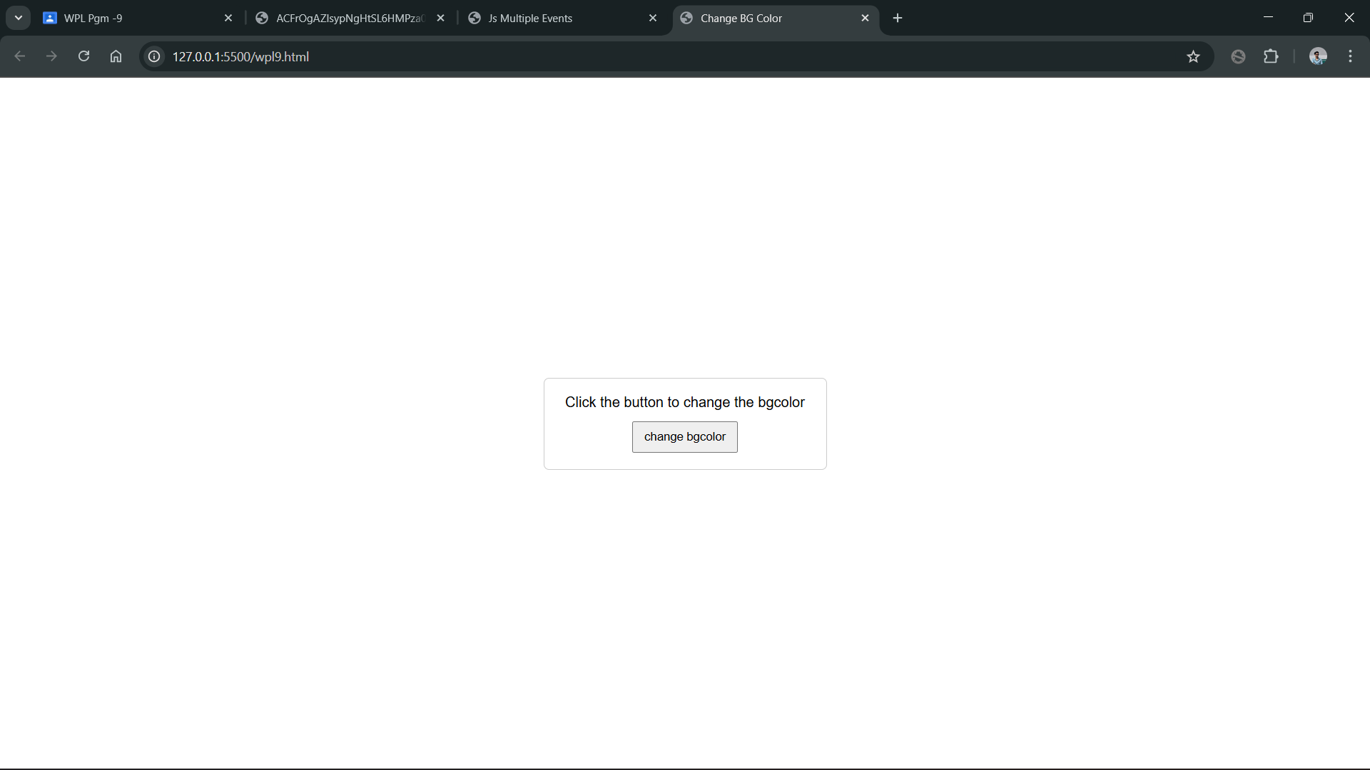
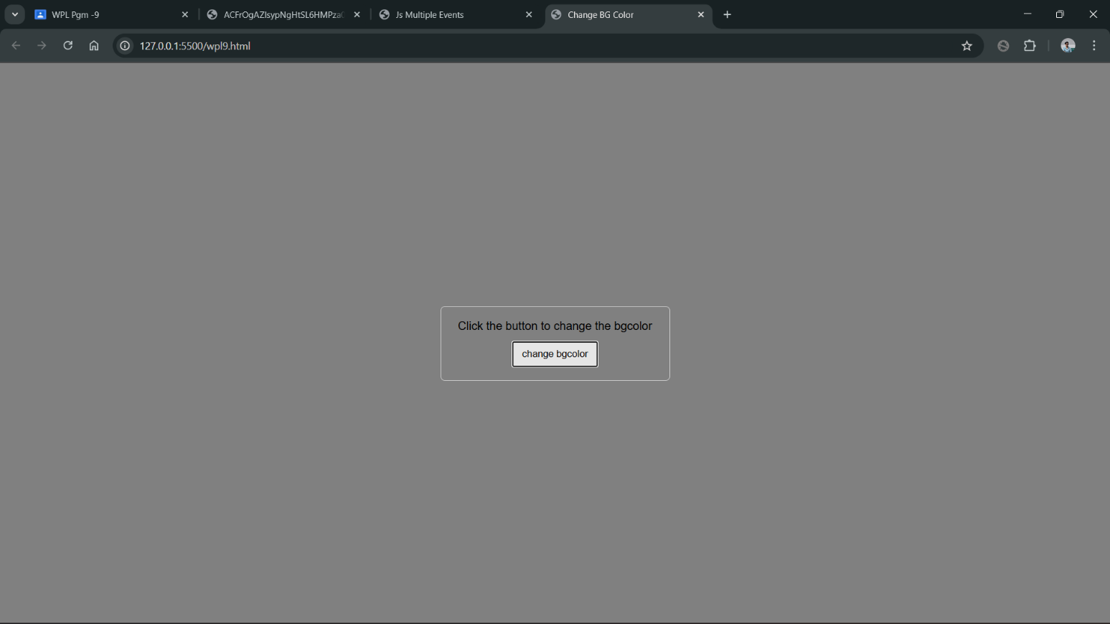
PROGRAM 10:
Create an HTML page to display a new image and text when the mouse comes over the existing content in the page using JavaScript Event Handling mechanism.
PROGRAM CODE:

index.html
<html>
<head>
<title>Mouse Over Image</title>
<style>
body { font-family: Arial, sans-serif; padding: 30px; background: #f7f7f7; }
#card { width: 320px; padding: 10px; background: #fff; border: 1px solid #ddd; border-radius: 6px; text-align: center; cursor: pointer; }
#card img { max-width: 100%; height: auto; display: block; margin: 0 auto 10px; }
#caption { color: #333; margin: 0; }
</style>
</head>
<body>
<h2>Simple Mouseover Events</h2>

<div id="card" aria-label="Interactive card">
<img id="pic" src="./original.png" alt="Original image">
<p id="caption">This is the original image. Move your mouse over the box.</p>
</div>

<script>
var card = document.getElementById('card');
var pic = document.getElementById('pic');
var caption = document.getElementById('caption');

var originalSrc = pic.src;
var originalText = caption.textContent;

var hoverSrc = "./new.png";
var hoverText = "Nice, You hovered over it, here's new text and image.";

card.addEventListener('mouseover', function () {
pic.src = hoverSrc;
caption.textContent = hoverText;
});

card.addEventListener('mouseout', function () {
pic.src = originalSrc;
caption.textContent = originalText;
});
</script>
</body>
</html>

relative.css:
.box-container { border: 3px solid #0066cc; padding: 20px; margin: 40px; height: 300px;
background-color: #f0f8ff;
} .box { width: 150px; height: 100px; background-color: #4682b4; color: white; text-align: center; font-size: 1.2em; margin: 10px;
}
.relative-box { position: relative; right: 40px; bottom: 20px; background-color: #ff6347; z-index: 10;
}
.normal-box { background-color: #ccc;
color: #333;
}

absolute.css
.box { width: 150px; height: 100px; background-color: #4682b4; color: white; text-align: center; line-height: 100px; font-size: 1.2em; margin: 10px;
}
.absolute-container { position: relative; border: 3px solid #556b2f; padding: 20px; margin: 40px; height: 300px;
background-color: #f0fff0;
}
.absolute-box { position: absolute; right: 30px; bottom: 30px; background-color: #da70d6;
z-index: 10; margin: 0;
}
OUTPUT:
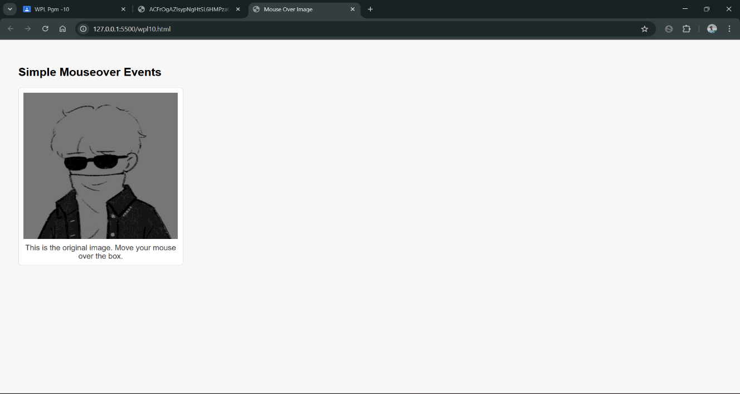

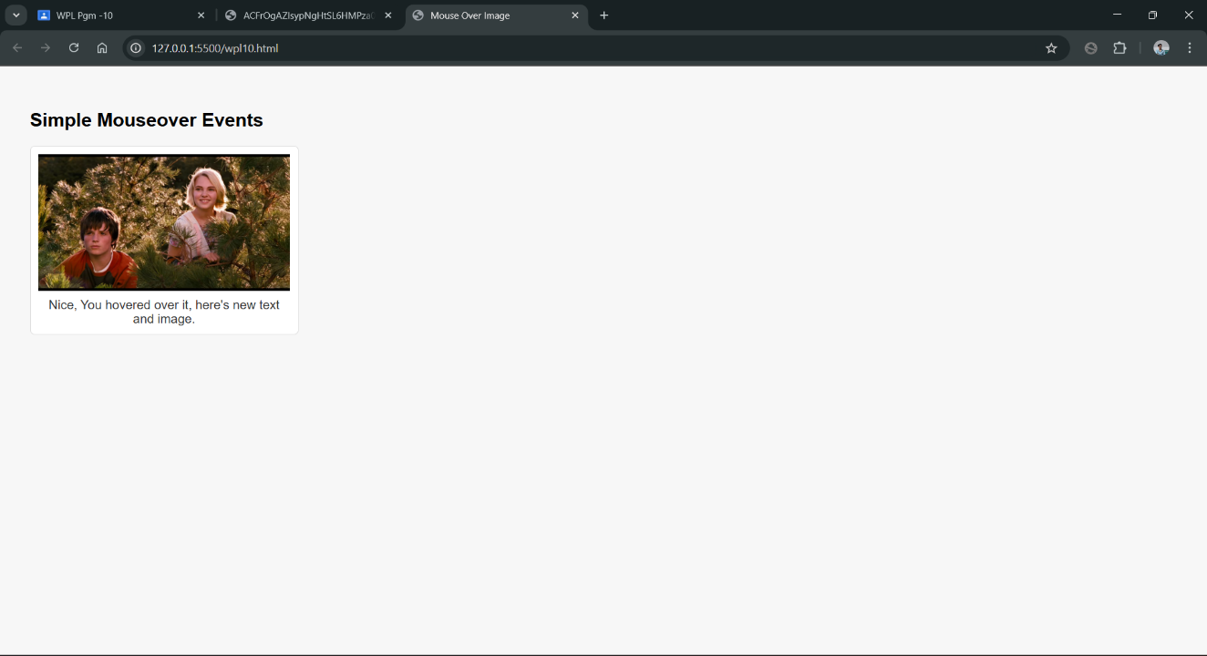

PROGRAM 11:
Create a HTML registration form and validate the form using JavaScript code. The validation should include the following:
1. Name validation/Mandatory field validation
2. password validation
3. Email validation
4. Mobile number validation
PROGRAM CODE:

form.html
<html>
<head>
<title>Registration Form</title>
<style>
body { font-family: Arial, sans-serif; background:#f7f7f7; padding:20px; }
.container { max-width:420px; margin:40px auto; padding:20px; border: 1px solid black}
h2 { margin-top:0; font-weight:600; }
.field { margin-bottom:14px; }
label { display:block; font-size:14px; margin-bottom:6px; }
input[type="text"], input[type="email"], input[type="password"], input[type="tel"] {
width:100%; padding:8px 10px; border:1px solid #ccc; box-sizing:border-box;
}
.error { color:#b00020; font-size:13px; margin-top:6px; display:none; }
.success { color:green; font-size:14px; margin-top:8px; display:none; }
button { padding:10px 14px; border:0; background:#0078d4; color:#fff; cursor:pointer; }
button:disabled { opacity:0.6; cursor:not-allowed; }
</style>
</head>
<body>
<div class="container">
<h2>Register</h2>
<form id="regForm" novalidate>
<div class="field">
<label for="name">Full name</label>
<input id="name" name="name" type="text" autocomplete="name" />
<div id="nameErr" class="error">Please enter your name (letters and spaces only).</div>
</div>

<div class="field">
<label for="email">Email</label>
<input id="email" name="email" type="email" autocomplete="email" />
<div id="emailErr" class="error">Please enter a valid email address.</div>
</div>

<div class="field">
<label for="mobile">Mobile number</label>
<input id="mobile" name="mobile" type="tel" inputmode="numeric" placeholder="10 digits" />
<div id="mobileErr" class="error">Please enter a valid 10-digit mobile number.</div>
</div>

<div class="field">
<label for="password">Password</label>
<input id="password" name="password" type="password" autocomplete="new-password" />
<div id="passwordErr" class="error">Password must be at least 8 chars, include upper and lower case letters and a number.</div>
</div>

<div style="margin-top:12px;">
<button type="submit" id="submitBtn">Create account</button>
</div>

<div id="formSuccess" class="success">Registration successful!</div>
</form>
</div>

<script>
const form = document.getElementById('regForm');
const nameInput = document.getElementById('name');
const emailInput = document.getElementById('email');
const mobileInput = document.getElementById('mobile');
const passwordInput = document.getElementById('password');

const nameErr = document.getElementById('nameErr');
const emailErr = document.getElementById('emailErr');
const mobileErr = document.getElementById('mobileErr');
const passwordErr = document.getElementById('passwordErr');
const formSuccess = document.getElementById('formSuccess');

function showError(el, msgEl) {
el.setAttribute('aria-invalid', 'true');
msgEl.style.display = 'block';
}
function clearError(el, msgEl) {
el.removeAttribute('aria-invalid');
msgEl.style.display = 'none';
}

function validateName() {
const val = nameInput.value.trim();
const ok = /^[A-Za-z ]{2,}$/.test(val);
if (!ok) showError(nameInput, nameErr); else clearError(nameInput, nameErr);
return ok;
}

function validateEmail() {
const val = emailInput.value.trim();
const ok = /^[^\s@]+@[^\s@]+\.[^\s@]{2,}$/.test(val);
if (!ok) showError(emailInput, emailErr); else clearError(emailInput, emailErr);
return ok;
}

function validateMobile() {
const val = mobileInput.value.replace(/\D/g, '');
const ok = /^\d{10}$/.test(val);
if (!ok) showError(mobileInput, mobileErr); else clearError(mobileInput, mobileErr);
return ok;
}

function validatePassword() {
const val = passwordInput.value;
const ok = /^(?=.*[a-z])(?=.*[A-Z])(?=.*\d).{8,}$/.test(val);
if (!ok) showError(passwordInput, passwordErr); else clearError(passwordInput, passwordErr);
return ok;
}

nameInput.addEventListener('input', validateName);
emailInput.addEventListener('input', validateEmail);
mobileInput.addEventListener('input', validateMobile);
passwordInput.addEventListener('input', validatePassword);

form.addEventListener('submit', function (e) {
e.preventDefault();
formSuccess.style.display = 'none';

const okName = validateName();
const okEmail = validateEmail();
const okMobile = validateMobile();
const okPassword = validatePassword();

if (okName && okEmail && okMobile && okPassword) {
formSuccess.style.display = 'block';
form.reset();
[nameErr, emailErr, mobileErr, passwordErr].forEach(el => el.style.display = 'none');
} else {
const firstInvalid = form.querySelector('[aria-invalid="true"]');
if (firstInvalid) firstInvalid.focus();
}
});
</script>
</body>
</html>

OUTPUT:

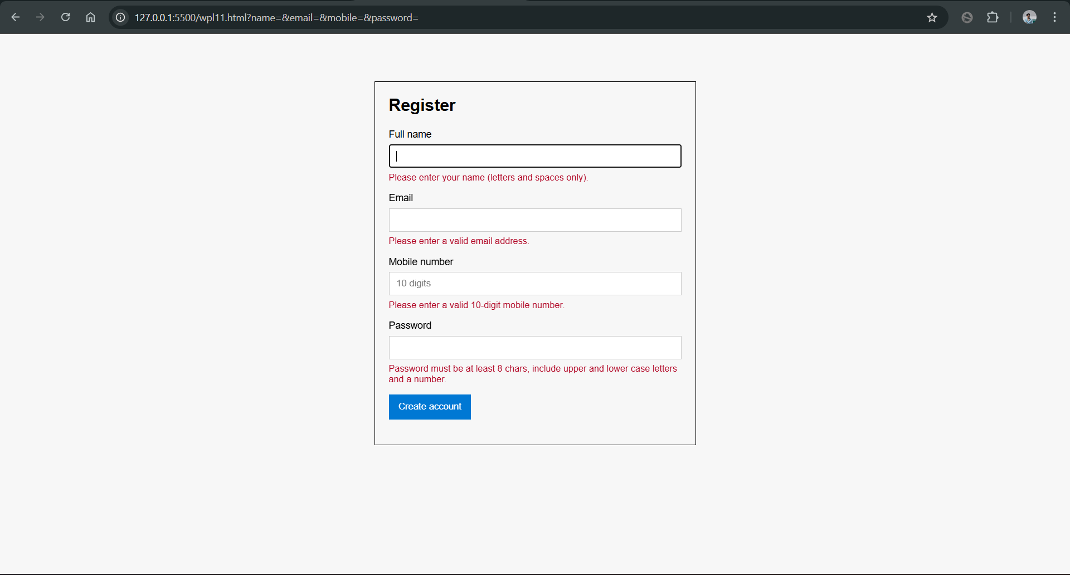
PROGRAM 12:
Design and develop a complete online exam using Html, CSS and JavaScript. Minimum 4-5 questions should be in the online exam, and the results should be displayed on completion.
PROGRAM CODE:

exam.html
<html>
<head>
<title>Online Exam</title>
<style>
body {
font-family: Arial, Helvetica, sans-serif;
background: #f0f4f8;
margin: 0;
padding: 20px;
color: #222;
}

.wrap {
max-width: 800px;
margin: 30px auto;
padding: 10px;
}

.card {
background: #fff;
border: 1px solid #ccc;
border-radius: 6px;
padding: 20px;
}

header {
margin-bottom: 12px;
}
h1 {
font-size: 18px;
margin: 0;
color: #111;
}

.questions {
margin-top: 10px;
}
.q {
padding: 10px;
border: 1px solid #e0e0e0;
border-radius: 4px;
margin-bottom: 10px;
background: #fafafa;
}
.q h3 {
font-size: 14px;
margin: 0 0 8px 0;
}

.options label {
display: block;
padding: 6px;
margin-bottom: 6px;
border-radius: 4px;
cursor: pointer;
background: transparent;
border: 1px solid transparent;
}
.options label:hover {
background: #fff;
border-color: #e6e6e6;
}
.options input {
margin-right: 8px;
}

.controls {
margin-top: 12px;
}
button {
padding: 8px 12px;
border: 0;
background: #007bff;
color: #fff;
border-radius: 4px;
cursor: pointer;
font-weight: 600;
}
button.secondary,
button[disabled] {
background: #e9ecef;
color: #6c757d;
border: 1px solid #ccc;
cursor: default;
}
</style>
</head>
<body>
<div class="wrap">
<div class="card" id="examCard">
<header>
<div>
<h1>Online Exam</h1>
</div>
</header>

<form id="examForm" class="questions" autocomplete="off" aria-live="polite">
<section class="q" data-q="1">
<h3>1. Which HTML element is used to define the largest heading?</h3>
<div class="options">
<label><input type="radio" name="q1" value="a"> &lt;heading&gt;</label>
<label><input type="radio" name="q1" value="b"> &lt;h1&gt;</label>
<label><input type="radio" name="q1" value="c"> &lt;head&gt;</label>
<label><input type="radio" name="q1" value="d"> &lt;title&gt;</label>
</div>
</section>

<section class="q" data-q="2">
<h3>2. Which CSS property controls the text size?</h3>
<div class="options">
<label><input type="radio" name="q2" value="a"> font-style</label>
<label><input type="radio" name="q2" value="b"> text-size</label>
<label><input type="radio" name="q2" value="c"> font-size</label>
<label><input type="radio" name="q2" value="d"> text-style</label>
</div>
</section>

<section class="q" data-q="3">
<h3>3. In JavaScript, which keyword is used to declare a block-scoped variable?</h3>
<div class="options">
<label><input type="radio" name="q3" value="a"> var</label>
<label><input type="radio" name="q3" value="b"> let</label>
<label><input type="radio" name="q3" value="c"> const</label>
<label><input type="radio" name="q3" value="d"> both b and c</label>
</div>
</section>

<section class="q" data-q="4">
<h3>4. Which HTTP status code means "Not Found"?</h3>
<div class="options">
<label><input type="radio" name="q4" value="a"> 200</label>
<label><input type="radio" name="q4" value="b"> 301</label>
<label><input type="radio" name="q4" value="c"> 404</label>
<label><input type="radio" name="q4" value="d"> 500</label>
</div>
</section>

<section class="q" data-q="5">
<h3>5. Which of the following is a semantic HTML element?</h3>
<div class="options">
<label><input type="radio" name="q5" value="a"> &lt;div&gt;</label>
<label><input type="radio" name="q5" value="b"> &lt;span&gt;</label>
<label><input type="radio" name="q5" value="c"> &lt;article&gt;</label>
<label><input type="radio" name="q5" value="d"> &lt;br&gt;</label>
</div>
</section>

<div class="controls" role="group" aria-label="Exam controls">
<button type="button" id="submitBtn" class="secondary" disabled>Submit Answers</button>
</div>

</form>
</div>
</div>

<script>
var correct = { q1: 'b', q2: 'c', q3: 'd', q4: 'c', q5: 'c' };
var examForm = document.getElementById('examForm');
var submitBtn = document.getElementById('submitBtn');

function enableSubmission(enable){
submitBtn.disabled = !enable;
submitBtn.classList.toggle('secondary', !enable);
}

function readAnswers(){
const data = {};
const formData = new FormData(examForm);
for (let i=1;i<=5;i++){
data['q'+i] = formData.get('q'+i) || null;
}
return data;
}

function gradeAnswers(answers){
let score=0;
const details = [];
for (let i=1;i<=5;i++){
const key='q'+i;
const user = answers[key];
const correctAns = correct[key];
const isCorrect = user && user === correctAns;
if (isCorrect) score++;
details.push({ q: i, user, correct: correctAns, isCorrect });
}
return { score, details, total: 5 };
}

function renderResultPopUp(report){
const percent = Math.round((report.score/report.total)*100);
let grade = 'F';
if (percent >= 90) grade='A';
else if (percent >= 75) grade='B';
else if (percent >= 60) grade='C';
else if (percent >= 50) grade='D';

let text = `Score: ${report.score} / ${report.total} \nGrade: ${grade}\n\nCorrect answers:\n`;
report.details.forEach(d => {
const corrText = d.correct ? d.correct.toUpperCase() : 'N/A';
const qText = Array.from(document.querySelectorAll('.q'))[d.q-1].querySelector('h3').textContent;
text += `Q${d.q}: ${corrText}\n`;
});

alert(text);
}

examForm.addEventListener('change', function() {
var answers = readAnswers();
var any = false;
for (var k in answers) {
if (answers.hasOwnProperty(k) && answers[k] !== null) {
any = true;
break;
}
}
enableSubmission(any);
});

submitBtn.addEventListener('click', function() {
var answers = readAnswers();
var report = gradeAnswers(answers);
renderResultPopUp(report);
enableSubmission(false);
});

enableSubmission(false);
</script>
</body>
</html>

OUTPUT:
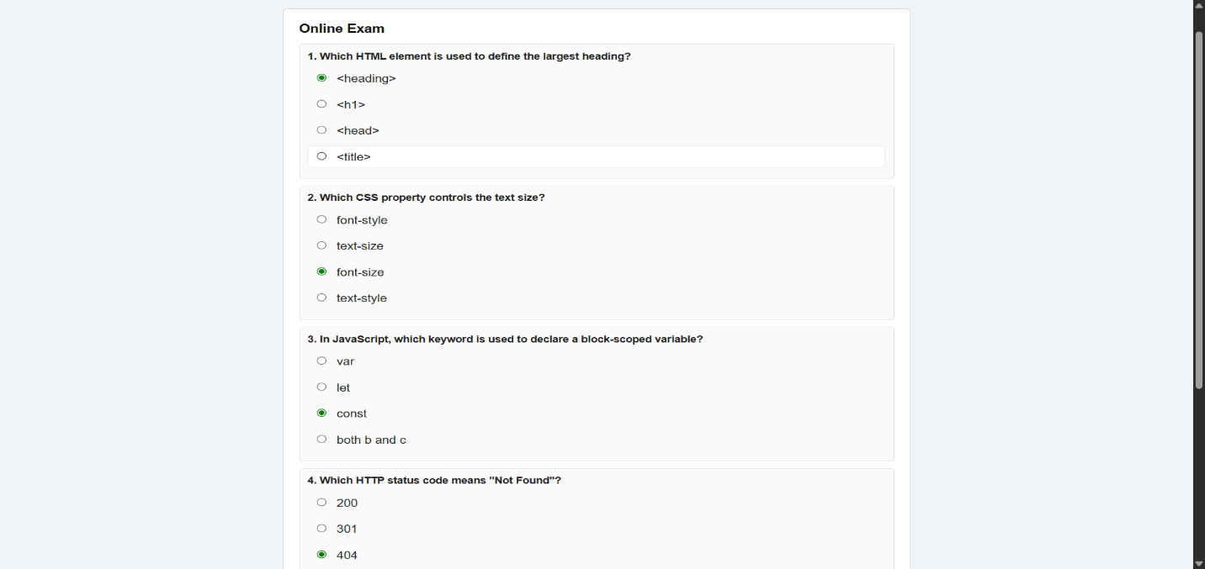
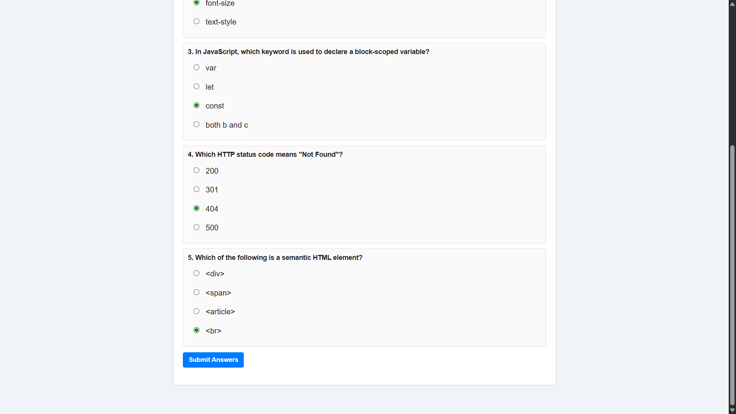
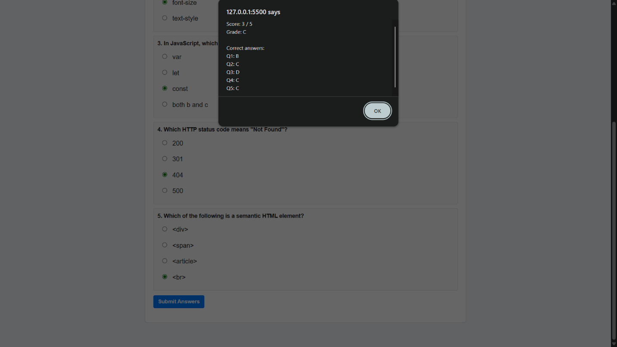

Lab Cycle 3
CO3: Create functional components using both client-side and server-side scripting to support dynamic web behaviour.

PROGRAM 13:
Build a PHP code to store name of students in an array and display it using print_r function. Sort and display the same using asort & arsort functions.
PROGRAM CODE:

index.php
<html>
<head>
<title>php</title>
</head>
<body>
<?php
$std=array("2"=>"goutham","3"=>"kumar","1"=>"reddy");
foreach($std as $key => $value){
echo "$value<br>";
}
echo "Sor􀆟ng ascending using asort :<br>";
asort($std);
print_r($std);
echo "<br>Sor􀆟ng descending using asort :<br>";
arsort($std);
print_r($std);
?>
</body>
</html>

OUTPUT:

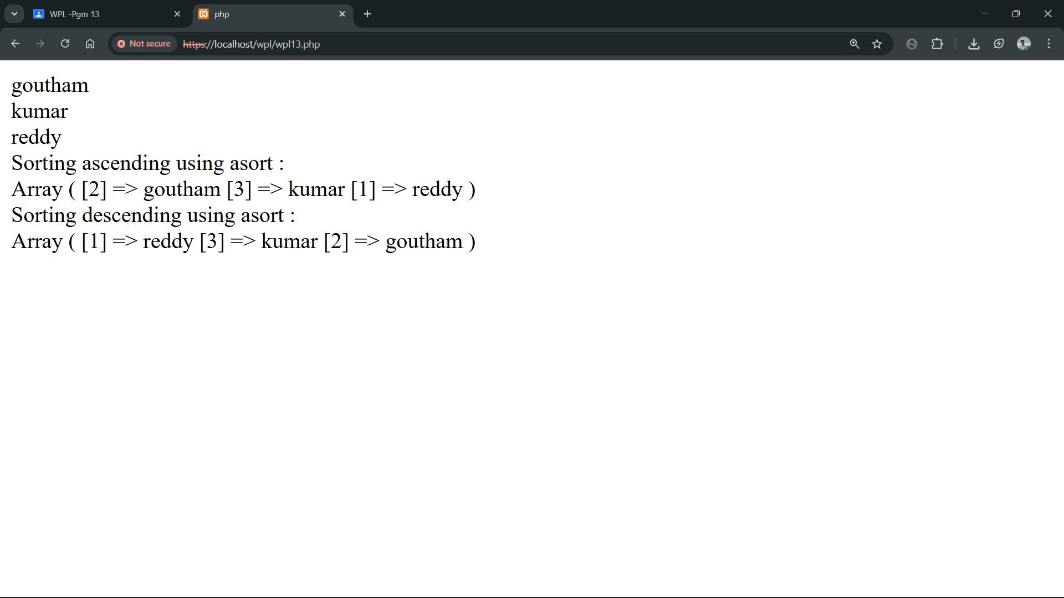
PROGRAM 14:
Build a PHP code to store name of Indian Cricket players in an array and display the same in HTML table.

PROGRAM CODE:

index.php
<html>
<head>
<title>php</title>
</head>
<body>
<?php
$std = array("Virat Kohli", "Rohit Sharma", "Jasprit Bumrah", "Ravindra Jadeja", "KL
Rahul");
foreach($std as $value){
echo '<table border="1" cellpadding="5" cellspacing="0">';
echo '<tr><th>SI No</th><th>Players</th></tr>';
echo '<tr><td>';
foreach($std as $i => $p){ echo ($i+1) . '<br>'; }
echo '</td><td>';
foreach($std as $p){ echo ($p) . '<br>'; }
echo '</td></tr></table>';
break;
}
?>
</body>
</html>
OUTPUT:

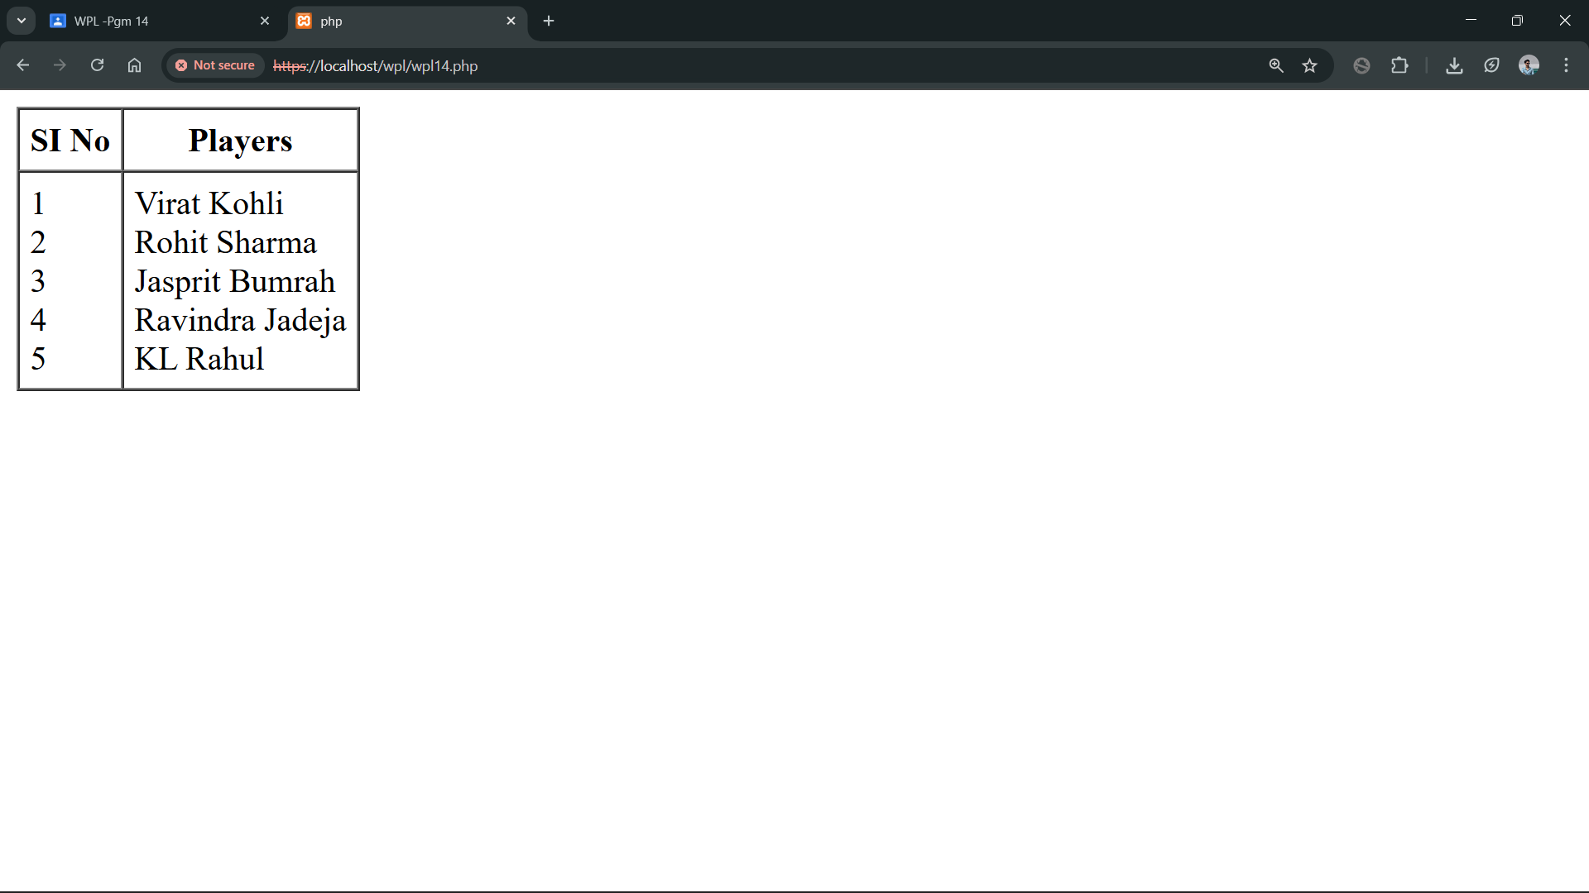

PROGRAM 15:
Design a registration form in HTML, and do necessary server side validations using PHP.

PROGRAM CODE:

index.php
<html>
<head>
<title>Simple Form</title>
<style>
body{background:#f5f5f5;font-family:Arial,Helve􀆟ca,sansserif;
color:#222;padding:20px}
.c{width:640px;margin:20px auto;background:#fff;border:1px solid
#ccc;padding:20px;box-sizing:border-box}
h2{text-align:center;margin:6px 0 18px 0;font-size:20px}
form{font-size:14px}
.row{margin-bo􀆩om:12px;display:flex;align-items:center}
label{display:inline-block;width:140px;font-weight:600;color:#333;textalign:
right;margin-right:12px}
input[type="text"],input[type="tel"],textarea{border:1px solid
#bbb;padding:6px;flex:1;box-sizing:border-box;background:#fff;color:#000}
textarea{height:80px}
.g{display:flex;align-items:center;gap:12px}
.g label{font-weight:400;text-align:le􀅌;width:auto;margin:0}
input[type="submit"]{background:#007bff;color:#fff;border:1px solid
#0069d9;padding:8px 14px;cursor:pointer;font-weight:600}
.submit{flex:1}
@media(maxwidth:
700px){.c{width:95%}.row{display:block}label{display:block;width:auto;marginbo
􀆩om:6px;textalign:
le􀅌}input[type="text"],textarea,input[type="tel"]{width:100%}.submit{textalign:
le􀅌}}
</style>
</head>
<body>
<?php
$name = $email = $gender = $mobile = "";
if ($_SERVER["REQUEST_METHOD"] == "POST") {
$name = test_input($_POST["name"] ?? "");
$email = test_input($_POST["email"] ?? "");
$mobile = test_input($_POST["mobile"] ?? "");
$gender = test_input($_POST["gender"] ?? "");
}
func􀆟on test_input($data) {
$data = trim($data);
$data = stripslashes($data);
$data = htmlspecialchars($data);
return $data;
}
?>
<div class="c">
<h2>Form</h2>
<form method="post" ac􀆟on="<?php echo
htmlspecialchars($_SERVER["PHP_SELF"]);?>">
<div class="row">
<label for="name">Name:</label>
<input id="name" type="text" name="name" value="<?php echo $name; ?>">
</div>
<div class="row">
<label for="email">E-mail:</label>
<input id="email" type="text" name="email" value="<?php echo $email; ?>">
</div>
<div class="row">
<label for="mobile">Mobile:</label>
<input id="mobile" type="tel" name="mobile" value="<?php echo $mobile; ?>">
</div>
<div class="row">
<label>Gender:</label>
<div class="g">
<label><input type="radio" name="gender" value="female" <?php if ($gender
=== "female") echo "checked"; ?>> Female</label>
<label><input type="radio" name="gender" value="male" <?php if ($gender ===
"male") echo "checked"; ?>> Male</label>
<label><input type="radio" name="gender" value="other" <?php if ($gender ===
"other") echo "checked"; ?>> Other</label>
</div>
</div>
<div class="row">
<label></label>
<div class="submit">
<input type="submit" name="submit" value="Submit">
</div>
</div>
</form>
<?php
echo "<h2>Your Input:</h2>";
echo $name;
echo "<br>";
echo $email;
echo "<br>";
echo $mobile;
echo "<br>";
echo $gender;
?>
</div>
</body>
</html>

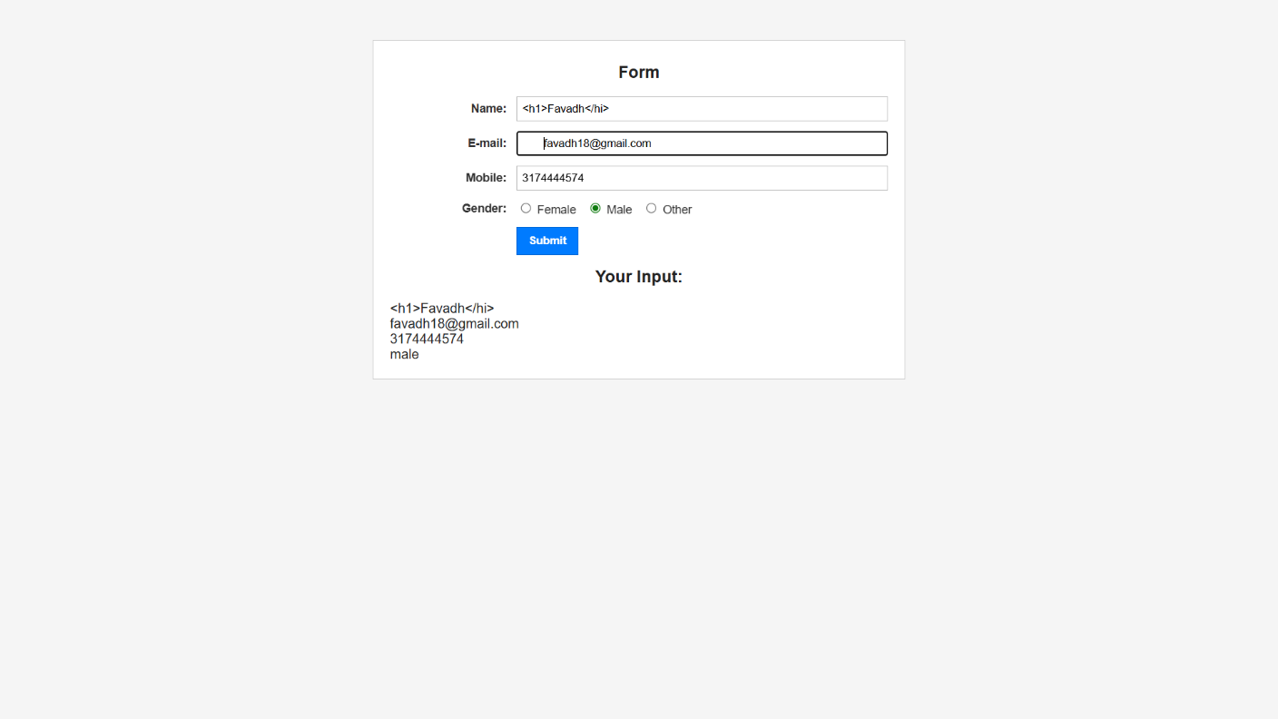
OUTPUT:

PROGRAM 16:
Develop a user-friendly electricity bill calculator using HTML and PHP. Collect the consumer data, and the units used, through an input form. Based on the given tariff, calculate the consumer bill amount.

PROGRAM CODE:

index.php
<html>
<head>
<title>Form</title>
</head>
<body>
<form method="post" ac􀆟on="<?php echo $_SERVER['PHP_SELF']; ?>">
Consumer name:<input type="text" name="CName"><br>
Consumer No:<input type="text" name="CNo"><br>
Unit:<input type="text" name="unit"><br>
<input type="submit" name="submit">
</form>
<?php
if ($_SERVER['REQUEST_METHOD'] === 'POST') {
$CName = $_POST['CName'];
$CNo = $_POST['CNo'];
$unit = (float)$_POST['unit'];
$remaining = $unit;
$bill = 0.0;
$breakdown = [];
$􀆟ers = [
[100, 5.0],
[100, 7.5],
[PHP_INT_MAX, 10.0],
];
foreach ($􀆟ers as $t) {
if ($remaining <= 0) break;
$limit = $t[0]; $rate = $t[1];
$u = min($remaining, $limit);
$charge = $u * $rate;
$bill += $charge;
$breakdown[] = "{$u} unit(s) x Rs.{$rate} = Rs." . number_format($charge, 2);
$remaining -= $u;
}
echo "Consumer Name: $CName<br>";
echo "Consumer No: $CNo<br>";
echo "Units: $unit<br><br>";
echo "Bill breakdown:<br>";
foreach ($breakdown as $line) echo $line . "<br>";
echo "<strong>Total Amount Payable: Rs." . number_format($bill, 2) .
"</strong><br>";
}
?>
</body>
</html>

OUTPUT:

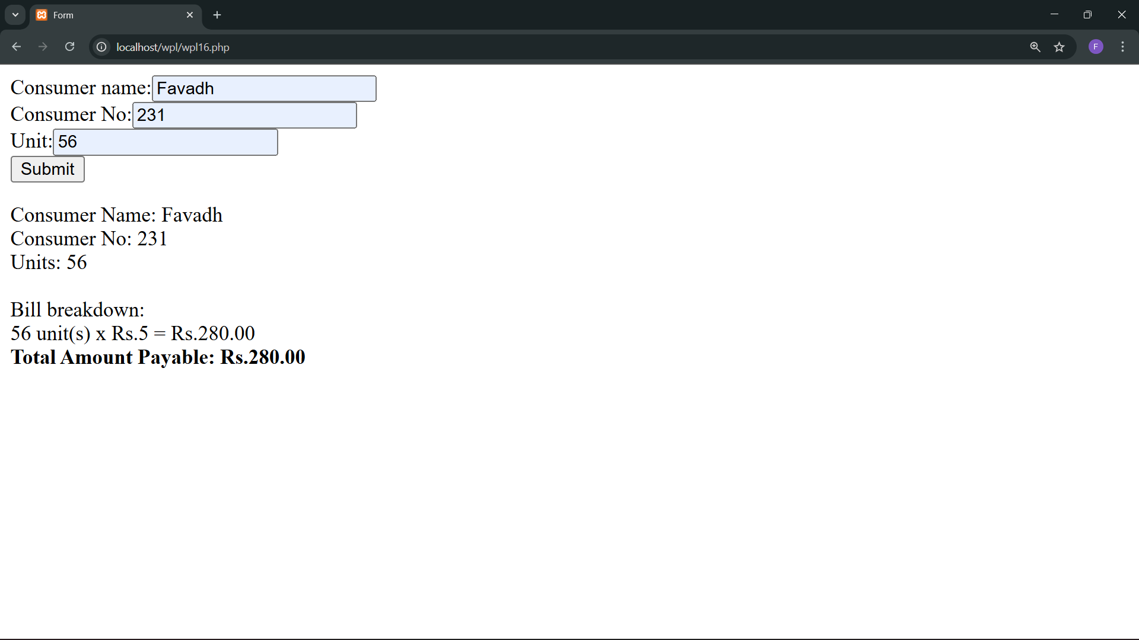

Lab Cycle 4
CO4: Develop programs to link front-end interfaces with back-end databases to enable data storage, retrieval, and processing.

PROGRAM 17:
Develop a PHP program to connect to a database and retrieve data from a table and show the details in a neat format.

PROGRAM CODE:

index.php
<html>
<head>
<title>server</title>
</head>
<body>
<?php
$dbConn = mysqli_connect("localhost","root", "", "mca");
if(!$dbConn){
die("Connec􀆟on failed:".mysqli_connect_error());
}
echo"Connected successfully<br>";
$sql="SELECT * FROM books";
$result = mysqli_query($dbConn, $sql);
if(mysqli_num_rows($result)>0){
while($row=mysqli_fetch_assoc($result)){
echo "Book ID:" .$row["Book_ID"]." Book Name:" .$row["Book_Name"].
" Book Price: ".$row["Book_Price"]."<br>";
}
} else{
echo "No records found";
}
mysqli_close($dbConn);
?>
</body>
</html>
OUTPUT:

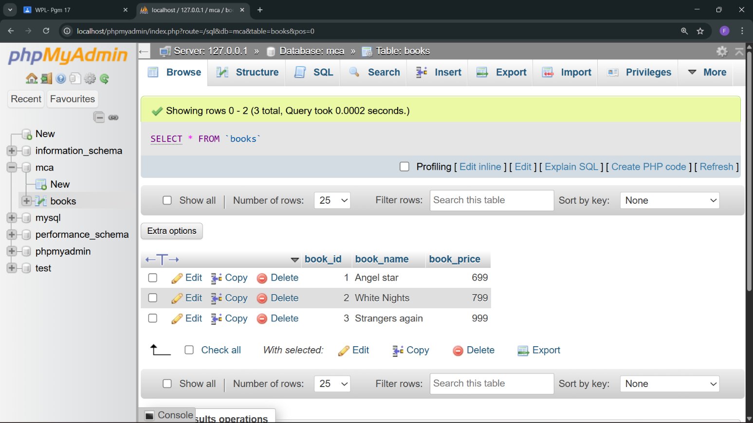

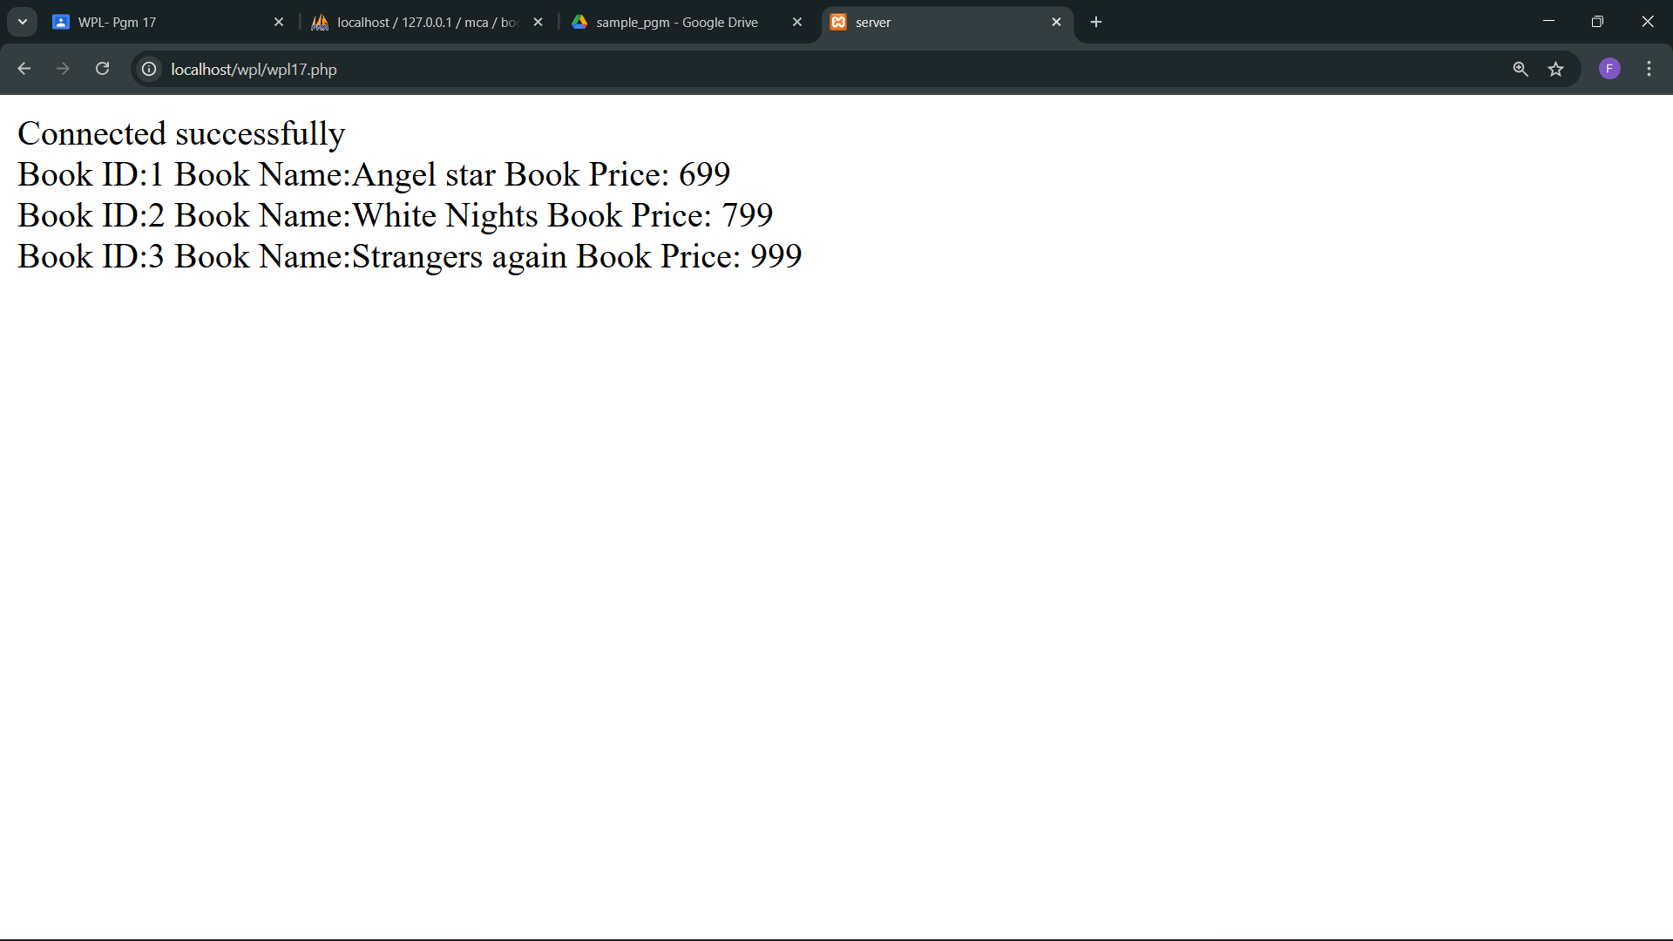

Lab Cycle 5
CO5: Assemble and deploy complete web applications by integrating interface design, scripting, and database connectivity.

PROGRAM 18:
Develop an application in PHP and MySQL, to accept book details viz. Book id, title, authors, edition and publisher from an HTML form in a web page and save the records in a MySQL database on submission. The program also should include a search function given the author's name, and display the search results.

PROGRAM CODE:

client.php
<html>
<head>
<title>Form</title>
</head>
<body>
<form method="post" ac􀆟on="server.php">
Book Id:<input type="text" name="BID"><br>
Book Title:<input type="text" name="BName"><br>
Author:<input type="text" name="BAuthor"><br>
Edition:<input type="text" name="BEdition"><br>
Publisher:<input type="text" name="BPublisher"><br>
<input type="submit" name="adding">
</form>
<form method="post" ac􀆟on="<?php echo $_SERVER['PHP_SELF'];?>">
Search: <input type="text" name="searchInput">
<input type="submit" name="searching">
</form>
<?php
if($_SERVER["REQUEST_METHOD"] == "POST"){
$keyEle=$_REQUEST['searchInput'];
$dbConn = mysqli_connect("localhost","root", "", "mca");
if(!$dbConn){
die("Connec􀆟on failed:".mysqli_connect_error());
}
$sql="SELECT * FROM books WHERE Book_Author='$keyEle'";
$result = mysqli_query($dbConn, $sql);
if(mysqli_num_rows($result)>0){
while($row=mysqli_fetch_assoc($result)){
echo "Book ID:" .$row["Book_ID"]." Book Title:" .$row["Book_Name"]. "Book
Author: ".$row["Book_Author"]." Book Edition: ".$row["Book_Edition"]. "Book
Publisher: ".$row["Book_Publisher"]."<br>";
}
} else{
echo "No records found";
}
}
?>
</body>
</html>

client.php

<?php
if($_SERVER["REQUEST_METHOD"] == "POST"){
$BID=$_REQUEST['BID'];
$BName=$_REQUEST['BName'];
$BAuthor=$_REQUEST['BAuthor'];
$BEdition=$_REQUEST['BEdition'];
$BPublisher=$_REQUEST['BPublisher'];
if(empty($BID) || empty($BName) || empty($BAuthor) || empty($BEdition) ||
empty($BPublisher)){
echo "<p>Datas are not uploaded</p>";
} else{
$dbConn = mysqli_connect("localhost","root", "", "mca");
if(!$dbConn){
die("Connec􀆟on failed:".mysqli_connect_error());
}
echo"Connected successfully<br>";
$sql="INSERT INTO books VALUES ($BID, '$BName', '$BAuthor', '$BEdition',
'$BPublisher')";
if(mysqli_query($dbConn, $sql)){
echo "Inserted successfully<br><br>";
} else{
echo "couldn't Inserted: ".mysqli_error($dbConn);
}
$sql="SELECT * FROM books";
$result = mysqli_query($dbConn, $sql);
if(mysqli_num_rows($result)>0){
while($row=mysqli_fetch_assoc($result)){
echo "Book ID:" .$row["Book_ID"]." Book Title:" .$row["Book_Name"]. "Book
Author: ".$row["Book_Author"]." Book Edition: ".$row["Book_Edition"]. "Book
Publisher: ".$row["Book_Publisher"]."<br>";
}
} else{
echo "No records found";
}
mysqli_close($dbConn);
}
} else{
echo "<p>Server issue!!!</p>";
}
?>

OUTPUT:

