WPL – 18
client.php:
<html>
<head>
<title>Form</title>
</head>
<body>

<form method="post" action="server.php">
Book Id:<input type="text" name="BID"><br>
Book Title:<input type="text" name="BName"><br>
Author:<input type="text" name="BAuthor"><br>
Edition:<input type="text" name="BEdition"><br>
Publisher:<input type="text" name="BPublisher"><br>

<input type="submit" name="adding">
</form>

<form method="post" action="<?php echo $_SERVER['PHP_SELF'];?>">
Search: <input type="text" name="searchInput">
<input type="submit" name="searching">
</form>
<?php
if($_SERVER["REQUEST_METHOD"] == "POST"){
$keyEle=$_REQUEST['searchInput'];

$dbConn = mysqli_connect("localhost","root", "", "mca");
if(!$dbConn){
die("Connection failed:".mysqli_connect_error());
}

$sql="SELECT * FROM books WHERE Book_Author='$keyEle'";
$result = mysqli_query($dbConn, $sql);

if(mysqli_num_rows($result)>0){
while($row=mysqli_fetch_assoc($result)){
echo "Book ID:" .$row["Book_ID"]." Book Title:" .$row["Book_Name"]. "Book Author: ".$row["Book_Author"]." Book Edition: ".$row["Book_Edition"]. "Book Publisher: ".$row["Book_Publisher"]."<br>";
}
} else{
echo "No records found";
}

}
?>
</body>
</html>

server.php:
<?php
if($_SERVER["REQUEST_METHOD"] == "POST"){
$BID=$_REQUEST['BID'];
$BName=$_REQUEST['BName'];
$BAuthor=$_REQUEST['BAuthor'];
$BEdition=$_REQUEST['BEdition'];
$BPublisher=$_REQUEST['BPublisher'];

if(empty($BID) || empty($BName) || empty($BAuthor) || empty($BEdition) || empty($BPublisher)){
echo "<p>Datas are not uploaded</p>";
} else{
$dbConn = mysqli_connect("localhost","root", "", "mca");
if(!$dbConn){
die("Connection failed:".mysqli_connect_error());
}
echo"Connected successfully<br>";

$sql="INSERT INTO books VALUES ($BID, '$BName', '$BAuthor', '$BEdition', '$BPublisher')";
if(mysqli_query($dbConn, $sql)){
echo "Inserted successfully<br><br>";
} else{
echo "couldn't Inserted: ".mysqli_error($dbConn);
}

$sql="SELECT * FROM books";
$result = mysqli_query($dbConn, $sql);

if(mysqli_num_rows($result)>0){
while($row=mysqli_fetch_assoc($result)){
echo "Book ID:" .$row["Book_ID"]." Book Title:" .$row["Book_Name"]. "Book Author: ".$row["Book_Author"]." Book Edition: ".$row["Book_Edition"]. "Book Publisher: ".$row["Book_Publisher"]."<br>";
}
} else{
echo "No records found";
}
mysqli_close($dbConn);
}
} else{
echo "<p>Server issue!!!</p>";
}
?>

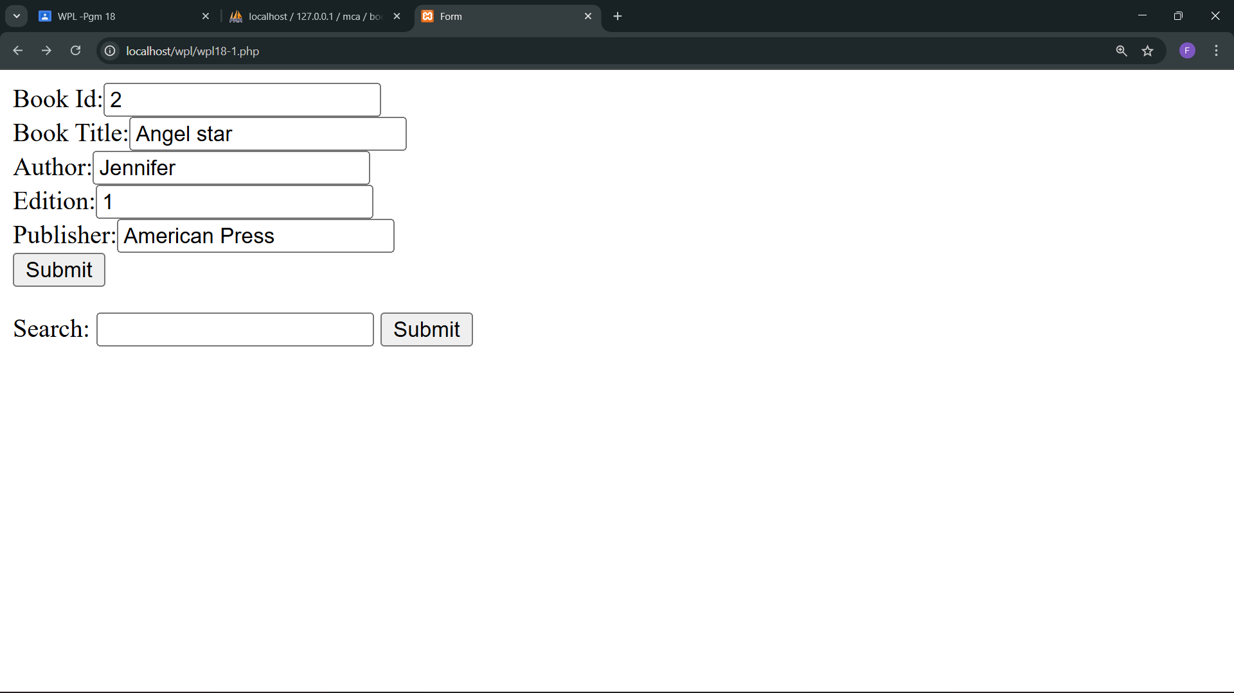
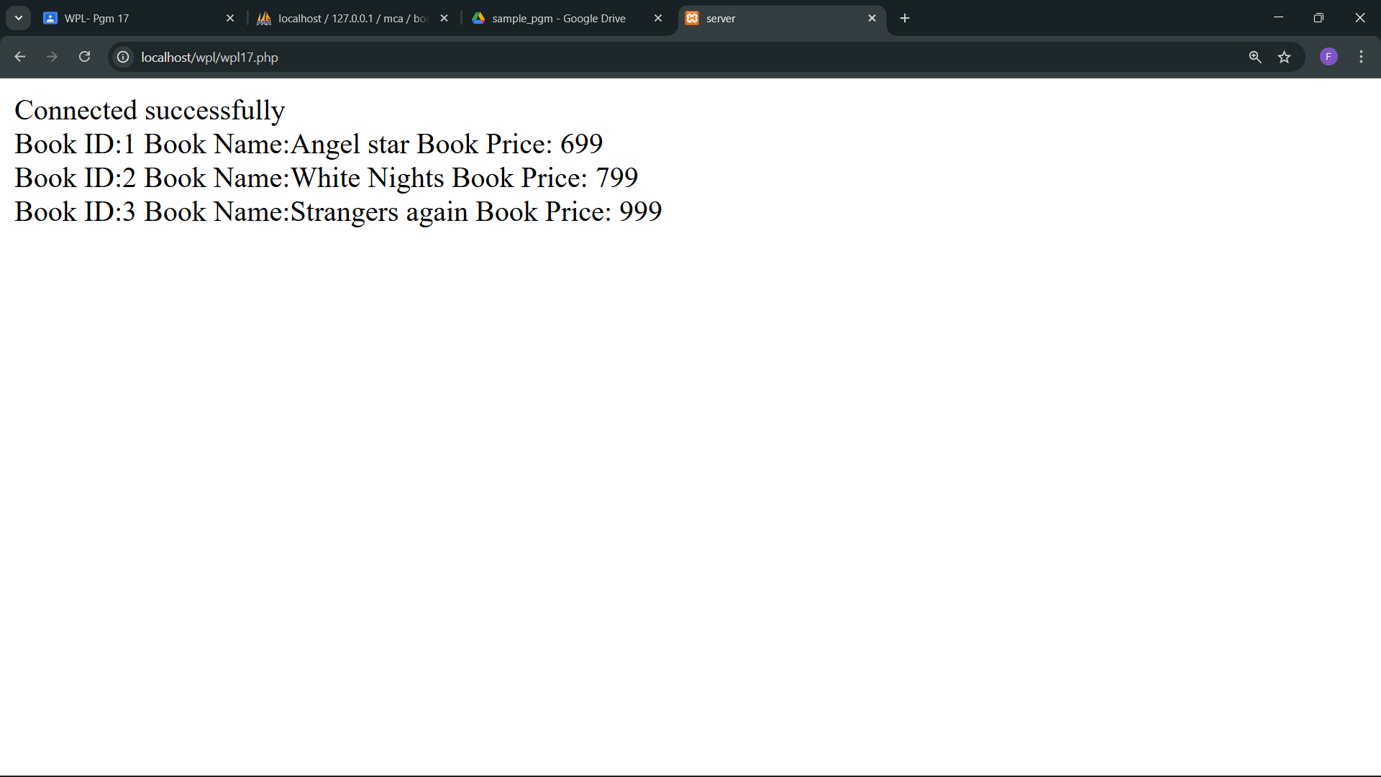
output:
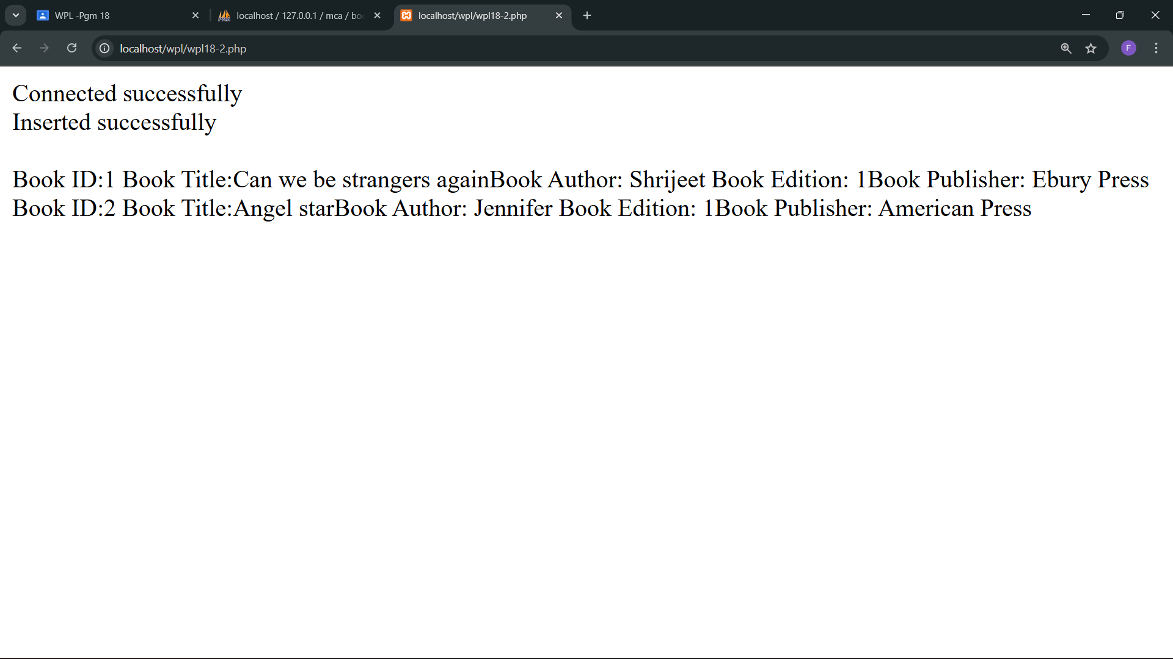
Displaying the inserted datas:

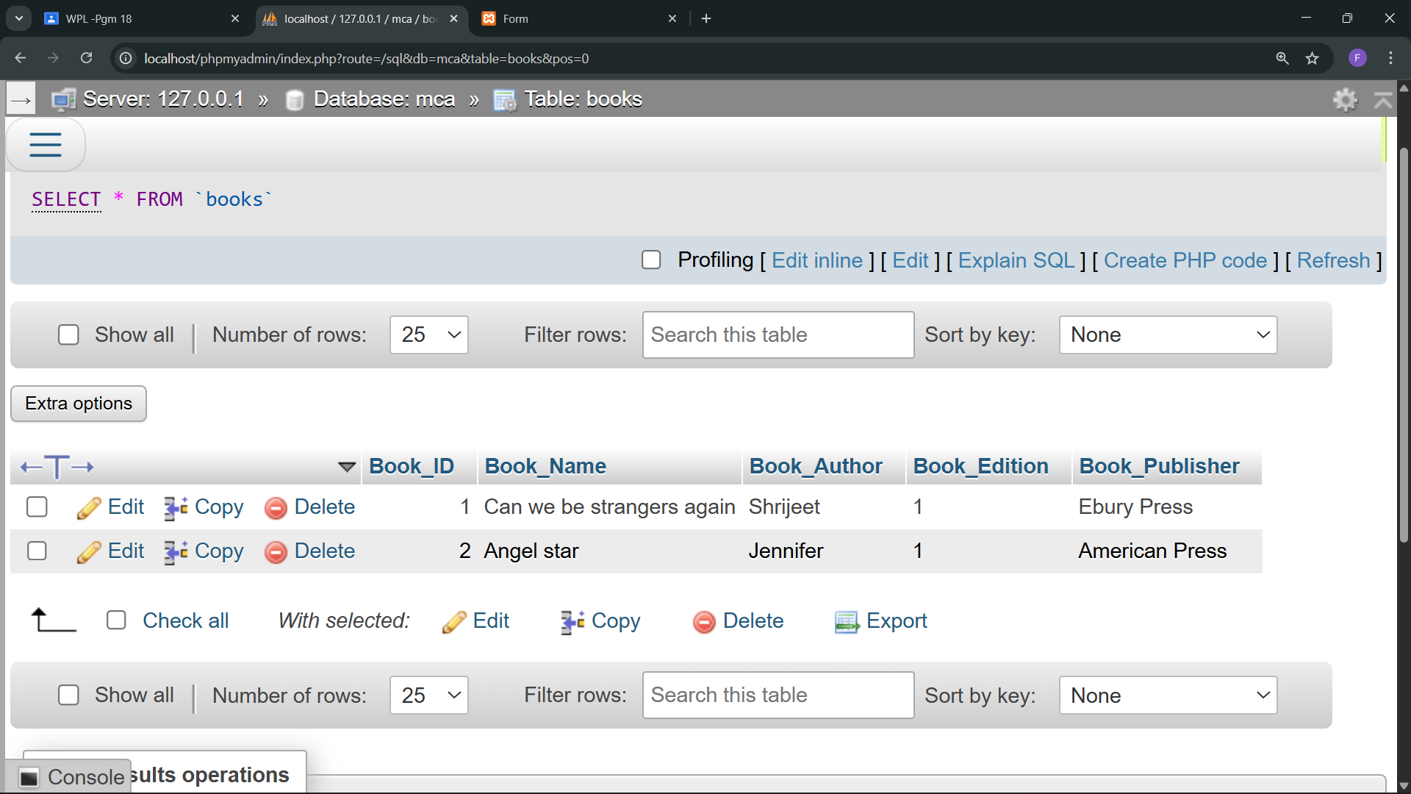
Inserted datas in the DB:
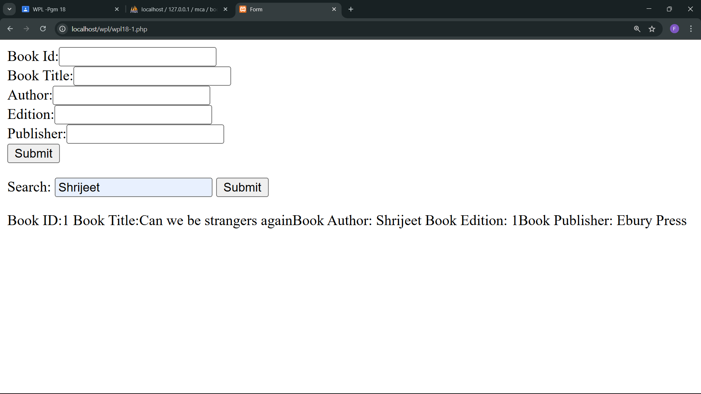
Searching function using Author:

