DATA SCIENCE ANALYSIS REPORT
Sales Prediction using Python: Advertising Spend, Regression Modeling, and Marketing Strategy
A regression-based analysis of TV, Radio, and Newspaper advertising spend and their impact on sales

Prepared using Python (pandas, NumPy, scikit-learn, statsmodels, Matplotlib, Seaborn)
Data source: Advertising dataset (TV / Radio / Newspaper spend vs. Sales, 200 observations)

Table of Contents

1. Executive Summary
This report analyzes a 200-observation advertising dataset to predict sales from spend on three channels — TV, Radio, and Newspaper — and to quantify how changes in advertising spend on each channel move sales outcomes. The objective was to clean and prepare the data, select and justify model features, fit and compare several regression approaches, and translate the strongest model's coefficients into concrete marketing-budget guidance.
The central finding is that advertising spend is a strong, learnable predictor of sales, but the relationship is not purely linear. A degree-2 polynomial regression — which captures diminishing returns and cross-channel synergy — outperformed a plain linear model substantially (test R² of 0.987 vs. 0.899), confirming that the way channels interact matters as much as how much is spent on each individually.
Key statistics from the analysis:
Metric | Value
Observations analyzed | 200 (no missing/duplicate data found)
Channels modeled | TV, Radio, Newspaper
Best model | Polynomial Regression (degree 2)
Best model test R² / RMSE | 0.987 / 0.643
Linear model test R² (for interpretability) | 0.899
Strongest single predictor (correlation) | TV (r = 0.78)
Most efficient channel per dollar spent | Radio (coefficient 0.189 vs. TV's 0.045)
Weakest predictor | Newspaper (r = 0.23, coefficient ≈ 0)
Simulated impact of 20% Newspaper→Radio budget shift | +8.1% predicted sales

These findings point toward a clear, low-risk reallocation opportunity: shifting marginal budget away from Newspaper (which shows almost no independent relationship with sales) toward Radio (the most efficient channel per dollar) while maintaining the dominant TV budget that anchors total sales volume.

2. Data and Methodology

2.1 Data Source
The dataset contains 200 rows, each representing a market or product with advertising spend (in $ thousands) on TV, Radio, and Newspaper, and the resulting Sales (in thousands of units). It is a cross-sectional dataset — each row is an independent snapshot, with no date/time column linking rows in sequence, and no explicit “target segment” or “platform” field beyond the three spend channels themselves.

2.2 Cleaning Steps Performed
- Index column removal — the raw CSV's unnamed leading index column (1–200) was dropped, keeping only the four substantive columns.
- Missing data check — all four numeric columns (TV, Radio, Newspaper, Sales) were checked; zero missing values were found.
- Duplicate check — zero exact duplicate rows were found.
- Validity check — all spend and sales values were confirmed non-negative (logically required); none failed this check.

2.3 Feature Engineering
- total_spend — the sum of TV + Radio + Newspaper spend per row.
- tv_share, radio_share, newspaper_share — each channel's share of that row's total spend — the closest available proxy for a platform/segment-mix feature, since the raw data has no explicit platform or audience-segment label.
- Interaction terms — pairwise products of channel spend (e.g. TV × Radio), used to test for cross-channel synergy effects.
- sales_per_spend — Sales divided by total_spend, a simple spend-efficiency proxy used for exploratory diagnostics.

2.4 Feature Selection
Pearson correlation with Sales was TV: 0.78, Radio: 0.58, Newspaper: 0.23 — all three channels carry independent, non-trivial signal, so all three were retained as model inputs. A Variance Inflation Factor (VIF) check confirmed low multicollinearity between the three raw channels (TV: 1.00, Radio: 1.14, Newspaper: 1.15, all well under the common VIF<5 threshold), meaning the three channels can be safely modeled together without their coefficients distorting one another.

2.5 Tools
All analysis was performed in Python using pandas/NumPy for data handling, scikit-learn for regression modeling and evaluation, statsmodels for the VIF multicollinearity check, and Matplotlib/Seaborn for visualization. No proprietary or paid tools were required.

3. Exploratory Data Analysis
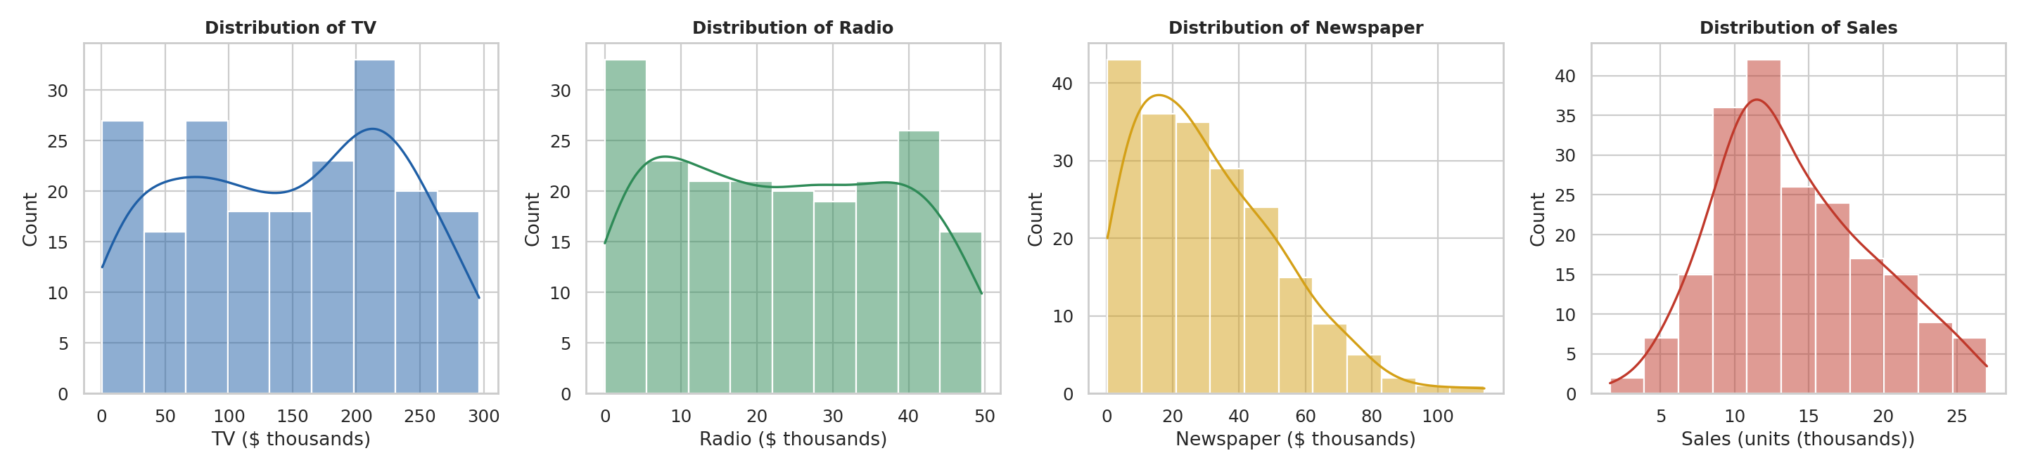
Figure 1. Distributions of TV, Radio, Newspaper spend and Sales.
Spend distributions vary meaningfully by channel: TV spend is broadly spread from near zero to almost $300k with a cluster around $200–250k; Radio spend is fairly uniform up to about $50k; Newspaper spend is right-skewed, concentrated under $40k with a long tail. Sales itself is roughly bell-shaped, centered around 12–14 thousand units.
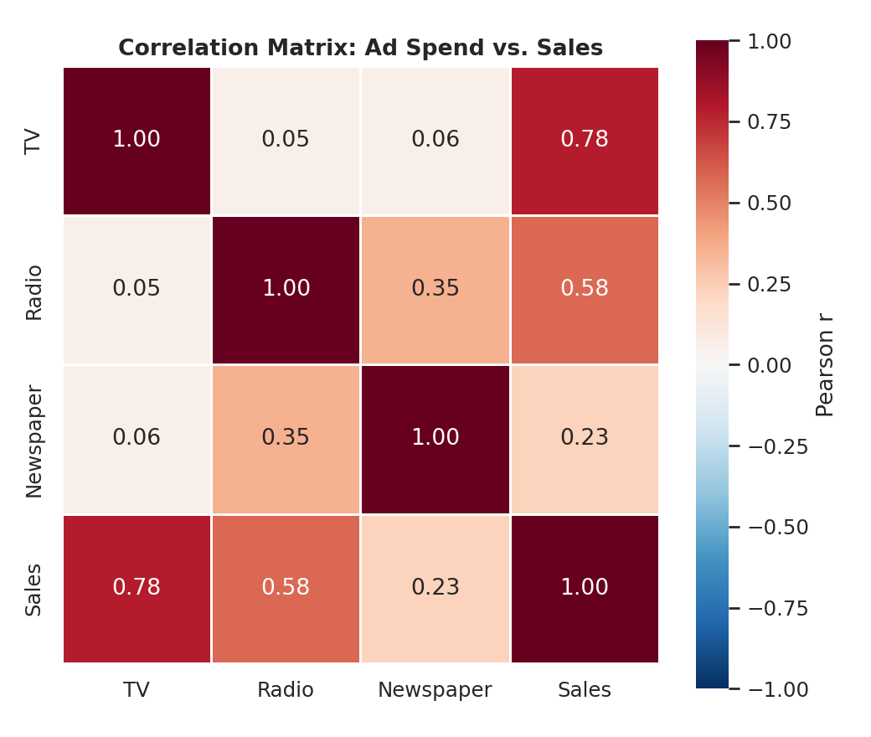
Figure 2. Correlation matrix between ad spend channels and Sales.
TV shows by far the strongest individual correlation with Sales (0.78), followed by Radio (0.58); Newspaper is weak (0.23) and also moderately correlated with Radio (0.35), suggesting some overlap in campaigns that use both channels together — a relationship explored further in the impact analysis.
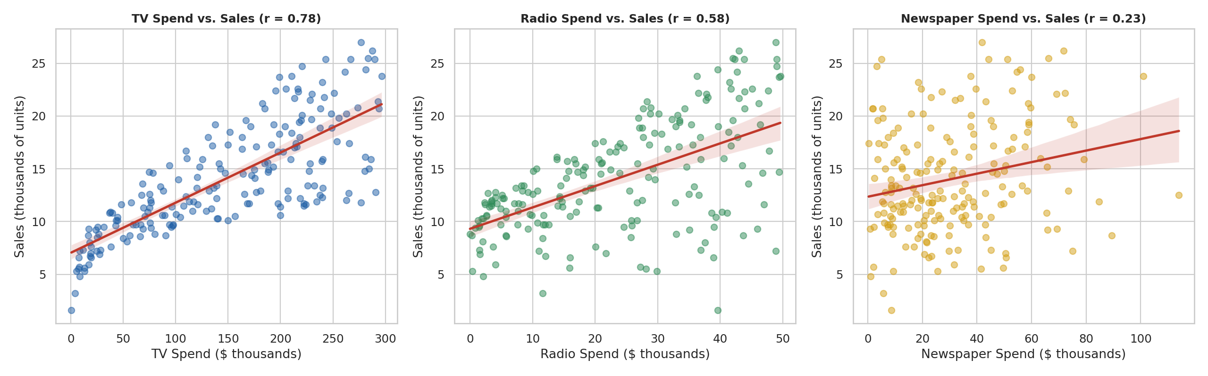
Figure 3. Spend vs. Sales scatter plots with fitted trend line, by channel.
The scatter plots make the relative predictive strength visually clear: TV vs. Sales shows a tight, clearly upward trend; Radio vs. Sales shows a real but noisier upward trend; Newspaper vs. Sales is nearly flat with wide scatter, visually confirming its weak correlation.

4. Predictive Modeling
Four regression approaches were trained on an 80/20 train/test split (160 training rows, 40 held-out test rows) and compared using 5-fold cross-validation on the training set:
- Linear Regression — the interpretable baseline; assumes a constant, additive effect per dollar of spend on each channel.
- Ridge Regression — L2-regularized linear regression; included as a robustness check against overfitting (results were nearly identical to plain linear regression, indicating overfitting was not a major concern at this sample size).
- Polynomial Regression (degree 2) — adds squared and pairwise-interaction terms, allowing the model to capture diminishing returns within a channel and synergy between channels.
- Random Forest — an ensemble of 300 decision trees (max depth 5); captures non-linear relationships and interactions automatically without manually specifying them.
Model | Test R² | Test RMSE | Test MAE | CV R² (mean ± std)
Polynomial Regression (deg=2) | 0.987 | 0.643 | 0.526 | 0.978 ± 0.017
Random Forest | 0.977 | 0.858 | 0.682 | 0.958 ± 0.013
Ridge Regression | 0.899 | 1.782 | 1.461 | 0.870 ± 0.072
Linear Regression | 0.899 | 1.782 | 1.461 | 0.870 ± 0.072

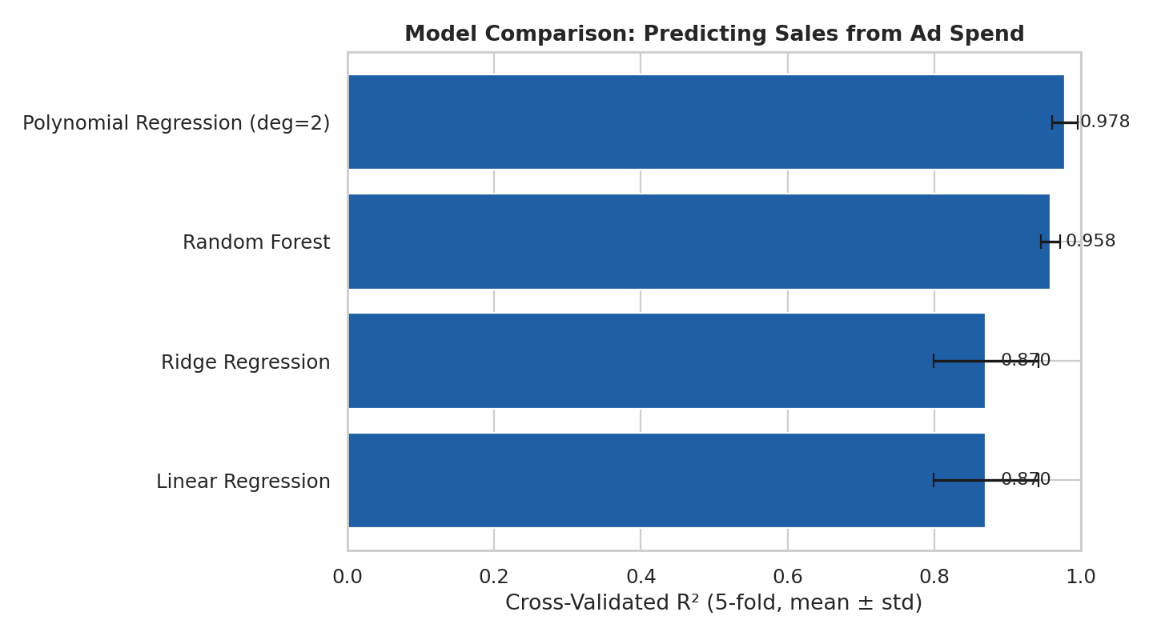
Figure 4. Cross-validated R² comparison across all four models.
Polynomial Regression (degree 2) was selected as the best model: it achieved the highest test and cross-validated R², the lowest error metrics, and one of the lowest variances across folds — indicating both strong accuracy and stable generalization. Its outperformance over the linear model is itself an important finding: it confirms that the true relationship between ad spend and sales includes diminishing returns and/or cross-channel synergy that a purely additive model misses.
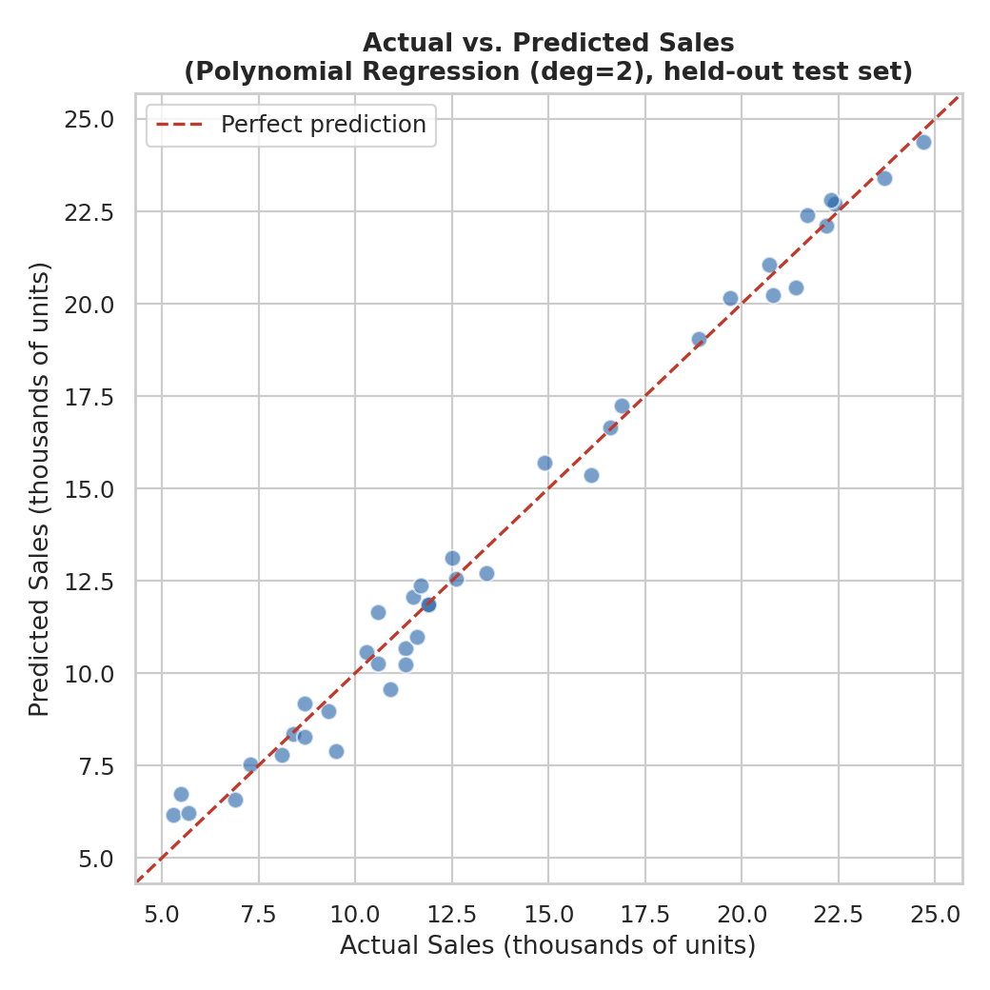
Figure 5. Actual vs. predicted sales on the held-out test set, best model.
Predicted values track actual sales closely across the full range, with points clustering tightly around the perfect-prediction line and only mild scatter at the lower end of the sales range.
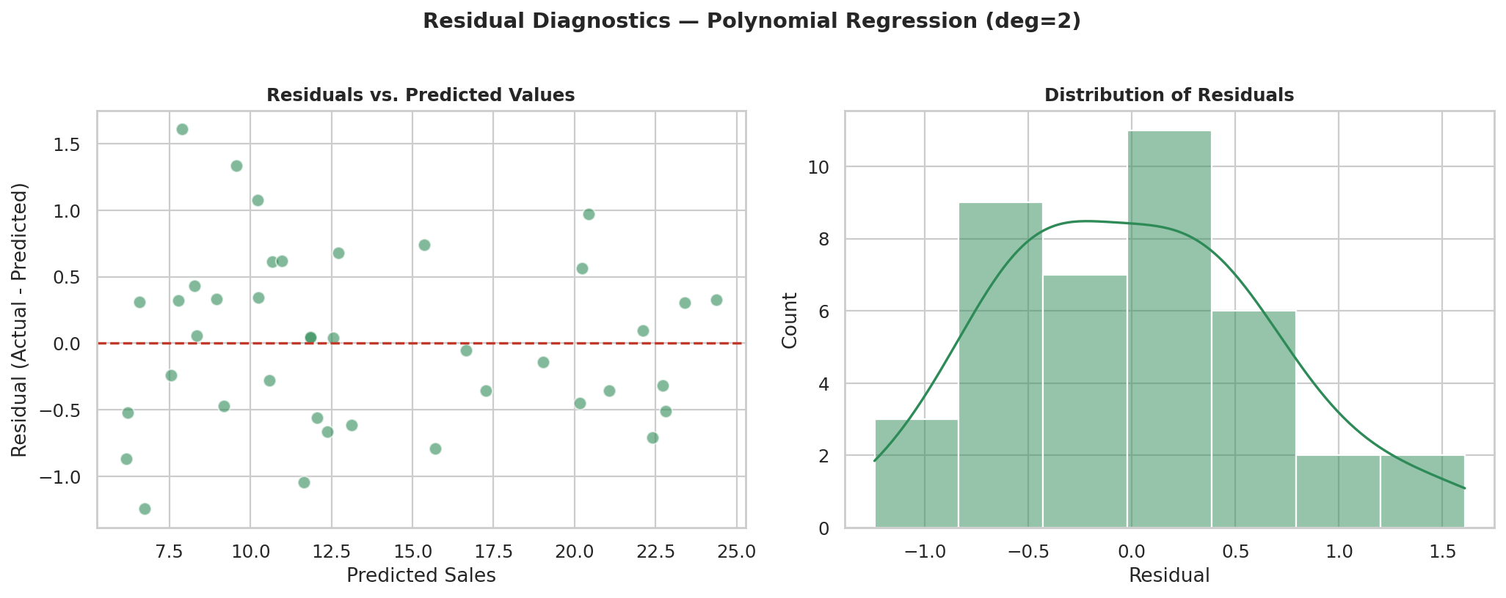
Figure 6. Residual diagnostics for the best model.
Residuals are centered around zero with no strong funnel or curvature pattern against predicted values, and their distribution is roughly symmetric and unimodal — both signs that the model's errors are well-behaved rather than systematically biased in a particular direction or sales range.
For interpretability, the Linear Regression coefficients were retained and used for the impact analysis in Section 5, since they translate directly into a “$ in → units out” statement that the polynomial and forest models do not:
Sales ≈ 2.98 + 0.045 × TV + 0.189 × Radio + 0.003 × Newspaper
(TV and Radio spend in $ thousands; Sales in thousands of units; Newspaper's coefficient is effectively negligible.)

5. Advertising Impact Analysis
To translate model coefficients into business language, sales elasticity was computed for each channel — the % change in sales associated with a 1% change in that channel's spend, evaluated at average spend levels.
Channel | Coefficient | Avg. Spend ($k) | Elasticity
TV | 0.045 | 147.0 | 46.9%
Radio | 0.189 | 23.3 | 31.4%
Newspaper | 0.003 | 30.6 | 0.6%

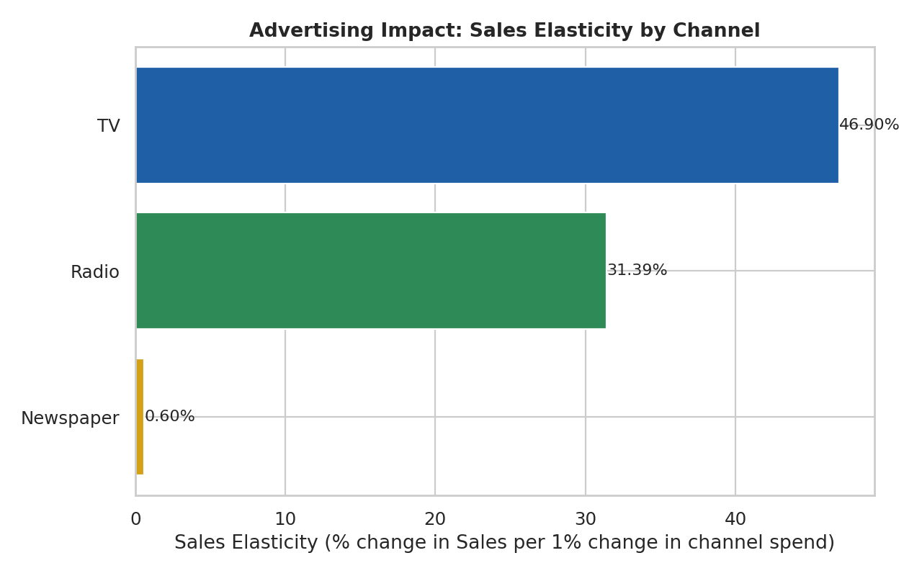
Figure 7. Sales elasticity by advertising channel.
TV shows the largest total elasticity, but mainly because it commands by far the largest share of the budget ($147k average vs. $23k for Radio) — not because each dollar of TV spend is more powerful. In fact, Radio's per-dollar coefficient (0.189) is more than four times larger than TV's (0.045), meaning Radio converts spend into sales more efficiently; it simply receives a much smaller budget. Newspaper's near-zero coefficient indicates no measurable independent contribution to sales once TV and Radio are accounted for.

5.1 Budget Reallocation Scenario
To make this concrete, a simple what-if scenario was simulated: shift 20% of the average Newspaper budget (≈$6.1k) into Radio, holding total spend fixed, and use the fitted linear model to predict the resulting change in sales.
Scenario | TV ($k) | Radio ($k) | Newspaper ($k) | Predicted Sales | Change
Current average allocation | 147.0 | 23.3 | 30.6 | 14.04 | —
Shift 20% Newspaper → Radio | 147.0 | 29.4 | 24.4 | 15.18 | +8.1%

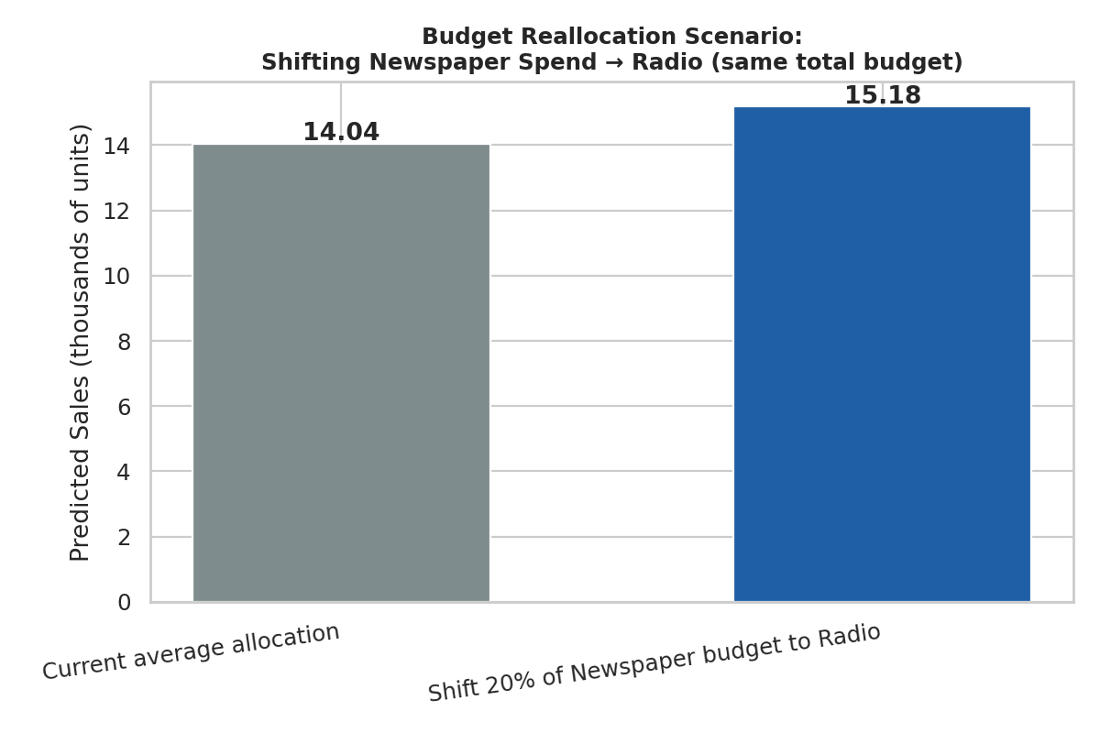
Figure 8. Predicted sales under the current vs. reallocated budget scenario.
This is a model-based simulation, not a guarantee — see Section 7 for caveats on extrapolating regression results into real budget decisions — but it illustrates, in concrete terms, the size of the opportunity implied by Radio's stronger per-dollar effect.

6. Key Insights and Business Recommendations

6.1 Summary of Key Findings
- Advertising spend predicts sales well — all three channels carry real signal (TV r=0.78, Radio r=0.58, Newspaper r=0.23), but TV and Radio dominate the relationship with sales.
- The relationship is non-linear — the degree-2 polynomial model's large outperformance over linear regression (R² 0.987 vs. 0.899) shows that ad spend does not translate into sales in a simple, constant, additive way — diminishing returns and/or cross-channel synergy are present.
- Radio is the most efficient channel per dollar — TV's high total elasticity is a function of its large budget share, not necessarily superior per-dollar efficiency; Radio's coefficient is over 4x TV's.
- Newspaper is not a sales driver in this data — once TV and Radio are controlled for, Newspaper spend shows essentially no independent relationship with sales in this dataset.
- A modest reallocation has an outsized simulated impact — a 20% Newspaper-to-Radio shift, with total budget unchanged, is associated with an +8.1% increase in predicted sales — a meaningful, low-cost reallocation opportunity.

6.2 Policy / Marketing Recommendations
- 1. Reallocate incremental budget from Newspaper to Radio. Begin with a modest shift (e.g., the 20% simulated here) from Newspaper into Radio, monitor actual sales response, and scale the shift if results track the model's prediction.
- 2. Maintain TV as the core budget anchor, but test increases incrementally. TV remains the single largest driver of total sales volume due to its scale; it should not be cut, but very large further increases should be piloted incrementally given evidence of non-linear (likely diminishing) returns.
- 3. Re-purpose or reduce Newspaper spend. Newspaper's spend should be evaluated against whatever its real objective is (e.g., local reach, brand presence) rather than treated as a sales-driving channel, since this data does not support that role for it.
- 4. Validate with a real-world test before scaling. Before committing a large, permanent budget shift, run a regional or time-boxed holdout test moving real budget from Newspaper to Radio and measure the actual sales lift, since the current model is observational rather than a controlled experiment.
- 5. Collect richer platform/segment data going forward. If true platform/segment-level data becomes available (e.g., digital sub-channels, audience demographics), re-run this pipeline with those features for a more granular allocation strategy than the channel-level view used here.

7. Limitations and Notes on Tools Used
- No explicit segment/platform feature — the source data has no explicit “target segment” or “platform” field beyond the three ad channels; channel was used as the platform dimension, and spend-share features were engineered as the closest proxy for segment/platform mix available.
- No time dimension — each row is an independent market/product snapshot with no date column, so this is a cross-sectional regression analysis, not a time-series forecast; a true time-series model (e.g., ARIMA, Prophet) would require sequential, time-stamped sales data, which was not present in the source file.
- Small sample size — 200 rows is workable for the regression methods used, but elasticity and scenario figures should be treated as directional estimates, not precise forecasts, and should be re-validated as more data becomes available.
- Correlation vs. causation — the model is observational; the budget-reallocation scenario is a simulation based on fitted coefficients, not evidence from a controlled experiment. Real budget changes should be tested incrementally before being scaled.
- Extrapolation risk — predictions and elasticity estimates are most reliable within the observed spend ranges (TV: $0.7k–$296k, Radio: $0–$49.6k, Newspaper: $0.3k–$114k); recommendations assume changes within or near this range.
- Tools — this analysis was performed entirely with open-source Python libraries (pandas, NumPy, scikit-learn, statsmodels, Matplotlib, Seaborn). No external paid tools, APIs, or services were required.

8. Project Repository
This report is part of a complete, version-controlled project repository (“sales-prediction-python”), organized as follows:
- data/raw/ — the original, untouched source file.
- data/processed/ — the cleaned, feature-engineered dataset produced by the cleaning script.
- src/ — four numbered Python scripts run in sequence — (1) data cleaning, (2) EDA & feature selection, (3) model training & comparison, (4) advertising impact analysis — so the entire pipeline can be reproduced or extended from raw data to final recommendations.
- outputs/ — all generated chart PNGs (outputs/figures/), summary CSV tables (outputs/tables/), and the saved fitted models (outputs/models/).
- reports/ — this report, in both DOCX and PDF format.
- Project root — a README with setup instructions, key findings, and a reproducible run sequence; a requirements.txt listing the open-source Python dependencies; and an MIT license for the code.
No proprietary or paid tools were required anywhere in this pipeline — only open-source Python libraries already listed in requirements.txt.

