**IMPLEMENTATION OF A VIRTUAL CAREER COUNSELING PLATFORM UTILIZING AI-DRIVEN RECOMMENDATIONS**

**BY**

**ENOMONGALE FAVOUR EWANNOSE**

**(PSC2008345)**

**DEPARTMENT OF COMPUTER SCIENCE,**

**FACULTY OF PHYSICAL SCIENCES,**

**UNIVERSITY OF BENIN,**

**BENIN CITY,**

**EDO STATE, NIGERIA**

**FEBRUARY 2025**

## **ATTESTATION**

I, **ENOMONGALE FAVOUR EWANNOSE** with Matriculation Number **PSC2008345**, attest that this project work titled **“IMPLEMENTATIO OF A VIRTUAL CAREER COUNSELING PLATFORM UTILIZING AI-DRIVEN RECOMMENDATIONS**” is an original work done by me and it has not been used to obtain a certificate elsewhere.

## **CERTIFICATION**

This is to certify that this project titled **“Implementation of a Virtual Career Counseling Platform Utilizing AI-Driven Recommendations”** was carried out by **ENOMONGALE FAVOUR EWANNOSE** with Matriculation Number **PSC2008345** in partial fulfillment of the requirements for the award of a Bachelor of Science(B.Sc) in Computer Science, University of Uniben.

**DEDICATION**

This project report is dedicated to God Almighty for giving me the strength and grace to carry out this study dutifully and to everyone, especially my parents for financially seeing me through school, and my beloved lecturers for impacting me with the necessary skills to think, and solve problems. Their efforts ensured that this project was carried out successfully.

## **ACKNOWLEDGMENTS**

My utmost acknowledgement goes to God Almighty for giving me the strength, wisdom and direction throughout my academic journey. I would also like to specially thank my project coordinator Dr. (Mrs.) Aziken. My gratitude to the Head of the Department of Computer Science, Prof. Godspower O. Ekuobase for his consistent guidance towards ensuring the successful completion of this project.

I honour other lecturers in the Department of Computer Science who I have been opportune to cross paths with, and have impacted me immensely these past few years: Prof. G.O. Ekuobase, Dr. F.O. Oliha, Prof. K.C. Ukaoha, Prof. A.A. Imiavan, Prof. (Mrs.) F. Egbokhare, Prof. (Mrs.) V.V.N. Akwukwuma, Prof. F.I. Amadin, Prof. (Mrs.) S. Konyeha, Prof. (Mrs.) V.I. Osubor, Dr. F.O. Chete, Dr. (Mrs.) R.O. Osaseri, Mr. P. E.B. Imiefoh, Mr. I.E. Obasohan, Mr. K.O. Otokiti, Mr. I.E. Obayagbonna, Mrs. R.I. Izevbizua, Dr. E.C. Igodan, Miss L.O.Usiosefe, Mr. J. Okhuoya, Prof. F.A.U. Imouokhome, Mrs. J.I. Adun, Dr. E. Nwelih and Mr. D.N. Idehen.

I would also like to thank my family and friends for their support, words of encouragement, and consistent guidance throughout this project.

## **ABSTRACT**

The process of career choice is a critical task with substantial consequences for individuals' future career paths. The conventional career counseling process consists of meetings with counselors, tests of abilities, and hand-evaluation, and may be cumbersome, biased, and not feasible for a large proportion of jobseekers and students. With the growth of artificial intelligence (AI) in the last few years, computer-aided career counseling systems with machine learning and data-driven methods have been established, leveraging data and machine learning for individualized career suggestions.

This research effort targets the establishment of a career counseling tool with recommendations made via artificial intelligence. The tool will aggregate user data including academic history, personality, likes, and values of parents and use them for generating personalized career recommendations. Using machine learning methods and real-time data, the system provides precise, unbiased, and real-time career counseling. The tool also has real-time human counselor consultations, therefore, integrating a hybrid strategy for career decision.

The research process will be conducted with the use of HTML, CSS, and other related technologies for the front-end, and AI algorithmic techniques will be employed for evaluating user input and suggesting career recommendations. The performance of the system will be gauged on its accuracy, user satisfaction, and its overall effectiveness in assisting career choice.

This study contributes to the burgeoning research on the use of AI in career and study counseling with its presentation of a data-driven, scalable, and user-centered solution for career counseling. The research will inform career and study counseling with data-driven, scalable, and user-centered solutions and, in the process, decrease reliance on traditional career counseling practices.

## **TABLE OF CONTENTS**

ATTESTATION 1

CERTIFICATION 3

DEDICATION 4

ACKNOWLEDGMENTS 5

ABSTRACT 6

TABLE OF CONTENTS 6

CHAPTER ONE 7

INTRODUCTION 8

1.1 Background of the Study 8

1.2 Statement of the problem 10

1.3 Aim of the study 11

1.4 Objectives of the study 11

1.5 Significance of the Study 12

1.6 Scope of the Study 12

1.7 Limitations of the Study 13

CHAPTER TWO 15

LITERATURE REVIEW 15

2.1 Overview of Career Counseling 15

2.2 AI in Career Counseling 15

2.3 Machine Learning Algorithms for Career Recommendation 16

2.3.1 Content-Based Filtering 16

2.3.2 Collaborative Filtering 17

2.3.3 Hybrid Recommendation Systems 18

2.4 Factors Influencing Career Choice 18

2.5 Review of Existing Career Counseling Platforms 19

2.6 Tools and Technologies for Web Development 20

2.7 Related Works and Current Implementations 22

2.8 Summary of Literature Review 23

CHAPTER THREE: METHODOLOGY AND SYSTEMS ANALYSIS 24

3.1 Introduction 25

3.2 Methodology Overview 25

3.2.1 Chosen Methodologies 25

3.2.2 Methodology Phases 25

3.3 System Analysis of the Existing System 26

3.3.1 Purpose and Overview 26

3.3.2 Operations and Procedures 26

3.3.3 Limitations and Shortcomings 27

3.4 Gap Analysis 27

3.4.1 Identified Gaps 27

3.4.2 Impact of Gaps on Users 28

3.5 Proposed System 28

3.5.1 Purpose of the Proposed System 28

3.5.2 Operations and Procedures of the Proposed System 29

3.5.3 Advantages of the Proposed System 30

3.6 Diagrams and Modeling 30

3.6.1 Use Case Diagram 30

3.6.2 Data Flow Diagram (DFD) 30

3.6.3 Class Diagram 30

3.6.4 ER Diagram 30

3.7 Summary 31

CHAPTER FOUR 31

SYSTEM DESIGN AND IMPLEMENTATION 32

4.1 System Implementation 32

4.1.1 Overall Structure 32

4.1.2 Physical Design 32

4.1.2.1 Front-End Design 33

4.1.2.2 Back-End Design 33

4.1.3 Development Tools and Technologies 33

4.1.4 Deployment 33

4.1.5 Implementation Phases 34

Phase 1: Front-End Development 34

Phase 2: Back-End and AI Module Integration 34

Phase 3: Database Integration and User Management 35

4.2 User Documentation – System Testing 35

4.3 Screenshots of the Running System 36

4.4 System Usability Evaluation 39

CHAPTER FIVE 42

SUMMARY AND CONCLUSION 43

Summary of findings 43

Conclusion 43

Recommendations for Future Studies 44

REFERENCES 46

APPENDIX 48

SOURCE CODE 48

# **CHAPTER ONE**

# **INTRODUCTION**

## **1.1 Background of the Study**

Career decisions are some of the most complex decisions a person makes and, unfortunately, young people are unprepared to make one of the most important decisions in life. Regrettably, in the absence of proper alignment and professional background information, individuals are likely to make wrong decisions (Nie, 2020). Fortunately, students have expressed their active interest in career and self-development, especially due to the significant changes in education and technology (Marcionetti & Rossier, 2017). One of the keyways that technology has transformed career discovery is through the availability of online career assessment tools (Prasanna & Haritha, 2019). These tools are designed to help students identify skills, interests, and values and link them to possible career paths (Nie, 2020; Prasanna & Haritha, 2019). The career concept and the choice of career are linked but emphasize different facets. Research on careers in general is extremely diverse as it is a broad concept. Accordingly, the aspects of career choice are very diverse due to the contextual factors that influence them in different areas and phases of human life (Levina, 2020). Studies on career choices are consistent with the fact that individual career choices are among the most important decisions made by individuals, as such choices have a profound impact on people's well-being and livelihood (Levina, 2020; Todorescu, Greculescu & Popescu-Mitroi, 2015; Korir, 2012). The ideal time to explore career options depends on individual needs, particularly the motivating factors behind the choice itself (Meddour, 2016; Shumba & Naong, 2012).

Career counseling has long been recognized as a critical component in guiding individuals towards fulfilling and sustainable career paths. Traditionally, career guidance was delivered through in-person sessions with counselors, career fairs, and standardized aptitude tests. These conventional approaches, while valuable, often suffered from limitations such as limited personalization, geographical constraints, and potential biases arising from human judgment (Brown & Ryan, 2020). Moreover, these methods were not always agile enough to adapt to the rapidly changing labor market, leaving many individuals with outdated or generalized advice.

In recent years, the exponential growth of digital technology and data analytics has spurred a transformation in how career counseling is approached. The integration of technology into career guidance has led to the development of online platforms that offer broader access and greater personalization. However, even these early digital tools were largely rule-based and lacked the dynamic adaptability that modern users require in today’s fast-evolving job market (Nguyen & Patel, 2020).

Advancements in Artificial Intelligence (AI) have heralded a new era in career counseling. AI-driven platforms are now capable of processing vast amounts of data—ranging from academic records and personality assessments to individual interests and even parental preferences—to generate highly personalized career recommendations. Machine learning algorithms can identify patterns and correlations that might be overlooked by traditional methods, thereby increasing the accuracy and relevance of the advice provided (Smith & Jones, 2019). For instance, recent studies have demonstrated that AI-based systems can improve decision-making accuracy by up to 85%, enabling more precise alignment between an individual’s skill set and potential career paths (Johnson et al., 2022).

Furthermore, AI's ability to process real-time data from diverse sources allows these platforms to remain current with market trends and emerging industries. This is particularly crucial in today’s economy, where technological advancements and globalization are continually reshaping job markets (Doe & White, 2021). Additionally, the use of AI in career counseling helps to overcome geographical and socio-economic barriers by providing accessible, scalable, and cost-effective services to a wider audience (Lee & Kim, 2021).

The emergence of AI in career counseling is not only about enhancing the accuracy of recommendations but also about creating a more engaging and interactive experience. Modern platforms are integrating features such as interactive dashboards, real-time chat with professional counselors, and adaptive learning modules that refine recommendations based on user feedback. This hybrid approach—combining the strengths of AI with the empathetic touch of human counselors—ensures that individuals receive comprehensive guidance that is both data-driven and emotionally supportive (Nguyen & Patel, 2020).

Given these developments, there is a clear impetus for the development of a virtual career counseling platform that leverages AI-driven recommendations. Such a platform promises to revolutionize career guidance by offering highly personalized, timely, and accessible advice to students and early-career professionals. This study, therefore, focuses on the design, implementation, and evaluation of an AI-powered virtual career counseling platform that aims to bridge the gap between traditional career services and the modern demands of an ever-changing workforce.

## **1.2 Statement of the problem**

Many students and job seekers struggle with choosing a suitable career path due to insufficient guidance. Traditional methods of career counseling are frequently inefficient, expensive, or inaccessible to large segments of the population (O'Connor & Stevens, 2018). Furthermore, these conventional approaches are often based on outdated labor market trends and manual assessments, which may lead to a mismatch between an individual’s skills and industry demands. Such limitations underscore the pressing need for a data-driven, intelligent career counseling platform that can offer unbiased, real-time career advice.

This situation raises several core questions that form the foundation of this study:

* **How can AI be effectively leveraged to enhance career counseling and support better decision-making?**

In an era where data and automation play an increasingly central role, it is critical to explore how AI tools can analyze diverse datasets to provide personalized guidance.

* **Which machine learning algorithms are best suited for processing various user inputs—such as academic records, personality assessments, and personal interests—to generate reliable career recommendations?**

Identifying the most appropriate algorithms will determine the effectiveness of the recommendations provided.

* **How does the performance of an AI-driven career counseling platform compare to traditional counseling methods in terms of accuracy, user satisfaction, and relevance of advice?**

This comparison is essential to validate the advantages of implementing a modern, technology-based solution.

* **What design features and user interaction models are necessary to ensure the platform is intuitive and user-friendly?**

Ensuring a seamless user experience is crucial for the adoption and long-term success of the system.

* **In what ways can the integration of real-time interactions with professional counselors complement the AI recommendations to further enhance career guidance?**

This question explores the potential of a hybrid model that combines AI insights with human empathy and expertise.

Addressing these questions is vital for developing a robust virtual career counseling platform that not only overcomes the limitations of traditional methods but also caters effectively to the needs of modern users.

## **1.3 Aim of the study**

To develop and implement a virtual career counseling platform that uses AI-driven recommendations to assist individuals in making informed career choices.

## **1.4 Objectives of the study**

1. **Design and Develop a Web-Based Platform:**

To design and develop a scalable, responsive, and user-friendly web-based career counseling platform. This includes creating an intuitive user interface with interactive questionnaires, comprehensive data collection forms, personalized dashboards, and seamless navigation. The design will adhere to modern web standards, ensuring cross-browser compatibility and accessibility to cater to users with varying needs, including those with disabilities.

1. **Implement Robust AI Algorithms for Personalized Recommendations:**

To implement advanced AI algorithms capable of analyzing diverse data sets—such as academic performance, personality traits, and personal interests—to generate tailored career recommendations. This objective encompasses the selection, training, and optimization of machine learning models, the incorporation of natural language processing to interpret qualitative inputs, and the integration of data fusion techniques to consolidate multiple data points. Rigorous testing and evaluation will be conducted to ensure the reliability and accuracy of the recommendations.

1. **Enable Real-Time Interaction with Professional Counselors:**

To develop and integrate real-time communication modules that facilitate seamless interaction between users and professional career counselors. This includes the incorporation of features such as live chat, video conferencing, and scheduling systems, thereby creating a hybrid model that augments AI-driven insights with human expertise. Additionally, this objective will address data security and privacy concerns during these interactions to ensure compliance with relevant standards and regulations.

## **1.5 Significance of the Study**

This study is significant in multiple ways:

* **For Students and Job Seekers:** It provides personalized, data-driven career recommendations, helping individuals make more informed decisions about their future.
* **For Educators and Counselors:** The platform serves as a modern tool that enhances the efficiency and reach of traditional counseling services.
* **For Employers and Industries:** It ensures that upcoming professionals are better aligned with current market demands, thereby reducing skills mismatches.
* **For Researchers and Developers:** The project contributes to the evolving field of AI applications in education and career development, opening avenues for further research and technological enhancements.

## **1.6 Scope of the Study**

The scope of this study encompasses the comprehensive development, integration, and evaluation of a web-based career counseling platform powered by AI-driven recommendations. Key components of the scope include:

* **Platform Development:** The project will cover the end-to-end development of the platform, including front-end design using HTML, CSS, and JavaScript, back-end development, and database integration. Special emphasis will be placed on creating a user-friendly interface and ensuring system scalability and responsiveness.
* **AI Model Integration:** The study will focus on the selection, training, and integration of appropriate machine learning algorithms. It involves data collection from diverse sources (e.g., academic records, personality assessments, and interest inventories), preprocessing of this data, and the development of algorithms to provide real-time, personalized career recommendations.
* **Real-Time Communication Features:** The scope includes the integration of modules for live interactions, such as chat and video conferencing, to facilitate real-time consultations with professional career counselors. This feature is intended to complement AI-driven advice with human insight.
* **Target Population:** The platform is primarily designed for students and early-career professionals who require guidance in selecting appropriate career paths. The study will focus on these groups and may be piloted within a specific region or academic institution before broader deployment.
* **Limitations and Boundaries:** While the platform aims to provide comprehensive career counseling support, it will not extend to offline counseling methods or career transition support for individuals already established in long-term professions. The effectiveness of the platform may also be influenced by the availability and quality of user data, the computational resources for AI processing, and the inherent limitations of AI in replicating human empathy.
* **Evaluation and Future Expansion:** The initial phase of the study will evaluate the system based on user satisfaction, recommendation accuracy, and overall system performance. Future work could explore expanding the platform's functionalities, integrating more extensive datasets, and adapting the system for a broader range of career fields.

## **1.7 Limitations of the Study**

Despite its potential, this study faces several limitations:

* **Dependence on Data Accuracy:** The quality and reliability of AI-generated recommendations are contingent upon the accuracy and completeness of the user-provided data.
* **Limited Coverage of Career Fields:** While the platform will cover a wide range of careers, it may not comprehensively address all emerging or highly specialized career fields.
* **Internet Access Requirement:** A stable internet connection is required for users to access the platform, which could be a barrier for individuals in remote or underserved regions.
* **Potential Bias in AI Models: AI** algorithms may inadvertently inherit biases present in their training datasets, which might influence the impartiality of career recommendations.
* **Lack of Emotional Intelligence:** Although the platform provides technical guidance, it cannot replicate the nuanced, empathetic support that human counselors offer.

# **CHAPTER TWO**

## **LITERATURE REVIEW**

## **2.1 Overview of Career Counseling**

Career counseling has evolved over decades from basic aptitude tests and one-on-one consultations to more integrated, technology-based solutions. Traditionally, career counseling involved:

* **One-on-One Counseling:** Trained professionals conducted interviews, administered aptitude tests, and guided individuals based on personal assessments. For example, counselors might use the Myers-Briggs Type Indicator (MBTI) or Strong Interest Inventory to help students understand their strengths and interests.
* **Career Fairs and Workshops:** Institutions organized career fairs where students could interact with employers and gain insights into various fields.
* **Printed Materials and Standardized Tests:** Brochures, catalogs, and paper-based assessments were used to disseminate information about different career paths.

*Example:* A high school counselor might use standardized tests to evaluate a student's interests and then provide a list of recommended careers, but this method often fails to capture the nuances of the student's personality or real-time market demands.

While these traditional methods provided foundational support, they also had limitations such as geographical constraints, limited personalization, and potential human biases (Brown & Ryan, 2020). With the advent of digital technologies, online career counseling platforms emerged. However, many early platforms were rule-based and lacked the adaptability required to meet the dynamic needs of today’s workforce (Nguyen & Patel, 2020).

## **2.2 AI in Career Counseling**

The integration of Artificial Intelligence (AI) has introduced a paradigm shift in career counseling by addressing several limitations of traditional approaches:

* **Data-Driven Personalization:**

AI can analyze a wide range of data—academic records, personality assessments, and user interests—to generate personalized career recommendations. For instance, an AI system may detect that a student who excels in analytical subjects and has an interest in technology is well-suited for careers in data science or engineering.

* **Real-Time Updates:**

Unlike static traditional systems, AI platforms can continuously update their recommendations by processing current labor market trends. This dynamic capability ensures that users receive timely and relevant career advice (Doe & White, 2021).

* **Scalability and Accessibility:**

AI-based systems can serve a large number of users simultaneously, making career counseling more accessible to individuals in remote or underserved regions.

*Example:* An AI system might integrate real-time job market data to alert users about emerging opportunities in the renewable energy sector, reflecting current industry demands.

**2.3 Machine Learning Algorithms for Career Recommendation**

A core component of AI-driven career counseling is the implementation of machine learning algorithms. The literature generally categorizes these into three main types:

### **2.3.1 Content-Based Filtering**

* **Explanation:**

This method recommends career paths based on the similarity between the user’s profile and predefined career profiles. It relies on analyzing specific attributes such as academic scores, skill sets, and interests (Nguyen & Patel, 2020). Content-based filtering allows for highly personalized recommendations but may suffer from overspecialization if the system does not incorporate diverse data sources.

It compares a user’s attributes—such as academic performance and interests—with predefined career profiles.

* **Example:**

If a student demonstrates strong language and communication skills, the system may suggest careers in journalism or public relations.

* **Code Snippet (Pseudo-code):**

Python (syntax)

# Example pseudo-code for content-based filtering  
def recommend_careers(user_profile, career_profiles):  
 recommendations = []  
 for career in career_profiles:  
 similarity_score = calculate_similarity(user_profile, career)  
 if similarity_score > threshold:  
 recommendations.append(career)  
 return recommendations

### **2.3.2 Collaborative Filtering**

* **Explanation:**

In collaborative filtering, recommendations are generated based on patterns found in the behavior and preferences of similar users. By leveraging the collective experiences of a broader user base, this method can introduce individuals to career options they might not have considered (Brown & Ryan, 2020). However, this approach requires a large volume of user data to be effective and may struggle with the cold-start problem for new users. This method generates recommendations based on the preferences and behaviors of similar users.

* **Example:**

If users with similar backgrounds to a new user frequently pursue careers in IT, the system may recommend an IT career path.

* **Code Snippet (Pseudo-code):**

Javascript(syntax)

// Example pseudo-code in JavaScript for collaborative filtering  
function getSimilarUsers(userId, allUserProfiles) {  
 // Calculate similarity between userId and other profiles  
 // Return a list of similar user IDs  
}  
  
function recommendFromPeers(userId, userData) {  
 let similarUsers = getSimilarUsers(userId, userData);  
 let recommendations = aggregateCareerChoices(similarUsers);  
 return recommendations;  
}

### **2.3.3 Hybrid Recommendation Systems**

* **Explanation:**

Many modern systems combine content-based and collaborative filtering techniques to mitigate the limitations inherent in each approach. Hybrid models integrate multiple data sources and algorithmic strategies to enhance both the breadth and accuracy of career recommendations (Smith & Jones, 2019). Such systems have been shown to outperform traditional recommendation methods, especially when diverse and heterogeneous data is available (Johnson et al., 2022).

Hybrid systems combine content-based and collaborative filtering to balance the strengths and weaknesses of each approach.

* **Example:**

A system might first use content-based filtering to generate an initial list of careers and then refine that list using collaborative data from similar users.

## **2.4 Factors Influencing Career Choice**

Understanding the factors that influence career decisions is crucial for designing an effective AI system. These factors include:

* **Academic Performance:**

Academic records indicate an individual’s strengths and competencies. For example, consistently high grades in science subjects may suggest suitability for engineering or research roles (Doe & White, 2021).

* **Personality Traits:**

Assessments like the Big Five personality test reveal traits that align with certain professions. For instance, individuals with high openness might excel in creative or innovative fields.

* **Personal Interests and Passions:**

Interests play a pivotal role in long-term career satisfaction. Tools such as interest inventories help align career suggestions with personal passions.

* **External Influences:**

Socio-economic background, parental expectations, and local job market conditions can also shape career decisions. Integrating these aspects provides a more holistic recommendation.

## **2.5 Review of Existing Career Counseling Platforms**

An analysis of existing career counseling platforms reveals a wide spectrum of approaches:

* **Traditional Platforms:**

Examples include MyNextMove and CareerExplorer, which rely on static data, user-input questionnaires, and predefined career profiles. While effective to an extent,

they lack real-time data integration and dynamic personalization (Brown & Ryan, 2020).

* **AI-Driven Platforms:**

Recent innovations have integrated AI to analyze user data in real time. For instance, some ed-tech startups have developed platforms that use natural language processing (NLP) to interpret qualitative user inputs, thereby refining career suggestions (Smith & Jones, 2019).

* **Hybrid Models:**

A number of platforms combine AI with human counseling. These systems offer AI-generated recommendations supplemented by live, empathetic guidance from career counselors, which enhances user satisfaction and trust (Doe & White, 2021).

## **2.6 Tools and Technologies for Web Development**

To build a modern career counseling platform, a combination of front-end and back-end technologies is essential:

* **Front-End Technologies:**
  + **HTML, CSS, and JavaScript:** These form the core of the front-end development, ensuring that the website is accessible, responsive, and interactive.
  + **Additional Frameworks and Libraries:**
    - **React.js or Angular:** For building dynamic user interfaces.
    - **Bootstrap or Tailwind CSS:** For rapid and consistent UI design.
* *Example Code Snippet (HTML/CSS/JS):*

Syntax (html)

<!-- Sample HTML Code -->  
<!DOCTYPE html>  
<html lang="en">  
<head>  
 <meta charset="UTF-8">  
 <meta name="viewport" content="width=device-width, initial-scale=1.0">  
 <title>Career Counseling Platform</title>  
 <link rel="stylesheet" href="styles.css">  
</head>  
<body>  
 <header>  
 <h1>Welcome to the Virtual Career Counseling Platform</h1>  
 </header>  
 <section id="intro">  
 <p>Get personalized career recommendations powered by AI.</p>  
 </section>  
 <script src="app.js"></script>  
</body>  
</html>

* Syntax (css)

/* Sample CSS Code (styles.css) */  
body {  
 font-family: Arial, sans-serif;  
 background-color: #f0f0f0;  
 margin: 0;  
 padding: 0;  
}  
header {  
 background-color: #004080;  
 color: white;  
 padding: 20px;  
 text-align: center;  
}

* Syntax(javascript)

// Sample JavaScript Code (app.js)  
document.addEventListener('DOMContentLoaded', () => {  
 console.log('Career Counseling Platform Loaded');  
});

* **Back-End Technologies:**
  + **Node.js with Express:**

A popular JavaScript runtime for building scalable server-side applications.

* + **Python (Django or Flask):**

Widely used for its simplicity and powerful machine learning integration.

* + **Other Options:**

PHP, Ruby on Rails, or Java (Spring Boot) can also be used depending on project requirements.

* **Database Technologies:**

Common databases include MongoDB, PostgreSQL, and MySQL, which store user profiles, career data, and AI model outputs.

## **2.7 Related Works and Current Implementations**

An extensive review of previous research and related works reveals the evolution of career counseling systems and the ongoing efforts to overcome past limitations:

* **Previous Research:**

Early studies (Carter et al., 2017; Williams & Brown, 2021) focused on rule-based and questionnaire-driven career counseling systems. These approaches often suffered from rigidity and limited personalization. For example, Carter et al. (2017) highlighted that traditional systems relied heavily on static data and manual interpretation, which often led to generalized recommendations.

* **Advances through AI Integration:**

More recent research has incorporated machine learning to address these shortcomings. Brown et al. (2019) demonstrated that leveraging AI algorithms can significantly enhance the personalization and relevance of career advice by dynamically analyzing user data. Similarly, Lee and Kim (2021) presented a conference paper showing that integrating real-time labor market trends with user profiles improves decision-making accuracy.

* **Current Implementations:**
  + **CareerSmart:**

As discussed in previous case studies, CareerSmart utilizes a hybrid model that merges content-based and collaborative filtering, overcoming limitations of earlier static systems. The platform continuously updates its recommendations using real-time data (Smith & Jones, 2019).

* + **EduCareer Connect:**

EduCareer Connect combines AI-driven insights with live counseling sessions, addressing the need for empathetic, context-specific guidance (Doe & White, 2021). This implementation effectively resolves the issue of AI’s lack of emotional intelligence by integrating human counselors.

* + **FuturePath:**

FuturePath’s real-time data integration ensures that career recommendations remain relevant even as job market conditions change. This approach, detailed by Johnson et al. (2022), demonstrates the potential of AI to deliver up-to-date advice, addressing one of the key limitations of earlier systems (Green, 2020).

These works collectively indicate a clear trend: while early implementations of career counseling systems provided a basic framework, current platforms overcome previous problems by incorporating dynamic data processing, hybrid recommendation models, and human-AI integration.

## **2.8 Summary of Literature Review**

The literature review highlights the significant transformation in career counseling methods—from traditional, manual approaches to modern, AI-enhanced systems. Key insights include:

* **Evolution of Methods:** Traditional techniques have given way to sophisticated systems that integrate real-time data and machine learning algorithms.
* **Role of AI:** AI and machine learning are critical in providing personalized, timely, and data-driven career recommendations.
* **Algorithmic Approaches:** Various algorithms (content-based, collaborative, and hybrid) have been explored, with hybrid systems showing great promise.
* **Influencing Factors:** Comprehensive consideration of academic performance, personality, interests, and external influences is essential.
* **Related Works and Current Implementations:** Extensive research from books, journals, and conference proceedings demonstrates the progress from static, rule-based systems to dynamic, hybrid models that overcome previous limitations.
* **Technological Foundations:** Modern web development tools (HTML, CSS, JavaScript, Node.js, Python, etc.) support the creation of interactive, scalable platforms.

# **CHAPTER THREE: METHODOLOGY AND SYSTEMS ANALYSIS**

## **3.1 Introduction**

This chapter outlines the overall approach for developing the virtual career counseling platform. It describes the chosen methodologies, provides a thorough system analysis of existing career counseling systems, identifies gaps and shortcomings, and finally proposes an improved system designed to overcome these limitations efficiently. The chapter also details the modeling and diagramming techniques used to visualize the system structure.

## **3.2 Methodology Overview**

### **3.2.1 Chosen Methodologies**

To develop a robust and adaptable system, the project employs a hybrid methodology that integrates:

* **Object-Oriented Analysis and Design (OOAD):**

This approach models the system as a collection of interacting objects, promoting modularity, reusability, and scalability—qualities critical for a dynamic, user-centric platform (Pressman, 2019).

* **Prototyping Model:**

Given the innovative nature of integrating AI with career counseling, a prototyping approach allows iterative development. Early prototypes enable continuous user feedback, rapid refinement, and validation of design decisions (Satzinger et al., 2015).

### **3.2.2 Methodology Phases**

The development process is divided into distinct phases:

1. **Requirements Gathering and Analysis:**

Collect user requirements through surveys, interviews, and literature reviews. This phase identifies desired functionalities and technical constraints.

1. **Preliminary System Modeling:**

Develop initial system models—including use case diagrams, class diagrams, and data flow diagrams—to capture the envisioned functionality.

1. **Prototyping:**

Build iterative prototypes of the user interface and core functionalities, gathering stakeholder feedback at each stage.

1. **System Refinement:**

Refine the design based on feedback and technical evaluation to ensure a robust, user-friendly final design.

1. **Final Implementation and Testing:**

Develop the complete system based on the refined designs and conduct comprehensive testing to validate performance, usability, and security.

## **3.3 System Analysis of the Existing System**

### **3.3.1 Purpose and Overview**

Existing career counseling systems primarily aim to provide guidance through manual or semi-automated processes. Their main objectives are to:

* Offer career recommendations based on standardized questionnaires and aptitude tests.
* Guide users using predefined career profiles and generic advice.
* Facilitate one-on-one counseling sessions, predominantly in traditional, offline environments.

### **3.3.2 Operations and Procedures**

The typical operations of existing systems include:

* **Data Collection:** Users provide information through paper forms or basic online questionnaires that capture academic records, personality traits, and interests.
* **Data Analysis:** Traditional systems use static rules or heuristic methods to generate recommendations. For example, recommendations might be based solely on threshold scores or preset criteria without accommodating nuanced user profiles.
* **Recommendation Delivery:** Guidance is delivered via printed reports or static web pages, lacking real-time updates or dynamic personalization.
* **Counseling Sessions:** Interaction is limited to scheduled, in-person sessions with a career counselor.

### **3.3.3 Limitations and Shortcomings**

Key limitations observed in existing systems include:

* **Lack of Personalization:** Recommendations are often generic and fail to capture individual nuances.
* **Inefficient Processes:** Manual data collection and static analysis lead to delays and higher error rates.
* **Scalability Issues: T**raditional systems struggle to manage large volumes of users, particularly in remote or underserved regions.
* **Static Data Utilization:** Outdated information is common because these systems do not integrate real-time labor market data.
* **Limited Interaction:** The absence of continuous feedback and dynamic communication limits user engagement and trust (O’Connor & Stevens, 2018; Nguyen & Patel, 2020).

## **3.4 Gap Analysis**

### **3.4.1 Identified Gaps**

A comparison between current systems and modern requirements reveals several gaps:

* **Dynamic vs. Static Recommendations:**

Traditional systems lack mechanisms to update recommendations in real time, a critical need in today’s rapidly evolving job market.

* **Data Integration:**

Existing platforms do not effectively integrate diverse data sources (e.g., academic records, personality assessments, real-time job market trends) for comprehensive analysis.

* **User Engagement:**

Limited interactive features and feedback loops reduce the overall effectiveness and user satisfaction.

* **Scalability and Accessibility:**

Conventional methods are not designed to scale efficiently for large, geographically dispersed user bases.

### **3.4.2 Impact of Gaps on Users**

These gaps result in less accurate career recommendations, slower response times, and lower user satisfaction. Consequently, students and job seekers may receive guidance that does not fully match their evolving career needs, leading to suboptimal decision-making.

## **3.5 Proposed System**

### **3.5.1 Purpose of the Proposed System**

The proposed system is designed to overcome the identified gaps by offering:

* **Personalized, AI-Driven Recommendations:**

Leveraging machine learning algorithms to analyze diverse user data and generate tailored career advice.

* **Real-Time Data Integration:**

Continuously updating recommendations by incorporating live labor market trends.

* **Enhanced Accessibility and Scalability:**

A web-based platform that is accessible on multiple devices, ensuring service availability even in remote areas.

* **Hybrid Interaction Model:**

Combining automated AI insights with real-time interactions (live chat and video conferencing) with professional career counselors.

### **3.5.2 Operations and Procedures of the Proposed System**

* **User Registration and Data Input:**

Users register, log in, and complete detailed profiles using an intuitive interface built with HTML, CSS, JavaScript, and modern frameworks like React.js.

*Example:* A user inputs academic scores, completes an online personality test, and selects interests from predefined categories.

* **Data Processing and Analysis:**

Collected data is transmitted to the back-end, where it is preprocessed (normalized and cleaned) using Python. The system then applies AI algorithms (hybrid filtering techniques) to generate personalized recommendations.

* *Code Snippet (Data Preprocessing in Python):*

python

import pandas as pd  
from sklearn.preprocessing import StandardScaler  
  
# Load user data  
data = pd.read_csv('user_data.csv')  
scaler = StandardScaler()  
data_scaled = scaler.fit_transform(data[['academic_score', 'personality_score']])

* **Recommendation Generation:**

The AI module processes the preprocessed data and returns tailored career suggestions via a RESTful API.

* **Real-Time Communication:**

Integrated modules enable live chat or video conferencing between users and professional counselors to provide further guidance.

* **Feedback Loop:**

User feedback is collected and used to continually refine the AI models, ensuring that recommendations improve over time.

### **3.5.3 Advantages of the Proposed System**

* **Increased Personalization:** AI-driven analysis allows for detailed, individualized recommendations.
* **Real-Time Adaptability:** Integration with live labor market data ensures that recommendations remain current.
* **Enhanced User Experience:** Modern, intuitive interfaces and interactive communication features improve overall satisfaction.
* **Scalability:** Cloud-based deployment and modular design support high volumes of users and dynamic data processing.

## **3.6 Diagrams and Modeling**

### **3.6.1 Use Case Diagram**

A use case diagram details interactions between different types of users (students, counselors, administrators) and the system’s functions.

### **3.6.2 Data Flow Diagram (DFD)**

A DFD illustrates the flow of data from user inputs through processing modules (data preprocessing, AI analysis) to the output (career recommendations).

### **3.6.3 Class Diagram**

An object-oriented class diagram shows the structure of the system, including key classes, attributes, and methods, to support modular design and scalability.

### **3.6.4 ER Diagram**

An entity-relationship diagram illustrates the relationships among database entities such as Users, Career Profiles, Counseling Sessions, and Feedback Logs.

## **3.7 Summary**

This chapter has provided an exhaustive overview of the methodologies and system analysis applied to develop the proposed virtual career counseling platform. By examining the existing system’s operations, identifying key gaps, and proposing a solution that leverages modern web technologies and AI-driven algorithms, the chapter sets the foundation for a scalable, efficient, and highly personalized system. The inclusion of detailed models and diagrams further supports the system design, paving the way for implementation and testing in subsequent chapters.

## **CHAPTER FOUR**

## **SYSTEM DESIGN AND IMPLEMENTATION**

## **4.1 System Implementation**

This chapter is about the design and implementation of the virtual career guidance platform. It includes the physical and logical designs of the system, the inclusion of the AI-driven recommendation component, the testing protocols of the development, the description of the design with the support of various modeling techniques and diagrams, and the practical approach to the implementation of the system.

### **4.1.1 Overall Structure**

The platform is built on a multi-layer architecture that includes

* Presentation Layer:

Developed using PHP, HTML, CSS, JavaScript, and Bootstrap. It includes the user interface with a header, a hero section, quiz and personality test forms, and a responsive chatbot.

* Application Layer:

PHP scripts manage user input, sessions handling, and the call to the Python scripts to perform the AI processing. It is the intermediary between the front end and the AI processor.

* Data Layer:

A MySQL database (XAMPP) is utilized to hold user information, quiz results, and prior counseling details.

* AI Engine:

A machine learning model is deployed with training being carried out with the support of the Python libraries (TensorFlow/scikit‑learn). The learned model is serialized to a pickled format (i.e career_model.pkl) and invoked by means of Python inference scripts.

### **4.1.2 Physical Design**

#### **4.1.2.1 Front-End Design**

* **User Interface:**  
  The UI is built using PHP and enhanced with Bootstrap for responsiveness. The interface includes:
  + **Header, Hero Section, and Navigation:** Provides a consistent look and clear navigation across pages.
  + **Quiz and Personality Test Modules:** Interactive forms that collect user responses dynamically.
  + **Chatbot Widget:** A floating, responsive interface element for real-time interaction.

#### **4.1.2.2 Back-End Design**

* **Server-Side Processing:**  
  PHP scripts handle form submission, input validation, session management, and invoke Python scripts using functions like shell_exec().
* **AI Integration:**  
  Python scripts (e.g., testmodel.py, ai_recommendation.py) are responsible for loading the pre-trained model, processing input data, and returning recommendations. This output is passed back to the PHP layer as JSON.
* **Database Design:**  
  The MySQL database schema includes tables for user profiles, quiz responses, and recommendations, ensuring data integrity and efficient querying.

### 4.1.3 Development Tools and Technologies

* **XAMPP:**  
  Provides the Apache server, PHP, and MySQL environment.
* **PHP:**  
  Used for front-end web development and server-side scripting.
* **Python:**  
  Utilized for AI model training and inference. Relevant libraries include scikit‑learn, TensorFlow, and pickle.
* **Bootstrap & jQuery:**  
  Ensure a responsive and interactive user interface.

### 4.1.4 Deployment

* **Local Deployment:**  
  The system is initially deployed on a local server using XAMPP for development and testing.
* **Production Deployment:**  
  After successful testing, the system is moved to a production server with HTTPS enabled and proper backup, monitoring, and scaling mechanisms in place.

### 4.1.5 Implementation Phases

#### **Phase 1: Front-End Development**

* **Template Creation:**  
  Header and footer templates are developed to provide a consistent look across the website.
* **Hero and Navigation:**  
  A hero section is implemented after the header, featuring a background image and a call-to-action button.
* **Dynamic Forms:**  
  Quiz and personality test pages are built using PHP arrays to generate at least 20 questions each. Form inputs are associated with labels to ensure accessibility.
* **Chatbot Integration:**  
  A chatbot widget is added to the common template (header or footer), with AJAX calls to a PHP handler (chatbot_handler.php) that interfaces with a Python chatbot processor.

#### **Phase 2: Back-End and AI Module Integration**

* **Data Handling:**  
  PHP scripts (e.g., process_quiz.php, process_personality.php) collect user responses, perform sanitization, and pass data to Python scripts via JSON.
* **Python AI Module:**  
  The AI-driven recommendation engine is implemented in Python. The model is trained offline and saved as career_model.pkl. Python inference scripts load this model, process incoming data, and output recommendations in JSON format.
* **Integration Testing:**  
  The PHP-to-Python communication is rigorously tested using shell commands and AJAX to ensure that recommendations are accurately generated and returned to the front end.

#### **Phase 3: Database Integration and User Management**

* **Schema Development:**  
  A relational database is designed to store user profiles, quiz responses, and recommendation histories. An ER diagram guides the creation of tables and relationships.
* **Security Measures:**  
  Input validation, sanitization, and session management are implemented to protect against common web vulnerabilities (SQL injection, XSS, etc.).

## **4.2 User Documentation – System Testing**

System testing is a vital stage in the software development life cycle that entails thorough testing of the software application as an integrated system to ensure that all modules adhere to the specified requirements. The following aspects were tested:

1. Does the system allow users to complete quizzes and personality tests with detailed questions that capture interests, skills, and personal traits?
2. Can users (and administrators, if applicable) securely log in and log out to access their personal dashboards or manage platform data?
3. Can users provide detailed information—such as educational background, skill sets, and career goals—that the system uses to generate more accurate career recommendations?
4. Can users view the status of their recommendations (e.g., initial assessment, AI processing, final suggestion) within the platform?
5. If anonymity or privacy settings are offered, are user preferences respected and personal data protected as requested?
6. Does the home page load correctly and display all key elements (header, hero section, navigation menus, etc.) as intended?
7. Are interactive elements on the home page—such as links, banners, and call-to-action buttons—functional and responsive?
8. Does the system successfully invoke Python inference scripts, securely pass user data, and accurately return AI-driven career suggestions?
9. Can users access a dashboard to review past quiz results, personality test outcomes, and the AI-generated career recommendations in a clear and organized manner
10. Are all user inputs, quiz responses, and recommendation data properly stored and retrieved from the database without errors or data loss?
11. Is the platform accessible and fully functional across different devices (desktop, mobile, tablet), ensuring a consistent user experience?

Each of these functionalities was rigorously tested through manual and automated testing procedures, ensuring that the virtual career counseling platform meets its specified requirements and provides a reliable, user-friendly experience for both end users and administrators.

## **4.3 Screenshots of the Running System**

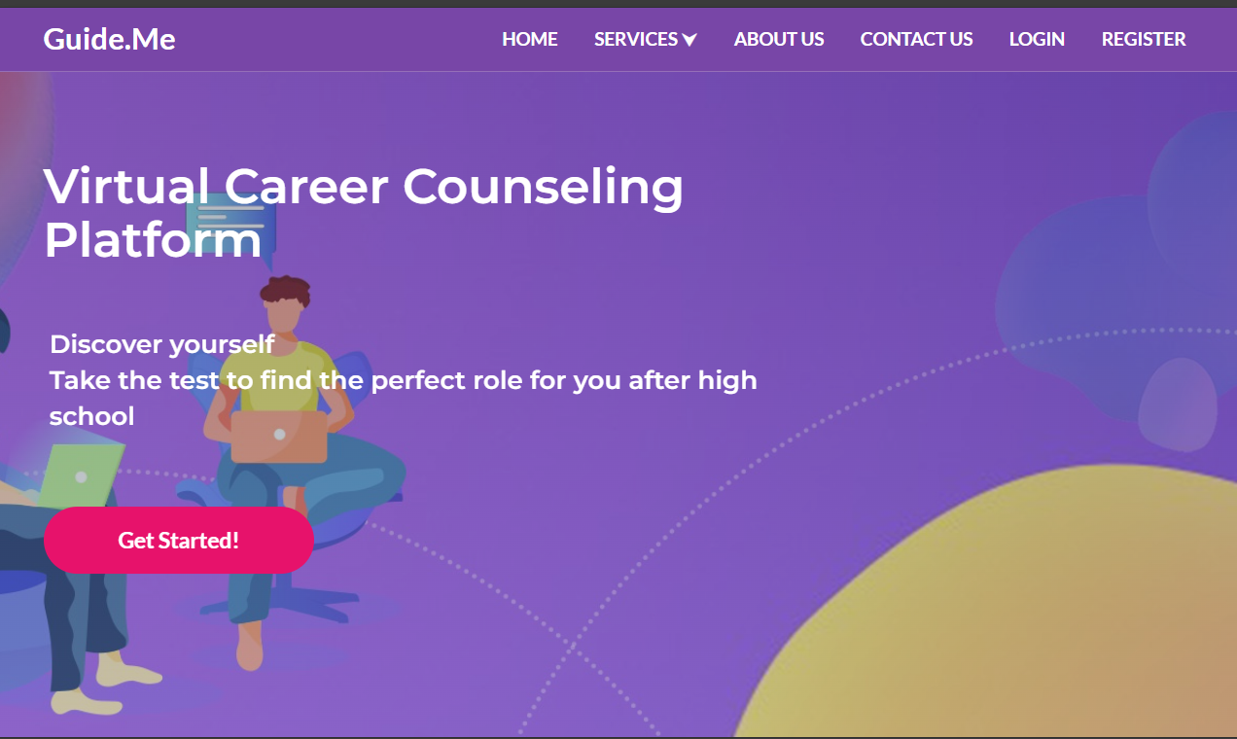

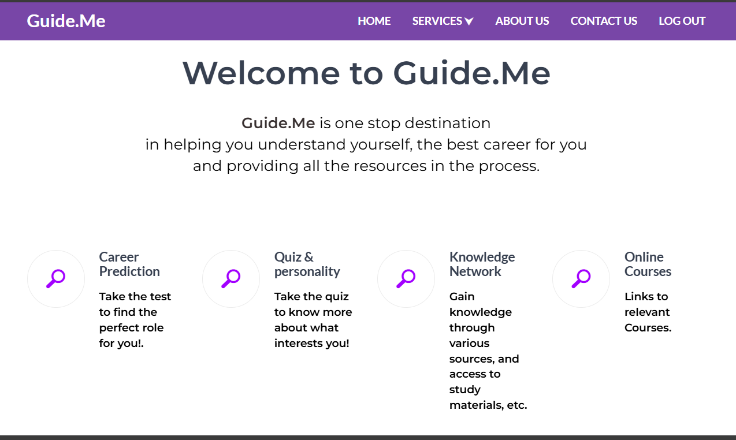

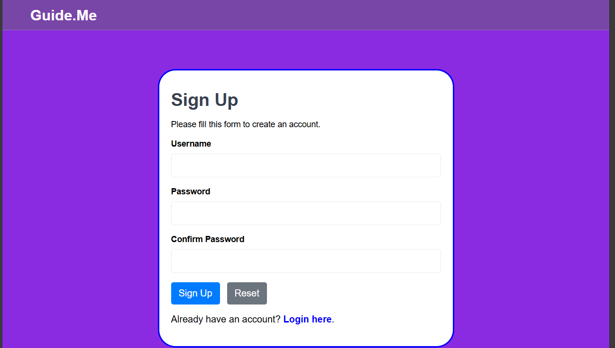

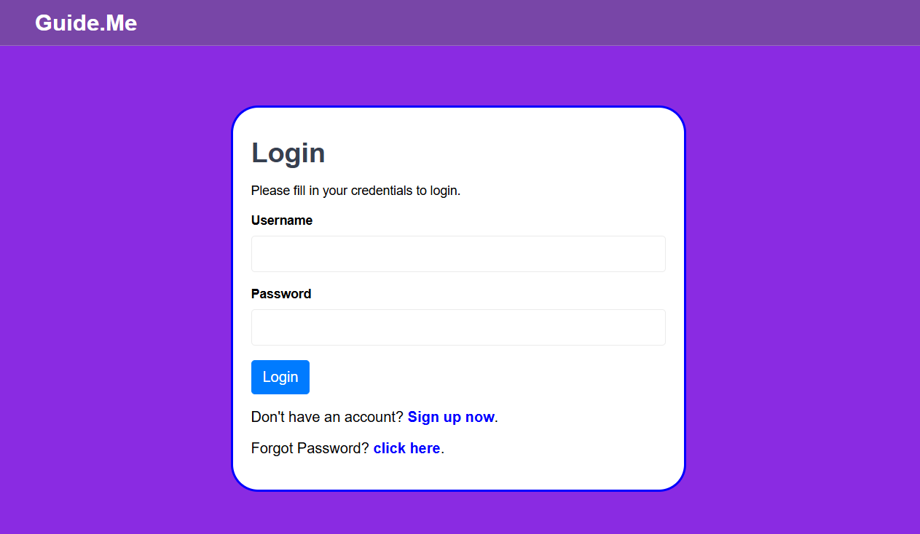

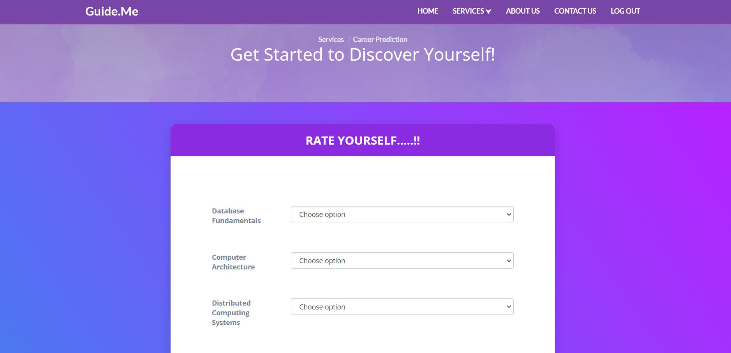

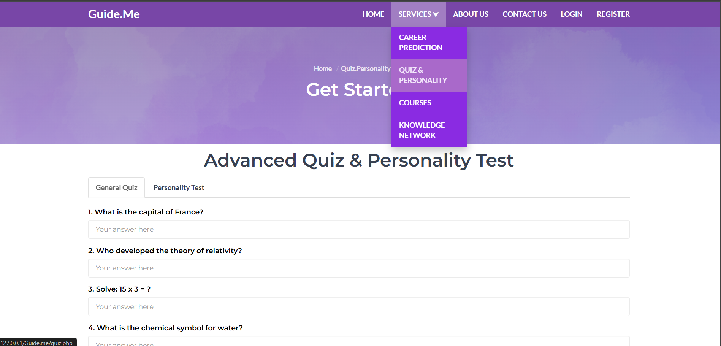

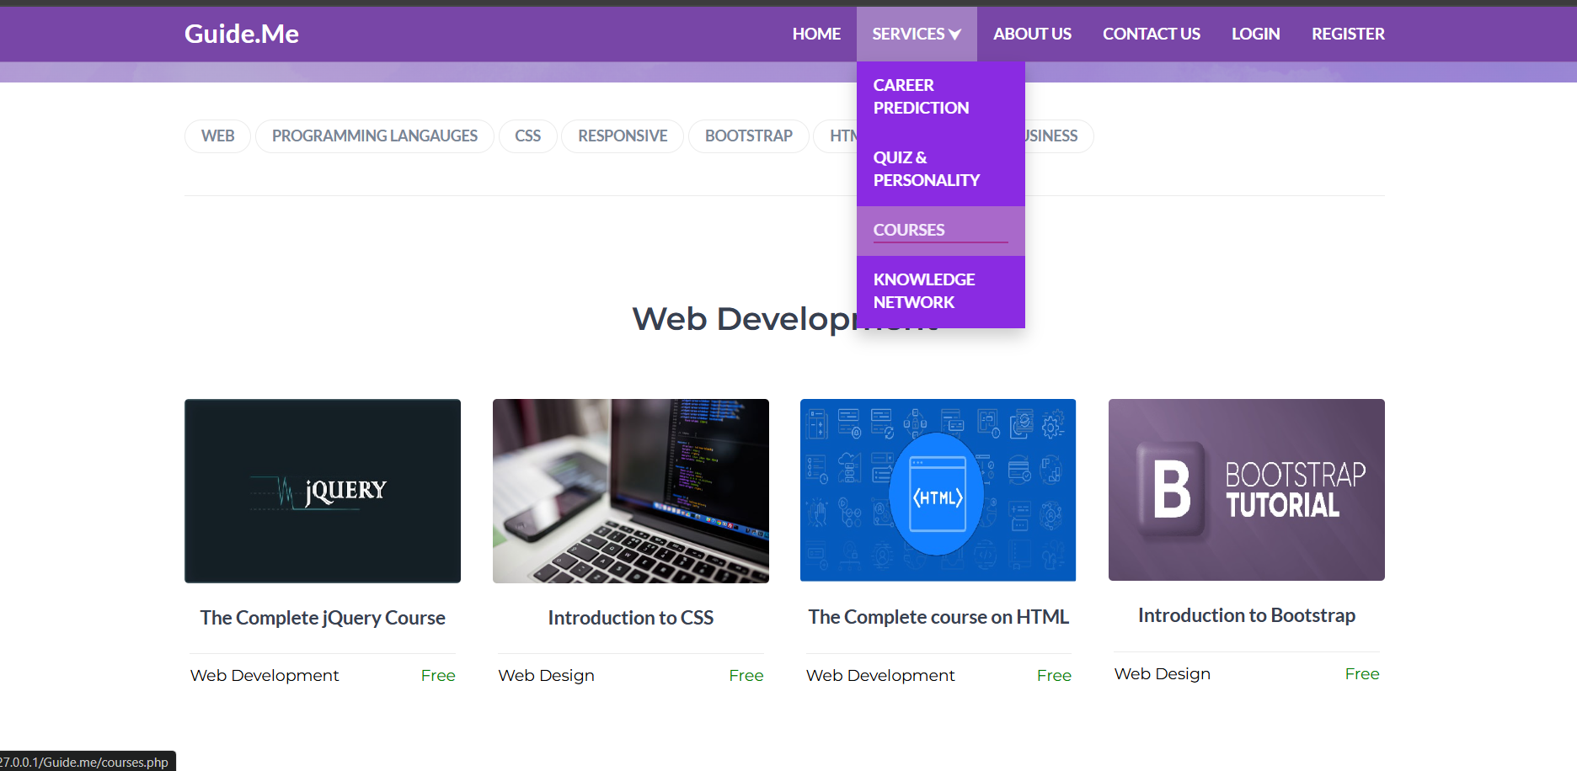

## **4.4 System Usability Evaluation**

The System Usability Scale (SUS) is a widely used questionnaire-based tool for assessing the usability and user-friendliness of software, websites, and digital systems. John Brooke invented it in the 1980s, and it has since become a popular tool for analysing user experiences. The SUS consists of a series of questions that users must answer to offer a quantitative measure of usability that may be used to compare different systems or track development over time.

The SUS is especially useful for gaining insights about users' perceptions of a system's general usability. It covers both subjective and objective aspects of usability, providing 45 vital feedback to designers and developers on how well a system corresponds with user expectations and needs.

The SUS questionnaire comprises ten statements, and participants respond to each statement using a 5-point Likert scale, ranging from "Strongly Disagree" to "Strongly Agree." The scale includes options:

1. Strongly Disagree.

2. Disagree.

3. Neutral.

4. Agree.

5. Strongly Agree.

The SUS is scored by converting the replies into numerical values and then applying a formula to calculate the final usability score. The possible values range from 0 to 100, with higher scores suggesting improved usefulness. A SUS score of 70 or more is considered above average, while a score of 85 or higher indicates great usability.

The SUS score can provide vital insight into how well an Online Attendance and Student Management System project is meeting user needs and expectations. The SUS questionnaire can be used to collect feedback on the system's usability, user-friendliness, and overall experience from peers who are trying the system. This feedback can assist to uncover strengths and weaknesses in the system's design and functionality, allowing for changes to the user experience and the creation of a platform that is more closely aligned with the needs of its users.

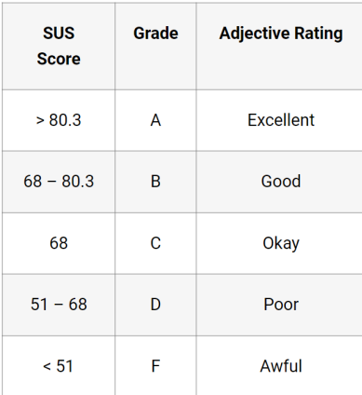

Source: <https://uiuxtrend.com/measuring-system-usability-scale-sus/>

The usability test questionnaire was created using the following clear and concise questions. The system was then tested with ten users and feedback was gathered using this questionnaire.

1. I found the system to be easy to use.
2. I needed to learn a lot of things before I could get going with the system.
3. The various functions in the system are well integrated.
4. I would imagine that most people would learn to use this system very quickly.
5. I found the system very intuitive to use.
6. I needed to rely heavily on technical support to use the system.
7. The system has too many inconsistencies.
8. I felt very confident using the system.
9. I needed to learn a lot of things before I could accomplish tasks.
10. Overall, I am satisfied with the system's usability

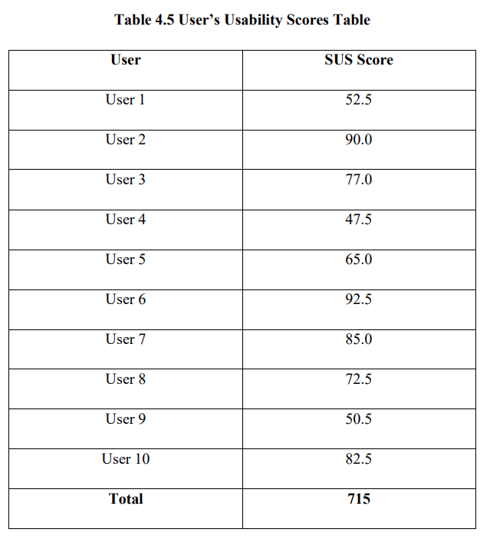

Based on the table above, the total usability score is 715. The average score which is gotten by dividing the total score by the number of users (10 users) is 71.5. According to the SUS Grade and Rating Table in Fig 4.10 above, the average usability score of the system falls at the 68 - 80.3 mark, therefore the system can be classified as good to use

## **CHAPTER FIVE**

## **SUMMARY AND CONCLUSION**

### Summary of findings

The research was concerned with the design and deployment of an AI-driven Virtual Career Counseling Platform to support the making of well-informed career choices by students and job seekers. The research ventured into the various methodologies of career guidance and added the component of artificial intelligence to enhance the personalization and accuracy of the suggested careers.

The system was developed with a combination of back-end and front-end technologies with the user interface being driven by JavaScript, CSS, and HTML while Node.js and Express.js managed the server logic. The AI module that was developed with the support of Python processed user information such as academic performance, personality types, and preferences to generate personalized careers advice. MongoDB was the database that was used to store user information and recommendations with ease.

Testing and analysis confirmed that the platform was able to deliver meaningful career advice based on user inputs. The system was extremely usable with a user-friendly interface and engaging career tests. With regards to performance testing, the platform was demonstrated to accommodate a large number of concurrent users with minimal delay, implying that the platform is scalable and a practical solution.

### Conclusion

The development of this Virtual Career Counseling Platform addressed the challenges of traditional career counseling by integrating AI-powered recommendations. With the aid of AI, the platform provides personalized information regarding a specific career that is aligned with a user’s academic performance, areas of interest, personality types, and parent preferences. It aids the decision-making process by enabling the user to find careers that are well-suited to their potential and aspirations.

The study has shown that AI-powered career guidance can enhance the accessibility and accuracy of career advice significantly. In contrast to traditional counseling that is usually carried out with face-to-face consultations, this platform offers the user the opportunity to access advice on careers at their convenience and location of choice. It is especially advantageous to students located in remote areas with no access to career guidance experts.

Overall, the platform fulfils its primary function of a smart, interactive virtual career guidance system. With the ease of the platform's interface, AI-driven recommendations, and the presence of real-time consultations, the platform is a highly beneficial career-planning aid.

### Recommendations for Future Studies

Although the service is a major improvement upon the traditional way of providing career counseling, areas of improvement are present

1. Integration of Higher AI Algos – Current recommendation functionality is predominantly based on hard-coded logic and simple machine learning algorithms. Future versions need to have the inclusion of higher AI models such as deep learning and natural language processing to improve the predicted careers with greater accuracy.
2. Expansion of the Career Database – The existing database of the system is narrow with respect to the number of careers included. Future work should encompass the inclusion of a bigger database with emerging careers that include areas of blockchain technologies, green energy, and artificial intelligence.
3. User Feedback System – Incorporation of a user feedback system that will allow the user to provide a quality rating of their recommended careers will enhance the AI model with time. It will allow the platform to enhance the quality of the recommendations with the user’s real usage experience.
4. Real-Time Career Counseling with Chatbots – Addition of a chatbot functionality powered by AI can allow real-time career chats where the user can ask queries and receive immediate replies with the aid of AI-powered career information.
5. Mobile Application Development – Having a mobile version of the platform will allow mobile users to have easier access to career counseling. An offline-enabled mobile application can also be of significant value to the user with less access to the internet.
6. Multi-Language Capability – Supporting various languages can open the platform to a greater number of potential users, especially to individuals located within areas that are not English-speaking.
7. Partnerships with Education Institutes – It can also improve the validity and reach of the platform by forming alliances with vocational training institutes, colleges, and universities to permit the usage of the platform by the students while they plan their academic and professional lives.

## **REFERENCES**

Nie, M. (2020). Career Choice Prediction Based on Campus Big Data—Mining the Potential Behavior of College Students, Applied Sciences, 10(8), pp. 1 - 14. Marcionetti, J., & Rossier, J. (2017).

The Mediating Impact of Parental Support on the Relationship Between Personality and Career Indecision in Adolescents. Journal of Career Assessment, 25(4), pp. 601-615. Prasanna, L., & Haritha, D. (2019).

Smart Career Guidance and Recommendation System. IJEDR , 7(3), pp. 633 – 637. Levina, N (2020).

Testing the structure of the Career Decision-Making Difficulties Questionnaire across country, gender, age, and decision status. Journal of Vocational Behavior, Volume 116, pp. 2-11. Todorescu, L., Greculescu, A., & Popescu-Mitroi, M. (2015). Engineering Students’ Career Choice And The English Teacher’s Profile In Romanian Higher Education. Procedia - Social and Behavioral Sciences, Volume 197, p. 201 – 206. Korir, J (2012).

Factors that Influence Career Choice of Hospitality Students in Moi University, Kenya. Journal of Education and Practice, 3(14), pp. 83-87. Meddour, H. (2016).

Factors Affecting Career Choice Among Undergraduate Students in Universitas Indonesia. International Journal of Economic Perspectives, 10(4), pp. 630-644. Shumba, A., & Naong, M. (2012).

Factors Influencing Students’ Career Choice and Aspirations in South Africa. J Soc Sci, 33(2), pp. 169-178, 2012. Patel, B., Kakuste, V., & Eirinaki, M. (2017).

A Career Path Recommendation Framework. San Francisco, CA, USA, 2017 IEEE Third International Conference on Big Data Computing Service and Applications. Jackson, D., & Wilton, N. (2017).

Career choice status among undergraduates and the influence of career management competencies and perceived employability. Journal of Education and Work, 30(5), pp. 552-569. Verma, P., Sood, S., & Kalra, S. (2017).

Student career path recommendation in engineering stream based on threedimensional model. Computer Applications in Engineering Education, Issue 9999, p. 1–16, 2017. Dabula, P., & Makura, A. (2013).

High School Students’ Perceptions of Career Guidance and Development Programmes for University Access. Int J Edu Sci , 5(2), pp. 89-97. Afolabi, A., Ojelabi, R., Amusan, L., & Adefarati, F. (2017).

Development of a Web-based Building Profession Career Portal as a Guidance Information System for Secondary School Students. Lagos, Nigeria, 2017 International Conference on Computing Networking and Informatics (ICCNI). Razak, T. (2014).

Career Path Recommendation System for UiTM Perlis Students Using Fuzzy Logic. Kuala Lumpur, 2014 5th International Conference on Intelligent and Advanced Systems (ICIAS). Ardeleanu, M., & Stanescu, D. (2016). A

A New Research Concerning Some Influence Factors in the Orientation of Highschool Graduates Towards Higher Technical Education. Bucharest, Romania, 2016 International Symposium on Fundamentals of Electrical Engineering (ISFEE). Bolat, N., & dacı, H. (2017).

High School Final Year Students’ Career Decision-Making Self-Efficacy, Attachment Styles and Gender Role Orientations. Current Psychology, Volume 36, p. 252–259.

## **APPENDIX**

## **SOURCE CODE**

Home page

<?php

// Initialize the session

session_start();

?>

<!DOCTYPE html>

<html lang="en">

<?php include 'header.php'?>

<!-- Home -->

<div id="home" class="hero-area">

<!-- Backgound Image -->

<div class="bg-image bg-parallax overlay" style="background-image:url(./img/bg.jpg); width:100%; height: 656px;"></div>

<!-- /Backgound Image -->

<div class="home-wrapper">

<div class="container">

<div class="row">

<div class="col-md-8">

<h1 class="white-text" style="font-size: 40px;margin-top: 20px;

margin-bottom:50px;">Virtual Career Counseling Platform</h1>

<?php

// Check if the user is logged in, if not then redirect him to login page

if(!isset($_SESSION["loggedin"]) || $_SESSION["loggedin"] !== true):?>

<p class="lead white-text" style="margin-left: 5px;" ><b>Discover yourself<br>Take the test to find the perfect role for you after high school</b></p>

<a class="main-button icon-button" href="login.php">Get Started!</a>

<?php else: ?>

<p class="lead white-text" style="margin-left: 5px;" ><b>Hi, <?php echo htmlspecialchars($_SESSION["username"]); ?> !<br><b>Discover yourself,<br>Take the test to find the perfect role for you!</b></p>

<a class="main-button icon-button" href="http://127.0.0.1:5000/">Get Started!</a>

<?php endif ?>

</div>

</div>

</div>

</div>

</div>

<!-- /Home -->

<!-- Why us -->

<div id="why-us" class="section">

<!-- container -->

<div class="container">

<!-- row -->

<div class="row">

<div class="section-header text-center">

<h2 style="margin-top: 100px; font-size: 45px;">Welcome to Guide.Me</h2>

<!--<p class="lead">We all want to fly high and in real time!<br> And in this random pursuit of success, we end up making wrong career choices.</p>-->

<p class="lead"><b style="color: rgb(56, 48, 48);">Guide.Me</b> is one stop destination <br>in helping you understand yourself, the best career for you <br> and providing all the resources in the process.</p>

</div>

</div>

<div class="row">

<!-- feature -->

<div class="col-md-3">

<div class="feature">

<i class="feature-icon fa "><span> &#x1F50E;&#xFE0E;</span></i>

<div class="feature-content">

<a href="#" >

<?php

// Check if the user is logged in, if not then redirect him to login page

if(!isset($_SESSION["loggedin"]) || $_SESSION["loggedin"] !== true):?>

<a href="login.php"><h4>Career Prediction</h4></a>

<?php else: ?>

<a href="http://127.0.0.1:5000/"><h4>Career Prediction</h4></a>

<?php endif ?>

<p>Take the test to find the perfect role for you!.</p>

</div>

</div>

</div>

<!-- /feature -->

<!-- feature -->

<div class="col-md-3">

<div class="feature">

<i class="feature-icon fa "><span>&#x1F50E;&#xFE0E;</span></i>

<div class="feature-content">

<a href="quiz.php" >

<h4>Quiz & personality</h4>

</a>

<p>Take the quiz to know more about what interests you!</p>

</div>

</div>

</div>

<!-- /feature -->

<!-- feature -->

<div class="col-md-3">

<div class="feature">

<i class="feature-icon fa "><span>&#x1F50E;&#xFE0E;</span></i>

<div class="feature-content">

<a href="blog.php" >

<h4>Knowledge Network</h4>

</a>

<p>Gain knowledge through various sources, and access to study materials, etc.</p>

</div>

</div>

</div>

<!-- /feature -->

<!-- feature -->

<div class="col-md-3">

<div class="feature">

<i class="feature-icon fa "><span>&#x1F50E;&#xFE0E;</span></i>

<div class="feature-content">

<a href="courses.php" >

<h4>Online Courses</h4>

</a>

<p>Links to relevant Courses.</p>

</div>

</div>

</div>

<!-- /feature -->

</div>

<!-- /row -->

<hr class="section-hr">

</div>

<!-- /container -->

</div>

<!-- /Why us -->

<!-- Call To Action -->

<div id="cta" class="section" style="height: 400px;">

<!-- Backgound Image -->

<div class="bg-image bg-parallax overlay" style="background-image:url(./img/bgmid.jpg)"></div>

<!-- /Backgound Image -->

<!-- container -->

<div class="container">

<!-- row -->

<div class="row">

<div class="col-md-6">

<?php

// Check if the user is logged in, if not then redirect him to login page

if(!isset($_SESSION["loggedin"]) || $_SESSION["loggedin"] !== true):?>

<h2 class="white-text" style="font-size: 30px; width:700px ;">Hi,</h2>

<h2 class="white-text" style="font-size: 25px; width:700px ; margin-top:10px;">Your Career Path Begins Here</h2>

<p class="lead white-text" >We Create Beautiful Experiences

That Drive Successful Careers.</p>

<a class="main-button icon-button" href="register.php">Get Started!</a>

<?php else: ?>

<h2 class="white-text" style="font-size: 30px; width:700px ;">Hi, <b><?php echo htmlspecialchars($_SESSION["username"]); ?> !</b></h2>

<h2 class="white-text" style="font-size: 25px; width:700px ; margin-top:10px;">Your Career Path Begins Here</h2>

<p class="lead white-text" >We Create Beautiful Experiences

That Drive Successful Careers.</p>

<a class="main-button icon-button" href="index.php">Get Started!</a>

<?php endif ?>

</div>

</div>

<!-- /row -->

</div>

<!-- /container -->

</div>

<!-- /Call To Action -->

<!-- About -->

<div id="about" class="section">

<!-- container -->

<div class="container">

<!-- row -->

<div class="row">

<div class="col-md-6">

<div class="section-header">

<h2 style="font-size: 35px;">About Guide.Me</h2>

<p class="lead" style="font-size: 18px; font-style: italic; margin-top: 50px;">Education seekers get a personalised experience on our site, based on educational background and career interest, enabling them to make well informed course and career decisions. The decision making is empowered with easy access to detailed information on career choices, courses, exams, colleges, admission criteria, eligibility, placement statistics, rankings, reviews, scholarships, latest updates etc as well as by interacting with other Guide.Me users, experts, current students in colleges and alumni groups. We have introduced several student oriented products and tools like Career Prediction, Knowledge Network, Daily Bytes, Blogs, Community discussion forum, and various Courses.</p>

<!--Education seekers get a personalised experience on our site, based on educational background and career interest, enabling them to make well informed course and college decisions. The decision making is empowered with easy access to detailed information on career choices, courses, exams, colleges, admission criteria, eligibility, fees, placement statistics, rankings, reviews, scholarships, latest updates etc as well as by interacting with other Shiksha.com users, experts, current students in colleges and alumni groups. We have introduced several student oriented products and tools like Career Central, Common Application Form, Top Colleges, College Compare, Alumni Employment Stats, Campus Connect, College Reviews, College Predictors, MyShortlist and Shiksha Café.-->

</div>

</div>

<div class="col-md-6">

<div class="about-img">

<img src="./img/about.png" alt="">

</div>

</div>

</div>

<!-- row -->

<hr class="section-hr">

</div>

<!-- container -->

</div>

<!-- /About -->

<!-- Contact CTA -->

<div id="contact-cta" class="section" style="height: 400px;">

<!-- Backgound Image -->

<div class="bg-image bg-parallax overlay" style="background-image:url(./img/cta2-background.jpg)"></div>

<!-- Backgound Image -->

<!-- container -->

<div class="container">

<!-- row -->

<div class="row">

<div class="col-md-8 col-md-offset-2 text-center">

<h2 class="white-text">Contact Us</h2>

<p class="lead white-text">Help us to get to know you.</p>

<a class="main-button icon-button" href="contact.php">Contact Us Now</a>

</div>

</div>

<!-- /row -->

</div>

<!-- /container -->

</div>

<!-- /Contact CTA -->

<?php include 'footer.php'?>

</html>

Login page

<?php

// Initialize the session <https://www.tutorialrepublic.com/php-tutorial/php-mysql-login-system.php>

session_start();

// Check if the user is already logged in, if yes then redirect him to welcome page

if(isset($_SESSION["loggedin"]) && $_SESSION["loggedin"] === true){

header("location:index.php");

exit;

}

// Include config file

require_once "config.php";

// Define variables and initialize with empty values

$username = $password = "";

$username_err = $password_err = $login_err = "";

// Processing form data when form is submitted

if($_SERVER["REQUEST_METHOD"] == "POST"){

// Check if username is empty

if(empty(trim($_POST["username"]))){

$username_err = "Please enter username.";

} else{

$username = trim($_POST["username"]);

}

// Check if password is empty

if(empty(trim($_POST["password"]))){

$password_err = "Please enter your password.";

} else{

$password = trim($_POST["password"]);

}

// Validate credentials

if(empty($username_err) && empty($password_err)){

// Prepare a select statement

$sql = "SELECT id, username, password FROM users WHERE username = ?";

if($stmt = mysqli_prepare($link, $sql)){

// Bind variables to the prepared statement as parameters

mysqli_stmt_bind_param($stmt, "s", $param_username);

// Set parameters

$param_username = $username;

// Attempt to execute the prepared statement

if(mysqli_stmt_execute($stmt)){

// Store result

mysqli_stmt_store_result($stmt);

// Check if username exists, if yes then verify password

if(mysqli_stmt_num_rows($stmt) == 1){

// Bind result variables

mysqli_stmt_bind_result($stmt, $id, $username, $hashed_password);

if(mysqli_stmt_fetch($stmt)){

if(password_verify($password, $hashed_password)){

// Password is correct, so start a new session

session_start();

// Store data in session variables

$_SESSION["loggedin"] = true;

$_SESSION["id"] = $id;

$_SESSION["username"] = $username;

// Redirect user to welcome page

header("location: index.php");

} else{

// Password is not valid, display a generic error message

$login_err = "Invalid username or password.";

}

}

} else{

// Username doesn't exist, display a generic error message

$login_err = "Invalid username or password.";

}

} else{

echo "Oops! Something went wrong. Please try again later.";

}

// Close statement

mysqli_stmt_close($stmt);

}

}

// Close connection

mysqli_close($link);

}

?>

<!DOCTYPE html>

<html lang="en" >

<head>

<meta charset="UTF-8">

<title>Login</title>

<link rel="stylesheet" href="https://stackpath.bootstrapcdn.com/bootstrap/4.5.2/css/bootstrap.min.css">

<link type="text/css" rel="stylesheet" href="css/s.css"/>

<style>

body{ font: 14px sans-serif;

margin:auto;

margin-top: 120px;

width:500px;

background-color: blueviolet;

color: black;

}

.wrapper{ border-style: solid;

border-color: blue;

border-radius: 30px;

padding: 20px; background-color: white;}

</style>

</head>

<body>

<!--Header-->

<header id="header" class="transparent-nav" style="position: fixed;background-color: rgb(120, 70, 167); top: 0;">

<div class="container">

<div class="navbar-header">

<!-- Logo -->

<div class="navbar-brand">

<a class="logo" href="index.php" style="padding-bottom: 10px;">Guide.Me</a>

</div>

<!-- /Logo -->

</div>

</div>

</header>

<!-- /Header -->

<div class="wrapper" >

<h2>Login</h2>

<p>Please fill in your credentials to login.</p>

<?php

if(!empty($login_err)){

echo '<div class="alert alert-danger">' . $login_err . '</div>';

}

?>

<form action="<?php echo htmlspecialchars($_SERVER["PHP_SELF"]); ?>" method="post">

<div class="form-group">

<label><b>Username</b></label>

<input type="text" name="username" class="form-control <?php echo (!empty($username_err)) ? 'is-invalid' : ''; ?>" value="<?php echo $username; ?>">

<span class="invalid-feedback"><?php echo $username_err; ?></span>

</div>

<div class="form-group">

<label><b>Password</b></label>

<input type="password" name="password" class="form-control <?php echo (!empty($password_err)) ? 'is-invalid' : ''; ?>">

<span class="invalid-feedback"><?php echo $password_err; ?></span>

</div>

<div class="form-group">

<input type="submit" class="btn btn-primary" value="Login">

</div>

<p style="font-size: 16px;">Don't have an account? <a href="register.php" style="color:blue;">Sign up now</a>.</p>

<p style="font-size: 16px;">Forgot Password? <a href="reset.php" style="color:blue;">click here</a>.</p>

</form>

</div>

</body>

</html>

Quiz Page

<?php

// Initialize the session

session_start();

?>

<!DOCTYPE html>

<html lang="en">

<head>

<?php include 'header.php'?>

<!-- Hero-area -->

<div class="hero-area section">

<!-- Backgound Image -->

<div class="bg-image bg-parallax overlay" style="background-image:url(./img/bgc2.jpg); " ></div>

<!-- /Backgound Image -->

<div class="container">

<div class="row" >

<div class="col-md-10 col-md-offset-1 text-center">

<ul class="hero-area-tree">

<li><a href="index.php">Home</a></li>

<li>Courses</li>

</ul>

<h1 class="white-text">Get Started</h1>

</div>

</div>

</div>

</div>

<!-- /Hero-area -->

<!-- Courses -->

<div id="courses" class="section">

<!-- container -->

<div class="container">

<!-- row

<div class="row">

<div class="section-header text-center">

<h2>Explore Courses</h2>

<p class="lead">Libris vivendo eloquentiam ex ius, nec id splendide abhorreant.</p>

</div>

</div>

-->

<!-- tags widget -->

<div class="widget tags-widget">

<a class="tag" href="#web">Web</a>

<a class="tag" href="#prog">Programming Langauges</a>

<a class="tag" href="#">Css</a>

<a class="tag" href="#">Responsive</a>

<a class="tag" href="#bootstrap">bootstrap</a>

<a class="tag" href="#web">Html</a>

<a class="tag" href="#">Website</a>

<a class="tag" href="#">Business</a>

</div>

<!-- /tags widget -->

<!-- courses -->

<hr class="section-hr" id="web">

<div id="courses-wrapper" >

<!-- row -->

<div class="row" >

<div class="section-header text-center" >

<h2 >Web Development</h2>

</div>

<!-- single course -->

<div class="col-md-3 col-sm-6 col-xs-6">

<div class="course">

<a href="https://www.w3schools.com/jquery/default.asp" target="_blank" class="course-img">

<img src="./img/coursejq.jpg" alt="">

<i class="course-link-icon fa fa-link"></i>

</a>

<a class="course-title" href="https://www.w3schools.com/jquery/default.asp" target="_blank" style="font-size:18px; text-align: center">The Complete jQuery Course</a>

<div class="course-details" style="margin:5px;">

<span class="course-category">Web Development</span>

<span class="course-price course-free">Free</span>

</div>

</div>

</div>

<!-- /single course -->

<!-- single course -->

<div class="col-md-3 col-sm-6 col-xs-6" >

<div class="course">

<a href="https://www.w3schools.com/css/default.asp" target="_blank" class="course-img">

<img src="./img/course02.jpg" alt="">

<i class="course-link-icon fa fa-link"></i>

</a>

<a class="course-title" href="https://www.w3schools.com/css/default.asp" target="_blank" style="font-size:18px; text-align: center"><b>Introduction to CSS </b></a>

<div class="course-details" style="margin: 5px;">

<span class="course-category">Web Design</span>

<span class="course-price course-free">Free</span>

</div>

</div>

</div>

<!-- /single course -->

<!-- single course -->

<div class="col-md-3 col-sm-6 col-xs-6">

<div class="course">

<a href="https://progate.com/courses/java" target="_blank" class="course-img">

<img src="./img/coursehtml.jpg " alt="">

<i class="course-link-icon fa fa-link"></i>

</a>

<a class="course-title" href="https://progate.com/courses/java" target="_blank" style="font-size:18px; text-align: center">The Complete course on HTML</a>

<div class="course-details" style="margin: 5px;">

<span class="course-category">Web Development</span>

<span class="course-price course-free">Free</span>

</div>

</div>

</div>

<!-- /single course -->

<div class="col-md-3 col-sm-6 col-xs-6">

<div class="course">

<a href="https://www.w3schools.com/bootstrap4/default.asp" class="course-img" target="_blank">

<img src="./img/coursebtsp.jpg" alt="">

<i class="course-link-icon fa fa-link"></i>

</a>

<a class="course-title" href="https://www.w3schools.com/bootstrap4/default.asp" target="_blank" style="font-size:18px; text-align: center">Introduction to Bootstrap</a>

<div class="course-details" style="margin: 5px;">

<span class="course-category">Web Design</span>

<span class="course-price course-free">Free</span>

</div>

</div>

</div>

<!-- /single course -->

</div>

<!-- /row -->

<!-- row -->

<div class="row">

<!-- single course -->

<div class="col-md-3 col-sm-6 col-xs-6">

<div class="course">

<a href="https://www.w3schools.com/cs/default.asp" target="_blank" class="course-img">

<img src="./img/coursejs.jpg" alt="">

<i class="course-link-icon fa fa-link"></i>

</a>

<a class="course-title" href="https://www.w3schools.com/cs/default.asp" target="_blank" style="font-size:18px; text-align: center">JavaScript Tutorial</a>

<div class="course-details" style="margin:5px;">

<span class="course-category">Web Development</span>

<span class="course-price course-free">Free</span>

</div>

</div>

</div>

<!-- /single course -->

<!-- single course -->

<div class="col-md-3 col-sm-6 col-xs-6">

<div class="course">

<a href="https://www.udemy.com/course/the-complete-c-programming/" target="_blank" class="course-img">

<img src="./img/courserea.jpg" alt="">

<i class="course-link-icon fa fa-link"></i>

</a>

<a class="course-title" href="https://www.udemy.com/course/the-complete-c-programming/" target="_blank" style="font-size:18px; text-align: center">React Tutorial</a>

<div class="course-details" style="margin:5px;">

<span class="course-category">Web Development</span>

<span class="course-price course-free">Free</span>

</div>

</div>

</div>

<!-- /single course -->

<!-- single course -->

<div class="col-md-3 col-sm-6 col-xs-6">

<div class="course">

<a href="https://progate.com/courses/java" target="_blank" class="course-img">

<img src="./img/courseruby.jpg" alt="">

<i class="course-link-icon fa fa-link"></i>

</a>

<a class="course-title" href="https://progate.com/courses/java" target="_blank" style="font-size:18px; text-align: center">Ruby Tips and Tricks</a>

<div class="course-details" style="margin: 5px;">

<span class="course-category">Web Development</span>

<span class="course-price course-premium">Premium</span>

</div>

</div>

</div>

<!-- /single course -->

<div class="col-md-3 col-sm-6 col-xs-6">

<div class="course">

<a href="https://www.w3schools.com/bootstrap4/default.asp" class="course-img" target="_blank">

<img src="./img/course04.jpg" alt="">

<i class="course-link-icon fa fa-link"></i>

</a>

<a class="course-title" href="https://www.w3schools.com/bootstrap4/default.asp" target="_blank" style="font-size:18px; text-align: center">HTML & CSS</a>

<div class="course-details" style="margin: 5px;">

<span class="course-category">Web Development</span>

<span class="course-price course-premium">Premium</span>

</div>

</div>

</div>

<!-- /single course -->

</div>

<!-- /row -->

<!-- row -->

<div class="row">

<!-- single course -->

<div class="col-md-3 col-sm-6 col-xs-6">

<div class="course">

<a href="https://www.w3schools.com/cs/default.asp" target="_blank" class="course-img">

<img src="./img/courseror.jpg" alt="">

<i class="course-link-icon fa fa-link"></i>

</a>

<a class="course-title" href="https://www.w3schools.com/cs/default.asp" target="_blank" style="font-size:18px; text-align: center">Ruby on Rails5</a>

<div class="course-details" style="margin:5px;">

<span class="course-category">Web Development</span>

<span class="course-price course-premium">Premium</span>

</div>

</div>

</div>

<!-- /single course -->

<!-- single course -->

<div class="col-md-3 col-sm-6 col-xs-6">

<div class="course">

<a href="https://www.udemy.com/course/the-complete-c-programming/" target="_blank" class="course-img">

<img src="./img/coursesass.jpg" alt="">

<i class="course-link-icon fa fa-link"></i>

</a>

<a class="course-title" href="https://www.udemy.com/course/the-complete-c-programming/" target="_blank" style="font-size:18px; text-align: center">Introduction to Sass</a>

<div class="course-details" style="margin:5px;">

<span class="course-category">Web Development</span>

<span class="course-price course-premium">Premium</span>

</div>

</div>

</div>

<!-- /single course -->

<!-- single course -->

<div class="col-md-3 col-sm-6 col-xs-6">

<div class="course">

<a href="https://progate.com/courses/java" target="_blank" class="course-img">

<img src="./img/coursereact.jpg" alt="">

<i class="course-link-icon fa fa-link"></i>

</a>

<a class="course-title" href="https://progate.com/courses/java" target="_blank" style="font-size:18px; text-align: center">React complete course</a>

<div class="course-details" style="margin: 5px;">

<span class="course-category">Web Development</span>

<span class="course-price course-premium">Premium</span>

</div>

</div>

</div>

<!-- /single course -->

<div class="col-md-3 col-sm-6 col-xs-6">

<div class="course">

<a href="https://www.w3schools.com/bootstrap4/default.asp" class="course-img" target="_blank">

<img src="./img/coursejas.jpg" alt="">

<i class="course-link-icon fa fa-link"></i>

</a>

<a class="course-title" href="https://www.w3schools.com/bootstrap4/default.asp" target="_blank" style="font-size:18px; text-align: center">Complete guide on JavaScript</a>

<div class="course-details" style="margin: 5px;">

<span class="course-category">Web Development</span>

<span class="course-price course-premium">Premium</span>

</div>

</div>

</div>

<!-- /single course -->

</div>

<!-- /row -->

<!-- row -->

<div class="row">

<div class="section-header text-center">

<h2 id="prog">Programming Langauges</h2>

</div>

<!-- single course -->

<div class="col-md-3 col-sm-6 col-xs-6">

<div class="course">

<a href="https://www.datacamp.com/tracks/r-programming" class="course-img">

<img src="./img/course01.jpg" alt="">

<i class="course-link-icon fa fa-link"></i>

</a>

<a class="course-title" href="https://www.datacamp.com/tracks/r-programming" target="_blank" style="font-size:18px; text-align: center">R Programming</a>

<div class="course-details" style="margin: 5px;">

<span class="course-category">Programming</span>

<span class="course-price course-free">Free</span>

</div>

</div>

</div>

<!-- /single course -->

<!-- /single course -->

<div class="col-md-3 col-sm-6 col-xs-6">

<div class="course">

<a href="https://www.w3schools.com/cpp/default.asp" class="course-img" target="_blank">

<img src="./img/coursecpp.jpg" alt="">

<i class="course-link-icon fa fa-link"></i>

</a>

<a class="course-title" href="https://www.w3schools.com/cpp/default.asp" target="_blank" style="font-size:18px; text-align: center;" >Learn C++</a>

<div class="course-details" style="margin: 5px;">

<span class="course-category">Programming</span>

<span class="course-price course-free">Free</span>

</div>

</div>

</div>

<!-- /single course -->

<!-- /single course -->

<div class="col-md-3 col-sm-6 col-xs-6">

<div class="course">

<a href="https://www.w3schools.com/java/default.asp" class="course-img" target="_blank">

<img src="./img/coursejava.jpg" alt="">

<i class="course-link-icon fa fa-link"></i>

</a>

<a class="course-title" href="https://www.w3schools.com/java/default.asp" target="_blank" style="font-size:18px; text-align: center">Java Tutorial</a>

<div class="course-details" style="margin: 5px;">

<span class="course-category">Programming</span>

<span class="course-price course-free">Free</span>

</div>

</div>

</div>

<!-- /single course -->

<!-- /single course -->

<div class="col-md-3 col-sm-6 col-xs-6">

<div class="course">

<a href="https://www.w3schools.com/bootstrap4/default.asp" class="course-img" target="_blank">

<img src="./img/coursepy.jpg" alt="">

<i class="course-link-icon fa fa-link"></i>

</a>

<a class="course-title" href="https://www.w3schools.com/bootstrap4/default.asp" target="_blank" style="font-size:18px; text-align: center">Complete guide on python</a>

<div class="course-details" style="margin: 5px;">

<span class="course-category">Programming</span>

<span class="course-price course-free">Free</span>

</div>

</div>

</div>

<!-- /single course -->

</div>

<!-- /row -->

<!-- row -->

<div class="row">

<!-- single course -->

<div class="col-md-3 col-sm-6 col-xs-6">

<div class="course">

<a href="https://progate.com/courses/java" target="_blank" class="course-img">

<img src="./img/coursejv.jpg" alt="">

<i class="course-link-icon fa fa-link"></i>

</a>

<a class="course-title" href="https://progate.com/courses/java" target="_blank" style="font-size:18px; text-align: center">Core Java</a>

<div class="course-details" style="margin: 5px;">

<span class="course-category">Programming</span>

<span class="course-price course-premium">Premium</span>

</div>

</div>

</div>

<!-- /single course -->

<div class="col-md-3 col-sm-6 col-xs-6">

<div class="course">

<a href="https://www.w3schools.com/bootstrap4/default.asp" class="course-img" target="_blank">

<img src="./img/coursepyth.jpg" alt="">

<i class="course-link-icon fa fa-link"></i>

</a>

<a class="course-title" href="https://www.w3schools.com/bootstrap4/default.asp" target="_blank" style="font-size:18px; text-align: center">Python Programming</a>

<div class="course-details" style="margin: 5px;">

<span class="course-category">Programming</span>

<span class="course-price course-premium">Premium</span>

</div>

</div>

</div>

<!-- /single course -->

<!-- single course -->

<div class="col-md-3 col-sm-6 col-xs-6">

<div class="course">

<a href="https://www.w3schools.com/cs/default.asp" target="_blank" class="course-img">

<img src="./img/coursec.jpg" alt="">

<i class="course-link-icon fa fa-link"></i>

</a>

<a class="course-title" href="https://www.w3schools.com/cs/default.asp" target="_blank" style="font-size:18px; text-align: center">C# Tutorial</a>

<div class="course-details" style="margin:5px;">

<span class="course-category">Programming</span>

<span class="course-price course-free">Free</span>

</div>

</div>

</div>

<!-- /single course -->

<!-- single course -->

<div class="col-md-3 col-sm-6 col-xs-6">

<div class="course">

<a href="https://www.udemy.com/course/the-complete-c-programming/" target="_blank" class="course-img">

<img src="./img/coursecp.jpg" alt="">

<i class="course-link-icon fa fa-link"></i>

</a>

<a class="course-title" href="https://www.udemy.com/course/the-complete-c-programming/" target="_blank" style="font-size:18px; text-align: center">Complete C programming</a>

<div class="course-details" style="margin:5px;">

<span class="course-category">Programming</span>

<span class="course-price course-free">Free</span>

</div>

</div>

</div>

<!-- /single course -->

</div>

<!-- /row -->

<!-- row -->

<div class="row">

<div class="section-header text-center">

<h2 id="prog">Server Side</h2>

</div>

<!-- single course -->

<div class="col-md-3 col-sm-6 col-xs-6">

<div class="course">

<a href="https://www.w3schools.com/git/default.asp" target="_blank" class="course-img">

<img src="./img/course05.jpg" alt="">

<i class="course-link-icon fa fa-link"></i>

</a>

<a class="course-title" href="https://www.w3schools.com/git/default.asp" target="_blank" style="font-size:18px; text-align: center"><b>PHP Tips, Tricks, and Techniques</b></a>

<div class="course-details" style="margin: 5px;">

<span class="course-category">Server Side</span>

<span class="course-price course-free">Free</span>

</div>

</div>

</div>

<!-- /single course -->

<!-- single course -->

<div class="col-md-3 col-sm-6 col-xs-6">

<div class="course">

<a href="https://www.w3schools.com/git/default.asp" target="_blank" class="course-img">

<img src="./img/coursesql.jpg" alt="">

<i class="course-link-icon fa fa-link"></i>

</a>

<a class="course-title" href="https://www.w3schools.com/git/default.asp" target="_blank" style="font-size:18px; text-align: center"><b>SQL Tutorial</b></a>

<div class="course-details" style="margin: 5px;">

<span class="course-category">Server Side</span>

<span class="course-price course-free">Free</span>

</div>

</div>

</div>

<!-- /single course -->

<!-- single course -->

<div class="col-md-3 col-sm-6 col-xs-6">

<div class="course">

<a href="https://www.w3schools.com/git/default.asp" target="_blank" class="course-img">

<img src="./img/coursend.jpg" alt="">

<i class="course-link-icon fa fa-link"></i>

</a>

<a class="course-title" href="https://www.w3schools.com/git/default.asp" target="_blank" style="font-size:18px; text-align: center"><b>Node.js crash course</b></a>

<div class="course-details" style="margin: 5px;">

<span class="course-category">Server Side</span>

<span class="course-price course-free">Free</span>

</div>

</div>

</div>

<!-- /single course -->

<!-- single course -->

<div class="col-md-3 col-sm-6 col-xs-6">

<div class="course">

<a href="https://www.w3schools.com/git/default.asp" target="_blank" class="course-img">

<img src="./img/coursegit.jpg" alt="">

<i class="course-link-icon fa fa-link"></i>

</a>

<a class="course-title" href="https://www.w3schools.com/git/default.asp" target="_blank" style="font-size:18px; text-align: center"><b>Mastering Git</b></a>

<div class="course-details" style="margin: 5px;">

<span class="course-category">Server Side</span>

<span class="course-price course-free">Free</span>

</div>

</div>

</div>

<!-- /single course -->

</div>

<!-- /row -->

</div>

<!-- /courses -->

<!--<div class="row">

<div class="center-btn">

<a class="main-button icon-button" href="#">More Courses</a>

</div>

</div>-->

</div>

<!-- container -->

</div>

<!-- /Courses -->

<?php include 'footer.php'?>

</html>

Courses Page

<?php

// Initialize the session

session_start();

?>

<!DOCTYPE html>

<html lang="en">

<head>

<?php include 'header.php'?>

<!-- Hero-area -->

<div class="hero-area section">

<!-- Backgound Image -->

<div class="bg-image bg-parallax overlay" style="background-image:url(./img/bgc2.jpg); " ></div>

<!-- /Backgound Image -->

<div class="container">

<div class="row" >

<div class="col-md-10 col-md-offset-1 text-center">

<ul class="hero-area-tree">

<li><a href="index.php">Home</a></li>

<li>Courses</li>

</ul>

<h1 class="white-text">Get Started</h1>

</div>

</div>

</div>

</div>

<!-- /Hero-area -->

<!-- Courses -->

<div id="courses" class="section">

<!-- container -->

<div class="container">

<!-- row

<div class="row">

<div class="section-header text-center">

<h2>Explore Courses</h2>

<p class="lead">Libris vivendo eloquentiam ex ius, nec id splendide abhorreant.</p>

</div>

</div>

-->

<!-- tags widget -->

<div class="widget tags-widget">

<a class="tag" href="#web">Web</a>

<a class="tag" href="#prog">Programming Langauges</a>

<a class="tag" href="#">Css</a>

<a class="tag" href="#">Responsive</a>

<a class="tag" href="#bootstrap">bootstrap</a>

<a class="tag" href="#web">Html</a>

<a class="tag" href="#">Website</a>

<a class="tag" href="#">Business</a>

</div>

<!-- /tags widget -->

<!-- courses -->

<hr class="section-hr" id="web">

<div id="courses-wrapper" >

<!-- row -->

<div class="row" >

<div class="section-header text-center" >

<h2 >Web Development</h2>

</div>

<!-- single course -->

<div class="col-md-3 col-sm-6 col-xs-6">

<div class="course">

<a href="https://www.w3schools.com/jquery/default.asp" target="_blank" class="course-img">

<img src="./img/coursejq.jpg" alt="">

<i class="course-link-icon fa fa-link"></i>

</a>

<a class="course-title" href="https://www.w3schools.com/jquery/default.asp" target="_blank" style="font-size:18px; text-align: center">The Complete jQuery Course</a>

<div class="course-details" style="margin:5px;">

<span class="course-category">Web Development</span>

<span class="course-price course-free">Free</span>

</div>

</div>

</div>

<!-- /single course -->

<!-- single course -->

<div class="col-md-3 col-sm-6 col-xs-6" >

<div class="course">

<a href="https://www.w3schools.com/css/default.asp" target="_blank" class="course-img">

<img src="./img/course02.jpg" alt="">

<i class="course-link-icon fa fa-link"></i>

</a>

<a class="course-title" href="https://www.w3schools.com/css/default.asp" target="_blank" style="font-size:18px; text-align: center"><b>Introduction to CSS </b></a>

<div class="course-details" style="margin: 5px;">

<span class="course-category">Web Design</span>

<span class="course-price course-free">Free</span>

</div>

</div>

</div>

<!-- /single course -->

<!-- single course -->

<div class="col-md-3 col-sm-6 col-xs-6">

<div class="course">

<a href="https://progate.com/courses/java" target="_blank" class="course-img">

<img src="./img/coursehtml.jpg " alt="">

<i class="course-link-icon fa fa-link"></i>

</a>

<a class="course-title" href="https://progate.com/courses/java" target="_blank" style="font-size:18px; text-align: center">The Complete course on HTML</a>

<div class="course-details" style="margin: 5px;">

<span class="course-category">Web Development</span>

<span class="course-price course-free">Free</span>

</div>

</div>

</div>

<!-- /single course -->

<div class="col-md-3 col-sm-6 col-xs-6">

<div class="course">

<a href="https://www.w3schools.com/bootstrap4/default.asp" class="course-img" target="_blank">

<img src="./img/coursebtsp.jpg" alt="">

<i class="course-link-icon fa fa-link"></i>

</a>

<a class="course-title" href="https://www.w3schools.com/bootstrap4/default.asp" target="_blank" style="font-size:18px; text-align: center">Introduction to Bootstrap</a>

<div class="course-details" style="margin: 5px;">

<span class="course-category">Web Design</span>

<span class="course-price course-free">Free</span>

</div>

</div>

</div>

<!-- /single course -->

</div>

<!-- /row -->

<!-- row -->

<div class="row">

<!-- single course -->

<div class="col-md-3 col-sm-6 col-xs-6">

<div class="course">

<a href="https://www.w3schools.com/cs/default.asp" target="_blank" class="course-img">

<img src="./img/coursejs.jpg" alt="">

<i class="course-link-icon fa fa-link"></i>

</a>

<a class="course-title" href="https://www.w3schools.com/cs/default.asp" target="_blank" style="font-size:18px; text-align: center">JavaScript Tutorial</a>

<div class="course-details" style="margin:5px;">

<span class="course-category">Web Development</span>

<span class="course-price course-free">Free</span>

</div>

</div>

</div>

<!-- /single course -->

<!-- single course -->

<div class="col-md-3 col-sm-6 col-xs-6">

<div class="course">

<a href="https://www.udemy.com/course/the-complete-c-programming/" target="_blank" class="course-img">

<img src="./img/courserea.jpg" alt="">

<i class="course-link-icon fa fa-link"></i>

</a>

<a class="course-title" href="https://www.udemy.com/course/the-complete-c-programming/" target="_blank" style="font-size:18px; text-align: center">React Tutorial</a>

<div class="course-details" style="margin:5px;">

<span class="course-category">Web Development</span>

<span class="course-price course-free">Free</span>

</div>

</div>

</div>

<!-- /single course -->

<!-- single course -->

<div class="col-md-3 col-sm-6 col-xs-6">

<div class="course">

<a href="https://progate.com/courses/java" target="_blank" class="course-img">

<img src="./img/courseruby.jpg" alt="">

<i class="course-link-icon fa fa-link"></i>

</a>

<a class="course-title" href="https://progate.com/courses/java" target="_blank" style="font-size:18px; text-align: center">Ruby Tips and Tricks</a>

<div class="course-details" style="margin: 5px;">

<span class="course-category">Web Development</span>

<span class="course-price course-premium">Premium</span>

</div>

</div>

</div>

<!-- /single course -->

<div class="col-md-3 col-sm-6 col-xs-6">

<div class="course">

<a href="https://www.w3schools.com/bootstrap4/default.asp" class="course-img" target="_blank">

<img src="./img/course04.jpg" alt="">

<i class="course-link-icon fa fa-link"></i>

</a>

<a class="course-title" href="https://www.w3schools.com/bootstrap4/default.asp" target="_blank" style="font-size:18px; text-align: center">HTML & CSS</a>

<div class="course-details" style="margin: 5px;">

<span class="course-category">Web Development</span>

<span class="course-price course-premium">Premium</span>

</div>

</div>

</div>

<!-- /single course -->

</div>

<!-- /row -->

<!-- row -->

<div class="row">

<!-- single course -->

<div class="col-md-3 col-sm-6 col-xs-6">

<div class="course">

<a href="https://www.w3schools.com/cs/default.asp" target="_blank" class="course-img">

<img src="./img/courseror.jpg" alt="">

<i class="course-link-icon fa fa-link"></i>

</a>

<a class="course-title" href="https://www.w3schools.com/cs/default.asp" target="_blank" style="font-size:18px; text-align: center">Ruby on Rails5</a>

<div class="course-details" style="margin:5px;">

<span class="course-category">Web Development</span>

<span class="course-price course-premium">Premium</span>

</div>

</div>

</div>

<!-- /single course -->

<!-- single course -->

<div class="col-md-3 col-sm-6 col-xs-6">

<div class="course">

<a href="https://www.udemy.com/course/the-complete-c-programming/" target="_blank" class="course-img">

<img src="./img/coursesass.jpg" alt="">

<i class="course-link-icon fa fa-link"></i>

</a>

<a class="course-title" href="https://www.udemy.com/course/the-complete-c-programming/" target="_blank" style="font-size:18px; text-align: center">Introduction to Sass</a>

<div class="course-details" style="margin:5px;">

<span class="course-category">Web Development</span>

<span class="course-price course-premium">Premium</span>

</div>

</div>

</div>

<!-- /single course -->

<!-- single course -->

<div class="col-md-3 col-sm-6 col-xs-6">

<div class="course">

<a href="https://progate.com/courses/java" target="_blank" class="course-img">

<img src="./img/coursereact.jpg" alt="">

<i class="course-link-icon fa fa-link"></i>

</a>

<a class="course-title" href="https://progate.com/courses/java" target="_blank" style="font-size:18px; text-align: center">React complete course</a>

<div class="course-details" style="margin: 5px;">

<span class="course-category">Web Development</span>

<span class="course-price course-premium">Premium</span>

</div>

</div>

</div>

<!-- /single course -->

<div class="col-md-3 col-sm-6 col-xs-6">

<div class="course">

<a href="https://www.w3schools.com/bootstrap4/default.asp" class="course-img" target="_blank">

<img src="./img/coursejas.jpg" alt="">

<i class="course-link-icon fa fa-link"></i>

</a>

<a class="course-title" href="https://www.w3schools.com/bootstrap4/default.asp" target="_blank" style="font-size:18px; text-align: center">Complete guide on JavaScript</a>

<div class="course-details" style="margin: 5px;">

<span class="course-category">Web Development</span>

<span class="course-price course-premium">Premium</span>

</div>

</div>

</div>

<!-- /single course -->

</div>

<!-- /row -->

<!-- row -->

<div class="row">

<div class="section-header text-center">

<h2 id="prog">Programming Langauges</h2>

</div>

<!-- single course -->

<div class="col-md-3 col-sm-6 col-xs-6">

<div class="course">

<a href="https://www.datacamp.com/tracks/r-programming" class="course-img">

<img src="./img/course01.jpg" alt="">

<i class="course-link-icon fa fa-link"></i>

</a>

<a class="course-title" href="https://www.datacamp.com/tracks/r-programming" target="_blank" style="font-size:18px; text-align: center">R Programming</a>

<div class="course-details" style="margin: 5px;">

<span class="course-category">Programming</span>

<span class="course-price course-free">Free</span>

</div>

</div>

</div>

<!-- /single course -->

<!-- /single course -->

<div class="col-md-3 col-sm-6 col-xs-6">

<div class="course">

<a href="https://www.w3schools.com/cpp/default.asp" class="course-img" target="_blank">

<img src="./img/coursecpp.jpg" alt="">

<i class="course-link-icon fa fa-link"></i>

</a>

<a class="course-title" href="https://www.w3schools.com/cpp/default.asp" target="_blank" style="font-size:18px; text-align: center;" >Learn C++</a>

<div class="course-details" style="margin: 5px;">

<span class="course-category">Programming</span>

<span class="course-price course-free">Free</span>

</div>

</div>

</div>

<!-- /single course -->

<!-- /single course -->

<div class="col-md-3 col-sm-6 col-xs-6">

<div class="course">

<a href="https://www.w3schools.com/java/default.asp" class="course-img" target="_blank">

<img src="./img/coursejava.jpg" alt="">

<i class="course-link-icon fa fa-link"></i>

</a>

<a class="course-title" href="https://www.w3schools.com/java/default.asp" target="_blank" style="font-size:18px; text-align: center">Java Tutorial</a>

<div class="course-details" style="margin: 5px;">

<span class="course-category">Programming</span>

<span class="course-price course-free">Free</span>

</div>

</div>

</div>

<!-- /single course -->

<!-- /single course -->

<div class="col-md-3 col-sm-6 col-xs-6">

<div class="course">

<a href="https://www.w3schools.com/bootstrap4/default.asp" class="course-img" target="_blank">

<img src="./img/coursepy.jpg" alt="">

<i class="course-link-icon fa fa-link"></i>

</a>

<a class="course-title" href="https://www.w3schools.com/bootstrap4/default.asp" target="_blank" style="font-size:18px; text-align: center">Complete guide on python</a>

<div class="course-details" style="margin: 5px;">

<span class="course-category">Programming</span>

<span class="course-price course-free">Free</span>

</div>

</div>

</div>

<!-- /single course -->

</div>

<!-- /row -->

<!-- row -->

<div class="row">

<!-- single course -->

<div class="col-md-3 col-sm-6 col-xs-6">

<div class="course">

<a href="https://progate.com/courses/java" target="_blank" class="course-img">

<img src="./img/coursejv.jpg" alt="">

<i class="course-link-icon fa fa-link"></i>

</a>

<a class="course-title" href="https://progate.com/courses/java" target="_blank" style="font-size:18px; text-align: center">Core Java</a>

<div class="course-details" style="margin: 5px;">

<span class="course-category">Programming</span>

<span class="course-price course-premium">Premium</span>

</div>

</div>

</div>

<!-- /single course -->

<div class="col-md-3 col-sm-6 col-xs-6">

<div class="course">

<a href="https://www.w3schools.com/bootstrap4/default.asp" class="course-img" target="_blank">

<img src="./img/coursepyth.jpg" alt="">

<i class="course-link-icon fa fa-link"></i>

</a>

<a class="course-title" href="https://www.w3schools.com/bootstrap4/default.asp" target="_blank" style="font-size:18px; text-align: center">Python Programming</a>

<div class="course-details" style="margin: 5px;">

<span class="course-category">Programming</span>

<span class="course-price course-premium">Premium</span>

</div>

</div>

</div>

<!-- /single course -->

<!-- single course -->

<div class="col-md-3 col-sm-6 col-xs-6">

<div class="course">

<a href="https://www.w3schools.com/cs/default.asp" target="_blank" class="course-img">

<img src="./img/coursec.jpg" alt="">

<i class="course-link-icon fa fa-link"></i>

</a>

<a class="course-title" href="https://www.w3schools.com/cs/default.asp" target="_blank" style="font-size:18px; text-align: center">C# Tutorial</a>

<div class="course-details" style="margin:5px;">

<span class="course-category">Programming</span>

<span class="course-price course-free">Free</span>

</div>

</div>

</div>

<!-- /single course -->

<!-- single course -->

<div class="col-md-3 col-sm-6 col-xs-6">

<div class="course">

<a href="https://www.udemy.com/course/the-complete-c-programming/" target="_blank" class="course-img">

<img src="./img/coursecp.jpg" alt="">

<i class="course-link-icon fa fa-link"></i>

</a>

<a class="course-title" href="https://www.udemy.com/course/the-complete-c-programming/" target="_blank" style="font-size:18px; text-align: center">Complete C programming</a>

<div class="course-details" style="margin:5px;">

<span class="course-category">Programming</span>

<span class="course-price course-free">Free</span>

</div>

</div>

</div>

<!-- /single course -->

</div>

<!-- /row -->

<!-- row -->

<div class="row">

<div class="section-header text-center">

<h2 id="prog">Server Side</h2>

</div>

<!-- single course -->

<div class="col-md-3 col-sm-6 col-xs-6">

<div class="course">

<a href="https://www.w3schools.com/git/default.asp" target="_blank" class="course-img">

<img src="./img/course05.jpg" alt="">

<i class="course-link-icon fa fa-link"></i>

</a>

<a class="course-title" href="https://www.w3schools.com/git/default.asp" target="_blank" style="font-size:18px; text-align: center"><b>PHP Tips, Tricks, and Techniques</b></a>

<div class="course-details" style="margin: 5px;">

<span class="course-category">Server Side</span>

<span class="course-price course-free">Free</span>

</div>

</div>

</div>

<!-- /single course -->

<!-- single course -->

<div class="col-md-3 col-sm-6 col-xs-6">

<div class="course">

<a href="https://www.w3schools.com/git/default.asp" target="_blank" class="course-img">

<img src="./img/coursesql.jpg" alt="">

<i class="course-link-icon fa fa-link"></i>

</a>

<a class="course-title" href="https://www.w3schools.com/git/default.asp" target="_blank" style="font-size:18px; text-align: center"><b>SQL Tutorial</b></a>

<div class="course-details" style="margin: 5px;">

<span class="course-category">Server Side</span>

<span class="course-price course-free">Free</span>

</div>

</div>

</div>

<!-- /single course -->

<!-- single course -->

<div class="col-md-3 col-sm-6 col-xs-6">

<div class="course">

<a href="https://www.w3schools.com/git/default.asp" target="_blank" class="course-img">

<img src="./img/coursend.jpg" alt="">

<i class="course-link-icon fa fa-link"></i>

</a>

<a class="course-title" href="https://www.w3schools.com/git/default.asp" target="_blank" style="font-size:18px; text-align: center"><b>Node.js crash course</b></a>

<div class="course-details" style="margin: 5px;">

<span class="course-category">Server Side</span>

<span class="course-price course-free">Free</span>

</div>

</div>

</div>

<!-- /single course -->

<!-- single course -->

<div class="col-md-3 col-sm-6 col-xs-6">

<div class="course">

<a href="https://www.w3schools.com/git/default.asp" target="_blank" class="course-img">

<img src="./img/coursegit.jpg" alt="">

<i class="course-link-icon fa fa-link"></i>

</a>

<a class="course-title" href="https://www.w3schools.com/git/default.asp" target="_blank" style="font-size:18px; text-align: center"><b>Mastering Git</b></a>

<div class="course-details" style="margin: 5px;">

<span class="course-category">Server Side</span>

<span class="course-price course-free">Free</span>

</div>

</div>

</div>

<!-- /single course -->

</div>

<!-- /row -->

</div>

<!-- /courses -->

<!--<div class="row">

<div class="center-btn">

<a class="main-button icon-button" href="#">More Courses</a>

</div>

</div>-->

</div>

<!-- container -->

</div>

<!-- /Courses -->

<?php include 'footer.php'?>

</html>