National Textile University Faisalabad

Department of Computer Science
^{Name:} | ^{Ahmad Fawad}
^{Class:} | ^{BSSE A 6th}
^{Registration No:} | ¹¹²⁹
Course Name: | ^{Mobile App Dev}
^{Submitted To:} | ^{Sir Rehaan Sarwar}
^{Submission Date:} | ^{3/1/2026}

a Flutter Project Shortcut key → Ctrl+shift+p Create a Stateless Widget (stle) and Add AppBar to your Project. Change the color of the Appbar.
5. Create a Flutter Project Shortcut key → Ctrl+shift+p Create a Stateless Widget (stle) and Add AppBar to your Project. Change the color of the Appbar. Align the Text on the Appbar at center. Add you name at the center of the screen.

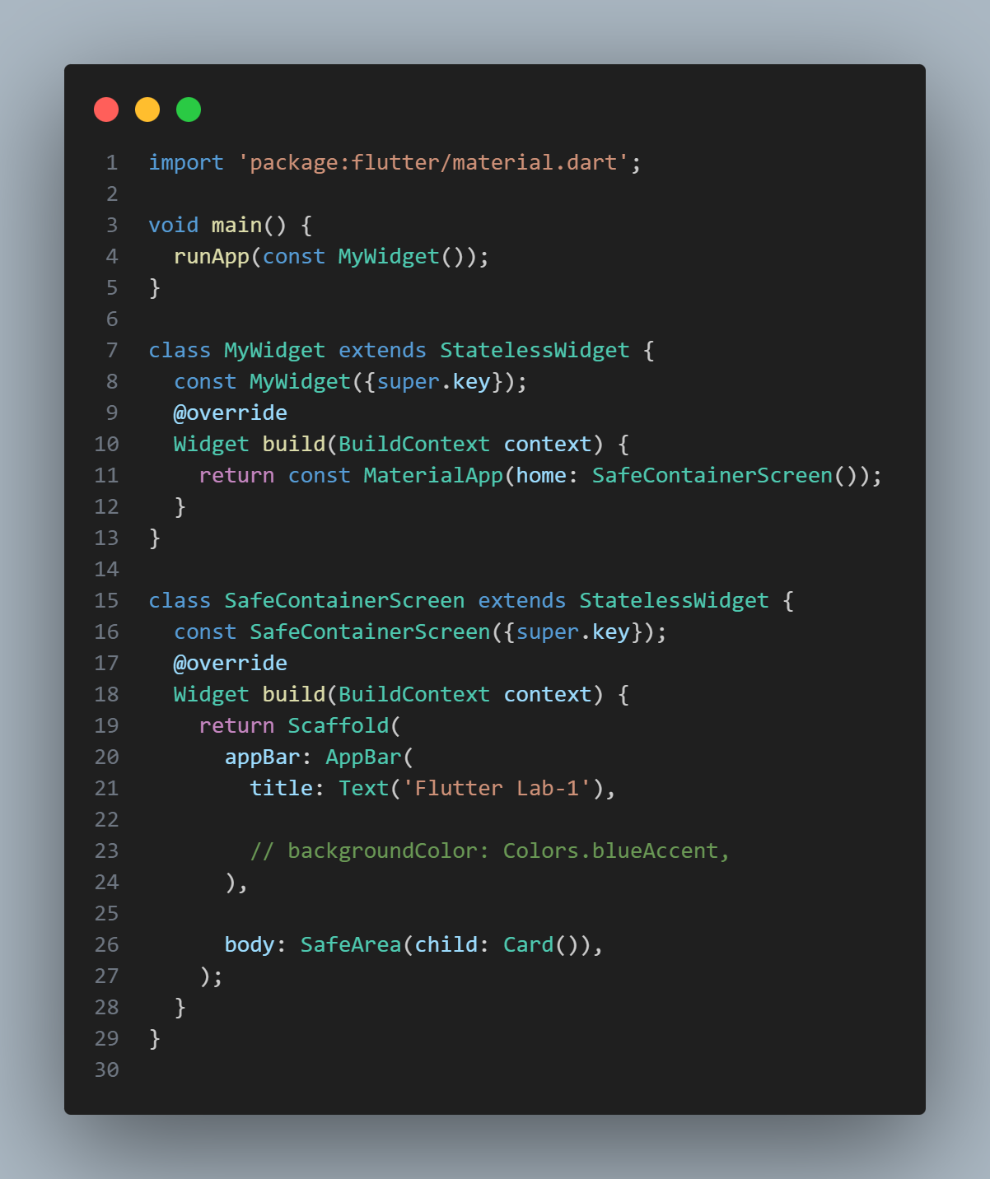

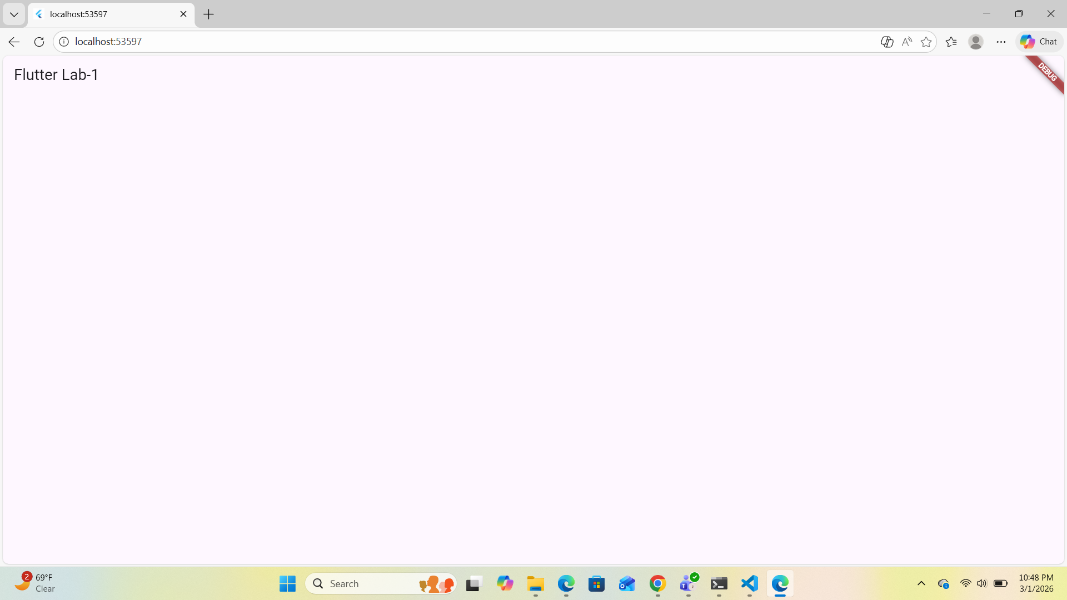

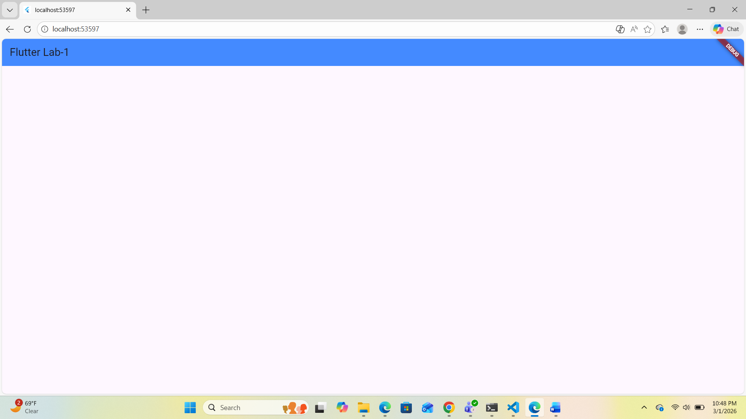

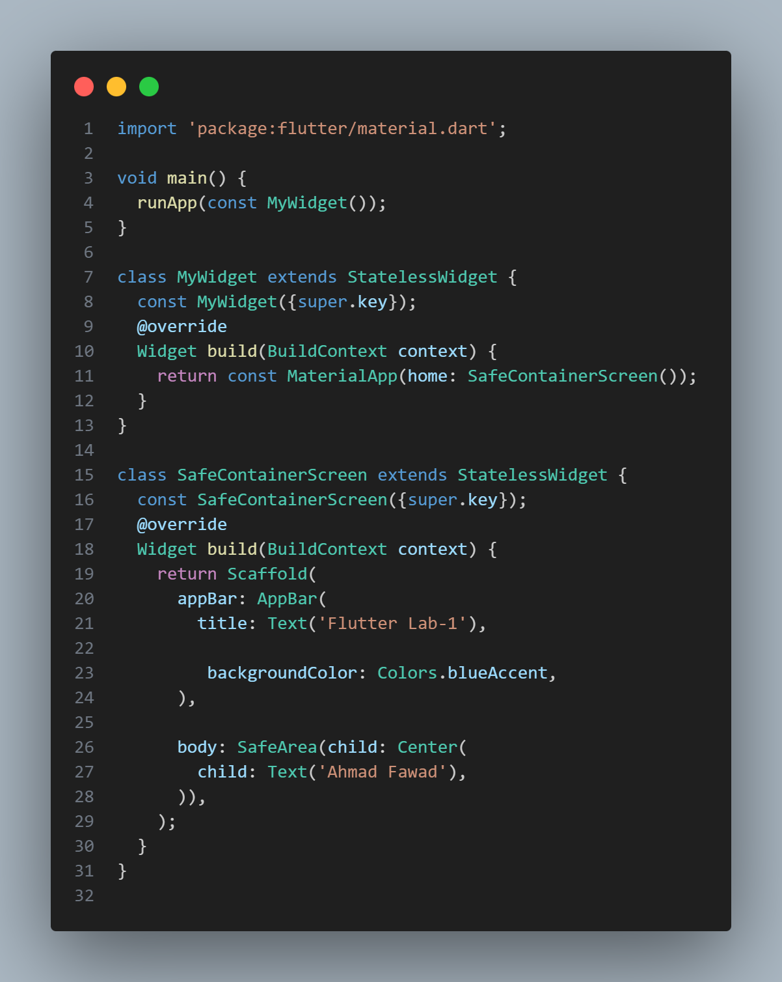
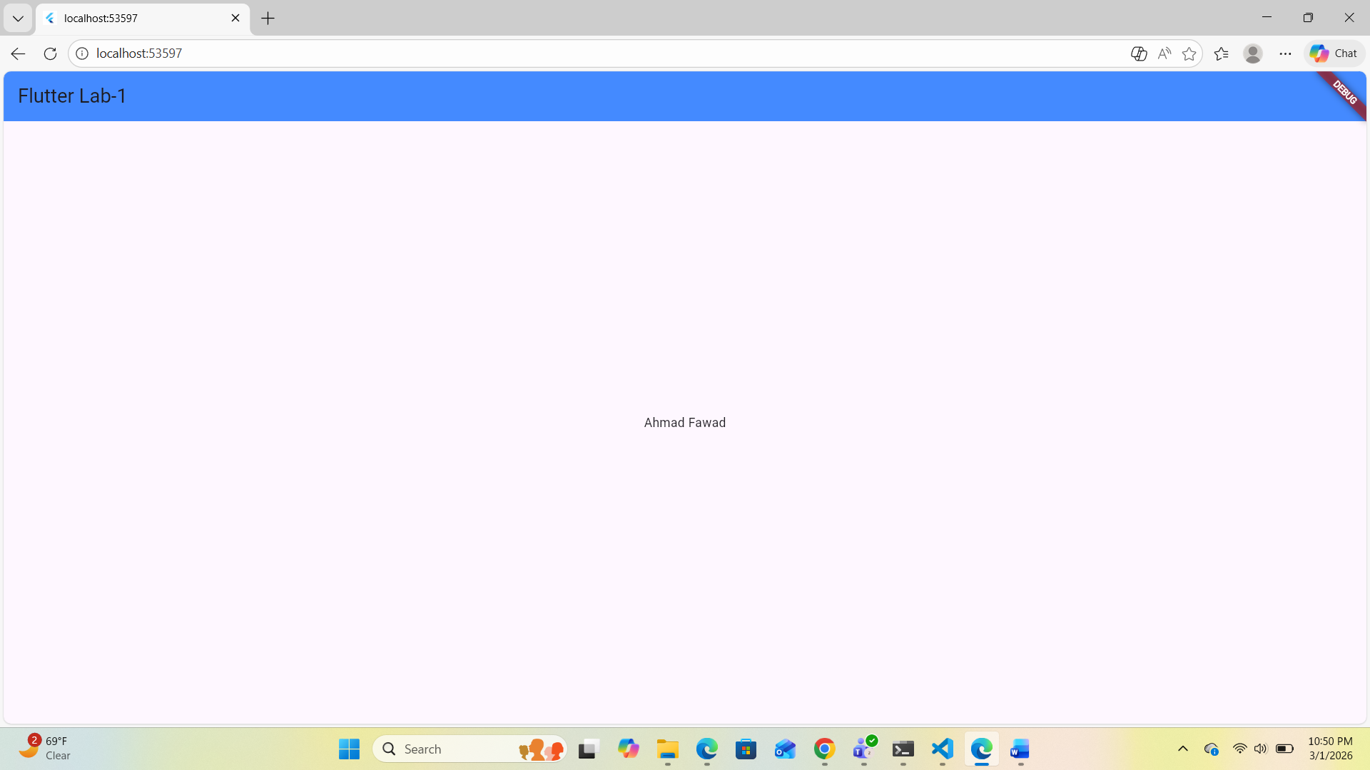

Use Size box for spaces Assets and Network Images • Download the image form google • Add assets to pubspec.yml file Add image to your Project by using assets Add Image to your roject by using Network Image