National Textile University Faisalabad

Department of Computer Science
^{Name:} | ^{Ahmad Fawad}
^{Class:} | ^{BSSE A 6th}
^{Registration No:} | ¹¹²⁹
Course Name: | ^{MAD}
^{Submitted To:} | ^{Sir Rehaan Sarwar}
^{Submission Date:} | ^{9/8/2026}

Phase 1: The Static Structure

Task 1: The Safe Scaffold o Create a StatelessWidget and return a Scaffold. o Wrap the body in a SafeArea to prevent the UI from hitting the status bar or notch.’

Task 2: The Header (Circular Avatar & Margin) o Use a Container with a margin (e.g., EdgeInsets.all(20.0)) to provide breathing room. o Place a CircleAvatar inside to represent the user's profile image.

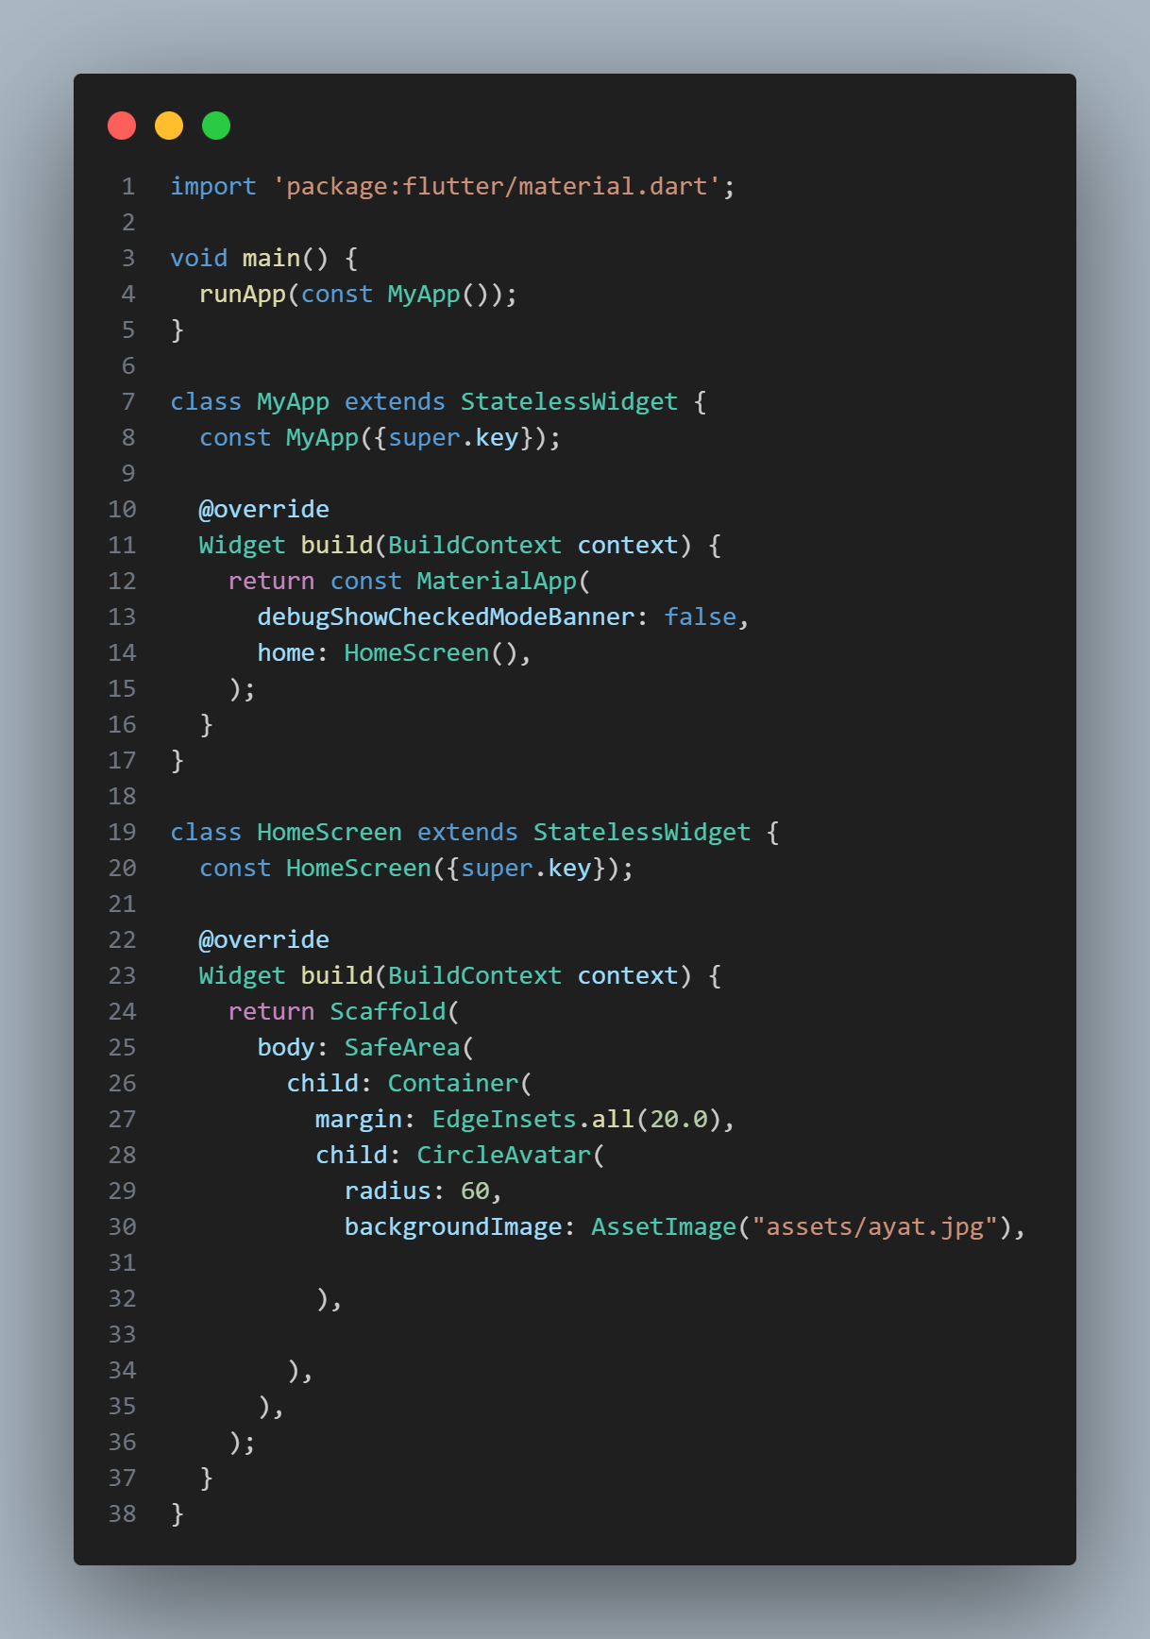
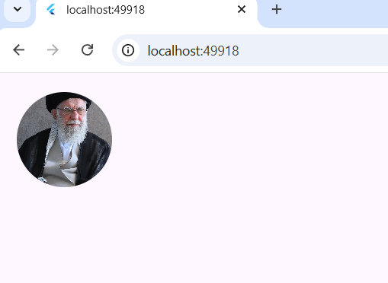

Task 3: Layout Alignment o Use a Column to stack the Avatar and two Text widgets (Name and Title). o Set crossAxisAlignment to CrossAxisAlignment.center to align all elements to the middle.
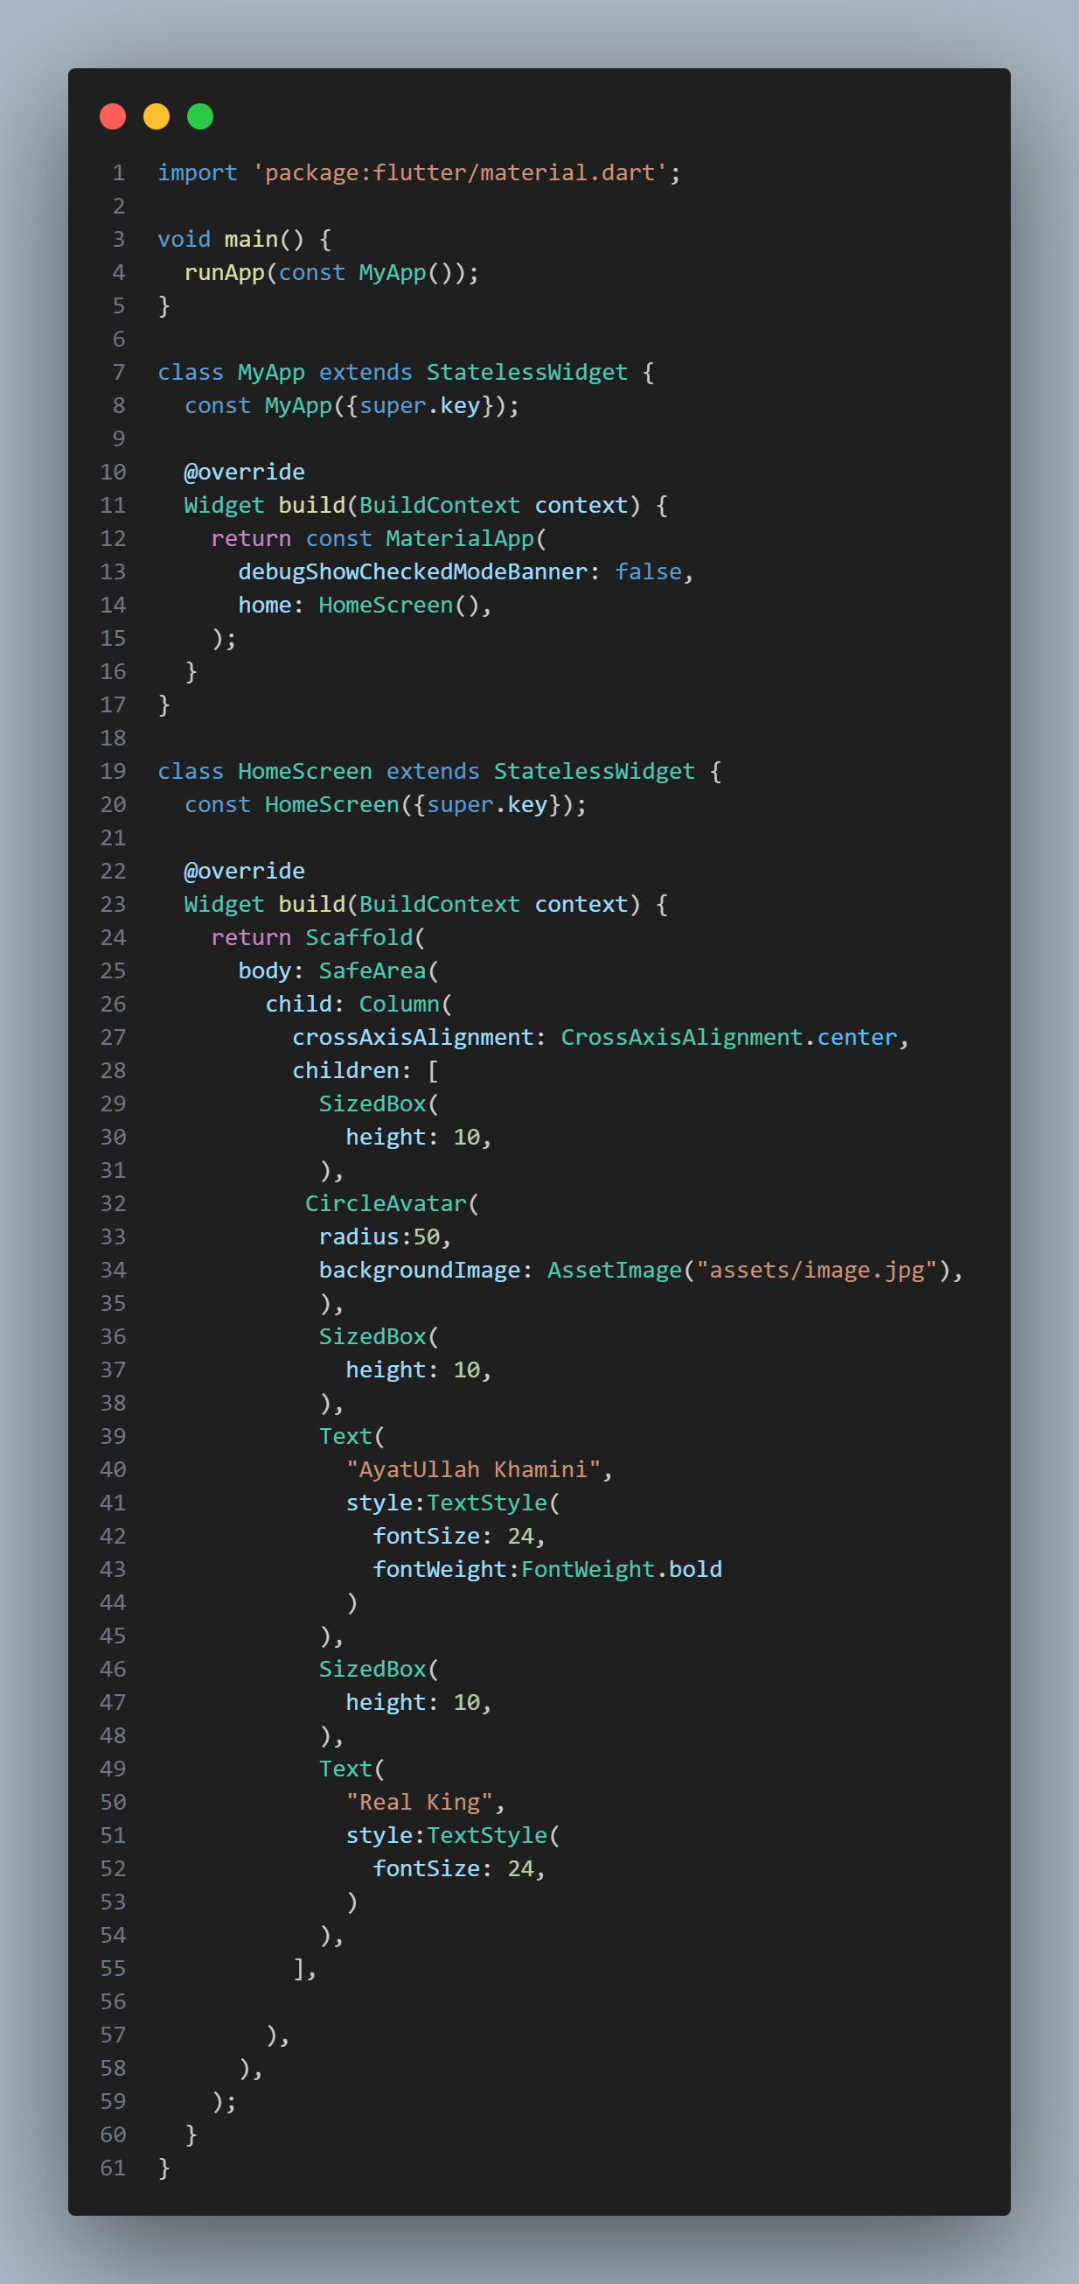
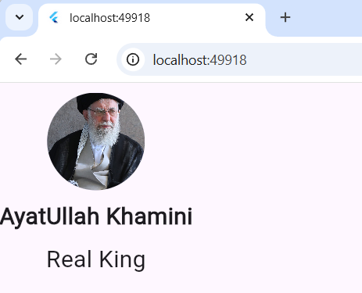

Phase 2: Proportional & Flexible Layouts

Task 4: The Body Content (Expanded & Proportions) o Add a Row below the header inside the main Column. o Insert two Container widgets inside this Row. o Wrap both in Expanded widgets. Set the first container's flex to 2 and the second to 1 to create a 2:1 width ratio.

Task 5: Spacing with SizedBox o Instead of using heavy padding, use a SizedBox with a fixed height or width to create gaps between widgets.
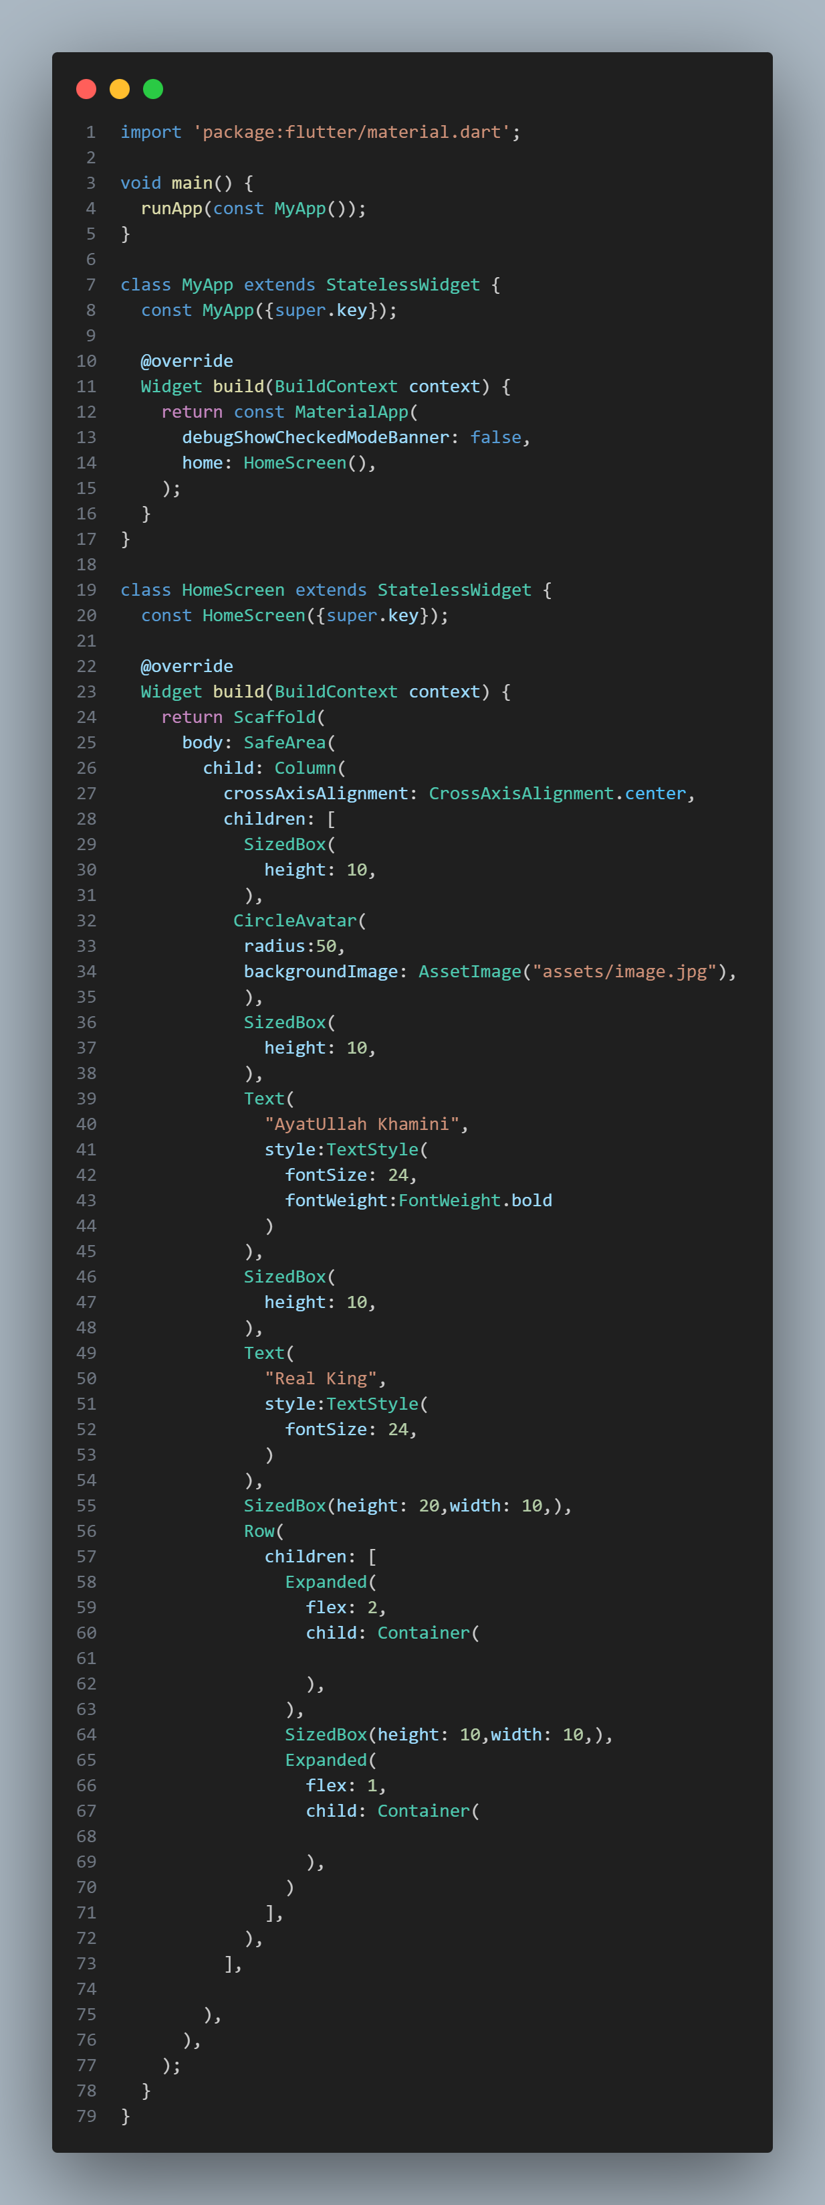
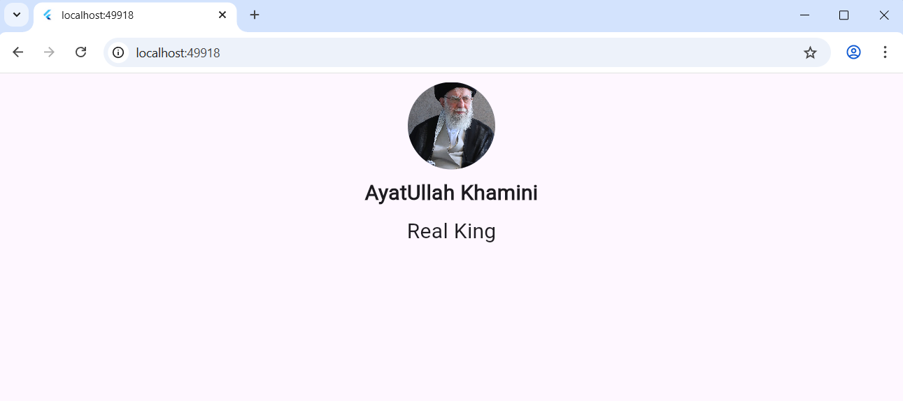

Phase 3: Interactivity & State Management

Task 6: Refactoring to StatefulWidget o Convert the widget from Stateless to Stateful using the stf shortcut. o Define a boolean variable isFollowed and an integer score in the _State class.

Task 7: Material Buttons & setState o Add an ElevatedButton for "Follow" and an IconButton for "Like". o In the onPressed callback, use setState() to toggle the isFollowed status or increment the score.

Task 8: Material Card Implementation o Wrap the statistics (score) in a Card widget to give it a shadowed, elevated look. o Use a ListTile inside the card for a clean "Icon + Title + Subtitle" arrangement.
