AI + GIS + Your Phone: The New Decision-Making Stack for Healthcare (and Beyond)
A district of 374,183 people. A 183-minute average trip to the nearest healthcare facility. A gap score of 100 out of 100 — computed automatically, from public data, and reachable by texting a bot. That’s not a pitch. It’s a real, running result from an open-source project I built for Khyber Pakhtunkhwa, Pakistan.
Here’s the pattern behind it — and why it applies to almost any resource-allocation decision, not just healthcare.
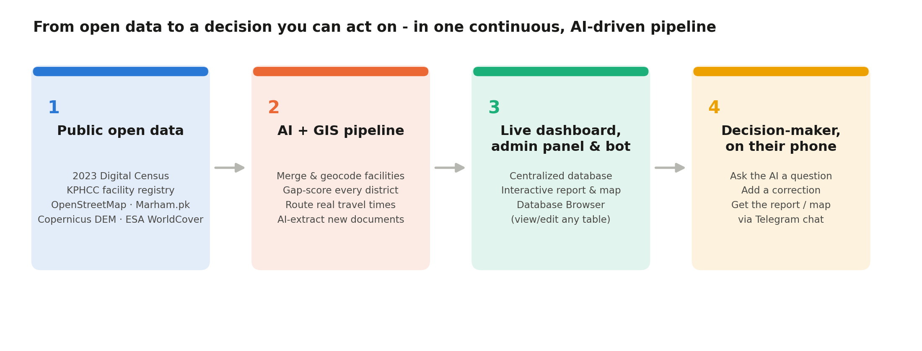

The bottleneck was never the data.
It was turning scattered, differently-shaped, differently-updated public data into one trustworthy answer to “where do we act first?” — and getting that answer to the person who actually needs it, when they need it.

What the pipeline actually does:
- Ingests — 25 automated stages pull the national census, a facility registry, OpenStreetMap, a commercial facility directory, and two satellite layers — all public, all free.
- Analyzes — merges ~1,600 facilities from three sources, computes real network+terrain travel time (not straight-line distance), and scores every district’s facility-access gap.
- Recommends — concrete new facility locations using machine learning, automatically avoiding water/snow/wetland pixels via real land-cover data.
- Delivers via — a Telegram bot with near-total admin-panel feature parity — ask it a question, correct a number, browse the database, pull the report — all from a phone, no webhook or server needed.
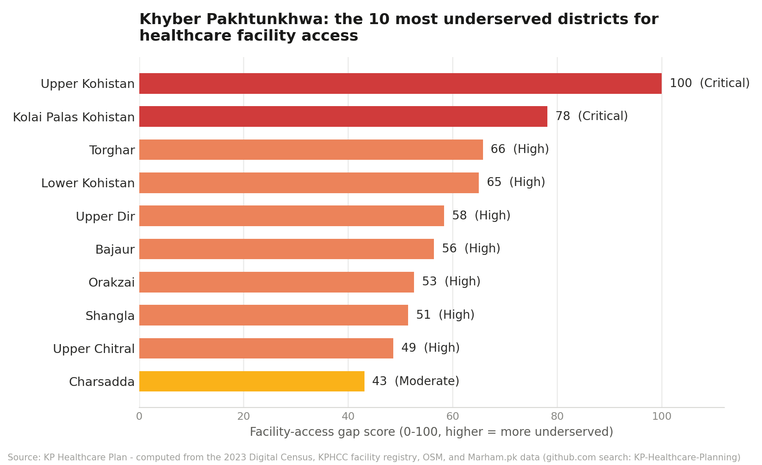
Real output: the 10 most underserved districts, ranked by a computed facility-access gap score.

The honest part:
The bot integration built and running today is Telegram — not WhatsApp. But the architecture is a thin chat layer over the same AI + database backend the web dashboard uses, and that pattern extends directly to WhatsApp or any other bot-API messaging platform. The point isn’t “Telegram” — it’s that a decision-support tool that only lives on a laptop dashboard doesn’t get used. One that lives in a chat app someone already has open, does.

Why this generalizes past healthcare:
- Disaster response — which districts need supplies pre-positioned, as rainfall data updates.
- Agriculture & food security — which regions are exposed to a bad harvest, cross-referencing satellite land-cover against market data.
- Infrastructure planning — where growth is outpacing school or clinic capacity.
- Any resource-allocation call — surfacing the worst-served areas from messy government data, without waiting months for a formal report.
None of the pieces are exotic: public data, a scripted pipeline, an AI provider of your choice (this project supports five — Claude, GPT, Gemini, Grok, Groq — never locked to one vendor), a small database, and a chat bot. What used to take a dedicated team and months now runs as a batch job and a phone conversation.
The full project — pipeline, dashboard, admin panel, bot, and even the complete AI-driven design/build/test history behind every feature — is open-source on GitHub, with a full step-by-step setup guide.
What’s the first dataset sitting on your team’s shelf that could be answering a decision like this today, if it were wired up the same way?
Built by Engr. Fawad Ali — reach out at fawadali1234567@gmail.com to talk about applying this pattern to your domain.
#ArtificialIntelligence #GIS #HealthcareInnovation #DigitalHealth #OpenData #DataForGood #DecisionIntelligence #GeospatialAnalytics #PublicHealth #Pakistan

