From Open Data to a Text Message: How AI and GIS Are Rewiring Healthcare Decision-Making
A real, working case study from Khyber Pakhtunkhwa, Pakistan — where a facility-access gap score, a real routing engine, and a chatbot turn a planner’s phone into a live decision-support tool.
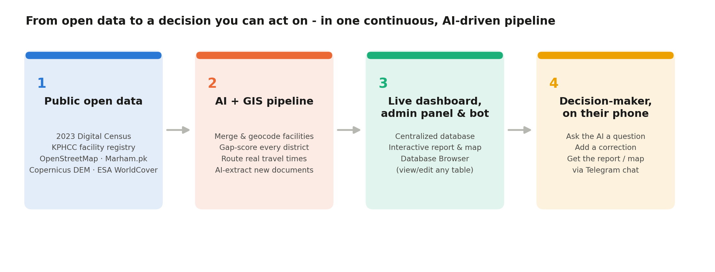
Somewhere in Khyber Pakhtunkhwa, a district called Upper Kohistan is home to 374,183 people. The nearest mapped healthcare facility, by real road network and terrain, is on average a 183-minute journey away. That number — computed, not estimated — is the single highest facility-access gap score of any of the province’s 35 districts: 100 out of 100, flagged “Critical.”
Nobody had to commission a new survey to learn that. It fell out of a data pipeline that took six public, already-existing datasets — a national census, a facility registry, OpenStreetMap, a commercial healthcare directory, and two satellite layers (elevation and land cover) — and turned them into a number a policymaker can act on, updated the moment any of that underlying data changes, and reachable from a phone, in a chat window.
That’s the actual subject of this piece. Not “AI will transform decision-making” as an abstraction, but what it concretely looks like when you build the whole pipeline end to end and run it against real data for a real province of over 40 million people.

The gap between “the data exists” and “a decision gets made”
Most of the raw material for good decisions already exists somewhere — a government PDF, a satellite archive, a spreadsheet an official maintains by hand. The bottleneck was never really data scarcity. It’s that turning scattered, differently-shaped, differently-updated data into one trustworthy answer to “where should we act first?” has traditionally needed a team, a procurement cycle, and months.
AI and GIS, used together and wired into a real application rather than a one-off notebook, collapse that timeline to something closer to real time. This project — the KP Healthcare Plan — is a working demonstration of exactly that collapse, built as an open-source portfolio piece and released publicly so the pattern itself, not just the result, is inspectable.

What “AI + GIS” actually means in practice
It’s a four-stage pipeline, and each stage does one clearly-scoped job:
- Public open data. Twenty-five automated pipeline stages fetch and clean the 2023 Digital Census, the KP Health Care Commission’s licensed-facility registry, OpenStreetMap, a commercial facility directory (Marham.pk), the Copernicus GLO-30 elevation model, and the ESA WorldCover land-cover dataset — all public, all free, all re-fetchable on demand.
- AI + GIS pipeline. The same pipeline merges and deduplicates roughly 1,600 facilities from three independent sources, computes a real network- and terrain-weighted travel time to the nearest facility for every district (not a straight-line guess), scores every district’s facility-access gap, and uses machine learning to recommend concrete coordinates for new facilities in the districts that need them most — automatically steered away from water, snow, and wetland pixels using the real land-cover data.
- A live dashboard and database, not a static report. All of it lands in a centralized, properly-typed database behind an interactive dashboard, an admin panel, and a generic “Database Browser” that can view and edit any table — including the pipeline’s own computed outputs — with zero custom code needed per table.
- A channel a decision-maker actually uses. This is the part most similar systems stop short of, and it’s the part this piece is really about.

The last mile: putting this in someone’s pocket
A dashboard nobody opens is not a decision-support tool — it’s a PDF with extra steps. The real unlock isn’t the analysis; it’s making the analysis reachable at the moment someone actually needs it, on the device they already have in their hand.
In this project, that channel is a Telegram bot with near-total feature parity with the full admin panel — using long-polling, so it needs no public server, no webhook, and no port-forwarding to work. From a phone, a health planner can:
- Ask a real question — “Why is Upper Kohistan flagged Critical?” — answered by an AI grounded only in the project’s real data digest, never inventing a number it doesn’t have.
- Add new information — upload a photo of a facility report and have an AI extract structured data from it, reviewed before it’s ever written anywhere.
- Fix a mistake — correct a population figure or a facility count, with the correction plausibility-checked by AI before it’s applied and the whole downstream analysis recomputed automatically.
- Browse or edit any table in the underlying database — from a table dropdown menu, in a chat message, no SQL required, no separate database client installed.
- Pull the current report or map — the current PDF or the styled map, on demand, without opening a laptop.
This is deliberately not framed as “Telegram is special.” The architecture underneath — a thin chat-command layer over the same AI and data backend the web dashboard already uses — extends the same way to WhatsApp or any other messaging platform with a bot API. Telegram is simply the one actually built and running in this project; the pattern is the point, not the specific app.

A real result, not a hypothetical one
Here’s what the pipeline actually produced for Khyber Pakhtunkhwa’s 35 districts, a province of roughly 40.6 million people, once real data was run all the way through:
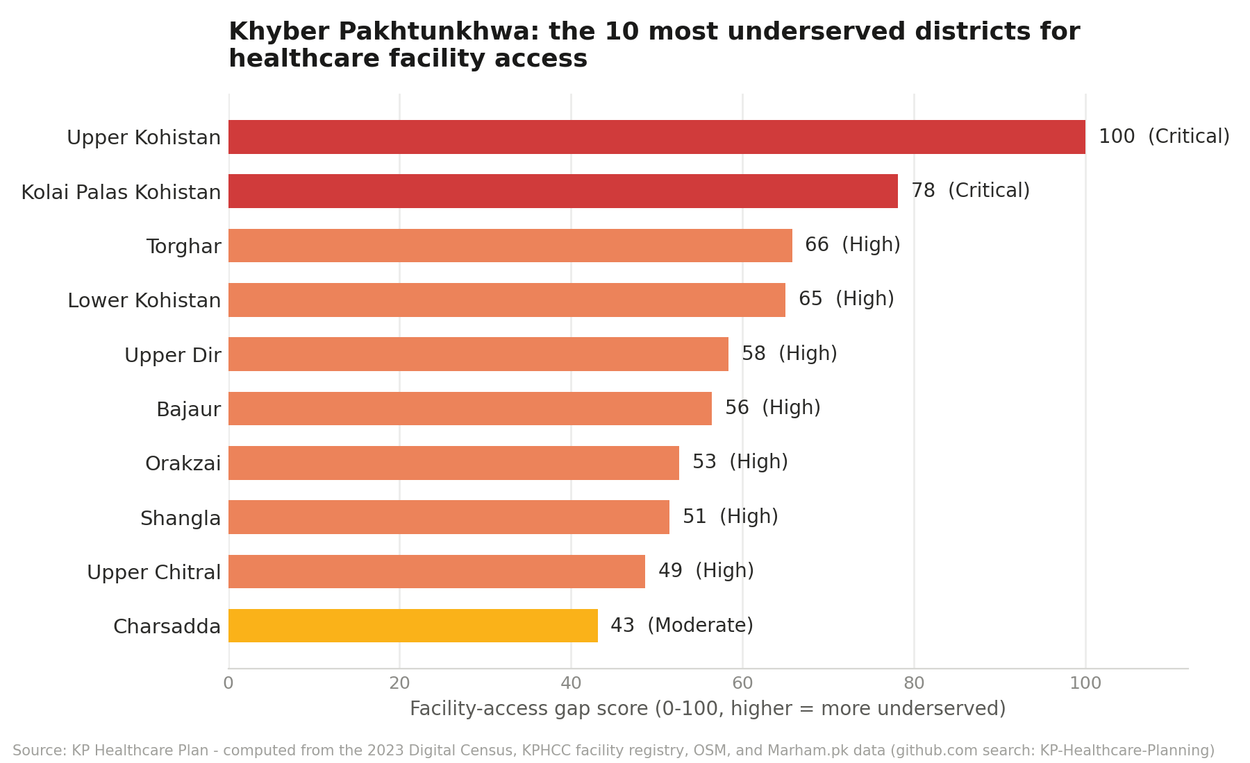
The ten districts with the highest computed facility-access gap score — a real output of the pipeline, not an illustration.
Beyond the ranking itself, the pipeline cross-validated its own findings against an independent data source: the districts it flagged as having the least built-up land (from real satellite land-cover analysis) were, overwhelmingly, the same districts already flagged hardest-to-serve by the terrain and routing analysis — two unrelated methods converging on the same answer. That kind of self-checking, done automatically and shown transparently, is exactly the sort of thing that turns “an AI said so” into something a policymaker can actually stand behind.

Where else this pattern applies
Healthcare is the case study here because the data and the stakes made it a clean, checkable proof of concept — but nothing about the pipeline is healthcare-specific. The same shape — open data in, AI+GIS analysis in the middle, a chat-reachable decision surface out — applies just as directly to:
- Disaster response — which flood-prone districts need pre-positioned supplies, updated as rainfall data comes in.
- Agriculture and food security — which regions are most exposed to a bad harvest, cross-referencing satellite land-cover trends against market and weather data.
- Urban and rural infrastructure planning — where growth is outpacing school or clinic capacity, computed from the same kind of census + facility-registry pattern used here.
- Any resource-allocation decision — surfacing the worst-served areas from messy, multi-source government data without waiting for a formal GIS team to compile a report.
The pattern is generalizable precisely because none of its pieces are exotic: public data, a scripted pipeline, an AI provider (this project supports five — Claude, GPT, Gemini, Grok, and Groq — chosen per task, never locked to one vendor), a small database, and a chat bot. What used to require a dedicated team and months now runs as a batch job and a phone conversation.

Try it yourself
The entire project — pipeline, dashboard, admin panel, Telegram bot integration, and even the full AI-driven design/build/test history behind every feature — is open-source on GitHub, with a step-by-step setup guide covering exactly how to get the database running and populated with real data on your own machine.

About the author
This project was designed and built by Engr. Fawad Ali. For questions, collaboration, or to discuss applying this pattern to a different domain, reach out at fawadali1234567@gmail.com.

