# Lab 14-Kernel Programming and Kernel Modules

## Tasks

* Write a program to use different modules of kernel and initialize them using init and exit.

**MODE FILE 1:**

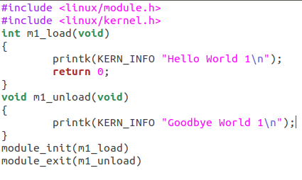

**MAKE FILE 1:**

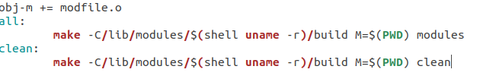

**OUTPUT 1:**



**MOD FILE 2:**

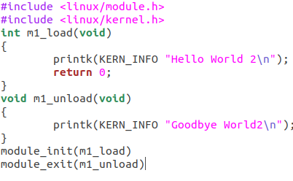

**MAKE FILE 2:**

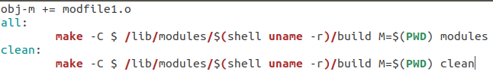

**OUTPUT 2:**

