# Lab 6-Linux Jobs Controls

## Tasks

* Look at the man page of “ps” and search for “STANDARD FORMAT SPECIFIERS” run the following command.

ps -o pid,ppid,cmd -u *your_user_id*

**Command & Output:**

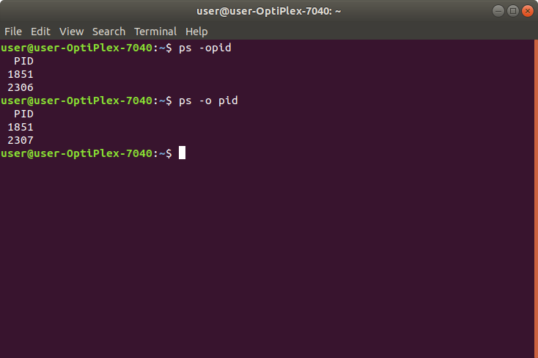

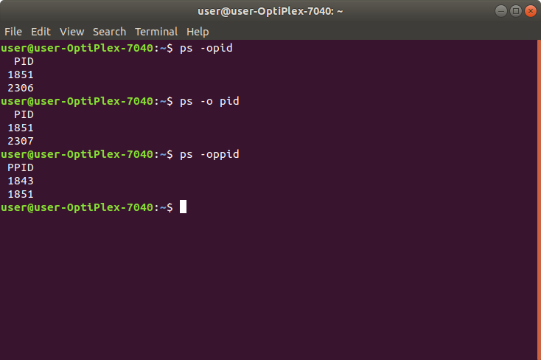

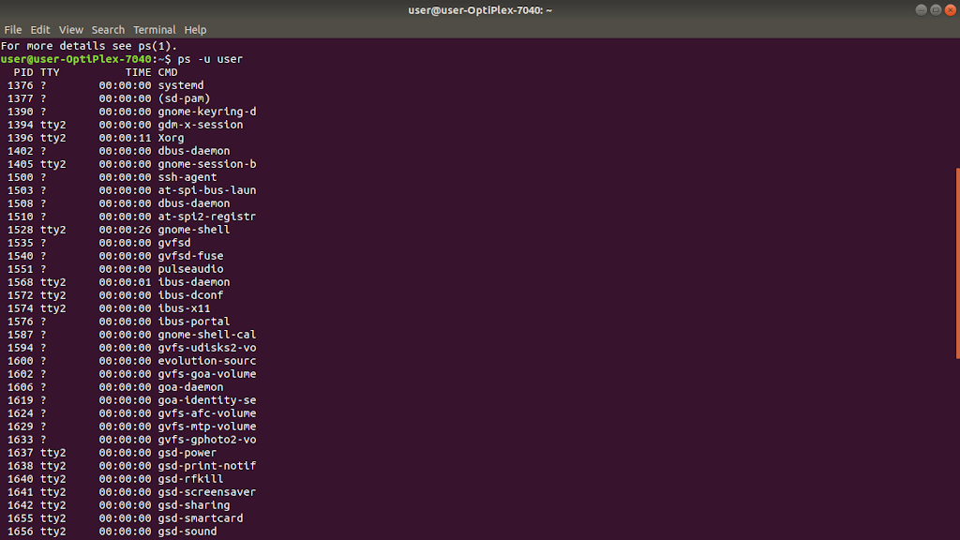

* What are the last three lines of output? now run the same command by adding the -H option.  
  ps -H -o pid,ppid,cmd -u *your_user_id*

**Command & Output:**

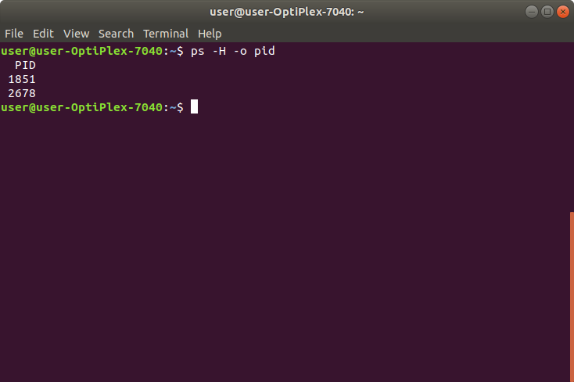

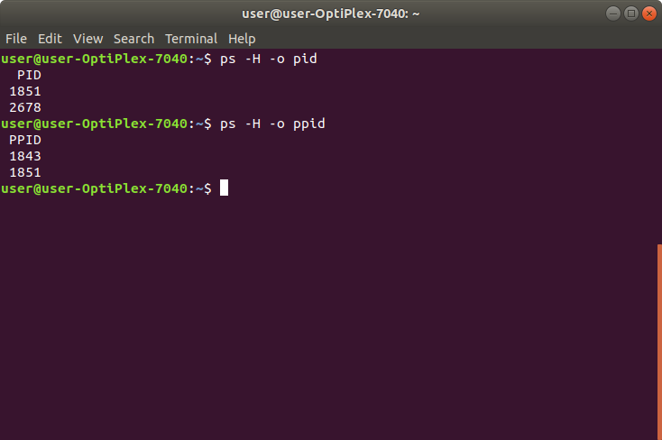

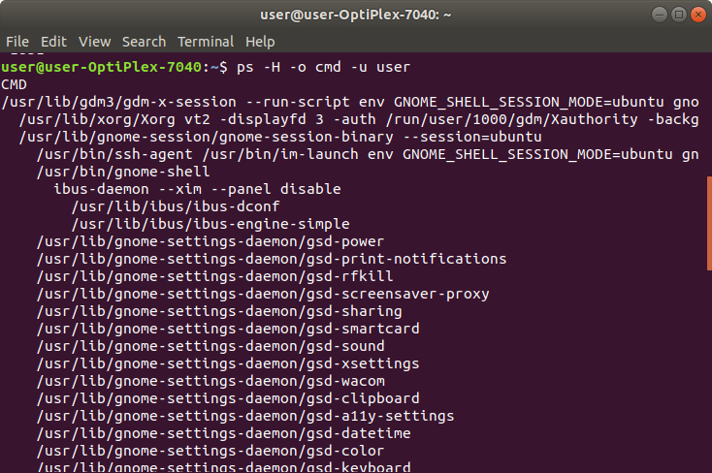

* How would you use the tail command in a pipe to obtain the last six lines of output from the “ps -A" command?

**Command & Output:**

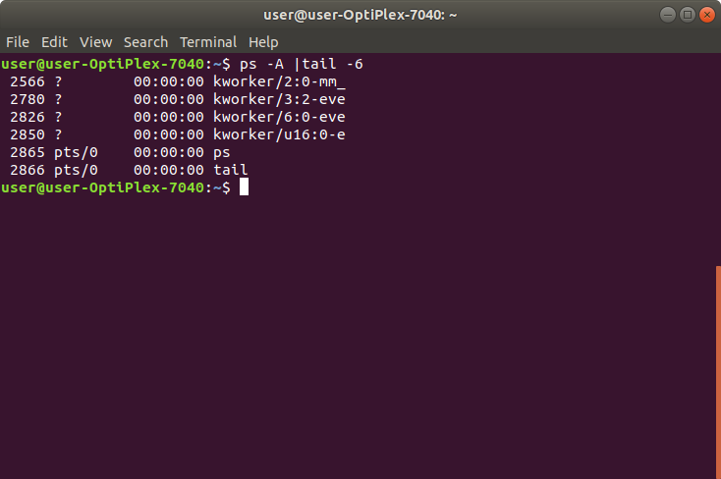

* Which pipe of commands would you use to count the number of processes owned by you only? Run the command and count how many processes you own?

**Command & Output:**

