# *Lab 02 – Working with UML Diagrams*

## *EXERCISE:*

***Task#01:***

***Design separate UML use case diagram for following scenarios***

***a) Bank ATM (Automatic Teller Machine) System***

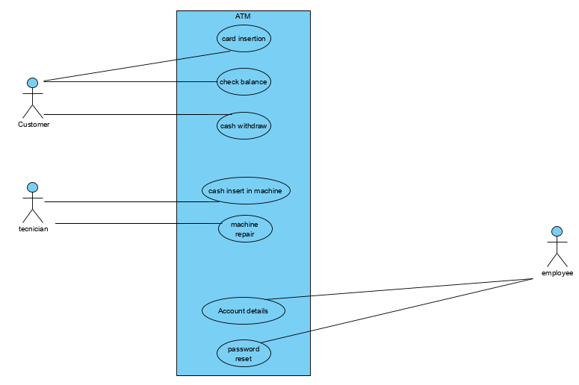

***b) Business Use case diagram for a Restaurant (Considering it from all prospectus like serving food,***

***hiring employees, purchasing raw material etc.)***

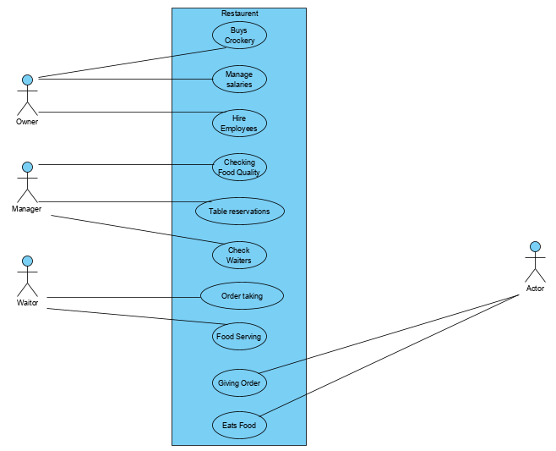

**Taking a scenario of your own choice (Note: Same scenario will be used for all UML diagram throughout this practical course)**

1. **For use case:**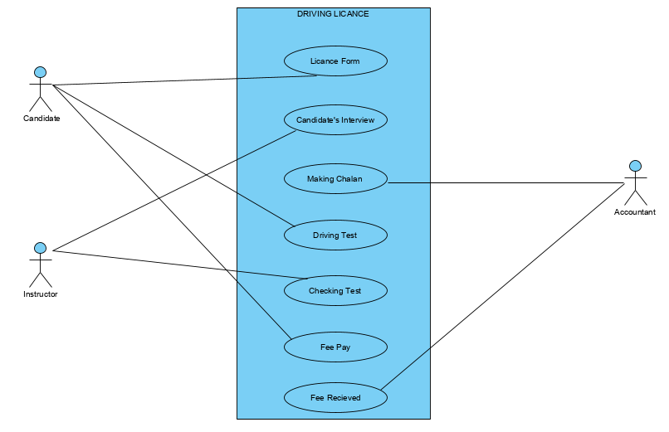

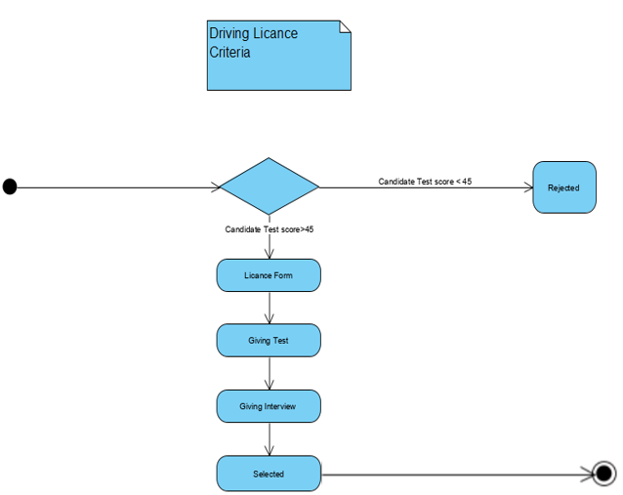**For Activity:**

**For Sequence:**

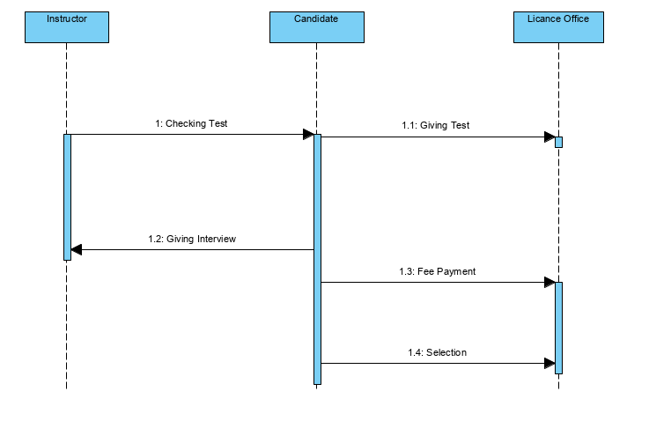

**Task#02:**

**What is importance of UML sequence diagram in practical life?**

Practical life applications can be implement in sequence diagram because it is easy to explain difficult things in an easy way. The sequence diagram is used primarily to show the interactions between objects in the sequential order that those interactions occur. We can also use the terms event **diagrams** or event scenarios to refer to a **sequence diagram**. **Sequence diagrams** describe how and in what order the objects in a system function.

**Task#03**

**Draw an activity diagram (Taking a scenario of your own choice)**

