# Lab 7 – Basic Programming Structures in MATLAB

## Exercise

### Exercise 1

**Write function which takes an input array and returns the sum and product of its elements as outputs**

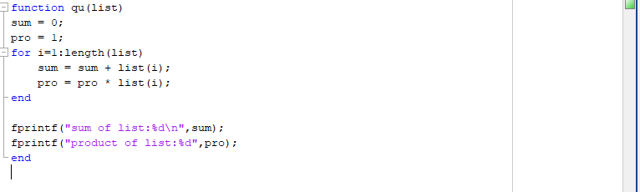



### Exercise 2

**Given the array:**

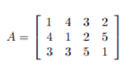

**use MATLAB statements to find:**

1. **The number of rows and columns in A**
2. **The maximum and minimum element values in A**
3. **The maximum and minimum element values in each row of A**
4. **The average value in each column**
5. **The average of all element values**

**a)**

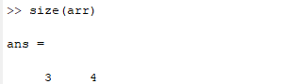

**b)**

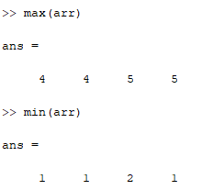

**c)**

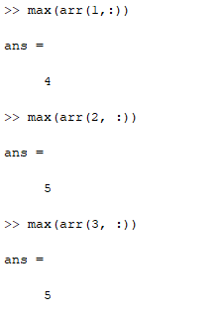

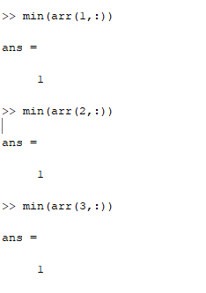

**d)**

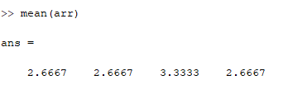

**e)**

