USER MANUAL

# Introduction to the System & Document

## Purpose

The main objective of this system user manual document is to provide a complete guideline to the intended users to how to use “UEstates”. This document contains all the necessary information required for the navigation of the project. It will explain all the screens of the system and how to navigate on them.

## Intended Readers

The main users of this system are customers who want to sale or rent their property and the agents who will help the customers in selling, buying or renting the properties. So, the people who will directly interact with this system are the intended users of this document i.e. **Customer** and **Agent**.

## System Responsibilities

The system will be responsible to let the intended users to login through their ID and Password. They have five chances to enter their correct user id and password. The system will provide a complete platform to the users to buy and sell their property easily. They will be able to search the property by area, block, size, property type, and price range. The results can also be sorted by size, price, date, customer, block, and property type. She/he can add more users and properties to the system and can also update the existing property. The user can also check the sales record through this system.

# Installation Instructions

## System Overview

The system is basically maintaining the data for the state agency. So agent is responsible for add and delete the user and property which is for sell/rent or lease. Agent can search the property by different filters. User can only view the properties which are for sell/rent or lease by search with different filters available.

## Hardware and Software Requirements

To deploy this software we need servers and any computer through which user can use the system .To use this software we need to install JRE and JDK into our system to run this application.

## Installation of Software

1. Click on the setup button.
2. You will see the agreement file, check accept and click on the next button.
3. Then it will ask for the use as agent or user, select desire choice and click on next.
4. If agent is selected then the registration form will appear for the agent or if user selected then form for the user.
5. Then installation begins.
6. Click on finish.
7. Congratulations, you successfully installed the system.

# System Navigation

## Login page

The login page contain User ID and password.

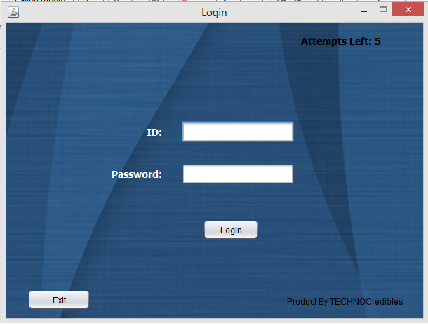

## For Agent

### Add User

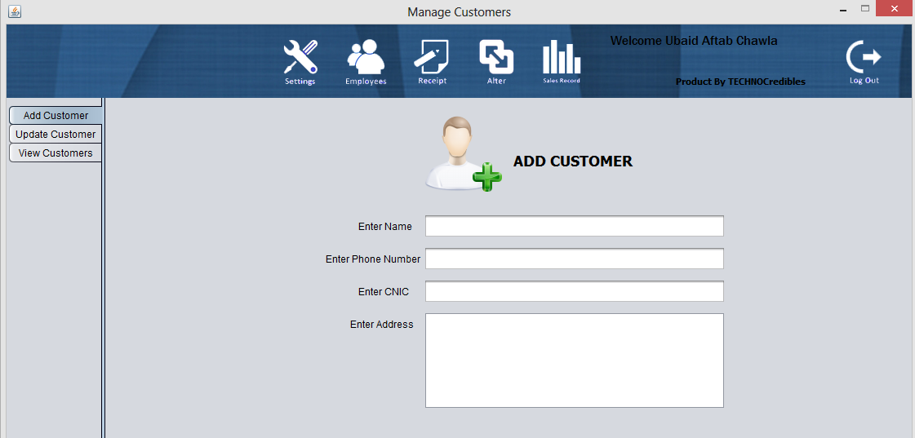

### Add Property

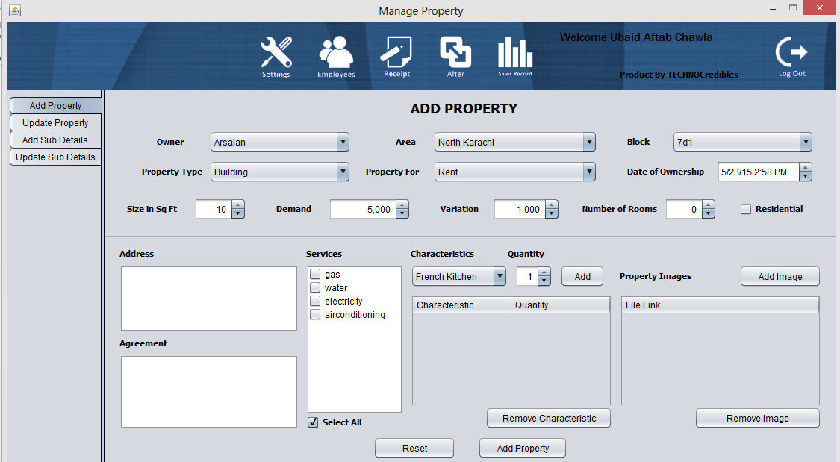

### Search property

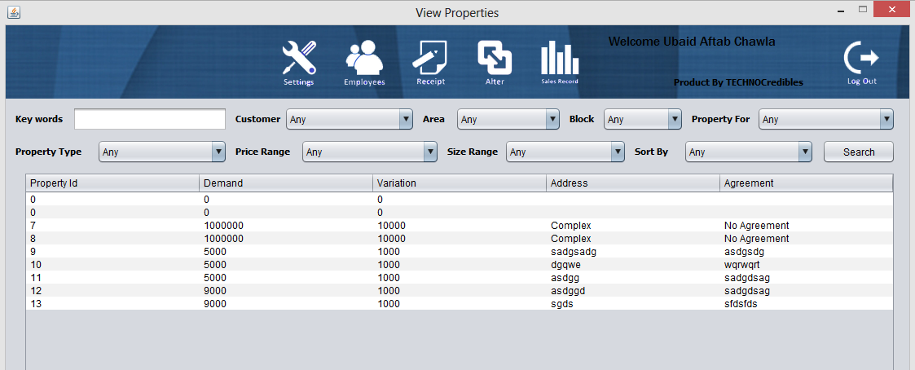

## For Customer

### Search property



# Conventions Used

The coding and development conventions we have used for this system is Java for the system programming and SQL for the development of the database. The database is placed on the online server. The Graphical User Interface of the made by using Swing, JPanel and JFrame which are the features provided by the Java to develop and interactive GUI.

# Maintenance and Operations

The system doesn’t require the proper maintenance as it is already managed and properly developed by the development team. The only part of the system which requires some maintenance is database, we always make sure that nobody has entered an unwanted or corrupted data.