**CONTROL SYSTEMS**

**PROJECT REPORT**



**Fall 2022**

**CSE310L Control Systems Lab**

**Submitted by: FAWAD ALI**

**Registration No: 19PWCSE1845**

**Class Section: C**

“On my honor, as student of University of Engineering and Technology, I have neither given nor received unauthorized assistance on this academic work.”

Student Signature: ______________

**Submitted to:**

**Dr. Salam Ahmed**

**Date (Jan, 11, 2023)**

Department of Computer Systems Engineering

**Project Report**

**Problem which is considered**

Consider the following state-space model:

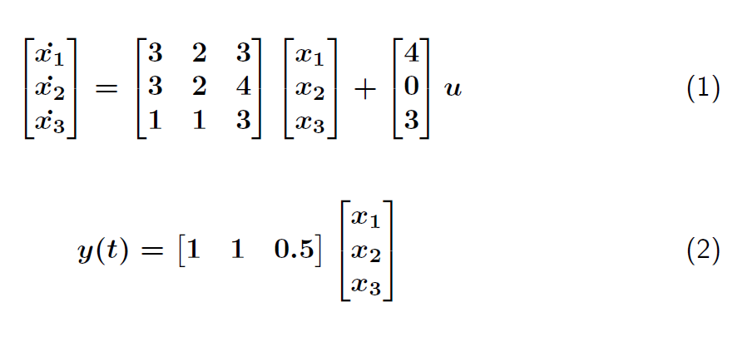

1. Check the stability of the system using all methods that you know.
2. Compute the controllability and observability for the system.If the system is unstable, design a suitable controller for it.
3. Simulate the system using the controller(that you design) and show all the responses.
4. Design a PID Controller and show the response of the system using PID Controller.Compare the results obtained in part c and d.
5. Compute the steady state errors before and after designing controller.
6. Design a tracking controller for step tracking of amplitude 7u(t) and ramp tracking of 2tu(t).

Guide for choosing desired location of controller eigen values: Consider regis- tration number 20PWCSE1234, then f = 1, g = 2, h = 3, i = 4.choose your controller eigen values as (-f x 2, -g x 2,-h x 2, -i x 2) and observer eigen values as (-f x 10, -g x 10,-h x 10, -i x 10). Use your own registration number instead of 20PWCSE1234.

Solution:

In this report, we address the above problem and explain each sub problem in detail.

## Stability analysis of the system:

In this section, we analyze the stability of the system. The stability can be checked using different ways namely eigenvalues, step response, poles, pole-zero map and RH-stability criteria. For our case, the system is of 3rd-order and therefore there will be three eigenvalues. Let *λ*1, *λ*2 and *λ*3 denote the eigenvalues of the system. The eigenvalues can be written as follows:

*λ*1 = *6.8023, λ*2 = 1.3099, *λ*3 = -0.1122

As we can see two of the eigenvalues is positive, which indicates the system is unstable. Next, we verify the same fact by observing the poles of the system. Let *p*1, *p*2 and *p*3 denote the poles of the system. The values for poles are as follows:

*p*1 = 6.8023*, p*2 = *1.3099*, *p*3 = *−*0*.1122*

We observe here again that two of the poles is positive, which indicates the system is unstable. Next, we verify the same fact by seeing the step-response of the system. The step-response of the open-loop system is shown in Figure 1.

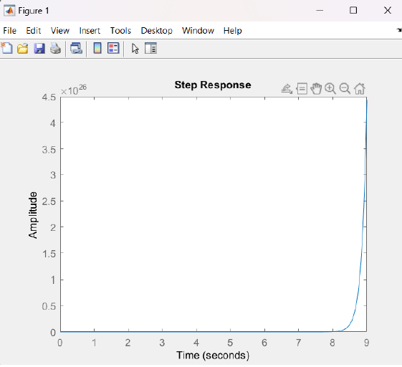

Figure 1: Plot of step response

From Figure 1, we can do the following analysis:

%*OS* = *∞*

*Tr* = *Undefined*

*Ts* = *Undefined*

*PeakV alue* = *∞*

*FinalV alue* = *∞*

Next, we construct a Routh-Hurwitz table to check the stability of the system. My equation is:

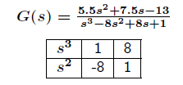

As there are sign changes in the first column, the system is unstable.

we can also find the stability of the system by pole-zero map’

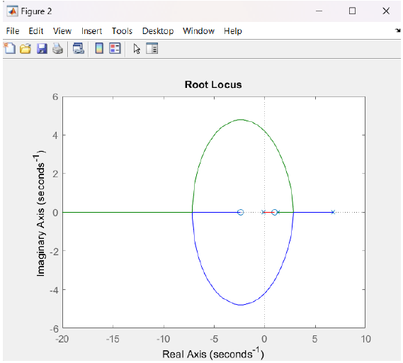

Figure 2: Plot of pole-zero map.

As we can see in figure 2, one of the poles is on the positive side which indicates the system is unstable.

## Controllability analysis of the system:

For Controllability, We Check the Rank(P)

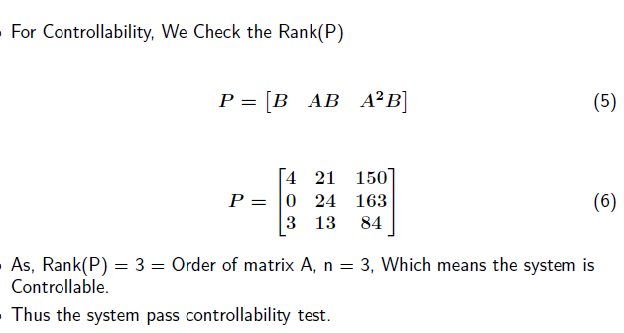

## Observability analysis of the system:

For Observability, We Check the Rank(Q)

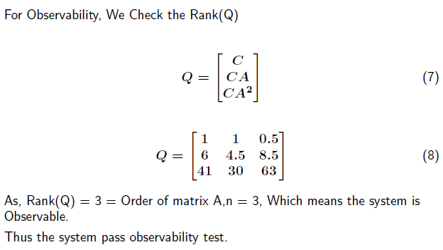

## Controller Design for the system:

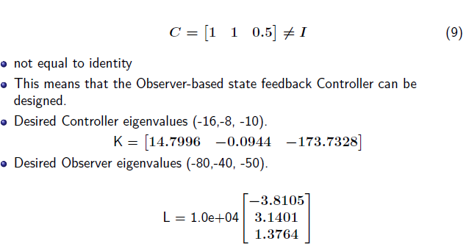

The observer-based state feedback controller Schematic is given below in figure 3

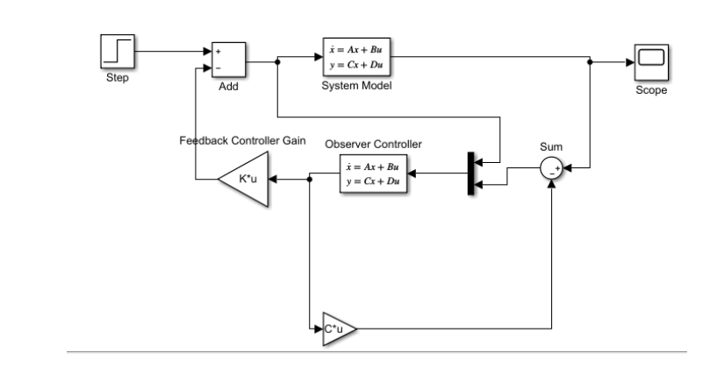

Figure 3: Schematic of Observer-based State Feedback Controller.

Step response of the observer-based state feedback controller is given below in figure 4

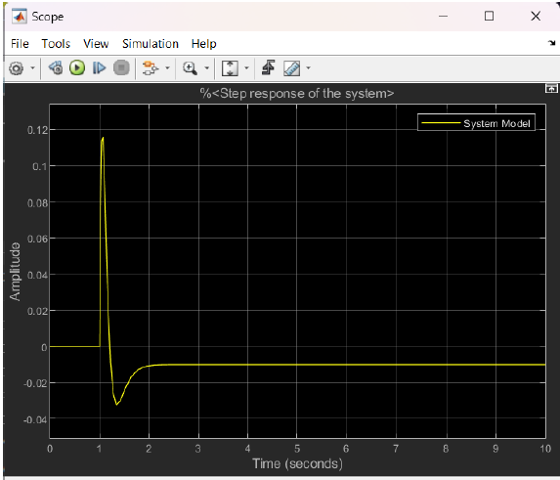

Figure 4: Plot of Observer-based State Feedback Controller.

Model of the PID controller with observer-based state feedback controller is given below

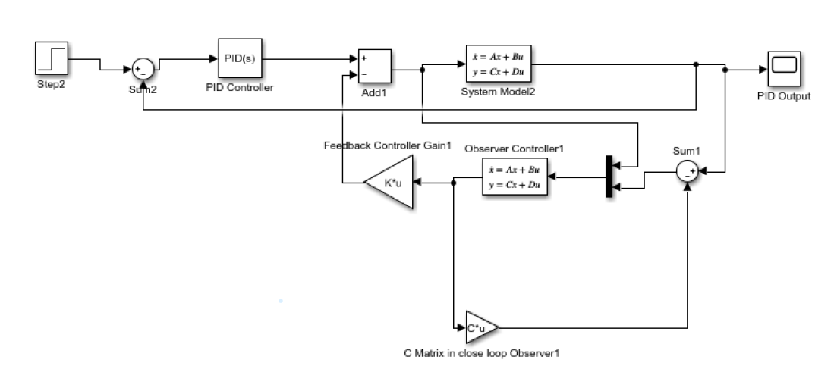

Figure 5: Schematic of PID Controller with controlled system.

The response of the system after the design of PID controller is given below

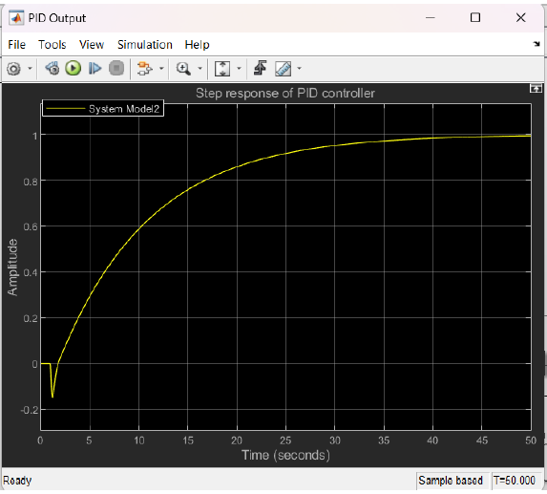

Figure 6: Plot of step response of PID controller.

## Steady State Errors:

Steady State error before controller is undefined because the system is unstable. Steady state error for step input, after the controller is.

Steady state error = input - output Steady state error Steady state error = 1 - (-0.01) = 1.01

Steady state error of the controlled system is given below

Step response of output show to minus in input.

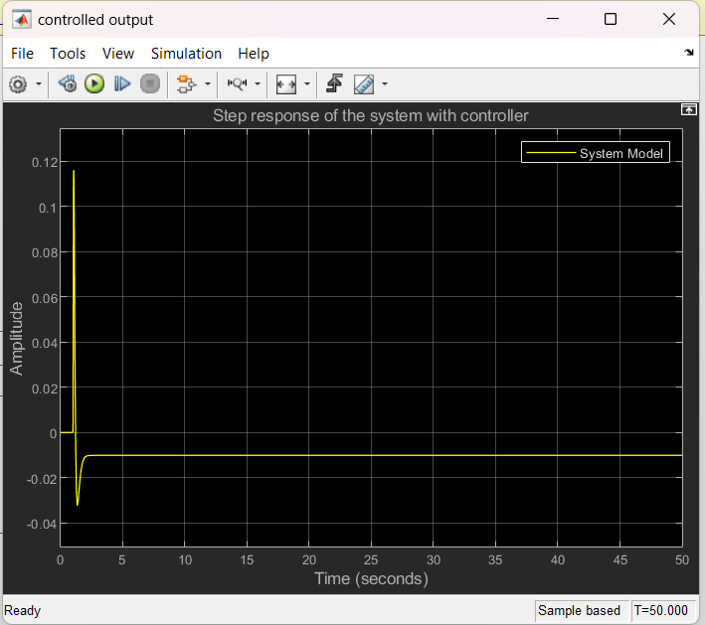

Figure 7: Steady state error after observer-based state feedback controller

Steady state error after PID controller is zero because for unit step intput the output of the PID controller is also one.

Steady state error = input - output Steady state error = 1 - 1 = 0

Step response after PID controller is given below

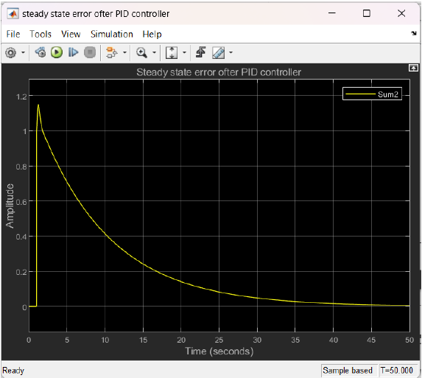

Figure 8: steady state error after PID controller.

Steady state error after step of 2u(t) is

Steady state error = input - output

steady state error = 2 - (-0.0277) = 2.0277

step response after step of 2u(t) is given below

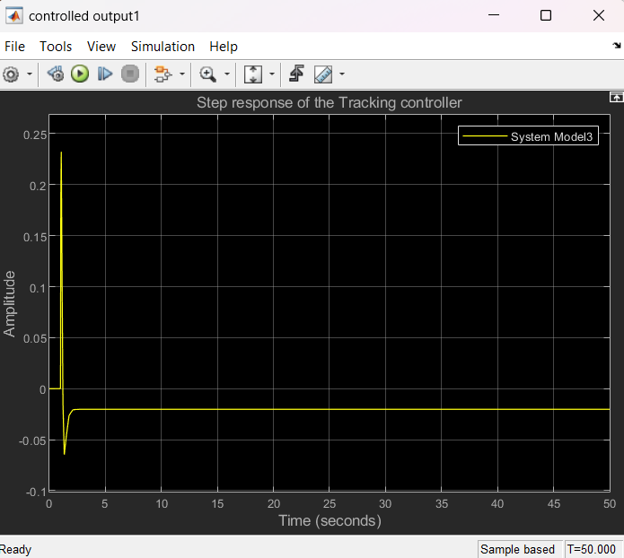

Figure 9: steady state error after tracking controller.

Steady state error for ramp input, after the controller is infinite because my controller is not tracking the ramp input.

The response for the ramp input is given below

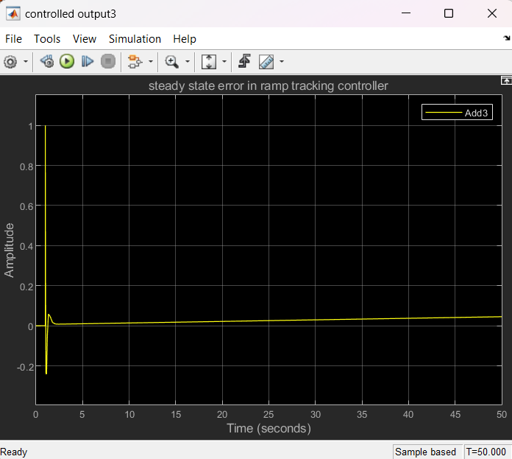

Figure 10: Ramp step response.

## Tracking Controller:

Figure 11: Plot of step tracking of amplitude 2u(t).



Figure 12: Plot of Ramp tracking of amplitude tu(t).

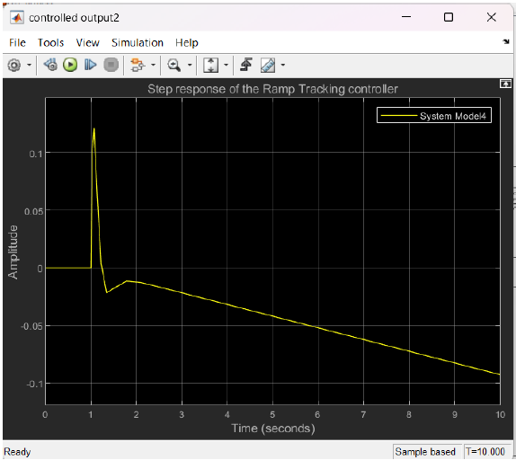

# **Results and Discussions:**

We simulated the above system. The schematic for simulation and all the responses are given one by one as above.