**WEB ENGINEERING LAB**

**Lab: 04**



**Spring 2023**

**Elective Web Engineering**

**Submitted by: FAWAD ALI**

**Registration No: 19PWCSE1845**

“On my honor, as student of University of Engineering and Technology, I have neither given nor received unauthorized assistance on this academic work.”

Student Signature: ______________

**Submitted to:**

# Engr. Madeha Mushtaq

**Date (March, 31, 2023)**

Department of Computer Systems Engineering

**JavaScript and jQuery**

**Objectives:**

Know about the JavaScript.

Know about the jQuery library of JavaScript.

How to use JavaScript and jQuery to create a dynamic web pages.

**Task: 01**

JavaScript is used to pre-compute the total cost of an order and display it to the customer before the order is submitted to the server for processing.

**Output:**

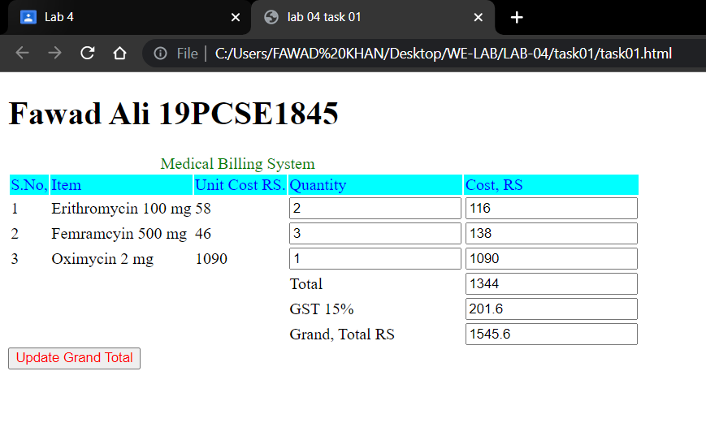

**Conclution:**

we create the form then inside form crete the table see above and use one button then write the

javaScript code to made these form in dynamic working to write the function to calculate the price when we enter the quatity ot items if press the button to calculate total price with GST.

**Task: 02**

Use jQuery to write a code that will change all the occurrences of “White” with the color specified in the text input field by clicking the “Change” button.

**Output:**

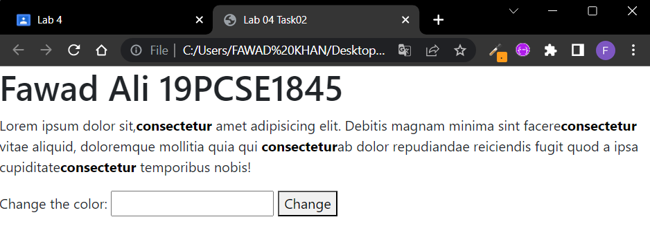

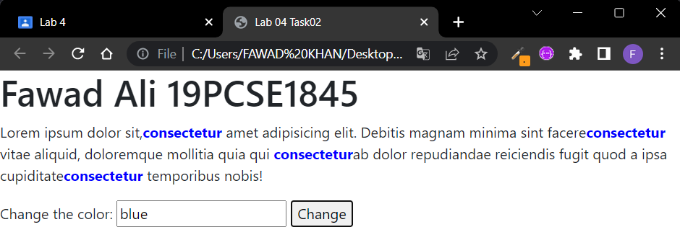

**Conclution:**

use jQuery ready class to change the css of the paragraph show in abpve we only change the color of the some text we can use this class to achive more functions. We studied the jQuery ready class.

**Task: 03**

Create an Html form as shown below, Use jQuery to perform the following functions:

* When the page is loaded, cities will not display.
* When the user selects the country Pakistan, all cities of Pakistan will show only.
* When the user selects any other country than Pakistan, a field is shown to enter the city name manually.

**Output:**

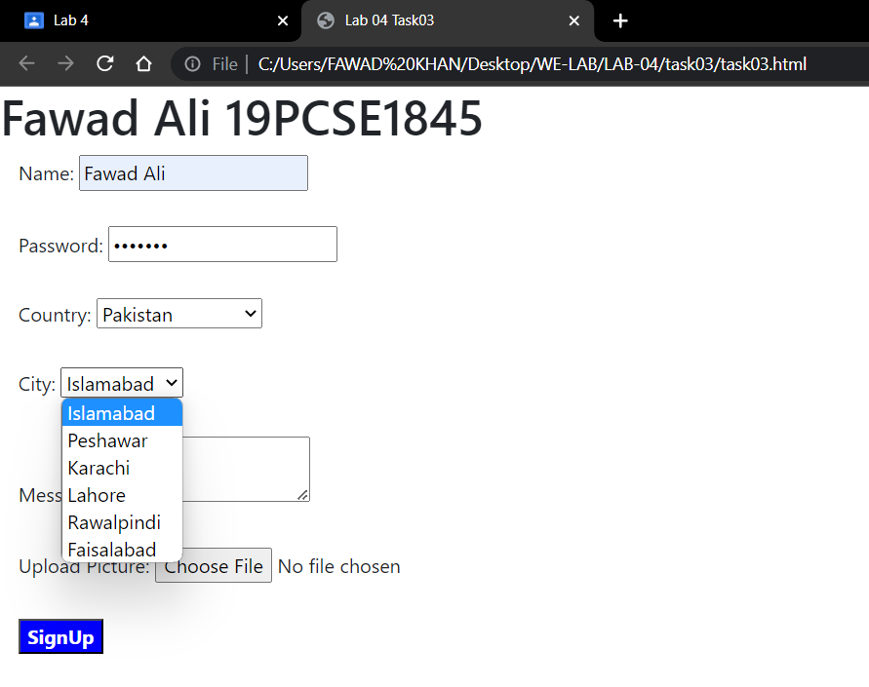

**Conclution:**

This task also use jQuery ready class and change class to perform this task we have the country dropdown chak if they equal to Pakistan then show the cities of Pakistan in cities dropdown.

**Task: 04**

**Use jQuery** .css(), .hasClass(), .removeClass(), .addclass(), .toggle Class(). .addClass(), .attr(), .append(). To achieve the output show in lab task.

**Output:**

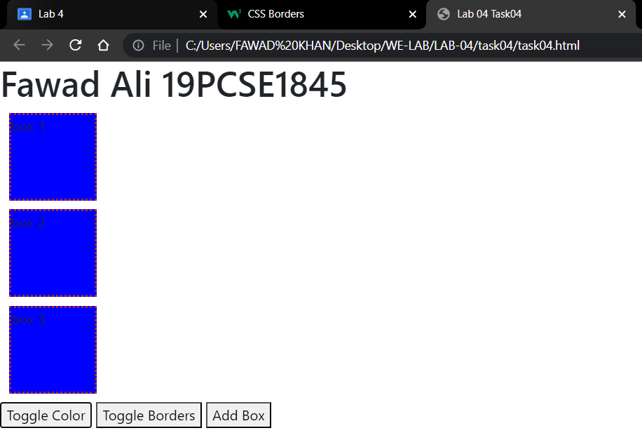

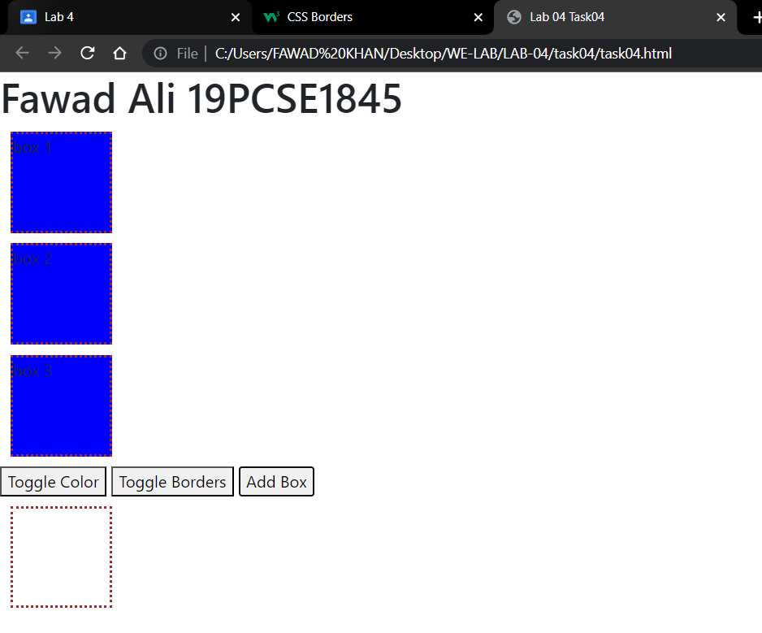

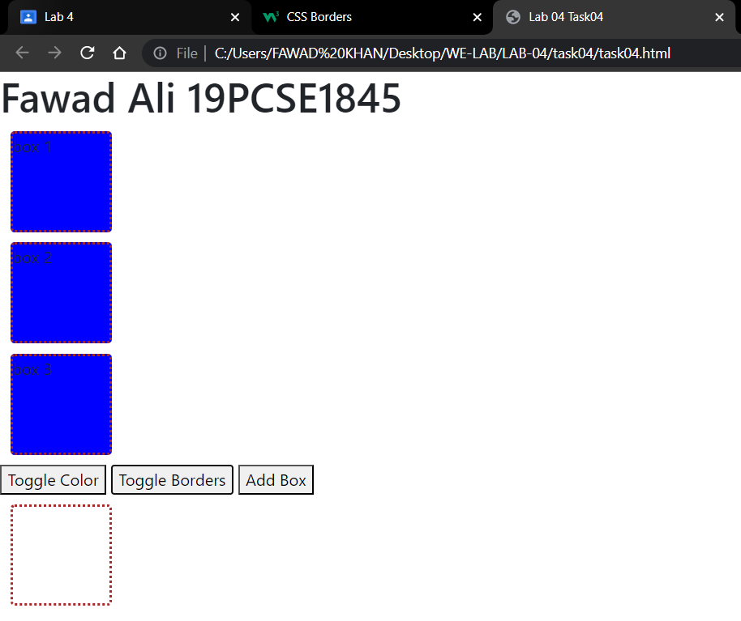

**Conclusion:**

we create the three box and three button when we press the toggle color to toggle the color and press toggle border to toggle border and press the add to add box the all functionality achieved it use jQuery library in the class of toggle Class and append To class. In this lab we studied the basic of jQuery Library.