**WEB ENGINEERING LAB**

**Lab: 03**



**Spring 2023**

**Elective Web Engineering**

**Submitted by: FAWAD ALI**

**Registration No: 19PWCSE1845**

“On my honor, as student of University of Engineering and Technology, I have neither given nor received unauthorized assistance on this academic work.”

Student Signature: ______________

**Submitted to:**

# Engr. Madeha Mushtaq

**Date (March, 17, 2023)**

Department of Computer Systems Engineering

**BootStrip Grid Layout**

**Objectives:**

Know about the Bootstrap framework.

How to use bootstrap in set the environment.

Know about different classes of bootstrap in how to use these classes.

**Task: 01**

In the task one we have create div block with the container-fluid class of bootstrap then we define the rows and column to design the below design.

**Output:**

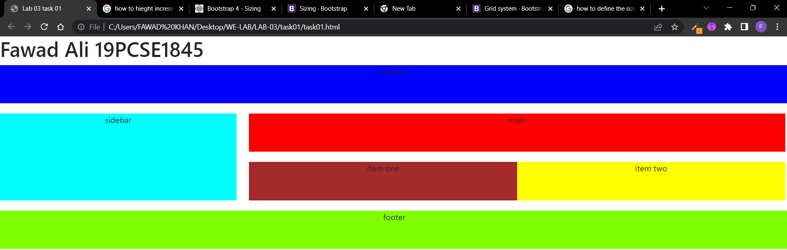

**Task: 02**

In this task also use container class of the bootstrap and rows Column then use the dropdown class of bootstrap to develop the dropdown which show in below.

**Output:**

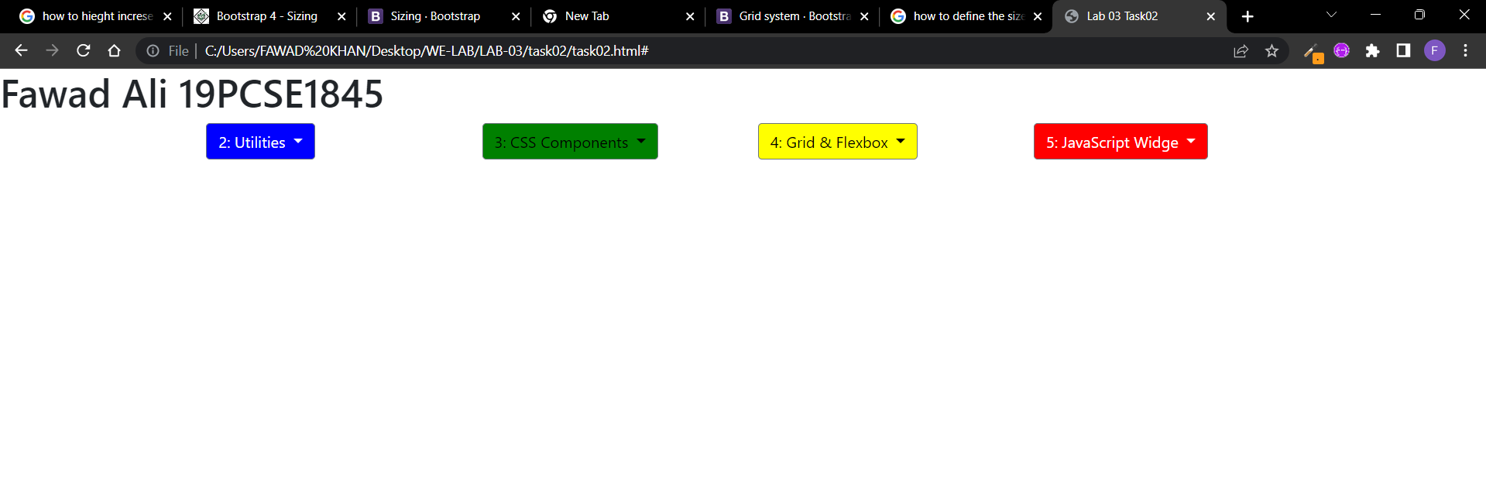

**Task: 03**

We use the bootstrap to developed the below page in use bootstrap classes such as “collapse navbar-collaps, d-flex, navbar navbar-expand-lg navbar-light bg-light, justify-content-end, row in justify-content-between, start, around, center end, etc.

**Output:**

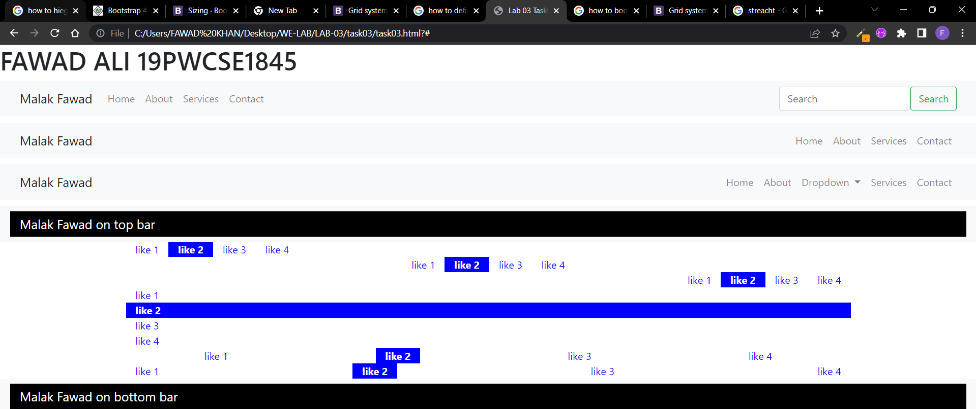

**Task: 04**

We developed the web page to show in below in this web page we use bootstrap frame work, in this is use bootstrap classes such as “row no-gutters, col-md-4, etc.

**Output:**

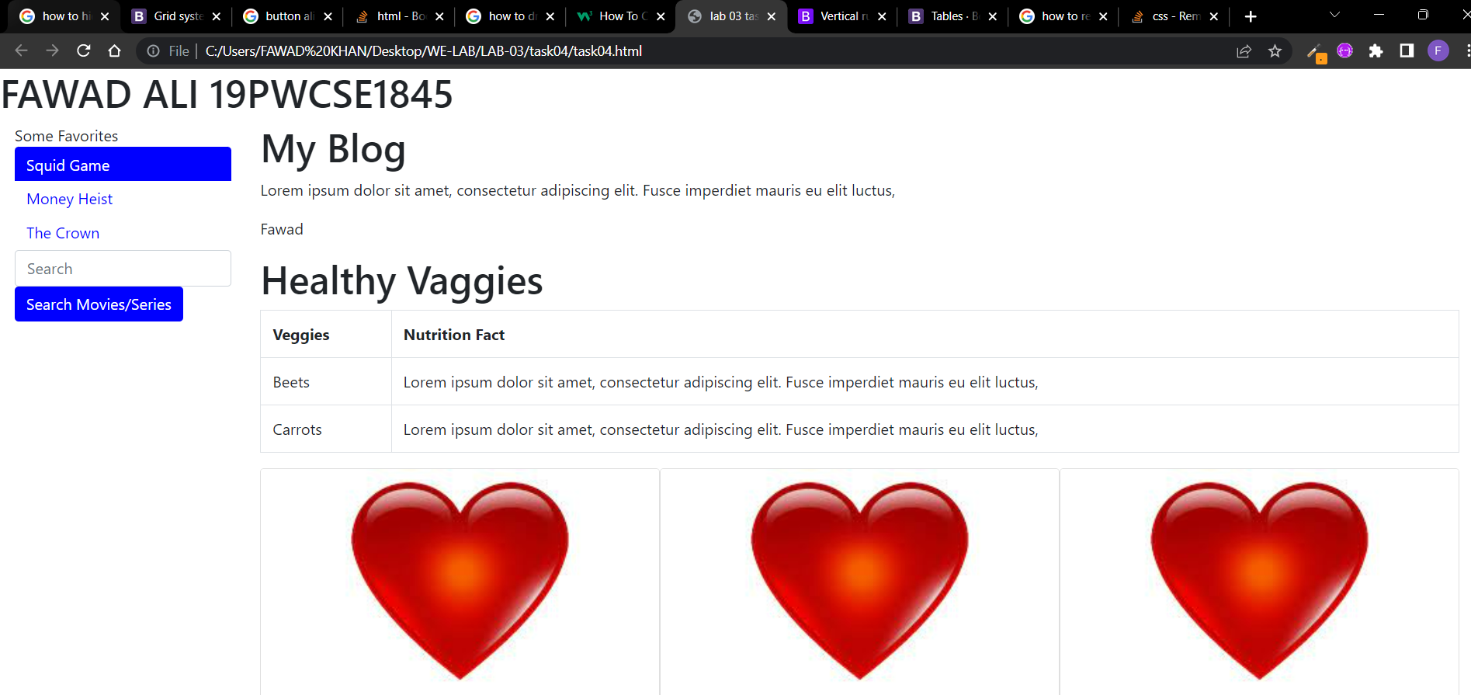

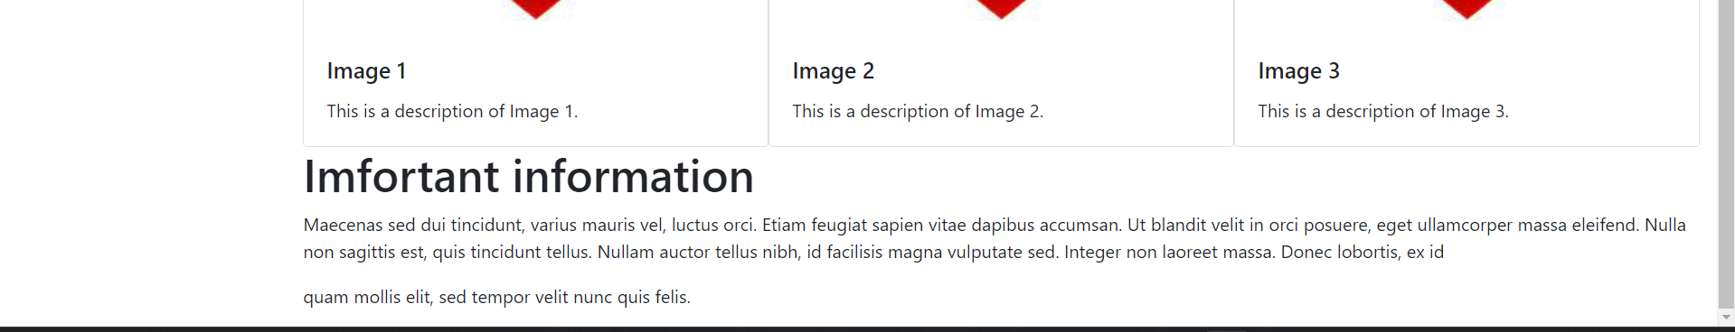

**Conclusion:**

We are studied css framework bootstrap learn the classes of the bootstrap.