StudyMateAI

FYP-II REPORT

BS(CS/SE/CYS/AI) Fall 2024

Name: Fawaz Ahmed
21k-4717
Name: Shahzaib Mirza
21-3819
Name: Muhammad Daniyal
21k-4723

Supervisor: Miss Saeeda Kanwal

Department of Computer Science

FAST-National University of Computer & Emerging Sciences, Karachi

Acknowledgement
We would like to express our heartfelt gratitude to our project supervisor, Miss Saeeda Kanwal, for her continuous guidance, support, and encouragement throughout the duration of our Final Year Project. Her insights and feedback were invaluable in shaping the direction of our work.
We are also deeply thankful to our jury members, Sir Nadeem Kafi and Sir Zain Ul Hassan, for their constructive feedback and valuable time, which greatly contributed to the improvement of our project.
Lastly, we extend our sincere appreciation to our esteemed institution, FAST-NUCES Karachi, for providing us with this research opportunity and the necessary resources to successfully complete our project.

Contents
Acknowledgement 2
Abstract 4
Introduction 5
Related Work 6
Requirements 7
Design 8
Implementation 13
Testing and Results 14
Future Scope 16
References 17

Abstract
StudyMateAI is an AI-driven web application designed to enhance self-learning by transforming educational content into interactive resources. The system generates topic-specific quizzes, concise notes, and summarized videos to help students study more efficiently. It uses a Retriever-Augmented Generation (RAG) pipeline, combining Gemini embeddings, ChromaDB, and Gemini 2.0 Flash to deliver accurate and context-aware outputs.
Built with Next.js (TypeScript) for the frontend, Node.js for backend APIs, and Flask for AI processing, the platform offers a smooth and responsive user experience. A personalized student dashboard enables users to generate focused quizzes, view results, and track learning progress over time—making StudyMateAI a powerful tool for modern, AI-assisted education.

Introduction
In today’s fast-paced educational landscape, students require intelligent tools that enhance learning efficiency, reduce manual effort, and provide personalized academic support. Traditional online learning platforms often impose subscription barriers and usage limitations, which restrict students' access to high-quality, on-demand learning resources. StudyMateAI bridges this gap by offering an AI-powered solution that streamlines the self-study process through automated quiz generation, intelligent video summarization, and personalized progress tracking—all within a user-friendly student dashboard.
Our primary focus is intelligent quiz generation from PDFs, allowing users to upload textbooks or notes and generate topic-specific quizzes using a Retriever-Augmented Generation (RAG) pipeline. The system leverages Gemini embeddings, ChromaDB, and Gemini 2.0 Flash to deliver accurate, subject-relevant questions, complete with scores, correct answers,

Related Work
Several platforms currently offer quiz generation or assessment tools, but they come with key limitations that StudyMateAI addresses. Below is a comparison of similar solutions:
- Revisely
Revisely is an online platform designed for teachers to mark assignments and provide feedback [1]. It allows for unlimited non-AI quizzes, but restricts users to just 50 AI-assessed answers and 5 AI-chat messages per day. Additionally, it only supports text input up to 25,000 characters and does not allow document uploads, making it unsuitable for processing complete study materials like full textbooks or PDFs.

- FlexiQuiz
FlexiQuiz provides tools to create and manage quizzes with features such as auto scoring, question banks, and multilingual support [2]. However, its free tier is highly limited, and the $17/month base plan still restricts access to advanced features. It lacks AI-powered quiz generation from raw educational content like PDFs or lecture notes and requires manual input of questions, which can be time-consuming.

- Questgen.ai
Questgen.ai is an AI-powered tool that generates quizzes from input text using NLP [3]. It offers 20 free runs with a 5,000-word limit per input, and users must copy-paste text manually since it does not support document uploads. It also lacks personalized dashboards or performance tracking, and the generated questions are not always tailored to specific topics or chapters.

Requirements
The development of StudyMateAI did not require any paid subscriptions or specialized hardware. All tools and frameworks used, including Next.js, TypeScript, Node.js, and Flask, are open-source and freely available. AI services like Gemini 2.0 Flash and ChromaDB were accessed through available APIs without additional cost.
Development and testing were performed on standard personal computers with no special hardware requirements. Version control and collaboration tools used were free-tier platforms, ensuring that the project could be completed without incurring extra expenses.

Design
For our project, we adopted a minimal, user-friendly, and interactive design approach to ensure ease of use and smooth navigation. Our focus was on creating an intuitive interface that allows students and teachers to effortlessly access the quiz generation, notes summarization, and video analysis features.
The application interface was structured to prioritize clarity and simplicity, with clearly defined sections for uploading study materials, generating quizzes, and tracking progress through the student dashboard. We used clean layouts and straightforward workflows to reduce cognitive load and enhance user engagement.
Below are snippets from the application illustrating the streamlined design and core functionalities implemented throughout the project.

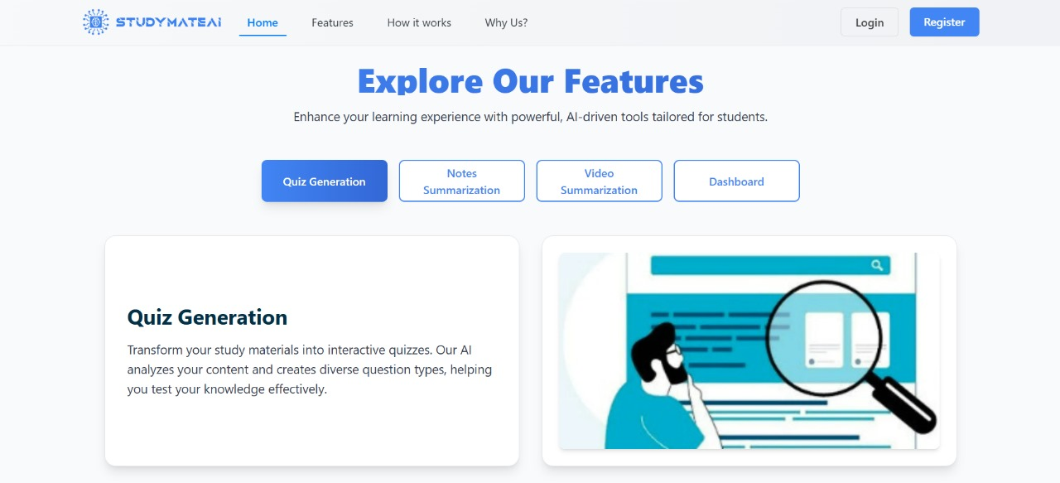

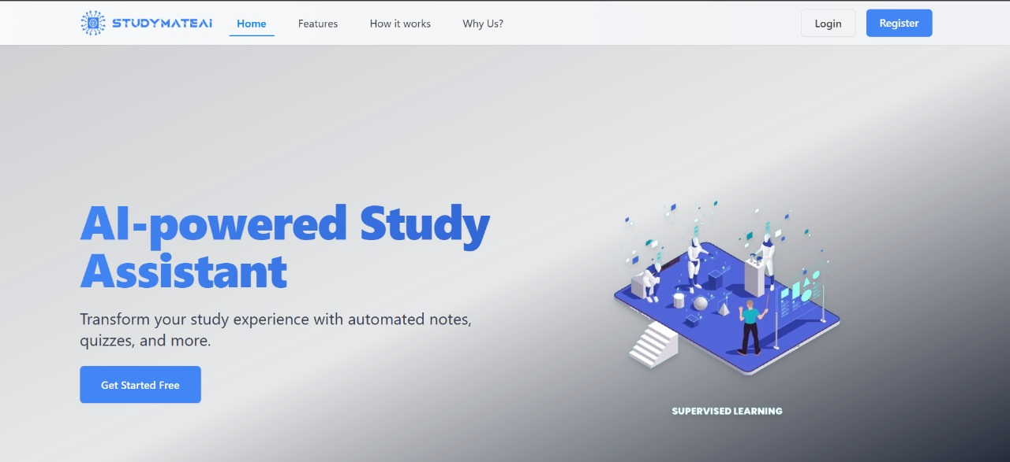

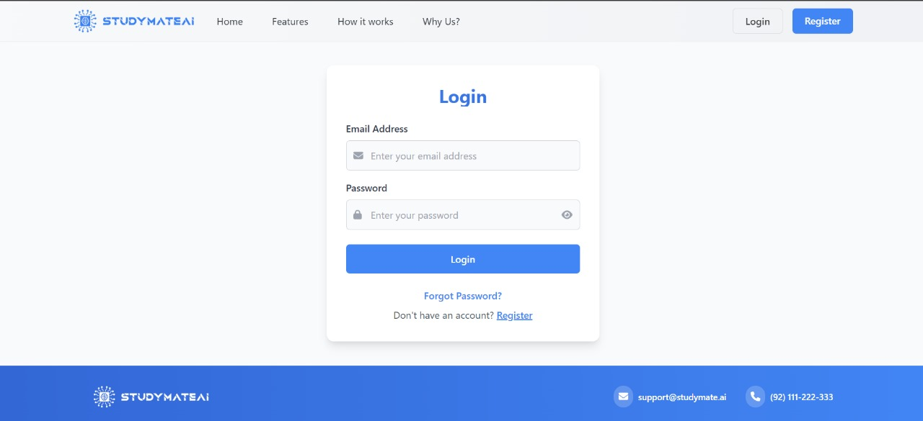

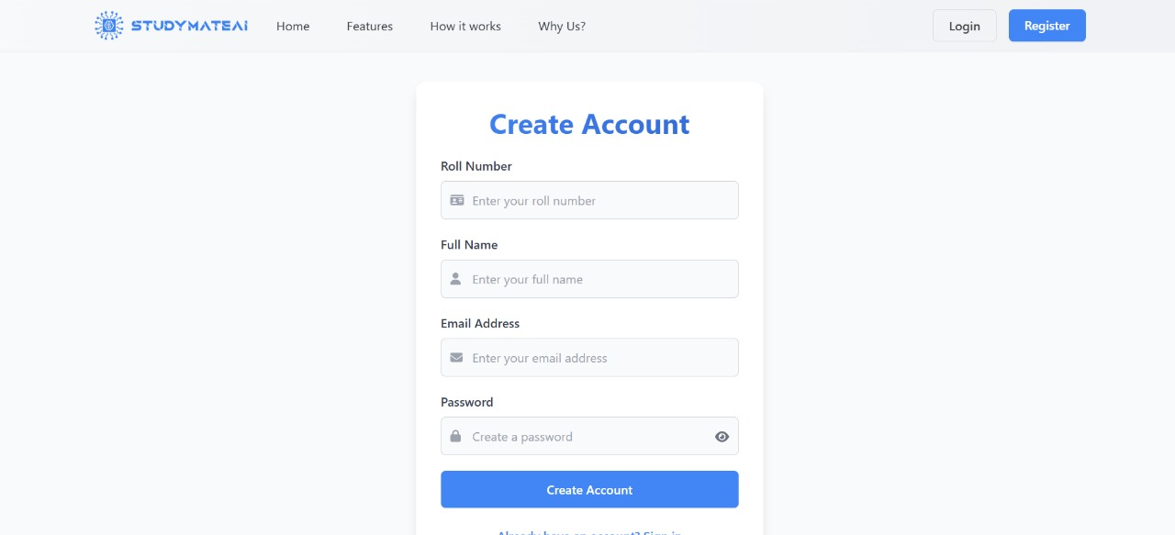

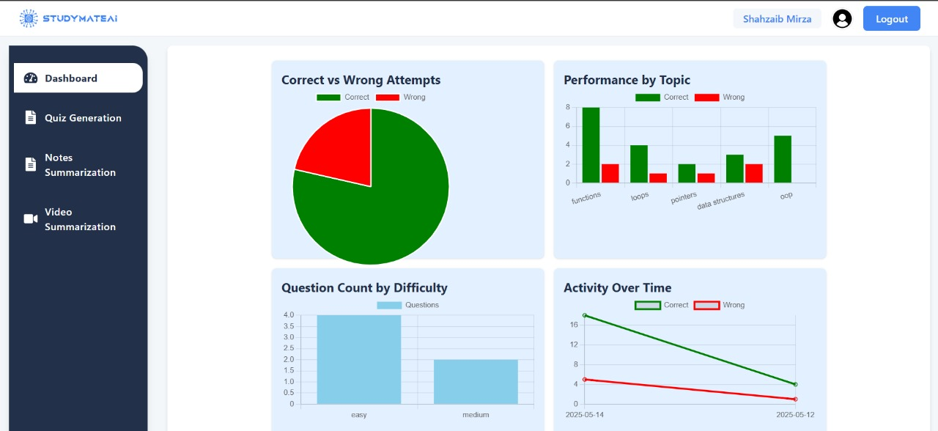

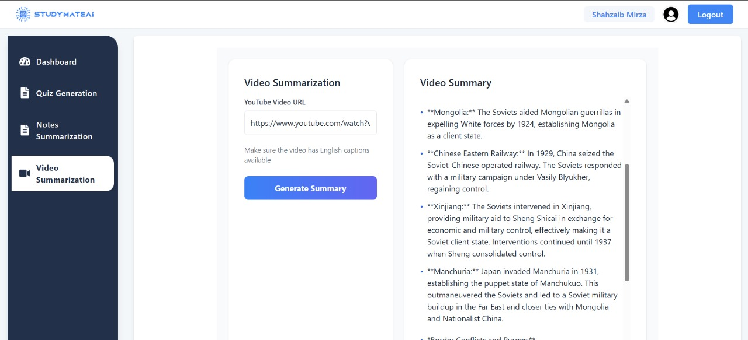

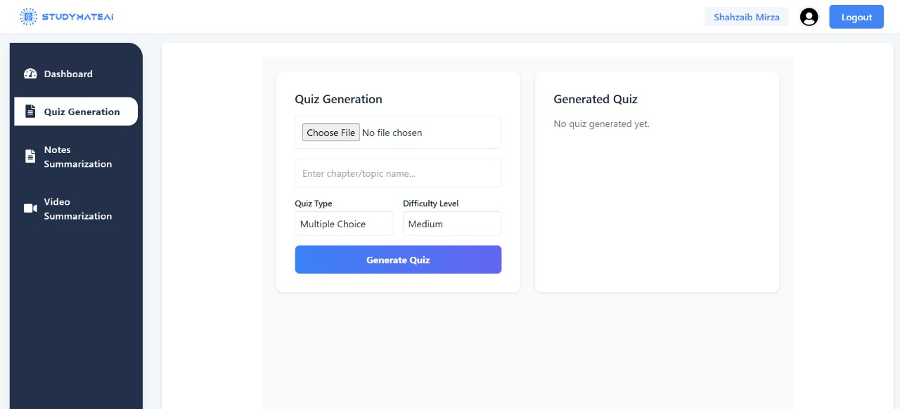
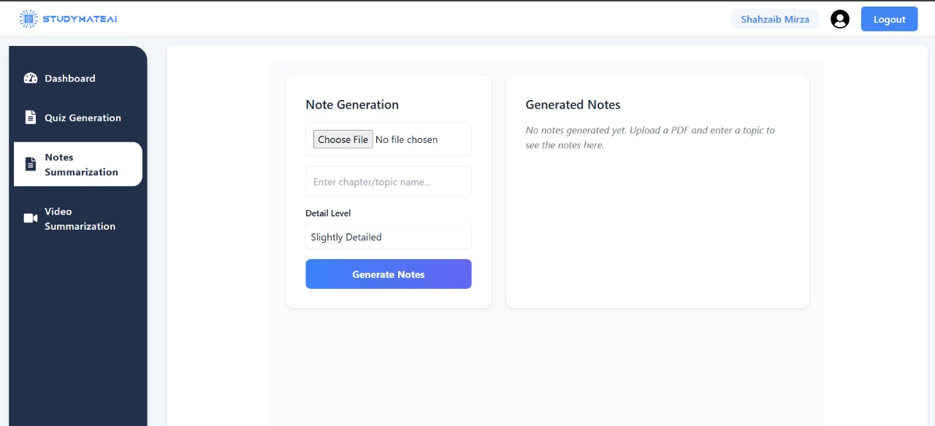

Implementation
The StudyMateAI system begins by allowing users to upload educational PDFs or provide YouTube video links as input. For PDFs, text extraction is performed using PyPDF2 for digital text and Tesseract OCR for scanned documents. In the case of videos, transcripts are obtained through the YouTube API to capture the spoken content accurately.
Once the raw text is extracted, it undergoes preprocessing to clean and format the data, preparing it for embedding. The cleaned content is then transformed into vector representations using Gemini embeddings, which capture the semantic meaning of the text. These embeddings are stored in ChromaDB, a vector database that facilitates efficient semantic search.
When a user requests notes, quizzes, or video summaries, a Retriever-Augmented Generation (RAG) pipeline is employed. This pipeline retrieves the most relevant content segments from the database based on the specified topic or input. The selected content is then passed to the Gemini 2.0 Flash model, which generates concise, topic-specific notes, logical quizzes, or video summaries.
The backend services are built with Node.js and Flask, while the frontend uses Next.js with TypeScript to provide a fast and responsive user interface. User data, quiz results, and progress are stored in a MongoDB database, enabling personalized student dashboards to track performance over time.
To support continuous learning, the system includes a student dashboard that tracks quiz attempts, scores, and progress over time, providing users with insights into their performance and helping guide their study efforts effectively.

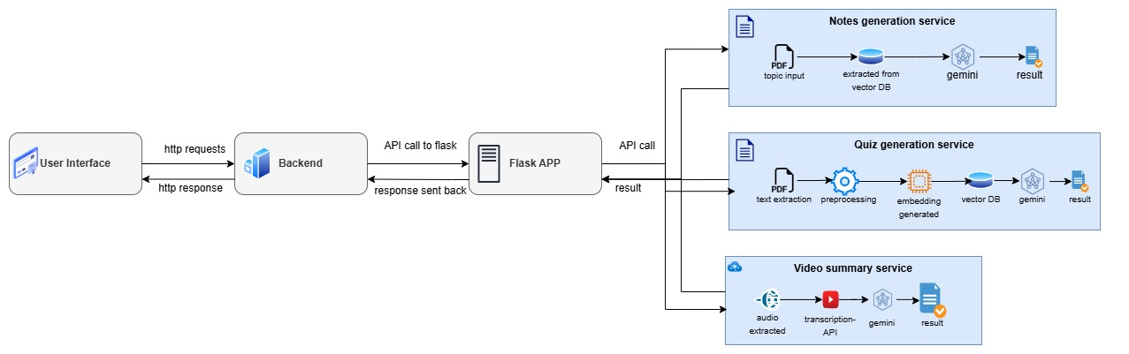Fig 1. System Diagram

Testing and Results
The testing phase of StudyMateAI focused on verifying the accuracy, usability, and performance of the core features—quiz generation, notes summarization, and video content analysis.
Functional Testing:
Each feature was tested with a variety of educational PDFs and YouTube videos covering different subjects and complexities. Text extraction was validated to ensure completeness and correctness for both digitally formatted and scanned documents. The Retriever-Augmented Generation (RAG) pipeline’s ability to retrieve relevant content was evaluated by comparing generated quizzes and notes against source material.
Performance Testing:
We assessed the response times for quiz generation and note summarization to ensure the system performs efficiently with larger documents and longer videos. The use of Gemini embeddings and ChromaDB enabled fast semantic search, with average retrieval times remaining within acceptable limits for a seamless user experience.
User Evaluation:
A group of students tested the platform to provide feedback on the intuitiveness of the interface, clarity of generated quizzes, and usefulness of the student dashboard. The feedback highlighted the ease of uploading materials and the helpfulness of instant quiz scoring with detailed explanations.

Conclusion
StudyMateAI successfully demonstrates how AI-powered tools can enhance the educational experience by automating the generation of topic-specific quizzes, notes, and video summaries from diverse learning materials. By leveraging advanced technologies such as Gemini embeddings, ChromaDB, and a Retriever-Augmented Generation pipeline, the system provides fast, accurate, and relevant outputs that support active learning and knowledge retention.
The integration of a student dashboard for tracking quiz performance further personalizes the learning process, helping users monitor their progress over time. The use of modern web technologies including Next.js, TypeScript, Node.js, Flask, and MongoDB ensured a responsive and scalable platform.
Overall, StudyMateAI addresses key challenges faced by students and teachers, offering a free, accessible, and effective educational resource. Future work could expand features, improve AI model capabilities, and explore additional content types to further enrich learning outcomes.

Future Scope
While StudyMateAI currently focuses on PDF and YouTube content, there are several areas for potential enhancement:
- More File Types: Extend support to additional formats like PPT, DOCX, and even handwritten notes using advanced OCR models.
- Multilingual Support: Enable processing and generation for non-English content to make the platform more inclusive.
- Collaborative Study: Introduce real-time collaboration features for students to generate and share notes and quizzes in groups.
- Voice Interaction: Integrate Text-to-Speech (TTS) functionality to read out quizzes and summaries, improving accessibility and engagement.
- Adaptive Learning Paths: Implement intelligent tracking to adjust quiz difficulty and content suggestions based on user performance over time.
These features will further enhance the usability and impact of StudyMateAI, transforming it into a comprehensive, AI-powered learning assistant.

References
[1] Revisely, "Online marking tool for teachers," [Online]. Available: https://revisely.com. [Accessed: Sept. 21, 2024].
[2] FlexiQuiz, "Create online quizzes, tests & exams," [Online]. Available: https://www.flexiquiz.com. [Accessed: Sept. 21, 2024].
[3] Questgen, “AI Quiz Generator,” [Online]. Available: https://www.questgen.ai. [Accessed: May 15, 2025].

