**Task 1: Simulation Exercise**

1. **Generate a matrix of numbers**

The first in this task is to define a function that creates a matrix with random integer values. First, we set the seed to ensure that the generated random numbers can be reproduced then create a vector before reshaping it into a matrix. We then call the function with several arguments to generate and print the matrix that will be used in the task.

Code:

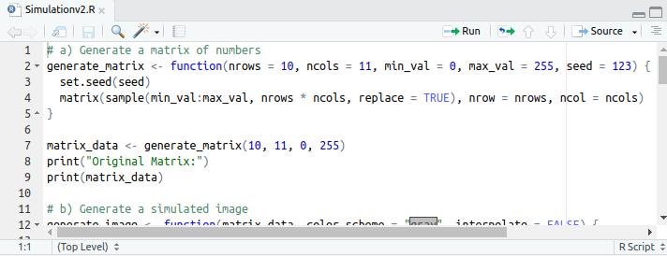

Output: Generated matrix

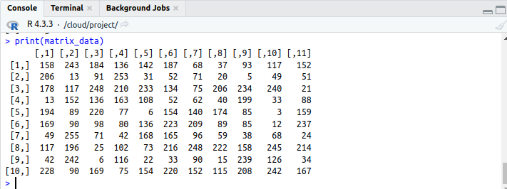

1. **Generate a simulated image**

In the second part, we define a function to create an image of the matrix. For clarity, the image was customized with color schemes and interpolation. In this case, the gray scale color scheme was used in this case for the simulated image and an additional heatmap with interpolation to make the image smoother.

Code:

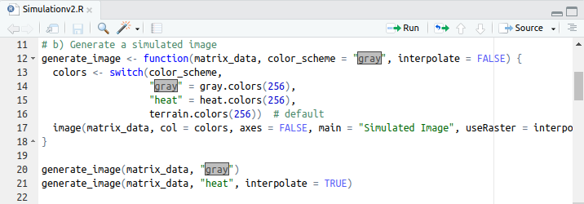

Output: Simulated Image

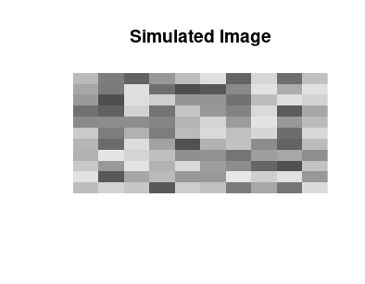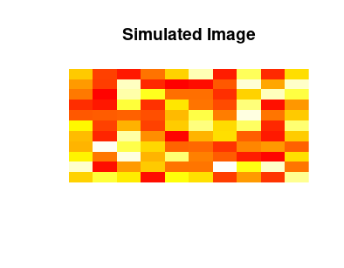

1. **Classify the simulated image**

In the third section, we proceed to classify the simulated image. Here, we define a function to assign labels to different ranges in the matrix. Technically, the function takes custom labels and breaks which then segment the data in categories including Very Low, Low, Medium, High, and Very High. Classification is vital in analyzing the distribution of values within the matrix. The final matrix is then printed:

Code:

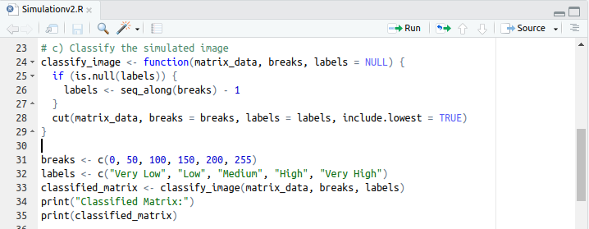

Output: Classified simulated image

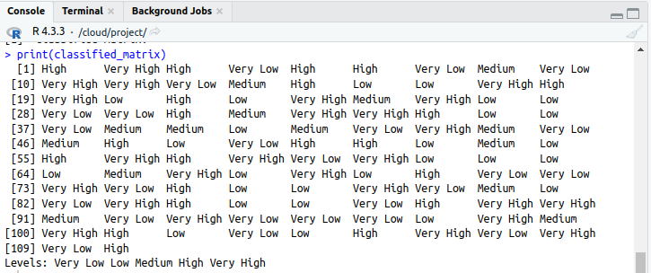

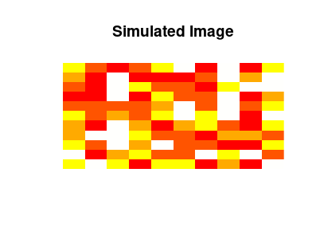

1. **Reclassify the simulated image**

The fourth section of the task reclassifies the simulated image using a function that basically segments the matrix in equal intervals. In this case, it divides the data into four categories as above named Low, Medium-Low, Medium-High, and High based on the segments.For visualization purposes, the reclassified image is converted to numeric values and displayed to show the new classification.

Code:

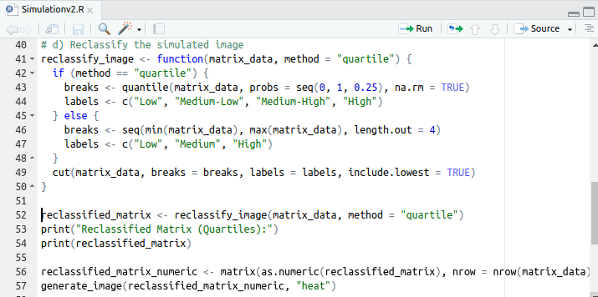

Output: Reclassified matrix and image

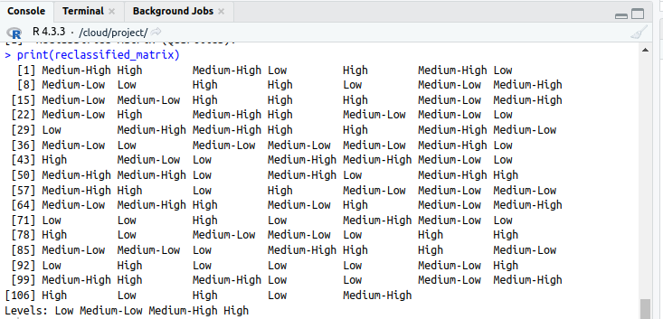

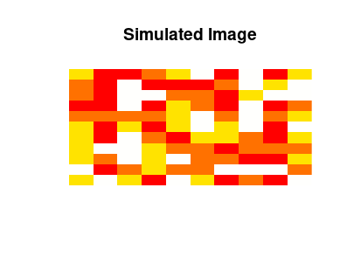

**Extras**

To help understand the process better, an extra function was defined to plot distributions of matrix values by creating histogram and bar plots. The histograms were useful in showing the distribution of values and the bar plots showed the frequency of each class. This was important in understanding the spread of the data and how its was affected by classification.

Code:

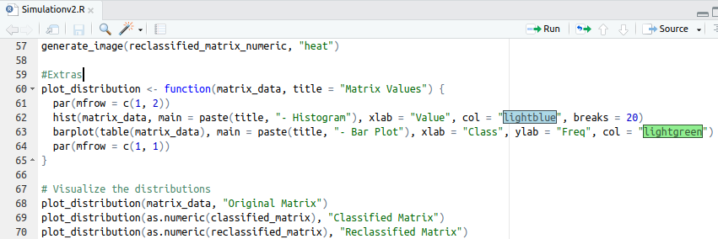

Output: Visualization

