**CS 330 Milestone One**

Student Name:

Date:

Course: CS 330 – Computer Graphics

Instructor:

**Selected 2D Image for 3D Scene Replication**

For the 3D scene project, I've chosen a photograph of a home office desk setup that includes a laptop, desk lamp, coffee mug, and a stack of books. I took a few pictures of the setup from different angles to better understand the shapes, proportions, and spatial relationships of the objects. This image is ideal because it provides us with a range of object shapes and textures, allowing for a visually pleasing but reasonably complex 3D scene.

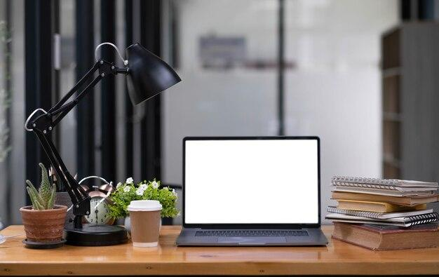

*Figure 1: Selected image*

**Objects Selected to be 3D Replicated**

The objects I will be replicating 3D are: Laptop, Desk lamp, Coffee mug, Stack of books, and Table pane. These objects were selected because each of them presents a unique geometric component and set of complex forms, so the project is both feasible and demanding. Laptop and desk lamp contain several geometric features, which will be beneficial in demonstrating the use of composite forms. Books and a coffee mug are simpler but necessary in order to create balance in the composition and create realism. Representing these ordinary household items in 3D space will further enhance my skills in modeling everyday objects.

**Basic 3D Shapes for Object Construction**

To build the 3D scene, I used the following basic 3D shapes as building blocks:

* Box: Used for the laptop base and screen, and for the books on the pile. Boxes are clearly rectangular volumes that are suitable for these objects.
* Cylinder: Used for the body and handle of the coffee mug, and for lamp base and neck pieces. Cylinders are well-suited for rounded objects that have constant cross-sections.
* Cone: Used in the shadow of the desk lamp, which tapers from a wide opening to a thin connection point.
* Plane: Used as the desktop to stabilize objects and imbue meaning in the scene.

The laptop, being composed of two parts (screen and base), will be composed of two boxes with a hinge joint. The desk lamp is a cylinder for the neck, a cone for the shade, and a box or small cylinder for the base, demonstrating an assembly of multiple shapes. The stack of books is a number of boxes stacked with slight offsets to provide realism. The expected final 3D Scene will look like this from different perspectives.

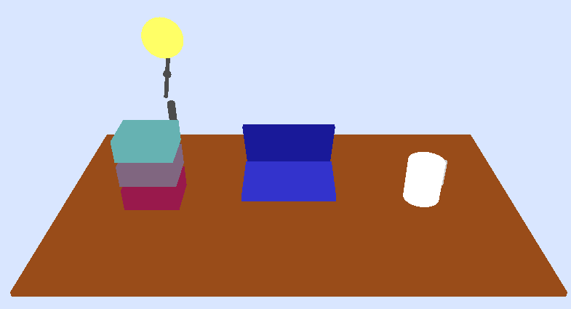

*Figure 2: Front Facing*

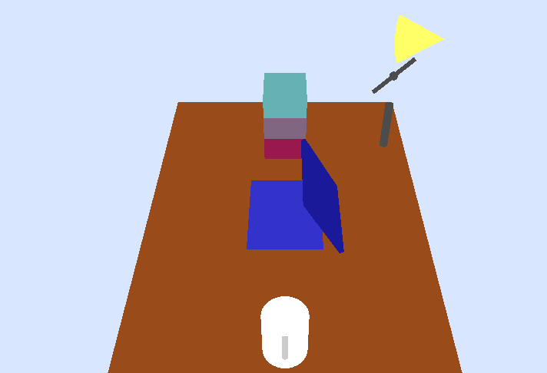

*Figure 3: Side facing*

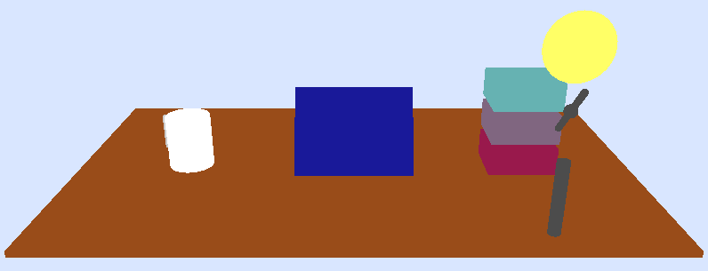

Figure 4: Back facing

This paper provides a structured, feasible plan to create an intriguing 3D scene using simple OpenGL primitives. The chosen objects provide variety in shape and complexity but are manageable within the milestone schedule. The multiple-angle images will enable precise modeling, and the combination of shapes ensures an interactive learning experience in constructing, texturing, and illuminating the scene.