**Project Proposal: Planning a Gubernatorial Campaign for California**

**Student’s name**

**Institutional affiliation**

**Professor’s name**

**Course**

**Date**

**1. Project Concept**

This project aims at planning, organizing, and executing a successful gubernatorial campaign for the California seat in 2028. The project’s goal is to result in a comprehensive and data-driven campaign that will involve effective political messaging aimed at enhancing the image of the candidate, building strong grassroots support, securing funding, and endorsements. Guiding this gubernatorial campaign project will be strong democratic values, establishing a strong digital footprint, and leveraging strategic engagements with voters. The key campaign deliverables will be: developing of the campaign strategy, fundraising for the campaign, recruitment of the campaign staff and training, departmentalisation of staff campaign staff, carrying out of target voter research, role out key political stakeholders’ engagement, National tours and media engagement, Town halls and public debate, managing election day, Post election results analysis. This project aims to ensure maximum voter and stakeholders’ engagement to ensure a successful campaign that will result in my election as the California governor in the 2028 elections.

**2. Proposed Timeline**

The campaign for the California gubernatorial seat will run for about 18 months. The key milestone activities of the campaign are listed in the table below:

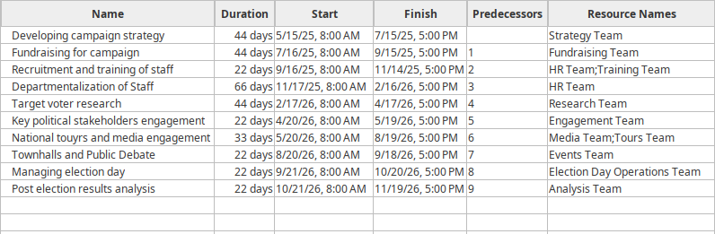

*Figure 1: Project timeline*

**3. Budget**

For the effective running of the proposed gubernatorial campaign for California, a budget of about $80 million is estimated. The budget aligns with the national mid-tier campaign provisions. The estimated budget is broken down into finer details in the table below:

| **Campaign cost Item** | **Amount in** $ in millions | **Detailed breakdown of cost item** |
| --- | --- | --- |
| Personnel cost | 15 | This will include salaries for campaign staff, consultants, legal, and media experts |
| Advertisement and media | 25 | This will include the cost incurred towards television, radio, print, and digital ad production and placements |
| Events and travelling | 15 | This will include the cost incurred towards rallies, town halls, accommodation, and logistics |
| Fundraising infrastructure | 8 | This will include the cost incurred towards platforms, donor engagement tools, and event costs |
| Volunteer management and training | 8 | This will include the cost incurred towards training modules, transportation, incentives, and kits |
| Technology and data management | 5 | This will include the cost incurred towards voter database tools, cybersecurity, and analytics |
| Contingency reserve | 4 | This will be money reserved for any unforeseen cost item. |

**4. Benefits**

This project outlines a detailed plan for California 2028 gubernatorial campaigns, offers several key benefits. One of the key benefits of the project is its ability to offer returns on investment in the presidential campaign by ensuring a successful campaign that will result in winning of seat. This project highlights key project deliverables and the timeline, which is critical for the success of the campaign. Highlighting the various project deliverables not osnly ensures that no vital project deliverable is forgotten, but also that they are carried out in good time to create space for the successful carrying out of their preceding activities. However, the major benefit of carrying out this project is to contribute to the social welfare of the society in California as my candidacy, if successful will want to contribute to the social good of the society through adaptation of administrative policies that will champion: economic growth, job creation, equitable representation, inclusivity, and building state profile that supports leadership positioning that offers long-term strategic gains.

**5. Action request**

This proposal for the campaign for the California gubernatorial seat seeks the professor’s approval in order to proceed to the next project management stages.

**Stakeholder Communication**

Hello, project team. We intend to carry out a project on a campaign for the California gubernatorial seat that will run for about 18 months. The project’s goal is to run a successful campaign that will result in winning the gubernatorial seat by ensuring that the campaign is comprehensive and data-driven, with effective political messaging aimed at enhancing the candidate's image, building strong grassroots support, securing funding, and endorsements. For the effective running of the proposed gubernatorial campaign for California, a budget of about $80 million is estimated. Some of the key cost items in the budget are personal costs, advertisement and media, events and travelling, fundraising infrastructure, volunteer management and training, technology and data management, and contingency reserve.

Each of the budget items will cost $15, $25, $15, $8, $8, $5, and $4 million, respectively. A successful carrying out of this project will result in various benefits. For instance, apart from ensuring that it will win the seat, it will usher in a new political dispensation in California for the benefit of the citizens. There will be enhanced social welfare for the citizens through the adaptation of administrative policies that will champion: economic growth, job creation, equitable representation, inclusivity, and building a state profile that supports leadership positioning that offers long-term strategic gains.