**Week 2: Gubernatorial Campaign for California**

**Student’s name**

**Institutional affiliation**

**Professor’s name**

**Course**

**Date**

1. **Project Work Breakdown Structure**

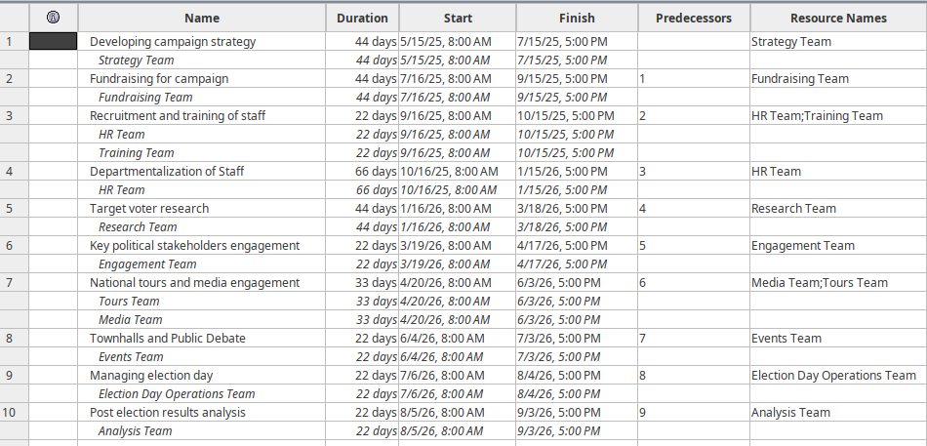

*Figure 1: Project WBS*

1. **Project Schedule (Gantt Chart)**

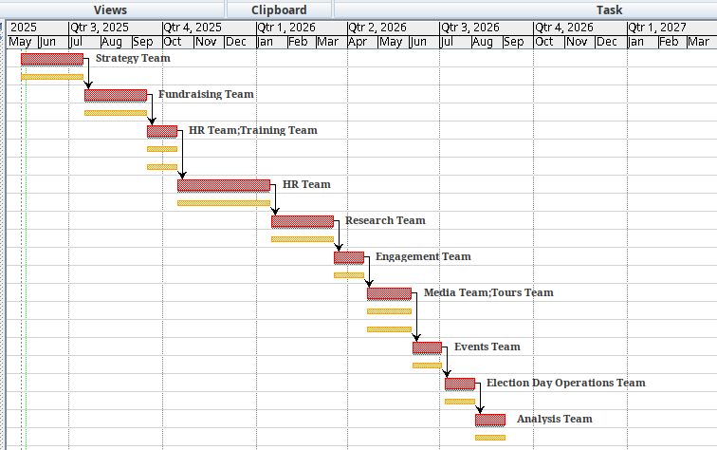

*Figure 2: Schedule*

1. **RACI Chart**

| **RACI Chart – Gubernatorial Campaign for California (2028)** | | | | | | | |
| --- | --- | --- | --- | --- | --- | --- | --- |
| **Task** | **Campaign Manager** | **Strategy Team** | **PR Team** | **Fundraising Team** | **Field Organizers / Volunteers** | **Candidate** | **Analysts** |
| Develop campaign strategy | A | R | C | C |  | C | S |
| Fundraising planning and execution | R | C |  | A |  | C |  |
| Recruit and train campaign staff | A | R |  |  | S |  |  |
| Departmentalize staff | A | R |  |  |  |  |  |
| Conduct voter research | C |  |  |  |  |  | A/R |
| Stakeholder engagement planning | A | R | C |  |  | C |  |
| National media tours | R | C | A |  |  | S |  |
| Town halls and public debates | R |  | A |  | S | A |  |
| Manage election day | A | C | C |  | R | S |  |
| Post-election result analysis | R |  |  |  |  |  | A |

**Legend**

R = Responsible (those who do the work)

A = Accountable (owns the task and decision)

C = Consulted (asked for input)

S = Support (assists with task execution)