**Week 3: Course Project Part 3**

**Student’s name**

**Institutional affiliation**

**Professor’s name**

**Course**

**Date**

1. **Network Diagram**

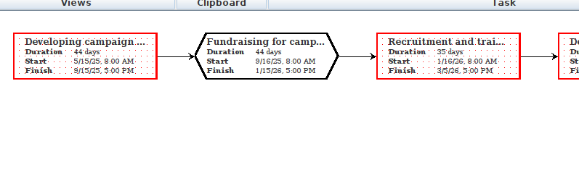*Figure 1: Network diagram*

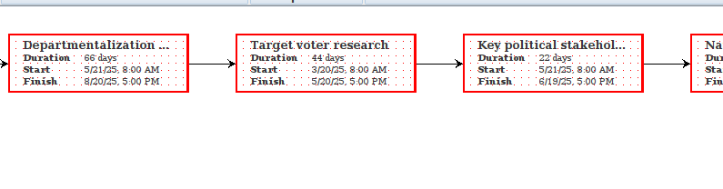

*Figure 2: Network diagram cont…*

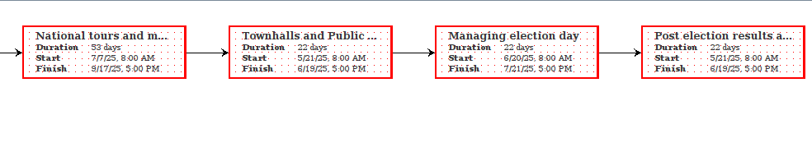

*Figure 3: Network diagram cont…*

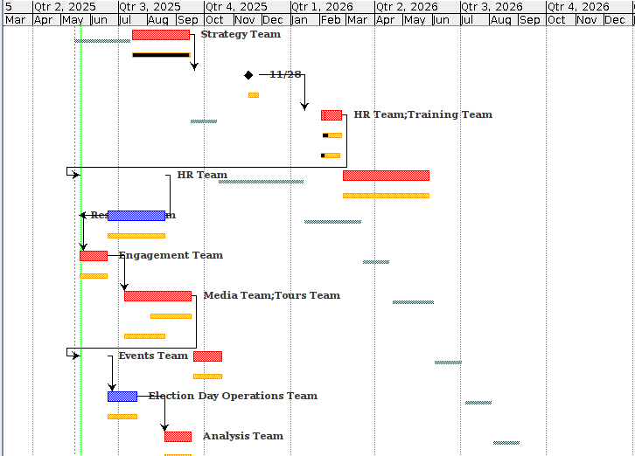

*Figure 4: Modified chart diagram to complement*

**Preliminary Scope and Budget Balancing**

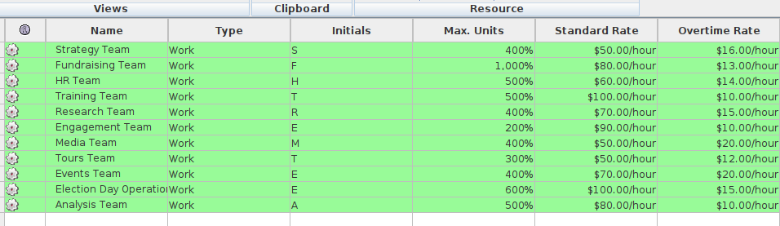

*Figure 5: Resources*

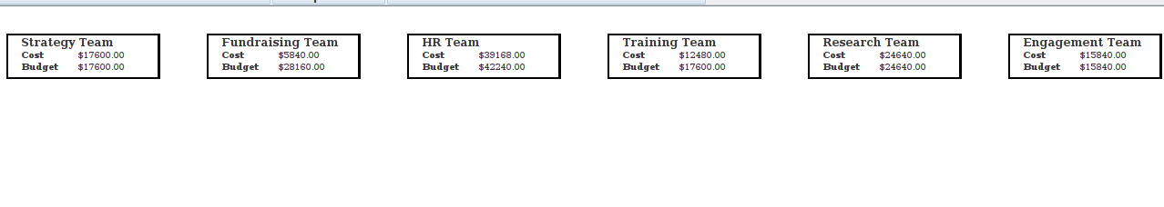

Resource allocation

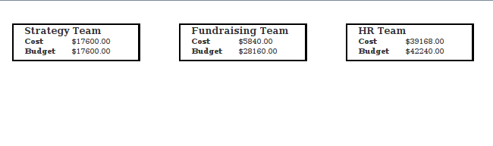

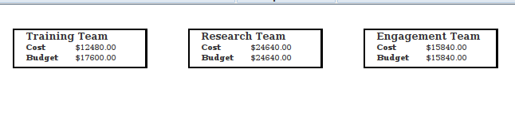

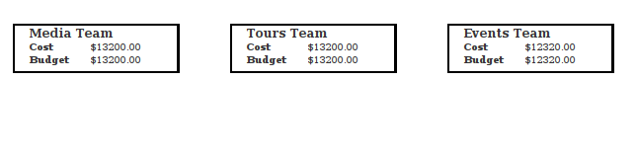

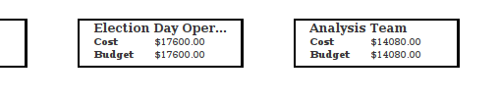

*Figure 6: Resource allocation*

Discussion

During the budgeting phase of the California Gubernatorial Campaign project, several aspects exceeded the original budget provided for the work. Top billing was taken by high costs for national media appearances, travel expenses related to statewide town halls, and fee billing for experienced campaign staff. Additionally, the execution of the digital strategy, such as social media advertising and voter analytics software, cost more than was originally anticipated. These budget overruns had necessitated severe realignments to remain within fiscal responsibility without compromising the campaign's strategic goals.

To stay within budget, the scope was reduced where unnecessary voter outreach was conducted in the early stages. For example, the number of town halls conducted in person was reduced and supplemented with inexpensive virtual webinars. Non-essential travel was reduced, and several campaign activities were combined to minimize logistical costs. Between departments, staff responsibilities were cross-trained to prevent the expense of hiring extra staff. Priorities were assigned to ensure deliverables that would have a high impact on voter contact and visibility, strategies such as digital involvement, stakeholder meetings, and political endorsements were preserved, while lower-order activities were suspended or cut back. This method assisted in matching the budget to the project's most impactful campaign targets.

**Resource Leveling**

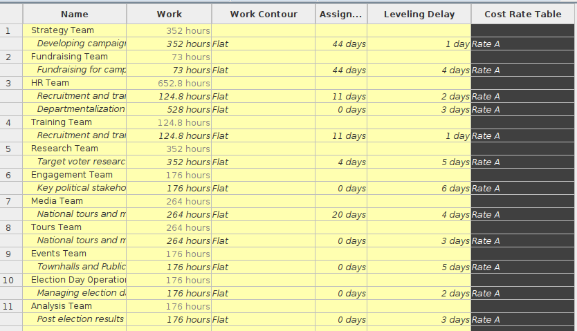

*Figure 7: Resource levelling*

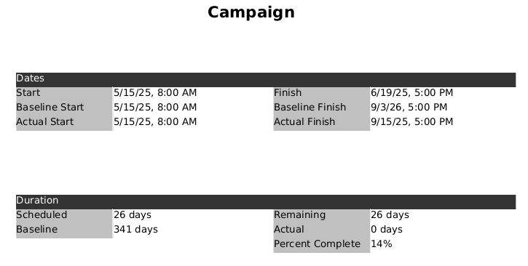

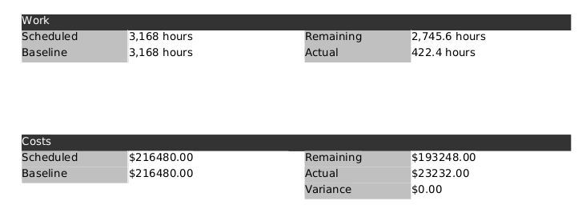

*Figure 8: Final resource allocation*

**Balancing Scope and Budget Discussion**

It required deliberate trade-offs and precise monitoring of high-cost areas to reconcile the California Gubernatorial Campaign project scope and budget. Initially, the scope had ambitious plans such as frequent national tours, extensive media campaigns, and a massive campaign staff. But since the cost breakdown showed budget restrictions, we had to reformulate our priorities. Through identifying the non-essential or deferrable components, i.e., how many physical town halls, it was possible to reduce the scope to within budget while not compromising on key deliverables such as campaign strategy, grassroots mobilization, and digital outreach.

In order to stay within budget, resource utilization was optimized with careful attention. Field staffing was reduced while cross-training existing staff to fill multiple functions. Digital venues were used in place of the actual locations for town halls and events to minimize travel and logistics costs. We also maximized the sequence and schedule of activities to be more resource-conformant without sacrificing campaign impact. This allowed us to retain the most valuable aspects of the campaign strategy without being too fiscally conservative.

As part of an effort to further improve the alignment of the project's budget with its scope, we also balanced the application of advanced scheduling techniques. Selective fast tracking was applied by overlapping campaign strategy formulation and initial grassroots mobilization activities. Where appropriate, crashing was achieved through the application of extra temporary resources to shorten the timelines of high-priority tasks like stakeholder engagement. Overwork for critical employees was similarly planned for high-pressure weeks such as pre-election weeks. These tactics helped maintain the tempo and improve time-cost convergence while minimizing disturbance in the overall project schedule.