**Employee Attrition and Retention Analysis**

Student Name

Date

**Employee Attrition and Retention Analysis**

**Introduction**

This report provides a comprehensive analysis of the organization's human capital, a valuable asset that plays an important role in valuation by potential acquirers. This analysis explores employee attrition and retention trends because employee retention is a reliable indicator of organizational stability and future performance. The results will help anticipate the concerns of potential buyers and recommend actionable initiatives for post-acquisition retention of core talent.

**Current Employee Demographics**

**Gender Distribution**

The current gender composition of the employees indicates a relatively moderate imbalance: 732 employees (59.37%) are males, and 501 employees (40.63%) are females.

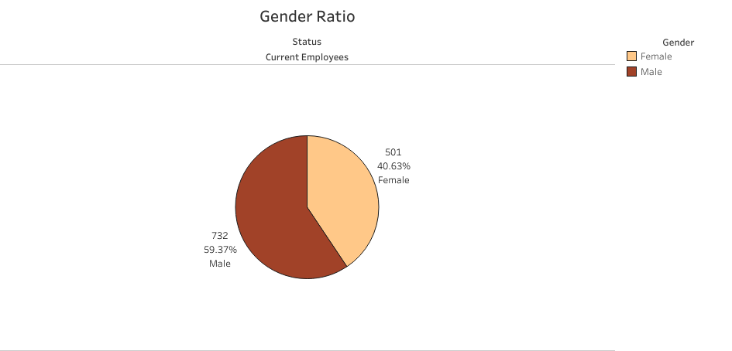

*Figure 1: Gender Ratio of Current Employees*

This predominantly male workforce composition can be a reflection of the underlying industry demographic trends or speculative bias in historical recruitment and promotional strategies. Understanding this dynamic is essential in forecasting inclusion and diversity targets during transition.

**Educational Attainment**

The majority of the employees hold undergraduate degrees (473 employees), followed by graduate degrees (340), associate degrees (238), high school diplomas (139), and some with doctorates (43).

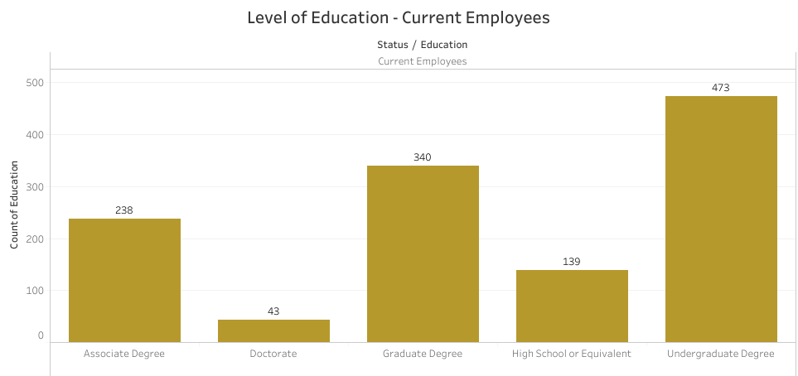

*Figure 2: Employee Education Levels*

This spread shows that the firm has a highly skilled workforce, which contributes to the value proposition. Such high levels of education are connected with flexibility, as well as specialized skillsets, which make it appealing to acquirers.

**Marital Status by Gender and Department**

When broken down by department, patterns start to show. In Human Resources, 28 are married, 21 are single, and 11 are divorced. Sales has 177 married, 100 single, and 77 divorced, and Research & Development (R&D) takes the lead with 384 married, 238 single, and 206 divorced.

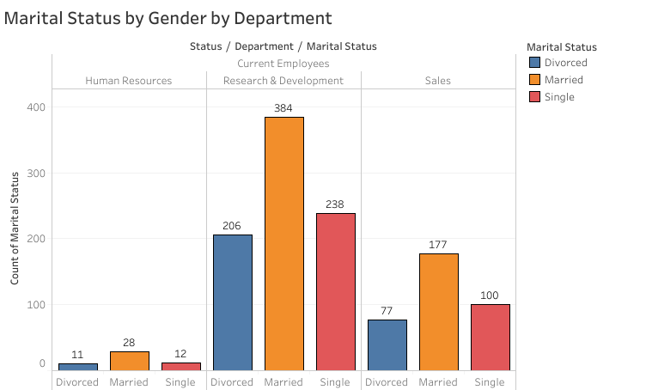

*Figure 3: Marital Status by Gender and Department*

Stress or travel-intensive departments can suffer more marital tension, resulting in increased divorce rates, most strikingly in R&D. This observation can assist in creating wellness and family support initiatives.

**Marital Status Among Current Employees**

Among current staff, 47.77% are married, 28.39% single, and 23.84% divorced.

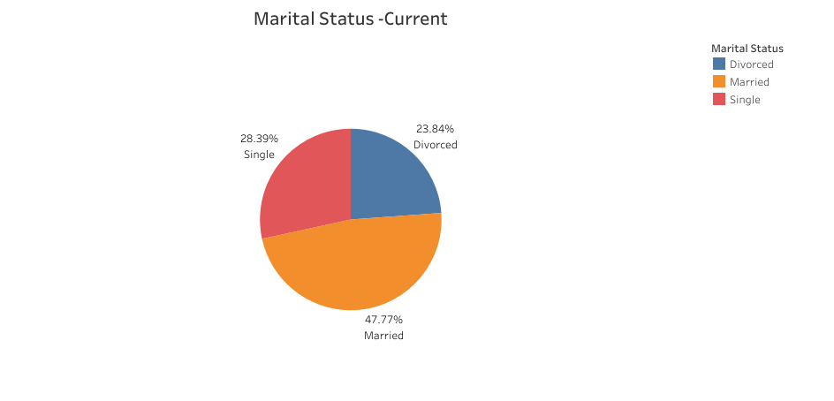

*Figure 4: Marital Status of Current Employees*

This relatively balanced distribution is an indication of life stage diversity among the workforce. It suggests the need for flexible policies to allow for varying family responsibilities, which can contribute to efforts at retention.

**Employee Attrition Analysis**

**Attrition by Business Travel Frequency**

Travel demands appear to impact turnover. Of former employees, 156 traveled rarely, 69 traveled regularly, and only 12 traveled never.

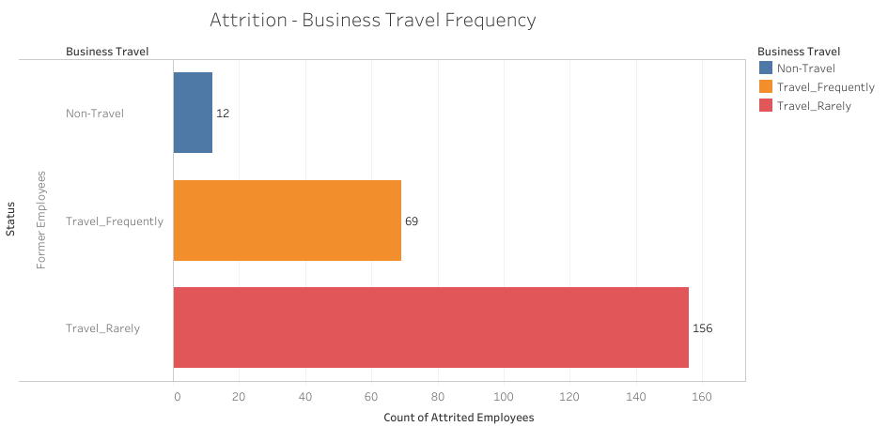

*Figure 5: Attrition by business travel frequency*

The data reveal that even regular travel can be a reason for employee turnover, maybe due to work-life conflict or inadequate travel support.

**Attrition by Work-Life Balance**

Looking at self-reported work-life balance scores of former employees reveals a strong pattern: 127 scored it a 3 (average), 58 scored it a 2 (below average), 27 scored it a 4 (above average), 25 scored it a 1 (poor).

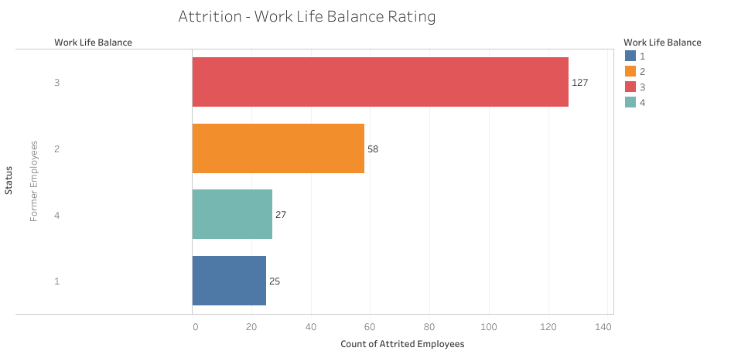

*Figure 6: Attrition by Work-Life Balance*

While most rated their balance as average, attrition remains high at all levels. This could be a perception vs. reality issue or other issues like compensation or culture.

**Job Roles with High Attrition**

The majority of attrition positions are: Laboratory Technician (62), Sales Executive (57), Research Scientist (47), and Sales Representative (33).

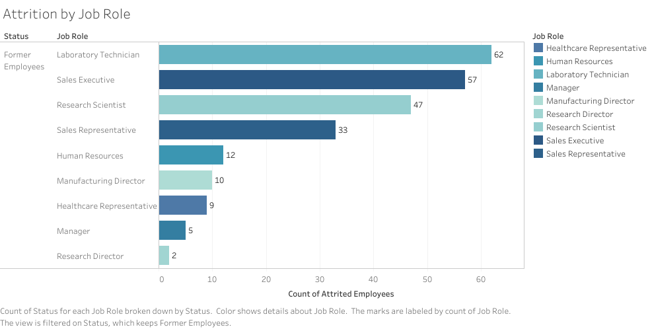

*Figure 7: Attrition by Job Role*

These positions could have less precise career advancement or high operational stress. Steep technical and customer-facing attrition suggests a need for greater professional development and assistance.

**Attrition by Department**

Departments having maximum attrition are: R&D (133), Sales (92), and HR (12).

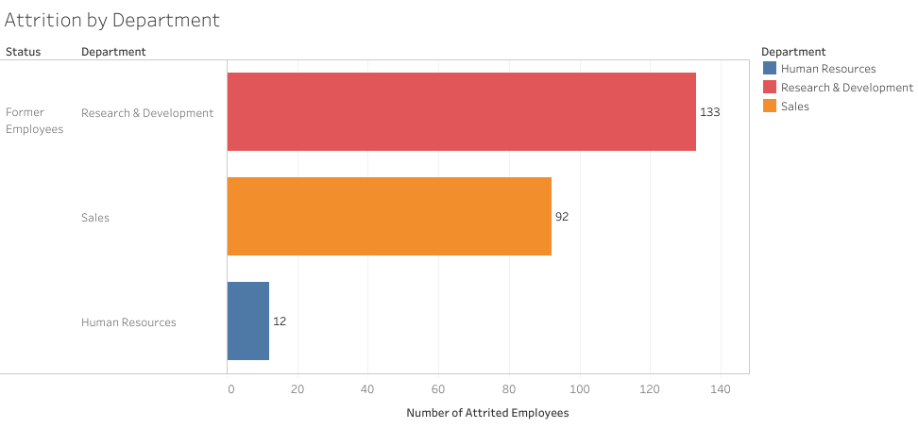

*Figure 8: Attrition by Department*

Attrition levels in R&D and Sales may reflect burnout of operations or unmet expectations. As a key function, R&D must be addressed to avoid loss of talent and IP.

**Attrition by Job Satisfaction**

Of the former employees, job satisfaction levels were: Satisfied: 30.8% (79 employees), Very Satisfied: 21.94% (52), Somewhat Satisfied: 19.41% (46), and Unsatisfied: 27.85% (66).

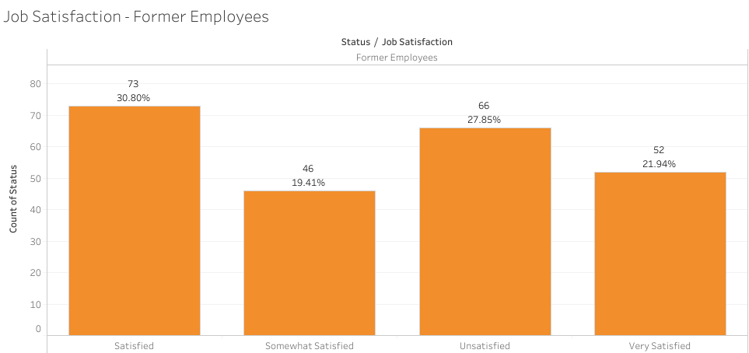

*Figure 9: Attrition by Job Satisfaction*

Even satisfied ones departed, so job satisfaction alone does not equal retention. Something else, like career growth, compensation, or work environment, was likely involved.

**Years at Company vs. Age of Former Employees**

The average length of service increases with age: 18 yrs: 0.75 yrs, 33 yrs: 5.97 yrs, and54 yrs: 8.67 yrs.

*Figure 10: Average Tenure by Age of Former Employees*

Younger employees exit earlier, possibly due to better alternative opportunities or unclear career possibilities. Greater tenure for later cohorts is a sign of loyalty or fewer alternative opportunities.