**BANASD602 Visual Analytics and Storytelling**

Name

Student ID

Email Address

Learning Facilitator

Submission date

**Assessment 3**

This assessment aims to data visualizations from the previous assessment based on the facilitator’s feedback. All the visualizations were modified as appropriate as highlighted below. For the first visualization of product categories that generate the highest revenues, we enhanced it by using a treemap instead of a bar chart. The opacity of the colors was reduced slightly and a border was added. This effectively enhanced how it looked and became clearer to the user as shown below:

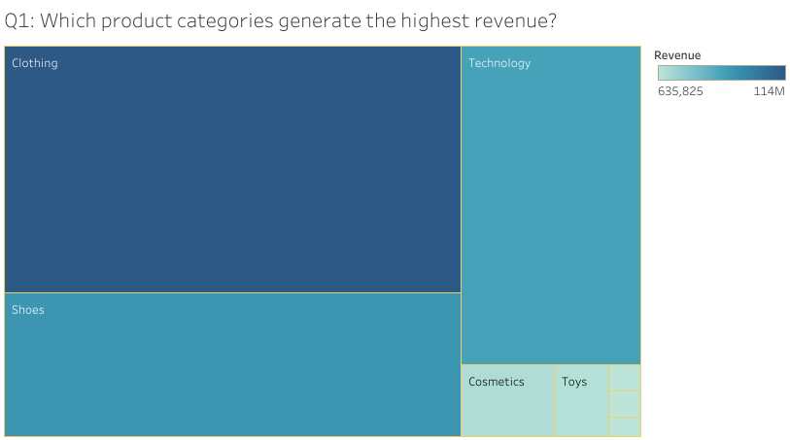

The second visualization seeks to compare how purchasing patterns differ across gender and age groups. Instead of a pie chart, I used a bar chart divided into two categories of male and female, with the bars representing age groups as shown below:

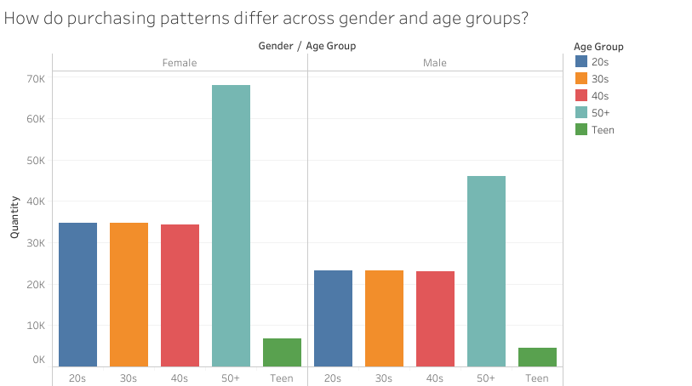

The next visualization sought to confirm whether there were seasonal fluctuations in sales volumes or customer footfall. This was previously represented using a bar chart. To enhance it, a bar chart and a line chart for revenue and invoice numbers were used across the months as shown below.

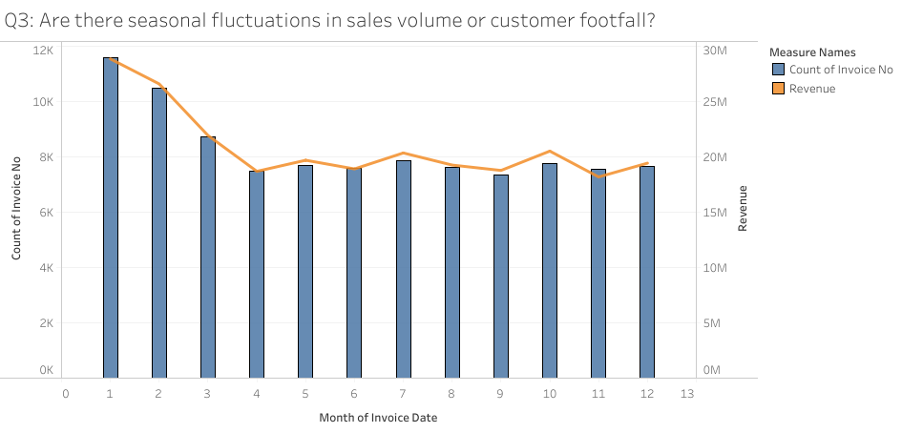

The fourth visualization sought to find out which payment methods were the most prevalent among different demographics. The previous visualization was a simple bar chart across genders. This was enhanced by using a vertical bar chart representing different age groups across both genders to capture more details as shown below:

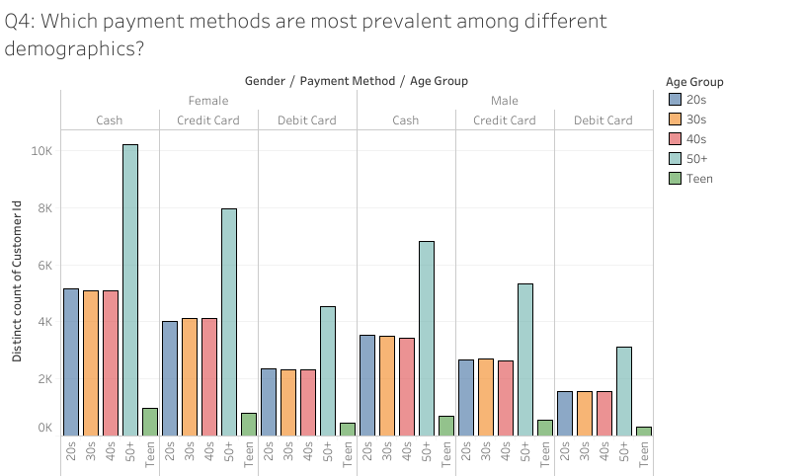

The final visualization sought to know which malls exhibit the strongest customer retention or loyalty. Previously, it was achieved using horizontal bar charts. To capture information and enhance it, we used horizontal bars to represent the total customer traffic for each mall as shown below:

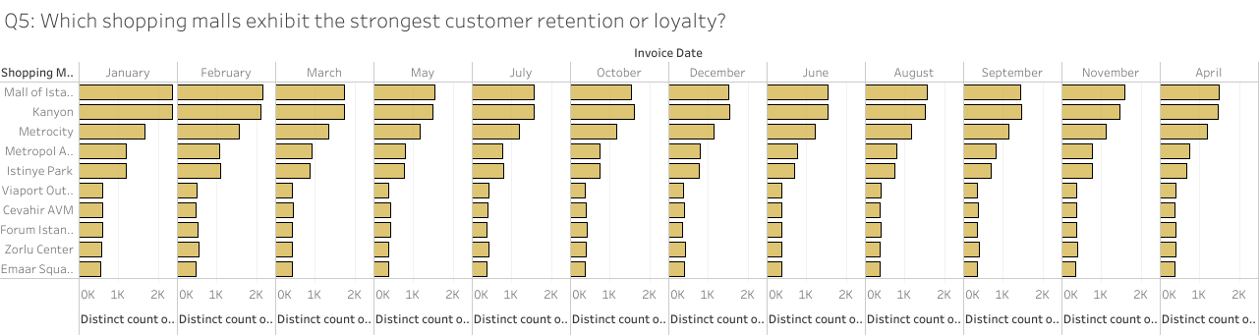

Finally, we created a dashboard that incorporates principles of data storytelling, with relevant filters and interactive elements and adhering to professional design principles as shown below.

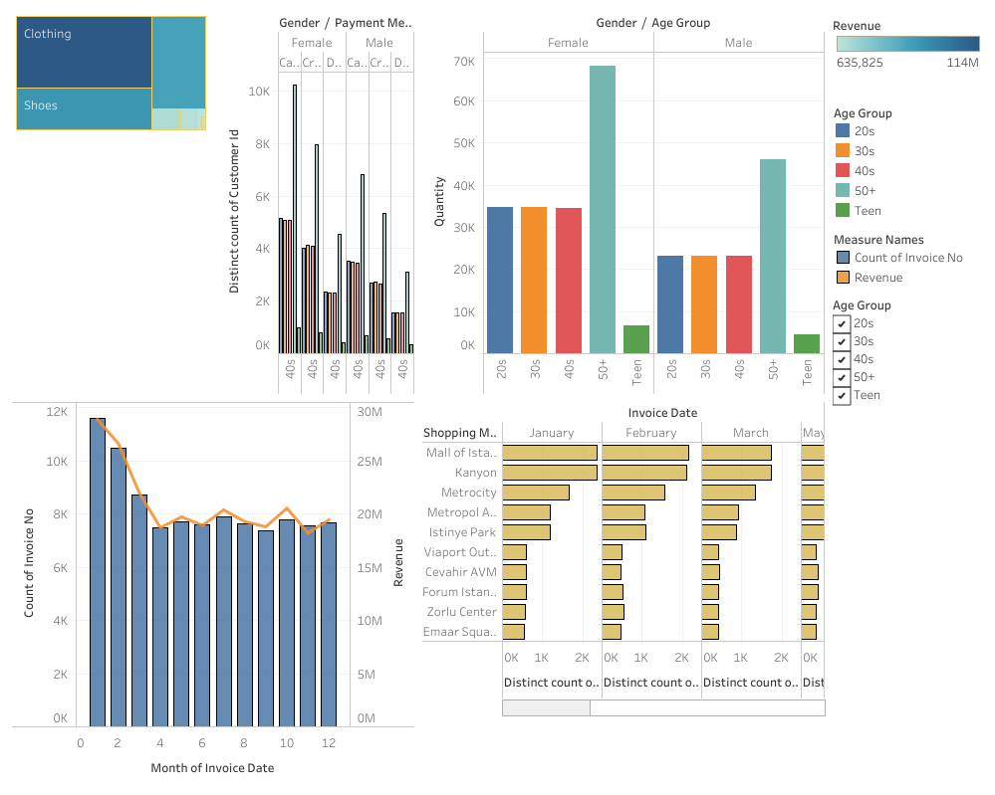

**References**

*Customer shopping dataset - Retail sales data*. (n.d.). Kaggle: Your Machine Learning and Data Science Community. Retrieved March 3, 2025, from <https://www.kaggle.com/datasets/mehmettahiraslan/customer-shopping-dataset?resource=download>

Banachewicz, K., & Massaron, L. (2022). *The Kaggle Book: Data analysis and machine learning for competitive data science*. Packt Publishing Ltd.