**HCUP Data Analysis Assignment**

Student Name

Date

**HCUP Data Analysis Assignment**

1. **Explore the Inpatient Database (Tuberculosis)**

Determine which year has the largest number of discharges and visualize the trend. The screenshot below shows a section of the downloaded data:

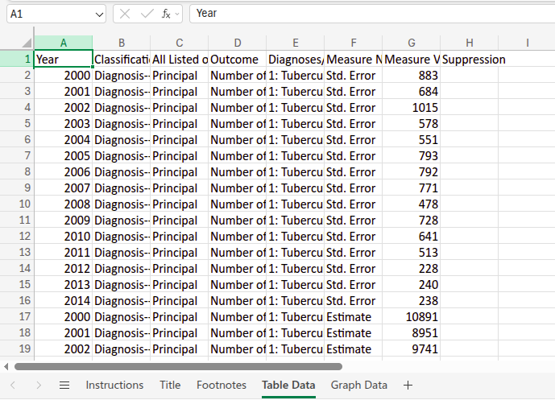

Next, we create a graph to show the overall data trend.

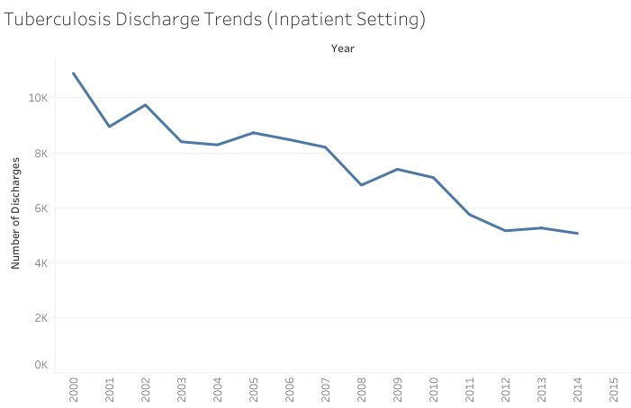

The year 2000 had the largest number of discharges at 10891 discharges.

1. **Explore the Emergency Department (ED) Database**

Compare three categories of ED visits. Below is a section of the data:

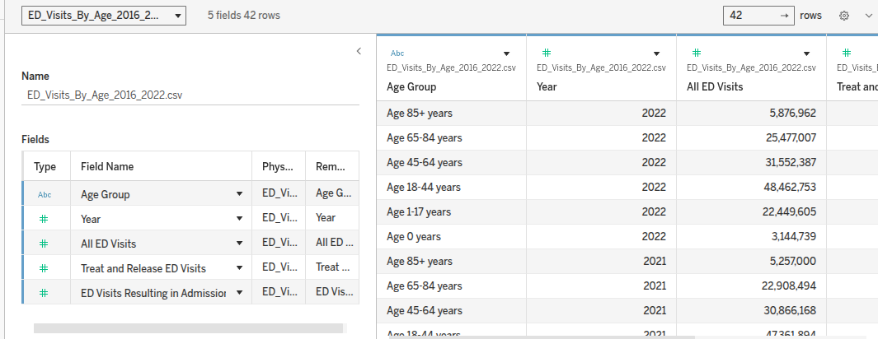

The comparative data display is:

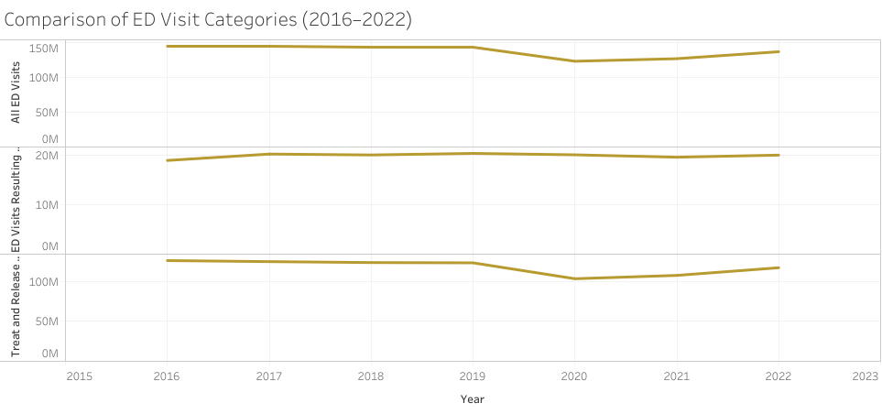

This graph shows that All ED Visits are consistently the highest, with Treat and Release following closely. Admissions make up the smallest share but still show stable patterns across the years.

1. **Explore the Community Inpatient Database (PQIs)**

This task aims to analyze trends in quality indicators and highlight one. Trends Identified:

* PQIs generally fluctuate year to year.
* Some indicators show improvement, while others worsen.
* Pediatric PQIs are consistently lower than adult PQIs.

The download data is as shown:

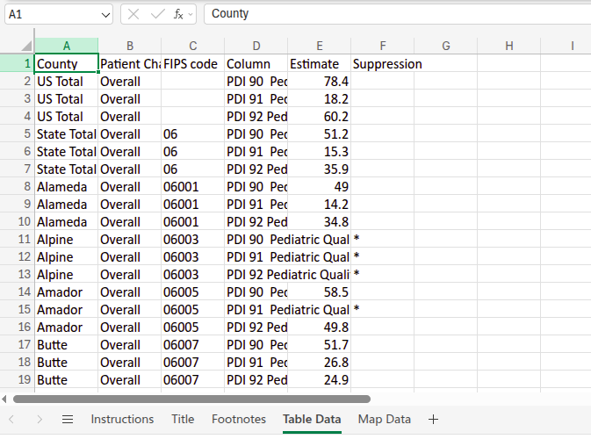

The implemented graph is as shown below:

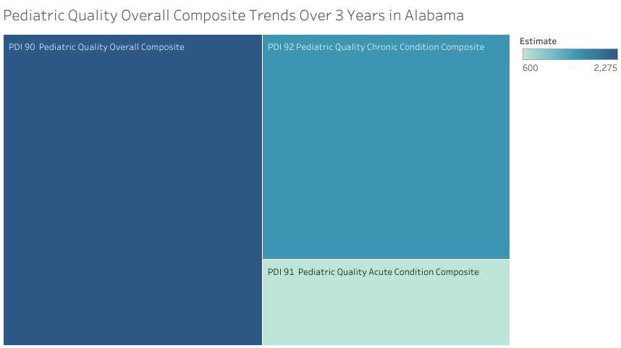

1. **Explore the Readmissions Database**

Determine which payer type has the highest readmission costs. The downloaded data is as shown below:

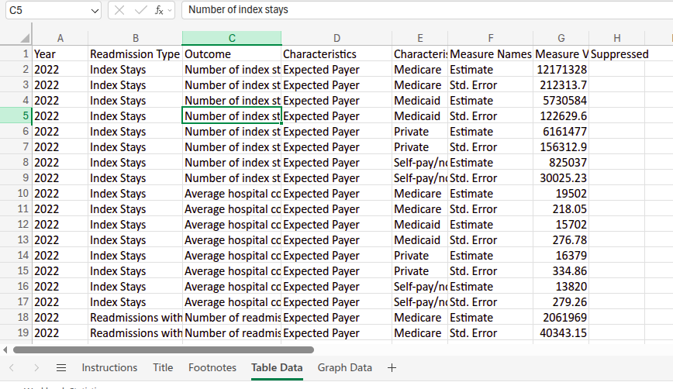

The visualized chart is as shown below:

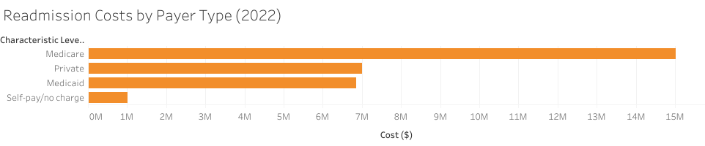

The pay type with the highest cost of readmissions is Medicare.

1. **Analyze and Evaluate**

Two graphs were selected for comparison: ED Visits by Category (Line Graph) and Readmissions by Payer (Bar Chart). Both of these graphs provide significant insight into several aspects of healthcare utilization and cost.

Similarities

Both charts allow for visualization of healthcare utilization, either over time or by category. Both show differences between groups, such as differences in ED use by service type and differences in readmission costs by payer type.

Differences

The ED Visits chart highlights service types and patient volume across multiple years, showing trends year-over-year. The Readmissions chart is a point-in-time snapshot of expenditure by type of payer, with a focus on fiscal impact rather than time trends.

Use in Health Information and Informatics Management (HIIM)

These graphs are useful tools in HIIM for monitoring service demand and identifying trends that inform capacity planning. They also assist in financial decision-making by highlighting higher costs or utilization areas.

Credibility of Data Source

The data was gathered from HCUPnet, a credible source developed by the Agency for Healthcare Research and Quality (AHRQ). As a U.S. government-operated database, it offers accurate, peer-reviewed health information for sound decision-making.