**Lab 6_1 Excel Submission**

Student Name

Date

**Lab 6_1 Excel Submission**

**Submission 1**

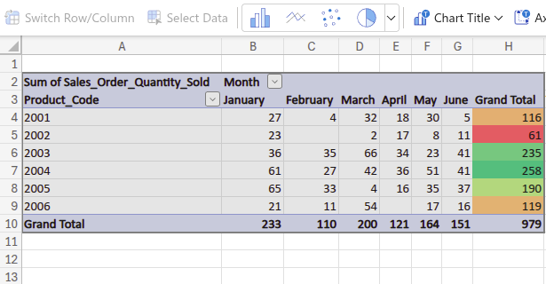

**Submission 2**

