**Lab 6.3 Tableau: Descriptive Analytics**

Student Name

Date

**Analyzing Sales Revenue by Customer**

**Submission 1**

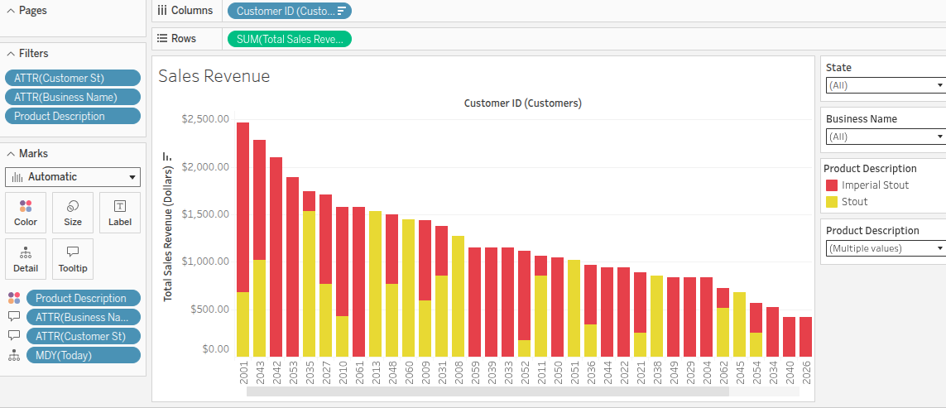

**Submission 2**

