**Lab 6.4 Excel: Descriptive Analytics**

Student Name

Date

**Creating a Dashboard Using Pivot Tables and Slicers**

Pivot Table 1: Total Cases Sold per Beer (Bar Chart)

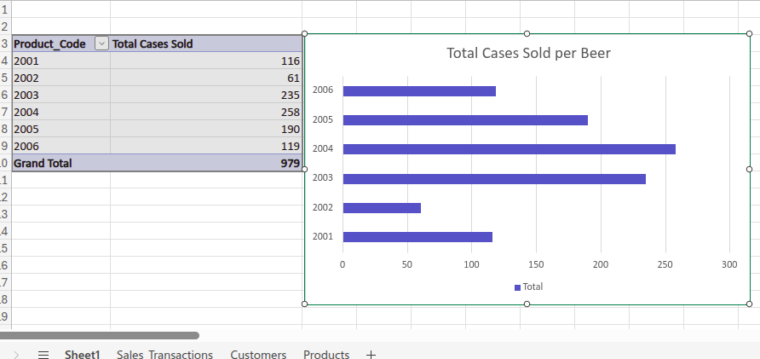

Pivot Table 2: Count of Sales Orders per Beer (Bar Chart)

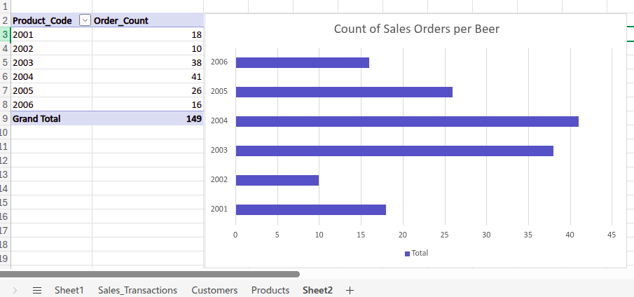

Pivot Table 3: Total Cases + Sales Count over Time (Line Chart)

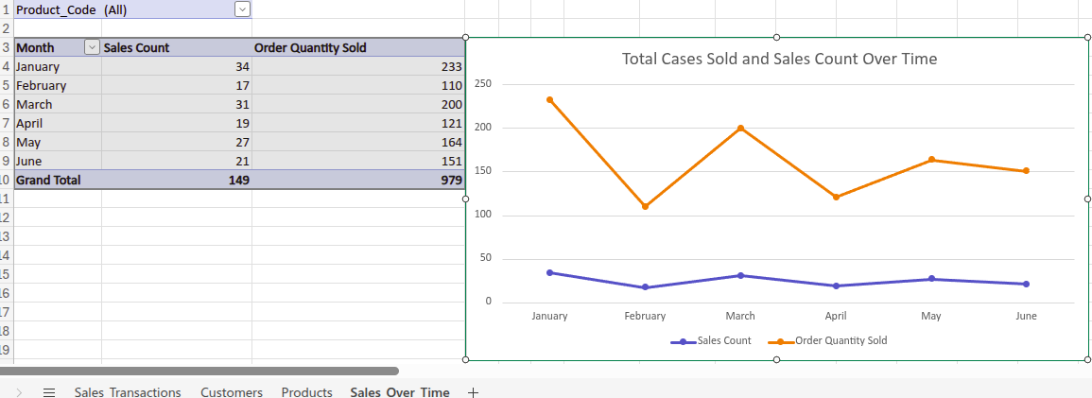

Dashboard-Level Slicer: Customer State

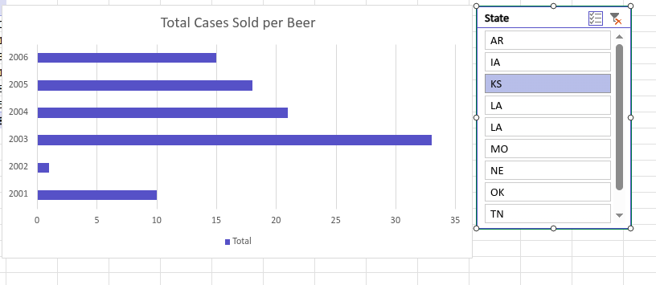

Report-Level Slicer: Filter Beer for Line Chart

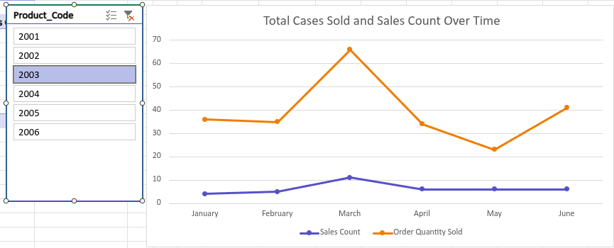

Final DashBoard

