**Lab 6.5 Tableau: Descriptive Analytics**

Student Name

Date

**Descriptive Analytics**

**Submission 1**

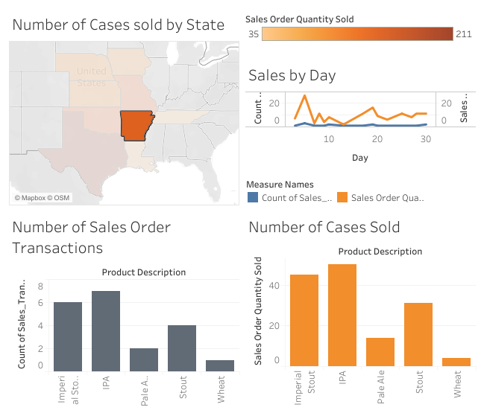

**Submission 2**

