**Methodology**

**Student Name**

**Date**

**Methodology Section**

**Participants**

The sample included 50 undergraduate students (25 female, 25 male) recruited from a large public university through the university research participation system. The inclusion criteria were that participants were between the ages of 18 and 30 years and frequent users of at least one messaging app (i.e., WhatsApp, Instagram, or iMessage). Participants received course credit in exchange for their participation. Informed consent was provided by all participants prior to participating in the study.

**Measures**

Intellectual Curiosity

Participants completed the Need for Cognition Scale (Cacioppo, Petty, & Kao, 1984), a well-validated self-report instrument aimed at assessing the intellectual curiosity facet of openness to experience. The scale consists of 18 items (e.g., "I would rather complex than simple problems," "I like tasks that require me to think creatively about solving problems") rated on a 5-point Likert scale ranging from 1 (strongly disagree) to 5 (strongly agree). Scores were summed to yield a total intellectual curiosity score, with higher scores reflecting greater curiosity. Participants were divided into two equal groups (n = 25 each) via a median split procedure after scoring: a low intellectual curiosity group and a high intellectual curiosity group. Sample items of the scale and full scoring instructions are included in Appendix A.

Emoji Use

Emoji use was assessed by analyzing written text responses of subjects to a simulated chat task. Subjects had to reply to a series of emotionally varied prompts (e.g., "Your friend tells you that they flunked a big exam," "You just got a new job offer") designed to draw out naturalistic language use. Responses were typed into a chat-style window designed to look like commonly used messaging apps. The total number of emojis used across all prompts was counted by hand by blind-trained coders. The frequency of emoji use was the dependent variable for this study. Prompt information and sample answers are included in Appendix B.

**Procedure**

Participants gave informed consent and then finished the intellectual curiosity questionnaire online through Qualtrics. They were then sorted into the high and low intellectual curiosity groups according to their scores as described above. The participants were then led to the simulated chat interface where they carried out the emoji use task. The entire process was completed in about 30 minutes. Demographic data (e.g., age, gender, daily emoji usage) were also collected for descriptive purposes, though these variables were not factored into the primary analysis.

**Design**

The experiment employed a between-subjects experimental design, with intellectual curiosity (high vs. low) as the independent variable and the number of emojis used during the simulated chat task as the dependent variable.

**Results**

Descriptive Statistics

Individuals in the low intellectual curiosity group (n = 25) used significantly more emojis (M = 230.72, SD = 86.24) than those in the high intellectual curiosity group (M = 163.44, SD = 65.98). This reveals a significant between-group difference in emoji use as a function of intellectual curiosity levels.

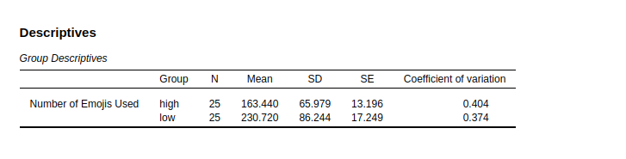

*Figure 1: Descriptive statistics*

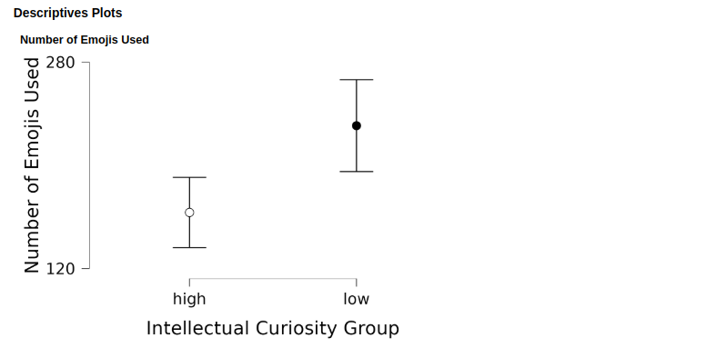

*Figure 2: Descriptive plots*

Assumption Checks

Shapiro-Wilk tests showed that the assumption of normality was met for the residuals of emoji use (W = 0.975, p =.360), meaning that the distribution of scores did not significantly deviate from normal. The Brown-Forsythe test showed that the variances between groups were equal (F(1, 48) = 1.370, p =.248), satisfying the assumption of homogeneity of variance.

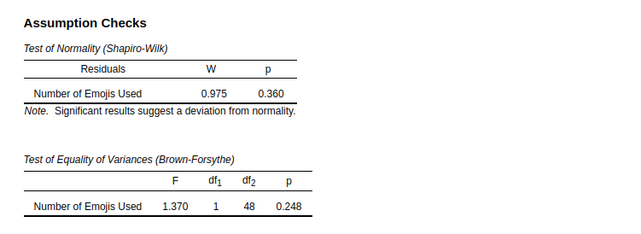

*Figure 3: Assumption checks*

Inferential Statistics

An independent samples t-test revealed that there was a significant difference in the use of emojis between the high and low intellectual curiosity groups: t(48) = -3.10, p =.003, Cohen's d = -0.88.

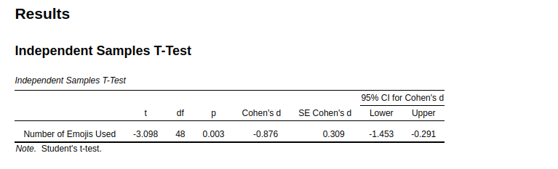

*Figure 4: t-Test results*

This is a large effect size, indicating that the groups not only differed in a statistically significant manner but also in a practically significant way. The 95% confidence interval for Cohen's d was between -1.45 and -0.29, providing further evidence for a consistent group difference.