

**Abstract**

This report outlines an experimental method to approximate the Young's modulus of a metal ruler through its vibration response. The motivation was to explore digital signal acquisition and frequency analysis for the structural characterization of low-resource environments. A Raspberry Pi Pico microcontroller and a microphone circuit were used to acquire vibration signals of a cantilevered ruler that was excited at varying overhang lengths. Zero-crossing detection was used to estimate the frequency of oscillation by a Python analysis pipeline. These frequencies were converted to Young's modulus values using beam vibration theory. While the modulus values measured had a wide range (528–1697 GPa) and deviated from the expected value for steel (~200 GPa), the trend confirmed theoretical expectations with a reducing frequency for increasing overhang. The experiment highlighted the feasibility of digital data acquisition and dynamic material property estimation using minimal electronics, though results were conditional on experimental setup and signal quality.

# Introduction

Understanding material mechanical properties is fundamental to engineering analysis and design. Of these properties, Young's modulus is very important in the assessment of how materials deform upon stress. Tensile testing machines and strain gauges are the equipment usually employed to determine Young's modulus, the conventional way, but this equipment may be unavailable in times of emergency or remoteness (Callister and Rethwisch, 2020).

In such a situation, the engineers should be able to measure material properties with makeshift equipment. This experiment solves the problem by replicating a field-based investigation, which is feasible given the limited electronics and computing resources. The experiment makes use of digital signal acquisition to find the Young's modulus of a metal ruler by observing its vibration response when the metal ruler is clamped in a cantilever arrangement. This method uses an inexpensive Raspberry Pi microcontroller and a microphone-based circuit to capture time-varying signals created when the ruler is hit (Raspberry Pi Foundation, 2021). The signals are then processed using Python to gain the vibration frequency using the beam theory equation.

The primary aim of this experiment is to investigate whether accurate estimates of Young's modulus can be achieved by using a zero-crossing frequency analysis technique on digital audio signals. It also seeks to assess the constraints of low-cost data acquisition systems as well as the sensitivity of the approach to experimental conditions such as geometry, damping, and sampling rate.

# Methods

This experiment focused on estimating the Young's modulus of a metal ruler by examining its vibration frequency using digital signal acquisition. The experiment consisted of setting the ruler as a cantilever beam clamped between a hardback book and the desk edge with free overhangs of 100 mm, 120 mm, and 140 mm. A circuit of a microphone was created using an electret condenser microphone and an amplifier to amplify the acoustic signal produced when the ruler was deflected and then released. The circuit output was connected to the ADC (Analog-to-Digital Converter) input of the Pi microcontroller, which recorded the signal at 5 kHz.

Data collection was carried out from a pre-written script loaded into the Pico using the Thonny IDE. For each trial, the vibration sound of the ruler was recorded and stored as CSV with relative file paths. At least one separate recording per overhang length was retained for analysis, chosen based on the audibility and prominence of the acoustic impulse. The Pico captured the analog signal for approximately one to two seconds after releasing the ruler.

Signal processing was performed with a custom Python script executed on a Jupyter Notebook. The script imported each raw signal CSV file and made a time-domain plot to identify the region of the decaying oscillation. A cropped part of the signal was isolated to reduce the impact of background noise. The mean of the cropped waveform was subtracted to remove any DC offset and center the signal around zero (Smith, 2017). The zero-crossing detection method was employed to calculate the number of times the waveform passed over the baseline, and the overall number of crossings was used to calculate the fundamental frequency using the formula $f=\frac{N}{2T}$. In this case, $N$ represents the number of zero crossings, and $T$ represents the time duration of the cropped signal.

The Young’s modulus was estimated through the relationship for a vibrating cantilever beam:

$E={(\frac{f}{0.56})}^{2}⋅\frac{{qL}^{4}}{I}$

$f$ is the estimated frequency, $L$ is the overhang length, $q$ presents mass per unit length ($ρbh$), and $I$ is the second moment of area ($\frac{{bh}^{3}}{12}$). The ruler’s width $b$ and thickness $h$ were 0.025 m and 0.001 m, respectively, and the material density $ρ$ was taken as 7850 kg/m³ (typical for steel). All constants and geometry were defined in SI units to ensure dimensional consistency.

Crucial results of the analysis included time-history plots of the cropped and original signals with superimposed zero-crossing markers. The plots were also saved as PNG files for subsequent inclusion in the report. In addition, the script also outputs the calculated Young's modulus and frequency for each trial to the console for direct comparison across the beam lengths.

# Results

The experiment provided acoustic signal recordings for overhang lengths of 100, 120, and 140 mm. The signal was successfully recorded in each instance with the Pi and processed to determine the frequency. The raw time-domain signals showed an initial high-amplitude impulse followed by exponentially decaying oscillations, characteristic of a damped cantilever vibration. Table 1 summarizes the measured and computed values for each length.

**Table 1: Summary of Experimental Results**

| **Overhang Length (m)** | **Zero Crossings** | **Frequency (Hz)** | **Young’s Modulus (GPa)** |
| --- | --- | --- | --- |
| 0.10 | 106 | 132.57 | 527.89 |
| 0.12 | 133 | 165.08 | 1697.47 |
| 0.14 | 90 | 112.56 | 1461.93 |

Figure 1 and Figure 2 plot the whole time history as well as the cropped signal with identified zero-crossings for the 100 mm case. Similarly, Figures 3–6 show the corresponding plots for overhangs of lengths 120 mm and 140 mm.

Figure 1: Full-time history for 100 mm overhang

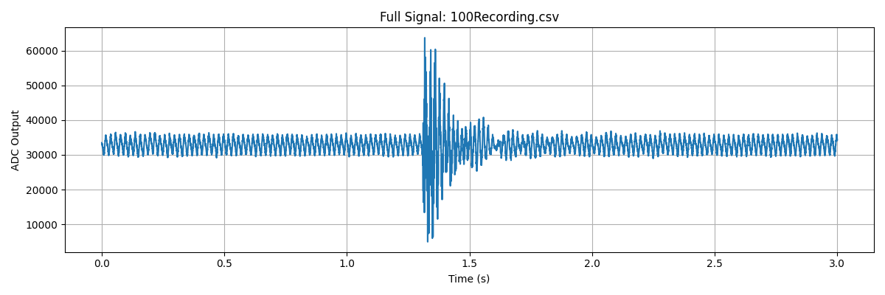

Figure 2: Cropped signal for 100 mm

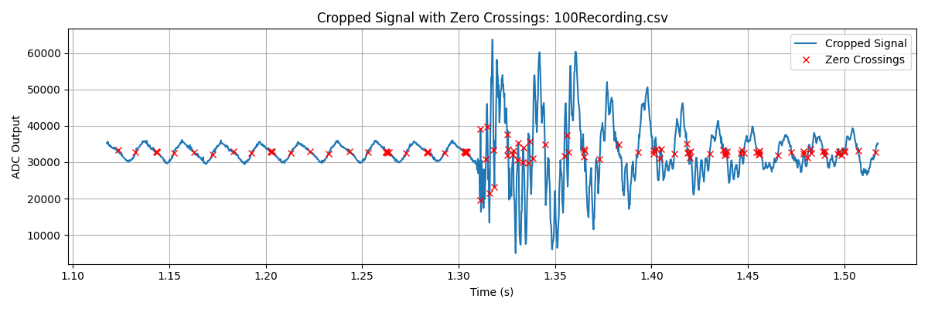

Figure 3: Full-time history for 120 mm overhang

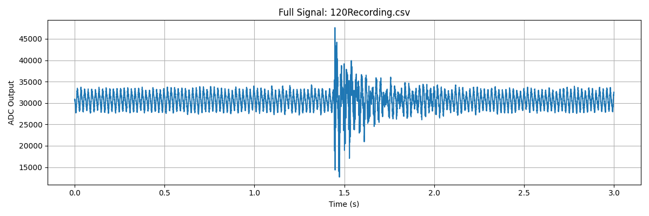

Figure 4: Cropped signal for 120 mm

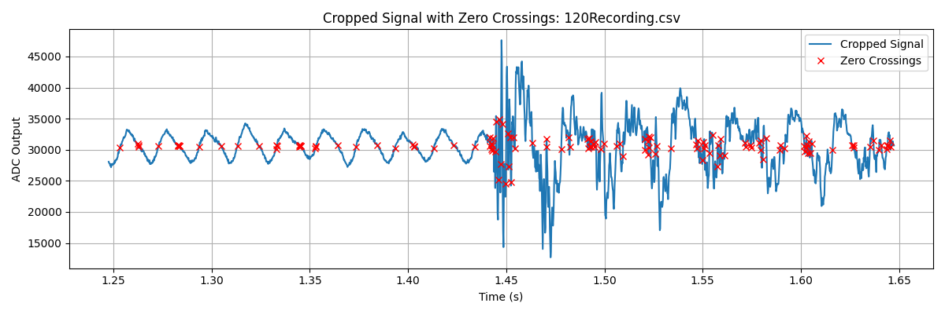

Figure 5: Full-time history for 140 mm overhang

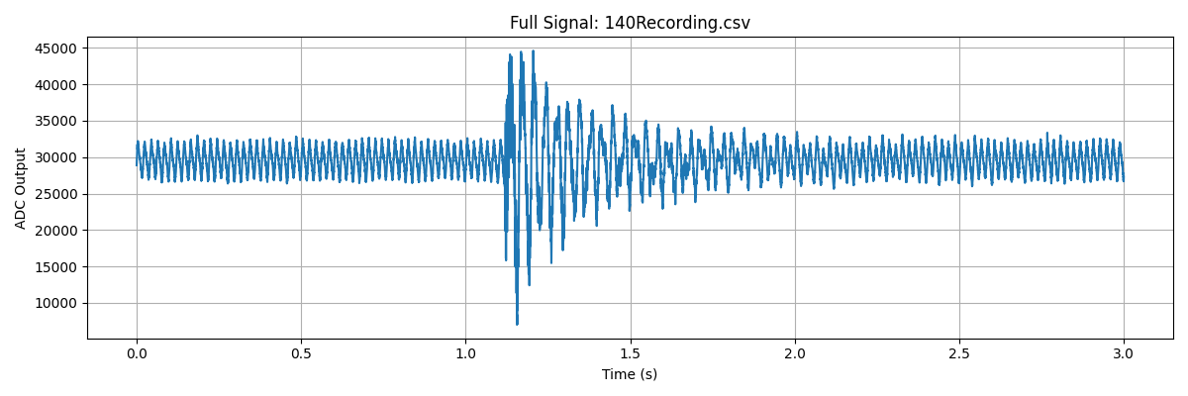

Figure 6: Cropped signal for 140 mm

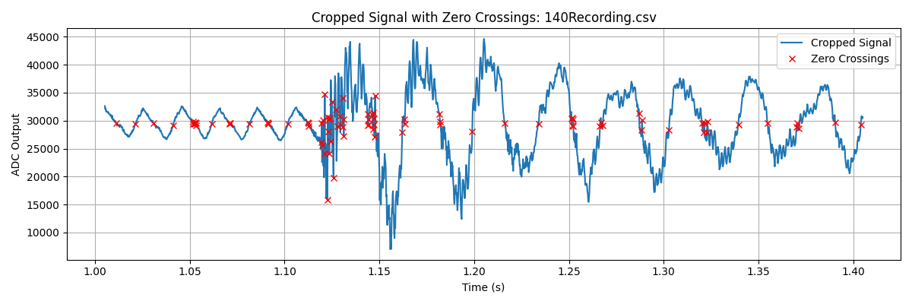

# Discussion

The results confirmed that the frequency of a cantilever beam decreases as the overhang length increases, as also predicted in classical vibration theory. The inverse nature of this relationship supported the use of the zero-crossing method in frequency estimation. It confirms that the equipment was capable of determining dynamic behavior from the metal ruler. The outcomes produced a satisfactory qualitative trend, but the Young's modulus values calculated, around 528 GPa to greater than 1690 GPa, were far above the expected theoretical value of steel around 200 GPa. This disparity points out some of the experimental design and signal processing issues that most likely resulted in overestimation (Bellanger, 2024).

A likely source of the error was when acquiring the signal. The microphone circuit may have introduced noise or distortion, particularly from external environmental noise or from imperfect breadboard connections. Aside from this, the low-cost analog-to-digital conversion of the Raspberry Pi Pico and the 5 kHz sampling rate employed might not have provided such a high resolution to locate zero-crossings as precisely, especially in sections of the signal that have very low amplitude or steep decay. The application of manual cropping and ruler vibration activation also produced human variability and timing anomalies.

Another significant source of imprecision was in the physical measurements on which Young's modulus calculations were founded. Minor errors in measuring beam thickness $h$ or overhang length $L$, can lead to large errors in both $I$ and $L^{4}$, respectively, both of which have a strong influence on the final modulus calculation. The second moment of area $I=\frac{{bh}^{3}}{12}$ is particularly sensitive to $h$, and even a small deviation (e.g., ±0.1 mm) creates drastic changes in calculated stiffness. Moreover, the ideal cantilever behavior and ideal clamping assumption failed in practice, as the ruler was clamped between the desk edge and the book, which introduced compliance and energy loss not accounted for in the theoretical model.

Despite these issues, the experiment was able to demonstrate the potential of exploiting digital signal acquisition and minimal processing techniques to measure material properties. The overall trend of the data indicates that it is possible to make the system measure relative changes in mechanical behavior, but measurements of the absolute modulus might be erroneous. Future improvements that are possible include having a stiffer and reproducible clamping device, the inclusion of a digital filter to remove noise within the signal, increasing the sampling rate, and carrying out each test several times to obtain averaged responses. Automating the cropping and thresholding process and standardization processes, as well as reducing subjectivity, can also be realized.

Finally, while the experimental method held great promise in outlining important trends, several practical shortcomings in signal quality, accuracy of measurement, and the assumptions in theory introduced significant error into the modulus calculations.

# Conclusion

This study efficiently validated a cheaper method that can be used to estimate the Young's modulus of a metal ruler by using signal acquisition and vibration analysis. With sound signals from vibrating cantilever beams recorded and submitted to zero-crossing analysis, modal frequencies were estimated and applied in modulus calculation. While absolute values obtained were much greater than anticipated, the experiment demonstrated that natural frequency is reduced with greater overhang length, in agreement with predictions. The apparatus was effective in demonstrating important concepts of dynamics, although refinement in clamping, signal filtering, and precision measurements is suggested for better results in future experiments.

**References**

Bellanger, M. (2024). Digital signal processing : theory and practice (; B. A. Engel, Trans.; Tenth edition). John Wiley & Sons, Inc. <https://doi.org/10.1002/9781394182695>

Callister, W.D. and Rethwisch, D.G., 2020. *Materials Science and Engineering: An Introduction*. 10th ed. Hoboken: Wiley.

Available at: <https://www.wiley.com/en-us/Materials+Science+and+Engineering:+An+Introduction,+10th+Edition-p-9781119405498>

Smith, S.W., 2017. T*he Scientist and Engineer's Guide to Digital Signal Processing.* California Technical Publishing.

Available at: <https://www.dspguide.com/>

Raspberry Pi Foundation, 2021. *Get Started with MicroPython on Raspberry Pi Pico*. Raspberry Pi Press.

Describes how to program the Pico and access ADC for signal acquisition.

Available at: <https://magazine.raspberrypi.com/books/micropython-pico>