**Tugas Kelas dan Objek**

**Pertemuan 5**

**Pemrograman Basis Objek**

Nama : Fawwas Nawwaf Sabil

NRP : 223040114

Kelas : B

Link commit git hub

[https://github.com/FawwasSabil25/PBO_223040114/commit/0a603938304d0702a088015e0b2cdc9070 bc6f28](https://github.com/FawwasSabil25/PBO_223040114/commit/0a603938304d0702a088015e0b2cdc9070bc6f28)

Latihan 1

Gelas.java

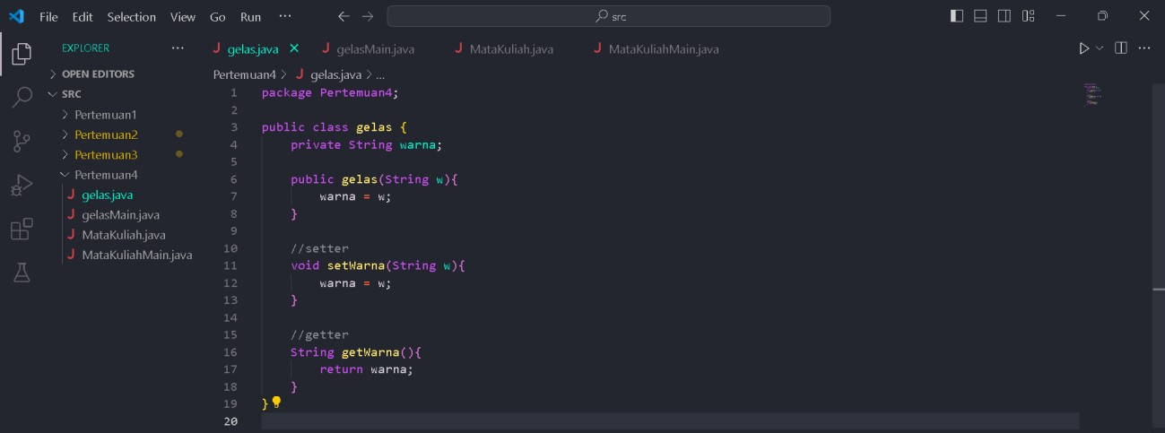

gelasMain.java

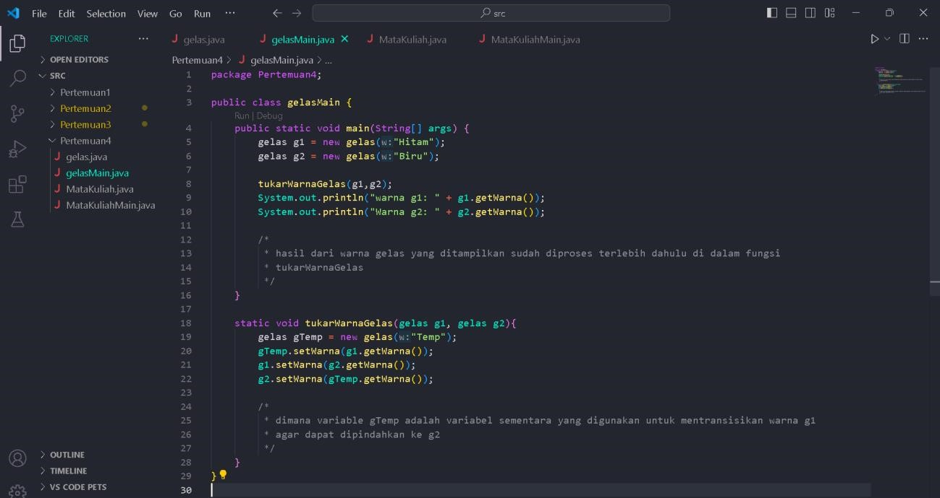

Output :

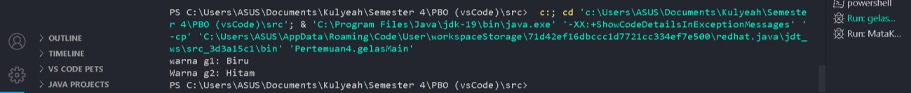

Latihan 2 sekaligus 3

(sudah dilengkapi fungsi nilaiIndex dan hitungIPK)

MataKuliah.java

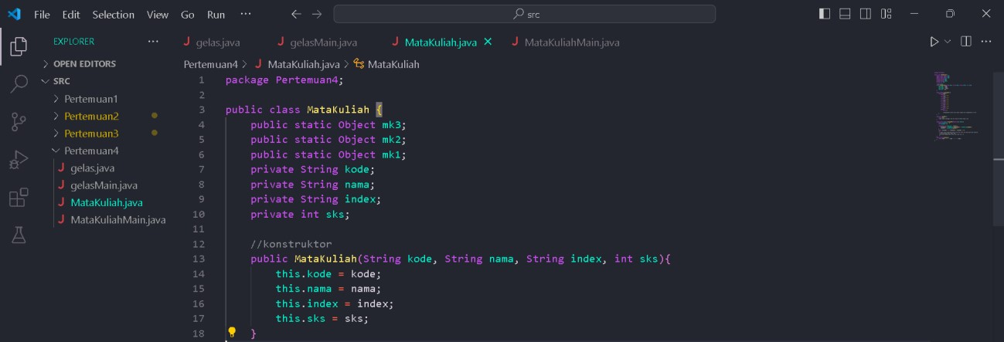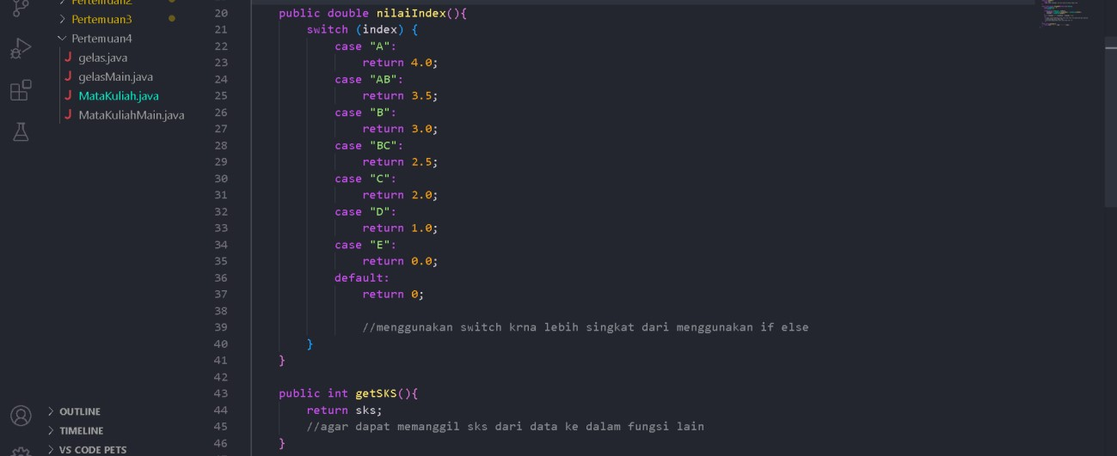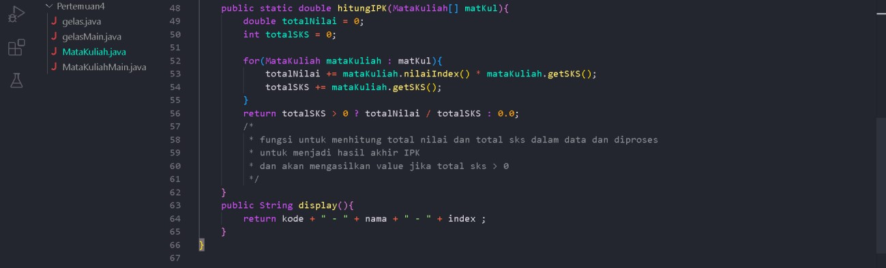

MataKuliahMain.java

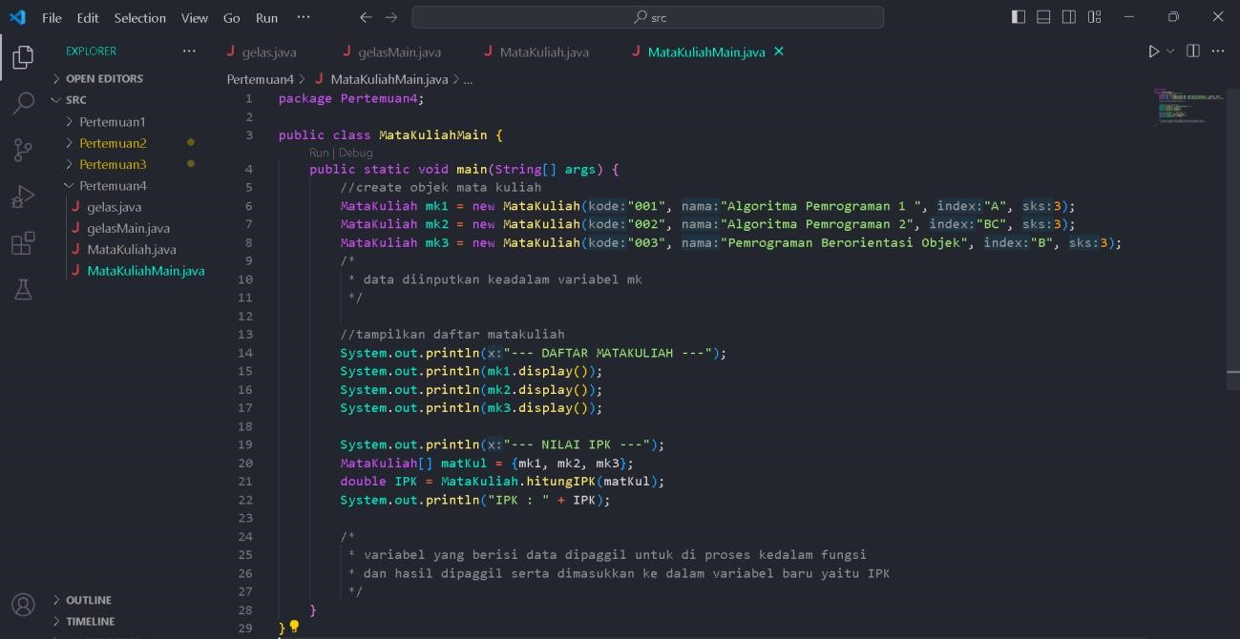

Output

