National University of Computer and Emerging Sciences

Lab Manual

Computer Organization and Assembly Language



Lab 10

|  |  |
| --- | --- |
| **Instructor** | Hazoor Ahmad/ Rida Mehmood |
| **Class** | CS3 |
| **Semester** | Fall 2022 |

Fast School of Computing

FAST-NU, Lahore, Pakistan

# Objectives

* Subroutines
* Display Memory
* String Instructions

**Contents**

Objectives 2

ACTIVITY 1: [50 Marks] 2

ACTIVITY 2: [50 Marks] 2

REFERENCES 4

**Note for all questions**: You can make as many memory variables, subroutines as you need. Must read all the manual before starting.

## ACTIVITY 1: [50 Marks]

Write a program that prints and prints the following messages: one message per keypress.

'msg1: Hi! I am YourName.'

'msg2: I am YourMode(Happy, Sad, etc).'

'msg3: I Study at FAST.'

'msg4: My Roll No is YourRoll#.'

Expected output after 4 key presses

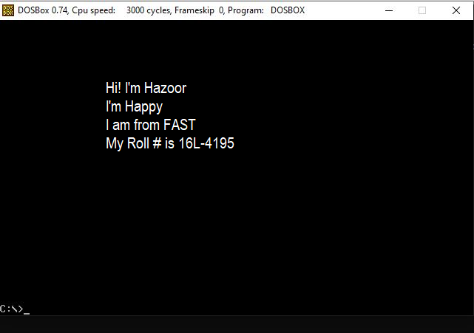

## ACTIVITY 2: [50 Marks]

[org 0x0100]

jmp code

w equ 70 ; width offset

x equ 50 ; starting x coordinate of line

y equ 100 ; starting y coordinate of line

c equ 60 ; color

code: mov ah, 0

mov al, 13h

int 10h

; draw diagonal 11:

mov cx, x

mov dx, y

mov al, c

u1: inc dx

mov ah, 0ch ; put pixel

int 10h

inc cx

cmp cx, x+w

jbe u1

;wait for keypress

mov ah,00

int 16h

mov ax, 0x4c00

int 21h

**Given**:

Start with given $(x,y) = (50,100)$ and in every loop iteration increment both Cx and Dx to reach $(x+w, y+w) = (120,170)$.

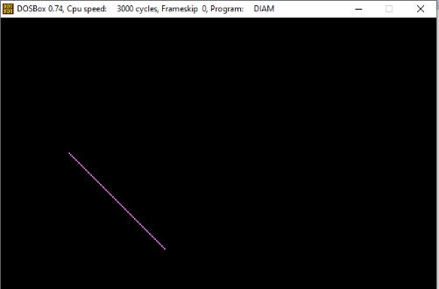 $⇔$ 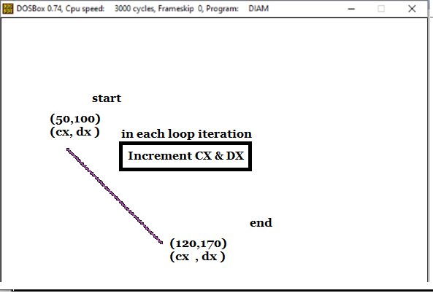

**Required**:

Similarly, you need to draw 4 lines as above satisfying the coordinates and increment or decrement as per requirement of the line as shown below.

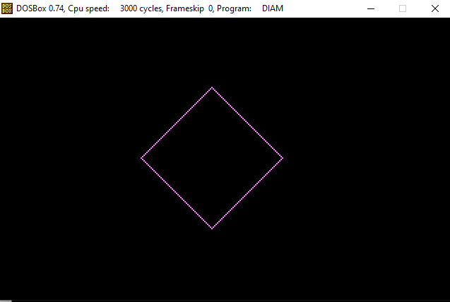 $⇔$ 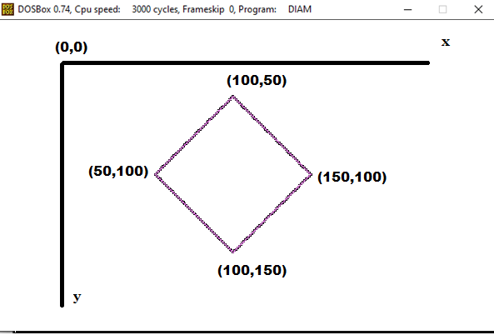

## REFERENCES

1. <https://www.youtube.com/watch?v=ylmCcDf3Oek>
2. http://www.dosbox.com/download.php?main=1
3. <http://sourceforge.net/projects/nasm>
4. <http://www.nasm.us/>
5. [http://www.programmersheaven.com/download/21643/download.aspx (AFD)](http://www.programmersheaven.com/download/21643/download.aspx)