# Compilation Instructions:

The instructions below should help you to compile the digital inking program.

## Installation requirements:

Run the following command to install all dependencies:

**pip install -r requirements.txt**

## Run Compilation Commands:

1. First run this command:

**pyinstaller --paths="path-to-your-site-packages\cv2" inking-gui.py**

1. You’ll see some new files and folders have been created in the directory. We are only interested in the inking-gui.spec file here:
   1. Open this file in a text editor
   2. Add these lines of code above block-cipher=None

* 1. 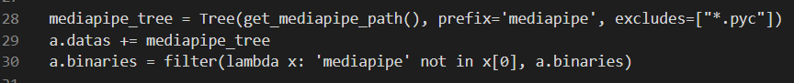Add the following lines of code after the pyz section:

1. Finally, run this command:

**pipenv run pyinstaller --debug=all inking-gui.spec --windowed --onefile**

## Results:

You should now see a dist folder in the root directory. Opening this will lead to another folder called “inking-gui” which contains the compiled project with all necessary files and folders, including the main executable file (.exe).