**Pressure Detector Project Report**

**Mastering Embedded System Online Diploma**

[**www.learn-in-depth.com**](http://www.learn-in-depth.com)

**First Term (Final Project 1)**

**Eng. Fawzy Mohamed Zaki**

**My Profile:**

**www.learn-in-depth.com/onlinediploma/fawzyking936%40gmail.com**

1)Case Study

-Assumptions :

1-The pressure Sensor will never fail

2-The alarm (led) will never fail

3-There MCU will always supplied with power

2) Method

This project will be done using V-Cycle method

3)Requirements Diagram

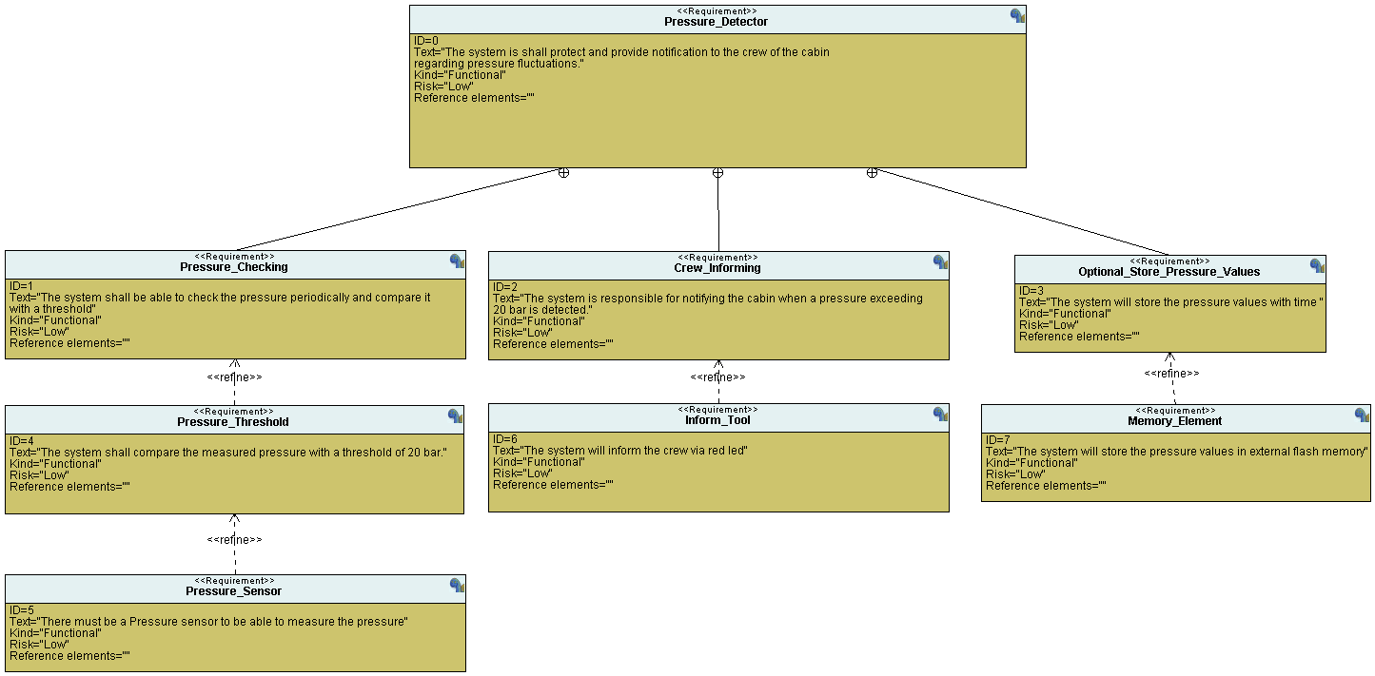

4) Space Exploration

This project will be implemented using Single MCU which is STM32F103C6 which contain ARM-Cortex-M3

5)System Analysis

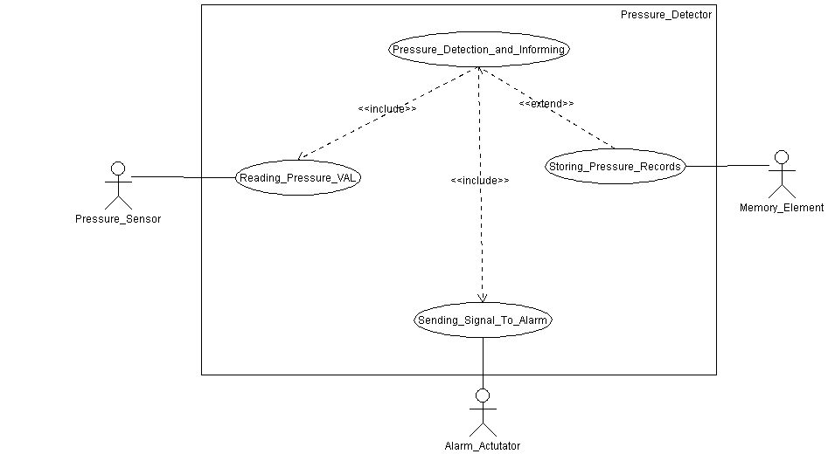-Use Case Diagram

-Activity Diagram

-Without Debug Information

-Sequence Diagram

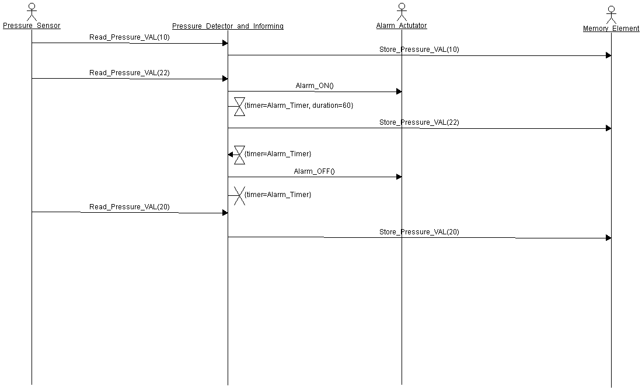

3)Navigate Symbol tables using nm.exe

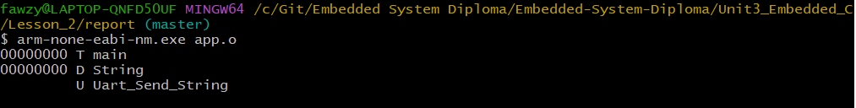



6)System Design

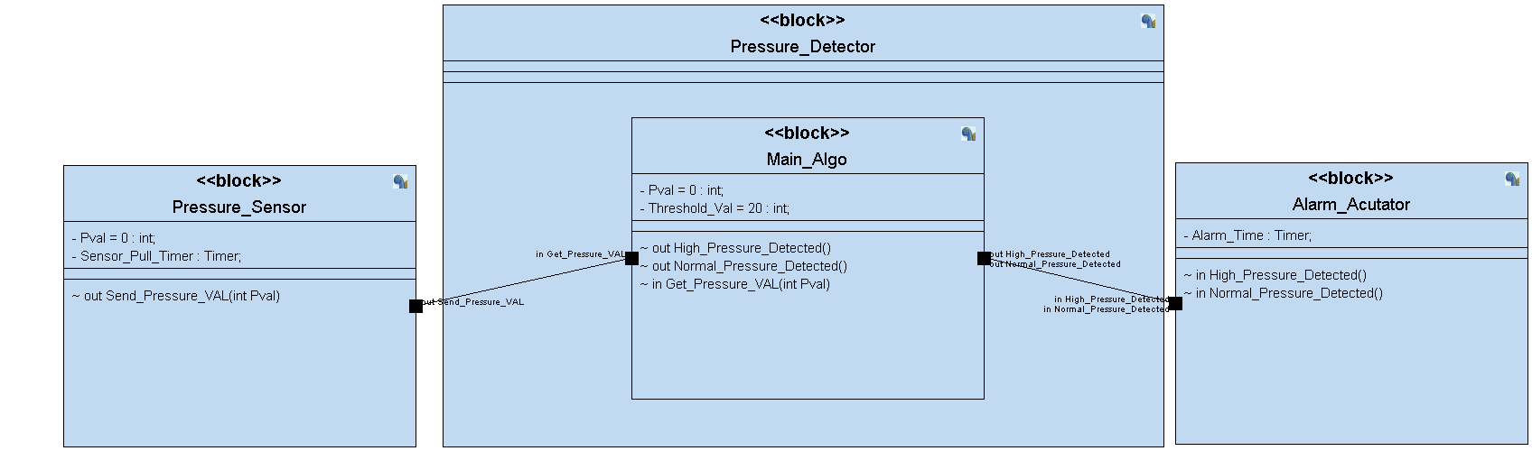-Block Diagram

-Pressure Sensor State Machine

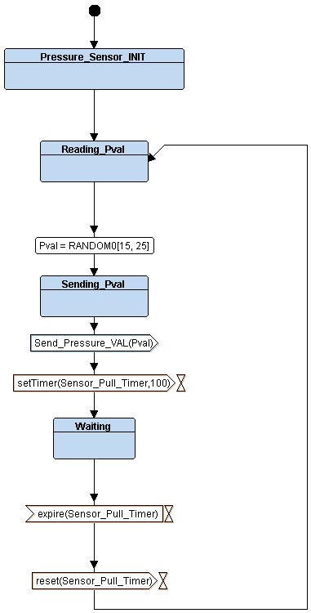

-Main_Algo State Machine

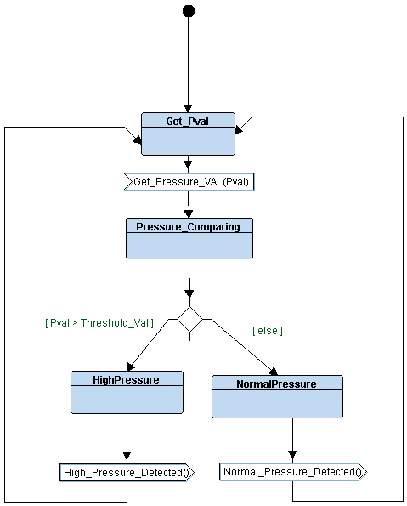

-Alarm_Acutator State Machine

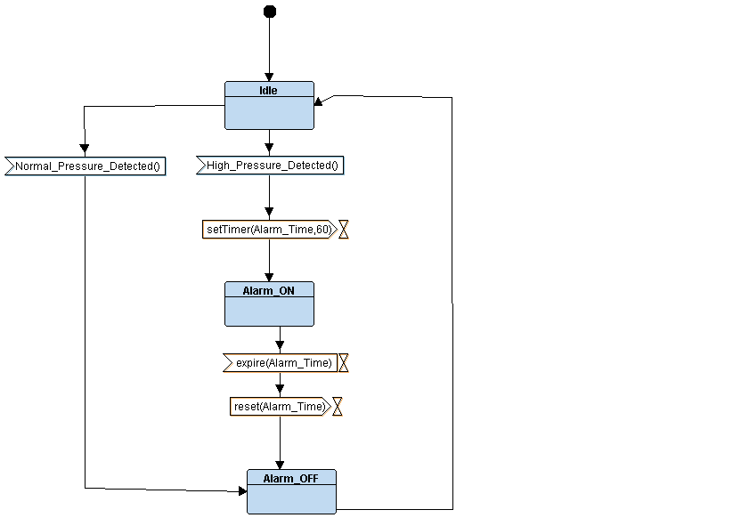

7) Logic Check

8) Simulation Results

-Case 1: input 00001111 (15 bar)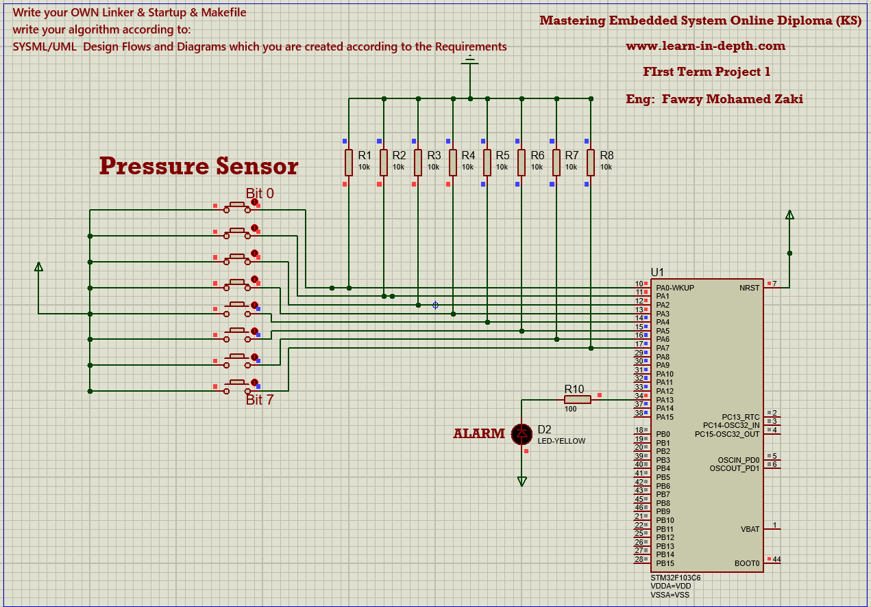

-Case 2: input 10001111 (143 bar)

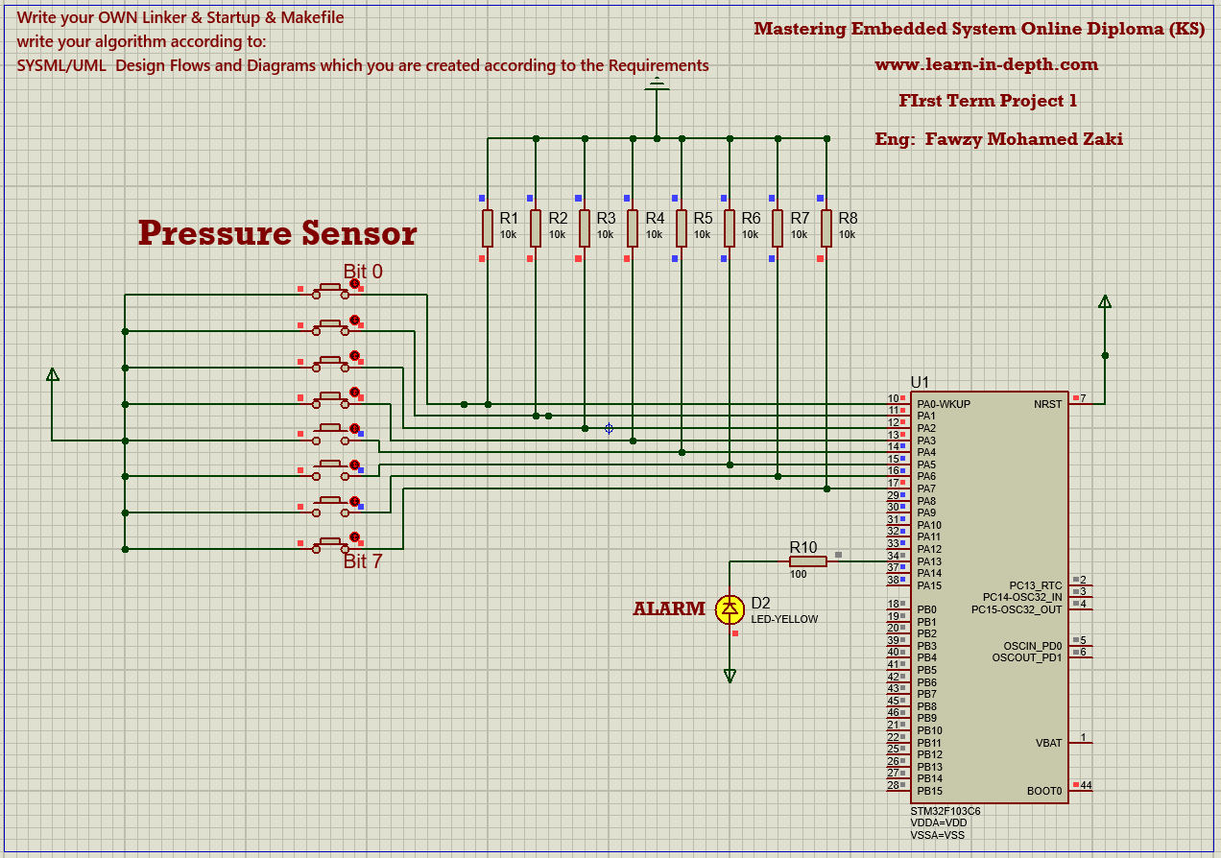

9)Symbol tables

-Pressure_Sensor.o

-Main_Algo.o

-Alarm_Acutator.o

-Main.o

-Led_Driver.o

-Final_Elf

10)Navigate Sections of object files

-Pressure_Sensor.o

-Main_Algo.o

-Alarm_Acutator.o

-Main.o

-Led_Driver.o

-Final_Elf

