

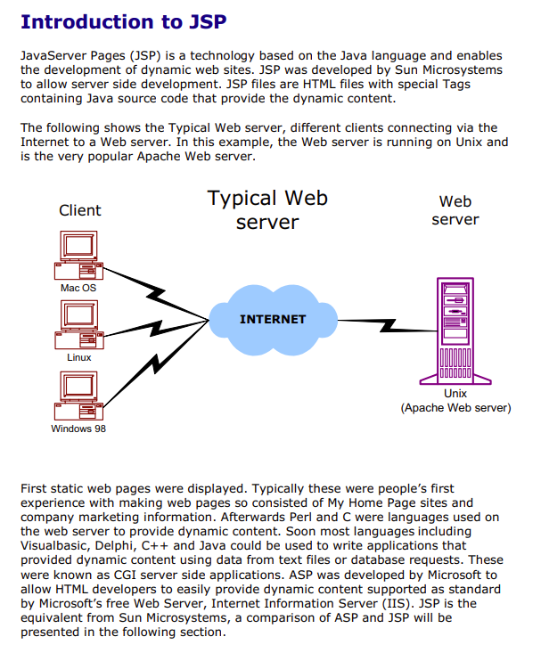

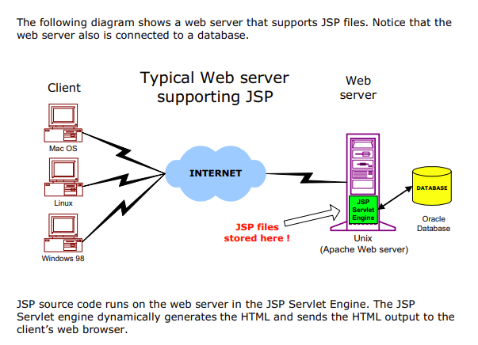

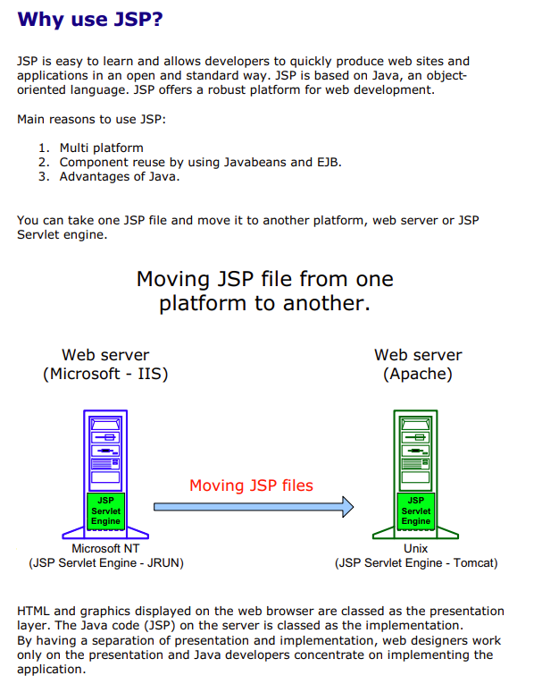

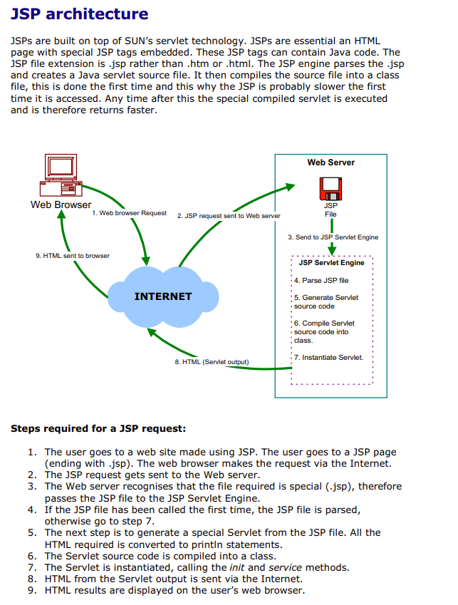

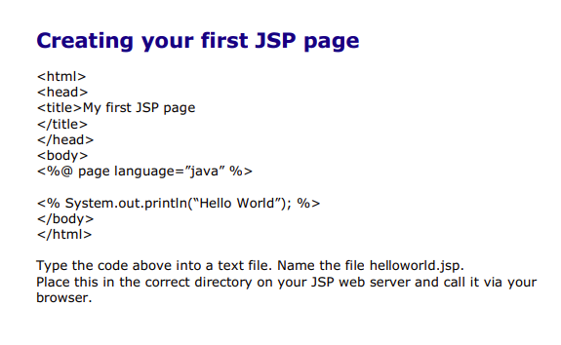



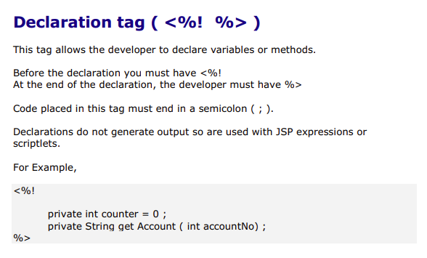

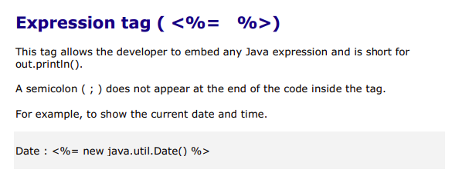

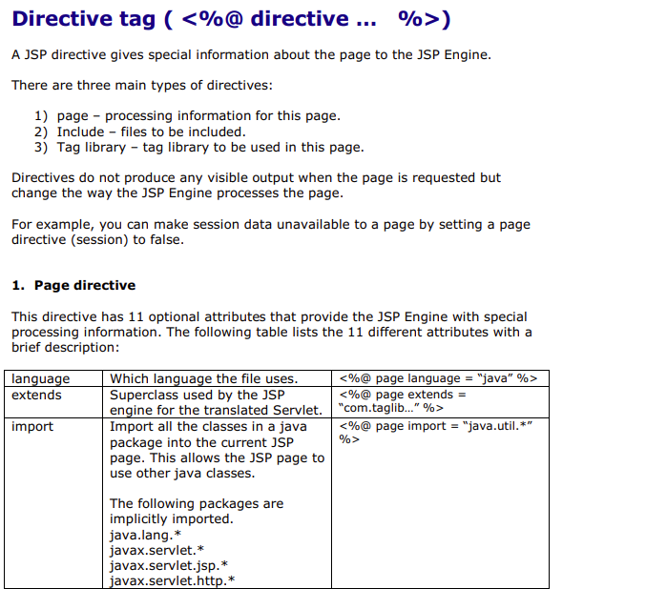

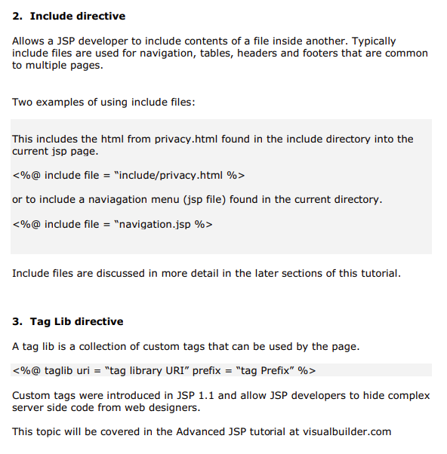

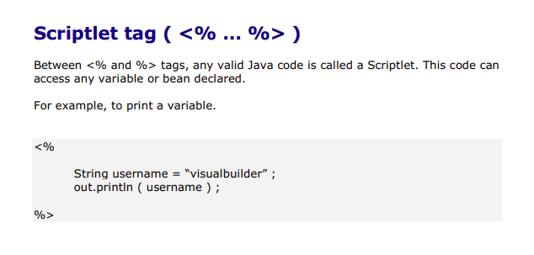

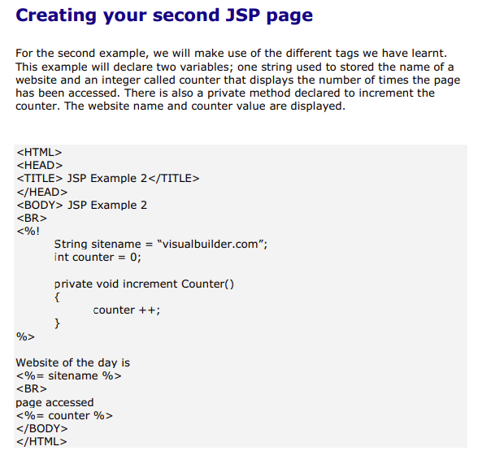

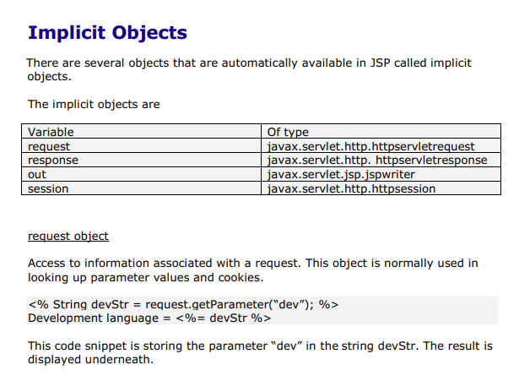

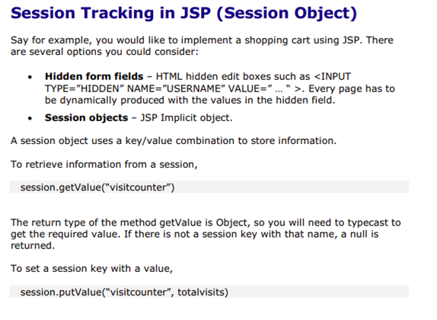

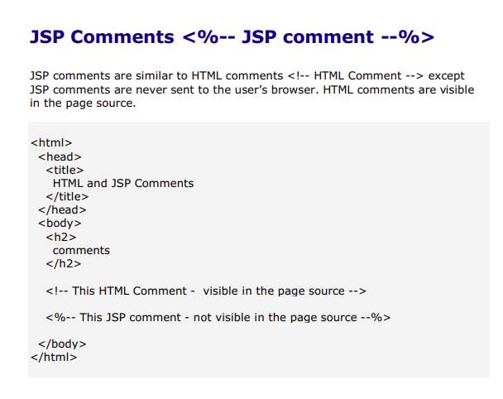



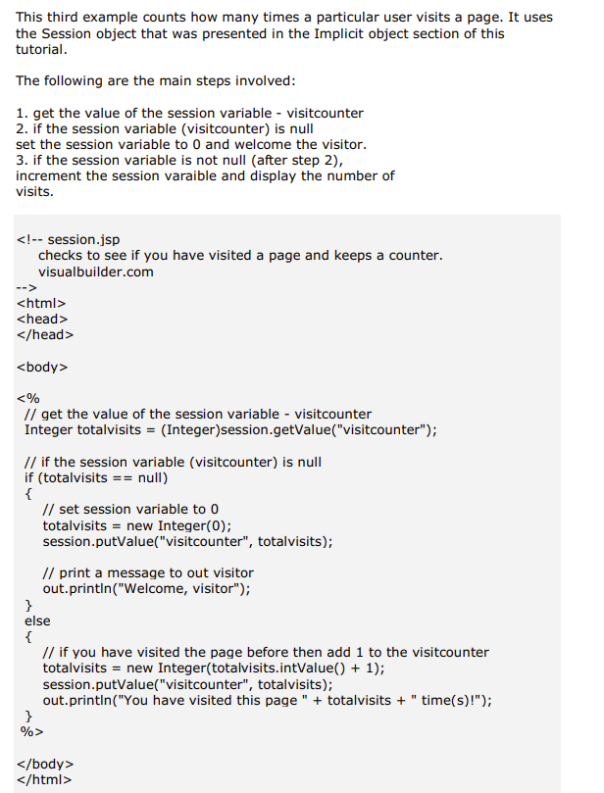

Database Access with JDBC (Java DataBase Connectivity)

JDBC Introduction

• JDBC provides a standard library for accessing relational databases
• Way to establish connection to database
• The data structure of query result (table)
• JDBC classes are in the java.sql package

Basic Steps in using JDBC

1. Load the driver
try
{
Class.forName("oracle.jdbc.driver.OracleDriver");
}
catch ( ClassNotFoundException cnfe)
{
System.out.println("Error loading driver: " cnfe);
}

2. Define the Connection URL
String host = "10.1.10.132";
String dbName = " sdevol ";
int port = 1521;
String oracleURL = "jdbc:oracle:thin:@" + host +":" + port + ":" + dbName;

3. Establish the Connection
String username = " refuser ";
String password = " refuser ";
Connection connection = DriverManager.getConnection(oracleURL,username,password);

4. Create a Statement
Statement statement = connection.createStatement();

5. Execute a Query
String query = "SELECT col1, col2, col3 FROM sometable";
ResultSet resultSet =statement.executeQuery(query);

– To modify the database, use executeUpdate, supplying a string that uses UPDATE, INSERT, or DELETE

6. Process the Result
while(resultSet.next()) {
System.out.println(resultSet.getString(1) + " " + resultSet.getString(2) + " " +resultSet.getString(3));
}
- First column has index 1, not 0
- You can also access result meta data (column names, etc.)

7. Close the Connection
connection.close();

Useful Statement Methods

• executeQuery
– Executes the SQL query and returns the data in a table (ResultSet)
– The resulting table may be empty but never null

ResultSet results = statement.executeQuery("SELECT a, b FROM table");

• executeUpdate
– Used to execute for INSERT, UPDATE, or DELETE SQL statements
– The return is the number of rows that were affected in the database
– Supports Data Definition Language (DDL) statements
CREATE TABLE, DROP TABLE and ALTER TABLE

int rows = statement.executeUpdate("DELETE FROM EMPLOYEES" + "WHERE STATUS=0");

