**Leyla Ismayilzada**

|  |  |
| --- | --- |
| **Date and Place of birth**: | 08.02.1995, Baku, Azerbaijan |
| **Address**: | 20b S.Mehmandarov st., Khatai district, Baku, Azerbaijan |
| **Mobile Phone**: | +994 55 704 60 96 / +994 50 622 85 11 |
| **Home**: | +994 12 579 36 70 |
| **E-mail**: | [lylsmylzdh@gmail.com](mailto:lylsmylzdh@gmail.com) |

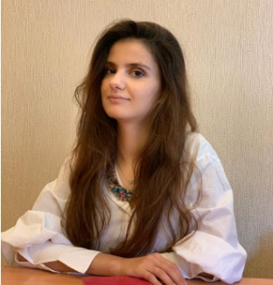

|  |  |
| --- | --- |
| **Summary** | Experienced software implementation specialist with more than two-years experience in IT industry. Having a considerably large portfolio of IT projects which both participated in and co-managed.  Experienced in SCRUM project management. |

|  |  |
| --- | --- |
| **Work experience** | *July 2018 -present*  **Prosys LLC, Baku, Azerbaijan** – *Software implementation specialist*  Responsibilities:   * Implement e-document management software built in customers' servers * Test existing and new features of software products and provide feedbacks for developers in case of bugs * Deliver training sessions for customers on the use of software products * Respond inquiries from customers regarding the software products and ensure the solution * Prepare comprehensive and detailed user manuals |
|  | *October 2016 – March 2018*  **Main Police Department of Baku City, Baku, Azerbaijan** – *clerk*  Responsibilities:   * Organized internal documentation as per the legislation and relevant procedures * Effectively used built-in software for the document management * Prepared the outgoing and incoming documents and archived them in accordance with the standards * Carried out daily office management |
|  | *May 2016 – August 2016*  **Azerkredit LLC, Baku, Azerbaijan** – *Human Resources intern*  Responsibilities:   * Prepared HR-related reports as needed * Carried out filing and other administrative duties as assigned * Inserted data of employees into the designed spreadsheet * Gathered necessary documents |

|  |  |
| --- | --- |
| **Higher Education** | **Baku State University (2012 – 2016)**  *Computer Sciences – Bachelor’s degree* |

|  |  |
| --- | --- |
| **Certifications** | Software Processes and Agile Practices, University of Alberta, *23 December 2020*Querying Databases Using SQL SELECT statement, Coursera, *13 December 2020*Introduction to Software Product Management, University of Alberta, *05 December 2020*International Scrum Product Owner, International Scrum Assembly, *01 August 2020*Sql for Data Science, University of California, *20 April 2020* |
| **Language & IT Skills** | Azerbaijani – native, Turkish – fluent, English – pre-intermediateWord, Excel, PowerPoint, OutlookMS SQL, SQL Oracle, HTML (basic), PowerBI (basic) |