节点树
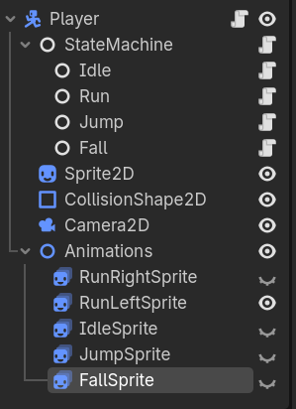

目录结构：
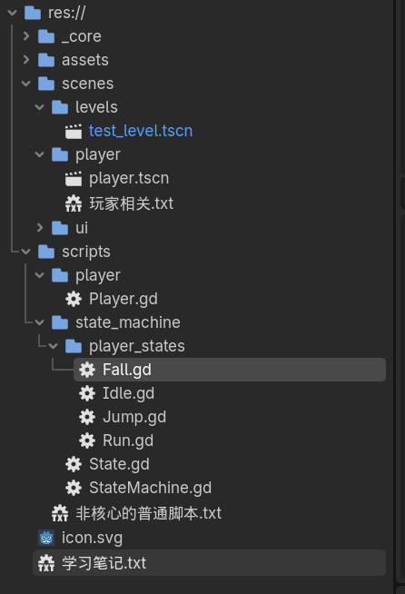

res://scripts/player/Player.gd
extends CharacterBody2D

var animations: Node2D
var current_sprite: AnimatedSprite2D = null
var facing_right: bool = true # 用于记忆方向

@export var walk_speed: int = 300
@export var fall_speed: int = 250

func _ready():
animations = find_child("Animations", true, false)
if animations == null:
print("错误：未找到 Animations 节点")
return
for child in animations.get_children():
child.visible = false

func play_animation(anim_name: String):
if animations == null:
return
var sprite_node_name = _get_sprite_node_name(anim_name)
var sprite = animations.get_node(sprite_node_name) as AnimatedSprite2D
if sprite == null:
print("找不到动画节点: ", sprite_node_name)
return
for child in animations.get_children():
child.visible = false
sprite.visible = true
sprite.play(anim_name)
current_sprite = sprite

# 如果是 idle 动画，根据记录的方向恢复翻转
if anim_name == "idle":
set_flip(not facing_right)

func _get_sprite_node_name(anim_name: String) -> String:
match anim_name:
"idle": return "IdleSprite"
"run_right": return "RunRightSprite"
"run_left": return "RunLeftSprite"
"jump": return "JumpSprite"
"fall": return "FallSprite"
_: return "IdleSprite"

func set_flip(flip: bool):
#flip = true 表示水平翻转（向左），false 表示不翻转（向右）
if current_sprite:
current_sprite.flip_h = flip
facing_right = not flip

func _physics_process(delta):
move_and_slide()

res://scripts/state_machine/State.gd
extends Node
class_name State

var player: CharacterBody2D
var state_machine: StateMachine

func enter(): pass
func exit(): pass
func update(_delta): pass
func physics_update(_delta): pass
func handle_input(_event): pass

res://scripts/state_machine/StateMachine.gd
extends Node
class_name StateMachine

@export var initial_state: State
var current_state: State

func _ready():
for child in get_children():
if child is State:
child.player = get_parent()
child.state_machine = self
change_state(initial_state)

func change_state(new_state: State):
if current_state:
current_state.exit()
current_state = new_state
current_state.enter()

func _process(delta):
if current_state:
current_state.update(delta)

func _physics_process(delta):
if current_state:
current_state.physics_update(delta)

func _input(event):
if current_state:
current_state.handle_input(event)

res://scripts/state_machine/player_states/Fall.gd
extends State

func enter():
player.velocity.y = player.fall_speed
player.play_animation("fall")

func physics_update(delta):
var direction = Input.get_axis("nav_left", "nav_right")
player.velocity.x = direction * player.walk_speed
if direction != 0:
player.set_flip(direction < 0)
if player.is_on_floor():
player.velocity.y = 0
if direction != 0:
state_machine.change_state(get_node("../Run"))
else:
state_machine.change_state(get_node("../Idle"))

res://scripts/state_machine/player_states/Idle.gd
extends State

func enter():
player.play_animation("idle")

func physics_update(delta):
if Input.is_action_just_pressed("jump"):
state_machine.change_state(get_node("../Jump"))
return
if not player.is_on_floor():
state_machine.change_state(get_node("../Fall"))
return
var direction = Input.get_axis("nav_left", "nav_right")
if direction != 0:
state_machine.change_state(get_node("../Run"))
else:
player.velocity.x = 0

res://scripts/state_machine/player_states/Run.gd
extends State

func enter():
var direction = sign(player.velocity.x)
if direction == 0:
direction = 1
_update_animation(direction)

func _update_animation(direction: int):
if direction > 0:
player.play_animation("run_right")
player.set_flip(false) # 朝右
else:
player.play_animation("run_left")
player.set_flip(true) # 朝左

func physics_update(delta):
if Input.is_action_just_pressed("jump"):
state_machine.change_state(get_node("../Jump"))
return
if not player.is_on_floor():
state_machine.change_state(get_node("../Fall"))
return
var direction = Input.get_axis("nav_left", "nav_right")
if direction == 0:
state_machine.change_state(get_node("../Idle"))
else:
player.velocity.x = direction * player.walk_speed
_update_animation(direction)

res://scripts/state_machine/player_states/Jump.gd
extends State

var jump_speed: int = -350
var jump_height: int = 100
var start_y: float = 0.0

func enter():
player.velocity.y = jump_speed
start_y = player.global_position.y
player.play_animation("jump")

func physics_update(delta):
var direction = Input.get_axis("nav_left", "nav_right")
player.velocity.x = direction * player.walk_speed
if direction != 0:
player.set_flip(direction < 0)
if start_y - player.global_position.y >= jump_height:
state_machine.change_state(get_node("../Fall"))

